DIVISION SS

- (2565) TRAFFIC CONTROL SIGNALS

This work consists of providing and installing materials and electrical equipment and installing Department provided materials as specified herein, for a complete operating new Rural Intersection Conflict Warning System (RICWS) and Roadway Lighting System at the intersection of _______ and _______ in ________, ________ County, in accordance with the applicable provisions of MnDOT 2545, 2564, and 2565; with the Plans; and the following:

2565 ABBREVIATIONS

A GLOSSARY OF ACRONYMS AND ABBREVIATIONS
Acronyms and abbreviation used in the Contract to represent full text in accordance with 1102 “Abbreviations and Measurement Units” and as shown in Table 2545-1:

Table 2565-1
Acronyms and Abbreviations Used
Acronym or Short Form | Full Name or Meaning
APL | Approved/Qualified Products List

- MATERIALS REQUIREMENTS

SS-2.1 GENERAL

(None)
Ensure Division S Special Provisions “As-Builts” are included in the Division S Special Provisions.
This would include the pay item 2011.601.
After the July 2015 Project letting date the As-Builts verbiage should automatically be included in Division S Special Provisions by MnDOT’s Project Management & Technical Support Office.
Note required verbiage below in the measurement and payment section of these special provisions.
All Red text must be removed from the special provisions prior to the special provisions being submitted for project letting.

SS-2.2 MATERIALS

    - Department Provided Materials

The Department provides to the Contractor (at no expense to the Contractor) the following materials and electrical equipment for the Contractor to install:

- One RICWS system controller cabinet each complete with controller unit and required flasher system control equipment (including Canoga Traffic Monitoring Card with firmware upgrade).

- Four sets of anchor rods, nuts, and washers to mount the Department provided RICWS system cabinet (one set = one anchor rod, nut, and washer).

- One 4-section rubber gasket to be installed between the bottom of the RICWS system cabinet and the concrete foundation.

- Two LED blankout signs.

(The following language is to be used for required warning stickers on the backside of sign panels being installed on the RICWS system project. See additional verbiage under construction requirements. The Specification Writer must include the appropriate contact person and phone number to the following paragraph).
All Red text must be removed from the special provisions prior to the special provisions being submitted for project letting.

- Warning stickers to be affixed on new sign panels in accordance with 2564.3.H.2.

    - Contractor Provided Equipment and Materials

- Rodent Intrusion Barrier

Rodent intrusion barrier listed on MnDOT’s Approved Products List for Lighting may be used instead of stainless steel woven wire cloth specified in 2545.2.X for double-nut connection light pole bases with a 10 ¾ in diameter base plate opening.

- Non-Invasive Micro-loop Detectors

Provide non-invasive micro-loop detectors (sensors) at locations shown on the Plans and in accordance with the following:

Use Canoga Traffic Sensing System Model 702 non-invasive micro-loop sensors (triple sensor assemblies at locations shown on the Plans).

Directional bore a 3 in NMC under the roadway.

Use the Canoga 702 sensor installation kit and Canoga 30003 home-run cable with the micro-loop sensors.

- Arc -Flash Hazard Warning Labels

- Provide 4 in H x 6 in W vinyl or polyester labels meeting the following:

(1.1) White background,
(1.2) Orange background behind the WARNING text,
(1.3) Black text,
(1.4) Self-adhesive,
(1.5) Machine printed letters and numbers, and
(1.6) Water-resistant.

- Figure 1 is for information and reference only.
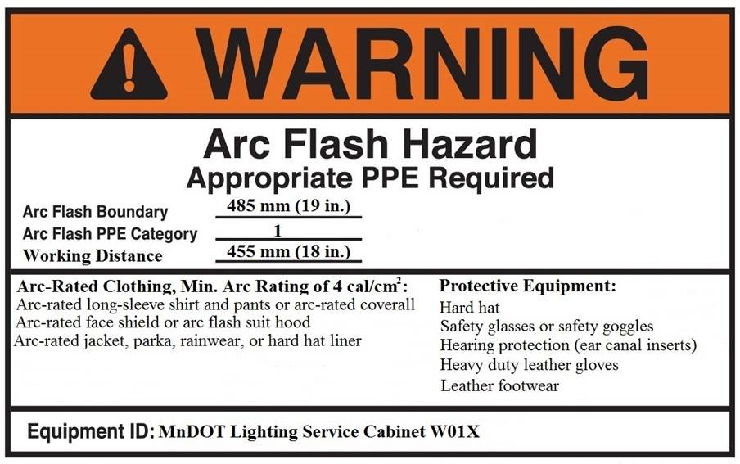
Figure 1: Arc-Flash Warning Label – Category 1

Include the paragraphs below only if the signal system is going to be painted. Add required paint color
All RED text must be removed from the special provisions prior to the special provisions being submitted for project letting.

- Light Pole Type 9-40 (Breakaway)

Provide and install stainless steel or aluminum breakaway light poles as specified in the Contract and meeting the following:

(1) 9 foot davit or mast arm type as shown on the Plans,
(2) 40 foot nominal luminaire mounting height, and
(3) High base plate or bottom of T Base designed for 1 in diameter anchor rods on a
15 in bolt circle as shown on MnDOT Light Foundation Design E Standard Plate
8127.

Provide and install a complete lighting unit as specified in the Contract.

- LED Roadway Luminaires Mounted at 40 Feet

Provide and install MnDOT approved LED Roadway Luminaires for mounting at 40 ftas shown on the Plan and the following:

MnDOT approved LED Roadway Luminaires for mounting at 40 ft are listed on the MnDOT’s APL for Lighting:

http://www.dot.state.mn.us/products/index.html

- Light Foundation, Design E

Provide and install a Concrete Light Foundation, Design E as specified in the Contract at locations shown on the Plan.

- Equipment Pad

Provide and install an equipment pad as specified in the Contract at locations shown in the Plan.

- Service Cabinet Type, Rural Lighting and Flasher (RLF)

Provide a MnDOT approved Type Rural Lighting and Flasher (RLF) Service Cabinet (120/240 VAC) for supplying power to the Flashing Beacon System and to the 120 volt Lighting System. Install the service cabinet on an equipment pad as specified in the Contract.

MnDOT approved Service Cabinets Type Rural Lighting and Flasher (RLF) are listed on the MnDOT APL for Roadway lighting:
http://www.dot.state.mn.us/products/index.html
- Flashers

Provide and install materials and electrical equipment for a complete operating single and dual flashers at the locations shown on the Plans and in accordance with the following:

(1) Flashing Beacon Assemblies:
(1.1) Provide 12 in polycarbonate vehicle signal heads for flashing beacon assemblies in accordance with MnDOT 3834.
(1.2) Use MnDOT approved Poly Carbonate Vehicle Signal Housings listed on the MnDOT’s APL for Signals:

http://www.dot.state.mn.us/products/index.html

(1.3) Provide and install a metal support plate (supplied by the signal head manufacturer) on the inside of the signal section at the attachment point of the mount (one plate inside the head at the attachment point).
(1.4) Provide 12 inch "Yellow" signal indications in accordance with MnDOT 3834 and as follows:
(1.4.1) Affix to the back of each "yellow" flasher indication a
permanent label indicating the date of installation to the satisfaction of the Engineer.
(1.4.2) Each flashing beacon assembly includes a cut away visor and background shield as shown on the Plans.
(1.4.3) Attach flasher beacons as shown on the Plans.

(2) Flashing Beacon Assembly Bracketing:
(2.1) Provide aluminum flashing beacon assembly bracketing with anodic coating as per MIL-A-8625C for Type II, Class I Coating.

(3) Wiring at Each Advance Warning Flasher:
(3.1) Provide a 3/c # 14 or a 4/c #14 signal control cable in accordance MnDOT 3815.2 between the controller cabinet and each flashing beacon atop the advance warning flasher assembly (or through a sign post mounted on box).

(4) Flasher Signs:
(4.1) Provide and install W3-X8a (ENTERING TRAFFIC), W3-X8aP (WHEN FLASHING), and W16-13P (WHEN FLASHING) signs with each flasher installation where noted in the Plans. Fabricate these signs in accordance with MnDOT 2564, and as detailed in the Plans.
(4.2) Provide sign base material and fabrication stickers that are in accordance with the applicable provisions of MnDOT 2564 and MnDOT 3352. Sign face and sign legend materials must be Sign Sheeting for Rigid Permanent Signs, Delineators, and Markers (Type IX or Type XI), except as specified below:
(4.2.1) Provide sign face with fluorescent yellow reflective sheeting.

(5) The retro reflective sheeting types and qualified products used for rigid permanent signs, markers and delineators can be found on the MnDOT Approved/Qualified Products Lists WEB site for Signing under Sheeting Materials.

http://www.dot.state.mn.us/products/index.html

(6) Mount each sign as detailed in the Plans.

(7) W3-X8b (TRAFFIC APPROACHING) blankout signs will be provided by the Department. Install as noted in the Plan and elsewhere in these Special Provisions.

(8) Flasher sign posts and mounting hardware for mounting of flashing beacons and intersection warning signs will be included as part of the pay item for each Flashing Beacon System, with no direct compensation being made therefore.

- CONSTRUCTION REQUIREMENTS

- Pick Up Department Provided Materials

Pick up materials and electrical equipment provided by the Department at MnDOT’s Electrical Services Section, 6000 Minnehaha Avenue, St. Paul, MN 55111-4014. Follow these requirements:

    - Request from MnDOT’s Electrical Services Section the materials and electrical equipment provided by the Department.
    - Direct the Electrical Services Section to the T.E. Request No. ______.
    - Request Department provided materials at least 30 business days in advance of needing the material on the project.
    - Notify MnDOT’s Electrical Services Section at least 3 business days in advance of intention to pick up materials and electrical equipment.
Contact:
- Electronic Maintenance Supervisor 651-366-5759,
- Stockroom 651-366-5720, or
- Transportation Program Supervisor 651-366-5753.
    - Pick up the Department provided materials and electrical equipment at the above specified location and transport them to the job site.
    - Secure each cabinet in an upright position when transporting to the job site. Ensure that each cabinet being transported will not tip and be damaged.
    - Notify the Engineer in advance of contacting MnDOT’s Electrical Services Section.

- Installation of Department Provided Materials

Install the Department provided RICWS controller cabinet complete with controller unit and required traffic signal control equipment.

Install the Department provided blank-out signs in accordance with the Contract.

Provide and install additional materials and electrical equipment for a complete operating RICWS system installation including:

  - A cabinet concrete foundation as part of the equipment pad concrete foundation using Department provided anchor rods, nuts, and washers.
  - Bonding and grounding materials and connections.
  - Terminating and connecting field wiring in the cabinet as directed by the Engineer to make the flashing beacon system fully operational.
  - Blank-out sign mounting hardware, cables and conductors.

The following paragraph needs to be modified to give contractor specific location to deliver the pallet back to MnDOT.
All RED text must be removed from the special provisions prior to the Special Provisions being submitted for project letting.

Protect the Department provided cabinet pallet from damage and return the pallet to MnDOT Central Electrical Inventory Center at the address specified herein, or the District Headquarters.

- Arc-Flash Hazard Warning Labeling

- Calculate available fault current in accordance with 2545.3X and 2565.3 CC.
- Establish available fault current and apply the appropriate label as follows.
- Use the current edition of NFPA 70E “Standard for Electrical Safety in the Workplace” to determine the required PPE category and personal protective equipment.
- If the available fault current is ≤ 25,000 amps then provide a label with the following information shown in Example 1.

Example 1
Warning
Arc Flash Hazard
Appropriate PPE Required
Arc Flash Boundary 19 Inches
Arc Flash PPE Category ____1___
Working Distance 18 Inches
Arc Flash Personal Protection Equipment (PPE)
List required clothing, Min Arc Rating of 4 cal/cm², and protective equipment in accordance with the PPE Table from the current edition of NFPA 70E Standard for Electrical Safety in the Workplace.
Equipment ID

- If the available fault current is ˃ 25,000 amps:

(5.1) Determine PPE requirements in accordance with the current edition of NFPA 70E Standard for Electrical Safety in the Workplace, and
(5.2) Provide a label with the following information shown in Example 2. Fill in the ___ (blank) with the required arc-flash PPE category and arc-flash boundary distance.

Example 2
Warning
Arc Flash Hazard
Appropriate PPE Required
Arc Flash Boundary Feet_
Arc Flash PPE Category ________
Working Distance 18 Inches
Arc Flash Personal Protection Equipment (PPE)
List required clothing, Min Arc Rating of ___ cal/cm², and protective equipment in accordance with the PPE Table from the current edition of NFPA 70E Standard for Electrical Safety in the Workplace.
Equipment ID

- Install labels on the front of the dead front door of the electric service cabinet at eye level.

- Concrete Equipment Pad

Install equipment pads for RICWS controller cabinets and Type RLF service cabinets as shown on the Plan and in accordance with 2545.3.F and 2565.3.F.

- Maintenance and Locating of Electrical Systems

Maintain and keep in operation new and existing electrical systems in accordance with 2545.3.B, 2565.3.B and as follows:

The Contractor is responsible for locating underground facilities of the flashing beacon system and the roadway lighting system during construction within the limits of the construction project, for the duration of the construction project in accordance with the applicable provisions of MnDOT 1514 and in accordance with Minnesota State Statute 216D.

Responsibility for locating underground facilities is transferred to the Contractor on the project start date as shown on the proposal.

The MnDOT locating group will provide an initial locate of existing MnDOT owned underground traffic control signal and roadway lighting system facilities within the project limits at the request of the Contractor at the start of the project. Submit the initial locate request to the MnDOT Locating Office at least four working days before the project start date.

Locate requests that are within the construction project limits will continue to be received by MnDOT’s Locating Office. These locate tickets will be forwarded to the Contractor’s representative responsible for coordinating locate requests within the projects limits. The locate tickets will be forwarded via e-mail or fax. Confirmation of receipt of the locate ticket must be sent by the Contractors representative back to the MnDOT’s Locating Office within two hours of MnDOT sending the Contractor’s representative the locate request.

Repair damage to a facility as the result of improperly locating or unmarked underground facilities within the project limits. Repair the damaged underground facilities to the satisfaction of the Engineer. This work is considered incidental.

Notify MnDOT’s Locating Office to provide contact information and establish the contractor has assumed responsibility for locating MnDOT’s underground facilities within the project limits. Complete the “Locating Responsibility Form” in this section and submit to the Engineer at the pre-construction meeting. Send a copy of the form to the following:

Electrical Services Dispatch
Phone: (651)366-5750
Fax: (651)366-5742
E mail: ElectricalServicesDispatch.dot@state.mn.us
6000 Minnehaha Ave. St. Paul, MN 55111-4014

and

Locating Supervisor
Phone: (651)755-9061
Fax: (651)366-5742
E mail: eric.klute@state.mn.us
6000 Minnehaha Ave. St. Paul, MN 55111-4014

(The following Section should be filled out by the specification writer to direct the contractor and project engineer to the correct person in the District.
All Red text must be removed from the special provisions prior to the special provisions being submitted for project letting.

MnDOT District Signal Operations
Name:
Phone:
Fax:
E mail:
Address:

(The following Section should be left on its own page so the contractor can remove it and use the blank page)
All Red text must be removed from the special provisions prior to the special provisions being submitted for project letting.

Locating Responsibility Form
Job S.P. Number ______________________
Job Type ______________________
Start Date ______________________
End Date ______________________
T.H. ______________________
Location ______________________
Lighting/ Signal Inspector ______________________
Contractor ______________________
Contractor (24 Hour Contact) ______________________
Project Manager ______________________
Phone Number ______________________
Fax Number ______________________
Email ______________________
Electrician ______________________
Phone Number ______________________
Locator Area ______________________
Project Engineer ______________________
Phone Number ______________________
Chief Inspector ______________________
Phone Number ______________________
Weekly Meeting ______________________

Until final written acceptance of the project by the Engineer (MnDOT 1716) this work is considered incidental.

During any periods of authorized work suspension, the contractor is responsible for maintenance of the existing, temporary, and newly constructed traffic control signal systems.

Provide to the Department contact information with the names and telephone numbers for 24 hours a day, 7 days a week maintenance as defined above.

- Electrical Service

Coordinate the installation of each electrical service, provide power to the service cabinets, and verify the actual work to be done and all associated costs.

Fees for the “Application for Electrical Service” and payment to the Electric Utility for providing the electrical service connections is the responsibility of the Contractor.

Secure approval from the Engineer for any changes to each electrical service as reflected in the Plans.

No measurement is made of the various items that constitute Electrical Service, however this work is included as part of the project (the electrical service costs will not be paid for as part of any pay item).

Provide the Engineer a copy of each invoice from the electric utilities. Payment is the power company invoice cost plus 10%. The payment is compensation in full for all costs incidental thereto, including, but not limited to, providing power to service cabinets, electric utility fees, electric utility coordination, notifying the Department of ownership details, and all materials and labor necessary to construct each electrical service.

- Non-Invasive Microloop Detectors Installation

Install non-invasive microloop detectors below the existing roadway pavement as shown on the Plan and in accordance with the manufacturer’s installation procedures. Open trenching of the roadway surface is not allowed for installation of microloop detectors below the roadway pavement.

- Sign Panel Warning Stickers

Install Department furnished warning stickers on new sign panels in accordance with MnDOT 2564.3.H.

- Blank

- Blankout Sign Installation

Provide and install Engineer approved mounting brackets and mounting hardware for each Department provided blankout sign so that housings are able to be attached to the square tube sign posts. Take caution so as not to damage Department provided blankout signs during transport and installation (provide a new blankout sign of the same make and model at no cost to the Department for any blankout sign damaged by the Contractor due to any Contractor operations). Provide all mounting hardware and complete mounting of the blankout sign panels securely to each square tube sign post at no expense to the Department.

Blankout signs require aiming of the LED sign message to align the viewing angle of the LED to the driver at the minor road stop bar. Align the blankout sign by aligning the sign structure without adding additional spacers between the sign structure and the blankout sign.

Adjust the blankout sign LED intensity by setting the dimmer to accommodate both day and night operation.

K. Light Pole Installation

Install 40 ft stainless steel light poles in accordance with 2545.3.H and the following:

Use a 12 in long wrench to snug tighten the top and leveling nuts pulling the handle with one arm in one smooth motion, or use a calibrated torque wrench to snug tighten the top and leveling nuts to 33 ft lbf.

After snug tight condition has been met for the top nuts and leveling nuts, fully tighten the anchor rods by rotating the top nuts 1/18 turn (1/3 of one face of a nut), or use a calibrated torque wrench to fully tighten the top nuts to 200 ft lbf.

48 h to 96 h after initial tightening, apply a re-tightening torque of 220 ft lbf with a calibrated torque wrench to the top nuts.

L. Compliance with NEC Article 110. 24

Provide fault current calculations in accordance with 2565.3.CC and as follows:

Fill out the following electric service information form shown below for traffic control signal systems.

Provide to the Engineer, before final acceptance of the project, four copies of the electric service information form for traffic control signal systems. The Engineer will distribute the copies to the following:

- MnDOT Electrical Services Section.
- MnDOT Traffic Electrical Systems Engineer.
- MnDOT District Traffic Engineer.
- City of _________ or County of________.

The Contractor provided "Electrical Service Information Form for Traffic Control Signal Systems" and available fault current calculations and labeling are considered incidental work.

(The following form should be left on its own page so it can be removed from the special provisions and used by the contractor) See the next page of this document
All Red text must be removed from the special provisions prior to the special provisions being submitted for project letting.
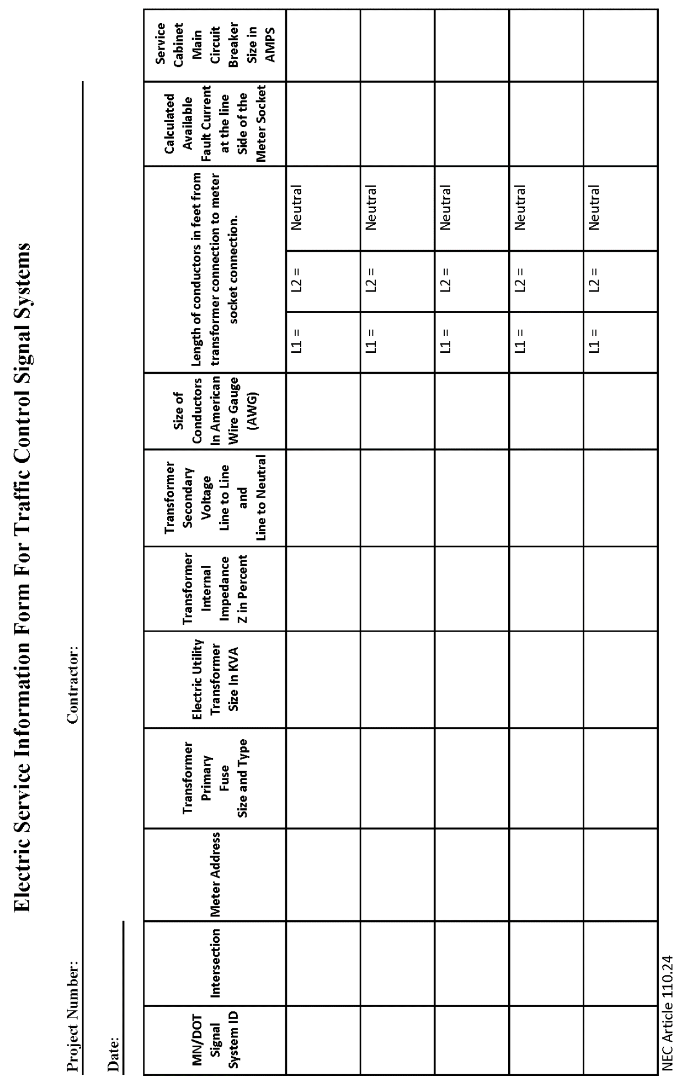

- MEASUREMENTS AND PAYMENTS
Ensure Division S Special Provisions “As-Builts” are included in the Division S Special Provisions.
This would include the pay item 2011.601.
2011.601/01000 | AS BUILT | AS BUILT | LS | LUMP SUM | 2018
The District needs to include the verbiage below to trigger installation of Divisions S Special Provisions.
Add the pay item as shown above to your pay item list.
All Red text must be removed from the special provisions prior to the special provisions being submitted for project letting.

- As Built Drawings and GPS Coordinates

As Built drawings and GPS coordinates in accordance with Division S Special Provisions “AS-Builts” including Pay Item No. 2011.601 (AS BUILT).

- TRAFFIC CONTROL SIGNAL SYSTEM

Providing and installing materials and electrical equipment and installing Department provided materials as specified herein, all to provide one complete operating new Rural Intersection Conflict Warning Systems (RICWS) (also denoted as “Flashing Beacon System”) located at the intersection of ______ and ________in _________, _____ County as contained in these Special Provisions and on the Plans will be measured as an integral unit and paid for as specified in MnDOT 2565.4 and MnDOT 2565.5 respectively for Item No. 2565.516 (FLASHING BEACON SYSTEM), at the Contract price SYSTEM, which price shall be compensation in full for costs incidental thereto.

C. LIGHTING SYSTEM

Roadway Lighting System will be included as part of the pay item for Item No. 2565.616 (FLASHING BEACON SYSTEM).

Only use the paragraph below when the District is requiring materials to be salvaged from a project.
All Red text must be removed from the special provisions prior to the special provisions being submitted for project letting.
D. HAUL SALVAGED MATERIAL

Delivery of salvaged materials to the Department at the location specified herein is paid for under Item No. 2104.601 (HAUL SALVAGED MATERIAL) at the contract LUMP SUM price and is considered payment in full for all costs relative to hauling the materials to, and depositing the materials, at the location specified herein.

Contractor Certification of Disposal

Project No.:____________ Location: ___________________________________

We, _________________________, hereby certify that the mast arm pole standards

(Name of Contractor)

were rendered unusable, and the mast arm pole standards, and if applicable, pedestal shafts and bases were removed, transported, and disposed of in accordance with all requirements of the Minnesota Pollution Control Agency (MPCA) and the Occupational Safety & Health Administration (OSHA) for the removal, transporting, and disposal of hazardous waste.

____________________________ ___________

SIGNATURE DATE

After signed and dated, the Contractor must submit this form to MnDOT’s project Engineer.
The Contractor must also submit to the Engineer a copy of the “Tipping Receipt” that the Contractor receives from the scrap yard or recycler.

