Jackalope Software Field Staff Guide
  - Written by staff from the Minnesota Department of Transportation
  - Website for the MnDOT Total Volume Program: http://www.dot.state.mn.us/traffic/data/index.html
  - Applies to software version 1.0.4.0.9
Contents
Setup before Registering 1
Registration for Jackalope 1
Count Plan 3
Finding Your Agency’s Sites 3
Exporting Field Listings 4
MEC – Submitting Count Data 6
MEC – Errors and Flags 8
Recounts 9
FAQs 9

Setup before Registering
- Jackalope must be viewed in Google Chrome; certain functions will not work in IE (Internet Explorer)
- Be sure to allow Jackalope to create popups in whatever web browser you’re using
  - Chrome: Settings > Advanced (at the bottom of the page) > Privacy and security > Content settings > Popups
    - Next to Allow, click “ADD” and paste the Jackalope URL
    - The vendor recommends clearing your cache on a regular basis and/or using an Incognito window
- Please note that not all features and buttons are used by field staff or fully developed by the software vendor, High Desert Traffic. Only features relevant to field staff will be discussed in this guide.
- Contact the Traffic Count staff at MnDOT if you have any questions or software issues: http://www.dot.state.mn.us/tda/contacts.html
- MnDOT staff should also create a connection to the following shared working folder once given access by MNIT:
  - Map to an available drive letter, \\Ad\co\TDA\Data\Traffic Monitoring\Districts

Registration for Jackalope
- Open URL
  - External MnDOT Test: http://dotapp6.dot.state.mn.us/Jackalope/
  - Internal MnDOT Test: http://tfatest/Jackalope/
  - External MnDOT Production: http://dotapp7.dot.state.mn.us/Jackalope
  - Internal MnDOT Production: http://tfa/Jackalope/
- To register, use a valid e-mail & password with minimum of 5 characters.
  - Click the “Register” button.
  - For the Sponsor Code, enter MN9999.
  - Fill out form with e-mail, password, first and last name.
  - Choose your agency (contact MnDOT if you do not see your agency).
  - Complete registration. You should be redirected to a screen that says “Registration submitted successfully!”
    - If you get an error message, screenshot the error and email it to MnDOT Traffic Count staff.
- MnDOT will email you when your account is enabled. Account within an agency sharing is not allowed.
- Ensure that at the top of your screen next to your login you see the word Sequence Number.
- Verify that you see the buttons shown below and that the active naming convention is set to “Sequence Number” (listed right before the username in the screen shot below).
  - Alerts – Not used by field staff at this time
  - Data Operations
    - Submit Files – Not used by field staff at this time
    - Manual Entry Counts (MEC) – Used to submit and review short duration counts
  - Reporting
    - Report Engine – Not used by field staff at this time
  - Count Plan
    - Yearly Schedule – Used to view counts scheduled for any given year, sites in need of recounts, and acquire field listings
  - Security
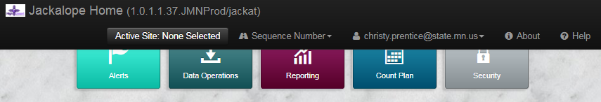
    - User Profile – Used to modify your email, password, names and agency

Count Plan
- Select “Count Plan” and then “Yearly Schedule.”
- This page will take some time to refresh as it is running several processes behind the scenes and can take up to a minute to load. The interface will open up on the year you most recently viewed.
- Confirm it is set to the intended target year and note that future years can and will change until season prep for that year is complete.
- Please ignore the comment of “(Double-click on a row to view/edit)” as this text does not apply to this screen.

Finding Your Agency’s Sites
- Sort and filter sites by typing into the blank, white fields below the column headers.
  - The default filter is “Contains,” but this can be changed by clinking on the sorting icon before the row to enter text.
  - To sort, click on the name of the field. To reverse the sort order, click on the field name again.
  - Only one filter can be used at a time within the same column. It is recommended that you export to Excel (see below) to perform more advanced sorting and filtering.
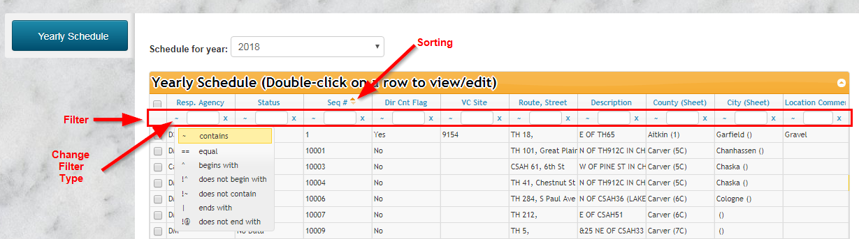
- Filter by your “Resp. Agency.”
  - Example: Type “DM” to find sites counted by the MnDOT Metro District.
  - Example: Type “Ramsey County” to find sites counted by Ramsey County.
- Filter by the “Status” column to see which counts are completed and which are not.
  - Good Data: A count within tolerance has been collected and the site is complete for the selected schedule year.
  - No Data: No counts have been entered/submitted for this site for the selected schedule year.
  - Errored: A count was entered/submitted but was outside acceptable tolerance or has an error and has not been reviewed by MnDOT. It will likely need to be recounted, but please wait for MnDOT to review before recounting.
  - Recount Requested: A count was entered/submitted but was outside the acceptable change tolerances and has been reviewed by MnDOT; obtain a recount and/or provide MnDOT with more information on the count
- Additional filters should be used as needed, such as “Route, Street” or “City.”
  - Example: Type “TH 25” and “Lanesboro” to find sites on TH 25 in the city of Lanesboro.
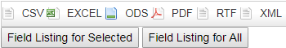
  - Example: Type “Anoka” in “County (Sheet)” and “SCHOOL” in “Location Comments” to get any school sites in Anoka county.

Exporting Field Listings
- EXCEL: Creates an Excel file of the filtered sites currently shown. Once exported, the data can be easily sorted and filtered in Excel for more in-depth analysis; additionally, you can see more than 100 records at a time which is the maximum number per page in Jackalope.
  - Please note that the Jackalope database stores the Sequence Number as a text field, so follow these steps to convert it to a Number field for easier sorting:
    - Click on the first sequence number.
    - Press CTRL+SHIFT+Down Arrow to select the entire column.
    - Click the yellow icon near the top left corner of your selection.
    - Click “Convert to Number” in order to allow sequence numbers to be filtered numerically.
    - Highlight the column headers and then click “Filter” under the “Sort & Filter” tab to allow more complex sorting than the Jackalope screen.
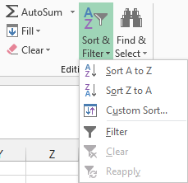
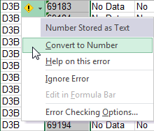
  - Once sorting and filtering is complete, the spreadsheet and be printed for use in the field.
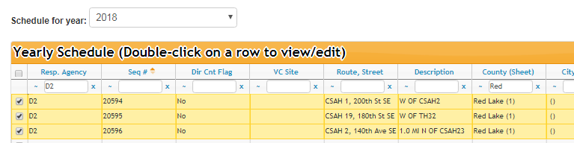
- Field Listing for Selected: Exports a PDF field list of the sites you checked on the left (max 100) that can be printed for use in the field. This option is best suited to smaller agencies with fewer counts or if you are focused on a specific area.
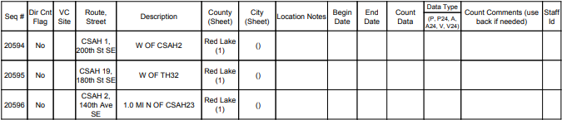
- Field Listing for All: Exports a PDF field list of all the sites filtered.
Column Name | What it means
Seq # | Sequence number or Site ID
Dir Cnt Flag | Should the count be set separately for each direction? Based on past site coding
VC Site | Vehicle Class Site ID (if assigned)
Route, Street | Route label and if coded the street name of the site
Description | General description of where to place the counter (if moved notify MnDOT)
County (Sheet) | County and if assigned the map sheet
City (Sheet) | City and map sheet, if assigned
Location Notes | Important information about the site, such as to count when school is in session
Begin Date | Blank, space for field staff to enter date counter was set
End Date | Blank, space for field staff to enter date counter was picked up
Data Type | Blank, space for field staff to enter type of collection (pairs or axles)
Count Comments | Blank, space for field staff to enter important field notes, such as new housing development
Staff ID | Blank, space for field staff to enter ID for resp. agency use (not sent to MnDOT)

MEC – Submitting Count Data
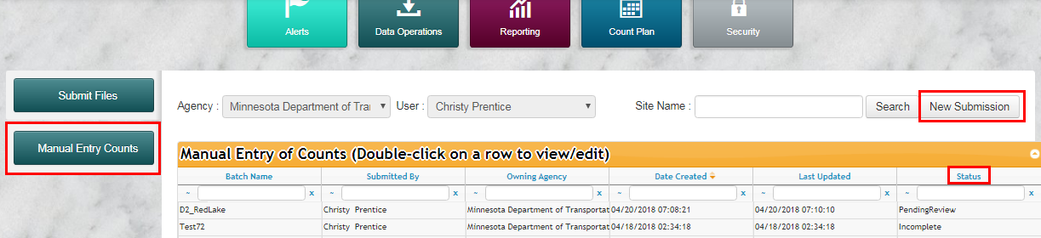
- Select “Data Operations” and then “Manual Entry Counts.” This page will show you count data that you have submitted, called either submissions or batches, and allow you to submit new data.
- Create a “New Submission” to manually enter raw count data.
  - Click the button and enter a title for the submission in the dialogue that pops up.
    - Enter a name that is unique and has meaning, such as “Metro_Edina_5-14to5-18-18_FieldStaff.”
    - If the title is left blank or greater than 30 characters, the batch will not be created.
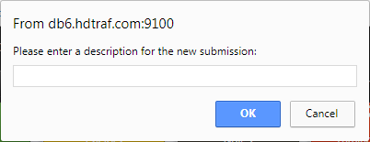
    - Click “OK” to create a new submission.
  - After the MEC window opens, verify that the batch “Name” is correct.
  - Select the name of the field staff who collected the data in the “Collected By” dropdown.
  - Confirm you are using the correct “Active Profile” (most agencies will only have one option).
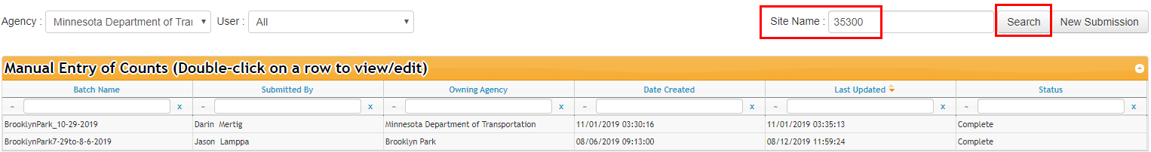
Note: The “Manual Entry Counts” screen is also be used to search for data you may have already submitted. If you suspect this is the case or you get a “Duplicate Count” error when entering data search the Batches of data, but DO NOT make edits or resubmit these completed batches.
- Enter Data in MEC Submission Grid.
  - In the submission grid, click in the blank row below the filters to begin entering data.
  - Use TAB to navigate across rows while entering data.
  - Use TAB at the end of a row to create a new blank row.
  - Use ENTER at the end of a row to complete without adding another row
  - If you use the popup calendar to select the date, click back in the Site cell before hitting TAB.
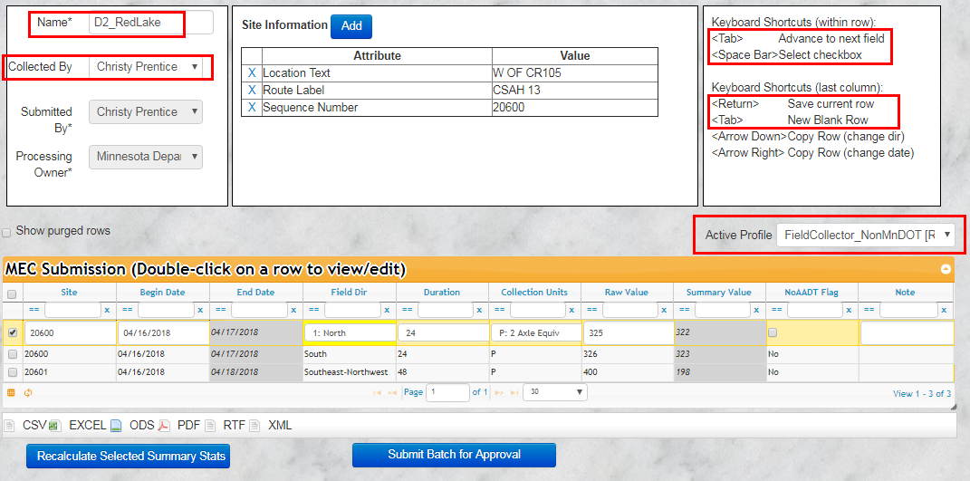
  - Verify the system default values for the “Field Dir,” “Duration,” and “Collection Units”. These selections control how the software creates a 24 hour adjusted value from the raw data entered. Modify the very first row if needed to ensure data is processed correctly.
Field Name | What to enter
Site | Sequence number. If entered in error correct before completing the row.
Begin Date | Begin date of data collection; must be entered in MM/DD/YYYY format (month, day, year). The software is set to use data from the prior row, so if the dates change be sure to modify it before completing the row.
End Date | Automatically calculated by Jackalope; leave blank.
Field Dir | Direction of the roadway. For undivided roads, use 0: Southeast-Northwest (both directions); for divided roads, create a new road for each row, such as 1: North and 5: South. Both directions must be included in the same submission.
Duration | The length of the data submitted in hours (24 or 48). If this is set to 48, this will divide the raw value by 2. If you are entering the weekday average for a two-day count, use 24.
Collection Units | Data type collection. P = pairs of axles, A = axles, or V = vehicles (rarely used).
Raw Value | Count data; unadjusted value.
Summary Value | Adjusted count. Automatically calculated by Jackalope; leave blank.
NoAADT Flag | Automatically calculated by Jackalope; DO NOT modify.
Note | Count comments, field observations and override notes.

MEC – Errors and Flags
- Any boxes highlighted in red are errored and MUST be fixed before the batch can be submitted.
- The specific error is shown if you hover the mouse over the error box (see list of errors and actions to take in table below).
- Fixing errors in most cases is done by marking the row of data with a problem/typo as “Error/Delete” in the Note field and then reentering the correct information in a new row. MnDOT staff will delete the problem row as indicated in your Note field.
- Overriding the flag is allowed for counts that are significantly higher or lower than past AADT if you have confirmed the count is not a typo and the count was taken under typical conditions.
Errors/Flags and Actions | What it looks like on the screen:
Typo: Fixed by contacting MnDOT. DO NOT change and resubmit after the row has already been completed. Confirm the top of your screen says “Sequence Number” | 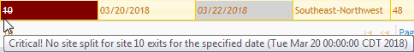
Typo: Fixed by editing the date to be before the current date. DO NOT change and resubmit after the row has already been completed. | 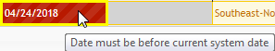
Typo: Fixed by editing the count value you meant to type or the collection units. | 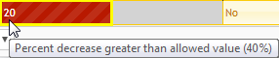
Override Flag: Right click in the box and click “Override” then enter a reason. | 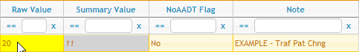
Duplicate Count: The count data entered (Site, Date and Direction) is already in the Jackalope database. Stop and check if your entire set of counts was already entered | 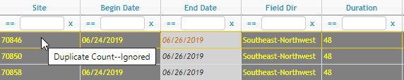
Please call MnDOT if you get a pop-up error like this. Do not try to bypass these types of problems | 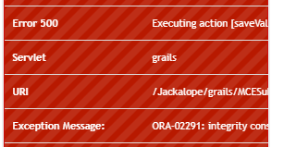
- Override Flag:
  - Right click in the box and click “Override.”
  - Enter a reason to override the QC:
    - If the “Note” cell was previously blank, describe the reason to accept the count.
    - If the “Note” cell already describes field conditions as to why the count should be accepted, then type “Revd” to confirm there are no typos.
- Once there are no longer any red boxes, click “Submit Batch for Approval.” The submission screen will now close. You may export your submission before doing so in order to keep a record of the count data.
  - Successfully submitted batches will have a status of “PendingReview” and MnDOT will review as soon as possible.
  - If there are any unresolved errors, a warning will pop-up to inform you how many errors remain. The batch will have a status of “Incomplete” and must be fixed before MnDOT will review for recount. Please call MnDOT if you get a pop-up “Runtime Error”, usually an “Executing Action”. Do not try to bypass these types of problems.
- You can filter and search the Manual Entry of Counts table to view specific batches.
  - The “Status” column should show Incomplete, Pending, or Complete depending on status of submission:
    - Incomplete: The batch was closed but not submitted or failed due to errors.
    - PendingReview: The batch was successfully submitted but has not been reviewed by CO.
    - Complete: The batch has been reviewed by CO; any changes to the status of sites in the submission will appear in the Yearly Schedule.
  - “Site Name:” allows you to find a specific sequence number within all of your submissions; please note that this will find all partial matches as well (search for “16” will find site “316”).

Recounts
- After you’ve finished submitting batches, the Yearly Schedule will instantly provide feedback in order to give you an idea of what Sites (Sequence Numbers) may need a recount in the future. See the “Count Plan” section above for an explanation of the Status.
- MnDOT plans to review all Batches marked as “PendingReview” within one week, after which the Batch “Status” will change to “Complete.”
- Once a Batch is marked as “Complete” any sites from your batch should have a status of “Good Data” or “Recount Requested” in the Yearly Schedule screen, though recounts should still be done a month after the first pass per the program guidelines.
- If there is a delay longer than one week, please e-mail us! We strive to provide feedback in a timely manner. MnDOT contacts can be found here: http://www.dot.state.mn.us/tda/contacts.html

FAQs
- Is Jackalope case sensitive?
The Jackalope URLs, as well as your email and password, are case sensitive.
- Can I sort the Sequence Numbers numerically in the Yearly Schedule?
Sequence Numbers do not sort numerically in the Yearly Schedule. This has been reported to the software vendor, but the change will come at additional cost to MnDOT as other DOTs using Jackalope do not have numerical identifiers. The Yearly Schedule table can be exported to excel for advanced sorting and filtering.
- Data operations, “Submit Files” – is this where I load my count files?
No, this if for MnDOT staff to submit continuous data and vehicle class data.
- Can I load data for a past Yearly Schedule and will that year’s schedule update in the “Status” column? Counts taken in previous years can be entered in Jackalope. However, they will not be used to determine a current AADT and the past Yearly Schedule “Status” will not update.

