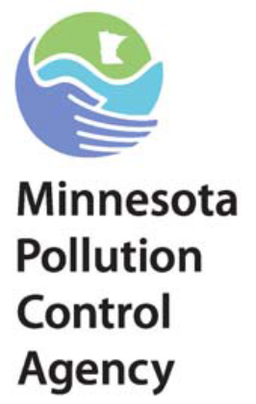
In 2014, Governor Dayton signed into law rail safety legislation that improves public safety and environmental protection in the case of a rail disaster. The Minnesota Pollution Control Agency (MPCA) is responsible for:
- Working with the railroads in their duty to protect the environment;
- Review railroad preparedness plans; and
- Direct improvements in railroad preparedness to protect the environment, if needed.

Response Timeframes
The new law sets timeframes in which railroads must be able to get their specialized people and equipment to a derailment site and get it deployed. The purpose of the new response timelines for railroads is to ensure that spilled oil is contained near the site of a derailment, the oil is recovered quickly, and that downstream sensitive areas are protected from spilled oil.

Response Plans
In addition, the new law requires railroads to submit a prevention and response plan to MPCA by June 30th, 2015 and every three year afterwards. MPCA is currently reviewing railroads existing spill plans.

The new law encourages use of mutual aid between industries, and establishment of cooperative caches of equipment by the railroads and other industries in order to quickly respond anywhere across the state. Railroads can make arrangements with fire departments to help in the railroad’s environmental response.

Take Home Drills
The MPCA has also presented each railroad with a difficult spill scenario. Railroads are required to describe how they would respond, using what equipment and people, arriving from where. These scenario-driven “take home” drills will help identify the arrangements that the railroads must put in place to be prepared to handle unit train spills anywhere in the State and to comply with the requirements of Chapter 115E. All of this will help railroads create a strong response plan before the June 2015 deadline.

For more information
Call the MPCA at (651) 296-6300 or (800) 657-3864 and ask for a member of the Emergency Response Team. Additional information is also available on the MPCA Web site at www.pca.state.mn.us/cleanup/ert.html.

