Compacted Concrete Pavement (CCP)
Progress Report – 12/31/2020

Title: Compacted Concrete Pavement

Project Number: TR201904

Principal Investigator (PI): Kamal H. Khayat, Ph.D., P.Eng.
Co-PI(s): n/a

Award date: | 9/24/2018
Scheduled completion date: | 12/31/2021 | % of project completed to date: | 90%
Total budget: | 125,000$ | % of budget expended to date: | 75%
Draft report due: | 10/31/2021 | Final report due: | 11/30/2021
1. Work currently underway during this reporting period.
The work in progress during this reporting period includes the analysis of falling weight deflectometer (FWD) of slabs with embedded sensors.
2. Activities accomplishments during this reporting period.

Analysis of environmental and load response performance data
This report is a continuation of the 5th and 7th quarterly reports submitted in Dec. 2019 and June 2020, respectively, where the analysis of MnDOT environmental and load response performance data were conducted. The analysis of MnDOT environmental and load response performance data includes the readings of three typical sets of sensors located at three different stations (551, 552, and 553) in the compacted concrete pavement (CCP) slab sections. Figure 1 shows a typical set of sensors located at one of the three stations. The sensors include two vibrating wire gauges aligned in the longitudinal and the transverse directions, as well as two thermocouples located at the top and the bottom of the CCP slab section.
Figure 1: Temperature readings of the thermistors attached to the top and the bottom of the slab section at station 551.
The adjusted temperature readings of the thermistors (XV) attached to the top and the bottom of the slab section at the three investigated stations 551, 552, and 553 are plotted separately in Figures 2, 3, and 4 and combined in Figure 5. The thermocouples readings at the top section of the three stations were referred to as XV 551-1, XV 552-1, and XV 553-1, while the bottom readings of the three stations were referred to as XV 551-2, XV 552-2, and XV 553-2. During the winter, the temperature varied between -2°C and 22°C, where the temperature reached its maximum value after approximately 24 hours of concrete placement. During summers, the temperature varied between 25°C and 48°C, where the temperature reached its maximum value at around the first week of August. The temperature variation between the top and the bottom of the slab was not significant, where a maximum temperature variation of less than 10°C was recorded in August 2020 at station 551. An overlap of data associated to the top and the bottom sensors of 552 and 553 cells was observed (Figures 3 and 4). The temperature starting increasing again to reach values between 28 and 48°C in August 2020.

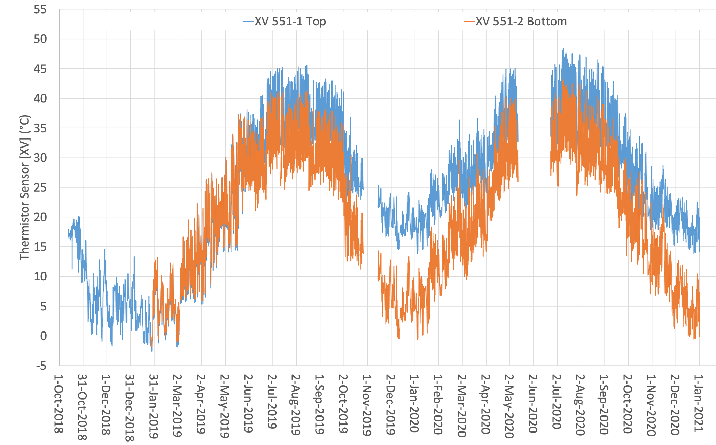
Figure 2: Temperature readings of the thermistors attached to the top and the bottom of the slab section at station 551.
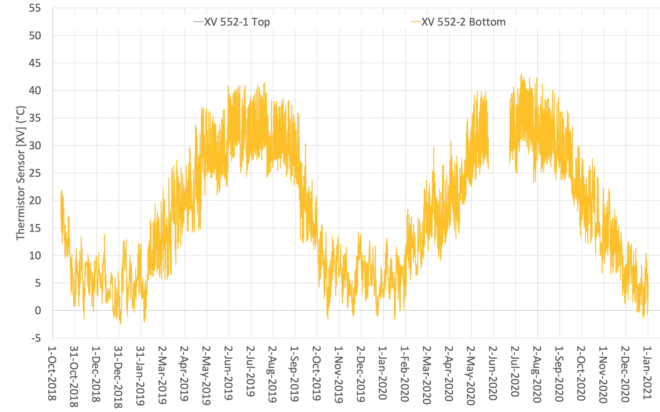
Figure 3: Temperature readings of the thermistors attached to the top and the bottom of the slab section at station 552.

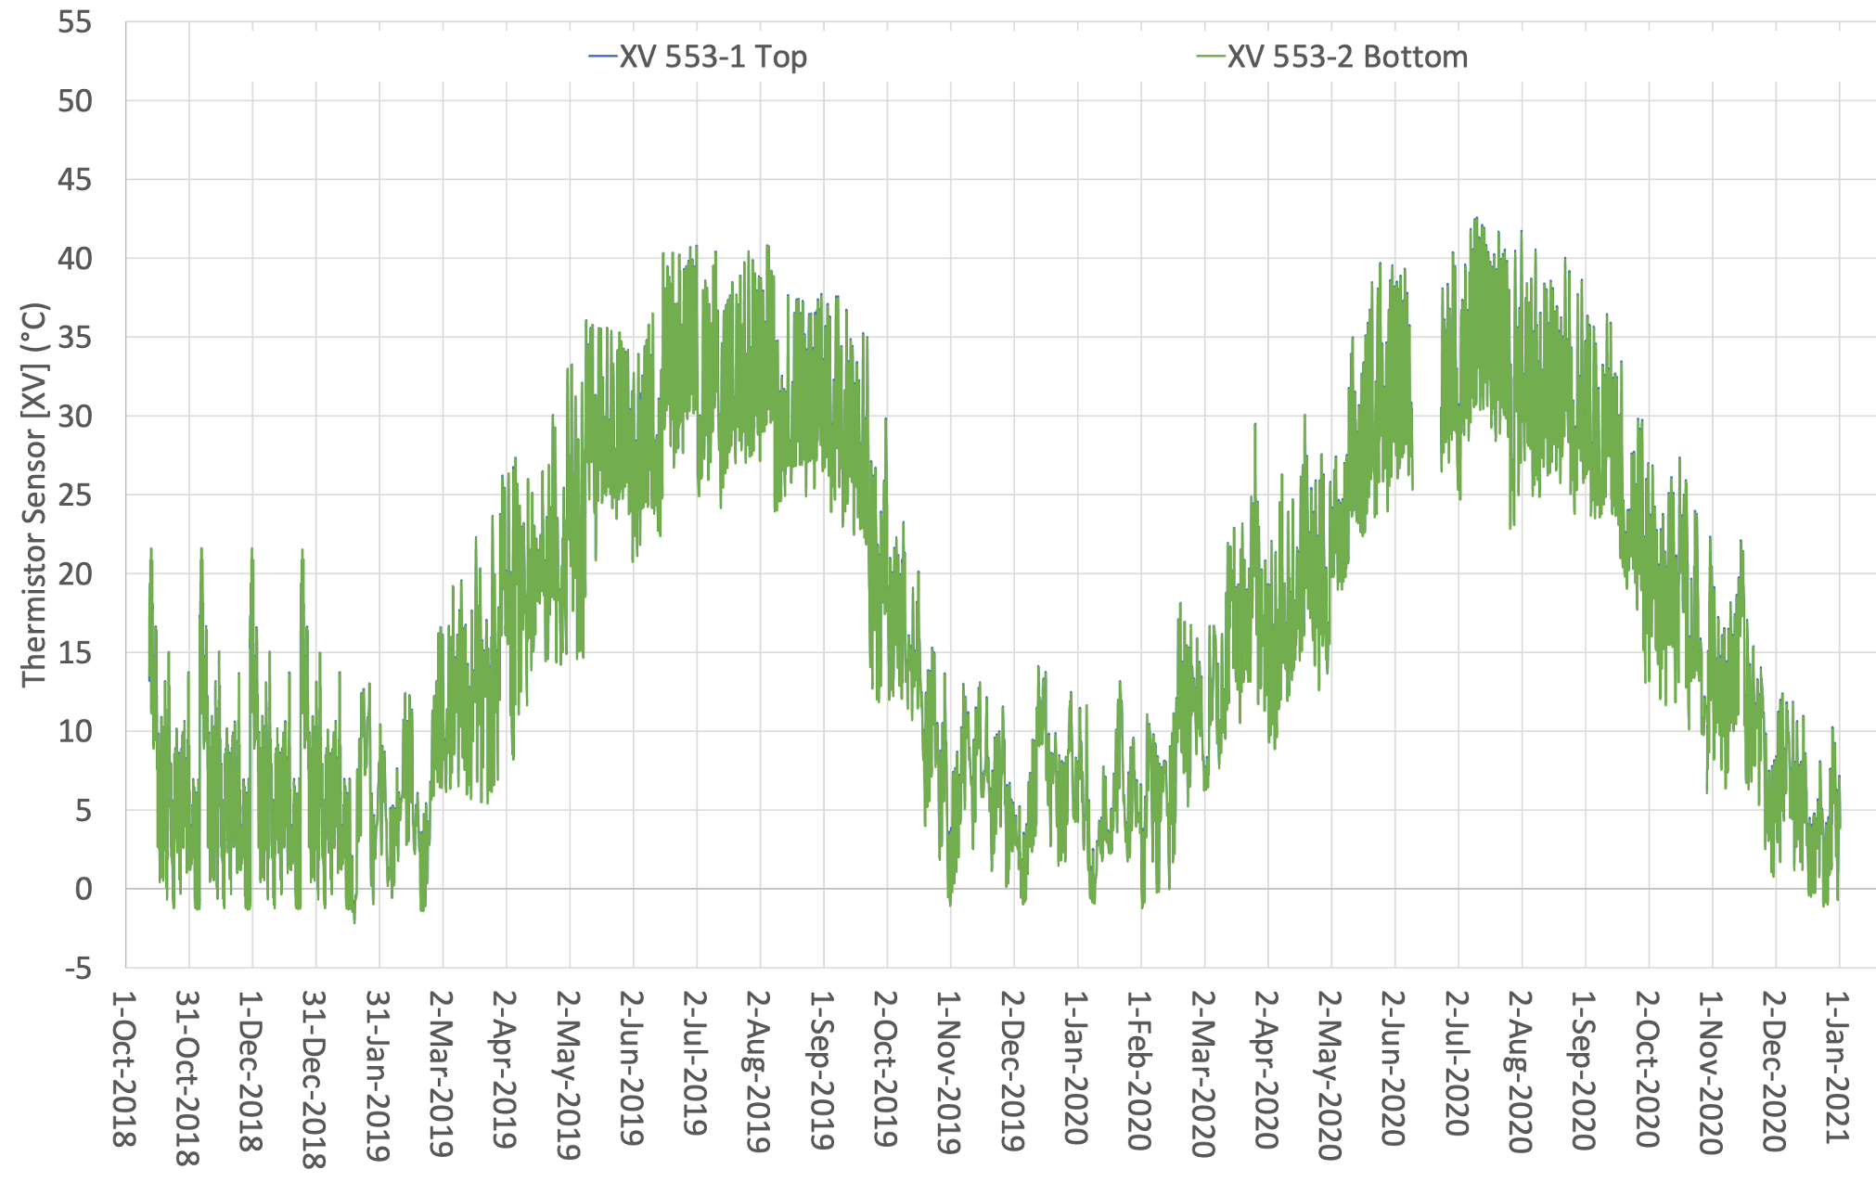
Figure 4: Temperature readings of the thermistors attached to the top and the bottom of the slab section at station 553.
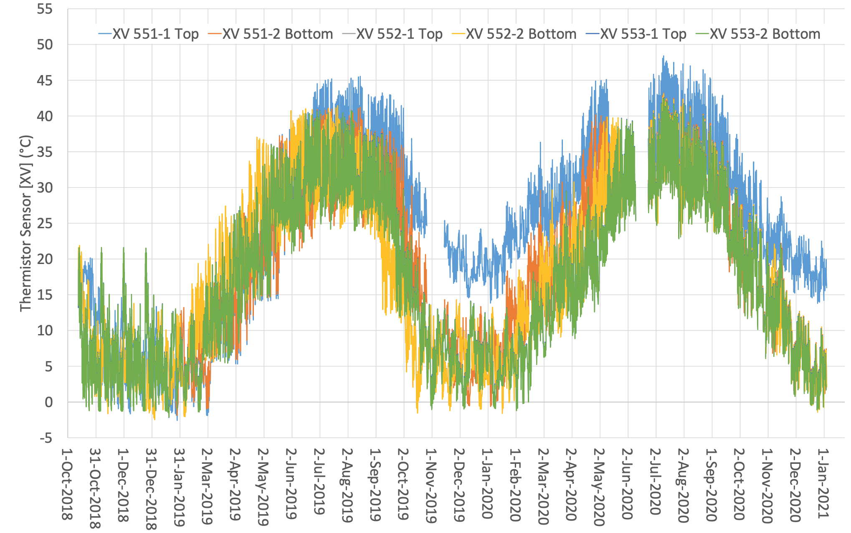
Figure 5: Temperature readings of the thermistors attached to the top and the bottom of the slab section at the three investigated stations.
The temperature variations between the top and the bottom sections at the three investigated stations are plotted in Figure 6. The temperature variation at the three investigated stations was found to reach zero on 10/12/2018 between 2:00 pm and 3:00 pm, which indicated that the concrete has hardened sufficiently to fully engage the sensors and the initial vibrating wire strain gauge (VW) values were considered.
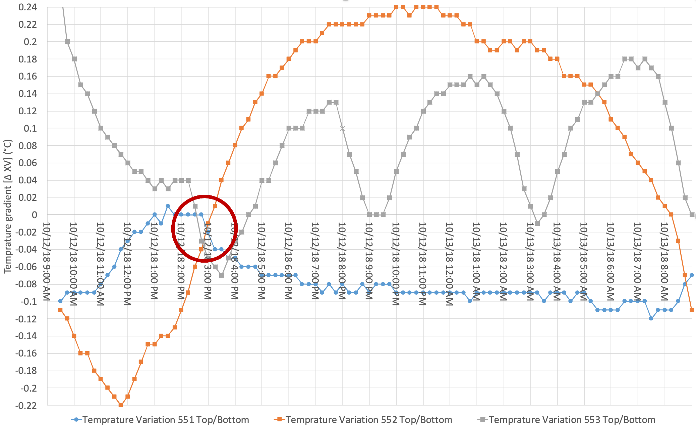
Figure 6: Temperature variations between the top and the bottom sections of the three investigated stations.
Figure 7 shows the strain variations of the longitudinal and the transverse directions of the investigated three stations that were referred to as VW 551-1, VW 551-2, VW 552-1, VW 552-2, VW 553-1, and VW 553-2, respectively. After approximately seven weeks of concrete placement, the longitudinal and transverse sections reached a maximum strain of 960 and 940 micro-strains, respectively. In general, the strain varied between 850 and 960 micro-strains. Both longitudinal and transverse strains went down in the summer reaching the lowest values in the first weeks of July. The strains after that started to increase. The rate of decrease of the transverse strain was much lower than the longitudinal strain. For example, at Station 551 the longitudinal strain was higher than the transverse strain up first week of May 2019, then the transverse strain started to be higher than the longitudinal one. Strain started to decrease again starting from January 2020 and up to June 2020 to reach values similar to those of June 2019 followed by an increase from August 2020 to January 2021.

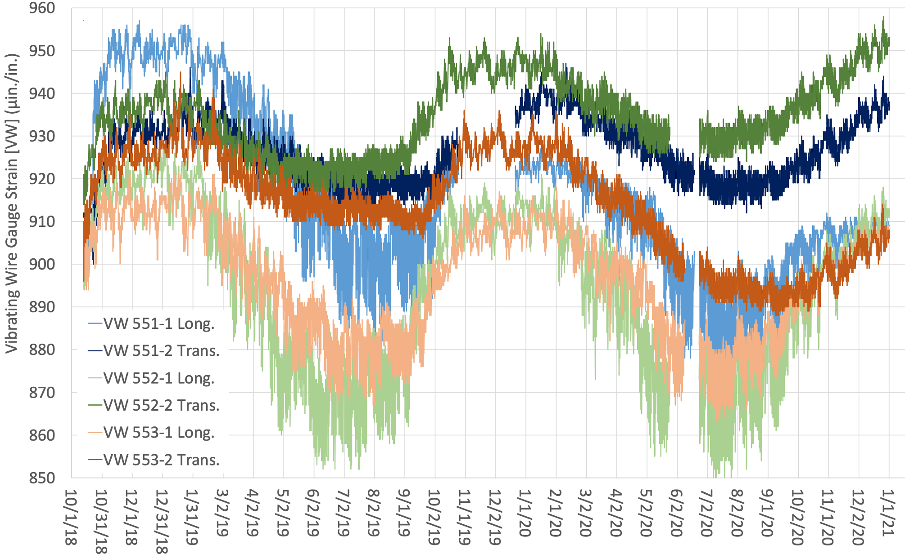
Figure 7: Strain variations at the longitudinal and the transverse directions of the three investigated stations.
Issues or problems that need to be addressed.

Next progress report due:
3/31/2021
Additional notes:
Activities planned for the next reporting period will include:
- A summary and analysis of data from FWD of slabs with embedded sensors will be included in the report.

