Compacted Concrete Pavement (CCP)
Progress Report – 9/30/2020

Title: Compacted Concrete Pavement

Project Number: TR201904

Principal Investigator (PI): Kamal H. Khayat, Ph.D., P.Eng.
Co-PI(s): n/a

Award date: | 9/24/2018
Scheduled completion date: | 12/31/2021 | % of project completed to date: | 90%
Total budget: | 125,000$ | % of budget expended to date: | 59%
Draft report due: | 10/31/2021 | Final report due: | 11/30/2021
1. Work currently underway during this reporting period.
The work in progress during this reporting period involves analysis of MnDOT environmental data. The data includes the readings of three typical sets of sensors located at three different cells (551, 552, and 553) in compacted concrete pavement (CCP) slab sections.
2. Activities accomplishments during this reporting period.
During this reporting period, the Missouri S&T team conducted controlled truck loading of slabs with embedded sensors, as well as the curling and warping measurements.
  - Truck loading test
To investigate the effect of fibers on performance of CCP, Missouri S&T conducted truck loading test on 3 cells (551, 552, and 553). The collected data was analysed and the outcome is reported. Figure 1 shows a typical set of sensors embedded in the CCP cells (located at each of the three stations). The sensors include dynamic strain gauges, two vibrating wire gauges aligned in the longitudinal and the transverse directions, as well as two thermocouples located at the top and the bottom of the CCP slab section. The green dashed line along the tested cells indicates the wheel path during the truckload testing that passes over the dynamic strain sensors. Figure 2 shows sensors and gauges that were instrumeted during paving of the road.

Figure 1 – Embedded sensors in the tested CCP cells

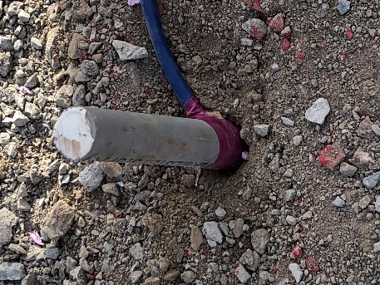 | 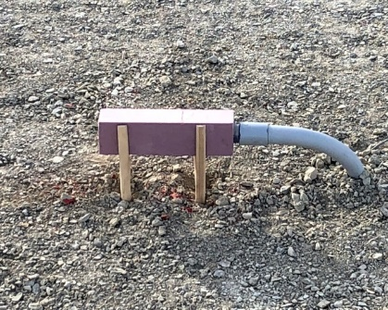
Thermocouple Tree, 8 - Sensor | Joint Opening Block Out
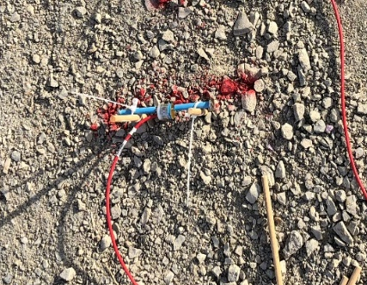 | 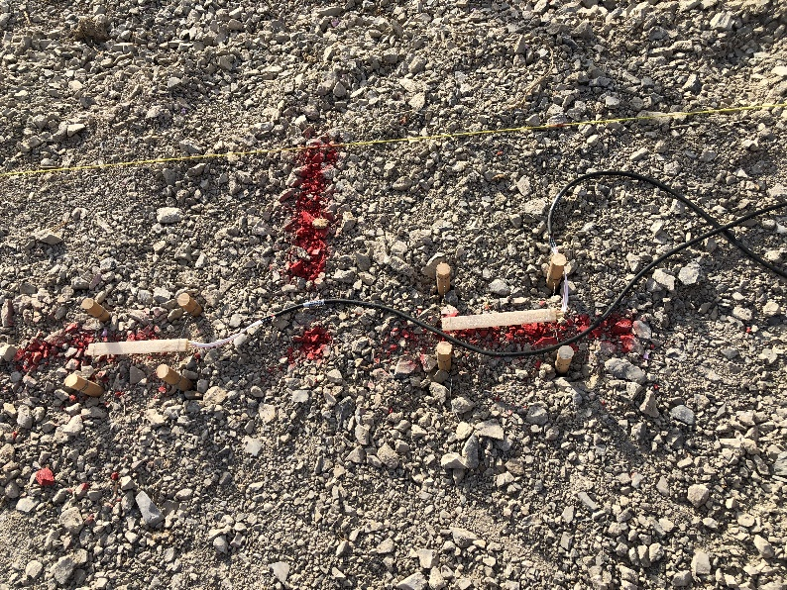
Vibrating Wire Strain Gauges | Dynamic Strain Gauges
Figure 2 – Sensors and gauges applied in Cells 551, 522 and 553.

Figure 3 provides a schematic of the truckload configuration. The truck loading test was conducted in a static, slow-moving (5 mph), and high-speed mode (10 and 20 mph). The static loading consisted of positioning the front wheel of the truck on top of the sensors to simulate the effect of static single axle loading. After the deformation was registered, the truck was move forward to have the tires of the rear tandem axle being positioned on sensor spots. In order to investigate the effect of speed on the pavement deformations, the truck was then passed over the marked sensor locations with different speeds varying from a slow crawling speed up to 20 mph.

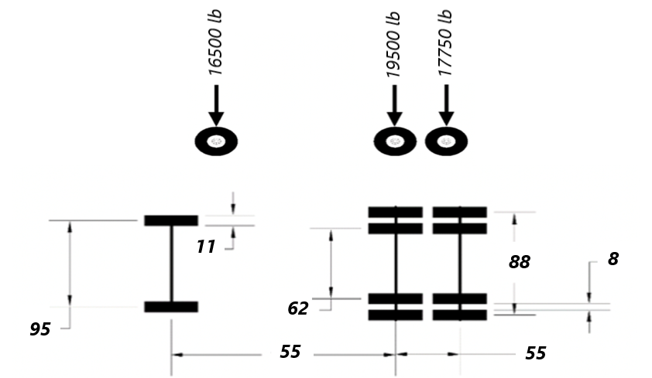
Figure 3 – Schematic of truckload configuration, dimensions in in.
For all loading scenarios, the wheel plane over dynamic strain sensors corresponds to that at the driver side and is used for loading the sensors. In the case of the tandem axle, the tires at the driver side were placed on top of the sensors. The weights of both the driver and passenger sides of the front and the rear axles were determined in a weigh station. Figure 4 shows the loaded truck at the weigh station.Table 1 shows the key parameters that were collected from the truck before the truck loading test on the testing day.
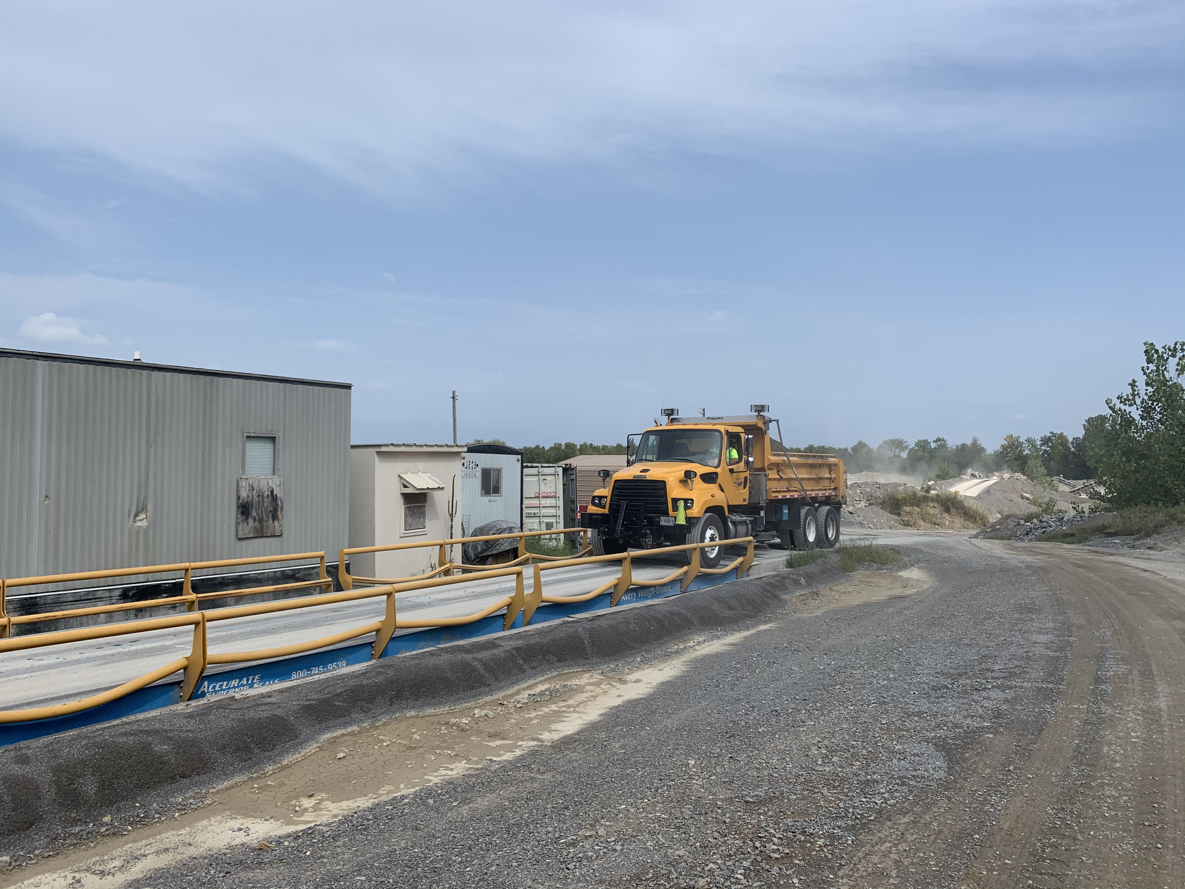
Figure 4 – Truck at the weigh station

Table 1 – Axle weights and pressure at tire-pavement contact area (driver side)
(to be determined)
Axle type | Single | Tandem
Tire position | Front tire | Front tires | Rear tires
Tire load (lb) | 16500 | 19500 | 17750
Contact pressure (psi)* | 141 | 196 | 179
*based on the dimensions between the tires and axles and contact area between the tires and the pavement surface (Ac)

Before conducting truck load testing, a deep metal scanner was used for detecting the exact sensors’ locations; then, the locations were marked to make sure that the truck wheels are placed on top of the sensors during testing. All for dynamic strain sensors for each cell were connected to jumbers according to the schematic strain gauge wiring plan provided by the MnDOT. Figure 5 shows the connection of four sensors to the jumper.

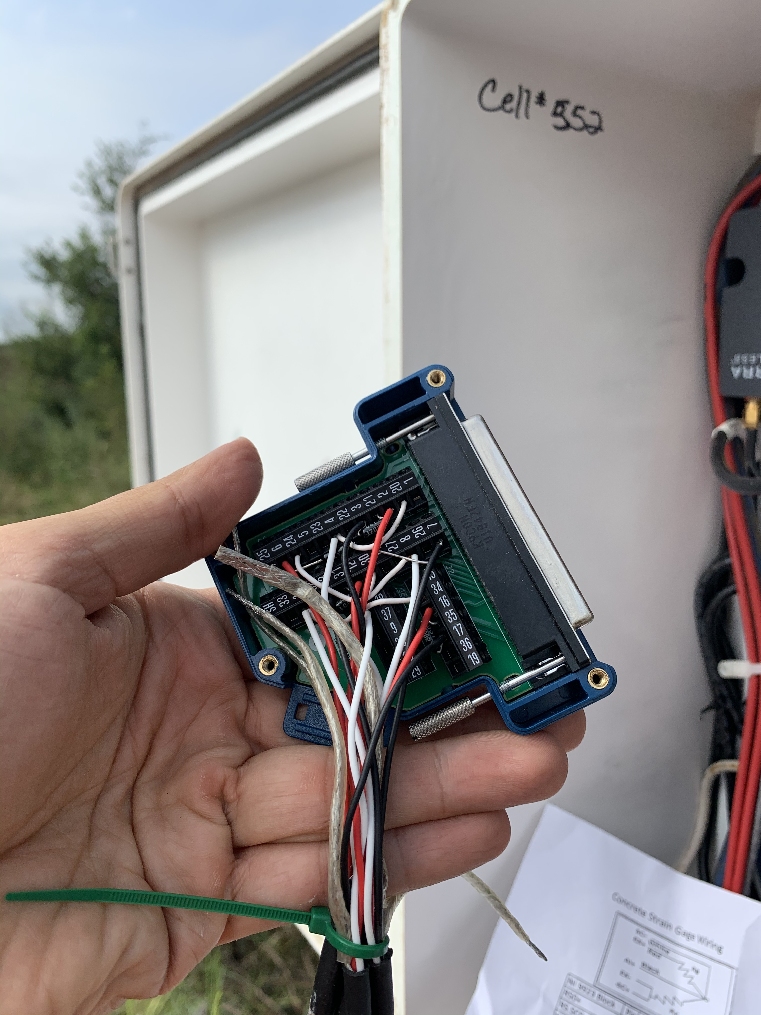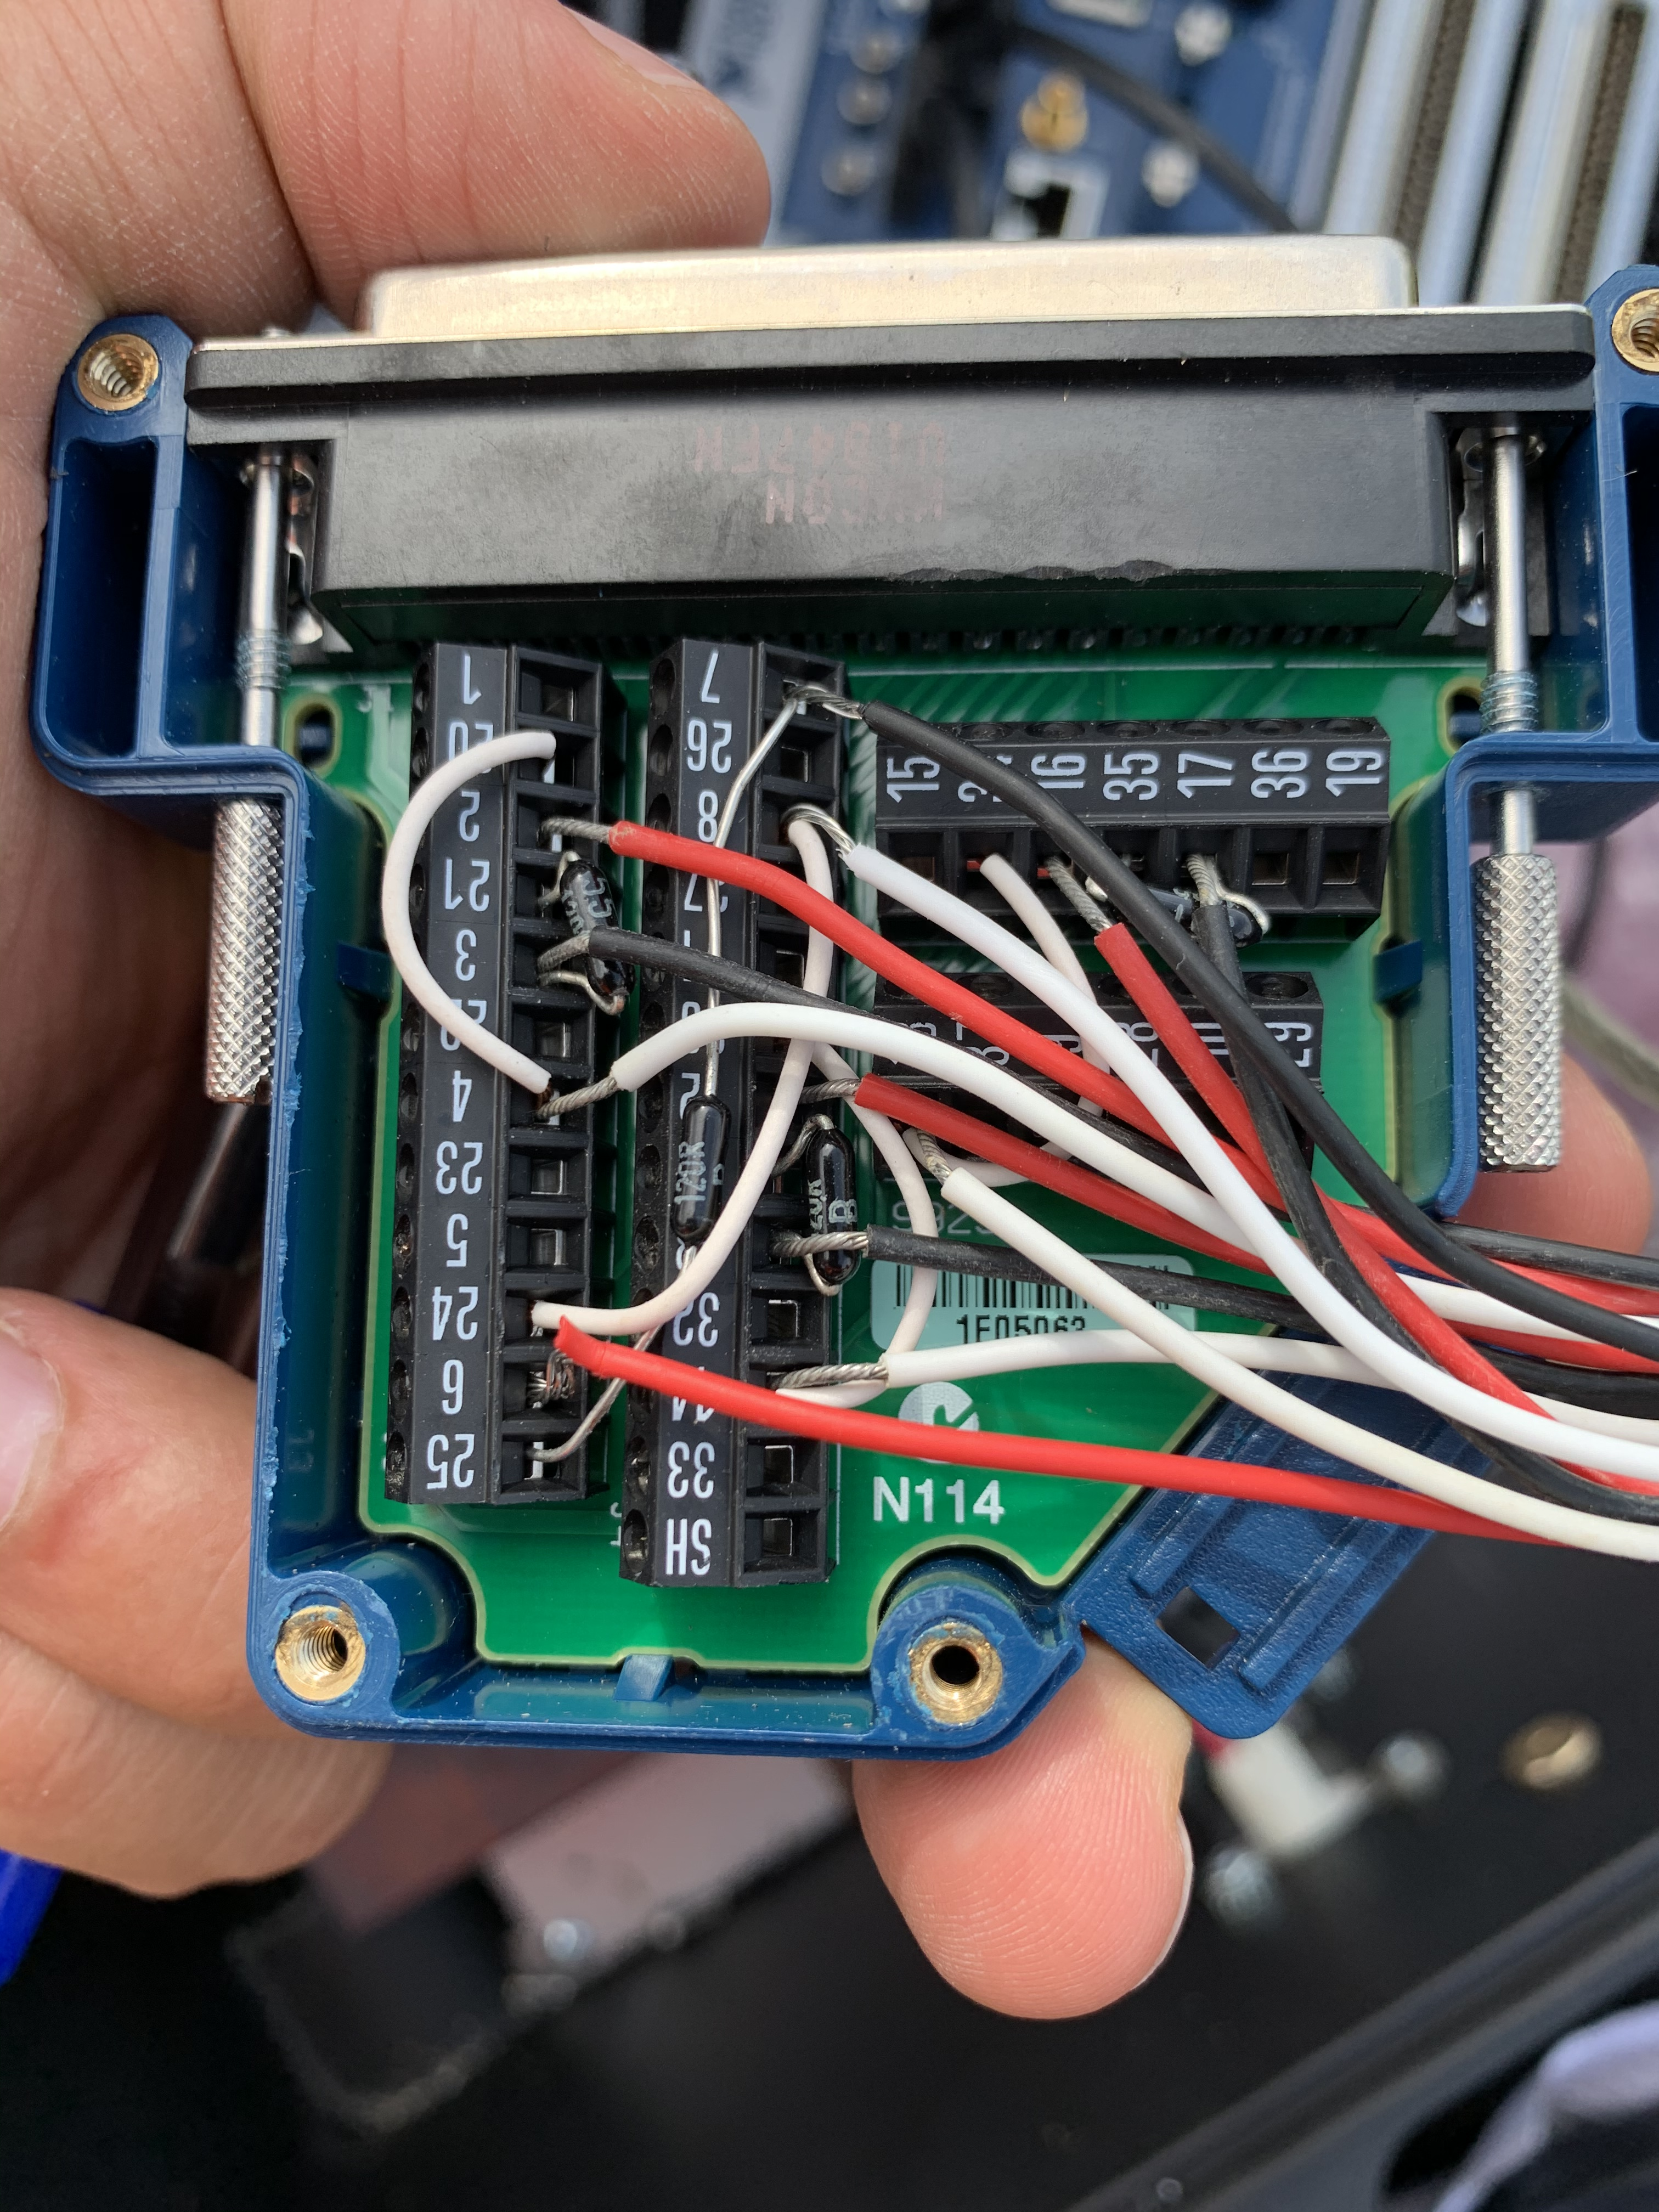
Figure 5 – Connection of sensors to jumper (picture shows connctions for Cell 552)

Trial tests were conducted by placing the tires at the driver side on top of the marked sensor locations. Figure 6 shows the truck passing over the marked sensor locations at a constant speed.

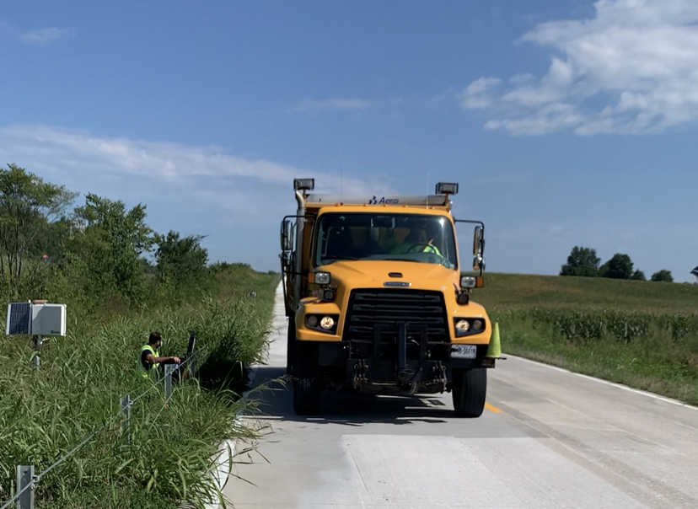
Figure 6 – Truck loading test
The collected data showed that only two sensors were responsive to the truck loading test. A decision was made with MoDOT and MnRoad to conduct the truck loading test again. The first truck loading test was done on August 27th, and the second one on September 16th. For the second test, the resistance of dynamic strain sensors (CE001, CE002, CE003, and CE004) was measured using an ohmmeter to assess the soundness of the sensors. Figure 7 shows the process of measurement of the the resistance. Table 2 lists the resistance recorded for each sensor at three cells.

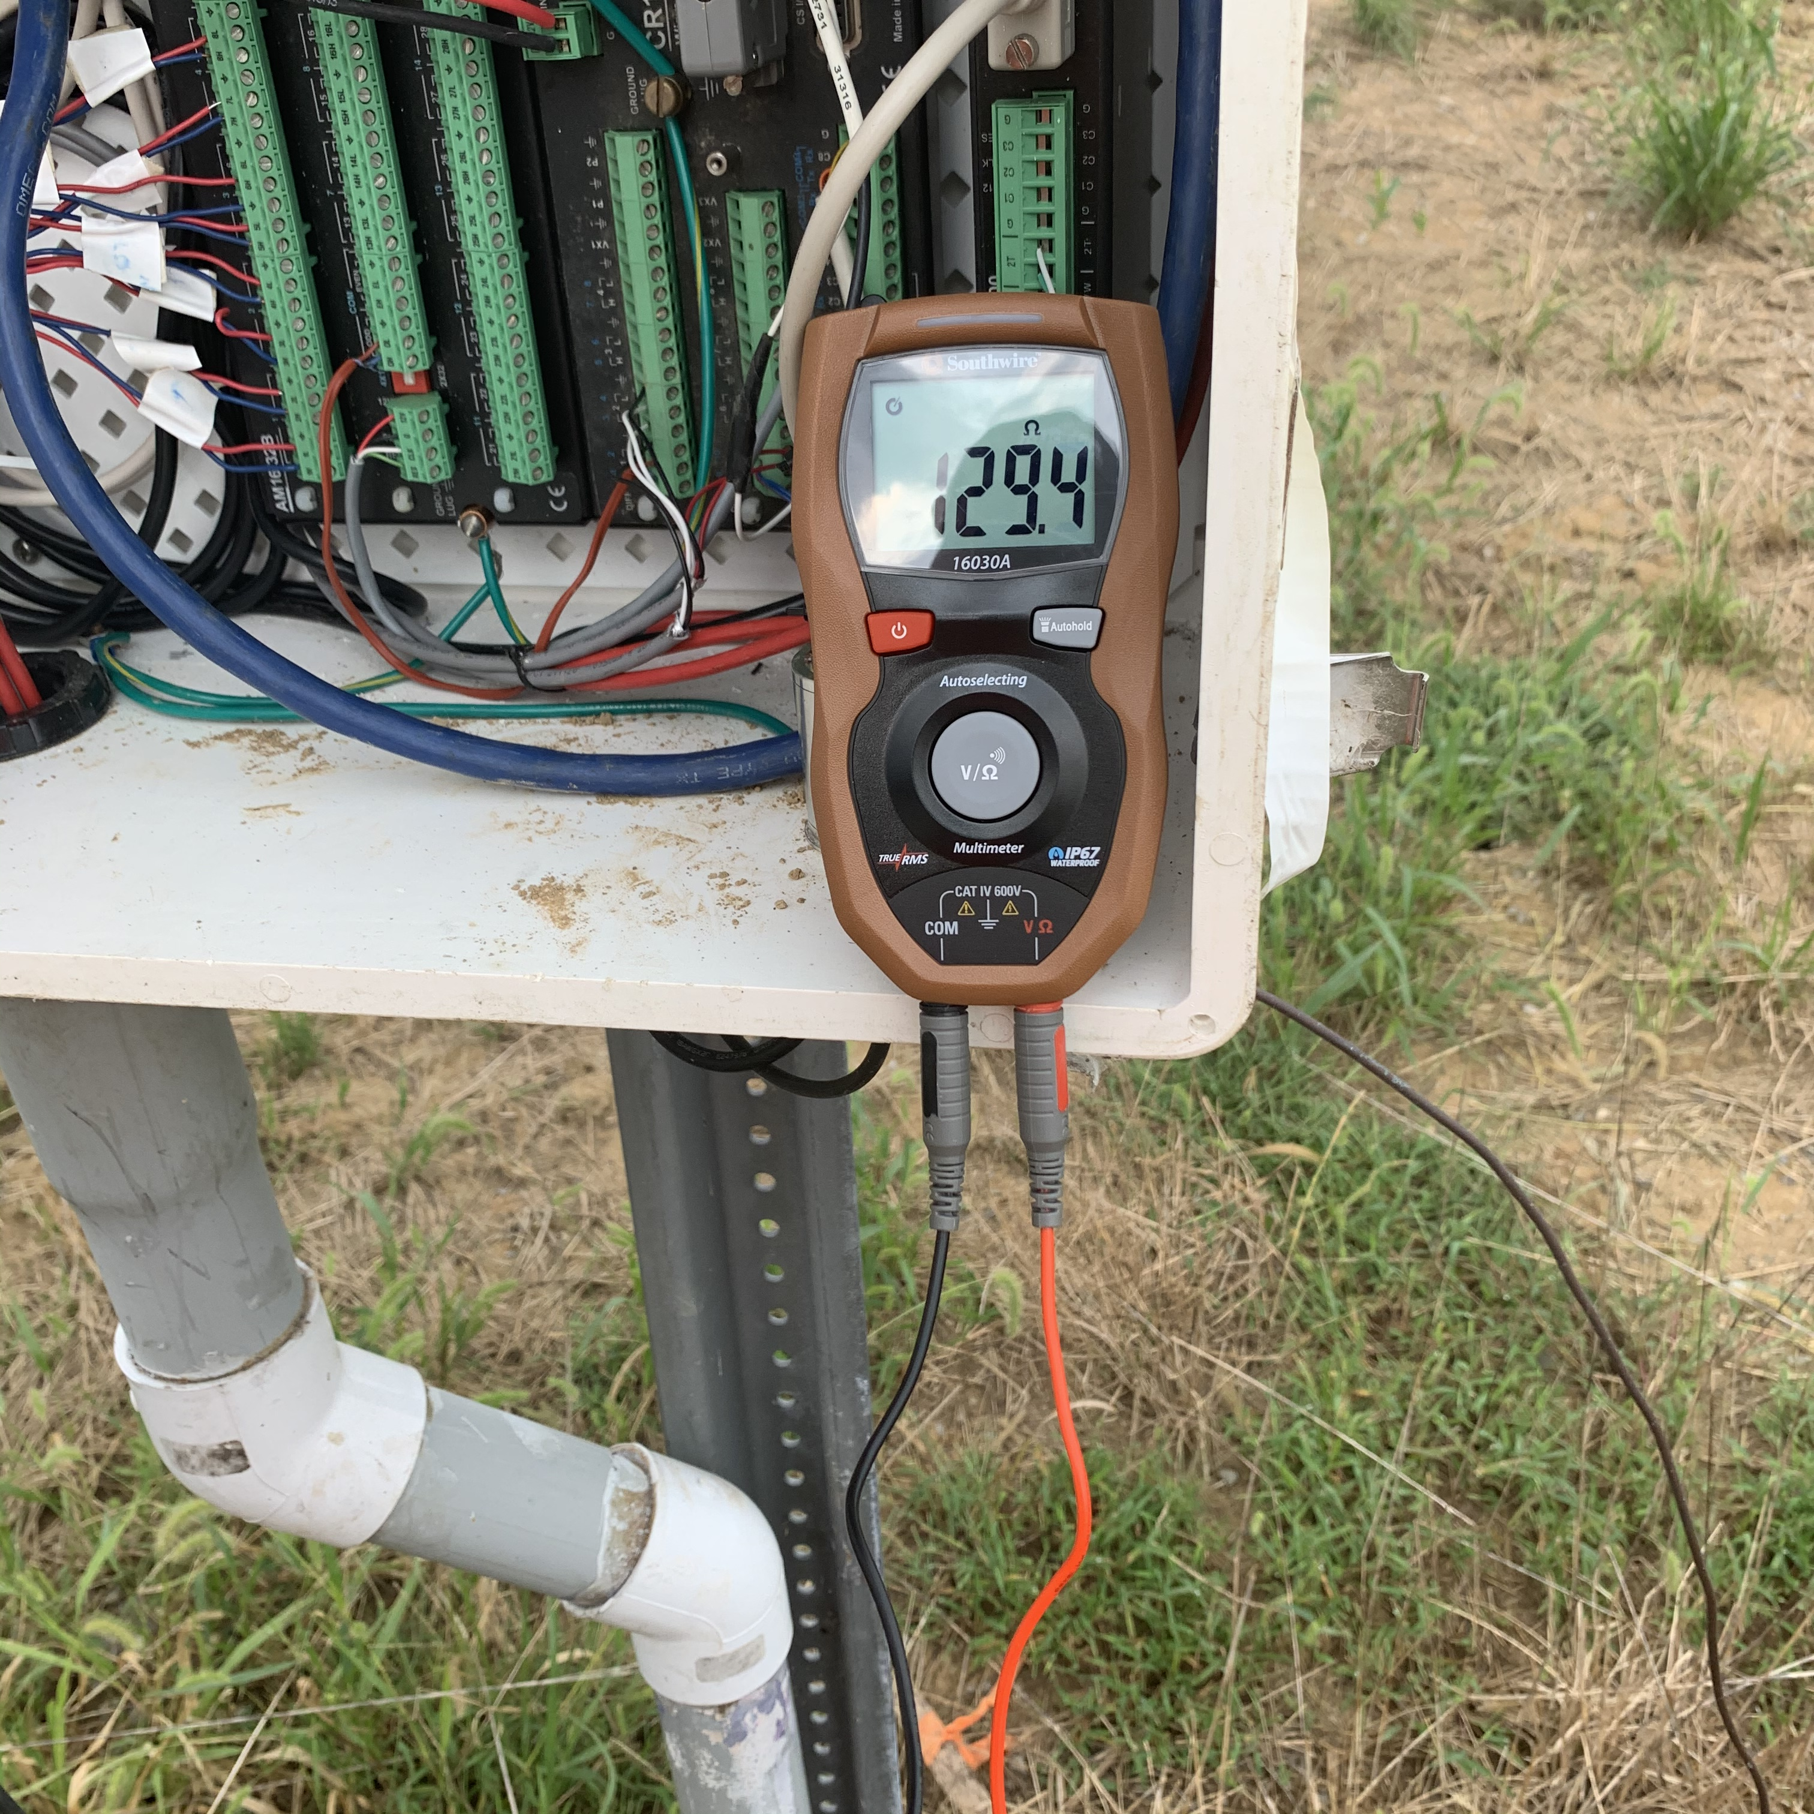
Figure 7 – Measurement of the sensors’ resistance prior to testing

Table 2 – Resistance of sensors (CE001, CE002, CE003, and CE004) for cells 551, 552, and 553
551CE001 | 551CE002
Black to white 1.6 ohms | Black to white 1.5 ohms
Red to Black 127 ohms | Red to Black 121.3 ohms
Red to White 127 ohms | Red to White 121.3 ohms
551CE003 | 551CE004
Black to White 1.7 ohms | Black to White 1.6 ohms
Red to Black 127.4 ohms | Red to Black 126. 5 ohms
Red to White 127.4 ohms | Red to Black 126.6 ohms
552CE001 | 552CE002
Black to White 1.5 ohms | Black to White 1.5 ohms
Red to Black 128 ohms | Red to Black 134.8 ohms
Red to White 128 ohms | Red to White 134.8 ohms
552CE003 | 552CE004
Black to White 1.5 ohms | Black to White 1.7 ohms
Red to Black 127.3 ohms | Red to Black 126.3 ohms
Red to White 127 ohms | Red to White 126.4 ohms
553CE001 | 553CE002
Black to White 1.2 ohms | Black to White 1.7 ohms
Red to Black 129 ohms | Red to Black 128 ohms
Red to White 129 ohms | Red to White 128 ohms
553CE003 | 553CE004
Black to White 1.7 ohms | Black to White 1.8 ohms
Red to Black 124.8 ohms | Red to Black 130 ohms
Red to White 124.8 ohms | Red to White 130 ohms
According to instructions from MnDOT, the settings of Data Aquizition System (DAQ) was adjusted to widen min/max signal input range of DAQ. Table 2 list the DAQ setting for Cells 551, 552, and 553.

Table 3 – Adjusted Data Aquizition System setting based on resistance of sensors
Cell | Signal input range |  | Gage factor | Gage resistance | Lead resistance
Cell | min | max | Gage factor | Gage resistance | Lead resistance
551 | -8k | 8k | 2 | 120 | 1.6
552 | -8k | 8k | 2 | 120 | 1.6
553 | -8k | 8k | 2 | 120 | 1.6
However, the data from the second trial confirmed that 10 out of the 12 embedded sensors were non-responsive. After discussion with MnDOT and MoDOT engineers, it was felt that the damage of the sensors can correspond to the compaction during the paving operations that led to excessive pressure on the sensors. Table 4 shows the values that were collected by the DAQ for the inactive sensors that show excessive amount of pressure they received during paving.
Table 4 – Value ranges recorded for non-responsive sensors
Cell | CE001 | CE002 | CE003 | CE004
551 | 54145.83* | 21728.19 | 54151.31 | 54165.77
552 | 54145.83 | 49016.3 | 54151.31 | 54165.77
553 | 54145.83 | 54170.56 | 37304.72 | 54165.77
*values highlighted in red show non-responsive sensors
Figures 8 and 9 show variations in stress direction during the truck movement for Cells 551 (mixture without fiber) and 553 (mixture with fiber). The size of cells were identical at width of 24 ft, length of 15 ft, and thinkness of 6 in. each.

Figure 8 – Variations in stress direction during the truck movement – bottom part of Pavement (Cell 551)

Figure 9 – Variations in stress direction during the truck movement – bottom part of Pavement (Cell 553)
The results of the responsive sensors show that cell 551 showed relatively higher range of strain values (from 4 to 10 με) when the speed increased to 10 mph. The strain under static load was 4 με. These values were limited to 10 με under different speed senarios and the strain recorded for cell 553 was 2 με under static load. The results showed that fibers reduced the strain under dynamic loads.
2.2 Curling and Warping
The curling and warping measurements were conducted as per ASTM E1364 on December 19th, 2018, September 27th, 2019, and September 16th, 2020. The CCP cells (Cells 551, 5522, and 553), were subjected to curling and warping measurements. The measurements were conducted in the longitudinal, transverse, and diagonal directions (Figure 10). Both morning and afternoon measurements were taken on the day of testing to obtain values under variable temperature and moisture conditions. The last curling and warping measurement on September 16th was conducted in the morning, due to consistent temperature and humidity throughout the day.
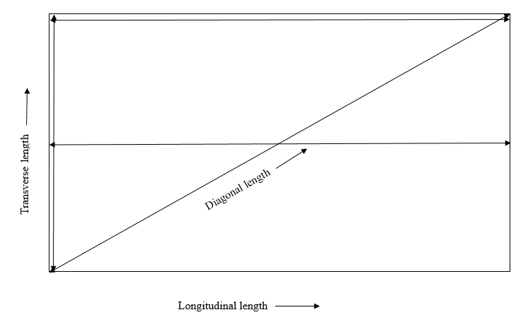 | Longitudinal length at edge: Long. Edge  Longitudinal length at mid-section: Long. Mid  Diagonal length: Diagonal  Transverse length at edge: Trans. Edge
Figure 10 – Direction of measurements - longitudinal, diagonal and transverse lengths.
Figure 11 shows the testing equipment which comprised of two steel columns (A and B) connected with metal string adjusted and tightened with roller components of the columns. The test was developed by Iowa State University. For precise measurement, columns A and B were anchored at joints (discontinuities between two cells) as shown in Figure 11. Then, the string was hooked off from column A and drawn to pass through the roller in column B. After that, the string was tightened firmly by adjusting a handle in column B. Two pins were placed under the string to make it tightened to avoid formation of sagging of string. A measuring tape was spread out along the string to record the locations of measured points. Prior to measurements, pavement surface was cleaned and temperature and ambient relative humidity (RH) were recorded and tabulated in Table 5.
Table 5 – Temperature and relative humidity data
Date | Time | Temperature (°F) | Relative humidity (%)
12/19/18 | Morning | 49 | 66
12/19/18 | Afternoon | 53 | 69
09/27/19 | Morning | 84 | 60
09/27/19 | Afternoon | 88 | 53
09/16/2020 | Morning (11:30 AM) | 76 | 67

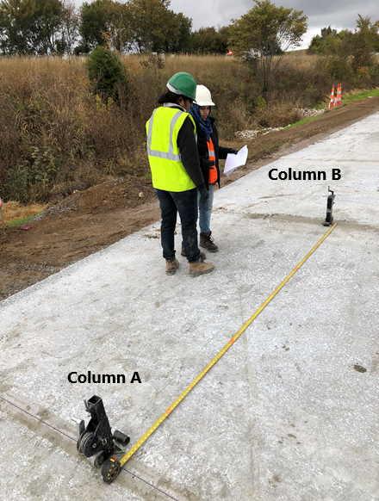 | 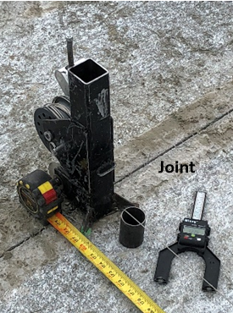 | 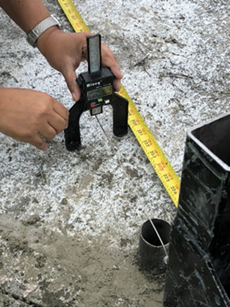
Figure 11 Test setup and measuring equipment
The measurement was conducted at a maximum measuring interval of 2 ft for Class 2 resolution (ASTM E1364). However, at critical locations of curling and warping (e.g., cell edges and center) intervals of 2 in. measurements along the profile were taken. A digital height gauge was used as a measuring gauge considering its convenient operation in the field. The data were collected at eye level to the string.
Figures 12-14 compare curling and warping readings of Cells 551 and 553 (with and without fibers). Figures 15-17 compare curling and warping readings of Cells 551 and 552 (without fibers with different panel sizes) in four reading directions, as illustrated in Figure 10. The results show that the cell with fibers (Cell 553) had more significant deflection especially those recorded in the diagonal direction, indicating the negative effect of fibers on dimensional stability.
As can be seen from Figures 12-14, the deflection readings of Cell 553 ranged from -1.25 to 0.5 in., while they were limited to -0.5 to 0.5 in. for Cells 551 and 552. The increased deflection of Cell 553 can be related to higher crack resistance developed by fiber reinforcement. Possible formation of microcracks in Cells 551 and 552 (without fibers) can increase the degree of freedom of the system and reduce the deformation. On the contrary, comparing results from Cell 551 and 552 (Figure 15-17) showed that size of the cells had some influence on the curling and warping deflection.
Comparing between the results from 12/19/18 and 09/16/20 (Figures 12-14 or Figures 15-17), the increase in time leads to a higher scatter in the deflection data. This is possibly due to the increase in the curiling and warping in the cells with increase in time. Additionally, no significant difference in the deflection can be observed between fiber reinforced and non-fiber reinforced cells with different length based on the collected data.
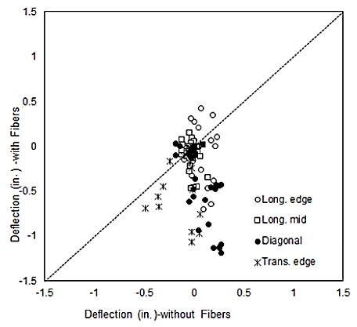
Figure 12 – Deflection (in.) of cells with fibers vs. without fibers measured on 12/19/18
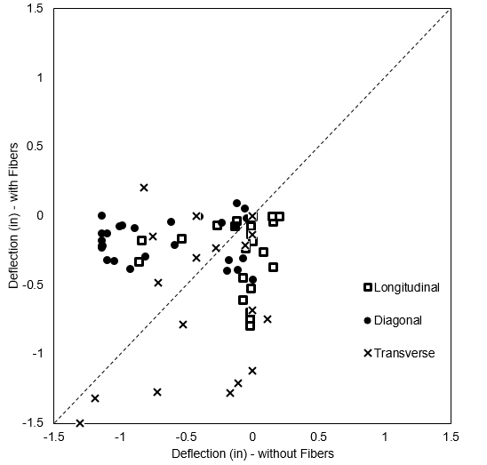
Figure 13 – Deflection (in.) of cells with fibers vs. without fibers measured on 09/27/19
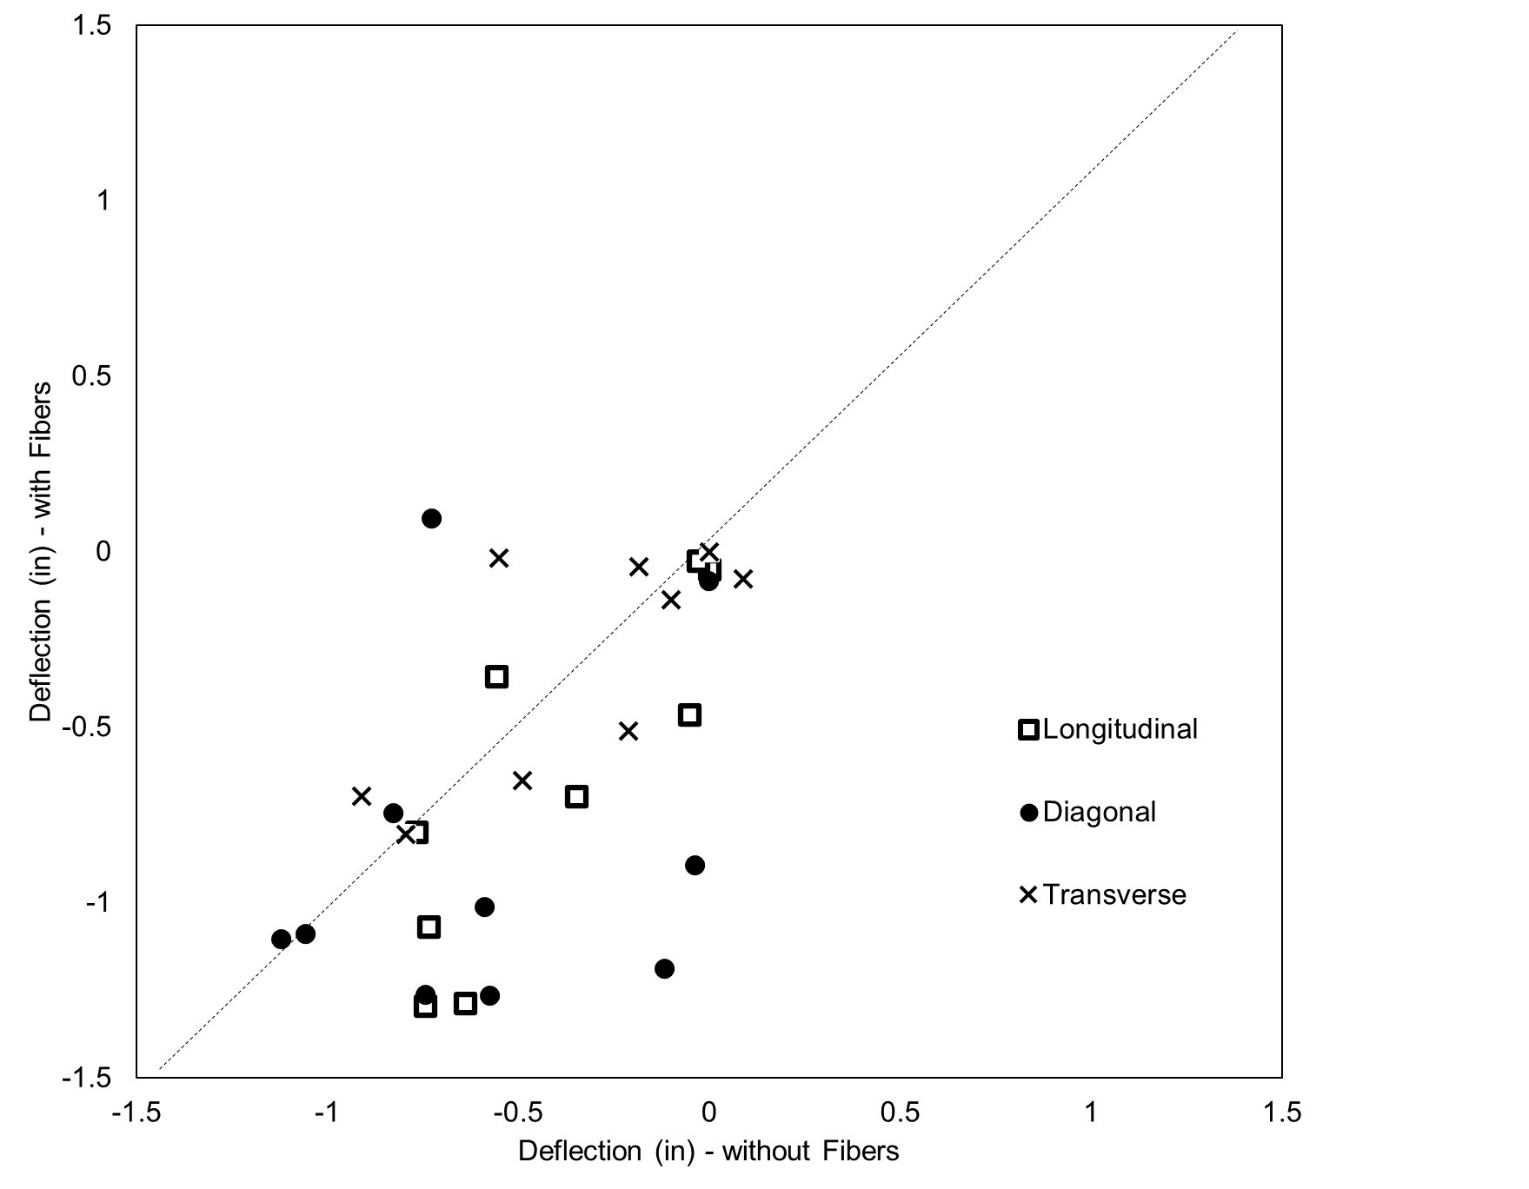
Figure 14 – Deflection (in.) of cells with fibers vs. without fibers measured on 09/16/20
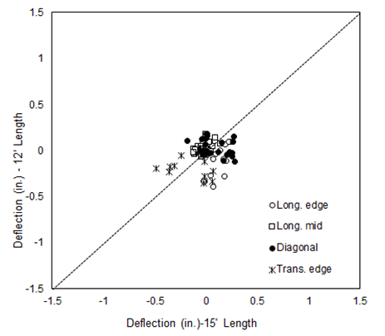
Figure 15 – Deflection (in.) of cells without fibers with L=12’ (Cell 551) vs. L=15’ (Cell 552) measured on 12/19/18

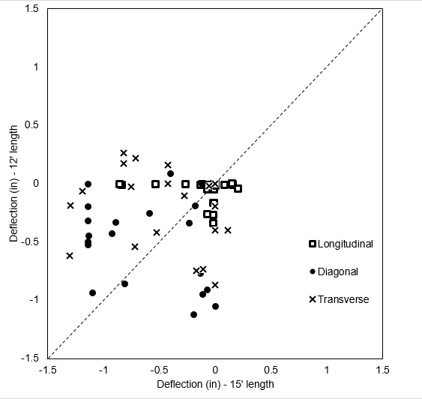
Figure 16 – Deflection (in.) of cells without fibers with L=12’ (Cell 551) vs. L=15’ (Cell 552) measured on 09/27/19
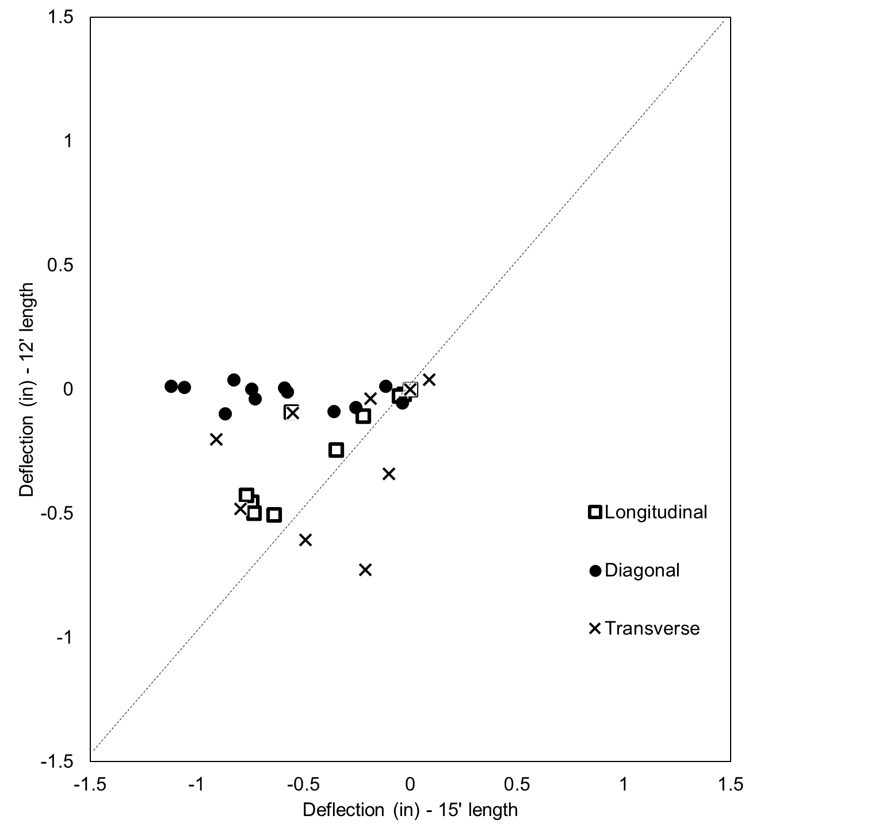
Figure 17 – Deflection (in.) of cells without fibers with L=12’ (Cell 551) vs. L=15’ (Cell 552) measured on 09/16/20
Issues or problems that need to be addressed.
The truck loading test and curling warping measuements were conducted as planned. The results showed that there was a high mortality rate of sensors (80%). The truck loading test was repeated with remote assistance of MnDOT; however, the second testing campaign was also indicative of the same mortality rate, and the collected data was within the same range as of the first test.
Next progress report due:
12/31/2020
Additional notes:
Activities planned for the next reporting period will include:
- periodic collection of load response data and analysis of MnDOT environmental and load response performance data.

