Surface Characteristics of Diamond Ground PCC Surfaces
NRRA State of Practice
June 6, 2020

Prepared for: NRRA Preventative Maintenance Team
Prepared by: Joseph Korzilius and Spencer Neff, SRF Consulting Group, Inc.

Summary Statement:
NRRA States have been diamond grinding concrete pavements for many years traditionally as a preservation treatment to improve smoothness and/or enhance friction and in new construction to meet contract requirements and avoid penalties. More recently diamond grinding has used for noise reduction. NRRA States that use diamond grinding have conducted research that can add to the collective knowledge base of this process and performance. This project explores the state of practice of diamond grinding PCC surfaces and the benefits.

Table of Contents
1 Background 5
1.1 Diamond Grinding 5
1.2 Why NRRA Members Wanted This 7
1.2.1 NRRA Members Involved 7
1.2.2 Why This Effort is Being Done 7
2 NRRA Member State Specifications 7
2.1 Summary of Specifications by State 7
2.2 California Department of Transportation 8
2.2.1 General Construction Requirements 8
2.2.2 Equipment Requirements 8
2.2.3 Smoothness Requirements 8
2.2.4 Grinding Slurry 9
2.2.5 Payment, Incentives, and Disincentives 9
2.3 Illinois Department of Transportation 10
2.3.1 General Construction Requirements 10
2.3.2 Equipment Requirements 10
2.3.3 Smoothness Requirements 10
2.3.4 Grinding Slurry 11
2.3.5 Payment, Incentives, and Disincentives 11
2.4 Iowa Department of Transportation 12
2.4.1 General Construction Requirements 12
2.4.2 Equipment Requirements 12
2.4.3 Smoothness Requirements 12
2.4.4 Grinding Slurry 13
2.4.5 Payment, Incentives, and Disincentives 13
2.5 Michigan Department of Transportation 14
2.5.1 General Construction Requirements 14
2.5.2 Equipment Requirements 15
2.5.3 Smoothness Requirements 15
2.5.4 Grinding Slurry 16
2.5.5 Payment, Incentives, and Disincentives 17
2.6 Minnesota Department of Transportation 17
2.6.1 General Construction Requirements 17
2.6.2 Equipment Requirements 17
2.6.3 Smoothness Requirements 18
2.6.4 Grinding Slurry 19
2.6.5 Payment, Incentives, and Disincentives 20
2.7 Missouri Department of Transportation 21
2.7.1 General Construction Requirements 21
2.7.2 Equipment Requirements 21
2.7.3 Smoothness Requirements 21
2.7.4 Grinding Slurry 22
2.7.5 Payment, Incentives, and Disincentives 22
2.8 North Dakota Department of Transportation 23
2.8.1 General Construction Requirements 23
2.8.2 Equipment Requirements 24
2.8.3 Smoothness Requirements 24
2.8.4 Grinding Slurry 24
2.8.5 Payment, Incentives, and Disincentives 25
2.9 Wisconsin Department of Transportation 25
2.9.1 General Construction Requirements 25
2.9.2 Equipment Requirements 26
2.9.3 Smoothness Requirements 26
2.9.4 Grinding Slurry 26
2.9.5 Payment, Incentives, and Disincentives 26
3 Smoothness, Friction, and Noise Data 27
3.1 California DOT 27
3.1.1 Smoothness Data 27
3.1.2 Friction Data 31
3.1.3 Noise Data 33
3.2 Illinois 34
3.2.1 Smoothness Data 34
3.3 Non NRRA Member State: Texas 35
4 Vulnerabilities and Cost Value 37
5 Research to Consider 37
6 References 37

Background

Diamond Grinding
Diamond grinding, surface planning and/or grooving, concrete pavements has generally been conducted on existing concrete pavements as a preservation technique to improve ride, reduce noise, and provide texture for enhanced friction. Although historically this treatment has been performed on existing pavements as a preservation technique, grinding is also used by Contractors on newly constructed concrete pavements to improve the initial smoothness for contract compliance and avoidance of deducts.

Where a pavement surface has become rough or lost surface friction grinding and grooving use gang-mounted diamond saw blades to shave off 1/8" or more depth from an existing concrete surface to restore these attributes. The depth of grinding should be sufficient to remove roughness from pavement distresses such as faulting and the removal of ruts from studded or tire chain wear.

Two attributes of surface texture effect friction: microtexture (wavelengths of 1µm to 0.5mm) generally provided in concrete surfaces by the fine aggregate and macrotexture (wavelengths of 0.5mm to 50mm) generally provided in concrete surfaces by a supplemental treatment such as broom burlap or artificial turf drag finish, tining, or grinding and grooving. Microtexture and macrotexture work together to provide wet weather pavement friction. While the purpose of grinding is mainly to restore ride quality and texture, grooving is generally used to reduce hydroplaning by providing escape channels for surface water. The main difference between grinding and grooving is in the depth of and distance between the grooves. The surface characteristics of the concrete after grinding are highly dependent on blade spacing.
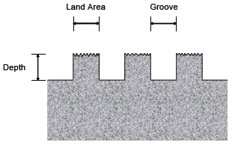
Figure 1.1 - A Typical Diamond Ground Corduroy Surface and The Corresponding Definitions.

Next Generation Concrete Surface (NGCS) is a diamond ground surface pattern developed to provide a profile absent of positive or upward texture to reduce tire pavement generated noise without compromising tire pavement friction and providing enhanced smoothness as an added benefit. The diamond saw-cut pattern is a “manufactured” surface that produces a flush texture aimed at reducing pavement tire noise and constructs the necessary micro and macro texture to maintain friction with an additional groove to address hydroplaning.

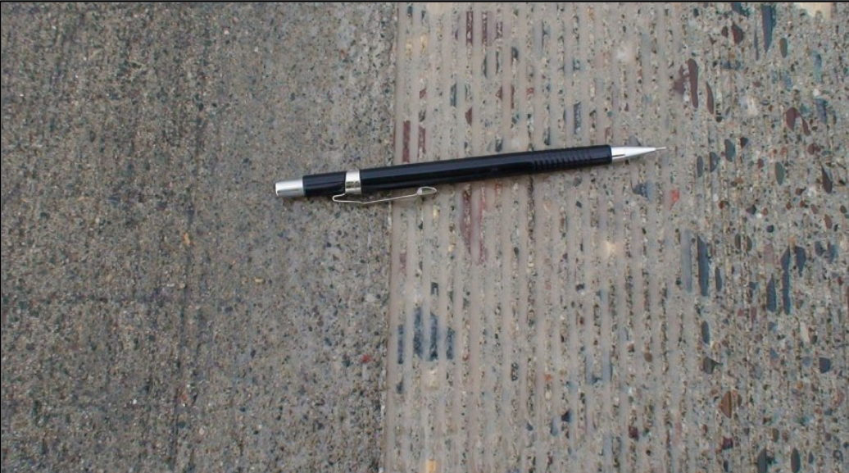
Figure 1.2 – Unground Surface (Left) and Conventional Grind (Right)

Figure 1.3 - Conventional Ground Surface (Left) and Next Generation Concrete Surface (NGCS) (Right)
PCC Surface Characteristics – Rehabilitation MnROAD Study,
July 2013, W. James Wilde (MN-RC 2013-18)
Some of the concerns due to diamond grinding are:
- Acceleration of materials related distresses (MRD) such as ASR, ACR, and D-Cracking
- Loss of pavement thickness and a reduction of the structural capacity of the pavement slab
- Decreasing skid resistance of the pavement surface as a result of a breakdown in macrotexture.
- Decreasing skid resistance attributed to polishing of the exposed surface.
- Premature joint deterioration due to deicing practices.

There is a need to develop guidance and test procedures that would allow determination of the suitability of diamond grinding on an MRD pavement.

Why NRRA Members Wanted This

NRRA Members Involved
Eight state agencies currently involved in the diamond grinding technology transfer, are California DOT, Illinois DOT, Iowa DOT, Michigan DOT, Minnesota DOT, Missouri DOT, North Dakota DOT, and Wisconsin DOT. These NRRA members wish to investigate the current practices of diamond grinding Portland Cement Concrete (PCC) surfaces and the benefits being observed.

Why This Effort is Being Done
The goal of this paper is to provide a synthesis on diamond grinding best practices being used by participating NRRA members. This synthesis includes summarizing specifications for construction of diamond ground surfaces in NRRA States in reference to procedures and equipment requirements.
The paper also hopes to identify test cells at MnROAD and test sections within MnDOT’s Pavement Management System that can be used as candidate sections to develop pre and post treatment texture performance curves for smoothness, noise, and friction. Where possible this paper explores when diamond grinding is best applied, improvement at the time of construction and how long improvements last, and potential vulnerabilities of diamond grinding.

NRRA Member State Specifications

Summary of Specifications by State
The NRRA States have specifications for blade spacing as well as grinding depth, width, spacing, and land area of grooves left in the pavement surface. These specifications determine what textures are produced. A summary of State specifications as published, and FHWA and NGCS grinding patterns, are included in the following table.

Table 2.1-1 - Typical Recommended or Specified Depth, Width, and Spacing Measurements
 | FHWA/ IGGA/ | NGCS | CA | IA | MI | MN | MO | ND | WI
Groove Width (in.) | 0.125 | 0.125 | 0.08 - 0.12 | 0.09 - 0.11* | 0.09 - 0.15 | 0.125 | 0.22 - 0.24 | 0.125
Groove Depth (in.) | 0.125 - 0.25 | 0.125 - 0.19 | 0.06 - 0.08 | 0.06 - 0.19 | 0.13 - 0.19 | 0.125 | 0.03 | 0.1875 | 0.06 - 0.19
Groove Land Area (in.) | 0.625 | 0.375 - 0.5 | + 0.65 |  | 0.75 | 0.125 |  | 0.625
Groove Spacing (in.) | 0.75 | 0.5 - 0.625 | 0.75 |  | 0.84 - 0.90 | 0.25 |  | 0.75
Grooves per Foot Width | 55 |  | 55 - 60 | 50 - 60 | 53 - 60** |  | 50 - 55
Note: Illinois specifications refer to Iowa specifications and therefore are not shown separately.
*Groove width can decrease to 0.08” for grinds on Gravel/Quartzite pavement rather than Limestone pavements.
**Number of grooves per foot can decrease to 50 – 54 for grinds on soft aggregates rather than hard aggregates.

California Department of Transportation

General Construction Requirements
Surfaces must be ground in the longitudinal direction the full lane width. Grinding is to begin and end at lines perpendicular to the roadway centerline. On both sides of joints and cracks a uniform texture shall be provided. Concrete grinding and grooving are not allowed during precipitation events. Grinding of concrete pavement may be required for not only new construction or rehabilitation but also as a preservation strategy on existing non-doweled concrete pavements that have faulted.
Acceptance of ground pavement is by smoothness and a minimum coefficient of friction. The California DOT accepts grooved areas if at least 95 percent of any 2 by 100 foot longitudinal pavement area is grooved except where prevented by irregularities in the pavement surface. The California DOT also maintains specifications that require a minimum coefficient of friction (the ratio between the force necessary to move one surface horizontally over another and the pressure between the two surfaces) of 0.30.

Equipment Requirements
The California DOT requires concrete roadway surfaces be grooved perpendicular to the centerline of the roadway. Grinding is performed parallel to the roadway centerline, in the direction of normal traffic flow the full width of the roadway. Grinding equipment must have diamond cutting blades mounted on a self-propelled machine designed for grinding and texturing concrete pavements that produces a parallel corduroy texture with grooves from 0.08 to 0.12 inch wide and from 55 to 60 grooves per foot of width. Grooves must be from 0.06 to 0.08 inch from the top of the ridge to the bottom of the groove. Grooving blades must be 0.095 ± 0.005 inch wide and spaced on 3/4-inch centers. Set blades to a depth from 0.125 to 0.25 inches for concrete pavement. Where inductive loop detectors are present the depth of cut is reduced to between 0.06 and 0.125 inches. The cross-slope must be uniform and have positive drainage across the traveled way and shoulder.
Smoothness Requirements
California employs the inertial profiler and FHWA's engineering software ProVAL to determine pavement smoothness using the International Roughness Index (IRI) and Mean Roughness Index (MRI) for reporting. Pavement smoothness is determined for each traffic lane in both the left and right wheel paths. Continuous IRI values are calculated for each wheel path with a 25-foot interval using a 250 mm filter. The MRI of the lane is the average IRI value for the left and right wheel paths for the same traffic lane.
For areas of localized roughness (ALR) or areas exceeding the specified thresholds for the MRI the contractor must submit a corrective grinding plan as an informational submittal before performing corrective grinding.
After grinding the pavement surface must comply with specifications for smoothness and friction.
Acceptance is by 0.1 mile sections with an MRI of 60 inches/mile or less and no areas of localized roughness greater than 120 inches/mile.
For areas that require pavement smoothness determined using a 12-foot straightedge the pavement surface must not vary from the lower edge of the straightedge by more than:
0.01 foot when the straightedge is laid parallel with the centerline
0.02 foot when the straightedge is laid perpendicular to the centerline
0.02 foot when the straightedge is laid within 24 feet of a pavement conform

The minimum acceptable coefficient of friction is 0.30 or at ramp termini 0.35.

Grinding Slurry
The Contractor is required to collect concrete waste and debris including slurry, grout, dust, demolition debris from operations that include saw cutting, coring, grinding, and grooving must be picked up. Materials from grinding and grooving must be picked up with a vacuum attachment on the equipment as work proceeds. Residue from grinding (and grooving) activities may not be left on the pavement, allowed to flow across the pavement, nor enter storm drain systems and receiving waters. Concrete grinding and grooving are not allowed during precipitation events. Liquid residue from concrete grooving or grinding activities is collected and disposed at an properly permitted disposal facility.
If authorized, the slurry collector may transport liquid grooving or grinding residue to a contractor-support facility for drying.

Payment, Incentives, and Disincentives
The payment of diamond grinding surfaces is by square yard.
The following figure shows a series of tables with different target smoothness ranges, dependent upon their project type, for Continuously Reinforced Concrete Pavement (CRCP) and Joint Plain Concrete Pavement (JPCP) and their corresponding incentive and disincentive payment modifiers.
Concrete Pavement Smoothness Selection Table
 | Pavement Type | Project Type |  | Smoothness Table
 | CRCP | New alignment or reconstruction |  | Target 60
 |  | Widening or lane replacement |  | Target 67.5
 | JPCP | New alignment or reconstruction
 |  | Widening or lane replacement |  | Target 75
 | CRCP/JPCP | Grinding existing pavement |  | Percent Improvement (PI)
Target 60 Smoothness Table
0.1-mi MRI (in/mi) |  |  | Pay Adjustment/0.1 mi |  | Corrective Actionª
≤ 45.00 |  |  | + $1500 |  | None
45.01 – 55.00 |  |  | + ((55 - MRI) x $150) |  | None
55.01 – 65.00 |  |  | 0 |  | None
65.01 – 80.00 |  |  | - ((MRI - 65) x $150) |  | Optional^{b}
> 80.00 |  |  | - |  | Mandatory^{c}
ªCorrective action must not reduce pavement thickness below minimums in section 40-1.01D(8)(c)(iv). Applicable to MRI only.
^{b}Diamond grinding allowed.
^{c}Correction is diamond grinding.

Target 67.5 Smoothness Table
0.1-mi MRI (in/mi) | Pay Adjustment/0.1 mi | Corrective Actionª
≤ 50.00 | + $1500 | None
50.01 – 60.00 | + ((60 - MRI) x $150) | None
60.01 – 75.00 | 0 | None
75.01 – 90.00 | - ((MRI - 75) x $150) | Optional^{b}
> 90.00 | - | Mandatory^{c}
ªCorrective action must not reduce pavement thickness below minimums in section 40-1.01D(8)(c)(iv). Applicable to MRI only.
^{b}Diamond grinding allowed.
^{c}Correction is diamond grinding.

Target 75 Smoothness Table
0.1-mi MRI (in/mi) | Pay Adjustment/0.1 mi | Corrective Actionª
≤ 50.00 | + $1500 | None
50.01 – 60.00 | + ((60 - MRI) x $150) | None
60.01 – 90.00 | 0 | None
> 90.00 | - | Mandatory^{b}
ªCorrective action must not reduce pavement thickness below minimums in section 40-1.01D(8)(c)(iv). Applicable to MRI only.
^{b}Mandatory correction is diamond grinding.
Percent Improvement Smoothness Table
0.1-mi MRI_{exist}ª (in/mi) |  | 0.1-mi MRI_{final}^{b} (in/mi) | Corrective Action
≤ 100 |  | ≤ 60 | None
 |  | >60 | Mandatory^{c}
> 100 |  | ≤ 0.6 x MRI_{exist} | None
 |  | > 0.6 x MRI_{exist} | Mandatory^{c}
ªExisting MRI
^{b}Final MRI
^{c}Mandatory correction is another pass of diamond grinding.

Figure 2.2.5-1 - California’s Incentive and Disincentives for CRCP and JPCP pavements for different smoothness targets.

Illinois Department of Transportation

General Construction Requirements
The finished surface of new and ground pavements is tested for smoothness.

Equipment Requirements
The grinding device shall be a self-propelled machine with multiple diamond saw blades. The machine shall be designed for grinding pavement surfaces and shall have a minimum effective head width of 4 ft. The diamond saw blades shall be gang mounted on the grinding head at a rate of 50 to 60 blades / foot.

Smoothness Requirements
Both wheel tracks are tested in each lane with testing performed 3 ft from and parallel to each lane edge. The profile index of each sublot in inches/mile. Any bump in excess of 0.30 inches is identified for correction.
High-Speed Pavement shall consist of pavement, ramps, and loops with a posted speed greater than 45 mph. In High-Speed Pavement sublots with an average profile index greater than 30.0, including bumps, shall be corrected to 30.0 inches/mile or less.
Low-Speed Mainline Pavement consists of ramps and loops with a posted speed of 45 mph or less. Low-Speed Pavement sublots with an average profile index greater than 45.0, including bumps, shall be corrected to 45.0 inches/mile or less.
The following pavement sections shall be tested using a 16 ft straightedge set to a 3/8 in. tolerance. Surface variations which exceed the 3/8 inches tolerance will be marked by the Engineer and shall be corrected by the Contractor.
- Pavement on horizontal curves with a centerline radius of 100 feet or less
- Pavement within the superelevation transition of such curves
- Pavement on vertical curves having a length of less than or equal to 200 ft in combination with an algebraic change in tangent grades greater than or equal to three percent
- The first 15 feet of a pavement section adjoining pavement where the Contractor is not responsible for the surface
- Intersections, variable width pavement segments, side street returns, crossovers and connector pavements, bridge approach slabs and other pavement surfaces as determined by the Engineer.

Corrective work shall have uniform texture and appearance and be applied to the full lane width. When completed corrected areas are retested. A protective coating is applied to areas of ground pavement.

Grinding Slurry
The removal of slurry shall be continuous throughout the grooving operations. The grinding and grooving equipment shall be equipped with vacuum slurry pickup equipment which shall continuously pick up water and sawing dust and pump the slurry to a collection tank.
The slurry shall be disposed of off-site.

Payment, Incentives, and Disincentives
The payment for diamond grinding is typically by the square yard unit measure.
The following table provides payment for incentives and disincentives, when applied, for the smoothness of the ground surface.
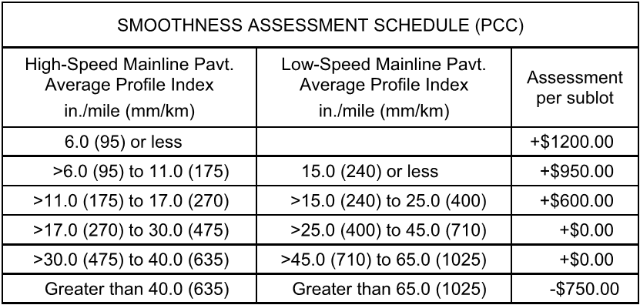
Figure 2.3.5-1 – Illinois DOT Payment Incentive/Disincentive Smoothness Schedule
Use a cutting head that is a minimum of 36 inches wide, unless a 24 inch cutting head is necessary due to space limitations.

Iowa Department of Transportation

General Construction Requirements
Grinding and texturing of the entire pavement surface shall be perfomed parallel to the centerline until the pavement surface on both sides of transverse joints and all cracks are in the same plane with no greater than 1/16 inch difference between adjacent sides of joints and cracks and the pavement surface meets the required smoothness. Feather grind into existing structures such as manholes and water valves in a manner that eliminates abrupt edges or drops and provides a uniform texture.
Ensure the ground surface is of uniform texture. In each lane, ensure at least 95% of the area in each 100-foot section has a newly textured surface. Depressed pavement areas, due to subsidence or other localized causes, and areas containing feathering due to pavement structures will be exempted from texturing requirements.
Except at joints and cracks, ensure grinding depth does not exceed 1/2 inch. At joints and cracks, ensure grinding depth does not exceed 3/4 inch.
For multiple passes, ensure overlaps do not exceed 1 inch. Begin at the crown of the roadway, proceeding toward the pavement edge with each subsequent pass. Ensure each subsequent pass is at least as deep as the previous pass in order to provide transverse drainage. All passes are to begin and end at the same station location. Ensure no unground areas are left between passes. For grinding adjacent to an unground turn lane or other pavement surface, feather smoothly from the edge of the ground surface to the unground surface leaving no more than a 1/8 inch ridge. If street surface to be ground includes a curb and gutter section, extend grinding to within 4 inches of the curb face and feather to provide proper drainage.

Equipment Requirements
Assemble and adjust the grinding head as necessary during the project to produce the following tolerances on pavements with the indicated coarse aggregates. Both the distance between grooves and the texture depth must be within the specified range to be in compliance. Assemble the grinding head to produce the tolerances indicated below for the type of coarse aggregate in the pavement.

Smoothness Requirements
Measure smoothness with a 10-foot straightedge. Regrind high spots to ensure no surface deviations greater than 1/8 inch remain.
When profilograph testing is specified in the contract documents, comply with Iowa DOT Materials I.M. 341 and the following requirements:
- Prior to performing any grinding work, provide a control profilogram for each lane and/or segment over 50 feet in length that is to be ground. Ensure pavement is relatively clean and free of debris prior to establishing the control profilogram.
- Ensure each segment of the finished ground surface has a final profile index less than or equal to 35% of the control profilogram trace or 22 inches per mile, whichever is greater, and does not include any bumps exceeding 1/2 inch in 25 feet.
- Correct all bumps and dips exceeding 0.5 inch within a 25-foot span until any bump or dip is 0.3 inch or less in a 25 foot span where a price adjustment is not assessed by the Engineer.
- Depressed pavement areas due to subsidence or other localized causes and areas where the maximum cut restricts further grinding will be excluded from testing with the profilograph when approved by the Engineer.
- Recheck smoothness following any regrinding activities to ensure compliance with the above requirements.
Where Schedule A Smoothness is required incentives for pavement smoothness will be paid for each segment of pavement with an initial index per mile per segment of 3.0 inches or less. For segments with an initial index of 7.1 to 10.0 inches per mile the Contractor will be assessed a price reduction. For segments with an index of 10.1 inches per mile and greater, grind the surface to a final index of 7.0 inches per mile or less.
Where Schedule B Smoothness is Required incentives are paid for smoothness with an initial index of 12 inches per mile per segment or less. For segments with an initial index of 22.1 to 30.0 inches per mile a price reduction is assessed. For segments with an index of 30.1 inches per mile and greater, grind the surface to a final index of 22.0 inches per mile or less.

Grinding Slurry
Continuously remove all slurry or residue resulting from the grinding operations with a well-maintained vacuum system and remove from the project limits. Ensure residue from grinding operations does not flow across lanes occupied by public traffic or into gutters, storm sewers, ditches, or other drainage facilities.

Payment, Incentives, and Disincentives
The payment of diamond grinding surfaces is by square yard.
Pavement smoothness will be compensated by adding to (incentive) or subtracting from (price reduction) the price bid for pavement a determined amount for each segment. The following tables show the payment incentive and disincentive for the smoothness of the ground surface.
A $900 price adjustment will be assessed for each dip not corrected in each pavement lane
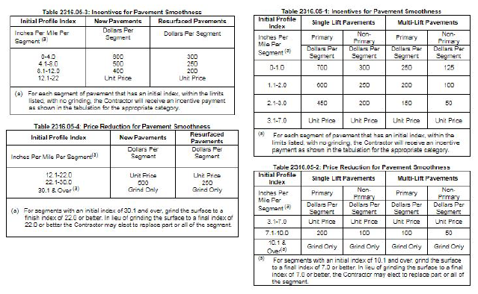
Figure 2.4.5-1 – Iowa DOT Payment Incentive/Disincentive Smoothness Schedule

Michigan Department of Transportation

General Construction Requirements
Diamond grind concrete pavement in the longitudinal direction beginning and ending at lines perpendicular to the pavement centerline. Taper grinding to existing pavement surface within 2 inches of Reflective Pavement Markers (RPMs), do not disturb RPMs. Texture at least 95 percent of the pavement surface unless otherwise directed by the Engineer. The Engineer will not require extra depth grinding to eliminate minor depressions.
After initial grinding, regrind faulted areas, greater than 1/16 inch, at transverse cracks and joints, until faulting is less than 1/16 inch.
Construct a uniform transverse slope with no depressions or misalignment greater than 1/8 inch when checked with a 10-foot straightedge. The Engineer will not apply straightedge requirements across longitudinal joints or outside ground areas.
Provide for cross slope drainage. To provide drainage and the required riding surface, transition grind auxiliary or ramp lanes from the mainline edge. The Engineer will determine the transitions from ground to unground pavement surfaces.
Seal joints after grinding.

Equipment Requirements
Provide diamond blades, spaced as required for the application, and mounted on a self-propelled machine designed for grinding and texturing pavement. Use equipment that will not cause damage to the underlying surface of the pavement. Do not use grinding equipment that ravels or spalls the concrete pavement, fractures aggregate, or damages the transverse or longitudinal joints. Provide grinding equipment that produces the required texture.
Furnish and operate a profiler to measure ride quality for quality control purposes.
For each day acceptance measurements are taken, the Engineer will verify that the profiler passes all daily checks as outlined in MTM 726.

Smoothness Requirements
Use quality control measurement, profilograph or profiler, to locate and mark surface irregularities requiring correction. Alternate bump finding methods which utilize ProVAL software may be used.
Straight edge requirements apply to all areas including predetermined excluded areas. Excluded areas include areas where the constructed pavement must match grades of an existing feature, ramps other than freeway to freeway ramps, ramp tapers, shoulders, railroad crossings, bridges, major at grade intersections with staged construction, areas surrounding utility and drainage structures, and pavement gapped areas.
Submit a ride quality plan that includes equipment to be used to measure ride quality, proposed excluded areas, method to correct surface irregularities, correction layout method, and the anticipated testing schedule.
Ride quality measurements shall be reported as the International Roughness Index (IRI). Acceptance shall be in tenth-mile segments in the direction of travel. Segments that include an excluded area shall be reported as partial segments. IRI values are reported for each tenth mile segment and are the average of the left and right wheel path values. The following tables show the IRI requirements for different design speeds.

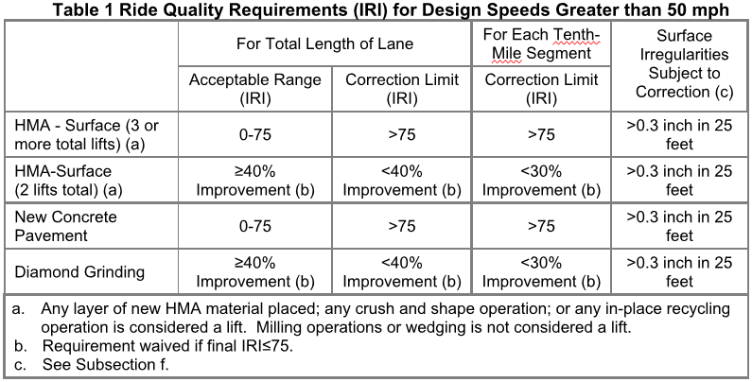
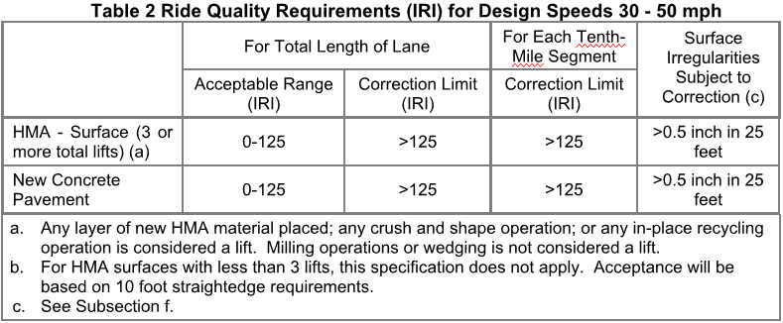
Figure 2.5.3-1 – Michigan DOTs Required IRI Values for Different Design Speeds

Grinding Slurry
To remove residue and excess water, provide vacuum equipment that extracts the slurry material from the pavement and prevents dust from escaping into the air. Before beginning the grinding, obtain the Engineer’s approval of the grinding residue spreading and disposal method. If surface runoff occurs, collect and haul the grinding residue to an Engineer-approved location on the project.
Do not allow grinding residue to enter enclosed drainage systems. If approved by the Engineer, grinding residue may be spread along the roadway slopes provided residue is kept at least 5 feet away from the curb or a water-filled ditch and at least 100 feet from a natural stream or lake.
The Department will take random samples of the grinding residue and cooling water for chemical testing.
Collect, haul and dispose of grinding residue at no additional cost to the Department.
Provide a written pH control plan to the Engineer prior to diamond grinding. The residue must be sampled and tested to determine if the slurry is a corrosive hazardous waste (pH greater than or equal to 12.5 or lower than 2). Monitor continuously throughout the diamond grinding process to ensure that the pH levels are maintained If the grinding residue or slurry is generated, collected and hauled with a pH greater than 12.5, then a licensed hazardous waste hauler is required to transport the material.
Options for the Diamond Grinding Slurry (Non-Hazardous Only) include:
- Collect and dispose of diamond grinding concrete pavement slurry within MDOT right-of-way.
- Dispose of as an industrial waste
- Dewater using mechanical separation to reduce, reuse, and recycle portions of the diamond grinding concrete pavement slurry for projects with enclosed drainage systems.

Payment, Incentives, and Disincentives
Contract pay item is by the square yard. The unit price includes the cost of collecting, hauling, and spreading grinding residue. The Engineer will include the final textured surface area in the measurement and will not deduct minor areas of untextured pavement if the minor areas total no greater than 5 percent of the area shown on the plans.
All costs associated with quality control ride quality measurements or additional passes or regrinding to meet ride quality requirements are included in other items of work and will not be paid for separately.
All corrections within the limits of ride quality will be done at the Contractor’s expense.
No payment incentives nor disincentives for Michigan were found.

Minnesota Department of Transportation

General Construction Requirements
At the completion of concrete grinding, any rolling 100-foot section of a lane is required to have at least 95 percent ground surface texture.
Provide a smooth transition to and from intersecting roadways by grinding a smooth vertical taper from the newly created grinding elevation up to the intersecting roadway elevation. Provide all traffic control associated with the testing and any corrective action (when applicable) that is required of the final pavement surface.
Install permanent pavement markings after the completion of concrete grinding. Replace any permanent pavement marking damaged or destroyed by concrete grinding at no cost to the Department.
Provide a grinder capable of constructing an evenly spaced longitudinal land and groove (line type) texture that is true in grade and uniform in appearance. The texture runs parallel to centerline or parallel to the outside edge of the pavement in areas of taper.

Equipment Requirements
The height tolerance of the lands (depth of groove) is 1/8th in ± 1/16th in when measured from the bottom of the groove to the peak of the land. The land area (width) between grooves is dependent upon the type of aggregate in the concrete pavement. Select the number of blades per foot to provide the following land area requirements in accordance with the table below, “Land Area between Grooves.”

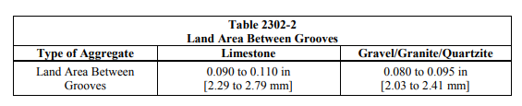
Figure 2.6.2-1 - Minnesota’s Different Land Area to be Used on Pavements with Different Aggregate Types

Smoothness Requirements
MnDOT defines “Smoothness” as the Mean Roughness Index (MRI) value per 0.1 mi segment. “Areas of Localized Roughness” (ALR) are areas where a continuous MRI calculation is equal to or exceeds the limiting criteria for a 25 ft interval, as calculated using the FHWA’s Profile Viewing and Analysis (ProVAL) software.
Provide a MnDOT certified, calibrated, and documented profiler capable of producing a profilogram and exporting raw profile data. Provide a trained and certified operator knowledgeable in the use of the profile analysis software whom has passed MnDOT’s online training course.
Provide the Engineer with current, valid documentation, issued by the MnDOT, indicating both Profiler and operator certification. Each lane is separated into segments 0.1 mi in length and tested and evaluated separately. Each lane is separated into segments 0.1 mi in length and tested and evaluated separately.
Table 2302-3, “Areas Excluded from Smoothness Evaluation” indicates areas excluded from Smoothness evaluation, but still require measurement with an IP, and are subject to evaluation for ALR and the 10 ft [3.05 m] straightedge.
Table 2302-3
Areas Excluded from Smoothness Evaluation
Roadways with posted speed limits less than 50 mph
Ramps and loops
Acceleration and deceleration lanes less than or equal to 1,000 ft. in length
Bridge decks and approach panels unless ground under the same contract.
(The occurrence of bridges shall not interrupt the continuity determination.)
Crossover intersections if the intersecting roadway is not closed. Begin and end exclusions 100 ft. upstream / downstream from the intersection radius.

Table 2302-4, “Areas Excluded from Smoothness and ALR Evaluation” indicates areas excluded from surface testing with the IP but are subject to evaluation with the 10 ft straightedge.
Table 2302-4
Areas Excluded from Smoothness and ALR Evaluation
Turn lanes and Loops
10 ft. on either side of obstructions in lane that obstruction is located.
Before intersections that end at a stop sign or yield signs and roundabouts- begin and end exclusions 100 ft. upstream / downstream from the intersection radius.

ProVAL is required to conduct a profile analysis to determine Smoothness and ALR. Obtain the Smoothness values in an individual lane using the ProVAL software “Smoothness Assurance” analysis with the 250 mm filter.
Variations equal to 1/4 inch or less within the span of the 10-foot straightedge are accepted. Corrective work will be required on vertical deviations greater than 1/4 inch in any direction.
The maximum elevation deviation and vertical lip tolerance between grinder passes is 1/8 in.

Grinding Slurry
At the pre-grinding meeting, submit to the Engineer in writing the proposed Slurry Management Plan the grinding contractor will utilize to remain in conformance with Specification
The Contractor must not permit residue and water to flow across adjacent traffic lanes, flow onto shoulder, flow off bridge decks, flow into gutters, or flow onto private property. The Contractor shall provide a plan for both the on-site and off-site slurry management. The Contractor shall choose, and the Engineer will approve, the methods for slurry management.
The Engineer will allow the Contractor to spread the slurry within MnDOT right of way on the vegetated slopes and medians in accordance with the following requirements:
The Contractor shall spread the slurry at a rate to prevent sediment buildup of greater than 1/2 inch in locations that flow away from the roadway, where a vegetated buffer zone away from any identifiable point of concentrated storm water flow is maintained, minimize sediment infiltration into drainage systems.
Monitor and control the pH of the slurry for all operations to maintain a pH between 6 and 12
On-site slurry management is prohibited in the following areas of environmental sensitivity:
- MnDNR Public Waters Inventory
- National Wetland Inventory
- Calcareous Fens
- Permanent vegetation designated for preservation, such as areas adjacent to the right of way identified as a ‘Site of Biodiversity Significance’ or ‘Native Plant Community’ by the DNR Minnesota Biological Survey (MBS).
- Prairie remnants, including but not limited to areas adjacent to Railroad Rights-of-way Prairies.
- Wooded areas with specimen trees
- Locations with Federal or State listed Threatened or Endangered plant species
- Locations with Federal or State listed Threatened or Endangered aquatic species
- Historic Properties
Require slurry collection as follows:
- Roadways: that utilize curb and gutter to convey storm water to catch basin inlets into a closed drainage system (storm sewers).
- Inlet structures that utilize a piping system to convey storm water directly into stormwater treatment facilities or AES.
- Bridge Deck grinding
- Stormwater treatment ponds
- Infiltration/filtration basins

Payment, Incentives, and Disincentives
Measurement will be to the nearest square yard of concrete area ground based on the width ground times the length ground.
Payment for Concrete Grinding at the contract price per square yard unit of measure is full compensation including Diamond grinding the concrete pavement, IP profiling, corrective work needed to meet smoothness specifications, grinding tapers, traffic control, and slurry disposal necessary to meet Specification requirements.
Table 2302-5
Smoothness Pay Adjustments and Corrective Work for Concrete Pavements
Smoothness  in/mi | Pay Adjustment  $/0.1 mi
< 40.0 | $600.00
≥ 40.0 to < 60.0 | 1800 – [30 × Smoothness]
≥ 60.0 to < 70.0 | 0.00
≥ 70.0 | Corrective Work to ≤ 60.0 in/mi
Figure 2.6.5-1 Minnesota DOT’s Payment Incentive/Disincentive Based On Smoothness Requirements

Table 2302-6
ALR Monetary Deductions and Corrective Work Requirements
Equation | 25 ft Continuous MRI, in/mi | Corrective Work or Monetary Deduction, per linear 1.0 ft
With posted vehicle speed > 45 mph | < 175.0 [2.76] | Acceptable
 | ≥ 175.0 to < 250.0 | Corrective Work or $25.00,  as directed by the Engineer
 | ≥ 250.0 | Corrective Work  as directed by Engineer
Ramps, loops, Crossover intersections if the intersecting roadway is not closed, any roadway with a posted vehicle speed ≤ 45 mph [73 km/hr] | < 225.0 | Acceptable
 | ≥ 225.0 to < 275.0 | $10.00
 | ≥ 275.0 | $25.00
Figure 2.6.5-2 - Minnesota’s Payment Incentive/Disincentive Requirements Based On IRI

Missouri Department of Transportation

General Construction Requirements
Diamond grind the existing concrete pavement to provide a uniform finished surface that is true to grade and uniform in appearance with a longitudinal line type texture having parallel longitudinal corrugations that present a narrow ridge corduroy-type appearance. The final surface shall be free of excessively large scarification marks and have the grade and cross slope specified, with a maximum tolerance of 1/16 inch across adjacent sides of joints and cracks. Any surface variations greater than 1/8 inch, when measured longitudinally with a 10-foot straightedge, shall be reground. The cross-slope shall have no misalignments or depressions greater than ¼ inch, when measured with a 12-foot straightedge placed perpendicular to the centerline. Straightedge requirements do not apply across longitudinal joints or outside the ground area.
The grooves shall be evenly spaced with peaks of the ridges approximately 1/32 inch higher than the bottoms of the grooves. There shall be approximately 50-55 grooves per foot measured perpendicular to the centerline. Under no circumstances shall the grinding depth exceed 1/4 inch from the top of the original surface.

Equipment Requirements
Provide diamond blades, spaced as required for the application, and mounted on a self-propelled machine designed for grinding and texturing pavement. Use equipment that will not cause damage to the underlying surface of the pavement. Do not use grinding equipment that ravels or spalls the concrete pavement, fractures aggregate, or damages the transverse or longitudinal joints. Provide grinding equipment that produces the required texture.
The equipment shall be of a size that will grind a strip at least 3 feet wide using diamond blades, and shall not cause spalls at cracks, joints or other locations.

Smoothness Requirements
Prior to performing any grinding work, after completion of all pavement repair, the contractor collects the International Roughness Index (IRI) from the right wheel path of each lane being diamond ground as a control. The control IRI is used to identify the required target smoothness for the project such that after grinding the finished surface profile in the right wheel path shows a minimum 65% improvement or is less than a total 80 inches per mile whichever is the greater for acceptance. After review, the Engineer may identify additional correction to be performed. Once the acceptance criteria are met the contractor is not be allowed to make additional corrective grinding to increase payment.
The Missouri DOT specifies the ProVAL software program to compute IRI. Ten percent of the total diamond ground lane miles shall be profiled by MoDOT to compare with the contractor results
The following areas are tested with a 10-foot straightedge and excluded from profiling:
- Bridge decks and concrete approach pavements
- Pavement on horizontal curves and within the super-elevation transition areas for curves with the centerline radius of curve less than 1000 feet
- Pavement on vertical curves having a "K" value less than 90 and a length less than 500 feet
- Pavement width transitions
- Fifty feet in direction of travel on each side of utility appurtenances, manholes, valve boxes, etc.
- Fifty feet in direction of travel on each side of intersecting routes with special grade transitions
- Shoulders
- Interruptions designated by the engineer which provide independently placed sections shorter than 50 feet
- The last 15 feet of any section where the contractor is not responsible for the adjoining surface
- Any lane which abuts an existing lane not constructed under the same contract
- Internal profiling may be waived by the engineer in other specific locations if impractical to profile

Grinding Slurry
The contractor shall have the engineer’s approval for the method of spreading and disposal of the residue prior to beginning any grinding operations.
The contractor shall remove and dispose of all residue from the grinding in a manner and at a location to satisfy environmental regulations. The residue shall not enter into gutters or closed drainage systems. No residue shall be spread within 100 feet of any streams, lakes or other open bodies of water.
The contractor may disperse residue onto unpaved shoulders, adjacent roadside embankments, or median ditch areas of divided highways where the residue runoff can percolate into the soil.

Payment, Incentives, and Disincentives
The accepted quantity of ground pavement surface will be paid for at the contract unit price for diamond grinding concrete pavement. Final measurement will not be made except for authorized changes during construction or where appreciable errors are found in the contract quantity. Where required, measurement will be made to the nearest square yard. Payment is made on a per segment basis.
Measurement will be based upon the full pavement lane width. No deduction will be made for gaps within the pavement lane to avoid striping, raised pavement markers, manholes or other structures. The following tables show the payment incentives and disincentives.

IRI, inches per mile | Increase in Contract Unit Price
40.0 or less | $0.25
40.1 to 54.0 | $0.15
54.1 to 80.0 | None
80.1 or greater | None*
*After correction to at least 35 percent improvement of the control profile or 80.0 inches per mile, whichever is greater.
Figure 2.7.5-1 - Missouri’s Payment Incentives/Disincentives for Different Measurements of IRI

North Dakota Department of Transportation

General Construction Requirements
Use a self-propelled grinder equipped with diamond blades that is capable of uniformly grinding or removing the surface to the specified depth without damaging the underlying concrete. Do not use equipment that causes strain or damage to the underlying surface of the pavement.
Perform grinding in the longitudinal direction so grinding begins and ends at lines normal to the pavement centerline. Do not overlap more than 2 inches between passes and ensure the depth variance between adjacent passes is less than 1/8 inch. Feather the grinding at the beginning and end of each pass.
Ensure the surface of the ground pavement has a texture consisting of grooves between 0.090 and 0.130 inches wide. Keep the peaks of the ridges approximately 1/32 inch higher than the bottom of the grooves. Grind high shoulders to provide drainage and safety. Grind the full width of the lane and daylight grinding on the shoulder by performing a feather pass.
Along roadways with speed limits 45 MPH or greater, grind lots to maximum IRI of 68.0 in/mile. Grind localized roughness areas to maximum IRI of 80.0 in/mile.
Along roadways with Speed Limits Less than 45 MPH grind lots to maximum IRI of 100.0 in/mile. Grind localized roughness areas to maximum IRI of 180.0 in/mile.

Equipment Requirements
The diamond grinder shall be equipped with diamond blades mounted on a self-propelled machine designed for grinding a recess into the pavement surface. It shall be equipped with a dust collection system capable of removing and containing airborne emissions incurred during grooving operations. It uses mounted diamond blades on a floating head with controls capable of providing uniform depth and alignment.

Smoothness Requirements
The Engineer may use the straight edge method, the profiler method, or both to determine surface tolerances and ride quality.
Schedule a time for the profile to be collected. The Engineer will use lasers collect the profile information in each wheel path of each lane. The profile will be traced at approximately 31 and 97 inches, measured from the left edge of the lane, as determined by the direction of traffic. Smoothness will be evaluated by IRI generated using ProVal software with the application of a 250 millimeter filter. The Mean Ride Index (MRI), the average IRI of the two-wheel paths, option in ProVal is used for evaluation.
Areas of localized roughness are identified by the Smoothness Assurance Module (SAM) within ProVal.

Grinding Slurry
When grinding in areas with speeds less than 45 mph, areas with curb and gutter, and areas adjacent to waterways continuously collect all slurry or residue resulting from the grinding operation. Dispose of the slurry or residue as specified.
Unless otherwise designated in the contract, grinding slurry becomes the property of the Contractor. If material is transferred to another entity, provide a copy of the agreement entered into between the parties. If the Contractor determines that the material will be disposed of the material must be disposed through a beneficial use or at an approved permanent waste management facility.

Payment, Incentives, and Disincentives
The payment of diamond grinding is paid for in Square Yards. The following table shows the ride quality incentives for smoothness.
The Engineer will apply liquidated damages of $1,500 for each area that has been ground that is identified as needing further corrective action.
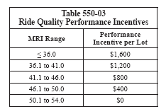
Figure 2.8.5-1 - North Dakota DOTs Payment Incentives for Smoothness

Wisconsin Department of Transportation

General Construction Requirements
After grinding the contractor is required to provide a surface that is true in grade and uniform in appearance. Begin and end grinding at termini that is perpendicular to the roadway centerline and provide a longitudinal line-type texture having corrugations parallel to the outside pavement edge. The specifications require a minimum of 95 percent of any 4-foot by 100-foot section is textured and limit overlap of adjacent grinding passes to 1-inch or less with no un-ground surface area visible between passes.
Ensure that diamond blades provide the proper surface finish for the aggregate type. Ridges must be 1/16 to 3/16 inches higher than the bottom of the grooves and uniformly spaced between grooves at 0.09 to 0.11 inches for limestone and 0.06 to 0.09 inches for gravels. Remove unbroken fins as the engineer directs.
The maximum depth of grinding is 3/4 inches from the top of the original surface. Grinding across joints and cracks should leave no more than 1/16th of an inch differential between the adjacent sides of the joint or crack.
Provide smooth transitions from the edge of the mainline to shoulders, adjacent lanes, and ramps leaving no more than 3/16 – inch ridge at transitions. Provide lateral draining by maintaining a constant slope between grinding extremities in each lane including grinding into adjacent pavement and paved shoulders as necessary to feather in a smooth transition. Do not grind bridge approach slabs unless necessary to provide a smooth transition.
Do not grind over valves, manholes, or other fixtures. Provide a smooth taper from the diamond ground surface to the top of the fixture.

Equipment Requirements
Use self-propelled grinding machines with depth, grade, and slope controls designed for grinding and texturing concrete. Equip grinding machines with diamond blades and a vacuuming system capable of removing liquid and solid residue from the ground surface. Shroud the machine to prevent discharging loosened material into adjacent work areas or live traffic lanes.
Select the number of diamond blades per foot that will provide the proper surface finish for the aggregate type. Do not use equipment that causes raveling, aggregate fractures, joint deflection, or other damage to material remaining in place.
Maintain equipment in proper working order. Ensure that the match and depth control wheels are round. Stop grinding and immediately replace out-of-round wheels.
For intermittent grinding required for ride correction ensure that the grinding machine will grind a strip at least 3 feet wide and has an effective wheel base of 12 feet or more. The engineer may require continuous grinding equipment if intermittent grinding equipment does not produce acceptable results.

Smoothness Requirements
Ensure that the finished cross slope conforms to the plans and has no depressions or slope misalignment greater than 1/4 inch in 12 feet when measured with a 12-foot straightedge. Straight edging is required to identify depressions or slope misalignment
Measure IRI for surfaces the contract designates for continuous grinding both before and after grinding with a non-contact profiler, locating ALR and determining the IRI in each wheel path. The contractor must provide the name and certifications for the profiler operator and identify segment locations of each profile run.

Grinding Slurry
Remove solid and liquid grinding residues from the roadway by vacuuming. Leave the roadway in a clean, damp condition immediately behind the grinding machine. Remove residue immediately in areas of cross traffic. Do not allow residue to flow or blow across lanes used by public traffic or to enter any storm sewer, stream, lake, reservoir, marsh, or wetland. Dispose of residue and water at an acceptable material disposal site off the project limits as shown in the Erosion Control Implementation Plan (ECIP). Wisconsin Administrative Code requires contractors to prepare an ECIP for projects.

Payment, Incentives, and Disincentives
The Department will measure Continuous Diamond Grinding Concrete Pavement by the square yard acceptable completed, measured as the final textured surface area regardless of the number of passes required to achieve acceptable results. The Department will include minor areas of un-ground surface within the ground area.
If conditions require a feather pass into the shoulder, adjacent lanes, or ramps, the department will also measure an area 2 feet wide times the length of the feather pass or an additional 20 square yards whichever is greater.
Pavement for Continuous Diamond Grinding Concrete Pavement is full compensation for grinding to improve ide including measuring IRI before and after grinding; feathering in adjacent surfaces; for removing unbroken fins; and for hauling and off-site disposal of grinding residue. The department will adjust pay for smoothness.
Corrective grinding is incidental to the contract.

Smoothness, Friction, and Noise Data

California DOT

Smoothness Data
The following chart, with a 5-year outlook of data, is a smoothed plot of IRI data before and after diamond grinding. All roadways show a marked improvement in smoothness immediately following the grinding operations then over a 2-year duration no significant change in IRI. IRI values remained less than their original values in all cases for at least 3 years of service. The California DOT estimates that at the rate shown, the roadways will be able to survive more than 10 years to achieve their IRI prior to grinding. A follow up of this data, if the roadway sections remain available would be noteworthy.

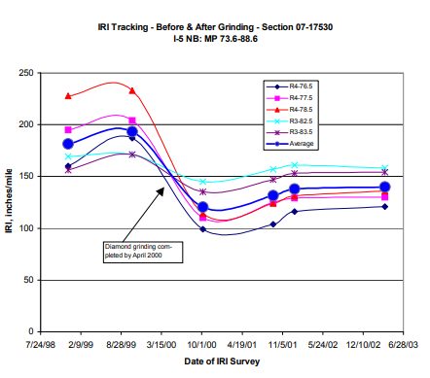
Figure 3.1.1-1- IRI data for Several Roadways in the California Highway System

The following chart shows the ratio of before grind to after grind IRI values compared against the IRI before grinding. The linear relationship suggests that a more damaged and rough roadway will have a larger benefit to being diamond ground compared to a less damaged roadway. To summarize the obvious, in general a roadway with a higher IRI will improve more drastically than a roadway with a lower IRI value.
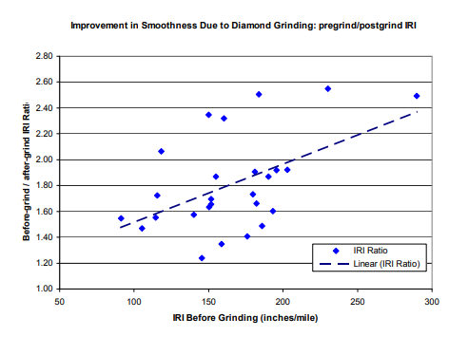
Figure 3.1.1-2 - The Ratio of IRI Values Compared Against the IRI Value Before Grinding Occurs

The following chart plots the predicted longevity of treated roadways. The chart shows that with a conservative certainty level of 90%, the design life is expected to be around 13.5 years. The DOT notes that the figure reflects the national average of 14 years of longevity based on a 50% certainty level.
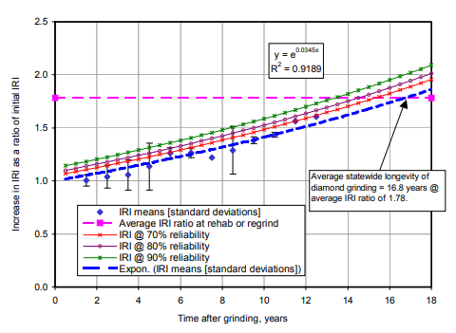
Figure 3.1.1-3 - Increase of IRI Shown Over Time until Rehab is Ineffective

The following chart shows the increase in smoothness with different grinding techniques and textures. The Conventions Diamond Grind (CDG) and Grind and Groove (GNG) textures are shown. The IRI decreased after grinding and reduced the variance in IRI over the roadways treated.
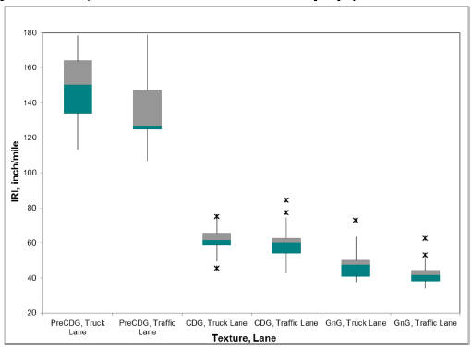
Figure 3.1.1-4 - IRI Values Pre Treatment and Post Treatment for Different Texture Types

Friction Data
The following chart shows the improvement of friction of treated roadways after diamond grinding. The GNG showed the most variance in the truck lane testing, but still improved the friction in the lane compared to the untreated truck lane.
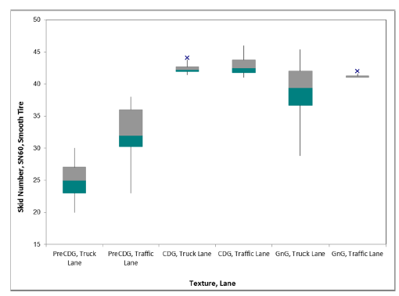
Figure 3.1.2-1 - Friction Skid Values for Traffic Lanes Pre And Post Treatment

Noise Data
The following chart shows the decrease in noise for lanes treated with CDG and GNG. While the chart does show that treated lanes are more quiet than untreated lanes, it is worth noting the scale and range of the data; the decibel output ranges from 100 dBA minimum to 105 dBA maximum. Therefore, while the treatment does reduce the noise, it only reduces traffic noise by 5% at best.
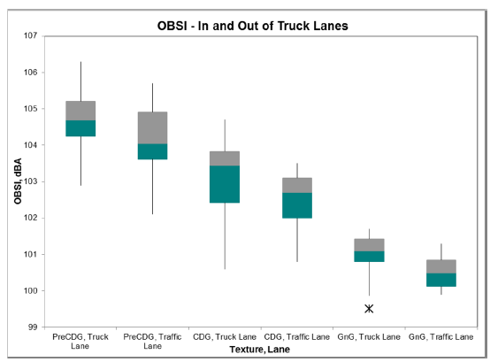
Figure 3.1.3-1 - The Noise Data for Traffic Lanes Pre and Post Treatment

Illinois DOT

Smoothness Data
The following chart shows the IRI values for Illinois bridges and highways. On average, the highways have an IRI of 100, the bridges on average showed an IRI improvement from 162 to 116 pre and post treatment.
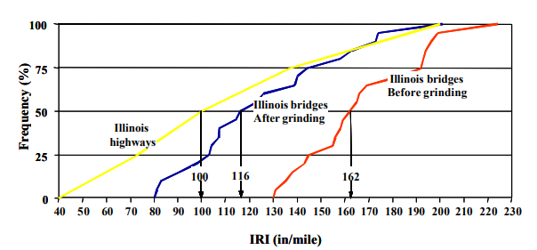
Figure 3.2.1-1 - The IRI Frequency of Highways and Bridges. The Bridges are Shown Pre and Post Treatment

Non NRRA Member State: Texas
The following charts summarize research completed by Texas DOT. Similarly to California, Texas collected data on diamond grinding with respect to IRI values, friction, and noise reduction. Additionally, Texas collected data on accident reductions in areas treated.
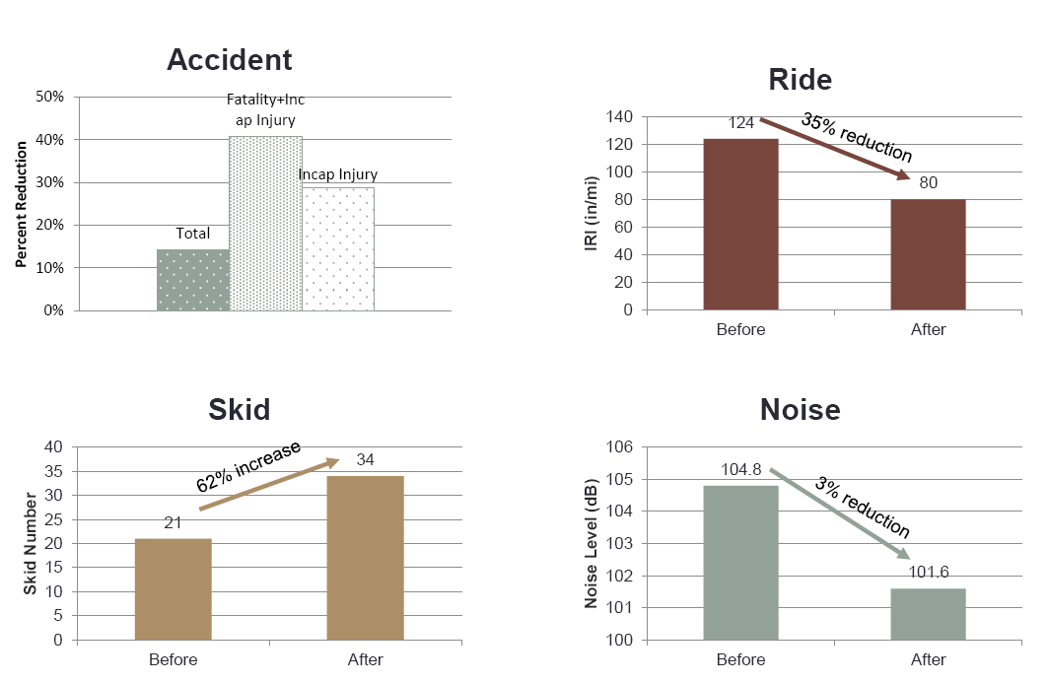
Figure 3.3-1 - The Data Collect by Texas on Accident Reduction, IRI Improvement, Friction, and Noise Reduction

The data collect by Texas matches the results of those collected by California. Both results show a similar improvement in smoothness, increase in friction, and reduction in noise.
The following two charts show the improvement in smoothness of diamond ground pavements over time. Both Diamond Grinding (DG) and Dowel Bar Retrofit (DBR) were used in the restoration work. The second chart shows that after a few years, DG alone tends to revert back to pre treatment IRI levels. The first chart shows that in conjunction with DG, DBR tends to maintain the improved levels of IRI longer than DG alone. Therefore, Texas recommends that all diamond grinding operations have a DBR component as well to aid in longevity.
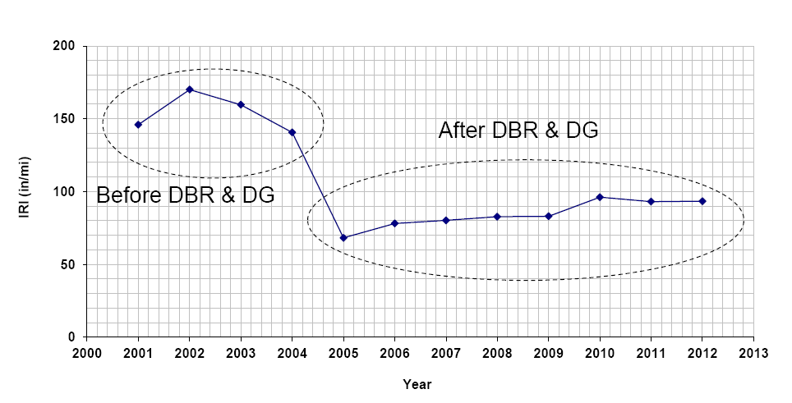
Figure 3.3-2 - The Smoothness Data for a Section of Roadway in Texas Pre and Post Treatment with Dowel Bar Retrofit
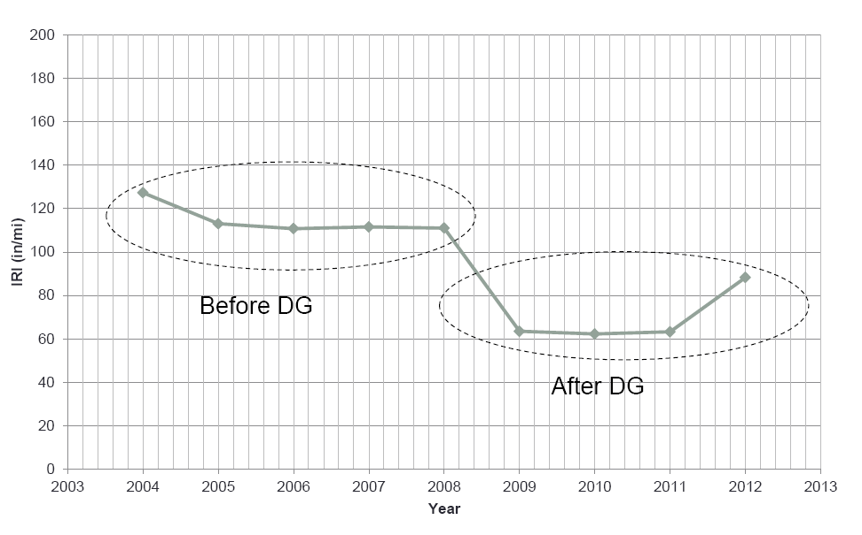
Figure 3.3-3 - Smoothness Data for a Section of Roadway with Diamond Grinding Only.

After 4 years the IRI values increased to nearly the starting values before diamond grinding without the use of dowel bar retrofit in addition to diamond grinding.

Vulnerabilities and Cost Value

Data shows that diamond grinding can improve smoothness, extend the service life of roadway segments by up to 16 years if the ratio of IRI before and after grinding is expected to be around 1.78 (see Figure 14). Between the research performed by California and Texas, the cost-effectiveness of diamond grinding appears to be best when diamond grinding is performed in conjunction with additional pavement rehabilitation.

Research to Consider
TBD After review/discussion with TAP

References

- Caltrans (2005) The Effectiveness of Diamond Grinding Concrete Pavements in California. California Department of Transportation, Sacramento, CA.

- Caltrans (2012) Evaluation of Grind and Groove (Next Generation Concrete Surface) Pilot Projects in California. California Department of Transportation, Sacramento, CA.

- Caltrans (2015) Standard Specifications. California Department of Transportation, Sacramento, CA.

- Caltrans (2018) Guidelines for Concrete Pavement Smoothness Requirements. California Department of Transportation, Sacramento, CA.

- IDOT (2005) Development of a Bridge Smoothness Specification for Illinois DOT. Illinois Department of Transportation, Springfield, IL.

- IDOT (2016) Standard Specifications for Road and Bridge Construction. Illinois Department of Transportation, Springfield, IL.

- IGGA (2009) Review of Industry Developed Smoothness Specifications.

- Iowa DOT (2012) Standard Specifications for Road and Bridge Construction. Iowa Department of Transportation, Ames, IA.

- MDOT (2012) Standard Specifications for Construction. Michigan Department of Transportation, Lansing, MI.

- MnDOT (2018) Standard Specifications for Construction. Minnesota Department of Transportation, St. Paul, MN.

- MnROAD (2010) Innovative Diamond Grinding on MnROAD Cells 7, 8, 9, and 37. Minnesota Department of Transportation, St. Paul, MN.

- MoDOT (2017) Standard Specifications for Highway Construction. Missouri Department of Transportation, Jefferson City, MO.

- MoDOT (2017) Diamond Grinding. Missouri Department of Transportation, Jefferson City, MO.

- NDDOT (2009) Evaluation of a Light Weight Profiler for Collections of Ride Quality Data on Asphalt and Concrete Pavements. North Dakota Department of Transportation Materials and Research Division, Bismarck, ND.

- NDDOT (2014) Standard Specifications for Road and Bridge Construction. North Dakota Department of Transportation, Bismarck, ND.

- TXDOT (2013) Diamond Grinding Overview of Pavement Performance in Texas. Texas Department of Transportation, San Antonio, TX.

- WisDOT (2018) Standard Specifications for Highway and Structure Construction. Wisconsin Department of Transportation, Madison, WI.

