[Fill in sections 4, 5, 7, 9, 16 and 17.]
Technical Report Documentation Page
1. Report No. | 2. | 3. Recipients Accession No.
MN/RC 2017-XX
4. Title and Subtitle |  | 5. Report Date
Effective Long Lasting Partial Depth Joint Repairs for Challenging Conditions – Draft Final Report |  | October 2020
 |  | 6.
7. Author(s) |  | 8. Performing Organization Report No.
Heidi Olson, Kenneth Tutu, Justin Lashley, Matthew Oman, Jerry Geib, Ben Worel |  | B1711754
9. Performing Organization Name and Address |  | 10. Project/Task/Work Unit No.
Braun Intertec Corporation
11001 Hampshire Avenue S
Minneapolis, MN 55438
 |  | 11. Contract (C) or Grant (G) No.
12. Sponsoring Organization Name and Address |  | 13. Type of Report and Period Covered
Minnesota Department of Transportation
Research Services & Library
395 John Ireland Boulevard, MS 330
St. Paul, Minnesota 55155-1899
 |  | 14. Sponsoring Agency Code
15. Supplementary Notes
http:// mndot.gov/research/reports/2017/2017XX.pdf
16. Abstract (Limit: 250 words)
As Portland cement concrete (PCC) pavements age, longitudinal and transverse joints can exhibit signs of distress as a result of traffic loading, climatic variations, materials related issues, and construction defects. Although only small areas are often involved, the joint distress can substantially disrupt traffic flow and increase pavement roughness sacrificing consumer ride comfort. When immediate action is required, temporary repairs are often made using readily available materials, such as cold mix or other asphalt materials. These temporary materials are oftentimes replaced at a later date with more permanent materials to re-establish the integrity and functionality of the concrete pavement. The goal of this project is to provide a guide for MnDOT and other agencies to establish an effective joint repair program. The final report will guide the reader through product selection, installation techniques, equipment needed for completing the repair, typical performance cost, along with the life expectancy of the repair products. This report provides information on the construction of the patches and their condition after the first two years of use.

17. Document Analysis/Descriptors |  | 18. Availability Statement
National Road Research Alliance, NRRA, MnROAD, concrete repair, joint repair, patch |  | No restrictions. Document available from: National Technical Information Services, Alexandria, Virginia 22312
19. Security Class (this report) | 20. Security Class (this page) | 21. No. of Pages | 22. Price
Report for Effective Long-Lasting PCC Partial Depth Joint Repairs for Challenging Conditions
Draft Final Report
Prepared by:
Heidi Olson - Braun Intertec Corporation
Kenneth Tutu - Braun Intertec Corporation
Justin Lashley - Braun Intertec Corporation
Matthew Oman - Braun Intertec Corporation

Published by:
Minnesota Department of Transportation
Research Services & Library
395 John Ireland Boulevard, MS 330
St. Paul, Minnesota 55155-1899

This report represents the results of research conducted by the authors and does not necessarily represent the views or policies of the Minnesota Department of Transportation or Braun Intertec Corporation. This report does not contain a standard or specified technique.
The authors, the Minnesota Department of Transportation, and Braun Intertec Corporation do not endorse products or manufacturers. Trade or manufacturers’ names appear herein solely because they are considered essential to this report.

TABLE OF CONTENTS

CHAPTER 1: Objectives 1
CHAPTER 2: Project Background 2
CHAPTER 3: Literature Review 4
3.1 INTRODUCTION 4
3.1.1 Partial Depth Repair 4
3.1.2 Applications and Limitations 5
3.2 MATERIAL CONSIDERATIONS 5
3.2.1 Material Properties 6
3.2.2 Material Types 8
3.2.3 Material Evaluation Methodology 13
3.3 CONSTRUCTION CONSIDERATIONS 14
3.3.1 Repair Area Demarcation 15
3.3.2 Deteriorated Concrete Removal 15
3.3.3 Joint Bond Breaker Installation 16
3.3.4 Bonding Agent Application 16
3.3.5 Mixing, Placement and Consolidation 16
3.3.6 Finishing, Curing and Sealing 17
3.4 PATCH PERFORMANCE 19
3.5 SUMMARY AND CONCLUSIONS 21
CHAPTER 4: Construction and Patch Performance 22
4.1 DISTRESS DESIGN 22
4.2 CONDITION RATING SCALE AND SERVICE LIFE 23
4.3 INSTALLATION AND PATCH PERFORMANCE DETAILS 26
4.3.1 Cell 94001 – CTS, Rapid Set DOT Repair Mix 27
4.3.2 Cell 94002 – SpecChem, RepCon 928 and Hot Mix Asphalt 28
4.3.3 Cell 94003 – Western Material and Design (2 products) 30
4.3.4 Cell 94004 – D.S. Brown, PaveSaver Polymeric Concrete Patch and Crafco, HP Concrete Cold Patch 32
4.3.5 Cell 94005 – Willamette Valley Company, FastPatch DPR 34
4.3.6 Cell 94006 – Five Star Products (2 Products) 35
4.3.7 Cell 94007 – TCC Materials, ProSpec Concrete Patching Mix 37
4.3.8 Cell 94008 –Aqua Patch Road Materials, Aqua Patch and TCC Materials, ProSpec Concrete Patching Mix 38
4.3.9 Cell 94009 – Crafco, HP Concrete Cold Patch 40
4.3.10 Cell 94010 – Crafco, Techrete-TBR 41
4.3.11 Cell 94011 – TCC Materials, 3U18 Modified 42
4.3.12 Cell 94012 – USG Ecofix 43
4.3.13 Cell 94013 – CTS, Rapid Set DOT Repair Mix and Helix Steel Fibers (2 fiber products) 44
4.3.14 Cell 94014 and 94015 – Hot Mix Asphalt 46
CHAPTER 5: REFERENCES 47

LIST OF FIGURES
Figure 3.1 Scored Joint Bond Breaker (Wilson et al., 1999a) 12
Figure 3.2 Joint Bond Breaker (Wilson et al., 1999a, as reproduced by Smith et al., 2014) 13
Figure 3.3 Methodology for New Product Evaluation (adapted from Tyson, 1977) 14
Figure 3.4 Joint Restoration Using Scored Bond Breaker (Wilson et al., 1999a) 18
Figure 4.1 Typical Layout of Patching Types for PCC Partial-Depth Repair Study 22
Figure 4.2 Patch Condition Rating = 4 [No Distress] 24
Figure 4.3 Patch Condition Rating = 3 [Linear cracks] 24
Figure 4.4 Patch Condition Rating = 2 [Linear cracks and <50% material loss] 24
Figure 4.5 Patch Condition Rating = 1 [Linear cracks and >50% material loss] 24
Figure 4.6 Product Average Condition Rating Summary 25
Figure 4.7 Patch Layout for Cell 94001 – CTS, Rapid Set DOT Repair Mix 27
Figure 4.8 Patch Layout for Cell 94002 (A) – SpecChem, RepCon 928 28
Figure 4.9 Patch Layout for Cell 94002 (B) – Hot Mix Asphalt 29
Figure 4.10 Patch Layout for Cell 94003 (A) – Western Material and Design, FasTrac 246 30
Figure 4.11 Patch Layout for Cell 94003 (B) – Western Material and Design, CE 700 HPC 31
Figure 4.12 Patch Layout for Cell 94004 (A) – D.S. Brown, PaveSaver Polymeric Concrete 32
Figure 4.13 Patch Layout for Cell 94004 (B) – Crafco, HP Concrete Cold Patch 33
Figure 4.14 Patch layout for Cell 94005 – Willamette Valley Company, FastPatch DPR 34
Figure 4.15 Patch Layout for Cell 94006 (A) – Five Star Products, Rapid Surface Repair Easy Mix 35
Figure 4.16 Patch Layout for Cell 94006 (B) – Five Star Products, Rapid Surface Repair Epoxy Mix 36
Figure 4.17 Patch Layout for Cell 94007 – TCC Materials, ProsSpec Concrete Patching Mix 37
Figure 4.18 Patch Layout for Cell 94008 (A) – Aqua Patch Road Materials, Aqua Patch 38
Figure 4.19 Patch Layout for Cell 94008 (B) – TCC Materials, ProSpec Concrete Patching Mix 39
Figure 4.20 Patch Layout for Cell 94009 – Crafco, HP Concrete Cold Patch 40
Figure 4.21 Patch Layout for Cell 94010 – Crafco, Techrete-TBR 41
Figure 4.22 Patch Layout for Cell 94011 – TCC Materials, 3U18 Modified 42
Figure 4.23 Patch Layout for Cell 94012 – USG Ecofix 43
Figure 4.24 Patch Layout for Cell 94013 (A) – CTS, Rapid Set DOT Repair Mix and Helix 5-25-Standard BA (Zinc Coated) Fibers 44
Figure 4.25 Patch Layout for Cell 94013 (B) – CTS, Rapid Set DOT Repair Mix and Helix 5-25-SS BA (Stainless Steel) Fibers 45
Figure 4.26 Patch Layout for Cell 94014 – Hot Mix Asphalt 46
Figure 4.27 Patch Layout for Cell 94015 – Hot Mix Asphalt 46

LIST OF TABLES
Table 2.1 Traffic Data between Patch Installation and Final Review 3
Table 3.1 PDR Opening Strengths (Frentress and Harrington, 2012; Elfino et al., 2013; Collier et al., 2018) 7
Table 3.2 Laboratory Test Methods for Evaluating Cementitious Repair Materials 8
Table 3.3 Cementitious Materials (Patel et al., 1993; Frentress and Harrington, 2012; Smith et al., 2014) 8
Table 3.4 Polymer-Based Materials (Patel et al., 1993; Frentress and Harrington, 2012; Smith et al., 2014) 9
Table 3.5 Construction-Related Problems and Suggested Solutions (Smith et al., 2014) 20
Table 4.1 Patch Condition Rating Scale 23

LIST OF ABBREVIATIONS
Below are the abbreviations for each patch type.
- CL: Centerline
- CLJ: Centerline Joint
- FL: Full Length
- CP: Corner Patch
- WP: Wheel Path
- ML: Mid-Lane
- MLJ: Mid-Lane Joint

Please refer to Figure 4.1 for orientation of each patch type.

EXECUTIVE SUMMARY

As Portland cement concrete (PCC) pavements age, longitudinal and transverse joints can exhibit signs of distress as a result of traffic loading, climatic variations, materials related issues, and construction defects. Although only small areas are often involved, the joint distress can substantially disrupt traffic flow and increase pavement roughness, sacrificing consumer ride comfort. When immediate action is required, temporary repairs are often made using readily available materials, such as cold mix or other asphalt materials. These temporary materials are oftentimes replaced at a later date with more permanent materials to re-establish the integrity and functionality of the concrete pavement.
This research project is being conducted to review alternative patch materials for PCC partial depth repairs and monitor whether these alternative materials last longer than the frequently used cold mix and asphalt patches.
To conduct this research, distresses were made manually within the PCC pavement along the old I-94 westbound at the Minnesota Road Research Facility (MnROAD). This report details the distresses that were patched, what products were used, how they were mixed, and how they were applied. The report also details a literature review that was performed to better understand the various patching materials, installation procedures, and previous research projects that have been completed on this topic.
MnDOT Research, District, material suppliers, and Braun Intertec personnel were onsite during the preparation and installation process to document the procedures required or used by each product. Documentation included equipment needed for preparation and installation process, and manufacturer guidelines or recommendations for the installation of each product.
Additionally, this report provides updates on the condition of the patches after three years of service. The conditions of the patches were rated on a scale of 0 to 4, with 0 being a failed patch and 4 being a patch with no signs of distress. Discussion of the patch conditions along with photos of the patches are included in this report. A matrix summarizing each material used, its installation process, and performance over the last three years is also included as part of this report.

Objectives
Joint distress can range from minor spalling that requires no immediate action to major distresses that can affect large areas of the pavement and significantly disrupt traffic. When immediate action is required, temporary repairs are often made using readily available materials, such as cold mix or other asphalt materials. These temporary materials are oftentimes replaced at a later date with more permanent materials to re-establish the integrity and functionality of the concrete pavement.
When longer-lasting materials are used in the initial joint repairs, the impact to travelers is reduced and additional costs for temporary materials and subsequent removals are eliminated. Different material types are available for longer-term repairs which vary widely in cost, required skill level for satisfactory placement, and time needed before opening to traffic. The performance of each of these materials can also vary widely making selection and installation of permanent repairs challenging.
The objective of this project is to provide a guide for NRRA members and other agencies to establish an effective partial depth repair program for concrete pavements. The final report guides the reader through product selection, installation techniques, equipment needed for completing the repair, typical performance, along with the life expectancy of the repair products. A matrix summarizing this information is included in Appendix A.

Project Background
The NRRA Preventive Maintenance team selected the original westbound lanes of I-94 that are adjacent to the MnROAD Facility to perform this research project. This portion of I-94 was originally constructed in 1973 with a 9-inch thick concrete pavement and skewed 27-foot spaced transverse joints. A total of 15 test sections consisting of three contiguous panels and two transition panels, one at either end, were prepared. Seven different patch types were created as shown in Figure 3.1. Sixteen different proprietary products were supplied by vendors for evaluation. Additionally, asphalt patching mix was used in two of the 15 sections.
MnDOT Research, MnDOT District, material suppliers, and Braun Intertec Corporation (Braun) personnel were onsite during the preparation and installation process to document the procedures required and/or used for each product. Documentation included equipment needed for preparation and installation process, and manufacturer guidelines or recommendations for the installation of each product.
The patches were installed during October 2017. Westbound I-94 traffic was placed on the partial depth patch sections beginning November 2, 2017 and remained there intermittently throughout the research project. Traffic is not usually placed on the old I-94 Westbound section during winter months or while research and other MnROAD events are occurring.
Traffic data was only available through May 11, 2020. The final site visit was performed on August 12, 2020. As such, the traffic counts are likely slightly higher than reported below. Once the traffic data becomes available, this report should be updated.
In total, the partial depth patch section carried traffic for 242 days between the installation date and May 11, 2020. In that time, nearly 6 million passenger cars and 1.25 million heavy commercial trucks drove over the partial depth patches. The traffic data is broken down into further detail in Table 2.1.
An annual review of the patch conditions was performed for three years after installation. The patch conditions were rated as described in Section 4.2. After the final review was completed, a matrix was developed to summarize each product’s performance over three years, along with details of how each product was installed. The product matrix is included in Appendix A.

Table 2.1 Traffic Data between Patch Installation and Final Review
Lane | Dates | Total Number of Cars | Total Number of Heavy Commercial Trucks | WIM Measured CESALs
Driving | Installation (11/2/17) to Year 1 Review (8/27/18) | 667,123 | 185,948 | 254,516
Driving | Year 1 Review (10/1/18) to Year 2 Review (9/16/19) | 1,417,522 | 426,697 | 405,948
Driving | Year 2 Review (10/14/19) to Final Review (5/11/20) | 508,820 | 165,456 | 228,961
Driving | Total (11/2/17 to 5/11/20) | 2,593,465 | 778,101 | 889,425
Passing | Installation (11/2/17) to Year 1 Review (8/27/18) | 908,868 | 63,909 | 55,239
Passing | Year 1 Review (10/1/18) to Year 2 Review (9/16/19) | 1,840,328 | 341,351 | 157,753
Passing | Year 2 Review (10/14/19) to Final Review (5/11/20) | 617,861 | 66,398 | 61,490
Passing | Total (11/2/17 to 5/11/20) | 3,367,057 | 471,658 | 274,482

Literature Review

INTRODUCTION

Partial Depth Repair
Partial depth repair (PDR) is the removal and replacement of deteriorated or spalled concrete in the upper portion of concrete pavements. Spalling is defined as cracking, breaking, or chipping away of concrete at joints and cracks, which is often caused by incompressible materials that accumulate in these openings. The incompressible materials hinder slab movement induced by thermal variations, thus resulting in high compressive stresses at joints and cracks. Spalling may occur at other locations on a pavement slab due to reasons such as snowplowing, poor construction practices and popouts (ACPA, 2004). Interestingly, the spalling experienced in Texas has been generally associated with the use of certain type of siliceous river gravel, which tends to exhibit higher elastic modulus, higher coefficient of thermal expansion (CTE) and weaker bonding (Folliard et al., 2006; Markey et al., 2006).
Spalling allows the ingress of water and more incompressible materials. It propagates under the influence of environmental and traffic factors, and if proper repair is delayed, particularly for pavements located in a wetter and colder climate, the distress could progress rapidly to minimize structural integrity, safety and ride quality. PDR replaces deteriorated concrete, restores ride quality, prevents further deterioration and provides a reservoir for resealing of joints and cracks (ACPA, 1989).
Due to the detrimental effects of spalling, some highway agencies spend substantial budget on spall repairs, estimated to be in excess of one billion dollars annually in the United States (Kuo et al., 1999). Increasing budget constraints and stricter requirements to minimize traffic delays and safety hazards have necessitated the need for better materials and installation techniques for rapid construction of long lasting repairs. It is believed that about 8 to 10 percent of spall repairs fail within a year, and about half of all pavement repairs fail within five years (MDOT, 1996). However, with optimal timing of repairs, proper selection of materials and good construction practices, it is possible to produce PDRs that could last 10 to 15 years or longer (Frentress and Harrington, 2012).
The primary objective of this literature review was to synthesize effective practices for producing long lasting PDRs. The review focused on applications and limitations of PDR; material and construction considerations; and field performance of PDRs. To achieve the above stated objective, over 30 publications compiled from transportation research databases, industry associations, university research centers and state departments of transportation (DOT) libraries, were reviewed.

Applications and Limitations
Historically, recommendations have limited the use of PDRs to the upper third of the pavement (e.g., Patel et al., 1993; Wilson et al., 1999a; ACPA, 2004). However, it is becoming common to use PDR to treat distresses that extend as deep as one-half of the slab thickness. For instance, Minnesota, Wisconsin, Michigan, Kansas, Missouri, Colorado and South Dakota have successfully utilized PDR to correct distresses that extended to one-half of the slab (Frentress and Harrington, 2012). Because most repair materials cannot accommodate high stresses induced by movements across working joints, cracks, load transfer devices and reinforcing steel, PDR is suitable for treating distresses located within the top one-third to one-half of the slab thickness (Smith et al., 2014). The following distresses have been successfully remedied with PDRs (Frentress and Harrington, 2012; Smith et al., 2014):
- Spalling caused by accumulation of incompressible materials in joints
- Spalling caused by poor construction practices, such as poor consolidation, inadequate curing, over-finishing, weak concrete, clay balls and inadequate reinforcing steel cover
- Spalling caused by freeze-thaw as a result of inadequate air void system
- Localized areas of deterioration or scaling limited to the upper one-third to one-half of the slab thickness and of sufficient size and depth to warrant repair
- Non-working longitudinal and transverse cracks
Despite the utility of PDR, it is ineffective in treating spalling caused by dowel bar misalignment; working cracks resulting from shrinkage, fatigue, or foundation movement; durability cracking (D-cracking); and material-related issues such as alkali-silica reactivity, alkali-carbonate reactivity and ettringite formation (Frentress and Harrington, 2012; Smith et al., 2014).
Pavement coring is recommended for ascertaining the depths of deterioration to enable a suitable repair option to be selected. Locations where deteriorations reach the depth of dowel bars are candidates for a full depth repair (Wilson et al., 1999a; Smith et al., 2014). To minimize the risk of premature failures, PDRs may be undertaken before overlay construction (Wilson et al., 1999a).

MATERIAL CONSIDERATIONS
Proper material considerations are essential for producing long lasting PDRs. Poor material selection and design has been found to cause patch failures within two to three years (ACPA, 2006). Wilson et al. (1999a) identified the following common material-related causes of premature PDR failures:
- Incompatibilities between the climatic conditions during repair installation and the materials
- Thermal incompatibility between the repair material and the existing concrete
- Extreme climatic conditions during the service life of the repairs
- Inadequate cure time prior to opening repairs to traffic
- Incompatibility between the joint bond breaker and the joint sealant material
The selection of a repair material for a particular project could be challenging, since many factors need consideration, including allowable lane closure time; environmental conditions; material properties, particularly shrinkage characteristics, CTE, curing time, compatibility between repair material and existing concrete; project size and funding; and performance requirements (Frentress and Harrington, 2012; Smith et al., 2014). Regardless, cost-effective materials that provide maximum benefits should be selected. The following subsections discuss some essential properties of repair materials, benefits and drawbacks of various material types and a framework for evaluating and approving new materials.

Material Properties
To shorten lane closure times, traffic loading is permitted when patches have gained minimum strength to sustain loads. Most highway agencies use flexural strength to determine traffic-opening times for full depth repairs (FDRs), since most of FDR structural failures are caused by high tensile stresses at the bottom of slabs (Frentress and Harrington, 2012). However, Frentress and Harrington (2012) recommended using compressive strength at opening as a criterion for selecting PDR mixtures, since PDRs mostly experience compressive stress; tensile stress is accommodated by the existing concrete.
There is no consensus on minimum strength requirements for opening PDRs to traffic. This is not surprising because several material, traffic and environmental factors influence such a criterion. Frentress and Harrington (2012) noted that, since PDRs are confined and supported by the underlying concrete, the minimum compressive strength requirement at opening should be lower (typically 1,600 to 1,800 psi) than that for conventional FDRs (typically 3,000 psi or higher). They also noted that higher opening compressive strengths (e.g., 3,000 psi) may increase the risk of short-term failures than lower opening strengths (e.g., 1,600 to 1,800 psi); the higher the opening strength, the higher the complexity of the repair material composition.
Table 3.1 shows the opening strength requirements of some agencies. By using the HIPERPAV software to analyze typical concrete mixtures constructed in Virginia, Elfino et al. (2013) recommended a minimum opening compressive strength of 1,600 psi, provided a maturity meter was used to monitor in-situ strength. They suggested the recommended opening strength could reduce cement quantities in repair mixtures compared with the current requirement of 2,000 psi. Similarly, Collier et al. (2018), after reviewing several opening strength requirements, suggested Louisiana Department of Transportation and Development reduce their current minimum compressive strength specification of 3,000 psi to 2,000 psi in order to increase durability, while minimizing construction costs and lane closure times. They also recommended adoption of the maturity method for monitoring in-situ strength.

Table 3.1 PDR Opening Strengths (Frentress and Harrington, 2012; Elfino et al., 2013; Collier et al., 2018)
State | Flexural Strength  (psi) | Compressive Strength  (psi)
New York | -- | 1,527
Kansas | 300 | 1,800
Missouri | -- | 1,600
Michigan | 300 | 1,800
Minnesota | 500 | 3,000
Colorado | -- | 2,500
Nebraska | -- | 3,625
Virginia | -- | 2,000
Louisiana | -- | 3,000
There seems to be a trend toward specifying lower opening compressive strengths for PDRs and using a maturity meter to monitor in-situ strength gain, particularly if very early opening is required (e.g., 4-hour curing time). For instance, the Virginia DOT allows the use of maturity meters to monitor in-situ strength, in order to facilitate rapid decision-making on traffic-opening times (Elfino et al, 2013).
Drying shrinkage and CTE of repair materials also impact the performance of PDRs; the greater the difference in these properties between the repair material and the existing concrete, the greater the risk of debonding (Smith et al., 2014). Emmons et al. (1993) indicated that most repair materials have greater shrinkage potential than conventional concrete, hence a repair material that is restrained in a patch could induce tensile stress as high as 1,000 psi.
Apart from possessing desirable strength and shrinkage characteristics, PDR materials should also be able to withstand deterioration from freezing and thawing. Therefore, freeze-thaw durability is an important material characteristic that needs consideration. Rapid strength-gain materials, although allow for early opening to traffic, are often prone to durability-related distresses owing to their reduced curing times and slower long-term strength gain (Van Dam et al., 2005; Frentress and Harrington, 2012). Using high-quality materials and construction techniques, reducing the water-to-cement ratio and increasing aggregate volume but maintaining workability are some suggested measures for achieving early-strength without adversely affecting durability (Van Dam et al., 2005).
Flowability, rate of strength gain, water and chloride ion impermeability and ability to develop strong bond with the existing concrete have also been identified as essential material characteristics that influence the long-term performance of repair concrete materials (Deshpande, 2006). Several laboratory test methods are available for evaluating the mechanical, durability and dimensional stability properties of cementitious repair materials. Table 3.2 shows examples of such tests.

Table 3.2 Laboratory Test Methods for Evaluating Cementitious Repair Materials
Property | Test Method
Compressive strength | ASTM C 39
Drying shrinkage | ASTM C 157
Restrained shrinkage | ASTM C 1581
Slant-shear bond strength | ASTM C 882 (modified by ASTM C 928)
Tensile bond strength | ASTM C 1583
Modulus of elasticity | ASTM C 469
Coefficient of thermal expansion | ASTM C 531
Freeze-thaw resistance | ASTM C 666

Material Types
PDR materials may be categorized as cementitious, polymer-based and bituminous materials. Bituminous materials are mostly used for temporary, emergency-type repairs, although some proprietary products may provide longer service lives. Research (e.g., Wilson et al., 1999a) shows that bituminous patches may perform well for three to four years, but rapidly deteriorate afterward. The rest of the review focuses on cementitious and polymer-based repair materials.

Cementitious Materials
Regular PCC mixtures are commonly used for PDRs. Mixtures containing Type III Portland cement or Type I Portland cement plus a set-accelerator are installed to open to traffic quickly. Table 3.3 summarizes some benefits and drawbacks of cementitious repair materials.
Table 3.3 Cementitious Materials (Patel et al., 1993; Frentress and Harrington, 2012; Smith et al., 2014)
Category | Benefits | Drawbacks
Portland cement concrete | - Type I cement mixtures install easily  - Type I cement rich mixtures gain strength rapidly in warm weather  - Type III cement mixtures set faster, allowing quicker opening to traffic | - Type I cement rich mixtures gain strength slowly in cold weather; they may need insulation layers  - Difficult to place Type III cement mixtures properly
Gypsum-based concretes | - Gain strength rapidly; can open to traffic in one hour  - Applicable in non-freezing conditions  - Not affected by deicing agents | - May not perform well under moisture or in a freezing weather  - Free sulfates in typical gypsum mixtures facilitate steel corrosion  - Dry conditions are needed to install
Magnesium phosphate concretes | - Set very quickly to yield high early-strength, impermeable material  - Bond well to clean and dry surfaces | - Small amounts of excess water can cause considerable strength loss  - Not compatible with certain types of limestone aggregate
High alumina concretes | - Gain strength rapidly, with good bonding capability on dry surfaces  - Exhibit high freeze-thaw damage resistance and very low shrinkage  - Applicable in low-temperature conditions | - Strength loss may occur over time due to a chemical conversion process during curing or later  - Conversion test can evaluate mix designs to ascertain if converted strength exceeds specified strength

Polymer-Based Concretes
Polymer resin, aggregate and a set initiator are the major constituents of polymer-based concretes. They have faster setting times than most cementitious materials and may be sensitive under certain field conditions (Frentress and Harrington, 2012). Aggregate is added to enhance thermal compatibility with the existing concrete, provide a wearing surface and improve economy (Patel et al., 1993). Table 3.4 presents some benefits and drawbacks of polymer-based concretes.
Table 3.4 Polymer-Based Materials (Patel et al., 1993; Frentress and Harrington, 2012; Smith et al., 2014)
Category | Benefits | Drawbacks
Epoxy concretes | - They are impermeable and have excellent bonding properties | - They must be thermally compatible with existing concrete to prevent patch failure (epoxies have higher CTE)  - Deep repairs should be placed in multiple lifts to control heat generation  - Not suitable to patch spalls caused by steel corrosion; adjacent sound concrete may deteriorate quickly
Methyl methacrylate (MMA) concretes | - Provide high compressive strength and good bonding  - Can be installed over a wide temperature range (40 to 130ºF) | - Many are volatile and may pose a health hazard from prolonged exposure
Polyester-styrene concretes | - Have similar properties as MMAs  - Generally cost less | - Slower rate of strength gain than MMAs
Polyurethane concretes | - They have very quick setting times (90 seconds)  - They are very flexible | - High CTE and large initial shrinkage  - Many are moisture-intolerant, but some manufacturers exempt their products

Miscellaneous Patching Materials
There is a continual search for innovative repair materials that provide cost-effective repair solutions. For instance, Parker and Shoemaker (1991) evaluated the potential benefits of incorporating steel fibers and anchors in rapid-setting cementitious repair materials. The anchors were U-shaped No. 4 reinforcing bars inserted in holes drilled in the slabs and filled with a rapid-setting polyester grout. The anticipated benefits of the anchors were bonding enhancement between the new and old concrete and load support after bond failure. While the inclusion of the anchors did not improve patch performance, patches constructed with steel fiber-reinforced PCC exhibited better performance. The superior performance was attributed to the larger tensile strength and ductility of the fiber-reinforced concrete, which enabled the patches to better resist cracking. Also, it was thought that the steel fiber improved resistance to shrinkage and microcracking during curing.
Some product manufacturers recommend adding pea gravel to their products, a process known as extension. Deshpande and Olek (2008) conducted laboratory evaluation of four commercial rapid-setting repair materials extended with pea gravel of nominal aggregate size of 9.5 mm. Both fresh properties (slump and setting time) and hardened properties (compressive strength, slant shear strength, cracking susceptibility, drying shrinkage and freeze-thaw durability) were considerably affected by the extension; the extended products did not necessarily exhibit the properties of rapid-setting repair materials required by ASTM C 928. Also, an additional amount of water was necessary for all the extended products to exhibit the desired workability.
Some newly proposed rapid-setting repair materials incorporate waste materials, such as fly ash and silica fume (e.g., Ghazy et al., 2016; Mohammadi et al., 2014). Song et al. (2017) formulated a rapid-setting repair material comprising fly ash, blast furnace slag and rice husk ash. Wang and Lomboy (2016) developed, for rapid repair applications, a mortar mix formula which incorporated Type I Portland cement, river sand, Class F fly ash, silica fume, limestone fines and a high-range water reducer. The mortar exhibited better self-consolidation, freeze-thaw durability and chloride ion impermeability than the commercial concrete repair product used as a control. Also, the compressive strength and modulus of rupture at one day were comparable to those of a conventional pavement concrete mixture at 28 days. However, the mortar exhibited higher autogenous shrinkage and slightly lower free drying shrinkage; the addition of micro-steel fibers slightly reduced the shrinkage. Further investigation into the fatigue and shrinkage cracking behavior of the mortar mix was recommended. Field trials will also help to evaluate the material’s performance under service conditions.
The search for newer and better repair materials and construction techniques is set to continue, and it is important an effective framework exists for an objective evaluation of potential products and their installation techniques. Section 3.2.5 presents a simple framework for evaluating new repair materials.

Accessory Materials
Bonding agents, curing materials and joint bond breakers are accessory materials that may be needed in the PDR construction process. These materials are briefly discussed below.
Bonding Agents
The bond strength between the repair and the existing concrete has a major impact on patch performance and, for early-opening-to-traffic patches, early development of bond strength is critical. Surface preparation, surface moisture condition, bonding agents, compressive strength of the repair material, curing and the presence of cracking all affect bond strength (Santos et al., 2012).
A bonding agent may not be required for some proprietary patch materials. However, the use of sand-cement grout as a bonding agent for cementitious repair materials is widely practiced. Two parts of Type I cement to one part of water and one part of sand is a popular grout recipe; however, Kansas DOT specifies a more fluid grout, comprising one part of Type I cement to three parts of water, meant to promote bonding, moisten and cool the repair area (Frentress and Harrington, 2012).
Riding and DonJuan (2014) concluded, from laboratory and field studies, that a water-to-cement ratio of one provided the best balance between workability, bond strength and wait time between grouting and material placement. A dried-out grout hinders bonding; hence, removal by sandblasting and re-application is required (Smith et al., 2014). Epoxy bonding agents have been used for both cementitious and proprietary repair materials to reduce lane closure times (Frentress and Harrington, 2012).
Curing Materials
PDRs are prone to rapid moisture loss because of their high surface-area-to-volume ratio (ACPA, 1989). Proper curing will help to maintain adequate moisture and temperature condition to facilitate strength gain, while minimizing shrinkage cracking. Frentress and Harrington (2012) identified the following characteristics of some common categories of curing compounds:

- Water-based curing compounds are readily available, but their water-retention properties reduce their caliber
- Linseed oil curing compounds provide good curing and help prevent shrinkage cracking
- Waxed-based curing compounds are very good and help to prevent shrinkage cracking
- Poly alpha methylstyrene has high solid content and requires constant mixing. If mixed properly, it provides good curing and significantly reduces shrinkage cracking.

ASTM C 309 and AASHTO M 148 provide specifications for most curing compounds. White-pigmented curing compounds create a sealing membrane that controls moisture loss; allow heat of hydration to escape, and provide curing for several days until worn out by traffic; the white color reflects solar radiation to check excessive heat development (Tyson, 1977; Van Dam et al., 2005). In hot weather, applying a white-pigmented curing compound (e.g., poly-alpha-methylstyrene) as soon as the bleed water evaporates is an effective curing method (Frentress and Harrington, 2012; Smith et al., 2014).
Moist burlap and polyethylene sheeting may also be used for curing, although they may not be the most effective method to use in hot weather because shrinkage cracking can occur from rapid moisture loss when the sheeting and burlap are removed to allow for traffic operations (Tyson 1977). Insulation blankets are effective for curing in cold weather as they retain the heat of hydration, thereby ensuring early strength development (Whiting et al., 1993; Smith et al., 2014). It is preferable to use insulating blankets in conjunction with curing compounds, since blankets alone do not significantly reduce the risk of plastic shrinkage (Whiting et al., 2005). It is advised not to place blankets just after applying a curing compound (Whiting et al., 2005).
Manufacturers of proprietary repair materials may recommend curing procedures for their products. Some highway agencies specify curing compound application rates that are 1.5 to 2 times typical rates as a precaution to prevent shrinkage cracking (Frentress and Harrington, 2012; Smith et al., 2014).

Joint Bond Breakers
Patches installed at joints or cracks, if they bond to the adjacent slab, often experience excessive compressive stresses due to slab movement. A compressible joint bond breaker prevents such undesirable bonding and relieve compressive stresses; the joint breaker also prevents the patch material from entering the joint or crack to hinder slab movement (Frentress and Harrington, 2012).
For best performance, a joint bond breaker must be nonabsorbent, closed cell, chemically inert, compressible with good recovery, compatible with joint sealant and heat resistant, if it is used with hot-poured sealants (Patel et al., 1993). Polyurethane, polystyrene, or polyethylene strips, and fiberboards have been frequently used as bond breakers to reduce the risk of joint patch failures (Patel et al., 1993). Because of the relatively high rigidity of fiberboard, it provides the most benefit at the lane-shoulder joint, where greater support is needed (Patel et al., 1993). Waxed cardboards fit well into irregular cracks, while maintaining their rigidity for placement of the repair material (Frentress and Harrington, 2012). It is noted that certain proprietary repair products have sufficient compressibility to tolerate joint movements without the need for a joint bond breaker (Smith et al., 2014).
As a good construction practice, a joint bond breaker should be scored (Figure 3.1) at an appropriate depth prior to installation and, upon curing of the patch material, the top strip of the bond breaker is removed to create a joint sealant reservoir (Wilson et al., 1999a). As Figure 3.2 shows, it is recommended bond breakers extend 1.0 inch (25mm) below and 3 inches (75 mm) beyond the repair boundaries to prevent the patch material from flowing into the joint during placement (Wilson et al., 1999a).

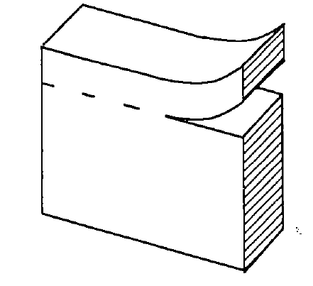
Figure 3.1 Scored Joint Bond Breaker (Wilson et al., 1999a)

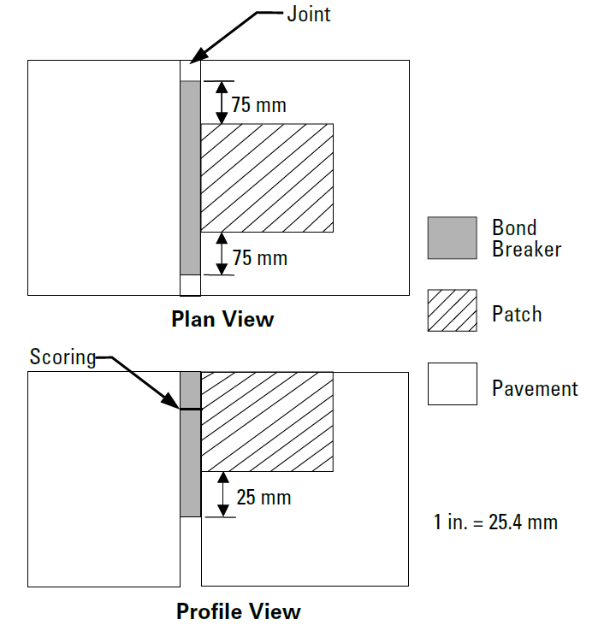

Figure 3.2 Joint Bond Breaker (Wilson et al., 1999a, as reproduced by Smith et al., 2014)

Material Evaluation Methodology
The proliferation of repair materials calls for an effective approach for their objective evaluation and adoption. Figure 3.3 shows a simple framework for evaluating new repair products (Tyson, 1977). Minimum material property values are established, based on laboratory testing or empirical experience. Products without sufficient verifiable test data to prove performance claims are screened out. If verifiable test data or an agency’s test results indicate that product has good potential, it is accepted for field trials. It is important to differentiate between material- and construction-related failures. Products that distinguish themselves in field trials may be adopted for general use, but satisfactory long-term performance must justify their continual use.
Several products may exhibit satisfactory performance in the field trials and a decision must be made regarding which product should be selected for a particular project. As previously discussed, several factors influence the selection of a repair material. In addition to the factors already discussed, it may also be useful to utilize a production chart that shows relationships between the approximate number of patches that could be installed, using a certain product, and the available lane closure time (Tyson, 1977). Such a chart will be useful, during project planning, to estimate overall lane closure time, provided the number of patches is known.

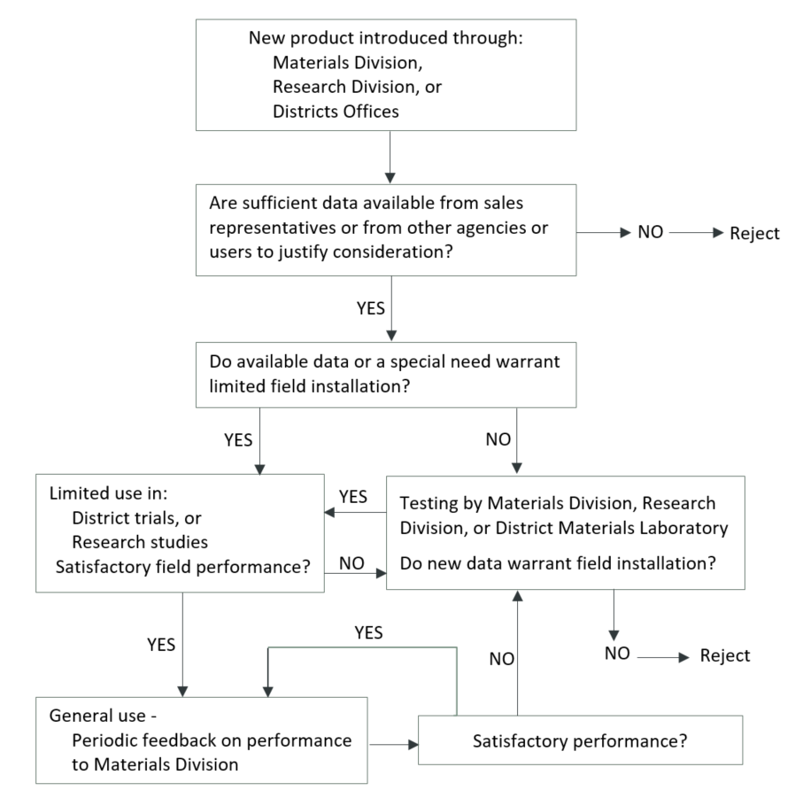
Figure 3.3 Methodology for New Product Evaluation (adapted from Tyson, 1977)

CONSTRUCTION CONSIDERATIONS
Tyson (1977) suggested that joint spall repairs be considered not later than the time when visual survey indicates 20 percent of the joints need PDRs. Best practices for constructing PDRs have been documented in various manuals (e.g., Patel et al., 1993; Wilson et al., 1999a; Frentress and Harrington, 2012; ACPA, 2004; ACPA, 2006). The performance of proprietary repair materials depends heavily on construction procedures, hence the manufacturer's instructions must be consulted to ensure proper installation. The construction of PDRs consists primarily of the following activities.

Repair Area Demarcation
It is widely recognized that a zone of unsound concrete, with no visual indication of distress, exists around the limits of visibly deteriorated areas. Numerous studies (e.g., Whiting et al., 1993; Chen et al., 2009) have highlighted the importance of including this zone in the repair boundaries. Tapping the pavement slabs with a steel rod or ball peen hammer, as well as dragging a metal chain, and listening to the nature of the resulting sound (a clear ringing sound indicates sound concrete; a dull sound indicates weak concrete) is a popular technique for determining the existence and extent of unsound concrete near spalls and joints that should be removed. Commercial sounding devices may also be used.
Repair limits should extend two to six inches beyond the identifiable unsound areas suggested by the sounding test to ensure all delaminated concrete is removed (Patel et al., 1993; Whiting et al., 1993; Frentress and Harrington, 2012). Square or rectangular repair boundaries with vertical faces improve the aesthetics of patched areas and minimize cracking associated with thin edges (ACPA, 1989; Chen et al., 2009). While it is generally recommended that patches should be at least two inches deep for stability reasons, recommended minimum length and width vary from 10 to 15 inches and from 4 to 10 inches, respectively (Patel et al., 1993; Frentress and Harrington, 2012). Deteriorated areas less than a foot apart are best repaired as one patch area and, where several small spalls are present at a joint, it is proper to patch the entire joint length (Patel et al., 1993). Some proprietary material manufacturers recommend suitable patch dimensions.

Deteriorated Concrete Removal
Methods for removing deteriorated concrete include saw-and-chip (saw-and-patch), cold-milling, chipping (chip-and-patch), clean-and-patch, sandblasting, airblasting and waterblasting. Each method has its benefits and drawbacks, which will not be fully discussed here. The Strategic Highway Research Program (SHRP)/Federal Highway Administration (FHWA) study (Wilson et al., 1999b), which explored cost-effective materials and procedures for constructing PDRs, found the chip-and-patch method to be more cost-effective. Also, a Texas study (Chen et al., 2009) noted that either the chip-and-patch or saw-and-patch could provide satisfactory results, if the repair boundaries were properly identified.
Cold-milling yields tapered edges, which may be considered as a drawback. Although tapered edges are prone to cracking, those produced by cold-milling have performed satisfactorily (ACPA, 1989). The clean-and-patch is mostly used for emergency repairs under adverse conditions, while sandblasting and airblasting are effective for cleaning repair areas after concrete removal, in order to get rid of loose particles and contaminants (Wilson et al., 1999a). Equipment availability, contractor expertise, allowable lane closure time, environmental conditions and project specifications dictate the selection of concrete removal methods. Regardless of the selected method, it must ensure:

- Complete and uniform removal of deteriorated concrete to correct dimensions
- Rough surfaces that promote interlock between the repair material and the existing concrete
- Saturated surface dry and freshly exposed concrete, with no significant damage

Joint Bond Breaker Installation
As previously mentioned, joint bond breakers relieve compressive stresses and prevent the repair material from flowing into joints or cracks to impede slab movement. A key recommendation of the SHRP/FHWA partial depth spall repair study (Wilson et al., 1999b) was related to joint restoration. A bond breaker must span the entire vertical face of joints that is exposed during concrete removal. In a Virginia study in which over 10,000 partial depth patches were installed along mostly transverse joints on 400 miles of jointed concrete interstate pavement lanes, Tyson (1977) reported that a large number of the patch failures resulted from lack of joint bond breaker or failure to install a bond breaker to cover the full depth of the patches; the lower portions of the patches were in contact with the adjacent slabs, exposing them to destructive effects of slab movements. Figure 3.2 illustrated a recommended installation procedure for joint bond breakers.

Bonding Agent Application
The clean, freshly exposed concrete must be thoroughly coated with a suitable bonding agent, ensuring that excess material does not collect in pockets. Typically, a soft-brittle brush is used to apply epoxy-based bonding agents, while stiff-brittle brush works best for cement-based grouts; spraying is recommended for large repair areas (Frentress and Harrington, 2012; Wilson et al., 1999a).
It is crucial to apply a bonding agent just prior to placing the repair material; if the agent sets before the repair material is installed, it should be removed by sandblasting and reapplied (Smith et al., 2014). In a study to evaluate the effect of bonding agent application on PDR performance, Riding and DonJuan (2014) found cementitious grouts exhibited higher shear and tensile strengths if the repair material was placed before the grout had cured for more than 15 minutes; the bond strength started to decrease once curing had passed 15 minutes. Another significant finding was that adequate bond strength was obtained if the repair material was placed on a substrate concrete in saturated surface dry condition.

Mixing, Placement and Consolidation
Using an appropriate mixing equipment and ensuring correct mixing proportions and duration are prerequisites for producing a good quality repair mixture. Warm water may be used for mixing if ambient air temperature is below 55ºF, and ice water at higher ambient temperatures (Wilson et al., 1999a). Excessive mixing of rapid-setting materials will reduce the available for installation, while adding water later could adversely affect strength (Wilson et al., 1999a).

Small drum mixers, paddle-type mixers, mortar mixers and Jiffy mixers are typically used; however, the size of a project may not warrant the use of high-volume mixing equipment (e.g., ready-mix trucks).
It is not recommended to place cementitious and most proprietary repair materials at ambient air temperatures below 40ºF (Wilson et al., 1999a). For instance, the Virginia DOT prohibits placing cementitious materials when air temperature is below 40ºF; the temperature of the material at the time of placement must range from 70 to 95ºF, unless otherwise approved (Elfino et al., 2013). Although some polymer-based concretes may be installed in cold weather, better performance results when they are installed under favorable conditions (Wilson et al., 1999a). Also, some polymer-based concretes, such as epoxies and methyl methacrylates, should be installed in maximum lift thickness of 2 inches due to their considerable heat of hydration; the time lag between lifts is often recommended by manufacturers (Wilson et al., 1999a). To avoid segregation, aggregate-containing patch materials should be placed with a shovel, slightly overfilling the patch area to compensate for volume reduction from consolidation (Wilson et al., 1999a).
Consolidation of repair mixtures using internal vibrators, vibrating screeds or manual tools will release trapped air to produce a dense material with improved durability and bonding characteristics. Poor consolidation often creates voids at the interface of the repair material and the underlying concrete, which could cause failures in less than a year (Tyson, 1977). Tools used for consolidation must be of an appropriate size and capacity for working in the repair area. Some best consolidation practices are summarized below (Wilson et al., 1999a; Smith et al., 2014):
- Holding vibrators at 15 to 30 degrees to the vertical and moving them through the entire fresh repair material according to a well-defined pattern
- Avoiding moving the repair material with vibrators to prevent segregation
- Determining adequacy of consolidation by observing when the material no longer settles, the release of air bubbles ceases, and a smooth layer of mortar appears on the surface

Finishing, Curing and Sealing
Finishing operations must be properly timed to prevent the trapping of concrete bleed water. Patches should be worked from the center toward the boundaries to pinch the patch material against the existing concrete in order to promote bonding (Wilson et al., 1999a; Frentress and Harrington, 2012). Overworking the concrete surface is strongly discouraged, so that the surface does not become brittle; susceptible to abrasion, freeze-thaw damage and chemical attack (Van Dam et al., 2005). Saw overcuts at the patch corners are typically filled with grout or joint sealant to prevent the ingress of moisture (Wilson et al., 1999a). Coating the boundaries of cementitious patches with a sand-cement grout will minimize moisture intrusion, which could cause delamination if it becomes frozen (ACPA, 1989; Whiting et al., 1993; Smith et al., 2014).

Some apply a textured finish to the patches (e.g., using a broom) in order to match the texture of the existing concrete; however, this practice has little effect on the overall skid resistance of the pavement (Wilson et al., 1999a).
As noted previously, properly curing the patch material prevents rapid moisture loss, thereby minimizing the risk of shrinkage cracking and scaling, while maximizing strength gain. Late or inadequate curing must be avoided, as it can reduce the ultimate strength of PDRs by up to 40 percent (Frentress and Harrington, 2012).
The PDR construction process typically ends with joint restoration, which may be accomplished in two ways. If a scored bond breaker was installed prior to placing the repair material, the tear-off strip is removed to create a reservoir for a joint sealant (Figure 3.4). Another approach is to timely saw the full depth of the PDR plus ¼ inch, sandblast and airblast the saw cut, followed by inserting a closed-cell backer rod and applying a joint sealant (Wilson et al., 1999a; Frentress and Harrington, 2012). The SHRP manual entitled Materials and Procedures for Repair of Joint Seals in Concrete Pavements (Evans and Romine, 1993) provides more information on joint sealing.

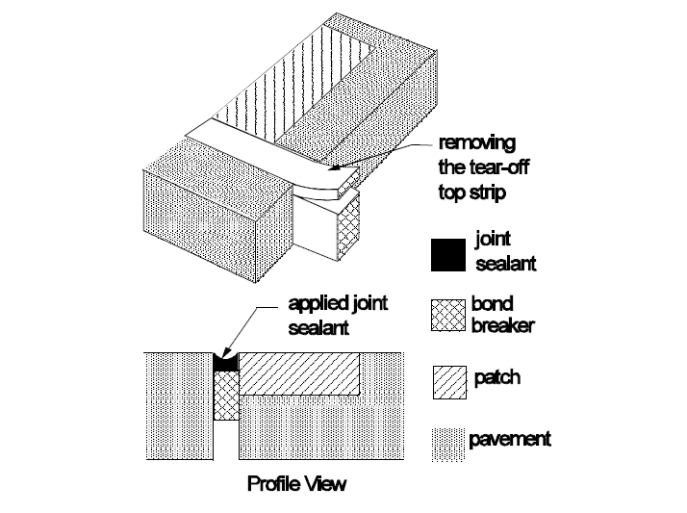
Figure 3.4 Joint Restoration Using Scored Bond Breaker (Wilson et al., 1999a)

PATCH PERFORMANCE
Wilson et al. (1999a) reviewed several documents which indicated 80 to 100 percent of well-constructed PDRs performed well after 3 to 10 years of service. Existing pavement condition, construction quality, material characteristics, traffic loading and environmental factors all influence the performance of PDRs. For instance, Parker and Shoemaker (1991) observed that PDRs constructed during warm weather (over 70ºF) performed better than those constructed during cold weather. The list below shows common construction-related causes of PDR failures (Wilson et al. 1999a; Frentress and Harrington, 2012; Smith et al., 2014):
- Inappropriate use of repair techniques and materials
- Failure to remove all deteriorated material or square the patch area
- Inadequate cleaning of the patch area
- Insufficient consolidation; inadequate or improper curing
- Poor bonding between the patch material and existing concrete
- Failure to properly restore joints
- Variability in patch material quality
- Incompatibility in thermal expansion between patch material and existing concrete

In a MnROAD study (Burnham et al., 2016) conducted between 2011 and 2014 to evaluate the field performance of 22 repair materials (16 cementitious, 3 polymer-based, 3 bituminous), a total of 93 partial depth joint patches were constructed on an 18-year old pavement that had developed material-related joint distresses. Some interesting findings from the study are summarized below:
- About 59 percent of the patches were in good condition (some random cracks, limited material loss) after three years in service
- Location seemed to have had little effect on performance: 61 percent of the PDRs installed near the centerline were in good condition versus 67 percent of those in loaded areas
- Although many of the slower setting repair products exhibited a higher survivability, they were considered unsuitable for early-opening-to-traffic applications.

Similarly, the SHRP/FHWA partial-depth spall repair study (Mojab et al., 1993; Wilson et al., 1999b), which began in 1991, evaluated 11 rapid-setting cementitious, polymer-based, bituminous repair materials and five repair methods (saw-and-patch, chip-and-patch, mill-and-patch, waterblast-and-patch, and clean-and-patch). A total of 1,607 partial-depth patches were constructed on moderate- to high-volume four-lane highways located in four climatic regions: wet-freeze, wet-nonfreeze, dry-freeze and dry-nonfreeze. Field performance was monitored for 51 to 87 months, depending on the site. Major distresses observed on the cementitious and polymer-based patches included spalling, cracking, faulting and debonding (Wilson et al., 1999b). It was recommended the required service life of PDRs should influence the selection of repair materials and construction methods. Smith et al. (2014) cited several sources to develop the guidelines in Table 3.5 for addressing common PDR construction-related problems.
Table 3.5 Construction-Related Problems and Suggested Solutions (Smith et al., 2014)
Problem | Typical Causes | Typical Solutions
Deterioration found to extend beyond the original repair boundaries | - This is an unforeseen problem because the true amount of deterioration is not known until the concrete is removed | - Extend the limits of the repair area to encompass all of the deterioration  - If the deterioration extends significantly deeper than one-third to one-half of the slab thickness, FDR should be placed
Repair failures associated with inadequate compression relief provision | - Compression relief is not provided  - Compression relief material is not deep or wide enough to accommodate joint movement below repair  - Compression relief does not extend to end of repair area | - Replace the repair, making sure to provide adequate compression relief
Dowel bar exposed during concrete removal | - Concrete deterioration extends deeper  - Improper concrete removal techniques | - FDR should be used instead of the planned PDR
Reinforcing steel exposed during concrete removal | - If the steel is located in the upper third of the slab, exposing it is likely unavoidable  - If steel is exposed below the upper third of the slab, either the concrete deterioration extends deeper or improper concrete removal techniques were used | - If the steel is in the upper third of the slab, the steel should be removed to the edges and the placement of the repair material should continue as planned  - If the exposed steel is below the upper third of the slab, FDR should be used instead of the planned PDR
Repair material flows into joint or crack |  | - Either remove and replace the repair, or mark the joint for sawing as soon as it can support a saw without raveling the mix  - If repair material is allowed to infiltrate a crack, it should be removed and replaced
  - The joint insert is not extending far enough into the adjacent joint/ crack and below repair
  - There is an incorrectly selected insert size for the joint/crack width
Shrinkage cracking and surface scaling due to improper finishing and/or curing | - These issues are common when the repair material is not cured properly or adequately or if extra water is added to the surface during finishing | - Minor scaling and shrinkage cracking are typically not major issues; the repair must be monitored for additional deterioration  - If excessive scaling and cracking is observed, the repair must be replaced
Repair cracking or debonding of repair material | - Joint insert is not used or used improperly  - Inappropriate joint insert dimensions  - Repair area was not cleaned immediately prior to grouting or concrete placement  - Grout dried out before placing concrete  - Curing compound is not adequate  - Repair material is shrinkage susceptible  - Repair material was placed under adverse environmental conditions | - If the repair fails prematurely due to one of these causes, replace the repair  - It is important to determine the cause of the premature failure to avoid repetition

SUMMARY AND CONCLUSIONS
The literature review synthesized several effective practices for producing long lasting PDRs. The review focused on the applicability and limitations of PDRs, material and construction considerations, and field performance of PDRs. Based on this review, the following summary and conclusions are presented:
- PDRs have been successfully used to treat spalling distresses within the top one-third to one-half of the slab thickness, except for those caused by dowel bar misalignment; working cracks caused by shrinkage, fatigue, or foundation movement; durability cracking; and material-related problems such as alkali-silica reactivity and alkali-carbonate reactivity.

- PDR materials may be categorized as cementitious, polymeric, or bituminous. In recent times, new repair materials have been proposed, some incorporate waste products, such as fly ash, blast furnace, slag silica fume and rice husk ash. An effective framework must exist for objectively evaluating new materials, as they become available.

- Curing, strength, shrinkage, thermal compatibility, bonding and freeze-thaw durability are some important characteristics that should be considered in the selection of repair materials.

- Minimum compressive strength requirement for opening PDRs to traffic varies. For example, the requirements of the nine DOTs cited in this review ranged from 1,527 to 3,625 psi. However, there seems to be a shift toward specifying lower opening strengths, as well as using the maturity concept to monitor in-situ strength, especially if very early opening is required.

- Bonding agents, curing compounds and joint bond breakers are accessory materials often needed for PDRs; their careful selection and application will enhance PDR performance.

- Many construction-related factors have been associated with premature PDR failures. However, research shows that well-constructed PDRs could perform well after 3 to 10 years of service. Several best practices for preparing repair areas; mixing, placing and consolidating repair materials; finishing and curing; as well as restoring joints were discussed in the literature review.

Construction and Patch Performance

DISTRESS DESIGN
A rotary head milling machine was used to create the distress areas (distress). The process of milling was more aggressive than anticipated and created much larger areas – both in width and depth – than would typically receive partial depth patching. As such, some of the material providers did not have enough material on-hand to patch all the distresses in a test cell. Some of the test cells contain two different patch materials to accommodate for the lack of product. The layout of patch materials used for each distress within each test cell are described in detail in Section 4.3.
Each distress was air blasted to remove the loose rubble left after the milling process. Several distresses were then sand blasted. However, due to a restricted time window and for the sake of streamlining the installation of the patches, not all of the distresses were sand blasted. Section 4.3 details which distresses were sand blasted in the observations of each individual cell. A final cleaning with a traditional leaf blower was performed in each distress before patch material was placed.
The figure below provides the typical patching types and locations within a test cell. Note that the order of the patching types varies within each cell, but each cell contains all types. The actual order of the patching types for each test cell are shown in Section 4.3.

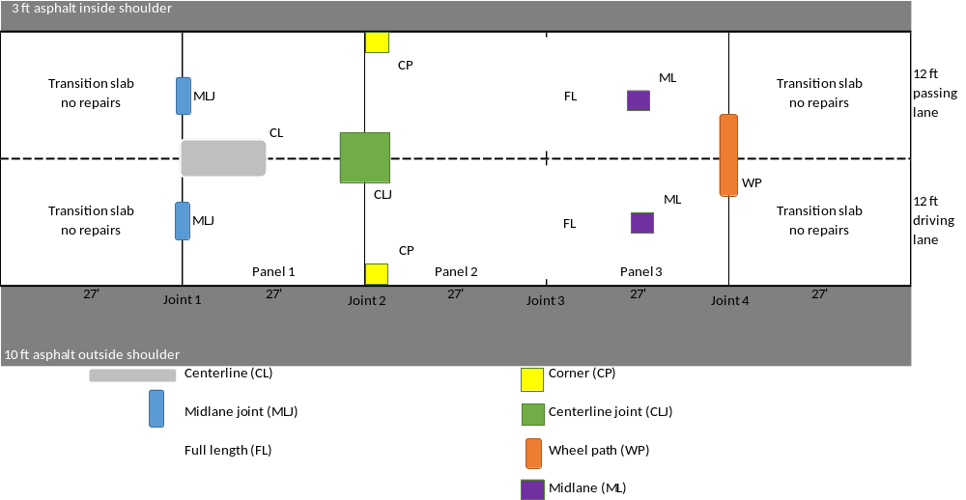
Figure 4.1 Typical Layout of Patching Types for PCC Partial-Depth Repair Study

CONDITION RATING SCALE AND SERVICE LIFE
MnDOT and Braun personnel developed a rating scale to use when reviewing the patch conditions. This scale is based on whether the original patch still exists and if so, what condition it is in. The scale ranges from 0 to 4, with 0 meaning the patch has failed and has been replaced, and 4 meaning the patch is intact and shows no signs of distress. Although the rating scale is only being used to review the cementitious and polymeric proprietary products, all of the patches were reviewed. The intention is to compare the “patch life” for typical HMA patches versus the proprietary product patches.
Note that shrinkage cracks were not considered a distress in these annual reviews. Shrinkage cracks are not identified in MnDOT’s Pavement Distress Identification Manual; however, they are common in concrete pavements. Shrinkage cracks are hairline cracks at the surface that develop during the setting and curing of concrete and typically do not extend through the entire depth of the patch or slab. As such, these cracks were not considered to decrease the integrity of the patches.
Table 4.1 depicts the details of the rating scale. The ratings of the patches within each test cell are discussed in Section 4.3 and included in Appendix B with the corresponding patch photos.
Table 4.1 Patch Condition Rating Scale
Rating | Patch Condition Description
4 | Excellent; 100% of patch is intact, only shrinkage cracks present
3 | Good; distresses (cracking and debonding) exist, but 100% of original patch is in place
2 | Fair; less than 50% of the original patch is gone/been replaced
1 | Poor; over 50% of the original patch is gone/been replaced
0 | Failed; original patch no longer exists

The figures below show examples of patches with each condition rating. During each annual review, the condition of each individual patch was noted. The ratings were then averaged for each different proprietary product. An average patch rating for each product year to year is included in the product matrix in Appendix A.
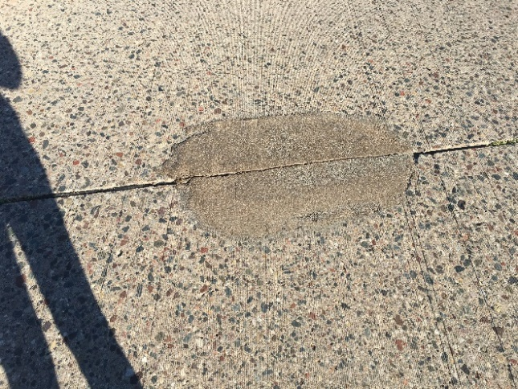
Figure 4.2 Patch Condition Rating = 4 [No Distress]

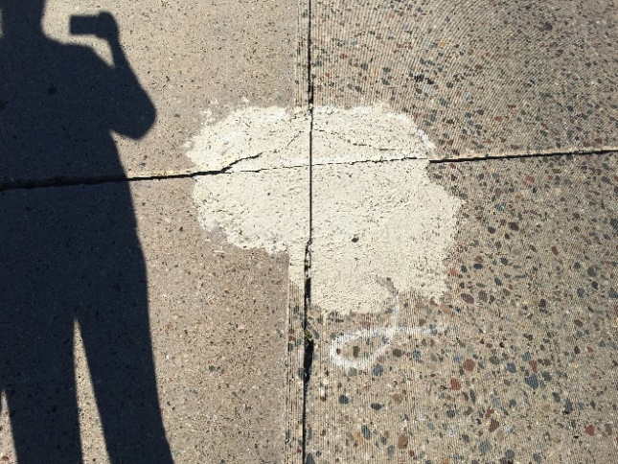
Figure 4.3 Patch Condition Rating = 3 [Linear cracks]

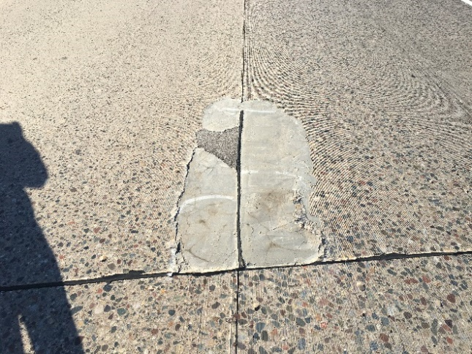
Figure 4.4 Patch Condition Rating = 2 [Linear cracks and <50% material loss]

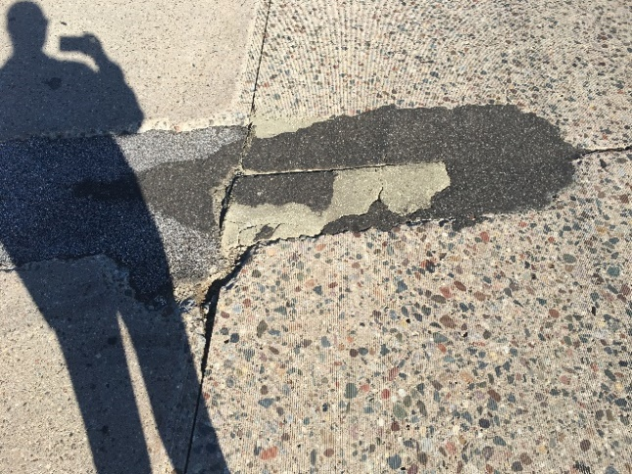
Figure 4.5 Patch Condition Rating = 1 [Linear cracks and >50% material loss]

The yearly average patch condition ratings for each proprietary product were then plotted in a graph to estimate how long each product will last. This graph is shown in Figure 4.6. Discussions between MnDOT and Braun personnel determined that a patch’s service life ends when the patch condition drops below a condition rating of about 1.5 on the scale developed for this research. This 1.5 rating suggests that a patch has lost about 50 percent or more of its material, which is typically when patches get repaired or replaced. Using the existing average patch condition ratings for each product, we were able to estimate how long it would take for each product to deteriorate to a condition rating of 1.5. The service life of each product is summarized in Section 4.3 and in the product matrix in Appendix A.

Figure 4.6 Product Average Condition Rating Summary

INSTALLATION AND PATCH PERFORMANCE DETAILS
During the installation process, it was decided to document how the material was installed, not necessarily what the best practices are. The Material Technical Data Sheets (MTDS) were reviewed to determine any best practices for each product and to determine more detailed information on the installation techniques and preparation needed of the patch.
It was observed that the patch materials came in a variety of packaging. There may be options for bulk quantities for larger repair projects. Some were contained in bags that are not waterproof while some were contained in buckets or waterproof materials. However, it should be noted that many of the materials are available in different sizes or quantities. The MTDS were reviewed for “shelf life” and storage requirements of each material. These items may play a role in deciding the appropriateness of each material for storage at maintenance facilities.
It was also noted that some materials required a mixer other than the standard revolving drum mixer that most maintenance crews currently utilize. Several products preferred and some required a mortar or shearing mixer. A few of the products could be mixed with a simple drill mixer with a paddle attachment. The mixing procedures are detailed in the sections below. The MTDS were also reviewed for any Standard Operating Procedures (SOP) for mixing each product as some suppliers were involved in mixing the product.
The curing time also varied amongst products. The MTDS provide generalized timeframe at varying temperatures along with the curing procedures for each material. The re-establishment of the joint was a large topic of discussion during the installation. Some suppliers utilized foam board or cardboard or a combination thereof. Some suppliers requested that their patches be sawed. It was observed during the installation that the foam board or cardboard was difficult to use, as it would routinely float in the material and needed to be weighted down. The sawing time to establish joints in the patches for some of the materials may have been too long to minimize the potential for cracking.
Figures 4.7 through 4.27 detail the patches and products placed in each cell. Below each layout figure is a discussion about the installation process of that product and the condition ratings of the patch materials throughout the research project.

Cell 94001 – CTS, Rapid Set DOT Repair Mix

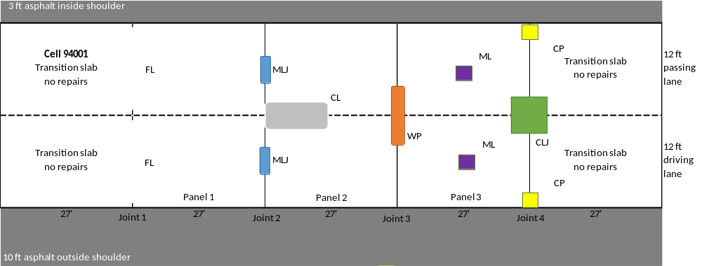
Figure 4.7 Patch Layout for Cell 94001 – CTS, Rapid Set DOT Repair Mix

The driving and passing lane were both sandblasted for this cell. Rapid Set DOT repair mix is a bagged product, 55 pounds. Approximately one 5-gallon bucket of 3/8-inch granite chips was added for each bag of mix added to the mixer, along with approximately 5 quarts of water per bag. The mixture was mixed for 3 minutes in a revolving drum mixer to provide the consistency desired. The mixture was then placed into a wheelbarrow and transported to the patches. The material was finished with traditional concrete tools. The patches were pre-wetted before placing material. Foam board was used to re-establish joints and patches were cured with plastic sheeting. The passing lane FL joint was mixed in a wheelbarrow and had a higher water-to-cementitious ratio than the other patches.

Over the last three years, the patches have developed shrinkage cracks and some minor linear cracks. The average patch rating for Cell 94001 during each annual review are listed below.

- First Year Review – 3.9
- Second Year Review – 3.7
- Third Year Review – 3.5

The patches are generally in good to excellent condition. The estimated patch life for this product is over five years.

Cell 94002 – SpecChem, RepCon 928 and Hot Mix Asphalt

94002 (A) – SpecChem, RepCon 928
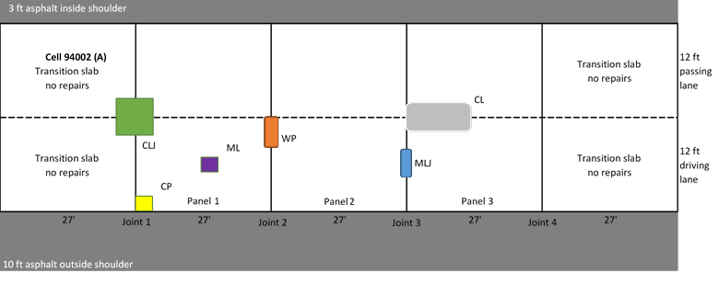
Figure 4.8 Patch Layout for Cell 94002 (A) – SpecChem, RepCon 928

The driving and passing lane were both sandblasted for this cell. RepCon 928 is a bagged product, 50 pounds. Approximately 2.5 quarts of water per bag were added in the mixer and mixed for 3 minutes in a revolving drum mixer. The mixture was then placed into a wheelbarrow and transported to the patches. The material was finished with traditional concrete tools. The patches were pre-wetted before placing material. Foam board was used to re-establish some joints while others were sawed, and patches were cured with plastic sheeting. Some cracking was noted in some patches the next day.

Over the last three years, the patches have developed linear cracks and some material loss. The average patch rating for Cell 94002(A) during each annual review are listed below.

- First Year Review – 3.7
- Second Year Review – 2.5
- Third Year Review – 2.3

The patches are generally in fair to good condition. The estimated patch life for this product is about 3.8 years.

94002 (B) – Hot Mix Asphalt
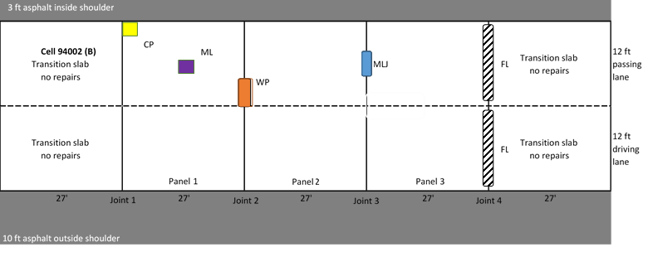
Figure 4.9 Patch Layout for Cell 94002 (B) – Hot Mix Asphalt

The passing lane CP, ML, WP, and MLJ and both FL patches were completed with HMA due to the amount of product required for the patches. The HMA material was installed similarly to the procedure described for Cells 94014 and 94015, which were all HMA material.

The HMA patches in Cell 94002 (B) have developed cracking and material loss. Most of the patches have required repairs. The HMA patches were not rated for condition during this research.

Cell 94003 – Western Material and Design (2 products)

94003 (A) FasTrac 246
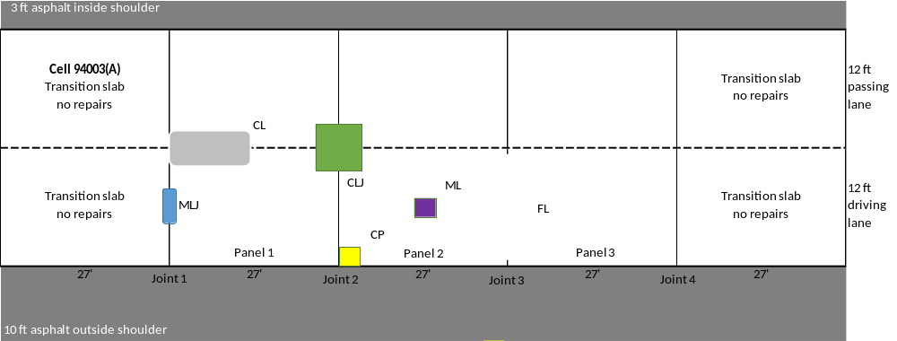
Figure 4.10 Patch Layout for Cell 94003 (A) – Western Material and Design, FasTrac 246

The driving lane and passing lane were both sandblasted. FasTrac 246 is a bagged product, 60 pounds. Approximately 2 quarts of water per bag were added in the mixer. The supplier utilized their own mixer which was a “screw” type mixer. The mixer attached to the front of a skid steer and was used to mix as well as place the concrete in the patches. The material was finished with traditional concrete tools. The patches were pre-wetted before placing material. Foam board was used to re-establish some joints while others were sawed. The patches were cured with plastic sheeting.

Over the last three years, the patches have developed shrinkage cracks and linear cracks. The average patch rating for Cell 94003(A) during each annual review are listed below.

- First Year Review – 4.0
- Second Year Review – 3.5
- Third Year Review – 3.5

The patches are generally in good to excellent condition. The estimated patch life for this product is over five years.

94003 (B) CE 700 HPC
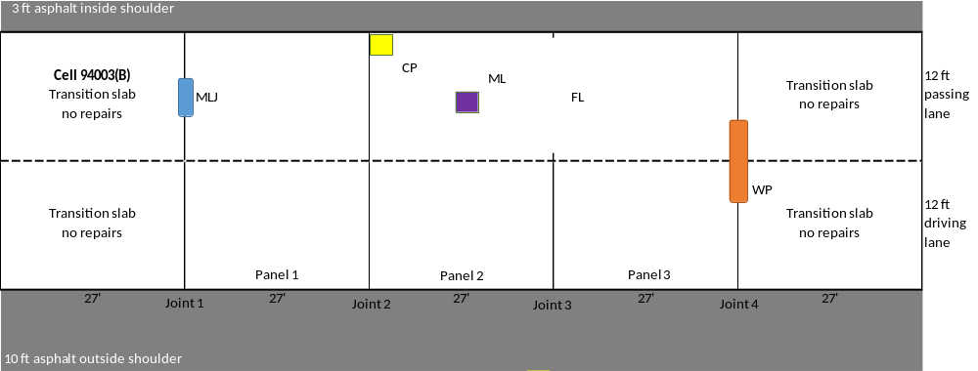
Figure 4.11 Patch Layout for Cell 94003 (B) – Western Material and Design, CE 700 HPC

The passing lane was sand blasted with the exception of the FL and WP repairs. The driving lane for the WP repair was sand blasted. CE 700 HPC is a 3-part system. Before mixing, the material was heated to approximately 70 to 80 degrees Fahrenheit. Part A (liquid polymer, 4 gallons) and Part B (liquid polymer, 4 gallons) are poured into the mixer and mixed for approximately 3 minutes. Then Part C (aggregate, 12 50-pound bags) was added. The supplier utilized their own mixer which was a “screw” type mixer. The mixer attached to the front of a skid steer and was used to mix as well as place the concrete in the patches. The material is finished with traditional concrete tools. Aggregate was broadcast onto the surface for added slip resistance. Cardboard was used to re-establish joints. The patches were not pre-wetted and were not cured.

Over the last three years, the patches have not developed any distresses. The average patch rating for Cell 94003(B) during each annual review are listed below.

- First Year Review – 4.0
- Second Year Review – 4.0
- Third Year Review – 4.0

The patches are in excellent condition. The estimated patch life for this product is over five years.

Cell 94004 – D.S. Brown, PaveSaver Polymeric Concrete Patch and Crafco, HP Concrete Cold Patch

94004 (A) – PaveSaver Polymeric Concrete Patch
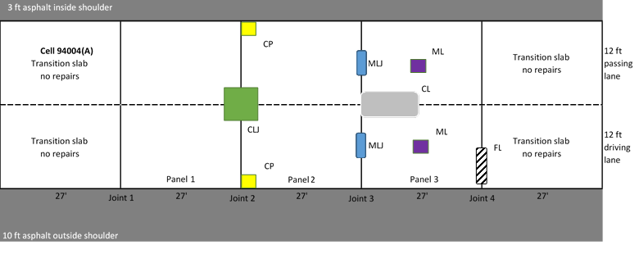
Figure 4.12 Patch Layout for Cell 94004 (A) – D.S. Brown, PaveSaver Polymeric Concrete Patch

The driving lane was sand blasted for all repairs while the passing lane was sand blasted only for the CL and ML repairs. PaveSaver Polymeric Concrete Patch is a 3-part system. Part A (1-gallon gray liquid) and Part B (1-gallon clear liquid) were poured into a 5-gallon bucket and mixed with a drill mixer with a paddle attachment for 3 minutes. The paddle mixer was placed towards the bottom of the bucket to minimize the introduction of air into the mixture. Part C (aggregate, 2 50-pound bags) was then placed into the bucket while mixing continued until the desired consistency was achieved. The material was poured from the bucket into the patch. The material was finished with traditional concrete tools. Cardboard was used to re-establish joints. The patches were not pre-wetted and were not cured.

Over the last three years, the patches have developed some shrinkage cracks and linear cracks. The average patch rating for Cell 94004(A) during each annual review are listed below.

- First Year Review – 4.0
- Second Year Review – 3.6
- Third Year Review – 3.4

The patches are generally in good to excellent condition. The estimated patch life for this product is over five years.

94004 (B) – Crafco, HP Concrete Cold Patch
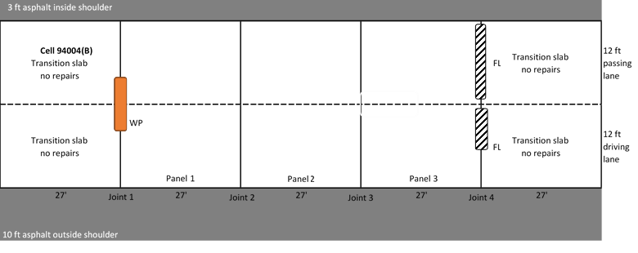
Figure 4.13 Patch Layout for Cell 94004 (B) – Crafco, HP Concrete Cold Patch

The WP, passing lane FL, and about half of the driving lane FL repairs were patched with the Crafco, HP Concrete Cold Patch, due to a lack of PaveSaver materials. The HP Concrete Cold Patch material was placed similarly to the procedure described for Cell 94009.

The patch condition summary is discussed in the Cell 94009 section of this report.

Cell 94005 – Willamette Valley Company, FastPatch DPR

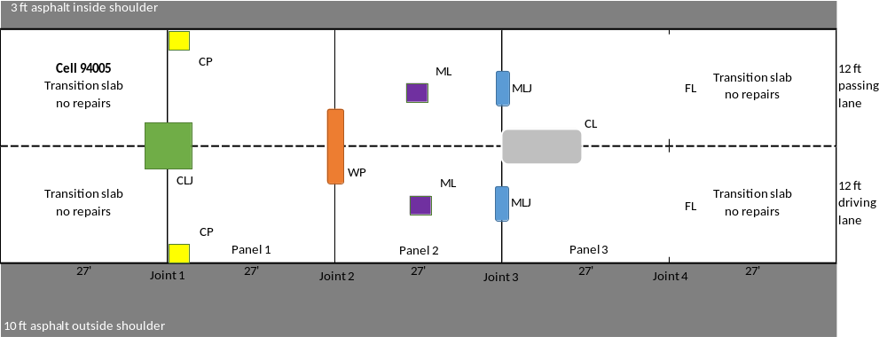
Figure 4.14 Patch layout for Cell 94005 – Willamette Valley Company, FastPatch DPR

The driving lane was sandblasted for all repairs and the passing lane was sand blasted for the CLJ and CL repairs. FastPatch is a 3-part system wholly contained in a 5-gallon bucket. Part A (11 liters) and Part B (6 liters) are packaged in separate packets inside the bucket while Part C (2.5 liters) is “loose” aggregate in the bucket. The mixing required a drill with a paddle attachment. Part A was added to Part C while mixing for 2 minutes then Part B was added while mixing for an additional 2 minutes. The material was poured from the bucket into the patch. The material is finished with traditional concrete tools. Foam board was used to re-establish the joints. Aggregate was broadcast onto the surface for added slip resistance. The patches were not pre-wetted and were not cured.

Over the last three years, the patches have developed some linear cracks. The average patch rating for Cell 94005 during each annual review are listed below.

- First Year Review – 4.0
- Second Year Review – 3.4
- Third Year Review – 3.4

The patches are generally in good to excellent condition. The estimated patch life for this product is over five years.

Cell 94006 – Five Star Products (2 Products)

94006 (A) Rapid Surface Repair Easy Mix
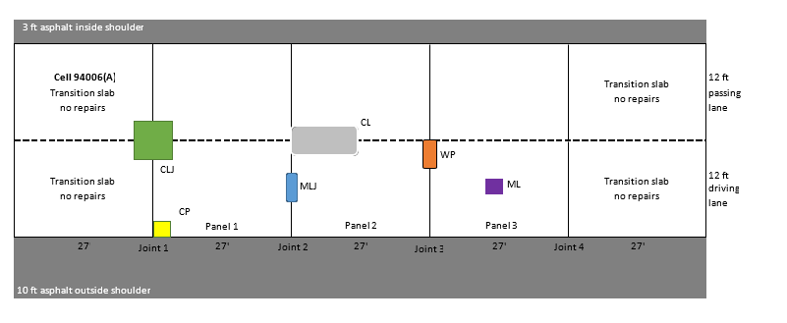
Figure 4.15 Patch Layout for Cell 94006 (A) – Five Star Products, Rapid Surface Repair Easy Mix

The driving lane was sand blasted along with the passing lane for the CL repair. Rapid Surface Repair Easy Mix is a 3-part system. Part A (1.21 liters) and Part B (1.21 liters) are poured into a 5-gallon bucket and mixed using a drill with a paddle attachment for approximately 30 seconds. Part C (50-pound aggregate bag) was added and mixed until the desired consistency was achieved. The material was poured from the bucket into the patch. The material is finished with traditional concrete tools. The patches were heated with a propane torch before placing the material. It was observed that the patches were most likely too large for this material, at least in the provided material sizes. It was difficult to place the material in more than one lift as the previous lift typically hardened before the second lift could be mixed.

Over the last three years, the patches have developed linear cracks and material loss. The average patch rating for Cell 94006(A) during each annual review are listed below.

- First Year Review – 3.5
- Second Year Review – 2.2
- Third Year Review – 1.8

The patches are generally in poor to fair condition. The estimated patch life for this product is about 3.4 years.

94006 (B) Rapid Surface Repair Epoxy Fix
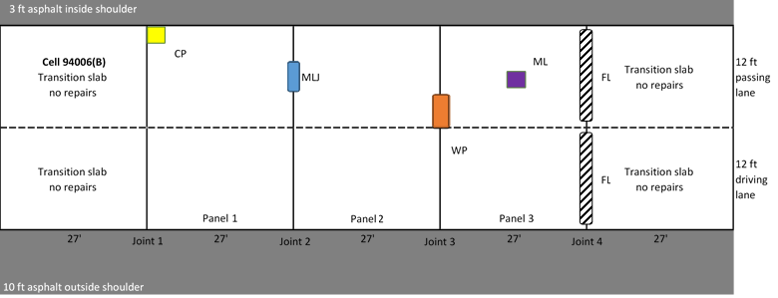
Figure 4.16 Patch Layout for Cell 94006 (B) – Five Star Products, Rapid Surface Repair Epoxy Mix

The passing lane was not sand blasted for these repairs. Rapid Surface Repair Epoxy Mix is a 3-part system. The 3/8-inch granite chips were placed into the patch. The supplier provided a dispensing system contained in a cargo van. The system mixed Part A and Part B together and dispensed the mixed product onto the granite chips. The mixture filled in the voids in the aggregate to fill the patch. The patches were heated with a propane torch before placing the material. Foam board was used to re-establish joints. Aggregate was broadcast onto the surface for added slip resistance. The patches were not cured.

Over the last three years, the patches have experienced significant material loss. Most patches have been completely replaced. The average patch rating for Cell 94006(B) during each annual review are listed below.

- First Year Review – 3.0
- Second Year Review – 0.5
- Third Year Review – 0.5

The patches are generally failed. Based on our review, the patch life for this product is less than two years.

Cell 94007 – TCC Materials, ProSpec Concrete Patching Mix

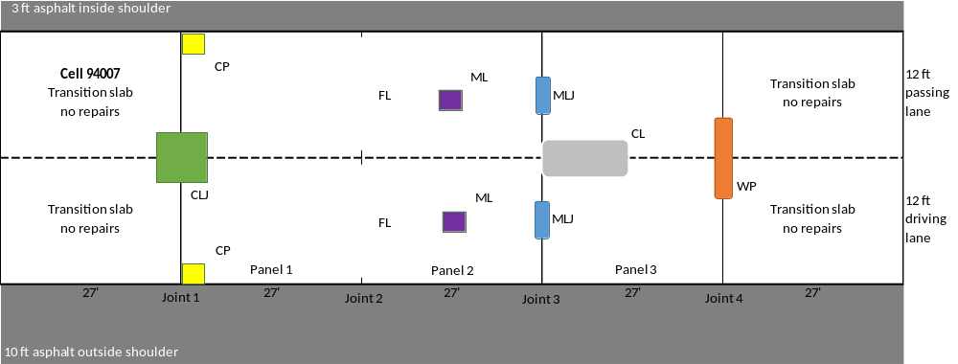
Figure 4.17 Patch Layout for Cell 94007 – TCC Materials, ProsSpec Concrete Patching Mix

The driving lane was sand blasted along with the passing lane for the CLJ and CL repairs. ProSpec Concrete Patching Mix is a bagged product, 50 pounds. Approximately 3 quarts of water was added to the mixture per bag. The mixer required for this product was a paddle or mortar mixer. A revolving drum mixer was not suitable. Mixing continued for 2 to 3 minutes until the desired consistency was obtained. The mixture was then placed into a wheelbarrow and transported to the patches. The material was finished with traditional concrete tools. Foam board was used to re-establish joints. The patches were pre-wetted before placing material and curing was completed using plastic sheets.

Over the last three years, the patches have developed shrinkage cracks, linear cracks, and some material loss. The average patch rating for Cell 94007 during each annual review are listed below.

- First Year Review – 3.3
- Second Year Review – 2.6
- Third Year Review – 2.6

The patches are generally in fair to good condition. The estimated patch life for this product is about 4.8 years.

Cell 94008 –Aqua Patch Road Materials, Aqua Patch and TCC Materials, ProSpec Concrete Patching Mix

94008 (A) – Aqua Patch Road Materials, Aqua Patch
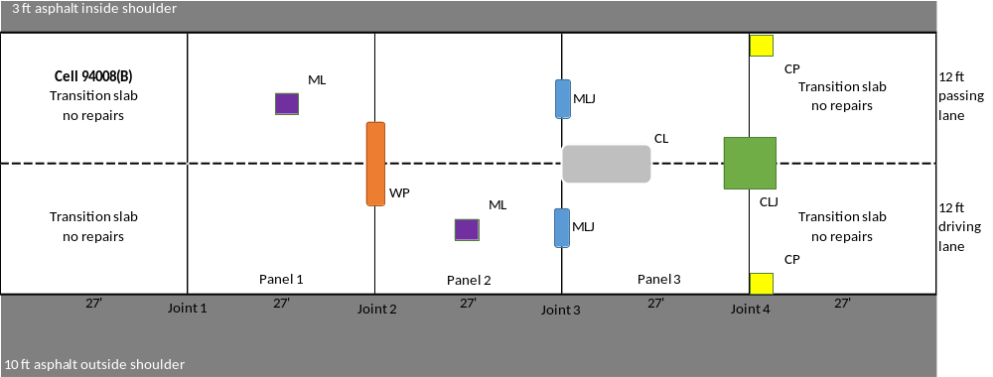
Figure 4.18 Patch Layout for Cell 94008 (A) – Aqua Patch Road Materials, Aqua Patch

The driving lane was sand blasted along with the passing lane for the CL and CLJ repairs. Aqua Patch is a bagged product, 50 pounds. There is no mixing or finishing required. The material is placed into the patch, water added, and tamped down.

Over the last three years, the patches have experienced significant material loss. Most patches have been completely replaced. The average patch rating for Cell 94008(A) during each annual review are listed below.

- First Year Review – 2.7
- Second Year Review – 0.9
- Third Year Review – 0.3

The patches are generally failed. Based on our review, the patch life for this product is less than two years.

94008 (B) – TCC Materials, ProSpec Concrete Patching Mix
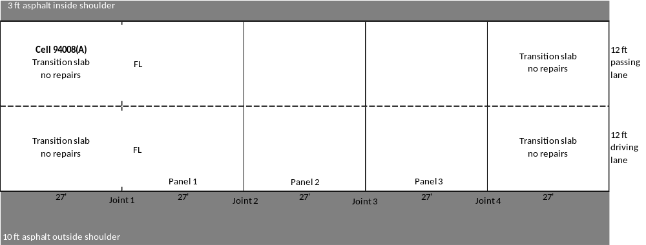
Figure 4.19 Patch Layout for Cell 94008 (B) – TCC Materials, ProSpec Concrete Patching Mix

The driving lane was sand blasted for the FL repair. The procedures for mixing and placing are the same as described for the material as used in Cell 94007.

The patch conditions for this product are summarized in the Cell 94007 section.

Cell 94009 – Crafco, HP Concrete Cold Patch

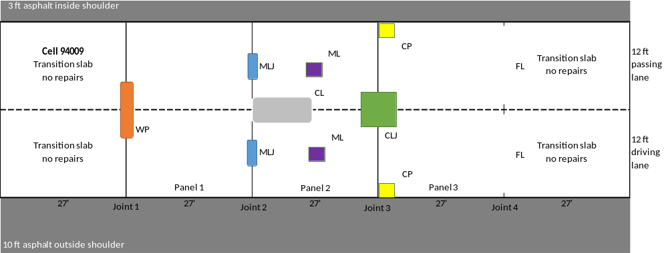
Figure 4.20 Patch Layout for Cell 94009 – Crafco, HP Concrete Cold Patch

The driving lane was sand blasted along with the passing lane for the CL and CLJ repairs. HP Concrete Cold Patch is a bagged product, 50 pounds. The material was placed in 2-inch lifts in patches where required. Each lift was compacted via a hand tamper. The final layer was placed approximately 1/2 inch above the top of the patch and hand tamped. There is no finishing of the material required. A bond breaker or Portland cement was used on the surface. The supplier then proceeded to drive back and forth over the product for final compaction.

Over the last three years, the patches have developed linear cracks. The patches have also compacted and become depressed. As such, most of the patches have been overlaid with HMA to re-level the patch to the existing surface. The average patch rating for Cell 94009 during each annual review are listed below.

- First Year Review – 4.0
- Second Year Review – 2.3
- Third Year Review – 2.0

The patches are generally in fair condition due to being overlaid. The estimated patch life for this product is about 3.2 years. However, the patches may last longer if enough material is placed in the patch to begin with.

Cell 94010 – Crafco, Techrete-TBR

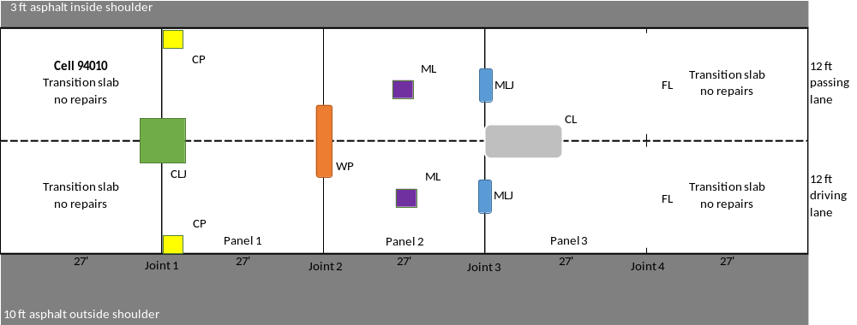
Figure 4.21 Patch Layout for Cell 94010 – Crafco, Techrete-TBR

Sand blasting was performed for all patches in the driving lane, and the passing lane CLJ. Techrete-TBR is a hot applied flexible mastic sealant. The material is in melt-able bags weighing 35 pounds, and heated and mixed in a melter to approximately 400 degrees Fahrenheit. The melter used in this application was a Crafco Patcher II. It was reported that most MnDOT districts have an approved melter that can be used for the Techrete-TBR patches. The melter is placed directly over the patch and the material moves down the shoot into the patch. Although sandblasting is not required, it is preferred. A primer is applied to each distress and dried before material is placed. There is no need to re-establish joints as the material should move with the slab. For deeper patches, material can be placed in two lifts. The first layer should “set” before the second lift is placed. The edges are finished with a heated tool, similar to a float used for traditional concrete finishing. An aggregate can be broadcast onto the surface for slip resistance although none was broadcast during the placement. Once the material has cooled it can be opened to traffic.

Over the last three years, the patches have developed some shrinkage cracks. The average patch rating for Cell 94010 during each annual review are listed below.

- First Year Review – 4.0
- Second Year Review – 3.9
- Third Year Review – 3.9

The patches are generally in good to excellent condition. The estimated patch life for this product is over five years.

Cell 94011 – TCC Materials, 3U18 Modified

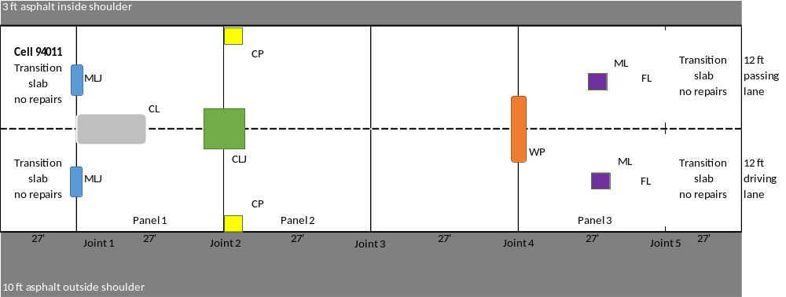
Figure 4.22 Patch Layout for Cell 94011 – TCC Materials, 3U18 Modified

The driving and passing lane were sand blasted. 3U18 Modified is a bagged product, 50-pound bags. Water was added to the product until an approximate 10-inch slump was achieved continuing the mixing for approximately 6 minutes. MnDOT also added two admixtures; one was reported to be an accelerating admixture, and the second was a water reducer. A revolving drum mixer was utilized to mix the product. The mixture was then placed into a wheelbarrow and transported to the patches. The material was finished with traditional concrete tools. The patches were saw cut to re-stablish joints. The patches were pre-wetted before placing material and curing was completed using plastic sheets.

Over the last three years, the patches have developed some shrinkage cracks and minor linear cracks. The average patch rating for Cell 94011 during each annual review are listed below.

- First Year Review – 4.0
- Second Year Review – 3.6
- Third Year Review – 3.6

The patches are generally in good to excellent condition. The estimated patch life for this product is over five years.

Cell 94012 – USG Ecofix

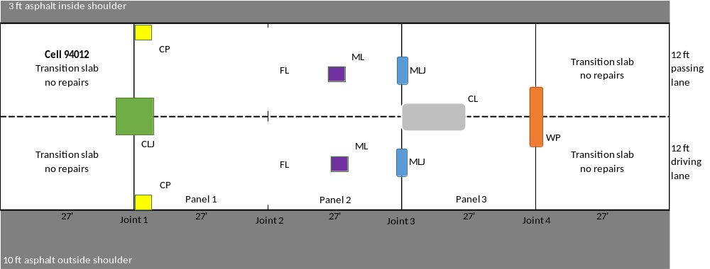
Figure 4.23 Patch Layout for Cell 94012 – USG Ecofix

The driving and passing lane were sand blasted. USG Ecofix is a bagged product, 50 pounds. Approximately 32.5 pounds of 3/8-inch granite chips and approximately 2.25 quarts of water were added per bag. The mixture was mixed in a revolving drum mixer for 2 to 3 minutes until the desired consistency was obtained. The mixture was then placed into a wheelbarrow and transported to the patches. The material was finished with traditional concrete tools. The patches were pre-wetted and saw cutting was utilized to re-establish the joints. The patches were cured with plastic sheets.

Over the last three years, the patches have developed shrinkage cracks and some minor linear cracks and material loss. The average patch rating for Cell 94012 during each annual review are listed below.

- First Year Review – 3.9
- Second Year Review – 3.4
- Third Year Review – 3.1

The patches are generally in good to excellent condition. The estimated patch life for this product is about five years.

Cell 94013 – CTS, Rapid Set DOT Repair Mix and Helix Steel Fibers (2 fiber products)

94013 (A) – CTS, Rapid Set DOT Repair Mix and Helix 5-25-Standard BA (Zinc Coated) Fibers
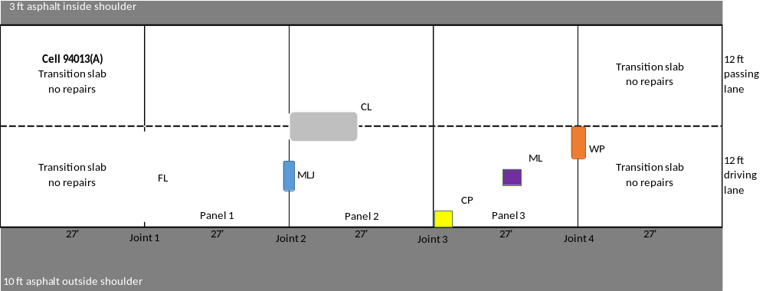
Figure 4.24 Patch Layout for Cell 94013 (A) – CTS, Rapid Set DOT Repair Mix and Helix 5-25-Standard BA (Zinc Coated) Fibers

The driving and passing lane were sand blasted. The material is a bagged product, 55 pounds, that was used in cell 94001. Approximately one 5-gallon bucket of 3/8-inch granite chips were added for each bag of material in the mixer along with approximately 5 quarts of water per bag. Helix zinc coated fibers were added to the mixture at the rate of 2 pounds per bag. The fiber was added to the granite chips and mixed before addition of the bagged product. Everything was mixed for approximately 3 minutes in a revolving drum mixer to provide the consistency desired, and then placed into a wheelbarrow and transported to the patches. The material was finished with traditional concrete tools. The distresses were pre-wetted before placing material. Foam board was used to re-establish joints and patches were cured with plastic sheeting.

Over the last three years, the patches have developed some minor linear cracks. The average patch rating for Cell 94013(A) during each annual review are listed below.

- First Year Review – 3.8
- Second Year Review – 3.7
- Third Year Review – 3.5

The patches are generally in good to excellent condition. The estimated patch life for this product is over five years.

94013(B) - CTS, Rapid Set DOT Repair Mix and Helix 5-25-SS BA (Stainless Steel) Fibers
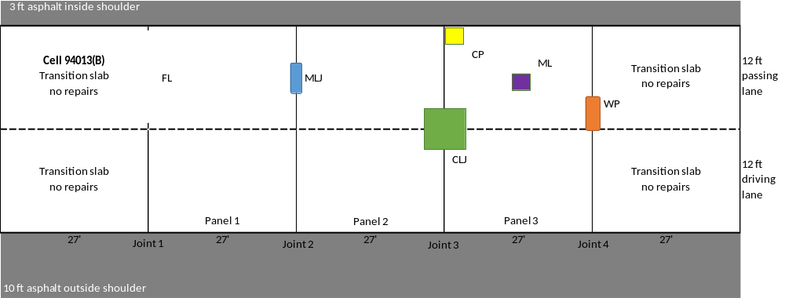
Figure 4.25 Patch Layout for Cell 94013 (B) – CTS, Rapid Set DOT Repair Mix and Helix 5-25-SS BA (Stainless Steel) Fibers

The driving and passing lane were sand blasted. The mixing procedures were the same as for Cell 94013 (A) with the difference being the utilization of stainless-steel fibers instead of zinc coated.

Over the last three years, the patches have developed linear cracks. The average patch rating for Cell 94013(B) during each annual review are listed below.

- First Year Review – 3.8
- Second Year Review – 3.3
- Third Year Review – 3.3

The patches are generally in good to excellent condition. The estimated patch life for this product is over five years.

Cell 94014 and 94015 – Hot Mix Asphalt

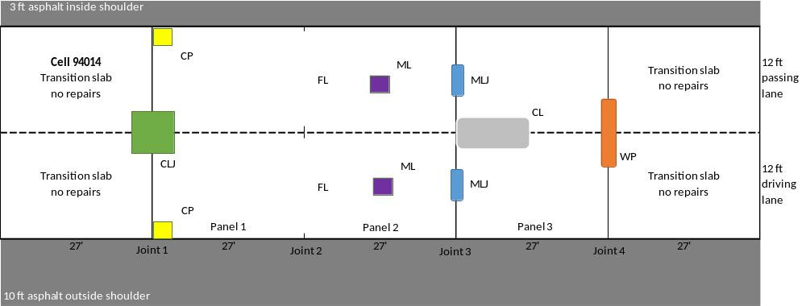
Figure 4.26 Patch Layout for Cell 94014 – Hot Mix Asphalt

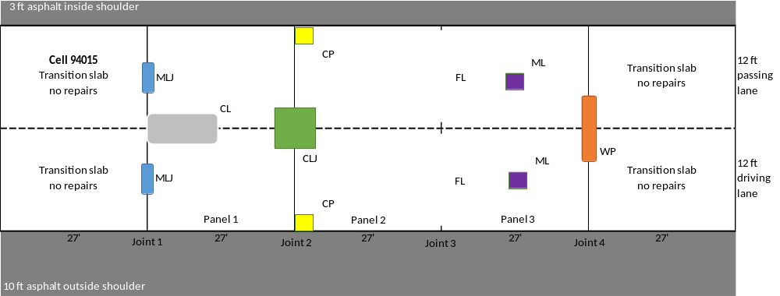
Figure 4.27 Patch Layout for Cell 94015 – Hot Mix Asphalt

The Hot Mix Asphalt was provided by District 3 and installed by MnROAD personnel. All patches were tack coated prior to mix placement. Compaction was achieved utilizing a small drum roller.

The HMA patches in Cells 94014 and 94015 have developed cracking and material loss. Most of the patches have required repairs. The HMA patches were not rated for condition during this research.

REFERENCES

American Concrete Pavement Association (ACPA). (1989). Guidelines for Partial-Depth Repair. Technical Bulletin 003.0 CPR Arlington Heights, Illinois.

American Concrete Pavement Association (ACPA). (2004). Concrete Crack and Partial-Depth Spall Repair Manual. Manual Number JP0023P. Skokie, Illinois.

American Concrete Pavement Association (ACPA). (2006). Concrete Pavement Field Reference: Preservation and Repair. Report EB239P. Skokie, Illinois.

Burnham, T., Johnson, E., & Worel, B. (2016). Performance of Various Partial-Depth Repair Materials at the MnROAD Facility. Minnesota Department of Transportation, St. Paul.

Chen, D. H., Won, M., Zhang, Q., & Scullion, T. (2006). Field Evaluations of the Patch Materials for Partial-Depth Repairs. Journal of Materials in Civil Engineering, 21(9), 518-522. doi: 10.1061/(ASCE)0899-1561(2009)21:9(518)

Collier, Z., Raghavendra, A., & Rupnow, T. (2018). Reliable Early Opening Strength for Concrete Pavements and Patch Work. Final Report Number FHWA/LA.17/589, Louisiana Department of Transportation and Development, Baton Rouge, Louisiana.

Deshpande, Y. S. (2006). Evaluation of Commercial Rapid-Setting Materials and Rapid-Setting Self-Consolidating Concrete for Dowel Bar Retrofit Applications. Doctoral Dissertation, Purdue University.

Deshpande, Y. & Olek, J. (2008). Performance of Rapid-Setting Repair Materials for Concrete Pavements. Paper Number 08-3094, Transportation Research Board 87th Annual Meeting Compendium of Papers DVD.

Elfino, M., Habib, A., Lundy, L., & Haider, S. (2013). Concrete Pavement Patching Challenges in Virginia. Transportation Research Record, 2347(1), 52–60. doi.org/10.3141/2347-06

Emmons, P. H., Vaysburd, A. M., & McDonald, J. E. (1993). A Rational Approach to Durable Concrete Repairs. Concrete International, 15(9), 40-45.

Evans, L.D. & Romine, A.R. (1993). Concrete Pavement Repair Manuals of Practice: Materials and Procedures for Repair of Joint Seals in Concrete Pavements. SHRP-H-349. Strategic Highway Research Program (SHRP), National Research Council, Washington, D.C.

Folliard, K., Sutfin, D., Turner, R., & Whitney, D. P. (2006). Fiber in Continuously Reinforced Concrete Pavements. Texas Department of Transportation Report Number FHWA/TX-07/0-4392-2, Austin, Texas

Frentress, D. P. & Harrington, D. S. (2012). Guide for Partial-Depth Repair of Concrete Pavements. Institute for Transportation, Iowa State University, Ames, Iowa.

Ghazy, A. Bassuoni, M.T. & Shalaby, A. (2016). Nano-modified Fly Ash Concrete: A Repair Option for Concrete Pavements. American Concrete Institute Materials Journal, 113 (2), 231-242

Kuo, S., Carlo, L., & Kuenzli, C. (1999). Evaluation of Patching Materials and Placement Techniques for Rigid Pavements and Bridge Decks. Final Report Number WPI 0510861. Florida Department of Transportation, Tallahassee, Florida.

Markey, S.M., Lee, S.I, Mukhopadhyay, A. K., Zollinger, D. G., Whitney, D. P., & Fowler, D. W. (2006). Investigation of Spall Repair Materials for Concrete Pavement. Texas Department of Transportation Report Number 0-5110-1, Austin, Texas

Mojab, C.A.G., Patel, A.J., & Romine, A. R. (1993). Innovative Materials Development and Testing. Volume 5: Partial Depth Spall Repair in Jointed Concrete Pavements. Report Number SHRP-H-356. Strategic Highway Research Program, National Research Council, Washington, D.C.

Michigan Department of Transportation (MDOT). (1996). Evaluating Pavement Patching Materials: Polymers and Elastomeric Concretes. Materials and Technology Research Record Issue Number 81. Lansing, Michigan.

Mohammadi, M., Moghtadaei, R. M., & Samani, N. A. (2014). Influence of Silica Fume and Metakaolin with Two Different Types of Interfacial Adhesives on the Bond Strength of Repaired Concrete. Construction and Building Materials, Volume 51, 141-150. doi.org/10.1016/j.conbuildmat.2013.10.048

Parker Jr., F. & Shoemaker, W. L. (1991). PCC Pavement Patching Materials and Procedures. Journal of Civil Engineering Materials, 3(1), 29-47. doi.org/10.1061/(ASCE)0899-1561(1991)3:1(29)

Patel, A.J., Mojab, C.A.G., & Romine, A.R. (1993). Concrete Pavement Repair Manuals of Practice: Materials and Procedures for Rapid Repair of Partial-Depth Spalls in Concrete Pavements. SHRP-H-349. Strategic Highway Research Program (SHRP), National Research Council, Washington, D.C.

Riding, K.A. & DonJuan, J. (2014). Evaluation of Bonding Agent Application on Concrete Patch Performance. Report Number 25-1121-0003-166, Mid-America Transportation Center, University of Nebraska-Lincoln, Nebraska.

Santos, D.S., Santos, P.M.D., & Dias-da-Costa, D. (2012). Effect of Surface Preparation and Bonding Agent on the Concrete-to-Concrete Interface Strength. Construction and Building Materials, Vol. 37, 102-110. doi.org/10.1016/j.conbuildmat.2012.07.028

Smith, K., Harrington, D., Pierce, L., Ram, P., & Smith, K. (2014). Concrete Pavement Preservation Guide, Second Edition. National Concrete Pavement Technology Center, Iowa State University, Ames, Iowa.

Song, L., Li, Z., Duan, P., Huang, M., Hao, X., & Yu, Y. (2017). Novel Low Cost and Durable Rapid-repair Material Derived from Industrial and Agricultural By-Products. Ceramics International, 43(16), 14511-14516. doi.org/10.1016/j.ceramint.2017.07.106

Tyson S. S. (1977). Partial-depth Repair of Jointed PCC Pavements: Cast-in-Place and Precast Procedures. Report VHTRC 77-R37, Virginia Highway and Transportation Research Council, Charlottesville, Virginia.

Wang, K. & Lomboy, G. (2016). Developing Green, Highly Flowable, Rapid Set, High Performance Concrete for Pavement Patch Repair. InTrans Project Reports. 214. Retrieved from http://lib.dr.iastate.edu/intrans_reports/214

Whiting, D., Todres, A., Nagi, M., Yu, T., Peshkin, D., & Darter, M. (1993). Synthesis of Current and Projected Concrete Highway Technology. Strategic Highway Research Report Number SHRP-C-345, National Research Council, Washington, D.C.

Wilson, T.P., Smith, K.L., & Romine, A.R. (1999a). Materials and Procedures for Rapid Repair of Partial-Depth Spalls in Concrete Pavements − Manual of Practice. FHWA-RD-99-152. Federal Highway Administration, McLean, Virginia.

Wilson, T.P., Smith, K.L., & Romine, A.R. (1999b). LTPP Pavement Maintenance Materials: PCC Partial-Depth Spall Repair Experiment. Final Report FHWA-RD-99-153. Federal Highway Administration, McLean, Virginia.

Van Dam, T.J., Peterson, K.R., Sutter, L.L., Panguluri, A., Sytsma, J., Buch, N., Kowli, R., & Desaraju, P. (2005). NCHRP Report 540: Guidelines for Early-Opening-to-Traffic Portland Cement Concrete for Pavement Rehabilitation. Transportation Research Board of the National Academies, Washington, DC.

