NRRA - Maintaining Poor Pavements
Project Closeout Summary by Joe Korzilius and Renae Kuehl, SRF Consulting Group
2/20/2020 TAP Meeting
SRF hosted a skype meeting with TAP members to determine next steps for this project. SRF has been working to collect data for this project for quite some time and do not believe enough data has been collected to successfully continue and complete this project. A significant portion of the budget remains, and we convened the TAP for a call to discuss how to move forward with this project.
Meeting attendees: Rob Green – Michigan; Andrew Hanz- MTE Services Inc; James Bittmann – MnDOT; Cody Brand – MnDOT; Jerry Gieb – MnDOT; Ben Worel – MnDOT, Pete Kemp - WI; Jason Bloomberg - MO; Renae Kuehl – SRF; Joe Korzelius - SRF

Discussion:
- MnDOT would like SRF to take the information we have a wrap it up, they are ok us saying that we didn’t receive enough data and close the project. SRF should summarize what we have and post it on the project website for future reference.
- Iowa - has some data that they provided- study is comprehensive and useful. Once Iowa is done with this project, maybe revisit this topic. Would need to be done outside of this project. The study will hopefully spark some interest.
- The value of this project is going to be low based on the responses we received
- How do we avoid getting to this place again in the future? This is a reoccurring issue in all research projects - getting people to volunteer to give data
- Michigan - understaffed and not enough time to pull together the data to share with the project.
- Poor roads are likely more on the local roads so we need to be reaching out to more agencies
- The data request is too big, would take too long to get the data pulled together.
- This project was looking for too much and too big and was setup for a lot of errors. Would need to pay each state to do pull the data.

Final Meeting Direction: SRF will summarize what we have/work completed (details projected below), provide raw data for future use, close out project, send final invoice

Summary of Work Completed to date

Task 1 – Literature Review:
- April 2018: Completed a Literature Review which included standard definitions approved by the TAP.
- May 2018: Literature Review posted to the NRRA Website.

Summary: This went well. Having standard definitions and a common understanding people could refer to was helpful in discussions.

Task 2 – Data Collection:
- April 30, 2018: initial survey transmitted to TAP
- May 25, 2018: Survey approved by TAP and first transmitted to NRRA State members. The survey was transmitted immediately after the May 23/24, 2018 Pavement Conference and presentation.
- September 6, 2018 a reminder email was transmitted. Also discussed at monthly meetings.
- September 18, 2018, MnDOT Elliot Keyes responded with a completed survey. The response included data for four (4) roadway segments that included Ride (IRI) and Structural Rating (SR).
- September 25, 2018 Missouri DOT - Michael Shea responded to the survey. Ride (IRI) data for one (1) Roadway section was provided at the May 22 presentation.

Summary: There are a number of questions on the survey and it would take time to complete. The responses included obtaining ride data for segments of roadway discussed. Since the starting point for all sections being evaluated are pavement in poor condition a description of the major distresses was preferable.

Ride data was determined and agreed to with the TAP as the measure to compare performance rather than specific distresses. Distresses would be discussed but ride data was deemed most important.

During this time period requests for data were made at TAP meetings monthly as well as reminder emails sent by Jerry and Ben. At the 2019 conference Iowa did say they were responding or had responded but I have no record of their response.

Presentations:
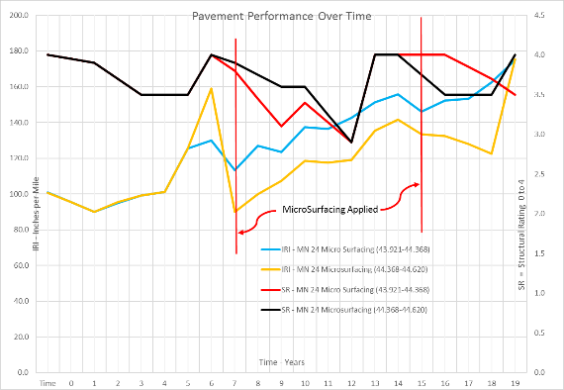
- May 23/24, 2018 Pavement Conference presentation.
  - Questions and Study were introduced to NRRA States.
  - Questions were transmitted to NRRA States after the conference May 25, 2918.

- November 16,2018 Webinar.
  - Focused on the data request for before and after ride IRI. Showed initial data (right) from MnDOT to listeners.

- May 22/23, 2019 Pavement Conference presentation.
  - This was a rehash of the Webinar as no new data was available.

Timeline:
- Initial contract executed December 2017.
- June 2019 the contract was extended to May of 2020.
- We are approaching May of 2020 and have not significantly progressed with obtaining the necessary data. For this reason we are recommending halting further work on this contract.

Attachments:
- Definitions (already posted on project website)
- Literature Review (already posted on project website)
- 2018 Conference PowerPoint
- 2018 Webinar PowerPoint (used again at the 2019 conference)
- Data from MnDOT
- Data from Missouri

