
Determining Pavement Design Criteria for Recycled Aggregate Base Materials - DRAFT

April 2018

TECH TRANSFER “STATE OF PRACTICE” DRAFT REPORT

PROJECT TITLE
Determining Pavement Design Criteria for Recycled Aggregate Base and Large Stone Subbase

MnDOT Project TPF-5(341)

PRINCIPAL INVESTIGATOR
Bora Cetin

PROJECT TECHNICAL ADVISORY COMMITTEE
Terry Beaudry
John Siekmeier
Deepak Maskey
Ed Johnson
James Bittmann
Tim Andersen
Jeff Horsfall
Richard Endres
Thomas Fennessey
Heather Shoup

MORE INFORMATION
Ben Worel
Research Operations Engineer
651-366-5522
ben.worel@state.mn.us

The NRRA pooled fund exists to provide guidance for the Phase III MnROAD research program. Led by an Executive Committee of state DOT members, NRRA will plan and oversee the entire lifecycle of MnROAD research, from the selection of research topics to communication and implementation of results. NRRA will consist of five project teams: Flexible, Rigid, Geotechnical, Preventive Maintenance and Technology Transfer.

NRRA members will help shape the MnROAD research program by guiding the selection of research projects, disseminating research results, and helping agencies put the results into place.


Introduction
The performances of the layers beneath the pavement surface (aggregate base, subbase, and subgrade) are very important for the long-term pavement performance since they help to distribute the vehicle loads in both rigid and flexible pavements (Little and Nair 2009). The aggregate base course is generally the first layer beneath the pavement surface course (Cosentino and Kalajian 2001). It is made of coarse-grained materials to provide a stiff and permeable layer (Schuettpelz et al. 2010, Haider et al. 2014, Cetin et al. 2014, Edil and Cetin 2015). Adequately stiff aggregate base course reduces the deformations and increases the lifespan of the pavement (Edil et al. 2012). The high stiffness of aggregate base layers improves the stability of the sublayers by improving the vertical load distribution (Zornberg 2017). Generally, virgin aggregates (VA) are used for an aggregate base course in pavement systems (Perkins et al. 2005).
About 1.33 billion tons of VA were produced in the US in 2017, and about 76% of the materials were used for pavement constructions (USGS 2018). The price of VA has increased due to the high demand, the depletion of natural sources and federal/local restrictions regarding material production (ACPA 2010). Using recycled aggregate base materials can help the environment by reducing the consumption of natural sources, improving waste utilization and decreasing the greenhouse gas emissions and energy consumption (Lee et al. 2010).
Recycled Aggregate Base Materials
Recycled asphalt pavement (RAP) (Figure 1) and recycled concrete aggregate (RCA) (Figure 2) have been used by some DOTs (Caltrans, IDOT, MnDOT, and WisDOT) in concrete-hot mix asphalt (HMA) mixtures and in aggregate base applications. Old asphalt pavement surfaces are milled to a specific depth (depending on the surface course thickness) and processed to obtain RAP (Edil 2011).
Existing hardened concrete from old pavement surfaces or from other structures such as buildings and bridges is crushed. Then, construction debris and steel used as a reinforcement are removed and the end product is called RCA (Edil et al. 2012; LRRB 2016). RAP and RCA materials can be either used at the same construction site or stockpiled for further applications. Producing and using these materials at the same construction site can help to reduce the cost and the duration of the construction. Up to 30% of cost savings could be achieved by in-place recycling of aggregate base materials (Edil 2011).
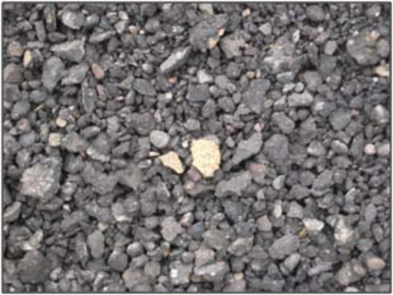
Figure 1. Recycled asphalt pavement (RAP) (Copeland 2011)
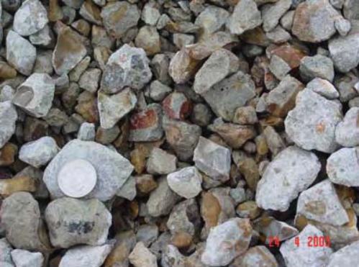
Figure 2. Recycled concrete aggregate (RCA) (Gonzalez and Moo-Young 2004)
Index Properties of RAP and RCA
Material characteristics such as mineralogy, gradation, angularity, and texture are different for each aggregate material (Tutumluer 2013). The index properties of RAP and RCA are highly affected by several factors such as the material source, the aggregate type, and the crushing operations. RAP and RCA can contain a variety of impurities such as steel, metal, and tire residual which affect their index properties. The amount of the impurities is not constant and is affected by the original material source and crushing methods (Jayakody et al. 2012).

Grain Characteristics
RCA particles tend to be relatively more angular than RAP particles. In addition, they tend to have rougher surface texture than RAP particles. Asphalt content (about 4.5 - 6%) and trapped air between asphalt and aggregate particles cause lower specific gravity values for RAP (Cosentino et al. 2003). On the other hand, RCA also has a relatively lower specific gravity than VA due to the presence of mortar bounds in RCA matrix (Snyder et al. 1994).
Gradation Characteristics
Original aggregate type, milling operations, and the crushing methods affect the gradation of RAP and RCA (Cosentino and Kalajian 2001). The gradation of RAP is generally similar to VA; however, depending on the milling and crushing methods, it may contain higher fines content (Chesner et al. 1998). In the MnDOT applications, RAP may be assumed as a class 7 material, if their gradation curves are similar. In addition, RCA can be considered as a class 5 aggregate, if they have similar gradation curves (LRRB 2016). Gradation of RCA affects its engineering properties considerably because fine particles may contain higher unhydrated cement compared to coarse particles (ACPA 2009).
Compaction Characteristics
RAP and RCA have different compaction characteristics than VA because of their different morphology such as water absorption capacity and angularity. The general trend (of Proctor compaction tests) for the dry unit weight of these materials is that RAP and RCA have lower maximum dry unit weight compared to VA when compacted. On the other hand, while RAP has lower optimum water content than VA, RCA shows a higher optimum moisture content (Figure 3) (Edil et al. 2012; Nokkaew et al. 2012; Sayed et al. 1993).
A similar trend is also observed in the RAP-VA and RCA-VA mixtures. The reduction in the maximum dry unit weight is directly proportional to the content of RAP or RCA in the RAP-VA and RCA-VA mixtures (Taha et al. 1999). Greater reductions in the maximum dry unit weight are seen with the use of more recycled aggregates in the mixtures (Bennert et al. 2000). While using higher RAP content causes a further reduction in the optimum water content (Locander 2009), the use of a higher amount of RCA leads to an increase in the optimum water content due to an increase in cement mortar content (Bennert et al. 2000).
It is stated by Kim et al. (2007) that gyratory compactor provided better results to simulate the in-situ conditions. Gyratory compaction results were closer to the densities obtained from the field by 4-in. (102 mm) and 6-in. (152 mm) sand cone tests (Figure 4).
The compaction characteristics of RAP change with temperature (Soleimanbeigi and Edil 2015). Due to the softening of asphalt binder at higher temperatures, binding quality between the aggregate particles improves and the dry unit weight increases (Montemayor 1998, as cited in Cosentino and Kalajian 2001).

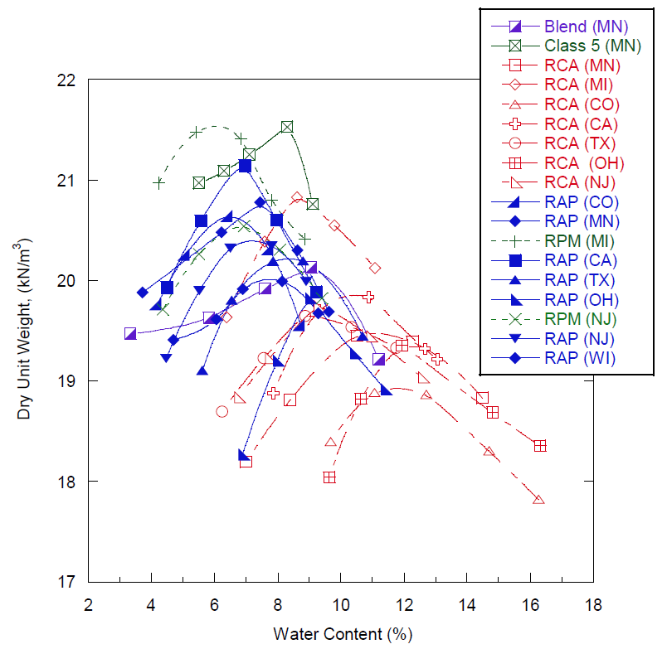
Figure 3. Compaction characteristics of RAP, RCA, and VA (Edil et al. 2012) *Abbreviations in parentheses represent locations of material sources.
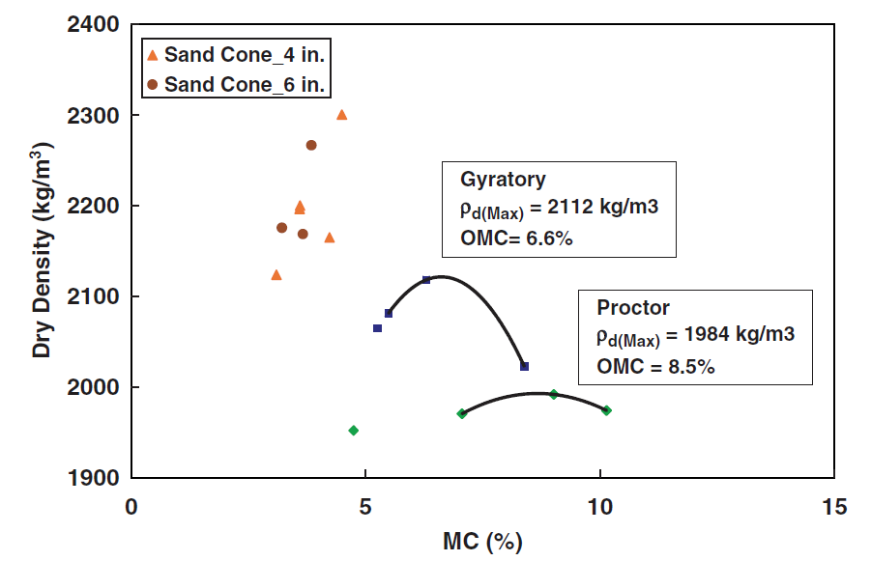
Figure 4. Difference between Proctor and gyratory compaction methods (Kim et al. 2007) *4 in. and 6 in. represent the diameters of sand cones
Engineering Properties of RAP and RCA
The previously stated material characteristics of RAP and RCA affect their engineering properties significantly. As a specific example, the stiffness of a base layer constructed with RAP is affected by original aggregate type, asphalt content, and gradation of RAP (Thakur and Han 2015).
Hydraulic Properties
While the apparent liquid contact angle of RAP tends to be greater than 90$°$, it is about 0$°$ for RCA (Figure 5) (Edil et al. 2012). RAP shows hydrophobic properties due to the asphalt coating (Edil et al. 2012; Rahardjo et al. 2010). RCA is known as a hydrophilic material because it contains unhydrated cement which increases its absorption capacity (Edil et al. 2012). Due to the hydrophobicity of RAP, they tend to have higher saturated hydraulic conductivity (k_{sat}) than RCA (Figure 6) (Nokkaew et al. 2012).
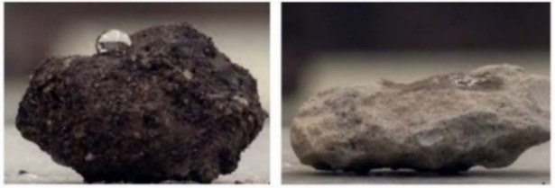
Figure 5. The water repellency of RAP (left) and RCA (right) (Edil et al. 2012)
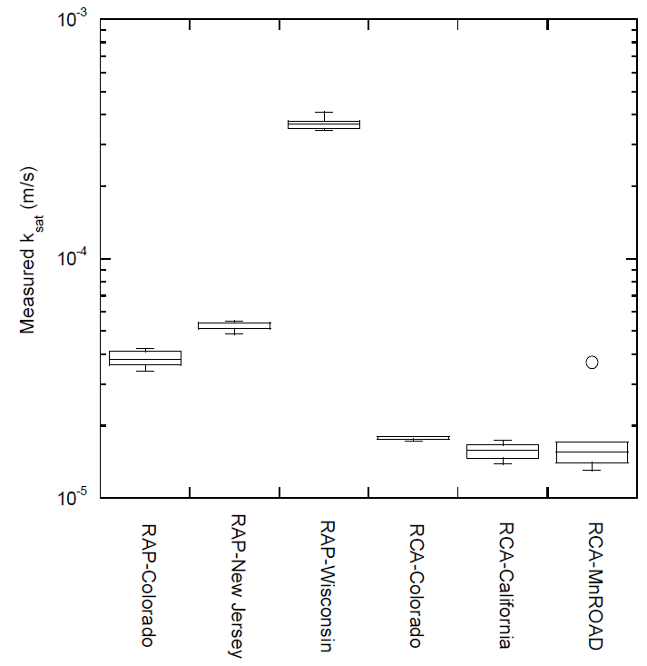
Figure 6. k_{sat} of RAP and RCA (Nokkaew et al. 2012)
Soil water characteristic curve (SWCC) shows the relationship between the suction and volumetric water content. There is a relationship between the contact angles and matric suction properties of soils. For RAP, positive matric suction is observed as a result of high contact angle (> 90$°$). It means that water can move freely between the RAP particles. On the other hand, RCA has a contact angle of about 0$°$, which causes negative matric suction. As a result, water will not move through RCA as freely as it will in RAP (if RAP and RCA have similar gradations) (Edil et al. 2012). Thus, if the gradations are similar, RAP tends to provide a better drainage layer than RCA (Edil et al. 2012; Hoppe et al. 2015).
Air-entry pressure ($Ψ$a) is the pressure required to start desaturation of the largest pores in the soil (Fredlund and Rahardjo 1993). There is a relationship between the contact angles and air entry pressures. The decrease in the contact angle increases the air entry pressure values. Thus, RAP tends to have lower air entry pressures than RCA due to their higher contact angles (> 90$°$). While large pores drain first in RAP, small pores drain first in RCA (Edil et al. 2012).
Bearing Capacity Properties
The general trend for RAP is that 100% RAP has lower California bearing ratio (CBR) than VA. In addition, an increase in the RAP content of the RAP-VA mixtures reduces the CBR (Bennert and Maher 2005; Guthrie et al. 2007) (Figure 7). Asphalt coating of RAP causes a reduction in the particle bonding and in the interlocking mechanism of particles. In addition, RAP may contain low fines content which can cause a reduction in the binding between particles (Ooi et al. 2010; Taha et al. 1999; Sayed et al. 1993).
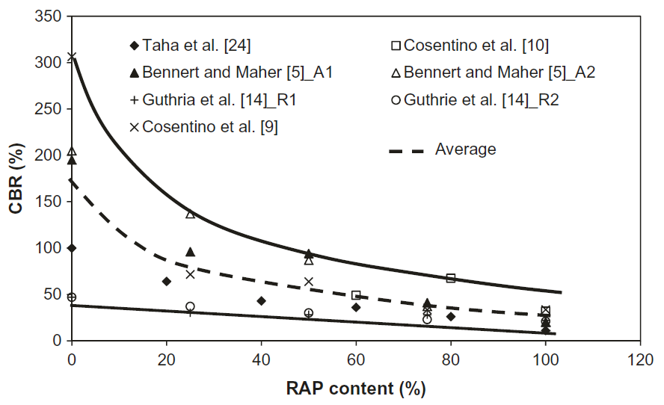
Figure 7. CBR values of the RAP-VA mixtures with different RAP contents (Thakur and Han 2015)
As stated before, compacting RAP at a relatively higher temperature increases its dry unit weight by improving the binding between particles. An increase in the dry unit weight leads to an increase in the Limerick bearing ratio (LBR) values (LBR = 1.25xCBR). Regardless of the compaction temperature, ambient temperature when the LBR tests are performed affects the LBR of RAP considerably. While an increase in the temperature causes a decrease in the LBR of RAP, a decrease in temperature leads to an increase in the LBR as a result of hardening of asphalt material (Cosentino and Kalajian 2001).
Different behaviors are observed in RCA for soaked and unsoaked conditions. While lower CBR values are seen in RCA for unsoaked conditions, an increase in CBR is observed for soaked conditions (Jayakody et al. 2012) due to the cementitious reactions of unhydrated cement. In addition, with an increase in the soaking period, relatively higher CBR values can be obtained due to the time-dependent cementitious reactions (Figure 8) (Garach et al. 2015).
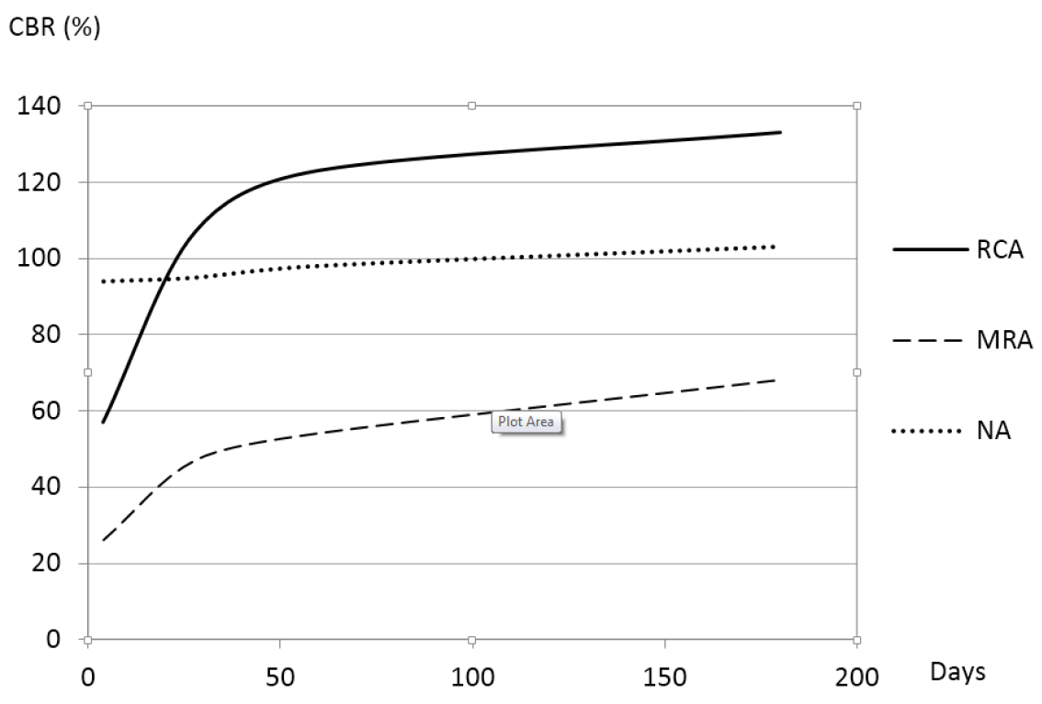
Figure 8. The effect of soaking period on the CBR of RCA (Garach et al. 2015) *NA – natural aggregates, MRA – mixed recycled aggregates
Shear Strength Properties
Normal and confining stresses, cohesion and internal friction angle are the main parameters that affect the shear strength of soils (Thakur and Han 2015). Under the same confining pressure, RAP, RCA, and VA tend to behave differently during static triaxial loading (Figure 9). In addition, depending on the gradation and morphology, e.g., fines content and angularity, VA tends to have higher friction angle and cohesion than RAP and RCA. RAP and RCA have comparable or generally lower shear strength than VA (Thakur and Han 2015).
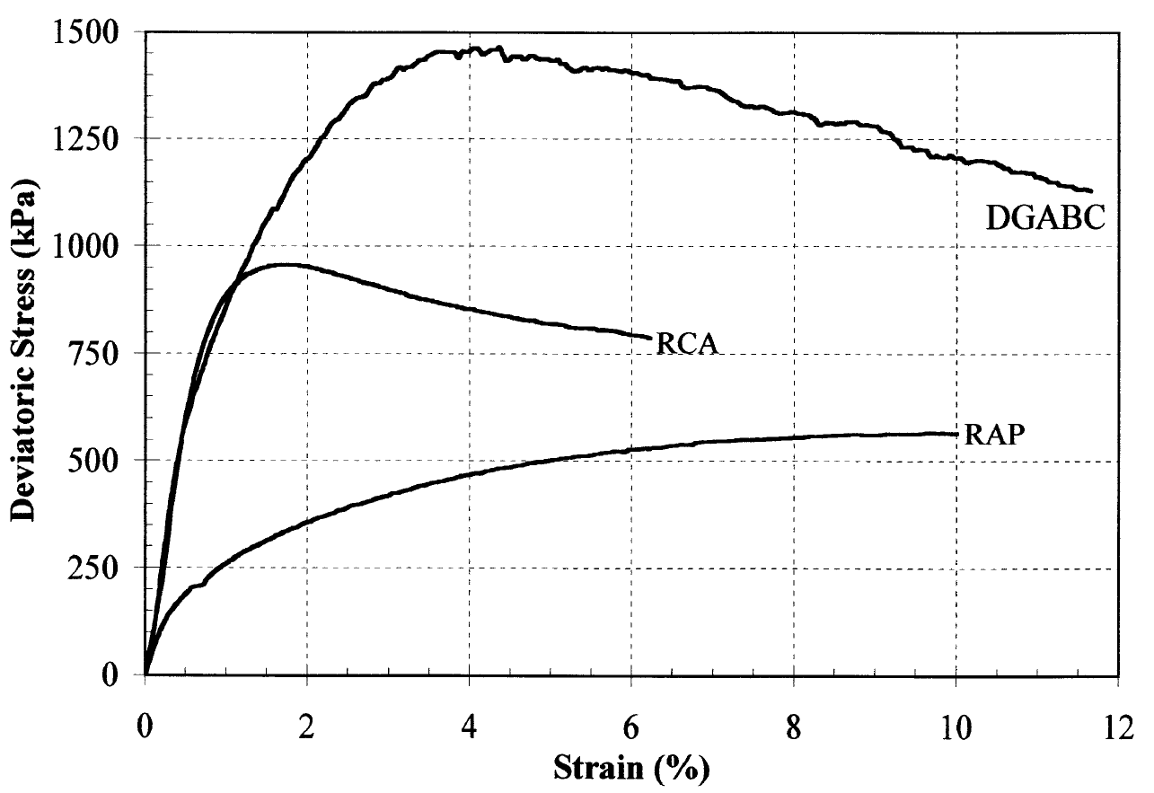
Figure 9. Stress-strain relationship of aggregates (Bennert et al. 2000) *DGABC - dense-graded aggregate base course
RAP content of the RAP-VA mixtures affects the friction angle and cohesion values of the mixtures. While an increase in the RAP content causes an increase in the friction angle, it leads to a decrease in the cohesion values in static (or rapid) triaxial tests (Figure 10) (Thakur and Han 2015).
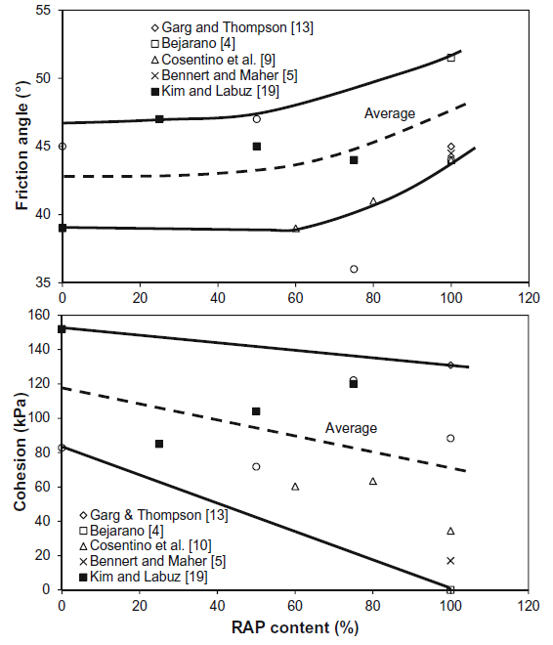
Figure 10. Friction angle and cohesion vs RAP content (Thakur and Han 2015)
RAP tends to show different shear strength characteristics at different temperatures due to the presence of temperature-sensitive asphalt content. There is an optimum temperature (its value depends on the material) that increases the shear strength of RAP. In addition, RAP tends to give lower shear strength values at lower and higher temperatures than the optimum temperature. In the static triaxial tests performed at various temperatures by Cosentino and Kalajian (2001), the highest principal stress at failure was observed at 37.8°C (100°F). While performing tests at various temperatures did not affect the internal friction of RAP considerably, increasing the temperature caused an increase in its cohesion (Cosentino and Kalajian 2001).
Stiffness Properties
The general trend is that higher resilient modulus values are observed in RAP and RCA compared to VA (MacGregor et al. 1999; Bennert et al. 2000; Cosentino et al. 2003; Abdelrahman et al. 2010; Rosa et al. 2017). Higher resilient moduli are seen with an increase in RAP and RCA contents in the RAP-VA and RCA-VA mixtures (Figure 11 for RAP and Figure 12 for RCA) (Thakur and Han 2015; Bennert et al. 2000; Edil et al. 2012). However, some exceptions could exist, e.g., RCA may not improve the stiffness of VA when they are mixed due to an increase in fines content (Bestgen et al. 2016a).
Angularity and surface texture affects the stiffness characteristics of aggregates by improving the interlocking between particles. RCA has angular particles and rough surface due to the crushing operations and the cement content; thus, it shows relatively higher resilient moduli than VA (Edil et al. 2012; Stolle et al. 2014; Kuo et al. 2002). In addition, secondary cementation of unhydrated cement content in the presence of water is another reason for higher observed resilient moduli (Bestgen et al. 2016a).
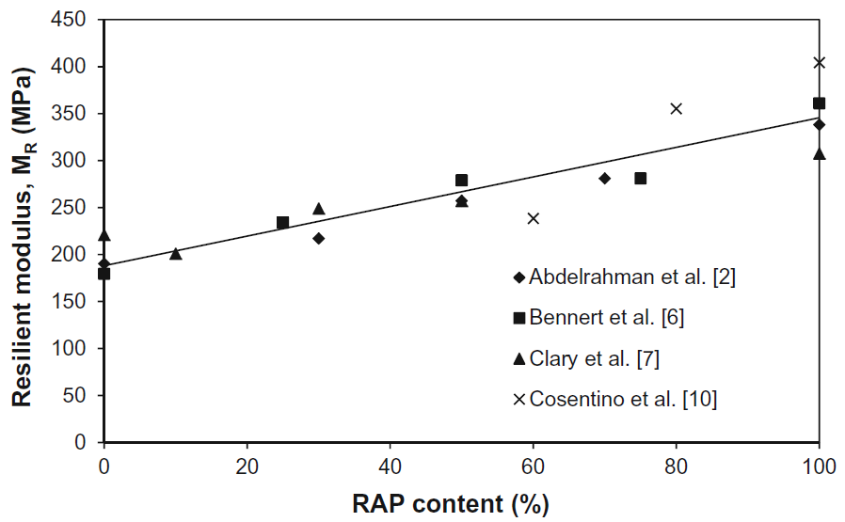
Figure 11. Effect of RAP content on the resilient modulus (Thakur and Han 2015)
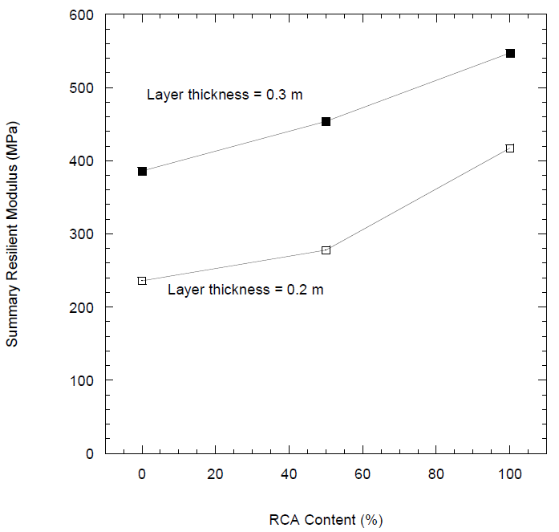
Figure 12. Effect of RCA content on the resilient modulus (Edil et al. 2012) *Summary resilient modulus: The modulus at a bulk stress of 208 kPa (NCHRP 1-28a).
RCA and VA are not as sensitive to temperature changes as RAP. RAP is sensitive to temperature due to its asphalt content which is a temperature-sensitive material (Wen et al. 2011; Soleimanbeigi et al. 2015). RAP and the RAP-VA mixtures show a decreasing stiffness trend as temperature increases (Soleimanbeigi et al. 2015) due to a reduction in the viscosity of asphalt after the asphalt softening point [45°C (113 °F) - 80°C (176 °F)] (Figure 13) (Read and Whiteoak 2003, as cited in Edil et al. 2012; Wen et al. 2011).
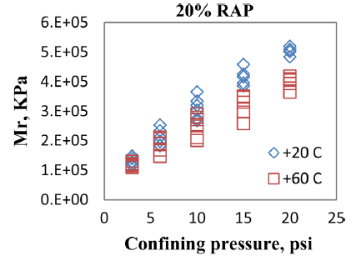
Figure 13. Effect of temperature on the resilient modulus of the VA-20% RAP mixture (Wen et al. 2011)
Permanent Deformation Properties
In general, RCA shows the lowest permanent deformation while RAP shows the highest permanent deformation (Figures 14 and 15 for RAP and RCA, respectively) (Bennert et al. 2000; Edil et al. 2012; LRRB 2016). A relatively higher permanent deformation occurs with an increase in the RAP content of the RAP-VA mixtures (Kim and Labuz 2007; Thakur and Han 2015). The reason why RAP shows the highest permanent deformation while it shows better stiffness properties is the progressive breakdown of its asphalt binder (Bennert et al. 2000). In addition, viscous creep behavior of the asphalt material is attributed as one of the reasons for observed high plastic deformation of RAP (Edil et al. 2012). On the other hand, an increase in the RCA content of the RCA-VA mixtures leads to a relatively lower permanent deformation (Bennert et al. 2000).
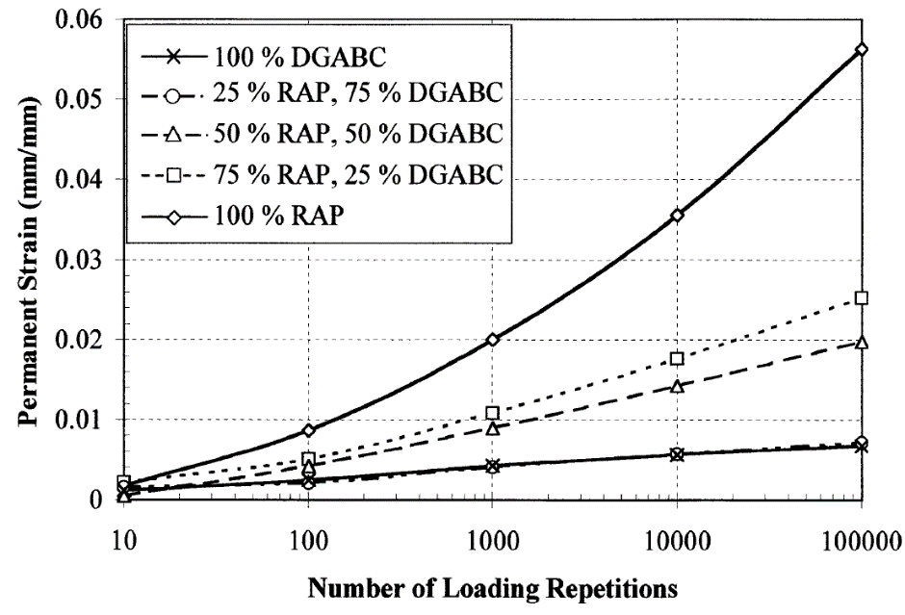
Figure 14. Permanent deformation of VA, RAP, and RAP-VA mixtures (Bennert et al. 2000) *DGABC - dense-graded aggregate base course
Different trends between RAP, RCA, and VA can be observed due to their different fines contents. VA may show lower permanent deformation than RCA due to its lower fines content (Bestgen et al. 2016a). While fines content has no significant effect on the resilient moduli properties of materials, it affects the permanent deformation mechanisms considerably. A relatively higher fines content leads to a higher permanent deformation of materials (Mishra and Tutumluer 2012). The angularity of RCA is another reason for the different trends between RCA and VA. Highly angular RCA particles may tend to deform easier than relatively more rounded particles, and relatively higher permanent deformation may be observed in RCA (Bestgen et al. 2016a).
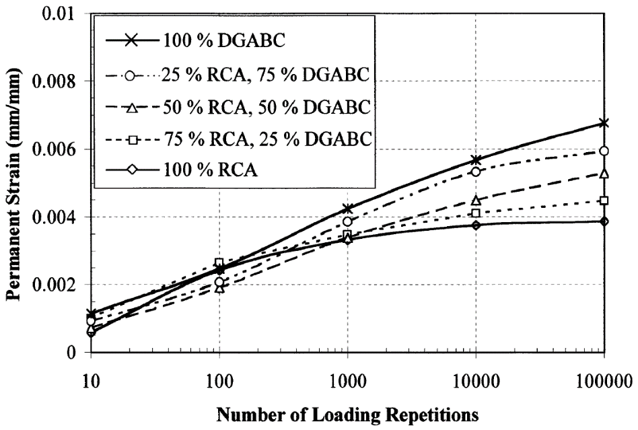
Figure 15. Permanent deformation of VA, RCA, and RCA-VA mixtures (Bennert et al. 2000) *DGABC - dense-graded aggregate base course
An increase in temperature leads to an increase in the permanent deformation of RAP because of the temperature-sensitivity of RAP. Asphalt loses its viscosity under higher temperatures (Edil et al. 2012; Soleimanbeigi et al. 2015). On the other hand, the temperature has little to no effect on RCA and VA.
Creep Properties
Granular materials are expected to show little to zero creep potential (Thakur and Han 2015). However, RAP tends to show creep potential due to its asphalt content. Asphalt material has viscoelastic properties and the presence of asphalt material leads to reorienting of particles under a static loading in the long-term (Cosentino et al. 2012; Yin et al. 2016). Repositioning of particles in the long-term due to the asphalt content causes the creep of RAP. Under a constant static loading, the creep potential of RAP increases at elevated temperatures (Figure 16) (Yin et al. 2016).
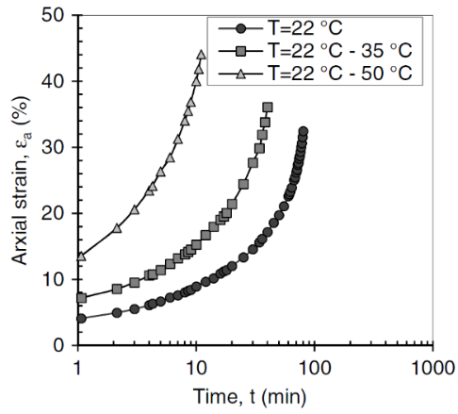
Figure 16. Creep properties of RAP at different temperatures (Yin et al. 2016)
As stated before, compaction of RAP at high temperatures improves its engineering properties because it improves the binding between aggregates (Montemayor 1998, as cited in Cosentino and Kalajian 2001). Yin et al. (2016) also demonstrated that lower axial strain was observed in the RAP specimens compacted and consolidated at 35°C (95°) or 50°C (122°F) compared to the specimens prepared at 22°C (72°F) (Figure 17).
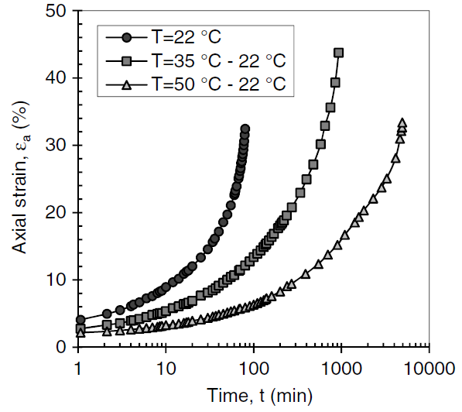
Figure 17. Creep properties of RAP compacted at different temperatures (Yin et al. 2016)
An increase in the RAP content of the RAP-VA mixtures leads to an increase in the creep potential (Cleary 2005 and Dikova 2006). In addition, the rate of creep deformation reduces as time progresses (Thakur and Han 2015). RAP should be mixed with a minimum 75% of VA to obtain the adequate reduction in the creep potential (Cosentino et al. 2012; Bleakley et al. 2014).
Freeze-Thaw Durability
The stiffness of RAP consistently decreases as freeze-thaw cycles continue. The first couple of freeze-thaw cycles are the most deteriorative ones (Edil et al. 2012; Soleimanbeigi et al. 2015; Rosa et al. 2017). As time progresses, RAP becomes more stable against freeze-thaw cycles and a reduction in the stiffness decrease rate of RAP is observed (Figure 18). Although the stiffness of RAP reduces with freeze-thaw cycles, it still shows higher resilient modulus than VA (Edil et al. 2012).
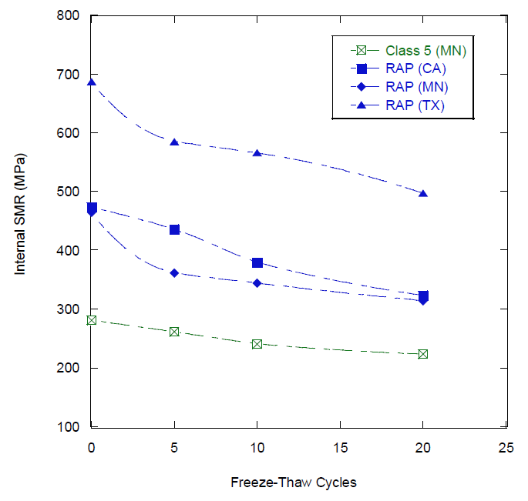
Figure 18. Effect of freeze-thaw cycles on the stiffness properties of RAP (Edil et al. 2012)
While a decrease in the stiffness of RCA is similar to that of observed in RAP for the first couple of freeze-thaw cycles, an increasing trend in the stiffness of RCA in the laboratory tests is observed in the later freeze-thaw cycles due to the self-cementing properties of RCA (Figure 19) (Poon et al. 2006; Edil et al. 2012; Soleimanbeigi et al. 2015; Bestgen et al. 2016a, Rosa et al. 2017).
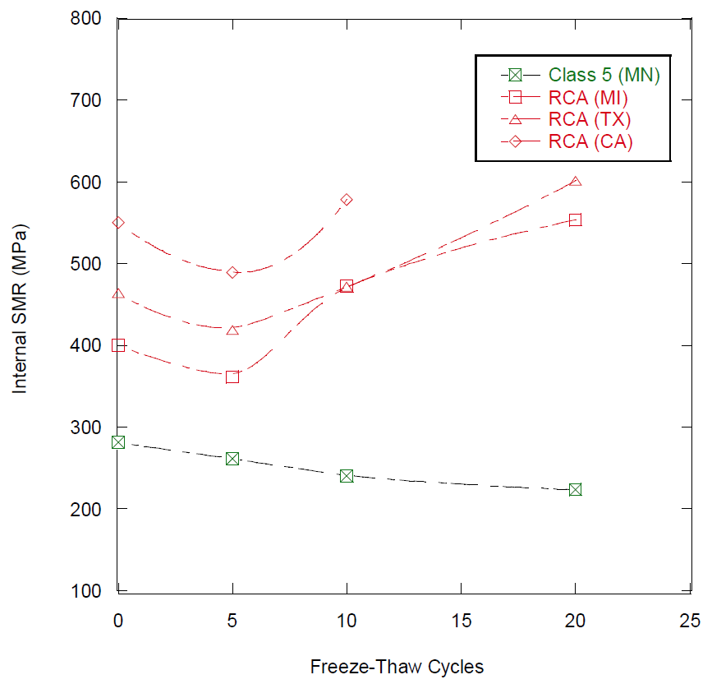
Figure 19. Effect of freeze-thaw cycles on the stiffness properties of RCA (Edil et al. 2012)
Wet-Dry Durability
Although fines may be washed away during wetting, there is an increasing trend of fines content in RCA due to exposing to wet-dry cycles. Due to the higher cohesion of RAP compared to RCA and VA, RAP material tends to stay more stable than other materials against wet-dry cycles (Edil et al. 2012).
Environmental Properties of RAP and RCA
Properties of RAP
Bituminous asphalt material consists of heavy metals and poly-aromatic hydrocarbons (PAHs) which may leach in a rainfall event and cause contamination (Shedivy et al. 2012).
pH Characteristics
Various pH values have been determined for RAP in the literature. Shedivy et al. (2012) observed from the batch leaching tests that pH of RAP was between 8.59 – 9.58. Kang et al. (2011) observed pH of 9.67 from the same test (Hoppe et al. 2015). Edil et al. (2012) observed that pH values of RAPs were between 8 and 10.5 in the same test.
Heavy Metal Leaching Characteristics
Asphalt surface, which will be crushed for RAP production is directly subjected to traffic flow. Tire residuals, corrosion of steel crash barriers, or brake pad/disc residuals of vehicles may introduce heavy metals to the asphalt surface (Muschack 1990; Hewitt and Rashed 1990, as cited in Shedivy et al. 2012).
The main heavy metals that may create environmental issues are arsenic (As) aluminum (Al), cadmium (Cd), chromium (Cr), lead (Pb), silver (Ag), antimony (Sb) and selenium (Se) (Hoppe et al. 2015; Edil et al. 2012). In general, heavy metal leaching from RAP is not a hazardous environmental issue and almost all heavy metals found in leachates are equal to or lower than the EPA drinking water standards (Edil et al. 2012; Cosentino et al. 2003; Shedivy et al. 2012).
Poly-Aromatic Hydrocarbons (PAHs) Leaching Characteristics
Incomplete burning of organic compounds is the main source of the PAHs. It is speculated that tire residuals, exhaust gasses, gasoline or diesel fuels are the sources of PAHs present in asphalt surface (Takada et al., 1990; Baek et al., 1991; Sadler et al., 1999; Brandt et al., 2001; Kriech et al., 2002, as cited in Shedivy et al. 2012).
Some of the important PAHs that needed to be tested for better understanding the environmental properties of RAP are acenaphthylene, benzo(a)anthracene, and benzo(ghi)perylene. In general, leaching of PAHs does not cause an environmental issue since their concentrations tend to be lower than the EPA drinking water standards according to the laboratory leaching tests (Hoppe et al. 2015; Shedivy et al. 2012).
Properties of RCA
Leaching characteristics of RCA have been one of the major focus areas because of the presence of cement paste, other cement additives, and alkalinity (Engelsen et al. 2010; Van Dam et al. 2011; Cetin et al. 2012).
Deicing applications to pavements during winter seasons may increase the chloride content of concrete pavement surfaces which is one of the RCA sources. Chloride may cause corrosion of steel pipes or affect the durability of RCA. Crushing of the concrete surface into a fine-grained RCA may contain a risk for potential failures due to the high chloride content; however, using a coarse-grained RCA minimizes the risk (ACPA 2009). In addition, since aggregate base layer constructed with RCA has a porous structure, there is no high concern about the volume change of the aggregate base layer constructed with RCA due to alkali-silica reactions (Van Dam et al. 2011).
pH Characteristics
The alkalinity of RCA is caused by the CaO and total Ca²⁺ compounds which present in the cement paste (Cetin et al. 2013). As a result of the cement content of RCA, it is expected that RCA demonstrates high pH values (Engelsen et al. 2009). pH of RCA may be in a range of 10.5 to 13 (Steffes 1999; Chen et al. 2013; Abbaspour et al. 2016).
Carbonation occurs when RCA is exposed to the atmosphere. Dissolved CO₂ from the atmosphere reacts with calcium hydroxide (or portlandite - Ca(OH)₂) and calcium-silicate-hydrate (C-S-H) gel present in the hardened concrete. The reaction forms CaCO₃ which reduces the pH (Garrabrants et al. 2004; Gervais et al. 2004, as cited in Bestgen et al. 2016b). Carbonation content increases over time (Abbaspour et al. 2016), and the pH of RCA decreases over time. pH values lower than 10 can be observed in the fully carbonated concrete (Engelsen et al. 2017). Stockpiled RCA tends to experience higher carbonation rates than the freshly crushed RCA because stockpiled RCA is exposed to several weather events such as rain which initiates more carbonation (Abbaspour et al. 2016).
Heavy Metal Leaching
Unlike RAP, RCA is suspected to have a high leaching potential for some metals such as aluminum (Al), silicon (Si), calcium (Ca), magnesium (Mg), chromium (Cr), copper (Cu), iron (Fe), and zinc (Zn) at high pH values (Engelsen et al. 2009; Engelsen et al. 2010; Edil et al. 2012; Bestgen et al. 2016b; Abbaspour et al. 2016). RCA tends to show different environmental behaviors because of the differences in the cement properties and source materials. Some of the metals may exceed the EPA drinking water standards in RCA; however, some of them may not show any hazardous leaching characteristics (Figure 20) (Edil et al. 2012; Gupta et al. 2018).
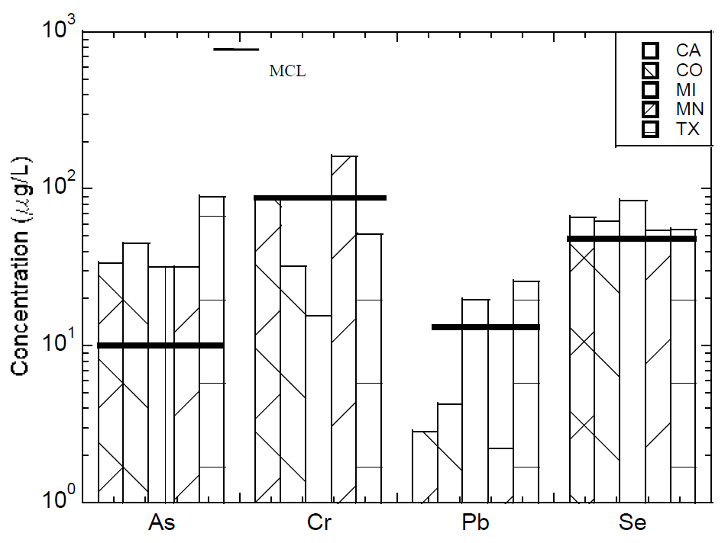
Figure 20. Concentrations of different metals and maximum contaminant levels (MCLs) for EPA drinking water standards (Edil et al. 2012)
Along with the pH, several other factors can affect the leaching characteristics of RCA such as aging, the liquid-to-solid ratio (L/S ratio), and gradation (Bestgen et al. 2016a-b; Abbaspour et al. 2016). The general trend for the effect of aging is that metal concentrations decrease with an increase in the aging due to the carbonation (Bestgen et al. 2016a). Increasing the liquid-to-solid ratio lowers the dissolved metal concentrations as a result of the higher dilution (Bestgen et al. 2016a). A finer material may yield a higher leaching potential because leaching is enhanced with the higher specific surface (Edil et al. 2012; Bestgen et al. 2016a).
A concern may arise with the use of RCA in aggregate base applications due to the tufaceous formation by leaching and precipitation of heavy metals (Ceylan et al. 2013; Abbaspour et al. 2016). First, CO₂ from atmosphere and H₂O present in material get in contact to form carbonic acid (H₂CO₃). Then, H⁺ and CO₃²⁻ form after two-step ionization of H₂CO₃. In the last step, Ca²⁺ released from cement at high pH environment reacts with CO₃²⁻ coming from the ionization of H₂CO₃ reacts and the reaction forms calcite (CaCO₃) (Feldmann et al. 1982). The drainage properties of aggregate base layers constructed with RCA and the granular subbase layers can be reduced as a result of the tufa formation (Phan 2010; Ceylan et al. 2013). In addition, pipes located beneath a pavement system for drainage purpose can be clogged by the tufa formation (Figure 21) (Ceylan et al. 2013). To minimize the problems related to the tufa formation, a coarser-size (bigger than No. 4 sieve) RCA can be used (Gupta and Dollimore 2002). Another method would be washing RCA before aggregate base application to fasten the carbonation process and remove the cementitious materials away from the RCA matrix (Snyder and Bruinsma 1996).
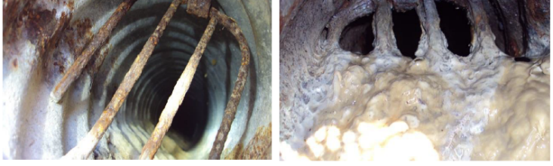
Figure 21. Clean pipe (left) and partially-clogged pipe (right) (Ceylan et al. 2013)
Design Methods
There have been methods and assumptions for using VA as aggregate base layers; however, designing pavement systems with recycled aggregates may be challenging (Edil 2011; LRRB 2016). AASHTO 1993 and Mechanistic-Empirical Pavement Design Guide (MEPDG) – AASHTOWare Pavement ME Design are the most commonly used design methods for pavements (Edil 2011; LRRB 2016). In addition, some local design methods are followed by some DOTs such as MnDOT’s Granular Equivalent Method or MnPAVE (LRRB 2016).
AASHTO 1993 Design Method
General Design Method
AASHTO 1993 design method is an empirical method based on the structural numbers (SN) indicating the structural capacity and the role of each pavement layer. The thickness and stiffness of each layer are the main parameters that are needed to be determined for calculating the SN of each layer (Edil 2011). The following equation is used to determine the overall SN (Locander 2009; Zornberg 2012; MacGregor et al. 1999).
$$\text{SN = }{\text{(a}}_{\text{1}}\text{× }{\text{D}}_{\text{1}}\text{) + (}{\text{a}}_{\text{2}}\text{× }{\text{D}}_{\text{2}}\text{× }{\text{m}}_{\text{2}}\text{) + (}{\text{a}}_{\text{3}}{\text{× D}}_{\text{3}}\text{× }{\text{m}}_{\text{3}}\text{)}$$
where;
a₁, a₂, a₃ = structural layer coefficients (based on stiffness) of the surface, base and subbase layers, respectively
D₁, D₂, D₃ = thicknesses (in inches) of the surface, base and subbase layers, respectively
m₂, m₃ = drainage coefficients of the base and subbase layers, respectively
The structural layer coefficient of a₂ (for base) is determined based on the layer stiffness (Kim et al. 2005; Cetin et al. 2010). The structural layer coefficient of base layers can be calculated by the following equation (Edil 2011):
a₂ = 0.249 × log SRM – 0.44
where; SRM is the summary resilient modulus (in MPa)
The general trend is that the layer coefficient increases with an increase in the layer stiffness (Rada and Witczak 1982).
In general, higher resilient modulus values are observed for RAP and RCA, and for the RAP-VA and RCA-VA mixtures compared to VA (MacGregor et al. 1999; Bennert et al. 2000; Cosentino et al. 2003; Abdelrahman et al. 2010). Thus, higher structural layer coefficient (a₂) is expected for an aggregate base layer built with RAP or RCA (MacGregor et al. 1999).
As mentioned before, RAP shows hydrophobic properties while RCA shows hydrophilic properties (Edil et al. 2012; Rahardjo et al. 2010). Due to the hydrophobicity of RAP, it tends to have higher k_{sat} than RCA (Nokkaew et al. 2012). If other parameters are constant, there is a direct relationship between the hydraulic conductivity and the drainage coefficients, e.g., the higher the hydraulic conductivity, the higher the drainage coefficient (MacGregor et al. 1999). Thus, it is expected that higher drainage coefficients should be used for RAP than those used for RCA.
Equivalency-Based Design Method
A pavement aggregate base layer built with recycled aggregates is designed to obtain the equivalent structural capacity of those built with VA (Edil 2011). In the equivalency-based design method, the overall structural numbers of pavements with or without recycled aggregates in the aggregate base layer are equalized.
Many state DOTs assume recycled aggregate base materials behave similarly to aggregate base layers built with conventional VA, e.g., RAP is used as a MnDOT Class 7 aggregate as long as it meets the specification requirements for the Class 7 aggregate (LRRB 2016). In the equivalency-based design method, MnDOT Class 5 material is used as a standard aggregate for equating the structural numbers with the pavements built with recycled aggregates (MnDOT 2005, as cited in Edil 2011).
Mechanistic-Empirical Pavement Design Guide (MEPDG)
Unlike the AASHTO 1993 design method which is an empirical approach, plastic deformation is taken into account in the MEPDG which is a mechanistic-empirical approach. Several parameters such as modulus values of layers, climate zone, traffic conditions, the designed service life of the pavement, and failure criteria are used to predict the most reliable design conditions. Design thicknesses can be determined by making iterations for specific materials and other related conditions (Edil 2011). The required parameters for the analysis can be obtained for RAP, RCA, VA, RAP-VA, and RCA-VA mixtures for performance estimates of pavement systems.
Selected Practices of State DOTs
California DOT
In California, recycled aggregates generated from crushed existing asphalt concrete (AC) and Portland cement concrete (PCC) are used in paved roads as aggregate base and subbase layers (Caltrans 2015). Recycled aggregates must meet the gradation and quality specifications stated for VA in the Caltrans Standard Specifications (CalRecycle 2014). The aggregate used as a base aggregate must meet the gradations and must show the adequate quality characteristics of Class 2 or Class 3 aggregates.
Illinois DOT
While RAP is sometimes used as a subbase material underlying VA in pavements, there is no application and specification related to RAP as an aggregate base course (McGarrah 2007; IDOT 2016). Crushed concrete produced from Portland cement concrete is allowed to be used along with crushed gravel and crushed stone for the aggregate base courses (IDOT 2016). Crushed concrete should meet the requirements of CA6 or CA10 aggregates for aggregate base applications (IDOT 2016).
Crushed concrete should be evaluated as class D for checking its quality in terms of Illinois Test Procedure (ITP) 96 (LA abrasion test). In addition, crushed concrete should be evaluated as a class C for Illinois Test Procedure (ITP) 203 which is used for the determination of deleterious particles in coarse aggregate. While the bearing ratio should be 80 for the aggregate base applications of typical materials, there is no requirement when crushed concrete is used (IDOT 2016).
Minnesota DOT
Both RAP and RCA are allowed to be used as aggregate base course materials (MnDOT 2018). RAP and RCA should meet the quality requirements which are the same for all aggregate classes (MnDOT 2018). Unless RAP content is less than 25% (by volume), the RAP-VA mixture is named recycled blend. A small percentage of recycled aggregate (< 25%) can be mixed with VA with no change in the class of aggregate and no change in the quality control measurements (McGarrah 2007). However, when the RAP exceeds 10% of the blend by volume, the gradation of RAP-VA mixture must meet the specified gradation for the aggregate class (McGarrah 2007). RAP and VA must be blended at the crushing site, not at the job site with stockpiles materials (McGarrah 2007).
Almost all concrete pavements in Minnesota are recycled as dense-graded base aggregate material (Gonzalez and Moo-Young 2004). To avoid the drainage problems related to RCA (e.g. tufa formation), fine-grained (< #4 sieve) particles in RCA must be eliminated. In addition, open-graded RCA can be mixed with natural aggregates to reduce the heavy metal leaching while improving the gradation of the blend (Snyder 1995, as cited in Gonzalez and Moo-Young 2004).
The RAP-VA or RCA-VA mixtures containing less than 25% of recycled aggregates should meet the gradations specified for different aggregate classes depending on the project (MnDOT 2018).
Missouri DOT
Reclaimed asphalt and concrete materials are allowed to be used as base aggregates as long as they meet the gradation specifications of type 1, type 5, and type 7 aggregates (MoDOT 2018). Type 1, type 5, and type 7 aggregates should contain deleterious materials no more than 15%. Deleterious materials should be distributed uniformly along with sand, silt, and clay contents. Plasticity index (PI) of materials passing No. 40 sieve should not be more than 6 (MoDOT 2018).
Wisconsin DOT
Reclaimed asphalt and crushed concrete are allowed for aggregate base applications (WisDOT 2018). Reclaimed asphalt is only suitable for dense 1 ¼-inch base type whereas crushed concrete is suitable for dense ¾-inch, dense 1 1/4 -inch, and dense 3-inch base types (WisDOT 2018). Materials should be free of deleterious materials such as shale, soft or porous rock fragments, coal, and organic particles. Reclaimed asphalt aggregates should contain at least 75% of reclaimed asphaltic pavement or surfacing. Crushed concrete aggregate should contain at least 90% crushed concrete, which is free of steel reinforcement or any other impurity. In addition, asphaltic pavement and surfacing material content should be lower than 10% in crushed concrete aggregate.
VA and recycled materials can be mixed at various percentages to create reprocessed materials or blended materials. Every single aggregate of blended materials must meet the specified aggregate base physical properties requirements and final blend must meet the specified gradation (WisDOT 2018).
Michigan DOT
Crushed concrete aggregates are allowed as long as they meet the gradation and quality specifications for Class 21AA, 21A, 22A, and 23A dense-graded aggregates. While crushed concrete should not contain more than 5% of brick, wood, plaster or asphalt by particle count, steel reinforcement pieces are allowed as long as they meet the specified gradation of stated dense-graded aggregate classes.
For environmental concerns such as heavy metal leaching, crushed concrete should not be used if there is no additional granular layer of at least 12 inches (with class I, II, IIA, or IIAA aggregates – Table 6.25) between the dense-graded base and an underdrain which the dense-graded base drains into. In addition, a geotextile liner or geomembrane can be used as an alternative to granular layer between the dense-graded base and the underdrain (MDOT 2012).
References
Abbaspour, A., Tanyu, B. F., & Cetin, B. (2016). Impact of aging on leaching characteristics of recycled concrete aggregate. Environmental Science and Pollution Research, 23(20), 20835-20852.
Abdelrahman, M., Alam, T., & Zollars, J. (2010). Performance of high recycled asphalt pavement (RAP) content as base layer in flexible pavement. The Journal of Solid Waste Technology and Management, 36(3), 131-142.
ACPA (2009). Recycling Concrete Pavements. Engineering Bulletin 043P. American Concrete Paving Association, Skokie, IL.
ACPA (2010). Why Recycle Concrete Pavements? TS043.1P. American Concrete Paving Association, Skokie, IL. http://1204075.sites.myregisteredsite.com/d ownloads/TS/EB0 43P /TS04 3.1P.pdf.
Baek, S. O., Field, R. A., Goldstone, M. E., Kirk, P. W., Lester, J. N., & Perry, R. (1991). A review of atmospheric polycyclic aromatic hydrocarbons: sources, fate and behavior. Water, air, and soil pollution, 60(3-4), 279-300.
Bennert, T., & Maher, A. (2005). The development of a performance specification for granular base and subbase material (No. FHWA-NJ-2005-003).
Bennert, T., Papp Jr, W., Maher, A., & Gucunski, N. (2000). Utilization of construction and demolition debris under traffic-type loading in base and subbase applications. Transportation research record: journal of the transportation research board, (1714), 33-39.
Bestgen, J. O., Cetin, B., & Tanyu, B. F. (2016b). Effects of extraction methods and factors on leaching of metals from recycled concrete aggregates. Environmental Science and Pollution Research, 23(13), 12983-13002.
Bestgen, J. O., Hatipoglu, M., Cetin, B., & Aydilek, A. H. (2016a). Mechanical and environmental suitability of recycled concrete aggregate as a highway base material. Journal of Materials in Civil Engineering, 28(9), 04016067.
Bleakley, A., Cosentino, P., Kalajian, E., & Patel, M. (2014). Strength and Creep Characteristics of Reclaimed Asphalt Pavement-Sand Blend Backfill in Mechanically Stabilized Earth Walls. Transportation Research Record: Journal of the Transportation Research Board, (2462), 18-27.
Brandt, H. C. A., & De Groot, P. C. (2001). Aqueous leaching of polycyclic aromatic hydrocarbons from bitumen and asphalt. Water research, 35(17), 4200-4207.
CalRecycle (2014). Construction and Demolition Debris Recycling, Caltrans Specifications for Aggregate Base and Subbase. California Department of Resources Recycling and Recovery, CA. http://www.calrecycle.ca.gov/Condemo/Specs/CaltransAgg.htm
CalTrans (2015). Standard Specifications. California Department of Transportation, Sacramento, CA.
Cetin, A., Kaya, Z., Cetin, B., & Aydilek, A. H. (2014). Influence of laboratory compaction method on mechanical and hydraulic characteristics of unbound granular base materials. Road Materials and Pavement Design, 15(1), 220-235.
Cetin, B., Aydilek, A. H., & Guney, Y. (2010). Stabilization of recycled base materials with high carbon fly ash. Resources, Conservation and Recycling, 54(11), 878-892.
Cetin, B., Aydilek, A. H., & Li, L. (2012). Experimental and numerical analysis of metal leaching from fly ash-amended highway bases. Waste management, 32(5), 965-978.
Cetin, B., Aydilek, A. H., & Li, L. (2013). Trace metal leaching from embankment soils amended with high-carbon fly ash. Journal of Geotechnical and Geoenvironmental Engineering, 140(1), 1-13.
Ceylan, H., Gopalakrishnan, K., Kim, S., and Steffes, R. F. (2013). “Evaluating Roadway Subsurface Drainage Practices,” IHRB Project TR-643. Institute for Transportation, Iowa State University, Ames, IA.
Chen, J., Tinjum, J., & Edil, T. (2013). Leaching of alkaline substances and heavy metals from recycled concrete aggregate used as unbound base course. Transportation Research Record: Journal of the Transportation Research Board, (2349), 81-90.
Chesner, W.H., Collins, R.J., and MacKay, M.H. (1998). User Guidelines for Waste and Byproduct Materials in Pavement Construction. FHWA-RD-97-148. Washington, DC.
Cleary, E. D. (2005). Long-term Behavior of RAP-soil Mixtures for Use as Backfill behind MSE Walls (M.S. Thesis), Florida Institute of Technology.
Copeland, A. (2011). Reclaimed asphalt pavement in asphalt mixtures: State of the practice (No. FHWA-HRT-11-021).
Cosentino, P. J., & Kalajian, E. H. (2001). Developing specifications for using recycled asphalt pavement as base, subbase or general fill materials (No. Final Report).
Cosentino, P. J., Kalajian, E. H., Bleakley, A. M., Diouf, B. S., Misilo, T. J., Petersen, A. J., Krajcik, R. E., & Sajjadi, A. M. (2012). Improving the properties of reclaimed asphalt pavement for roadway base applications (No. FL/DOT/BDK81 97702).
Cosentino, P. J., Kalajian, E. H., Shieh, C. S., Mathurin, W. J. K., Gomez, F. A., Cleary, E. D., & Treeratrakoon, A. (2003). Developing specifications for using recycled asphalt pavement as base, subbase or general fill materials, phase II (No. FL/DOT/RMC/06650-7754).
Dikova, D. (2006). Creep Behavior of RAP-Soil Mixtures in Earthwork Applications (M.S. Thesis), Florida Institute of Technology.
Edil, T. (2011). Specifications and recommendations for recycled materials used as unbound base course, Recycled Materials Resource Center, Univ. of Wisconsin-Madison, Madison, WI.
Edil, T. B., & Cetin, B. (2015). Freeze-thaw performance of chemically stabilized natural and recycled highway materials. Sciences in Cold and Arid Regions, 7(5), 0482-0491.
Edil, T. B., Tinjum, J. M., & Benson, C. H. (2012). Recycled Unbound Materials. Minnesota Department of Transportation. Report No. 2012-35. St. Paul, MN.
Engelsen, C. J., van der Sloot, H. A., & Petkovic, G. (2017). Long-term leaching from recycled concrete aggregates applied as sub-base material in road construction. Science of the Total Environment, 587, 94-101.
Engelsen, C. J., Van der Sloot, H. A., Wibetoe, G., Justnes, H., Lund, W., & Stoltenberg-Hansson, E. (2010). Leaching characterisation and geochemical modelling of minor and trace elements released from recycled concrete aggregates. Cement and concrete research, 40(12), 1639-1649.
Engelsen, C. J., van der Sloot, H. A., Wibetoe, G., Petkovic, G., Stoltenberg-Hansson, E., & Lund, W. (2009). Release of major elements from recycled concrete aggregates and geochemical modelling. Cement and Concrete Research, 39(5), 446-459.
Feldmann, R. M., Biros, D. J., & Middleton, D. L. (1982). Tufa precipitation and its effect on drainage of interstate highways in northeastern Ohio. Bulletin of the Association of Engineering Geologists, 19(4), 347-370.
Fredlund, D. G., & Rahardjo, H. (1993). Soil mechanics for unsaturated soils. A Wiley-Interscience Publication. John Wiley & Sons, Inc. New York.
Garach, L., López, M., Agrela, F., Ordóñez, J., Alegre, J., & Moya, J. A. (2015). Improvement of Bearing Capacity in Recycled Aggregates Suitable for Use as Unbound Road Sub-Base. Materials, 8(12), 8804-8816.
Garrabrants, A. C., Sanchez, F., & Kosson, D. S. (2004). Changes in constituent equilibrium leaching and pore water characteristics of a Portland cement mortar as a result of carbonation. Waste Management, 24(1), 19-36.
Gervais, C., Garrabrants, A. C., Sanchez, F., Barna, R., Moszkowicz, P., & Kosson, D. S. (2004). The effects of carbonation and drying during intermittent leaching on the release of inorganic constituents from a cement-based matrix. Cement and Concrete Research, 34(1), 119-131.
Gonzalez, G. P., & Moo-Young, H. K. (2004). Transportation applications of recycled concrete aggregate. FHWA State of the Practice National Review.
Gupta, J. D., and D. Dollimore (2002). Magnitude assessment of free lime and hydrated limes present in RPCC aggregates. Final Report FHWA/OH-2002/014, Ohio Department of Transportation.
Gupta, N., Kluge, M., Chadik, P. A., & Townsend, T. G. (2018). Recycled concrete aggregate as road base: Leaching constituents and neutralization by soil Interactions and dilution. Waste Management.
Guthrie, W., Cooley, D., & Eggett, D. (2007). Effects of reclaimed asphalt pavement on mechanical properties of base materials. Transportation Research Record: Journal of the Transportation Research Board, (2005), 44-52.
Haider, I., Kaya, Z., Cetin, A., Hatipoglu, M., Cetin, B., & Aydilek, A. H. (2014). Drainage and mechanical behavior of highway base materials. Journal of Irrigation and Drainage Engineering, 140(6), 04014012.
Hewitt, C. N., & Rashed, M. B. (1990). An integrated budget for selected pollutants for a major rural highway. Science of the total environment, 93, 375-384.
Hoppe, E. J., Lane, D. S., Fitch, G. M., & Shetty, S. (2015). Feasibility of reclaimed asphalt pavement (RAP) use as road base and subbase material (No. VCTIR 15-R6).
IDOT (2016). Standard Specifications for Road and Bridge Construction. Illinois Department of Transportation, Springfield, IL.
Jayakody, S., Gallage, C., & Kumar, A. (2012). Assessment of recycled concrete aggregate for road base and sub-base. In Proceedings of the Second International Conference on Geotechnique, Construction Materials and Environment (pp. 575-579). The GEOMATE International Society.
Kang, D. H., Gupta, S. C., Bloom, P. R., Ranaivoson, A. Z., Roberson, R., & Siekmeier, J. (2011). Recycled materials as substitutes for virgin aggregates in road construction: II. Inorganic contaminant leaching. Soil Science Society of America Journal, 75(4), 1276-1284.
Kim, W. H., Edil, T., Benson, C., & Tanyu, B. (2005). Structural contribution of geosynthetic-reinforced working platforms in flexible pavement. Transportation Research Record: Journal of the Transportation Research Board, (1936), 43-50.
Kim, W., & Labuz, J. F. (2007). Resilient Modulus and Strength of Base Course with Recycled Bituminous Material (No. MN/RC-2007-05).
Kim, W., Labuz, J., & Dai, S. (2007). Resilient modulus of base course containing recycled asphalt pavement. Transportation Research Record: Journal of the Transportation Research Board, (2005), 27-35.
Kriech, A. J., Kurek, J. T., Osborn, L. V., Wissel, H. L., & Sweeney, B. J. (2002). Determination of polycyclic aromatic compounds in asphalt and in corresponding leachate water. Polycyclic Aromatic Compounds, 22(3-4), 517-535.
Kuo, S. S., Mahgoub, H., & Nazef, A. (2002). Investigation of recycled concrete made with limestone aggregate for a base course in flexible pavement. Transportation Research Record: Journal of the Transportation Research Board, (1787), 99-108.
Lee, J., Edil, T., Tinjum, J., & Benson, C. (2010). Quantitative assessment of environmental and economic benefits of recycled materials in highway construction. Transportation Research Record: Journal of the Transportation Research Board, (2158), 138-142.
Little, D. N., and Nair, S. (2009). Recommended practice for stabilization of subgrade soils and base materials, National Cooperative Highway Research Program, Transportation Research Board of the National Academies.
Locander, R. (2009). Analysis of using Reclaimed Asphalt Pavement (RAP) as a Base Course Material. Colorado Department of Transportation DTD Applied Research and Innovation Branch (pp. 1-68). Report No. CDOT-2009-5.
LRRB (2016). Recycled Materials in Unbound Aggregate Base Layers in Minnesota. Transportation Research Synthesis (TRS 1604). Local Road Research Board, Minnesota Department of Transportation.
MacGregor, J., Highter, W., & DeGroot, D. (1999). Structural numbers for reclaimed asphalt pavement base and subbase course mixes. Transportation Research Record: Journal of the Transportation Research Board, (1687), 22-28.
McGarrah, E. J. (2007). Evaluation of current practices of reclaimed asphalt pavement/virgin aggregate as base course material. Washington Department of Transportation (No. WA-RD 713.1).
MDOT (2012). Standard Specifications for Construction. Michigan Department of Transportation.
Mishra, D., & Tutumluer, E. (2012). Aggregate physical properties affecting modulus and deformation characteristics of unsurfaced pavements. Journal of Materials in Civil Engineering, 24(9), 1144-1152.
MnDOT (2005). Standard Specifications for Construction (2005 Edition). Minnesota Department of Transportation, St. Paul, MN.
MnDOT (2018). Standard Specifications for Construction (2018 Edition). Minnesota Department of Transportation, St. Paul, MN.
MoDOT (2018). Missouri Standard Specifications for Highway Construction. Missouri Highways and Transportations Comission.
Montemayor, T. A. (1998). Compaction and Strength-Deformation Characteristics of Reclaimed Asphalt Pavement (MS thesis). Florida Institute of Technology, Melbourne, FL.
Muschack, W. (1990). Pollution of street runoff by traffic and local conditions. Sci. Total Environ. 93, 419–431.
Nokkaew, K., Tinjum, J. M., & Benson, C. H. (2012). Hydraulic properties of recycled asphalt pavement and recycled concrete aggregate. In GeoCongress 2012: State of the Art and Practice in Geotechnical Engineering (pp. 1476-1485).
Ooi, P. S., Archilla, A. R., Song, Y., & Sagario, M. L. Q. (2010). Application of recycled materials in highway projects (No. HWY-L-2005-04).
Perkins, S. W., Bowders, J. J., Christopher, B. R., & Berg, R. R. (2005). Geosynthetic reinforcement for pavement systems: US perspectives. In International Perspectives on Soil Reinforcement Applications (pp. 1-13).
Phan, T. H. (2010). Laboratory and Field Investigations of Recycled Portland Cement Concrete Subbase Aggregates. Ph.D. Thesis. Iowa State University, Ames, IA.
Poon, C. S., Qiao, X. C., & Chan, D. (2006). The cause and influence of self-cementing properties of fine recycled concrete aggregates on the properties of unbound sub-base. Waste management, 26(10), 1166-1172.
Rada, G., & Witczak, M. W. (1982). Material layer coefficients of unbound granular materials from resilient modulus. Transportation Research Record, 852, 15-21.
Rahardjo, H., Vilayvong, K., & Leong, E. C. (2010). Water characteristic curves of recycled materials. Geotechnical Testing Journal, 34(1), 89-96.
Read, J. and Whiteoak, D. (2003). “The Shell Bitumen Handbook, Fifth Edition.” Thomas Telford Publishing, London, UK.
Rosa, M., Cetin, B., Edil, T.B., and Benson, C.H. (2017), “Freeze-Thaw Performance of Natural Recycled and Stabilized Materials”, Journal of Materials-ASCE, vol. 29(6), article no. 04017015.
Sadler, R., Delamont, C., White, P., & Connell, D. (1999). Contaminants in soil as a result of leaching from asphalt. Toxicological & Environmental Chemistry, 68(1-2), 71-81.
Sayed, S. M., Pulsifer, J. M., & Schmitt, R. C. (1993). Construction and performance of shoulders using UNRAP base. Journal of materials in civil engineering, 5(3), 321-338.
Schuettpelz, C. C., Fratta, D., & Edil, T. B. (2010). Mechanistic corrections for determining the resilient modulus of base course materials based on elastic wave measurements. Journal of geotechnical and geoenvironmental engineering, 136(8), 1086-1094.
Shedivy, R.F., Meier, A., Edil, T.B., Tinjum, J.M., and Benson, C.H. (2012). Leaching Characteristics of Recycled Asphalt Pavement Used As Unbound Road Base. University of Wisconsin System Solid Waste Research Program, University of Wisconsin-Madison.
Snyder, M. (1995). “Use of Crushed Concrete Products in Minnesota Pavement Foundations”. Final Report. Report No. MN/RC-96/12. Minnesota Department of Transportation.
Snyder, M., & Bruinsma, J. (1996). Review of studies concerning effects of unbound crushed concrete bases on PCC pavement drainage. Transportation Research Record: Journal of the Transportation Research Board, (1519), 51-58.
Snyder, M., Smith, K. D., Vandenbossche, J. M., & Wade, M. J. (1994). Physical and Mechanical Properties of Recycled PCC Aggregate Concrete. Interim Report–Task A, DTFH61-93C-00133, US Department of Transportation, Federal Highway Administration.
Soleimanbeigi, A., & Edil, T. B. (2015). Compressibility of recycled materials for use as highway embankment fill. Journal of Geotechnical and Geoenvironmental Engineering, 141(5), 04015011.
Soleimanbeigi, A., Shedivy, R. F., Tinjum, J. M., & Edil, T. B. (2015). Climatic effect on resilient modulus of recycled unbound aggregates. Road Materials and Pavement Design, 16(4), 836-853.
Steffes, R. (1999). Laboratory study of the leachate from crushed Portland cement concrete base material (No. MLR-96-4). Iowa Department of Transportation, Ames, IA.
Stolle, D. F., Guo, P., & Emery, J. J. (2014). Mechanical properties of reclaimed asphalt pavement—natural aggregate blends for granular base. Canadian Journal of Civil Engineering, 41(6), 493-499.
Taha, R., Ali, G., Basma, A., & Al-Turk, O. (1999). Evaluation of reclaimed asphalt pavement aggregate in road bases and subbases. Transportation Research Record: Journal of the Transportation Research Board, (1652), 264-269.
Takada, H., Onda, T., & Ogura, N. (1990). Determination of polycyclic aromatic hydrocarbons in urban street dusts and their source materials by capillary gas chromatography. Environmental Science & Technology, 24(8), 1179-1186.
Thakur, J. K., & Han, J. (2015). Recent development of recycled asphalt pavement (RAP) bases treated for roadway applications. Transportation Infrastructure Geotechnology, 2(2), 68-86.
Tutumluer, E. (2013). Practices for Unbound Aggregate Pavement Layers. NCHRP Synthesis 445. Transportation Research Board of the National Academies, Washington, DC.
USGS (2018). Mineral Commodity Summaries. US Geological Survey.
Van Dam, T., Smith, K., Truschke, C., & Vitton, S. (2011). Using Recycled Concrete in MDOT’s Transportation Infrastructure - Manual of Practice (No. RC-1544).
Wen, H., Wu, M., & Uhlmeyer, J. (2011). Evaluation of the effects of climatic conditions on modulus of base materials with recycled asphalt pavement. Journal of ASTM International, 8(10), 1-13.
WisDOT (2018). Standard Specifications. Wisconsin Department of Transportation, WI.
Yin, J., Soleimanbeigi, A., Likos, W. J., & Edil, T. B. (2016). Effects of Temperature on Creep Behavior of Compacted Recycled Asphalt Pavement. Journal of Geotechnical and Geoenvironmental Engineering, 143(4), 06016028.
Zornberg, J. G. (2012). Geosynthetic-reinforced pavement systems. In 5th European Geosynthetics Congress, Valencia, Spain.
Zornberg, J. G. (2017). Functions and applications of geosynthetics in roadways. Procedia engineering, 189, 298-306.

