Determining Pavement Design Criteria for Large Stone Subbase Materials - DRAFT

April 2018

TECH TRANSFER “STATE OF PRACTICE” DRAFT REPORT

PROJECT TITLE
Determining Pavement Design Criteria for Recycled Aggregate Base and Large Stone Subbase

MnDOT Project TPF-5(341)

PRINCIPAL INVESTIGATOR
Bora Cetin

PROJECT TECHNICAL ADVISORY COMMITTEE
Terry Beaudry
John Siekmeier
Deepak Maskey
Ed Johnson
James Bittmann
Tim Andersen
Jeff Horsfall
Richard Endres
Thomas Fennessey
Heather Shoup

MORE INFORMATION
Ben Worel
Research Operations Engineer
651-366-5522
ben.worel@state.mn.us

The NRRA pooled fund exists to provide guidance for the Phase III MnROAD research program. Led by an Executive Committee of state DOT members, NRRA will plan and oversee the entire lifecycle of MnROAD research, from the selection of research topics to communication and implementation of results. NRRA will consist of five project teams: Flexible, Rigid, Geotechnical, Preventive Maintenance and Technology Transfer.

NRRA members will help shape the MnROAD research program by guiding the selection of research projects, disseminating research results, and helping agencies put the results into place.

Introduction
The main working mechanism of pavements is distributing the traffic and vehicle loads to the sub-layers. The quality of base, subbase, and subgrade layers underlying a surface course are significant for the long-term pavement performance (Little and Nair 2009). Subbase course (Figure 1) is generally the second main load carrying layer after the base course. It is an optional layer and it is used to increase the efficiency of load distribution (Hoppe et al. 2015) and to separate base and subgrade layers. They are constructed to create a working platform over weak and soft subgrade layers (Schuettpelz et al. 2010) and to eliminate water mitigation by capillary action (Zornberg 2012). In general, relatively lower-quality aggregates than base layer aggregates are used (Zornberg 2012). In addition, relatively more rounded particles than base course aggregates can be used (Perkins et al. 2005).
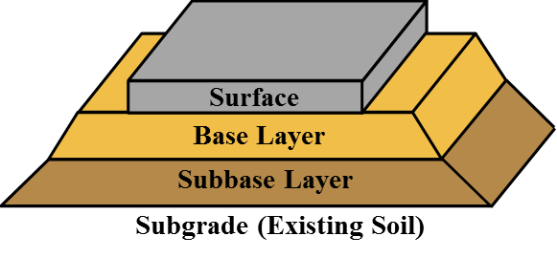
Figure 1. The general structure of rigid and flexible pavements
Subgrade layers of pavements should be strong and stable enough to withstand the loads and to increase the service life of pavements (Kazmee et al. 2016). Due to frost-heave and thaw-weakening susceptibility of fine-grained subgrade layers, coarse-grained aggregate (Figure 2) layers are constructed to minimize the instability caused by subgrade and to protect the upper layers (surface and base courses). Coarse-grained structure of aggregates minimizes the capillary action and help to evacuate the water coming from top layers easily (Uhlmeyer et al. 2003).
Large Stone Subbase Materials
The applications of large stone subbase (LSSB) materials as subbase layers and working platforms have been investigated by Idaho DOT, Illinois DOT, and Wisconsin DOT (Uhlmeyer et al. 2003; Kazmee et al. 2015; Kazmee et al. 2016). To improve the sustainability of pavement systems, the use of alternative materials such as LSSB materials (generally top size $≥$ 76 mm or 3 in.) has been becoming popular. Large stones generally go through a single crushing operation. Thus, the amount of energy consumed to break up larger aggregates to obtain conventional aggregate gradations for subbase applications can be reduced by using LSSB-type of materials (Kazmee et al. 2015).
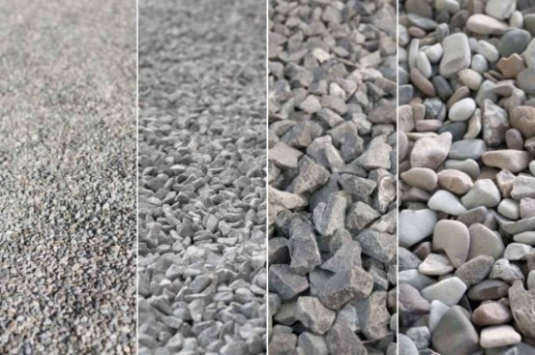
Figure 2. Fine- to coarse-grained aggregates (left to right) (http://engineeringfeed. com/8-factors-affect-workability-fresh-concrete)
Index and Engineering Properties of LSSB Materials
Due to their large-sizes and the limitations of the test equipment and laboratory facilities, the LSSB materials cannot be tested easily in the laboratory. However, several field observations have been made. Thus, a limited information is available in the literature regarding their index and engineering properties (Kazmee and Tutumluer 2015).
Grain and Gradation Characteristics
Since it is not practicable to sieve the large-size aggregates (e.g., LSSB) due to the limitations of the standard sieve sizes, high-resolution image techniques can be performed to obtain their particle size distribution (Kazmee and Tutumluer 2015). In addition, several other morphological properties such as the flat and elongated particles, the angularity of particles can be observed by imaging techniques. The angularity of aggregates increases as the crushing operations goes from the primary stage to further stages. In general, the large-size aggregates may have less angularity compared to conventional aggregates because they generally go through a single crushing operation (Kazmee et al. 2016).

Hydraulic Properties
Hydraulic properties of aggregates are highly affected by gradation. Fine particles fill the voids of the aggregate matrix and reduce the drainage properties of aggregates (Cosentino et al. 2003). It is expected that LSSB materials have good drainage properties since water can move freely through very large pores unless they do not contain a high amount of fines.
Stiffness Properties
Relatively higher stiffness values can be observed in large-size aggregates with the light weight deflectometer (LWD) test. In addition to higher stiffness values, fluctuation of the stiffness data can be observed with the LWD test due to larger voids presence in the large-size aggregates (Kazmee et al. 2016).
Permanent Deformation Properties
Increase in layer thicknesses leads to lower permanent deformation values because of improved stress distribution. Stress is distributed more effectively throughout a thicker layer (Cetin et al. 2010; Schaertl 2010, as cited in Edil et al. 2012). In addition, the presence of larger aggregates in the material matrix contributes to the strength and the resistance against deformation (Gray et al. 1962; Kazmee et al. 2016).
Different modes of permanent deformation failures can be observed in pavements and three main modes are classified as mode 0, mode 1, and mode 2 (Figure 3). Initial improper compaction of granular materials may leave large voids and mode 0 failure may be seen under loading conditions. Shear failure of a layer containing granular material may cause horizontal movement of particles beneath the wheel path, and mode 1 failure may be seen. Failure of weak subgrade layer leads to mode 2 type failure (Dawson and Kolisoja 2006). Less permanent deformation is observed in well-graded aggregates compared to uniformly-graded aggregates due to denser aggregate structure and less porous aggregate matrix (Kazmee et al. 2016).
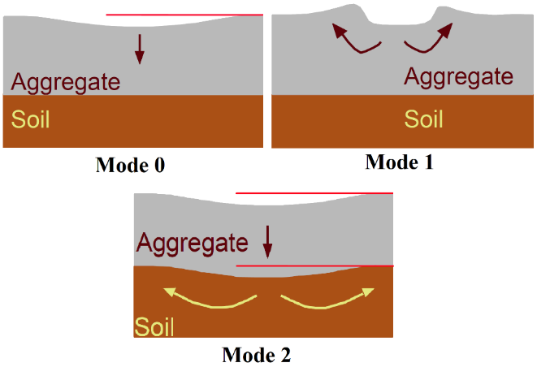
Figure 3. Permanent deformation failure modes of large size aggregates (Dawson and Kolisoja 2006)
Freeze-Thaw Durability
Coarse-grained materials are less susceptible to the freeze-thaw action than fine-grained materials due to their more porous structure. However, containing fine-grained particles more than 5-10% may cause the coarse-grained materials to be more frost susceptible (Konrad and Lemieux 2005).
Geosynthetic Applications
To improve the performance of pavements constructed over weak subgrade soils, geosynthetics can be used (Abu-Farsakh et al. 2016). In pavement constructions, geotextiles and geogrids (Figure 4) are the two commonly used geosynthetic types (Zornberg 2017). Geotextiles can be woven or nonwoven. Along with that, geogrids can be biaxial or multiaxial (Erickson and Drescher 2001; Zornberg 2017).
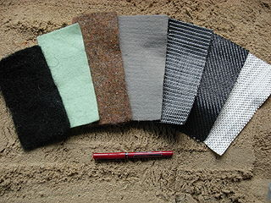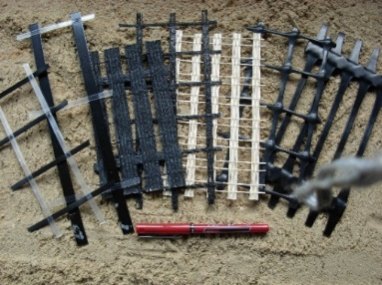
Figure 4. Geotextiles¹ (left) and geogrids² (right)
¹https://study.com/academy/lesson/what-is-geotextile-fabric-definition-types.html
²https://commons.wikimedia.org/wiki/File:Geogrids.JPG*
Functions of Geosynthetics
Main functions of geosynthetics in pavement systems are providing separation, filtration, and reinforcement (Zornberg 2012). To improve the performance of the layers beneath the surface, they can be used between base and subbase or between subbase and subgrade (Zornberg 2017).
Separation Function
Granular base layers tend to move into soft subgrade layer because of traffic loads and compaction effort during construction. Contamination of subgrade may cause serious problems as a result of a reduction in structural support. Presence of fine-grained materials in base layers may cause a reduction in shear strength and permeability. In addition, it may cause an increase in frost-susceptibility of base layers, which may cause detrimental problems in the long term (Zornberg 2017). To prevent the detrimental interaction between bases and subgrade layers, geosynthetics (mostly geotextiles) are used as a separation layer (Figure 5) (Erickson and Drescher 2001).
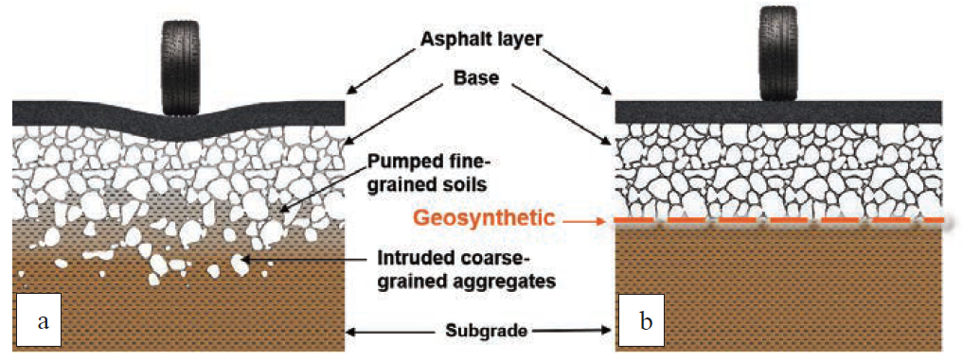
Figure 5. Separation function of geosynthetics (Zornberg 2017)
Filtration Function
Fine-grained subgrade soils tend to move towards the base layers as a result of upward movements of water. Geosynthetics can be used as a filtration layer between base layers and subgrade to prevent the movement of fine-grained soils while allowing water molecules to move freely to coarse-grained base layers (Figure 6) (Zornberg 2012; Erickson and Drescher 2001). Due to the large opening sizes of geogrids, geotextiles are more suitable for filtration applications.
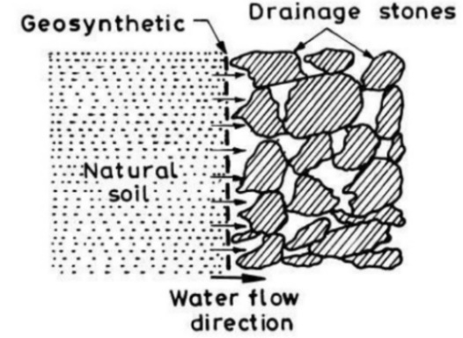
Figure 6. Filtration function of geosynthetics
(https://www.slideshare.net/samirsinhparmar/lec-2-functions-and-selection-of-geosynthetics)
Reinforcement Function
Using suitable geosynthetics can help to improve the bearing capacity of subgrade layer and to minimize the permanent deformation (Perkins et al. 2005). A better load distribution can be obtained and stresses acting on subgrade soils can be reduced (Figure 7) (Zornberg 2012). Providing lateral resistance, increasing bearing capacity, and acting as a tensioned membrane are the three main mechanisms of geosynthetic reinforcement (Holtz et al. 1998). Base layer thicknesses of pavements can be reduced by using geosynthetics. The use of these materials with the reduction in base layer thickness usually does not affect the expenses for maintenance purposes in the long-term. On the other hand, if geosynthetics are used without no change in the base layer thickness, maintenance costs can be reduced (Perkins et al. 2005).
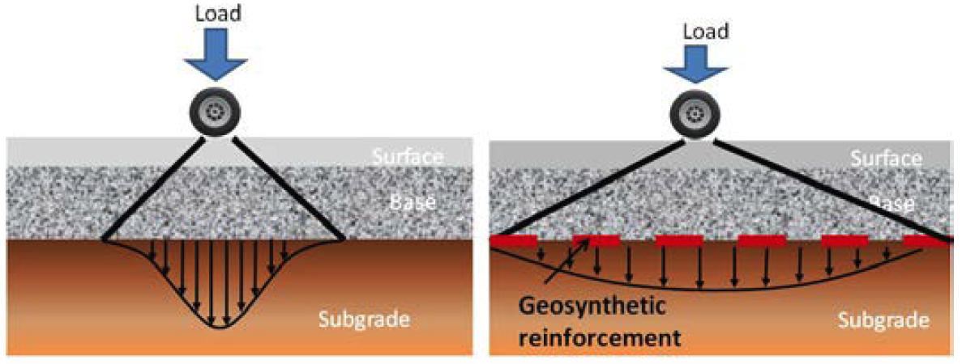
Figure 7. Load distribution mechanisms of (a) unreinforced pavement, and (b) reinforced pavement (Zornberg 2012)
Design Methods
The most commonly used design methods are AASHTO 1993 and Mechanistic-Empirical Pavement Design Guide (MEPDG) – AASHTOWare Pavement ME Design for designing rigid and flexible pavement systems (Edil 2011; LRRB 2016). There are also local design methods used by local agencies such as state DOTs, e.g., MnDOT’s Granular Equivalent Method (LRRB 2016).
AASHTO 1993 Design Method
General Design Method
AASHTO 1993 design method is an empirical method based on the structural numbers (SN) indicating the structural capacity and role of each pavement layer. The thickness and stiffness of each layer are the main parameters that are needed to be determined for calculating the SN of each layer (Edil 2011). Then, the following equation is used to determine the overall structural number (Locander 2009; Zornberg 2012; MacGregor et al. 1999).
$$\text{SN = }{\text{(a}}_{\text{1}}\text{× }{\text{D}}_{\text{1}}\text{) + (}{\text{a}}_{\text{2}}\text{× }{\text{D}}_{\text{2}}\text{× }{\text{m}}_{\text{2}}\text{) + (}{\text{a}}_{\text{3}}\text{×}{\text{ D}}_{\text{3}}\text{× }{\text{m}}_{\text{3}}\text{)}$$
where;
a₁, a₂, a₃ = structural layer coefficients (based on stiffness) of the surface, base and subbase layers, respectively
D₁, D₂, D₃ = thicknesses (in inches) of the surface, base and subbase layers, respectively
m₂, m₃ = drainage coefficients of the base and subbase layers, respectively
The structural layer coefficient of a₃ (for subbase) is determined based on the layer stiffness (Kim et al. 2005; Cetin et al. 2010). The following equation can be used to calculate the structural layer coefficient of the subbase layer (a₃) (AASHTO 1993).
a₃ = 0.227 × log M_{r3} – 0.839
where; M_{R3} is the resilient modulus of the granular subbase (lbs/in²)
The general trend is that the layer coefficient increases with an increase in the layer stiffness (Rada and Witczak 1982).
Modified Design Method for Reinforced Pavements
AASHTO 1993 design method can be modified if geosynthetics are intended to be used for reinforcing. The modifications are made based on the Traffic Benefit Ratio (TBR) and the Base Course Reduction (BCR) with the use of geosynthetics (Berg et al. 2000; Zornberg 2012).
The Traffic Benefit Ratio (TBR), or the Traffic Improvement Factor (TIF) in some references, is defined as the following equation (Berg et al. 2000; Zornberg 2012);
$$\text{TBR = }\frac{{\text{N}}_{\text{R}}}{{\text{N}}_{\text{U}}}$$
where;
N_{R} = the number of load cycles on a reinforced section to reach a defined failure state for (a given rutting depth)
N_{U} = the number of load cycles on an unreinforced section with the same geometry and material constituents that reaches the same defined failure state
Typical ranges for TBR values of 1.5 to 10 are defined for geotextiles and 1.5 to 70 for geogrids. W₁₈ is defined as the predicted number of 18-kip equivalent single-axle loads (ESALs) over the design life of the pavements which is modified by TBR as following (Zornberg 2012);
W₁₈ (reinforced) = TBR × W₁₈ (unreinforced)
The Base Course Reduction (BCR), or the Layer Coefficient Ratio (LCR) in some references, can be determined by field and laboratory tests and it is defined as the following equation (Zornberg 2012);
$$\text{BCR =} \frac{{\text{T}}_{\text{R}}}{{\text{T}}_{\text{U}}}$$
where;
T_{R} = the base-course thickness due to an addition of geosynthetic reinforcement
T_{U} = the thickness of the flexible pavement with the same materials but without reinforcement
The general range of BCR is given as 20% to 40% in the literature. The overall SN is modified by BCR as following (Berg et al. 2000);
$$\text{SN = }{\text{(a}}_{\text{1}}\text{× }{\text{D}}_{\text{1}}\text{) + BCR × (}{\text{a}}_{\text{2}}\text{× }{\text{D}}_{\text{2}}\text{× }{\text{m}}_{\text{2}}\text{) + (}{\text{a}}_{\text{3}}\text{×}{\text{ D}}_{\text{3}}\text{× }{\text{m}}_{\text{3}}\text{)}$$
Another alternative method for implementing the impact of geosynthetics in the pavement design is using structural numbers of reinforced pavement layers. Structural numbers obtained from layers in which less extensible geosynthetics are used (e.g., geogrids and woven geotextiles) are higher than the numbers obtained from layers constructed with more extensible geosynthetics (e.g., nonwoven geotextiles) (Kim et al. 2005).
Mechanistic-Empirical Pavement Design Guide – MEPDG
Unlike the AASHTO 1993 design method which is an empirical approach, plastic deformation is taken into account in the MEPDG which is a mechanistic-empirical approach. Several parameters such as modulus values of layers, climate zone, traffic conditions, the designed service life of the pavement, and failure criteria are used to obtain the most suitable design conditions. Design thicknesses can be determined by making iterations for specific materials and other related conditions (Edil 2011). Previously stated parameters can be obtained from experience or from other related projects.
Selected Practices of State DOTs
California DOT
The materials used as subbase aggregate must meet the gradation ranges and quality characteristics of Class 1, Class 2, or Class 3 aggregate (Caltrans 2015). However, the maximum aggregate size for the stated classes is 2 ½ in which do not meet the minimum 3 in aggregate size of LSSB.
Filter fabric can be placed on the subgrade before spreading the subbase layer. If the thickness of the subbase layer is more than 6 in, materials should be placed and compacted in 2 or more layers.
Illinois DOT
IDOT - Bureau of Design and Environment defines three new aggregates with gradation specifications named CS01 (8 in. top size), CS02 (6 in. top size), and RR01 (3 in. top size) in addition to conventional CA2 (2 in. top size) and CA6 (1 in. top size) aggregates for aggregate subgrade improvement applications. The nominal lift thickness of the newly-specified aggregates must not be more than 24 in (IDOT 2016).
Missouri DOT
Durable stones containing no more than 10% (by weight) of earth, sand, shale, and non-durable rock are allowed for base applications in addition to types 1, 5, and 7 aggregates. The maximum particle size depends on the layer thickness. No maximum aggregate size must exceed 6 in less than the lift thickness. The maximum aggregate size should be about 12 inches for 18-inch rock base. In addition, the maximum size should be about 9 inches for 12-inch rock base. The size and quality of material are visually inspected for acceptance at the job site (MoDOT 2018).
Wisconsin DOT
Large crushed stones (5 in. top size) are allowed for subgrade correction and improvement. Materials should be free of topsoil, organic materials, steel, or overburden materials. Crushed materials from non-durable rock may be rejected (WisDOT 2018).
References
AASHTO (1993). ‘‘Guide for Design of Pavement Structures’’, American Association of State Highway and Transportation Officials, Washington, DC
Abu-Farsakh, M., Hanandeh, S., Mohammad, L., & Chen, Q. (2016). Performance of geosynthetic reinforced/stabilized paved roads built over soft soil under cyclic plate loads. Geotextiles and Geomembranes, 44(6), 845-853.
Berg, R. R., Christopher, B. R., & Perkins, S. (2000). Geosynthetic reinforcement of the aggregate base/subbase courses of pavement structures (No. GMA White Paper II).
CalTrans (2015). Standard Specifications. California Department of Transportation, Sacramento, CA.
Cetin, B., Aydilek, A. H., & Guney, Y. (2010). Stabilization of recycled base materials with high carbon fly ash. Resources, Conservation and Recycling, 54(11), 878-892.
Cosentino, P. J., Kalajian, E. H., Shieh, C. S., Mathurin, W. J. K., Gomez, F. A., Cleary, E. D., & Treeratrakoon, A. (2003). Developing specifications for using recycled asphalt pavement as base, subbase or general fill materials, phase II (No. FL/DOT/RMC/06650-7754).
Dawson, A., & Kolisoja, P. (2006). Managing rutting in low volume roads: Executive summary. Finland.
Edil, T. (2011). Specifications and recommendations for recycled materials used as unbound base course, Recycled Materials Resource Center, Univ. of Wisconsin-Madison, Madison, WI.
Edil, T. B., Tinjum, J. M., & Benson, C. H. (2012). Recycled Unbound Materials. Minnesota Department of Transportation. Report No. 2012-35. St. Paul, MN.
Erickson, H., and Drescher, A. (2001). “The use of geosynthetics to reinforce low volume roads: Final report.” Rep. No. MN/RC-2001-15, Minnesota Department of Transportation, St. Paul, MN.
Gray, J. E. (1962). Characteristics of Graded Base Course Aggregates Determined by Triaxial Tests. National Crushed Stone Association. Engineering Bulletin, (12).
Holtz, R. D., Christopher, B. R., & Berg, R. R. (1998). Geosynthetic design and construction guidelines (No. FHWA HI-95-038).
Hoppe, E. J., Lane, D. S., Fitch, G. M., & Shetty, S. (2015). Feasibility of reclaimed asphalt pavement (RAP) use as road base and subbase material (No. VCTIR 15-R6).
IDOT (2016). Standard Specifications for Road and Bridge Construction. Illinois Department of Transportation, Springfield, IL.
Kazmee, H., & Tutumluer, E. (2015). Evaluation of aggregate subgrade materials used as pavement subgrade/granular subbase. Illinois Center for Transportation/Illinois Department of Transportation.
Kazmee, H., Mishra, D., & Tutumluer, E. (2015). Sustainable alternatives in low volume road base course applications evaluated through accelerated pavement testing. In IFCEE 2015 (pp. 409-418).
Kazmee, H., Tutumluer, E., & Beshears, S. (2016). Pavement working platforms constructed with large-size unconventional aggregates. Transportation Research Record: Journal of the Transportation Research Board, (2578), 1-11.
Kim, W. H., Edil, T., Benson, C., & Tanyu, B. (2005). Structural contribution of geosynthetic-reinforced working platforms in flexible pavement. Transportation Research Record: Journal of the Transportation Research Board, (1936), 43-50.
Konrad, J. M., & Lemieux, N. (2005). Influence of fines on frost heave characteristics of a well-graded base-course material. Canadian geotechnical journal, 42(2), 515-527.
Little, D. N., and Nair, S. (2009). Recommended practice for stabilization of subgrade soils and base materials, National Cooperative Highway Research Program, Transportation Research Board of the National Academies.
Locander, R. (2009). Analysis of using Reclaimed Asphalt Pavement (RAP) as a Base Course Material. Colorado Department of Transportation DTD Applied Research and Innovation Branch (pp. 1-68). Report No. CDOT-2009-5.
LRRB (2016). Recycled Materials in Unbound Aggregate Base Layers in Minnesota. Transportation Research Synthesis (TRS 1604). Local Road Research Board, Minnesota Department of Transportation.
MacGregor, J., Highter, W., & DeGroot, D. (1999). Structural numbers for reclaimed asphalt pavement base and subbase course mixes. Transportation Research Record: Journal of the Transportation Research Board, (1687), 22-28.
MoDOT (2018). Missouri Standard Specifications for Highway Construction. Missouri Highways and Transportations Comission.
Perkins, S. W., Bowders, J. J., Christopher, B. R., & Berg, R. R. (2005). Geosynthetic reinforcement for pavement systems: US perspectives. In International Perspectives on Soil Reinforcement Applications (pp. 1-13).
Rada, G., & Witczak, M. W. (1982). Material layer coefficients of unbound granular materials from resilient modulus. Transportation Research Record, 852, 15-21.
Schaertl, G.J. (2010). “Scaling and Equivalency of Bench-scale Tests to Field Scale Conditions.” MS Thesis, University of Wisconsin-Madison, WI.
Schuettpelz, C. C., Fratta, D., & Edil, T. B. (2010). Mechanistic corrections for determining the resilient modulus of base course materials based on elastic wave measurements. Journal of geotechnical and geoenvironmental engineering, 136(8), 1086-1094.
Uhlmeyer, J., Pierce, L., Lovejoy, J., Gribner, M., Mahoney, J., & Olson, G. (2003). Design and construction of rock cap roadways: Case study in Northeast Washington State. Transportation Research Record: Journal of the Transportation Research Board, (1821), 39-46.
WisDOT (2018). Standard Specifications. Wisconsin Department of Transportation, WI.
Zornberg, J. G. (2012). Geosynthetic-reinforced pavement systems. In 5th European Geosynthetics Congress, Valencia, Spain.
Zornberg, J. G. (2017). Functions and applications of geosynthetics in roadways. Procedia engineering, 189, 298-306.

