Title: Continuous Moisture Measurement during Pavement Foundation Construction
Authors: Soheil Nazarian, UTEP, nazarian@utep.edu,
Mark Baker, Private Consultant, bakergrd@cs.com
Abstract: Accurate and timely moisture measurement of earthwork during compaction of foundation layers is crucial to proper construction and long-term durability of the pavement structures. Since the traditional methods for measuring moisture are point specific, expensive, and/or time consuming, it is desirable to explore new devices that can provide the full coverage of the spatial variation of moisture.
This project will document the current state of knowledge concerning field moisture measurement during pavement foundation construction that also includes case studies that demonstrate cost savings resulting from more effective moisture measurement. This project will also provide critical information regarding the most effective moisture measurement devices suitable for improving compaction near structures such as retaining walls and bridge abutments. Finally, this proposal will demonstrate a prototype device capable of continuously measuring moisture during pavement foundation construction.
Introduction: In a series of publications (e.g., Tatsuoka and Correia, 2018), Tatsuoka, Correia, and their colleagues showed the importance of controlling the moisture content and degree of saturation during the construction of unbound pavement layers. Failing to estimate the moisture content accurately and promptly during construction may negatively impact the proper quality control/quality assurance (QC/QA) of compacted geomaterials (Roberson and Siekmeier, 2002; Nazarian et al., 2014). Although numerous methods and techniques have been proposed to measure moisture content, none of them have been able to deliver real-time, continuous moisture measurements that would aid the engineers in delivering more durable pavement structures.
Several techniques for determining the moisture content of geomaterials have been proposed throughout the years. These techniques, which can be classified based on their approaches and measuring principles, are normally divided into direct and indirect categories (Svensson, 1997). The direct method consists of extracting a soil sample from the desired location to be investigated. The soil sample is weighed before and after drying in an oven at a maximum temperature of 105°C (220°F). This is the gold standard for measuring the moisture content. However, it is neither nondestructive, continuous, nor real-time.
Indirect methods are based on the use of a radiation source or a probe in the soil for the measurement of moisture contents. Some examples of these methods (see Table 1) consist of the time domain reflectometry, ground penetrating radar (GPR), electromagnetic/dielectric measurements, soil resistivity/conductivity, etc. None of these methods measure the water content directly. They each measure a parameter that is correlated with the water content in the soil. Some of these methods only provide spot measurements, some require probe insertion, while most are typically nondestructive since the soil is only disturbed during installation (Evett et al., 2008).
Several techniques are still in the process of development to create automated continuous soil water content measurements in the field. Researchers around the world have been investigating these techniques to discover the most efficient method. Muller (2017) demonstrated an innovative semiautomatic approach using multi-offset GPR to achieve quantitative estimates of moisture content and layer depth predictions continuously over long lengths of the existing roads at traffic-speeds for unbound granular pavements. A 3D Noise-Modulated (NM-GPR) equipment was used for moisture content measurements by collecting a series of adjacent partially overlapping ground-coupled multi-offset measurements. Muller concluded that predictions using this approach matched well with the physical measurements of layer depth and moisture content of pavement layers. Several studies have experimented with near-infrared moisture sensors (e.g., Yonemaru et al., 2019). The technology has been found to work well with finer materials. However, the estimated moisture contents correlate better with the very shallow skin of the compacted geomaterials.
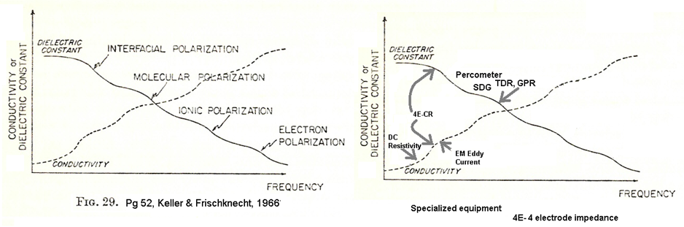
Figure 1a illustrates the various charge-transfer mechanisms of several methods discussed in Table 1, contributing to the measured dielectric constant or conductivity (resistivity is inversely proportional to conductivity). The portions of the curves shown in Figure 1a that are measured by the state of the art in pavement moisture studies are illustrated in Figure 1b. Conductivity and dielectric constant are directly dependent on one another. When measurements are made over small distances at high frequencies, the conductivity is high and polarization low. On the other hand, when measurements are made at lower frequencies, the longer travel distance permits the charges to encounter progressively more barriers, resulting in increased polarization and lower conductivity. The critical point of this discussion is that the current test methods that operate on measuring the dielectric constant over a limited frequency range (GPR/TDR) or conductivity (DC resistivity) do not fully characterize the influence of moisture content on the measured properties. A far more reliable proxy for moisture can be made by concurrently measuring the resistivity/conductivity and dielectric constant over a wider range, particularly at intermediate frequencies where charges travel on the scale of the pore space.
- Physical Characteristics Measured b) Range of Operation of Current Common Tests
Figure 1 – Variation of Dielectric Constant and Conductivity (Inverse of Resistivity) with Frequency (after Keller & Frischknecht, 1966)
Objective: The objective of this study is to demonstrate a prototype/breadboard of a device that can continuously measure moisture during pavement foundation construction (similar to Asphalt Rolling Density Meter (https://www.geophysical.com/products/pavescan-rdm) used for asphalt layer.
Proposed Technology. The proposed technology is based on the measurement of complex resistivity (CR) of geomaterials as a function of frequency, field strength, and measurement geometry to characterize moisture content and degree of saturation. The traditional DC or low-frequency resistivity measurements, which is characterized as the ratio of voltage to current (V/I) that a material can carry, is based on the assumption that the voltage and current are independent of the frequency with the expectation that a sine-wave of current flow accompanies a sine-wave of voltage, without delay or distortion. In the complex resistivity tests, the resistivity (V/I) amplitude is measured over a broad range of frequency along with the distortion (phase shift) between the voltage and current. The sinusoidal portion of V/I that is in-phase provides the resistivity and V/I with a 90-degree phase shift provides the dielectric constant. Alternatively, the inverse of resistivity is proportional to the conductivity of the geomaterial.
Relation to Unsaturated Soil Principles. The concept embodied by matric suction is that the air-water interface behaves differently in close association with mineral grain surfaces and reflects mineral grain size distribution and mineral surface charge, which control the pore pressure as pores fill with water. CR measures ionic conduction and polarization along adsorbed water at grain boundaries, ionic conduction through free pore fluid, and polarization at the air-water interface. Void content, moisture content, and pore size distribution control the in-phase and out-of-phase currents. Both high-frequency permittivity (via GPR/TDR EM tools) and low-frequency conductivity/resistivity have shown strong correlations to moisture content, but each responds to different moisture-related characteristics that require calibration for other uncontrolled variables. Dielectric permittivity in the 100 MHz to GHz range, which responds primarily to the permittivity from water-molecule rotation being an order of magnitude larger than that of aggregate, is not sensitive to the distribution of water in the pore, or air-water interactions. Water permittivity is typically suppressed by ionic influence from dissolved solids or mineral surface charges, leading to bias in materials with high fines content. Low-frequency resistivity measurements are dominated by the degree of saturation and water connectivity through the pore space, and secondarily by water volume. Low-frequency resistivity could probably be used with little calibration if enough measurements are made to distinguish residual moisture on fines, saturation variations, and void changes in compactions. This requires measuring a) material resistivity before watering, b) resistivity of the water added, and then c) pre- and d) post-compaction resistivity. CR at intermediate frequencies should distinguish saturated and unsaturated cases with an enhanced polarization signal with partial saturation from charges blocked from the movement at air-water interfaces and minimize the need to measure soil resistivity before watering, and the water resistivity.
Table 1. Indirect Tests Methods
Method | Measurement Principle | Explanation
Capacitance Meters | Oscillating circuit to measure changes in resonant frequency, or measure electrode impedance | A capacitor consists of two electrodes, insulated each other by a dielectric (in this case, the surrounding soil constitutes the dielectric in a capacitor). The probe detects and measures the change in frequency which has a direct relationship with the water content in the soil.
Ground Penetrating Radar (GPR) | Short pulses of electromagnetic waves through soil | Differences in transmission time and amplitude of the reflected pulse can be related to changes in permittivity (dielectric constant) that can be used to estimate the water content of the soil.
Conductivity Sensors | Electrical conductivity of a porous medium in contact with soil | An alternating current is driven into two electrodes in a porous material interacting with the soil. The amount of current is a measure of the conductivity and amount of water between the electrodes in the porous material.
Resistance measurements | Resistance between two electrodes | Moisture levels in the soil are measured in terms of their electrical resistance or dielectric property which vary at different moisture contents. As the moisture content increases, the electrical resistance of the soil decreases, and conductance increases.
EM Eddy Current | Induced transient magnetic field from currents | An alternating or stepped current in a transmitter coil induces a magnetic field in the soil. Eddy currents flow in response to the induced field and are picked up by a receiver coil. Measures the product of electrical conductivity and magnetic permeability.
4-Electrode Resistivity | Current induced at two electrodes. Voltage difference measured at two other electrodes | An alternating current is induced between two electrodes, either by metal-soil contact or capacitive-coupling at high voltages. A potential difference between two electrodes with no current flow is related to current and spacing. Electrode geometry controls the depth of investigation.
Knight (1991) investigated complex impedance at lower GPR frequencies (higher frequency than our proposed CR) and demonstrated laboratory resistivity hysteresis under drainage and imbibition constraints, with a proposed explanation that is nearly identical to that underlying matric suction measurements. She observed the strongest resistivity/saturation relation under draining conditions, indicating strong sensitivity to field conditions monitoring moisture during compaction. As such, the primary measurement of CR at appropriate frequencies is measuring many of the same attributes controlling the soil water characteristic curve (SWCC) mineral grain/adsorbed water/air system.
Advantages. Using CR measurements for monitoring moisture content during compaction has the following four distinct advantages.
- The frequency range that is most sensitive to polarization at the air/water interface can be determined for given pore size. GPR and TDR measurements in the 100 MHz to GHz range are dominated by water molecule rotation, sensitive to moisture content, but not moisture distribution in the pores of partially saturated geomaterials. Low-frequency (DC or < 200 Hz) resistivity measures polarization at the air-water interface but is also sensitive to lower-frequency polarization mechanisms for nonuniform fine-grained aggregate distribution in a geomaterial.
- The volume of the material investigated with CR measurements (similar to TDR) can be controllable by electrode geometry, in contrast to the decreasing depth of penetration with increasing frequency common to GPR or infrared.
- The feasibility of controlling the volume of investigation with CR facilitates the same measurements in both lab and field, simplifying material-specific calibration of the measurements.
- Using electrode measurements also lets us sidestep the usually uncontrolled factor of varying properties intrinsic to aggregate from different quarries, which can bias GPR/TDR/EM measurements.
Implementation. We expect the best diagnostic results from the CR method to come from a primary measurement of complex resistivity via a 4-electrode (4E) resistivity array, using surface contacts similar to the Proceq Resipod (https://www.proceq.com/uploads/tx_proceqproductcms/import_data/files/ Resipod%20Family_Sales%20Flyer_English_high.pdf). More sophisticated electronics permit variable frequency and variable amplitude sine-wave current induced at a pair of electrodes to drive the in-phase and out-of-phase voltage on a distinct pair of measurement electrodes.
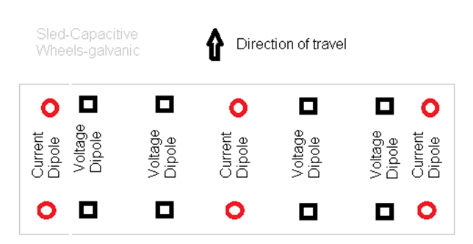
Potential hardware variants that may allow for less accurate, but faster continuous field measurement include using electromagnetically coupled eddy-currents (typically used for resistivity and magnetic susceptibility) sensors, or capacitive-coupled field injection technique used in the non-contact Ohm-Mapper (https://geometrics.com/wp-content/uploads/2018/10/OhmMapper_Spec_Sheet.pdf). Another potential field optimization is to use combinations of multiple current electrodes, and multiple potential electrode pairs to cover a larger spatial area (up to a lane width) to image lateral and depth variations. Continuous measurements in one position can measure time-depth moisture migration.
Instrumentation. A conceptual configuration of the system is shown in Figure 2, using an equatorial array geometry with multiple sources, giving both spatial variation and depth information. The following four independent components are necessary to implement CR for continuous field measurements:
- The electronics and lab electrode systems for making the CR measurement at the relevant frequencies need to be built and validated.
Figure 2 - A Conceptual Configuration of Proposed System
- A basic field electrode array needs to be designed and built that implements a small array of current injection and voltage sensing electrodes. This array could equally well be used for basic DC resistivity electronics in some form. Electrode spacings and geometries should be designed for target lift/layer thicknesses.
- Multiple arrays could be combined into a wider array should measurement up to road-width be desired.
- Software for interpreting DC resistivity measurements can be applied as a first pass. Success in the first stage will point toward implementing finite-difference modeling to improve array geometry and characterize the effect of resistivity anisotropy on the measurement. Besides, mixing laws predicting CR from composition do not exist, and particularly do not share common variables with matric suction models. Development and testing of these models require joint lab characterization and it appears assumptions used by de Lima and Sharma (1991) are appropriate for this development direction.
Equipment for measuring CR in the field and an array for making continuous measurements in construction settings cannot be purchased off-the-shelf. Commercial resistivity devices do not operate in this higher frequency range and make polarization measurements with unacceptable assumptions. Laboratory grade phase-lock amplifiers and distortion analyzers applicable to making CR measurements exist. In the past year, we have designed and prototyped a small inexpensive phase-locked signal generator and phase-sensitive detectors that exceed the noise-rejection and accuracy we need for the lab phase and can move directly into a field prototype under either 4E, EM, or capacitive-coupled approaches.
Field Operation. We envision field operation could be done very similarly to the Asphalt Rolling Density Meter currently used for obtaining the hot mix asphalt air voids content. The area will be mapped first to site locations for a few calibration samples. The field measurements and the results from the calibration samples will be used to provide a continuous map of the moisture content and its derivatives. Ideally, the CR measurements can be conducted at two stages. The first set of measurements can be carried out after material placement, watering, and mixing but before compaction as a process control to assist the contractor with identifying the distribution of fines, uniformity of watering, and a bound on whether adequate water was applied. The second set of tests can be conducted as part of quality control to ensure the appropriate distribution of the moisture content. If the two sets of measurements are carried out along the same section, the differential in CR measurements can only come from a reduction in voids and an increase in the degree of saturation. These measurements can be very valuable for understanding the process of compaction of different geomaterials.
Calibration. Calibration of the CR measurements to pavement performance can follow several paths. As the first step, several moisture-density specimens prepared for the Proctor tests can be used to develop moisture and degree of saturation vs. CR measurement curve (simultaneous with the moisture-density curve). This preliminary curve can be used to develop the moisture content/degree of saturation color-coded maps. As indicated above, for more rigorous calibration several samples of the geomaterial will be tested to develop a project-specific local calibration curve (very similar to the asphalt roller density meter). A more advanced approach that can be implemented in the future phases of this project involves the development of mixing laws that integrate the matric suction pore geometries with CR and stiffness prediction.
Variables: The key variables of the geomaterials are the volumetric and gravimetric moisture contents, degree of saturation, matric suction, dielectric permittivity, electrical conductively, and the oscillation frequency of the electromagnetic field created by the waveguides. Another variable that is significant in equipment design or configuration is the depth of investigation. The goal of the team is to test systematically the sensitivity of the proposed system to each of these parameters as discussed in the methodology section.
Hypothesis: The hypothesis is that the dielectric permittivity and electrical conductivity of in-place geomaterials can be continuously measured and used to estimate the moisture content and matric suction, which can then be displayed graphically as a moisture uniformity map.
Methodology: The project will include the following five tasks.
Task 1: Document Current State of Knowledge. A substantial review of the literature has been carried out in preparing this proposal. In this task the current state of knowledge related to field and laboratory methods that can measure or estimate material properties used to determine moisture content, degree of saturation and matric suction will be documented. As part of this task, several case studies that demonstrate the technical benefits and the cost savings resulting from more effective moisture monitoring will also be provided. Finally, this task will be concluded with a comprehensive and extended work plan for the smooth and timely execution of this project.
This task also consists of developing an experimental test plan to test up to ten different geomaterials. Based on the interaction with the panel, up to six geomaterials will be selected as a baseline for verification of the outcomes of this study. These materials will be preferably from the home State of the panel members for close interaction and feedback. We will sample an adequate amount of materials for laboratory and small-scale studies as described below. Our current thinking is to select two fine-grained soils (CL, CH, ML, or MH), two sandy materials (SW, SP, SM, or SC), and two coarse-grained materials (GW, GP, GM, or GC). These ranges provide a good basis for materials with different characteristics in terms of their interaction with moisture, levels of suction, levels of moduli, and their use as compacted geomaterials.
Task 2: Test Laboratory Prototype. Initial work has been carried out to prototype the devices for laboratory testing. We anticipate that the prototype will be functional by the time that Task 1 is completed.
The laboratory work will very closely follow the work that Sotelo (2012, https://www.dropbox.com/s/ 5lfcy14q936f5ex/Sotelo%20Thesis.pdf?dl=0) carried out as part of NCHRP Project 10-84 to evaluate the accuracy, precision, and applicability of three moisture content devices (soil density gauge, Purdue TDR, Campbell Scientific DOT 600). The laboratory testing on each material selected includes:
- Conduction of gradation and Atterberg limits tests on soil samples
- Development of moisture-density, moisture-CR (using the lab prototype, moisture modulus (using Free-free- resonant column tests), degree of saturation-CR. All these tests will be carried out at five different nominal moisture contents of optimum moisture content (OMC, OMC±10% OMC, and OMC±20%OMC). All tests will be carried out in duplicate to assess the repeatability of the results on the same specimens since all tests mentioned are nondestructive.
- Preparation of small-scale (24 in. high by 18 in. diameter) specimens (at strictly controlled densities and moisture contents placed in 2 in. lifts.
- Test the specimen with the prototype at least at five horizontal locations at three levels to determine the repeatability.
- Compare the moisture contents measured by the prototype with those from oven drying to determine the accuracy.
- Develop a database of all test results.
- Conduct analysis using statistical and process control tools to develop a preliminary operational tolerance, get a sense of the overall precision and bias of the device.
Task 3: Develop and Test Field Prototype. Concurrent with laboratory testing, a field version of the tool will be developed. This device will not be ruggedized or professionally packaged for day-to-day use but will be modular for ease of modification.
The last three months of this task will be dedicated to field testing of the field prototype at local sites to debug the system and ensure accuracy. The goals of this activity are the following:
- to verify the applicability of the results from small-scale and laboratory tests carried out as part of Task 2, and
- to establish the variability of the prototype under less controlled condition to delineate the equipment variability (established in Task 2) from site variability.
Aside from the tests enumerated in Task 2, we will carry the following activities at each testbed.
- Sample geomaterial from five points at windrow before compaction
- Monitor the increase in density and modulus of the layer with the number of passes at two points
- Carry continuous measurement with prototype along five lines three times
- Graphically summarize field data by mapping the spatial variation of moisture measurements
- Test ten points at least three times with the device shortly before and after compaction along with one NDG test at each point
- Retrieve samples for moisture content from ten points to validate the device’s results.
- Analyze field data to ensure that the two goals listed above are met.
Task 4: Demonstrate Prototype. Upon satisfactory testing of the prototype, the device will be demonstrated to the NRRA partners at a site either at MnROAD or any other location selected by the panel. To attract a wide audience, the demonstration can be arranged concurrently with one of the annual meetings of NRRA. This demonstration will be carried out along with an extensive presentation to obtain feedback for future modifications and improvements of the prototype.
Task 5: Communicate Results of Project. Upon completion of the project, our team will provide a draft project final report summarizing the results, findings, conclusions, and recommendations of the research. The report will comply with the NRRA requirements for style and organization. The final report will be print-ready and web-publishable formats and will be accompanied by:
- An executive summary (5 to 10 pages);
- A short video demonstrating the concept, the design, and the results of the prototype
- An implementation plan for improving and deploying the products of the research;
- A draft specification for compaction of geomaterials and supporting test methods in standard AASHTO format;
- An informational webinar to the members of NRRA
Schedule: The research team is requesting an 18-month time frame as shown below. Regular online meetings are proposed to ensure feedback from the panel to ensure the practicality of the outcomes.
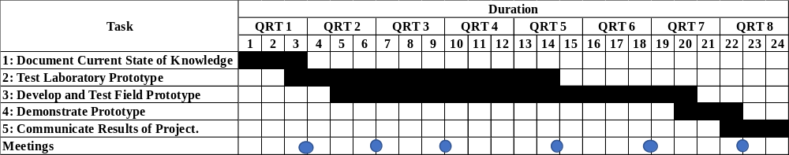
Budget: Table 2 contains the details of the budget requested. A total of $100,000 are requested from NRRA. Most of the budget is allocated to a graduate student to evaluate the prototype. Dr. Nazarian, as the PI, has been budget for about only 70 hours to manage this project. The Department of Civil Engineering has dedicated an additional 15% of Dr. Nazarian’s time to this project as a cost share of $51,626 along with an undergraduate research assistant for one semester at an estimated cost of $3225. As discussed in the partnership section, Dr. Mark Baker will join the team as a consultant. He has been budgeted for $10,000 from NRRA funds. In turn, Dr. Baker has provided 70 hours to the project as matching funds, along with the software and hardware required for this project. Dr. Baker will absorb the cost of developing the prototypes estimated as at least $10,000. As such, the matching funds exceeds the 20% requested by NRRA. An estimated $2,800 has been allocated for project-related travel and $2,187 towards expendable supplies and publication costs.

Table 2 – Detailed Budget
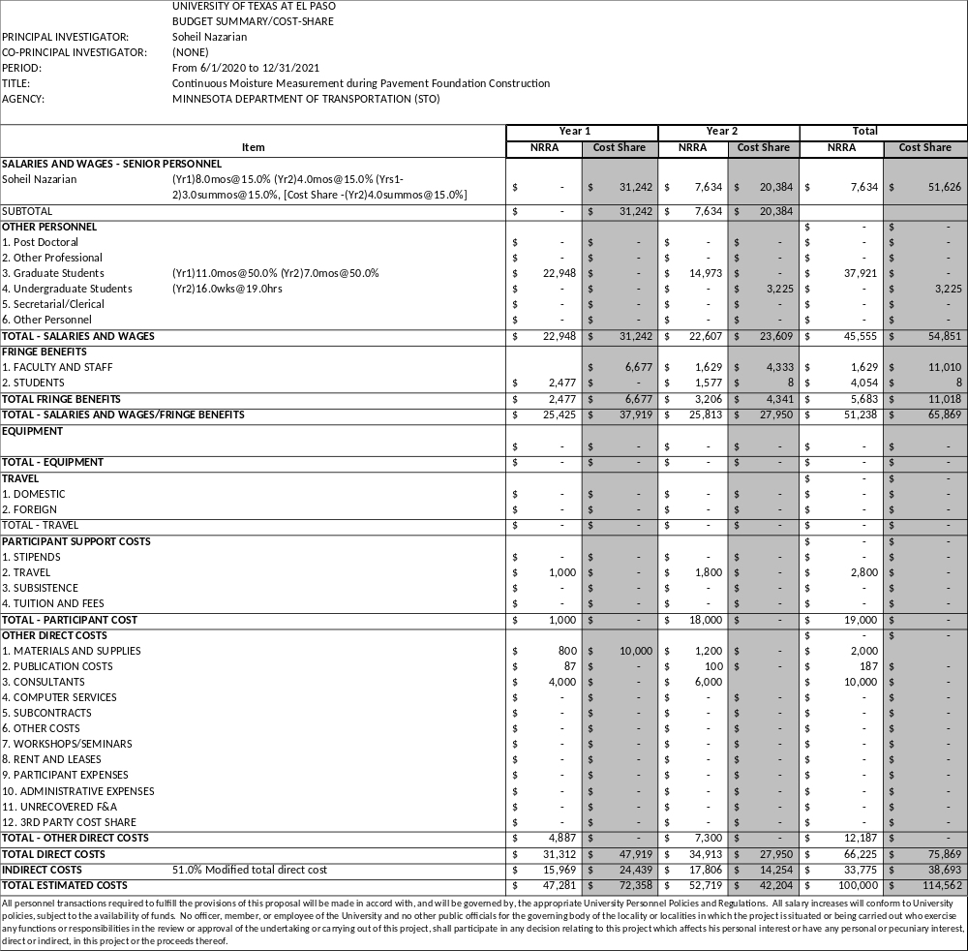

Partnerships: UTEP team will partner with Dr. Mark Baker. Dr. Nazarian is the Director of the Center for Transportation Infrastructure Systems at UTEP. He has more than 35 years of experience in the areas of materials and nondestructive testing as related to geotechnical and transportation infrastructure. He has significantly contributed to the body of knowledge in construction, quality management, and mechanistic characterization of earthwork using innovative technologies such as the Intelligent Compaction.
Dr. Baker’s career direction was set by an electrical engineering degree, then focused by two years as a field engineer with Schlumberger in S.E. Asia, repairing, operating, and interpreting some of the most sophisticated and well-engineered geophysical instruments of the time. During an M.S. at Purdue, he designed, built, and ran surveys with refraction seismic equipment, and reverse-engineered every piece of geophysical equipment in the department, documenting how it failed to measure what was promised. The following year at Keck, he redesigned 6 old instruments and developed two new products for hydrogeologic investigations. In the next five years, as a cog in the Exxon Lab, new designs included a hydraulic vibrator, induction, and gamma logging tools for coal mine roof-bolt holes, lab complex resistivity, and natural magnetic field measurements. At UTEP Dr. Baker was diverted from electrical methods by collaboration with Dr. Nazarian in developing the trailer and portable seismic pavement analyzer, resulting in a “best new product” award from TxDOT in 1997. Dr. Baker redesigned acoustic arrays for Rutgers’s bridge deck testing robot, leading to an ASCE Charles Pankow Award for innovation in 2014.
References
- de Lima, O. A. L., and Sharma, M. M., “A Generalized Maxwell-Wagner Theory for Membrane Polarization in Shaly Sands”, Geophysics, v57, n3, Mar 1992; pp. 431-440.
- Evett, S. R., Heng, L. K., Moutonnet, P., and Nguyen, M. L. 2008. “Field estimation of soil water content: A practical guide to methods, instrumentation, and sensor technology.” IAEA: Vienna.
- Keller, G. V., and Frischknecht, F. C., 1966, “Electrical Methods in Geophysical Prospecting”, Elsevier Science Ltd., 512 p.
- Knight, R., 1991, “Hysteresis in Electrical Resistivity of Partially Saturated Sandstone,” Geophysics, v56, n12, pp. 2139-2147.
- Muller, W., 2017. “Characterizing Moisture within Unbound Granular Pavements Using Multi-Offset Ground Penetrating Radar.” Dissertation, University of Queensland, Australia.
- Nazarian, S., Mazari, M., Abdallah, I., Puppala, A. J., Mohammad, L. N., & Abu-Farsakh, M. Y., 2014, “Modulus-Based Construction Specification for Compaction of Earthwork and Unbound Aggregate,” NCHRP Project 10-84
- Roberson and Siekmeier, 2002, “Determining Material Moisture Characteristics for Pavement Drainage and Mechanistic-Empirical Design,” Research Bulletin 2002-09, MnDOT.
- Saarenketo et al., 2002, “Effect of Seasonal Changes on Strength and Deformation Properties of Unbound and Bound Road Aggregates,” Bearing Capacity of Roads, Railways and Airfields.
- Sotelo, M. J., 2012, “Evaluation of Non-Nuclear Devices in Measuring Moisture Content and Density of Soils.” MS Thesis, The University of Texas at El Paso.
- Tatsuoka F., Gomes Correia A., 2018, “Importance of Controlling Degree of Saturation in Soil Compaction Linked to Soil Structure Design.” Transportation Geotechnics, Volume 17, Part B, pp. 3-23.
- Yonemaru Y., Fijisaki K., Yoshida T., Kobayashi H., Sakamoto H., 2020, “Automated Production Control System of Embankment Materials at Rock-Fill Dam. Proceedings Information Technology in Geo-Engineering, Springer Series in Geomechanics and Geoengineering.

