Illinois Test Procedure 405

Effective Date: January 1, 2016

Determining the Fracture Potential of Asphalt Mixtures Using the Illinois Flexibility Index Test (I-FIT)

# SCOPE

## This test method covers the determination of fracture energy (Gf) and post peak slope of asphalt mixtures using semicircular specimens in the Illinois Flexibility Index Test (I-FIT) conducted at an intermediate test temperature. These parameters are used to calculate the Flexibility Index (FI) to predict the resistance to fracture of an asphalt mixture. The index is used as part of the asphalt mixture evaluation and approval process. The method also includes procedures for calculating other relevant parameters derived from the load-displacement curve.

## These procedures apply to test specimens having a nominal maximum aggregate size (NMAS) of 19 mm or less. Lab compacted and field core specimens can be used. Lab compacted specimens shall be 150 ± 1 mm in diameter and 50 ± 1 mm thick. When field cores are used, specimens shall be 150 ± 8 mm in diameter and 25 to 50 mm thick. A thickness correction factor will need to be developed and applied for field cores tested at a thickness less than 45 mm.

## The I-FIT specimen is a half disc with a notch cut parallel to the loading and the vertical axis of the semicircular disc.

## This standard does not purport to address all of the safety concerns, if any, associated with its use. It is the responsibility of the user of this standard to establish and follow appropriate health and safety practices and determine the applicability of regulatory limitations prior to use.

# REFERENCED DOCUMENTS

## AASHTO Standards:

* T 166, Bulk Speciﬁc Gravity (Gmb) of Compacted Hot Mix Asphalt (HMA) Using Saturated Surface-Dry Specimens
* T 209, Theoretical Maximum Specific Gravity (*Gmm*) and Density of Hot Mix Asphalt (HMA)
* T 269, Percent Air Voids in Compacted Dense and Open Asphalt Mixtures
* T 283, Resistance of Compacted Asphalt Mixtures to Moisture-Induced Damage
* T 312, Preparing and Determining the Density of Asphalt Mixture Specimens by Means of the Superpave Gyratory Compactor

## ASTM Standards:

* D 8, Standard Terminology Relating to Materials for Roads and Pavements
* D 3549/D 3549M, Standard Test Method for Thickness or Height of Compacted Bituminous Paving Mixture Specimens
* D 5361/D 5361M, Standard Practice for Sampling Compacted Bituminous Mixtures for Laboratory Testing

# TERMINOLOGY

## *Definitions:*

### critical displacement, u1, —the intersection of the post-peak slope with the displacement-axis.

### displacement at peak load, u0, —recorded displacement at peak load.

### *fracture energy, Gf* —the energy required to create a unit surface area of a crack.

### *flexibility index*, *FI* — an index intended to characterize the damage resistance of asphalt mixtures.

### *linear variable displacement transducer, LVDT*—sensor device for measuring linear displacement.

### ligament area*, Arealig*—cross-sectional area of the specimen through which the crack propagates, calculated by multiplying the test specimen thickness and ligament length.

### *load line displacement, LLD*—the displacement measured in the direction of the load application.

### post-peak slope, m, —slope at the first inflection point of the load-displacement curve after the peak.

# SUMMARY OF METHOD

## An asphalt pavement core or Superpave Gyratory Compactor (SGC) compacted asphalt mixture specimen is trimmed and cut in half to create a semicircular shaped test specimen. A notch is sawn in the flat side of the semicircular specimen opposite the curved edge. The specimen is conditioned and maintained through testing at 25°C (77°F). The specimen is positioned in the fixture with the notched side down centered on two rollers. A load is applied along the vertical radius of the specimen and the loads and Load Line Displacement (LLD) are measured during the entire duration of the test. The load is applied such that a constant LLD rate of 50 mm/min is obtained and maintained for the duration of the test. The I-FIT test fixture and I-FIT specimen geometry are shown in Figure 1.

## Fracture Energy (Gf), post-peak slope (m), displacement at peak load (u0), strength, critical displacement (u1), and a FI are calculated from the load and LLD results.

I-FIT Lab Compacted Specimen

I-FIT Fixture

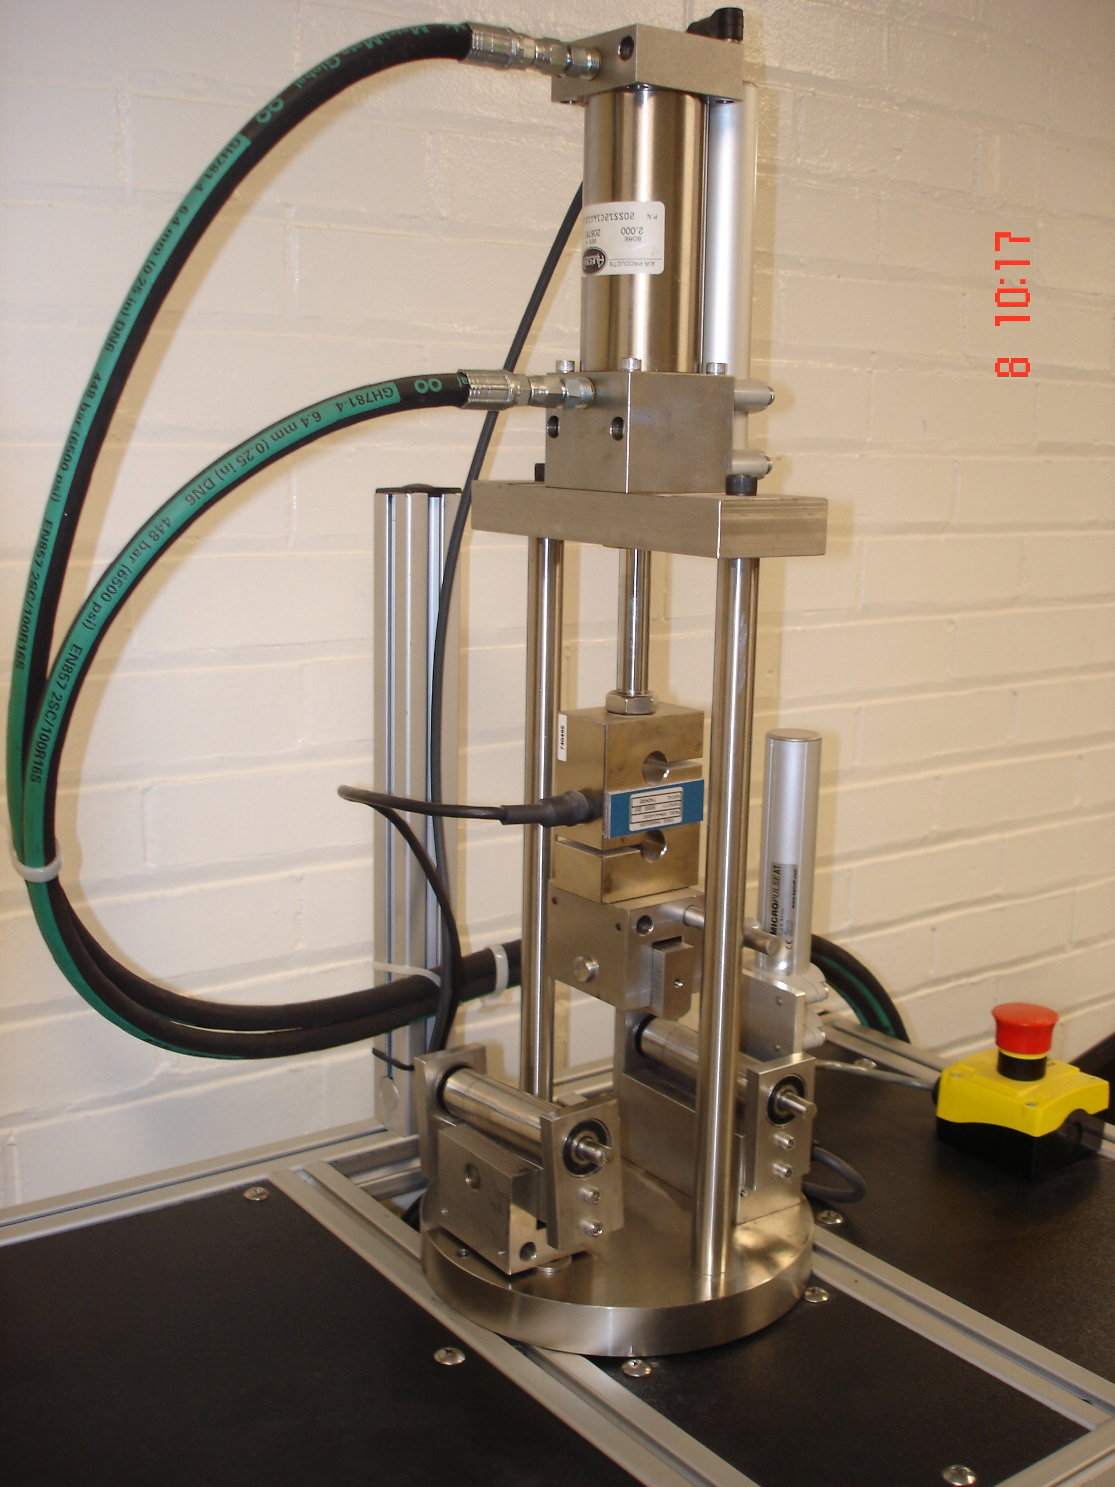

**Figure 1**— I-FIT Fixture and test specimen and configuration (dimensions in millimeters)

# SIGNIFICANCE AND USE

## The I-FIT test is used to determine fracture resistance parameters of an asphalt mixture at an intermediate temperature. From the fracture parameters obtained at intermediate temperature, the FI of an asphalt mixture is calculated. The FI is calculated from the Gf and post-peak slope of load-displacement curve. The FI provides a means to identify brittle mixes that are prone to premature cracking. The range for an acceptable FI will vary according to local environmental conditions, application of the mixture, nominal maximum aggregate size (NMAS), asphalt performance grade (PG), air voids, and expectation of service life, etc.

## The calculated Gf indicates an asphalt mixture’s overall capacity to resist cracking related damage. Generally, a mixture with higher Gf can withstand greater stresses with higher damage resistance. The FI should not be directly used in structural design and analysis. FI values obtained using this procedure are used in ranking cracking resistance of alternative mixes for a given layer in a structural design. Gf is a specimen size, loading time, and temperature dependent property. Fracture mechanisms for viscoelastic materials are influenced by crack front viscoelasticity and bulk material (far from crack front) viscoelasticity. Total calculated Gf from this test includes the amount of energy dissipated by crack propagation, viscoelastic mechanisms away from the crack front, and other inelastic irreversible processes (frictional and damage processes at the loading and support points).

## Gf is used as part of the FI to identify mixtures with increased fracture resistance.

## This test method can be used to measure and evaluate the cracking resistance of asphalt mixtures containing various asphalt binders, modifiers of asphalt binders, aggregate blends, fibers, and recycled materials.

## The specimens can be readily obtained from SGC compacted cylinders or from ﬁeld cores with a diameter of 150 mm.

# APPARATUS

## *Testing Machine*—An I-FIT test system consists of a closed-loop axial loading device, a load measuring device, a bend test ﬁxture, specimen deformation measurement devices, and a control and data acquisition system. A constant displacement-rate device such as a closed loop, feedback-controlled servo-hydraulic load frame shall be used.

## **Note 1**—An electromechanical, screw driven machine may be used if results are comparable to a closed loop, feedback-controlled servo-hydraulic load frame.

### *Axial Loading Device*—The loading device shall be capable of delivering a minimum load of 10N in compression with a minimum resolution of 5N.

### *Bend Test Fixture*—The ﬁxture is composed of a loading head, a steel base plate, and two steel rollers with a diameter (D) of 25 mm. The tip of the loading head has a contact curvature with a radius of 12.5 mm. The horizontal loading head shall pivot relative to the vertical loading axis to conform to slight specimen variations. Illustrations of the loading and supports are shown in Figures 2 and 3.

#### *Method* A—Typically the two 25 mm steel rollers are mounted on bearings through their axis of rotation and attached to the steel base plate with brackets. One of the steel rollers pivots on an axis perpendicular to the axis of loading to conform to slight specimen variations. A distance of 120 mm between the two steel rollers is maintained throughout the test.

#### *Method B*—An alternate fixture design uses two 25 mm steel rollers that each rotate in a U-shaped roller support steel block. The initial roller position is fixed by springs and backstops that establish the initial test span dimension of 120 mm. The support rollers are allowed to rotate away from the backstops during the test; but remain in contact with the sample.

### *Internal Displacement Measuring Device*— The displacement measurement can be performed using the machine’s stroke (position) transducer if the resolution of the stroke is sufficient (0.01 mm or lower). The fracture test displacement data may be corrected for system compliance, loading-pin penetration and specimen compression by performing a calibration of the testing system.

### *External Displacement Measuring Device*— If an internal displacement measuring device does not exist or has insufficient precision, an externally applied displacement measurement device such as a linear variable differential transducer (LVDT) can be used (Figure 2 and Figure 3).

**Front View**

**Side View**

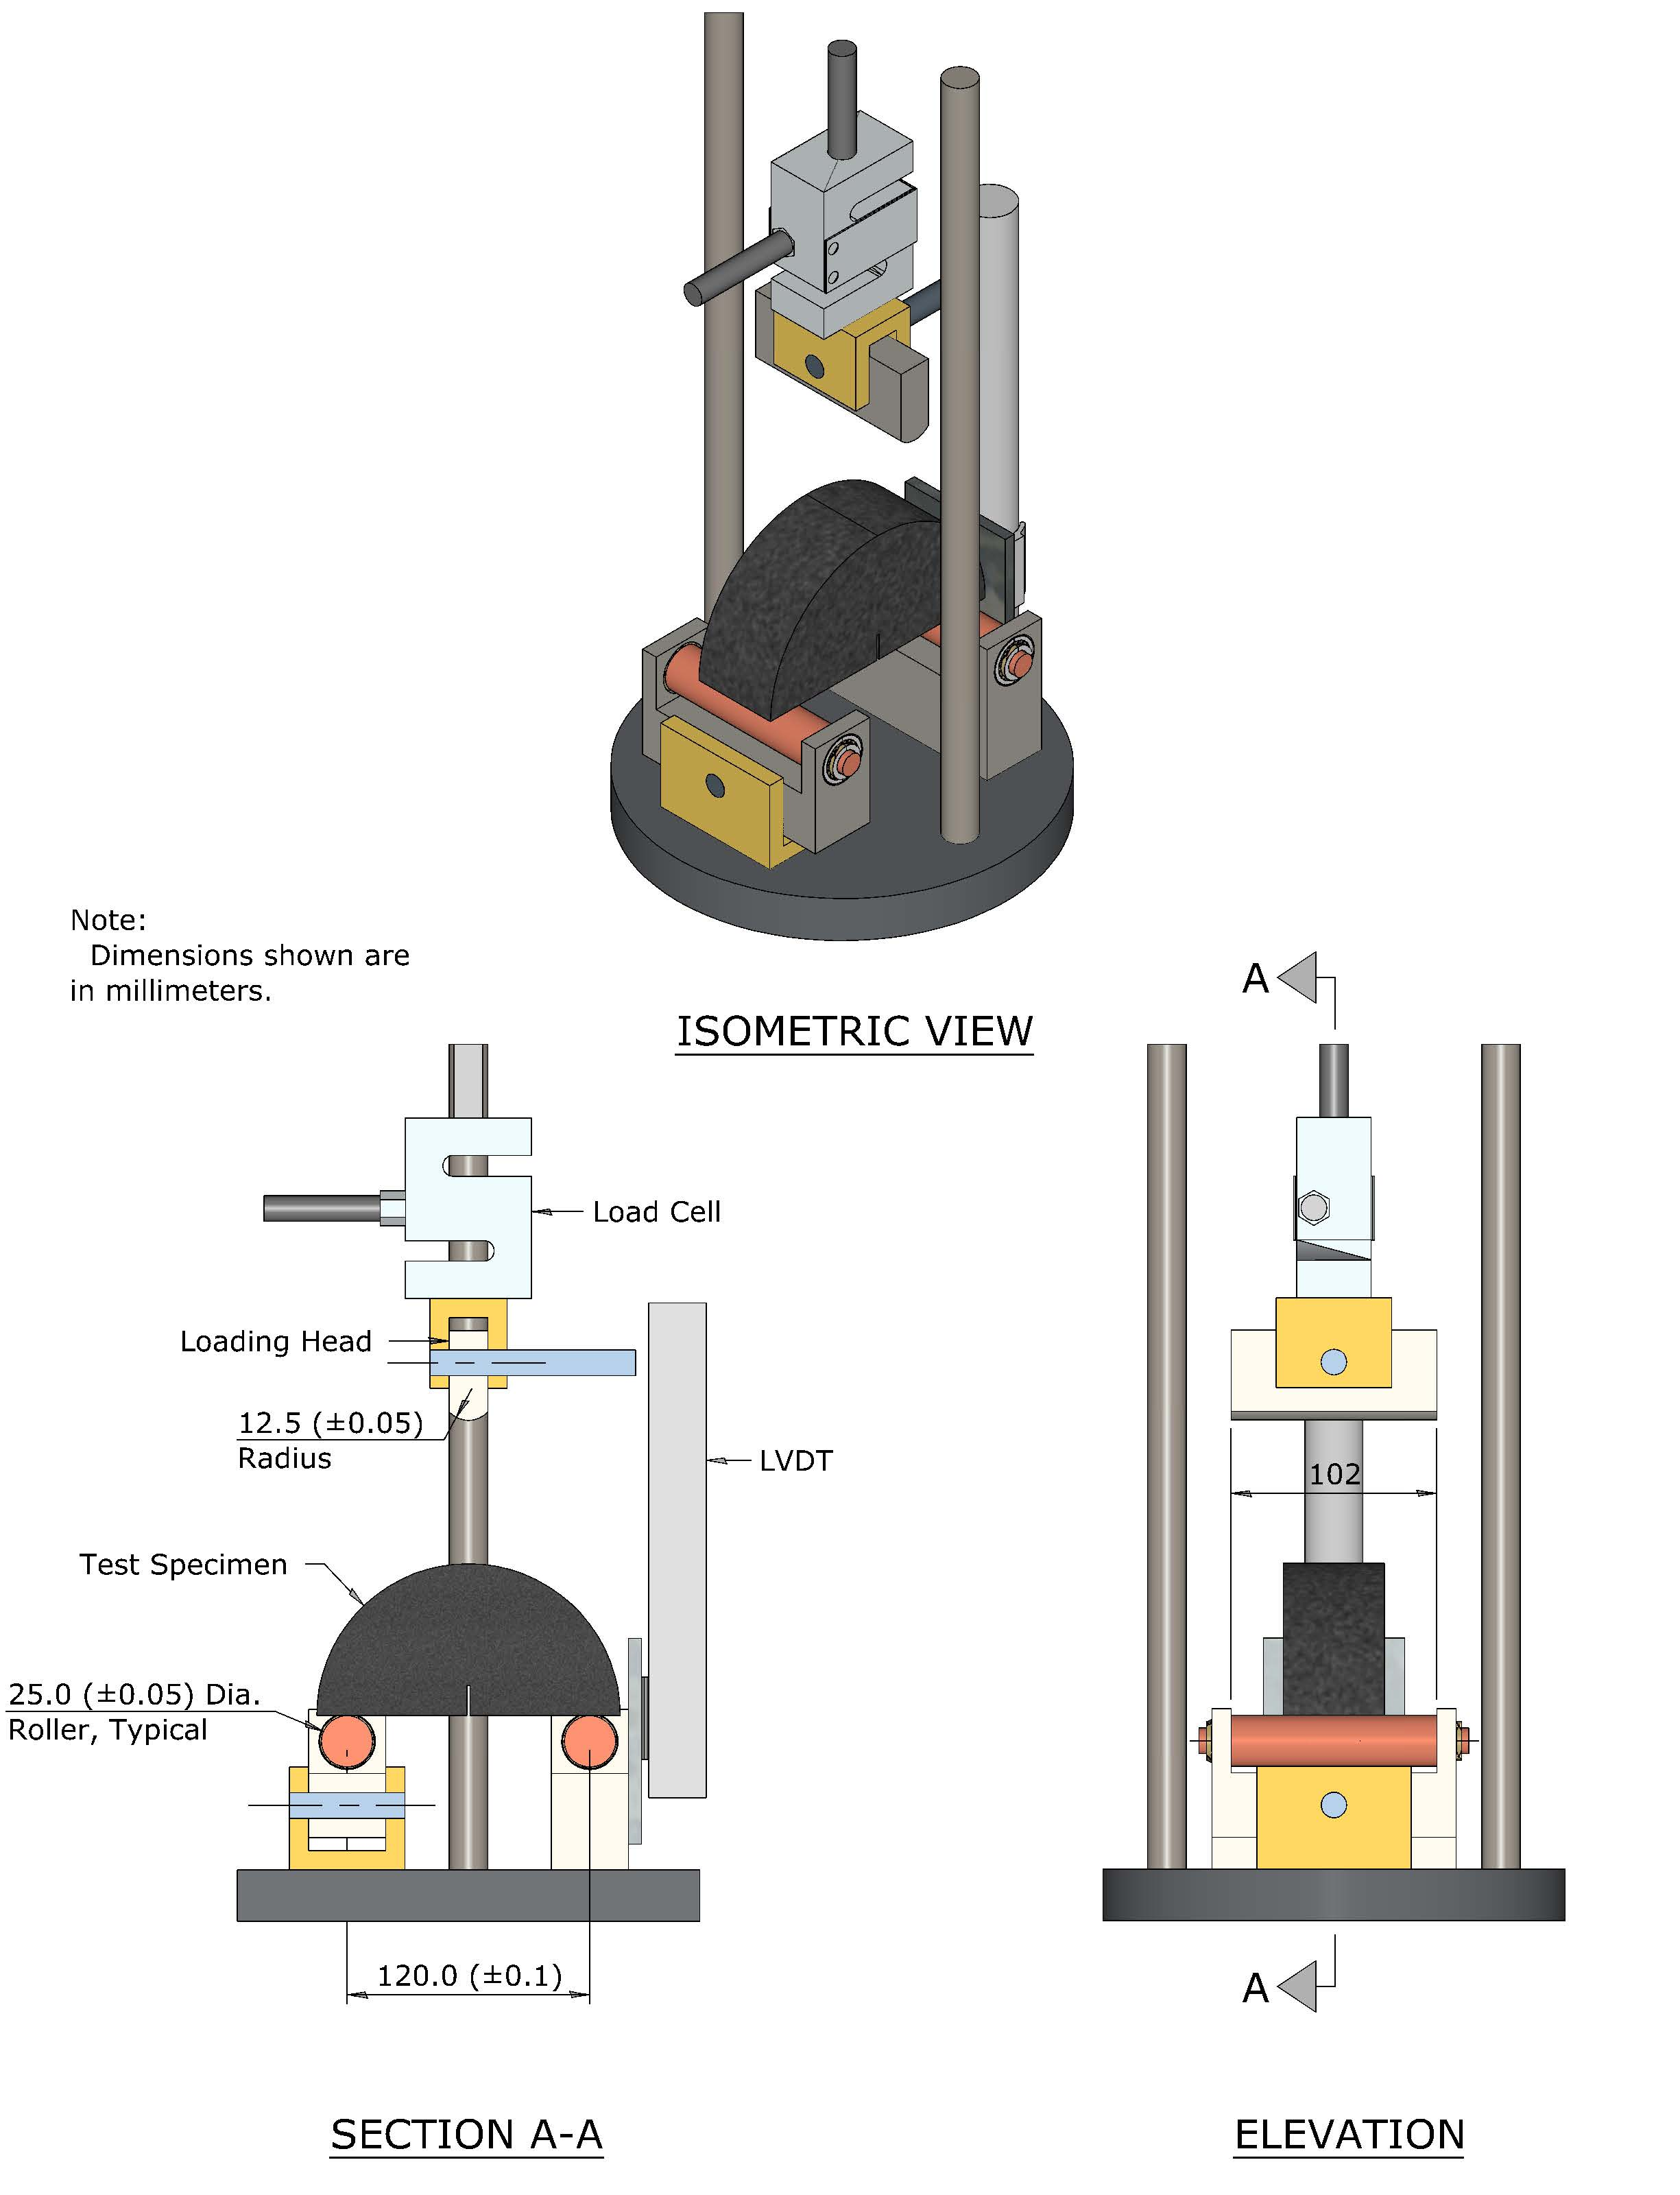

**Figure 2**— Method A

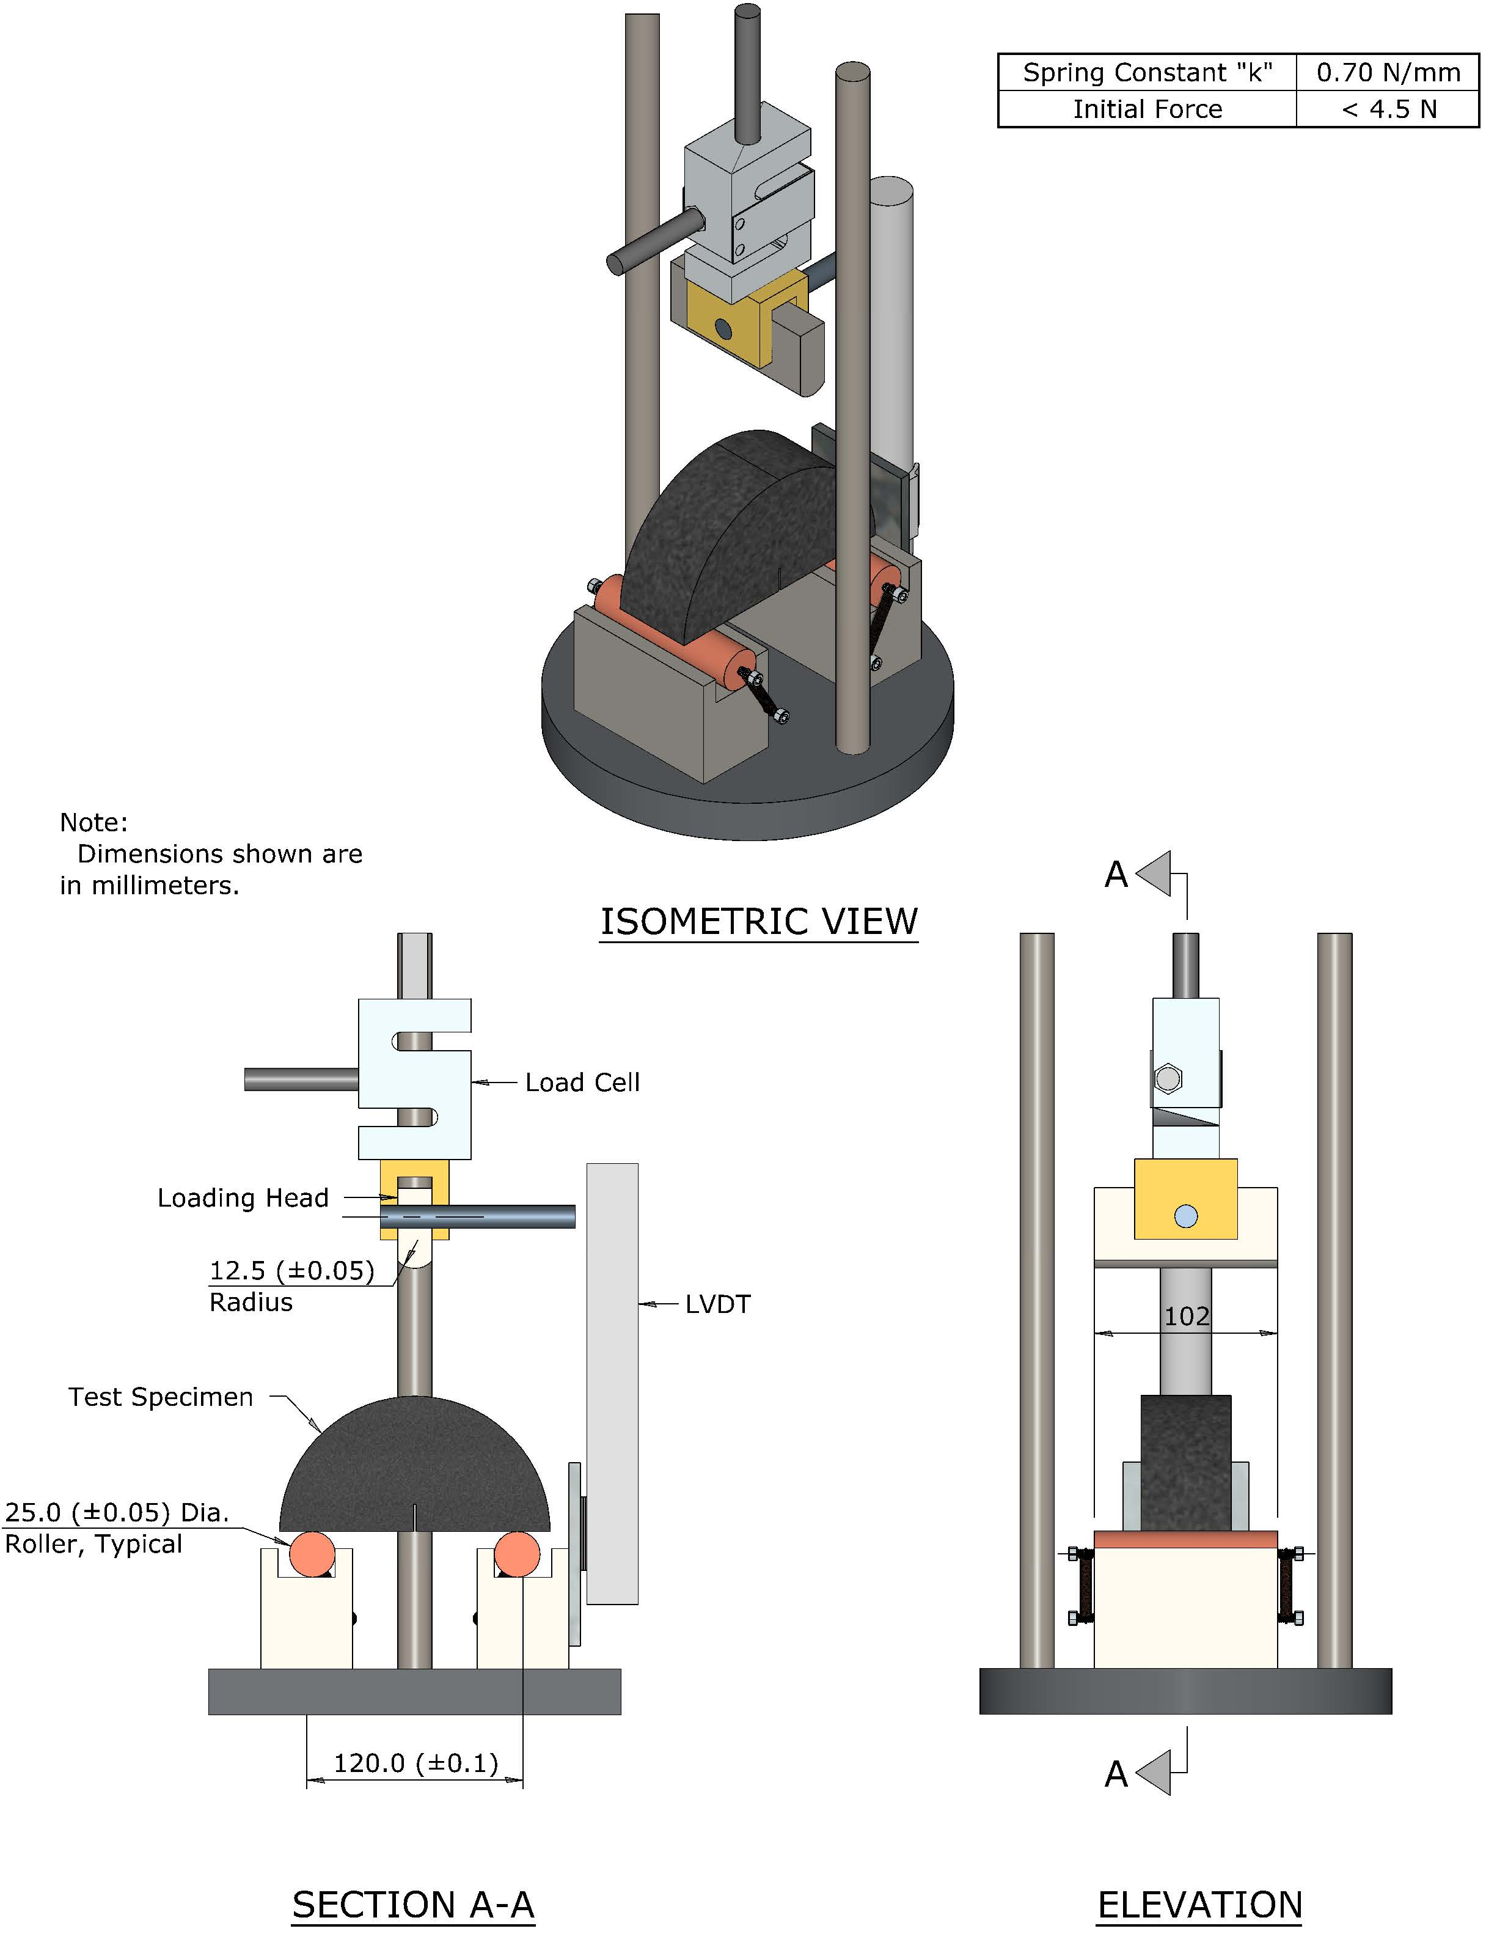

**Figure 3**—Method B

### *Control and Data Acquisition System*—Time and load, and LLD (using external and / or internal displacement measurement device) are recorded. The control data acquisition system is required to apply a constant LLD rate at a precision of 50 ± 1 mm/min and collect data at a minimum sampling frequency of 20 Hz in order to obtain a smooth load-load line displacement curve.

# HAZARDS

## Standard laboratory caution should be used in handling, compacting and fabricating asphalt mixtures test specimens in accordance with AASHTO T 312 and when using a saw for cutting specimens.

## 

# CALIBRATION AND STANDARDIZATION

## A water bath as used in AASHTO T 283 will be used to maintain the specimen at a constant and uniform temperature. An environmental chamber may be used in lieu of a water bath.

## **Note 2**— Caution should be used if an oven is selected for conditioning samples as this may result in variable sample conditioning and affect the test results.

## Verify the calibration of all measurement components (such as load cells and LVDTs) of the testing system.

## If any of the veriﬁcations yield data that does not comply with the accuracy speciﬁed, correct the problem prior to proceeding with testing. Appropriate action may include maintenance of system components, calibration of system components (using an independent calibration agency, service by the manufacturer, or in-house resources), or replacement of the system components.

# PREPARATION OF TEST SPECIMENS AND PRELIMINARY DETERMINATIONS

## *Specimen Size*—For mixtures with nominal maximum aggregate size of 19 mm or less, prepare the test specimens from a lab compacted SGC cylinder or from pavement cores. The final I-FIT test cylinders shall have smooth parallel faces with a thickness of 50 ± 1 mm and a diameter of 150 ± 1 mm (see Figure 4). If field specimens are used, the final test specimen dimensions shall be 150 ± 8 mm in diameter with smooth parallel faces 25 to 50 mm thick depending on available layer thickness.

**Note 3**—A typical laboratory saw for mixture specimen preparation can be used to obtain cylindrical discs with smooth parallel surfaces. A tile saw is recommended for cutting the 15 mm notch in the individual I-FIT test specimens. Diamond-impregnated cutting faces and water cooling are recommended to minimize damage to the specimen. When cutting the I-FIT specimens, it is recommended not to push the two halves against each other because it may create an uneven base surface of the test specimen that can affect the results.

### *SGC Specimens*—Prepare a minimum of one laboratory SGC specimen according to T 312 in the SGC with a compaction height a minimum of 160 mm ± 1 mm. From the middle of each 160 mm ± 1 mm-tall specimen, obtain two cylindrical 50 ± 1 mm thick discs (see Figure 4). Cut each disc into two identical “halves” resulting in four individual I-FIT test specimens. A minimum of three individual I-FIT specimens is defined as one I-FIT test.

### **Note 4**—It is recommended that a greater number of SGC specimens (and therefore a greater number of individual test specimens) be fabricated and tested to reduce the risk of a FI that is not representative of the mixture. This is especially important for marginal mixtures that have test results near the established pass/fail criteria.

### **Note 5**—For laboratory compacted specimens, the air voids shall be determined for each of the two circular discs. The air voids for each disc shall be 7.0 +/- 0.5%. It is suggested that the minimum height of the gyratory compacted specimens shall be a minimum 160 ± 1 mm height to achieve the target 7.0 +/- 0.5% air voids in each of the top and bottom discs (see Figure 4). If target air voids cannot be achieved for each disc with 160 ± 1 mm height of the compacted specimens, then the specimen height can be increased. If specimen height cannot be increased or if a SGC has difficulty in compacting 160 mm tall specimens, then two SGC specimens, each at least 115 mm tall, may be compacted and used instead. A 50 mm thick disc will be cut from the middle of each gyratory specimen which will result in four individual I-FIT test specimens.

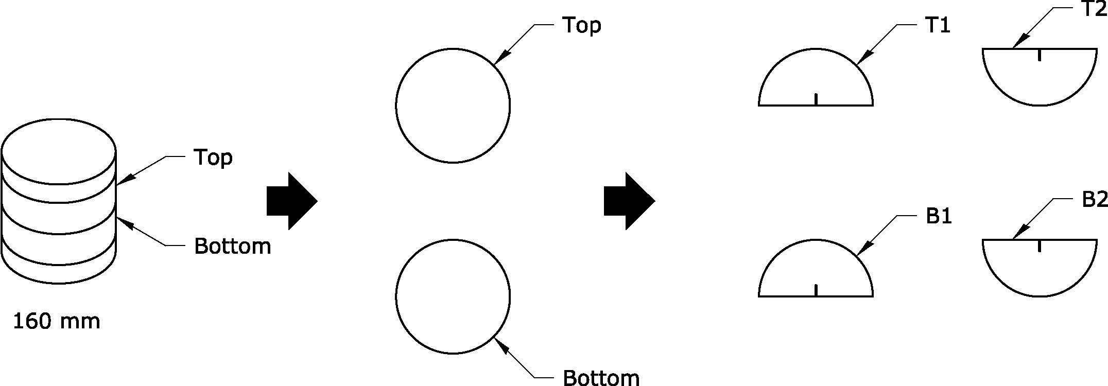

OR

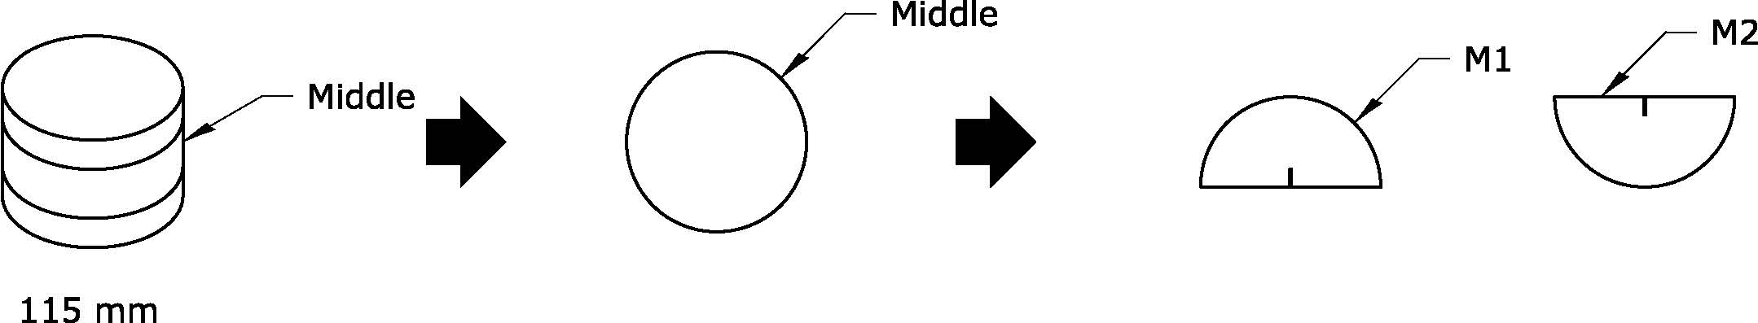

**Figure 4**— Specimen preparation from 160 mm or 115 mm SGC specimens

### *Field Cores*—Obtain field cores from the pavement in accordance with ASTM D 5361. Obtain one 150 mm diameter pavement cores if the lift thickness is greater than 75 mm or two 150 mm diameter cores if the lift thickness is less than 75 mm.

#### *Field Specimens*—From the pavement cores, prepare four replicate I-FIT test specimens with smooth, parallel surfaces that conform to the height and diameter requirements specified herein. The thickness of test specimens in most cases for field cores may vary from 25 to 50 mm. If the lift thickness is less than 50 mm, test specimens should be prepared as thick as possible but in no case be less than two times the nominal maximum aggregate size of the mixture or 25 mm whichever is greater. If lift thickness is greater than 50 mm, a 50 mm slice shall be prepared. Cores from pavements with lifts greater than 75 mm may be sliced to provide two cylindrical specimens of equal thickness. Cut each cylindrical specimen exactly in half to produce two identical, semicircular I-FIT specimens. Each slice of the field core shall have parallel, smooth faces.

## *Notch Cutting*— Cut a notch along the axis of symmetry of each individual I-FIT specimen to a depth of 15 ± 1 mm and 1.5 ± 0.1 mm (0.06 in.) in width (see Figure 1).

**Note 6**—If the notch terminates in an aggregate particle 9.5 mm or larger on both faces of the specimen, the specimen shall be discarded.

## *Determining Specimen Dimensions*— Measure the notch depth on both faces of the specimen and record the average value to the nearest 0.5 mm. Measure and record the ligament length (see Figure 1) and thickness of each specimen. The ligament length may be measured *directly* on both faces of the specimen with the average value recorded or the ligament length may be measured *indirectly* by subtracting the notch depth from the entire width (radius) of the specimen on both faces of the specimen and averaging the two measurements. Measure the specimen thickness approximately 19.0 mm (0.75 in.) on either side of the notch and on the curved edge directly across from the notch. Average the three measurements and record as the average thickness to the nearest 0.1 mm.

## *Determining the Bulk Speciﬁc Gravity*—Determine the bulk speciﬁc gravity on the discs obtained from SGC cylinders or field cores according to AASHTO T 166.

# TEST PROCEDURE

## *Conditioning*—Test specimens shall be conditioned in a water bath or an environmental chamber at 25 ± 0.5 °C for 2 ± 0.5 h.

### *Temperature Control* —The temperature of the specimen shall be maintained within 0.5 °C of the desired 25 ± 0.5 °C test temperature throughout the conditioning and testing periods. Testing shall be completed within 5 ± 1 minutes after removal from the water bath or environmental chamber.

## *Position Specimen*— Position the test specimen in the test fixture on the rollers so that it is centered in both the “x” and the “y” directions and so that the vertical axis of loading is aligned to pass from the center of the top radius of the specimen through the middle of the notch.

## *Contact Load*— First, impose a small contact load of 0.1 ± 0.01 kN in stroke control with a loading rate of 0.05 kN/s.

### *Record Contact Load*— Record the contact load to ensure it is achieved.

### *Loading*—After the contact load of 0.1 kN is reached, the test is conducted using LLD control at a rate of 50 mm/min. The test stops when the load drops below 0.1 kN.

# parameters

## *Determining Work of Fracture (Wf)*—The work of fracture is calculated as the area under the load vs. load line displacement curve (see Figure 5).

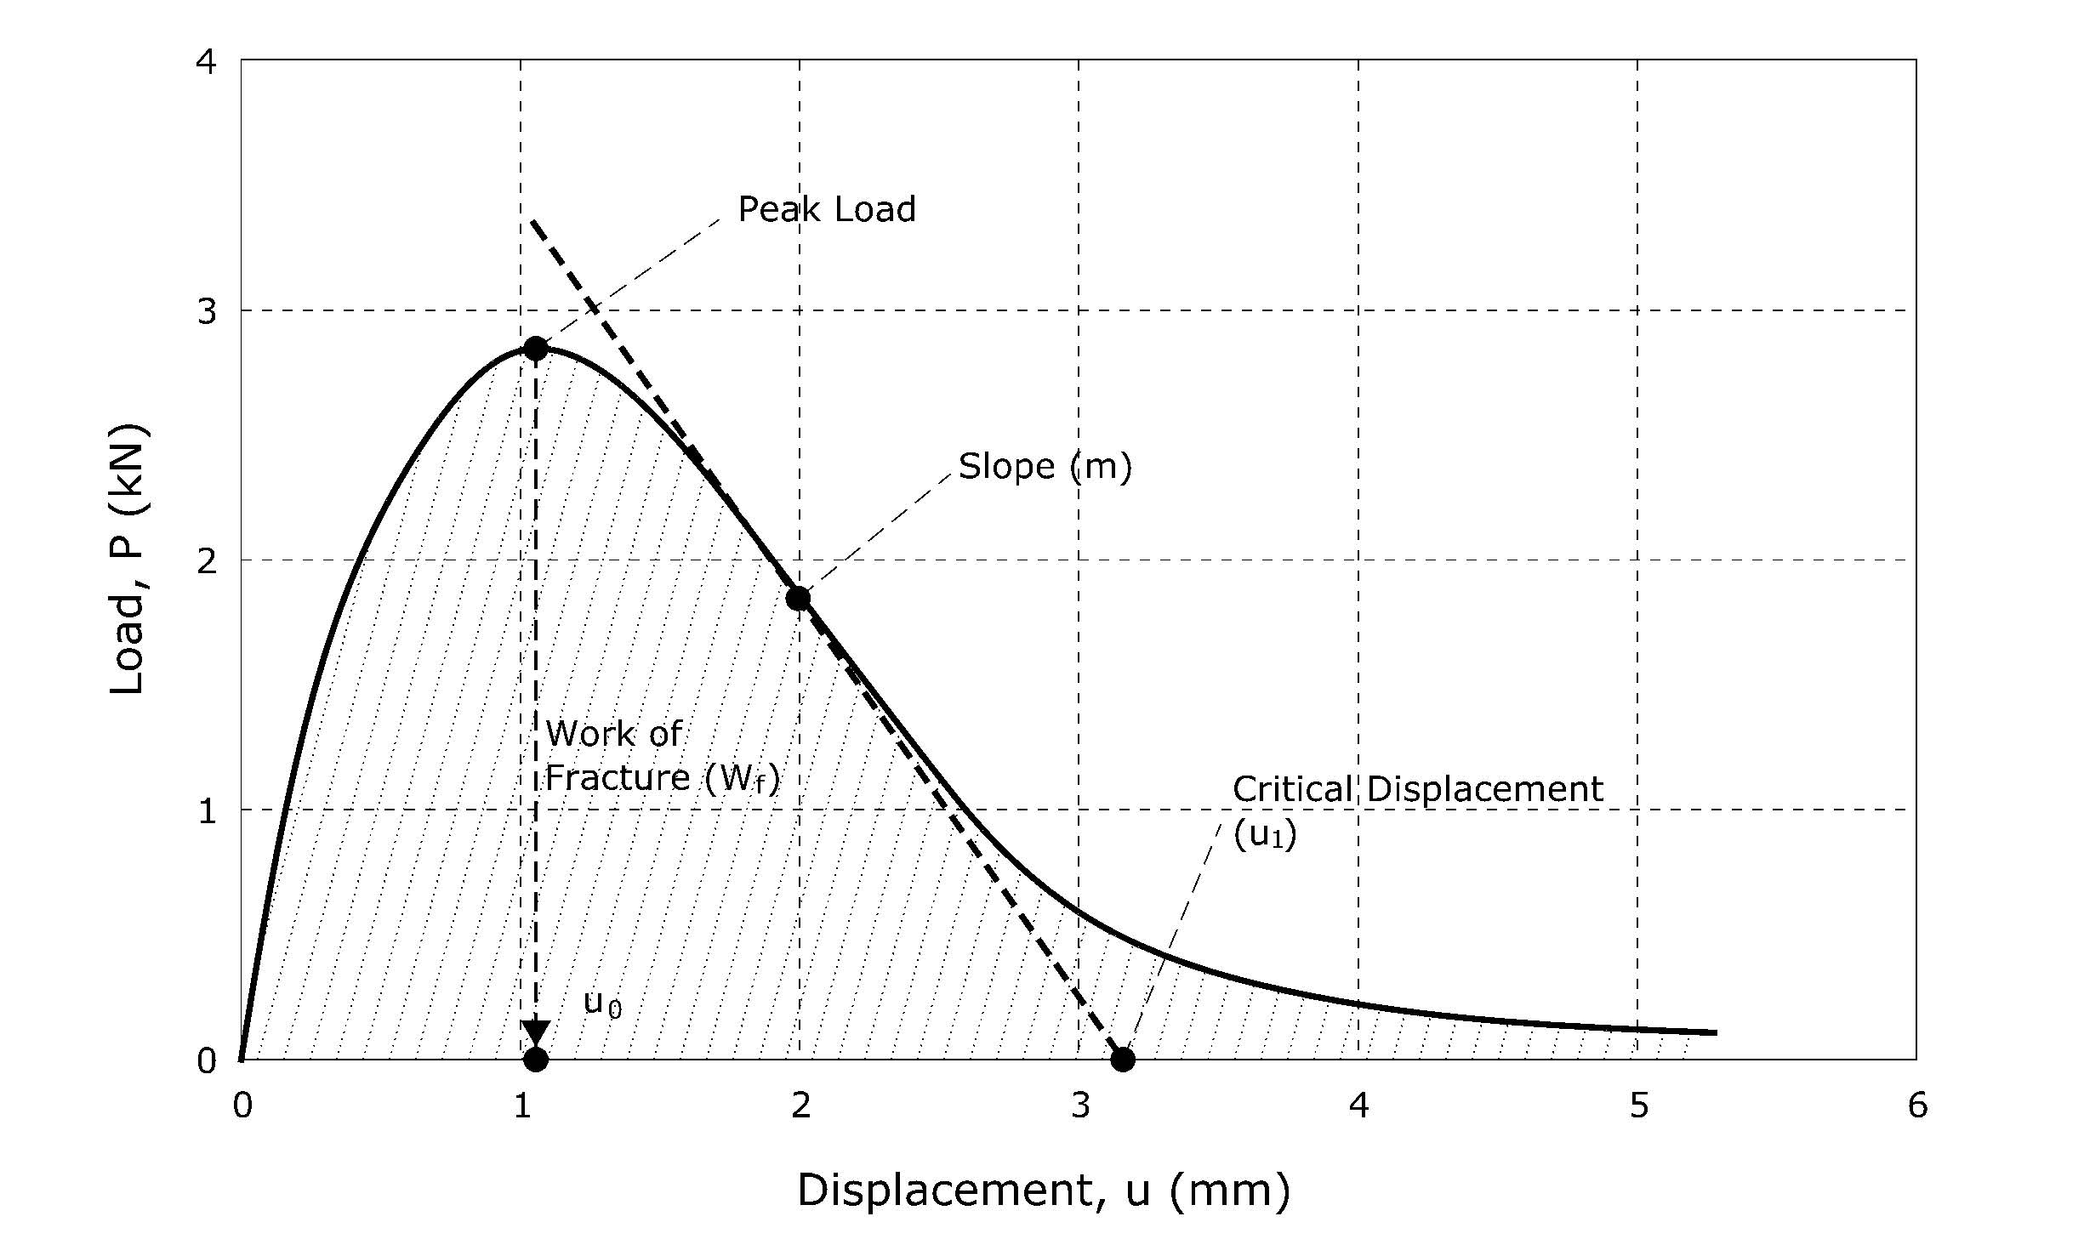

**Figure 5**—Recorded load (P) versus load line displacement (u) curve

## *Fracture Energy (Gf)*— GF is calculated by dividing the work of fracture (Wf) by the ligament area (the product of the ligament length and the thickness of the specimen) of the specimen measured prior to testing:

$G_{f}=\frac{W_{f}}{{Area}_{lig}}$ Equation 1

where:

Gf = fracture energy (Joules/m2);

Wf = work of fracture (Joules)

P = load (kN);

u = displacement (mm);

Arealig = ligament area = (r – a) *x* t, (mm2)

r = specimen radius (mm);

a = notch length (mm);

t = specimen thickness (mm)

m = post-peak slope (kN/mm)

**Note 7**—Gf is a size dependent property. This specification does not aim at calculating size independent Gf. Therefore, cracking resistance of asphalt mixes quantified with Gf may vary when the notch length to radius ratio changes.

## *Determining post-peak slope (m)* — The inflection point is determined on the load-displacement curve (Figure 5) after the peak load. The slope of the tangential curve drawn at the inflection point represents post-peak slope.

## *Determining displacement at peak load (uo)* — Find the displacement when peak load is reached.

## *Determining critical displacement (u1)* — Intersection of the tangential slope with the displacement axis yields the critical displacement value. A straight line is drawn connecting the inflection point and displacement axis with a slope m.

## *Flexibility Index (FI)* — Flexibility Index can be calculated (by the software) from the parameters obtained using the load displacement curve. The factor A is used for unit conversion and scaling. “A” is equal to 0.01.

|  |  |
| --- | --- |
|  | Equation 2 |

where:

$\left|m\right|$ = absolute value of m.

**Note 8**—When four individual I-FIT specimens are tested, the FI value that is farthest from the average of the four may be discarded as an outlier to lower the variability of the average FI value that is reported. When eight or more individual I-FIT specimens are tested, the highest and lowest FI values may be discarded as outliers to lower the variability of the average FI value that is reported.

# correction factors

## *Shift factor from lab to field specimens* — Apply a shift factor between SGC and pavement core specimens based on the age of field specimens, different criteria based on design, plant mix, and aged for different times. This shift factor still needs to be determined.

# REPORT

## Report the following information:

### Bulk speciﬁc gravity of each specimen tested, to the nearest 0.001;

### Average air void content of each disc, to the nearest 0.1;

### Thickness t and ligament length of each specimen tested, to the nearest 0.1 mm;

### Initial notch length a, to the nearest 0.5 mm;

### Peak load and coefficient of variation (COV) of peak load, to the nearest 0.1 kN;

### Post-peak slope and COV of post-peak slope (m), to the nearest 0.1 kN/mm

### Gf and COV of Gf to the nearest 1 J/m2.

### FI and COV of FI to the nearest 0.1.

# Precision and bias

## Precision— The research required to develop precision estimates has not been conducted.

## Bias— The research required to establish the bias of this method has not been conducted.

# KEYWORDS

## Fracture energy; asphalt mixture; Illinois flexibility index test (I-FIT); stiffness; work of fracture; flexibility index.