SFDR Checklist
 |  | PRE-GRIND CHECKS
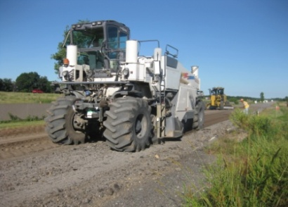 |  | #1 Depth (G&B Form 401)  #2 Gradation (G&B Form 101)  #3 Compaction (DCP >6”) (G&B Form 205)
 |  | BEFORE INJECTING OIL
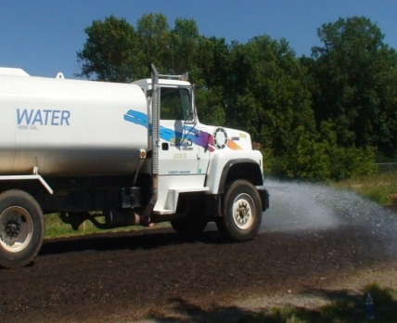 |  | #1 Check Mix Design Verification tests  #2 Verify Corrections to Pre-Grind  #2A. Gradation  #2B. Slopes/Grade/Etc.  #2C. Failing DCP Areas Reworked?  Immediately Prior to Injecting Oil  #3 Verify Moisture Tests Pass  #4 Verify Calibration of Vane Feeder (If Applicable, G&B Form 402)
 |  | DURING/AFTER INJECTING OIL
#1 | Take Samples of Oil According to MCS
#2 | Check Depth (G&B Form 401)
#3 | Check Yield (G&B Forms 402 &403)
#4 | Foamed AC Checks (if applicable, G&B form 404)
#5 | Specified Density (G&B Form 405)
#6 | Complete Visual Observations (G&B 406)

G&B 407
8-6-2012

