G&B 406
8-6-2012
Stabilized FDR Visual Checks
- Visual Observations. The consistency in the color of the material immediately behind the recycler will usually indicate whether proper machine set up. A gradual change in color across the width normally indicates that one end of the drum is lower than the other. A lighter appearance indicates dilution (under-application of water and bituminous stabilizing agent) caused by the drum not penetrating too deep into the pavement. A darker color indicates an over-application due to the drum not penetrating to the required depth. Bitumen treated material is not sticky and should therefore not adhere to the rear wheels of the recycler. The left picture shows what should be seen behind the recycler. The right picture shows material sticking to the rear wheels indicating that the treated material is poorly mixed. Stop the operation immediately to determine the cause; poorly mixed materials will also stick to the drum of the roller, causing material build-up and further problems.
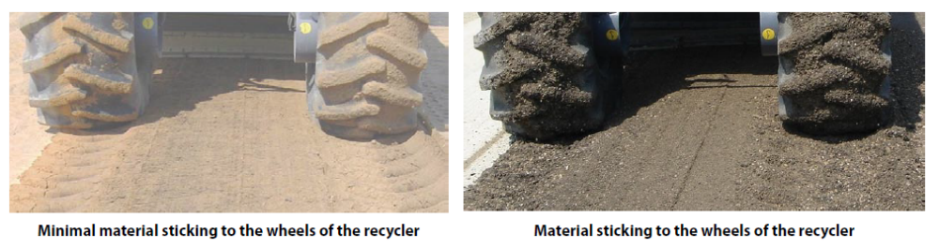
- Ball Test. Form a round ball (the size of a fist) from a sample of material picked up from behind the reclaimer and firmly squeezed it between both hands. Balls made with Foamed AC can be tested right away, but balls made with Emulsion must be left in the sun and allowed to dry for at least 30 minutes so that the bituminous emulsion can break (as indicated by the color changing from brown to black). Hold the ball between the thumb and index finger and gently apply pressure on opposite sides of the ball to gauge the cohesiveness of the material. The ball should deform before falling apart. Inspect the face of the broken ball too see how well the bituminous material has dispersed. If no bitumen can be seen, the mix is perfect. The more bituminous “blobs” or “stringers” there are, the worse the quality of the mix. Clean all loose material from the hands and observe the bituminous spots. The warmth of the hands and pressure applied will permit the bitumen to stick. Lots of tiny spots indicate good dispersion whilst larger “blobs” are the stringers resulting from poor dispersion.

