
Maintenance Research

Bulletin: August 2018

NTREC New Technology Research Equipment Committee
MOR Maintenance Operations Research

Upcoming Events

Fall NTREC Meeting
St. Cloud, MN
Sept 5th

SPOT 2018
Camp Ripley, MN

Train the Trainer
Sept 12th -15th

Trainees / Session One
Sept 17th - 21st
&
Sept 24th - 28th

Trainees / Session Two
Oct 15th - 19th
&
Oct 22nd - 26th

MN Maintenance Fall Expo
St. Cloud, MN
October 3rd & 4th

Maintenance Research
Website:
http://www.dot.state.mn.us/maintenance/research.html

Comments / Questions
Maintenance Research Program Administrator
651/366-3585
Mindy Heinkel

Wiper Shaker

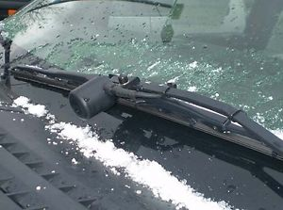

Visibility can be a serious safety concern during snow plow operations. Ice buildup on the wipers pose problems for our plow operators. Having to get out of their plow vehicles to clear the windshield and wipers is a safety hazard due to the possibility of fall injuries.

The Wiper Shaker uses vibration to break apart ice buildup on the windshield wipers. The compact unit clamps onto the existing wiper arm and activates with a simple push of the button inside the truck. An added bonus is that the Shaker Wiper can be used year round as it can also be used to dislodge leaves and twigs.

This project was awarded to District 6 and will be evaluated on 14 trucks in the Winona subarea. They will be evaluating time as they will be tracking the amount of time to stop to clean windshields. They will also be evaluating and tracking the reduction in accidents and injuries.

For more information contact:
Jon Beeman
Jon.beeman@state.mn.us

