

Minnesota CAV Innovation Alliance
Labor and Workforce Committee Meeting
September 9, 2020 Meeting Summary
Attendees: Michael Gorman, Split Rock Partners; Chris Hadfield, MnSCU Technology Center of Excellence; Tammy Meehan Russell, The Plum Catalyst; Kristin White, MnDOT CAV-X; Amber Backhaus, Auto Dealers Association; Ed Reynoso, Teamsters; Patrick Weldon, Polaris; John Dukich; MnDOT Government Affairs
- Recap of last meeting – CAV-X provided an overview of the June 26th meeting. The committee discussed potential goals of STEM outreach, curriculum development and a pilot project. The Commissioner appointed Chris Hadfield and Patrick Weldon as co-chairs of the committee. A duplicate meeting summary will be sent out to committee members.

- September 25th Governor’s Advisory Council meeting – This Committee reports out at the September meeting and again at the December meeting. Co-chairs shared the speakers they’ve invited, including the Michigan Middle Skills Report, the American Center for Mobility, DEED’s career development center (Career Force) and Carnegie Mellon CAV artificial intelligence researchers.

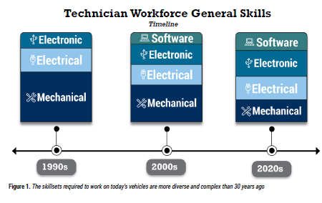
Members discussed that the definition of “workforce” includes technicians and mechanics. Some colleges are developing curriculum in this space. A good example is on page 4 of the Michigan Middle Skills Report (see below) sowing that software and electronics skills take more time to develop. The Committee voiced frustration that DEED does not do this type of CAV skills gap research.

- Committee goals
Members discuss the following committee goals, to discuss in front of the Council:
  - Convene and launch Labor and Workforce Committee; e.g. “get it up and running”
  - Build on participation, e.g. grow membership
  - Remain “granular” and specific, while being aware of other committees’ work (like Education and Outreach which crosses over into STEM outreach)
  - Identify key deliverables, including those below

- Committee deliverables: The members then identified key deliverables to accomplished in the next year, including:
  - Summary of existing CAV workforce development research
  - Assist DEED in any CAV gap analysis work moving forward
  - Produce a CAV supply and demand report and distribute
  - Gather anecdotal data and stories from technicians
Members discussed whether the University of Minnesota supports STEM career research. MnSCU uses Wanted Analytics TalentNeuron tool and has a data analysist. Co-char Hadfield could access the tool later this fall to create supply and demand report.
Other discussion topics included:
- Light duty technicians (e.g. oil change, etc.) skills need to be addressed
- Need balanced conversations, including both the benefits and challenges of displacement, mitigation and CAV skills opportunities
- Impact on displaced workers could be an area of leadership for Minnesota/this Committee. Need to think about collaboration with others
- Any project we do (e.g. a Committee pilot project) should track employment and progress
Action Items
- CAV-X will send out a meeting summary and summary from June meeting
- CAV-X send out draft deliverables for this Committee
- Ed Reynoso will reach out to National Teamsters to identify speakers for December’s meeting where we’ll hear stories about labor impacts
- Amber Backhaus will connect with Auto Dealers members to have them share their perspective at December meeting

