The Minnesota CAV Innovation Alliance is a broad statewide network to coordinate connected and automated vehicles activates – including research, projects, planning and policy – to help the state plan and prepare for emerging technologies.

Why create a statewide alliance?
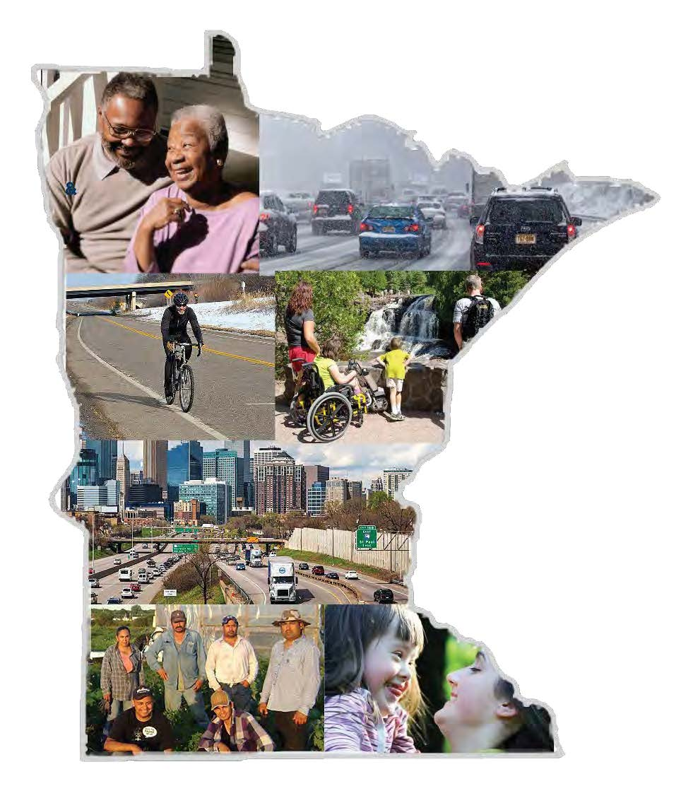
The 2018 Advisory Council Executive Report recommended building a statewide coalition - or an alliance - to coordinate activities throughout the state. In May 2020, the Council established the statewide CAV Innovation Alliance. The Alliance is intended to be a broad statewide network to coordinate CAV work across Minnesota. The Alliance is to be a “one stop shop” for CAV in Minnesota.

Goals
- Create a network of local, regional, and state organizations who share a commitment to planning and preparing for CAV and emerging technologies
- Coordinate CAV activities across the state to develop a unified program and avoid redundant research
- Implement Governor’s Advisory Council recommendations to advance the Council’s priorities
- Develop priorities for public-private research, pilots, and projects
- Meet regularly to discuss CAV project and research updates, share lessons learned, and best practices
Convene an annual conference to share lessons learned and develop priorities for the Alliance

Who is involved?
The CAV Innovation Alliance is a broad partnership that includes representatives from universities and technical colleges, private industry, nonprofits, and government. The Alliance coordinates CAV activities throughout the state. The Council is committed to building an inclusive alliance. The Alliance is open to any individual or organization interested in CAV, including members of the public. To join, contact Kristin.White@state.mn.us.

Who is involved?
The Alliance includes representatives from universities and technical colleges, private industry, nonprofits, and government. The Alliance is open to any individual or organization interested in CAV, including members of the public, and is committed to equity and inclusivity.
The Alliance created 5 subcommittees: Safety, Connectivity and Data, Infrastructure Investment, Labor and Workforce, and Education. MnDOT’s CAV-X staff support the Committees. Each committee regularly reports up to the Governor’s Advisory Council. Currently, the Alliance is working on an annual workplan to be completed by 2021.

CAV Vision
Build a future transportation system that is safe, equitable, accessible, efficient, healthy and sustainable.

