DEVELOPING A FUNCTIONAL GROUP WORK PACKAGE
IN P6
Purpose: How to develop a work package to be integrated into a schedule efficiently. The work package will include the functional group activities and will easily identify what the standard relationships are. The sample below is a simplified version of the MDR work package.
Work package Structure- The work package will include the following activities parts:
- Work with the functional group to identify all Activities under the WBS(s) with inter-work package logic. Use Activity names with 3-character smart prefix based on the WBS Name.

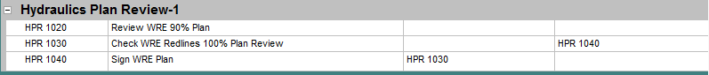

- Create a temporary WBS to contain temporary relationship activities representing the logic between the work package and schedule. Name the temporary WBS “Dissolvable Milestone (Dissolve after relationship Linked & remove node from WBS)”.

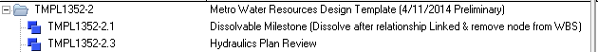

Create Temporary Activities to hold the relationships between the Work package and the final schedule. These temporary activities will be a mirror of the activities the work package is typically linked to in the final schedule. Temporary Activities will use the following naming convention:
- Temporary Activity ID’s will start with “ZZZ” followed by the actual Activity ID including smart prefix.
- Temporary Activity Name should match actual activity name in the template/schedule to aid in connecting the relationships. Indicate either pred/succ and include relationship type and template/work package in which the activity resides in.
- a. Link relationships between temporary activities and Work package activities.
b. Each temporary activity will have an open end that will get linked to the permanent activity.
- You may need to duplicate a temporary activity if it is both a predecessor and successor to different activities in the work package; this is indicated with ‘Pred’ or ‘Succ’.
*All activities in work package will have a predecessor and successor (excluding dissolvable milestones).

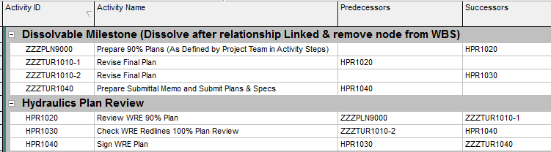
00
3
4
5b
5a
6
Succ: Prepare Submittal Memo and Submit Plans & Specs (FS) (Project Template)
Pred: Prepare 90% Plans (FS) (Project Template)
Pred: Revise Final Plan (FS) (Project Template)

Succ: Revise Final Plan (FS) (Project Template)

