Scoping Schedule Implementation
October 20, 2014

Purpose
The purpose of this document is to provide direction and guidance on how to use the Scoping Schedules for projects.

Background
Previous scheduling practices include the scoping activities within the design schedule. Without the scoping process completed, it is difficult for Project Managers to build accurate design schedules.
A separate Scoping Schedule will improve the accuracy of the design schedules. It will also improve reporting for the WIG Project Management Scoreboard.

When to Use
The WIG Project Management Battle scoreboard requires that all projects entering the four year STIP (State Transportation Improvement Program) have a quality scoping document. For projects entering the STIP, the districts must complete the scoping document by November 15th annually. MnDOT is currently scoping projects that will enter the FY 19 STIP.
When a district identifies a list of future projects to be scoped, the SSC will work with ADMIN to create a separate scoping schedule using the Scoping Schedule template below:
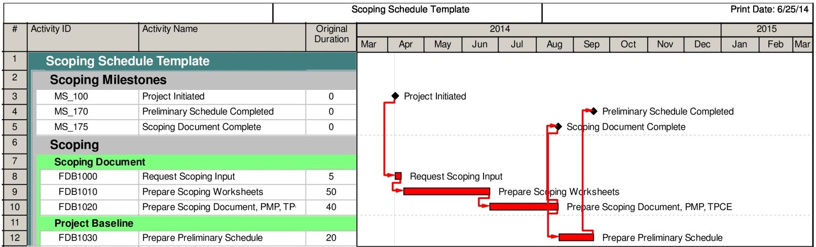

Role Loading, Activity Owners & Baselining
The template is base role loaded with the appropriate functional groups that are involved with the scoping process. The SSC will work with the PM to update and refine the role hours and role names to fit the project (see attached). Role Loading must be according to PD-00-08 (Role Loading).
The Project Manager will be the activity owner for all activities.
The scoping schedule MnDOT Baseline Status project code will be:
UNDEV (Undeveloped) when the scoping schedule shell is created by Admin.
PRSCH (Preliminary Schedule) when the SSC inserts the work package and tailors the schedule to the project with the PM.
BSLND (Baseline) when the PM approves the scoping schedule activities, roles, role hours, and durations.

Activity Descriptions
Request Scoping Input – All the activities required by the PM and functional groups to conduct scoping meetings, review data (including field visits), and gather information needed to compile the Scoping Worksheets.
Prepare Scoping Worksheets – All the activities required by the PM and functional groups to complete the scoping worksheets.
Prepare Scoping Document, PMP, TPCE – All the activities required by the PM to draft the Scoping Document, prepare a Project Management Plan (PMP), and Total Project Cost Estimate (TPCE).
Prepare Preliminary Schedule – This is the task to create the preliminary design schedule between the PM and SSC. It does not include base-lining the schedule.

Timeline for Implementation
FY 2015, 2016, 2017 and 2018 projects
If these projects are already scoped, a separate Scoping Schedule is not required. However, non-PPMS carryover schedules need to have Activity MS_175 Scoping Milestone added for WIG scoreboard reporting. PPMS carryover schedules need to have activity 1003 Project Scoping.
If project scoping has already started, follow FY 2019 requirements.
If scoping has not started, follow FY 2020 and beyond guidance.
FY 2019
All projects will use the new Scoping Schedule. However, if the scoping process has already started and will be completed by November 15, 2015, the PM can eliminate activities FDB1000 (Request Scoping Input) and FDB1010 (Prepare Scoping Worksheets).
All FY 2019 should have the activity FDB1020 (Prepare Scoping Document, PMP, TPCE) constrained to November 15, 2015. The Prepare Preliminary Schedule activity does not need to be constrained (some districts may want to constrain to a letting date).
FY 2020 & Beyond
All projects will use the new Scoping Schedule. Activity FDB1020 (Prepare Scoping Document, TMP, TPCE) shall be constrained for the following FY:
FY 2020 - Constrain to November 15, 2016
FY 2021 - Constrain to November 15, 2017
The prepare design schedule activity does not need to be constrained.

Questions
Please contact Jay Hietpas at jay.hietpas@state.mn.us or at 651-366-4698.

Role Hours for Scoping Schedule Template
