Default Report
MnDOT Project MGMT Role Definition Survey: PM Group
May 5th 2017, 9:48 am CDT
Q1 - Current Situation 1. PM Role and Accountability, Adequately Defined or Not? Do you believe that the role and accountabilities of the project manager within MnDOT (i.e. the functions and tasks that the PM performs and is responsible for) are adequately defined to support MnDOT project success and MnDOT organization effectiveness?
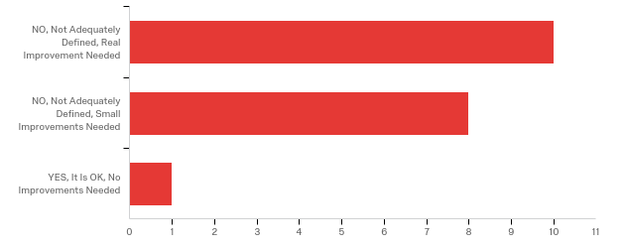

# | Answer | % | Count
1 | NO, Not Adequately Defined, Real Improvement Needed | 52.63% | 10
2 | NO, Not Adequately Defined, Small Improvements Needed | 42.11% | 8
3 | YES, It Is OK, No Improvements Needed | 5.26% | 1
 | Total | 100% | 19

Q2 - 2. Issues Resulting from the Current Situation with the Definition of the PM Role and Accountabilities Do you believe that the current way the PM role and accountabilities are defined have caused issues for MnDOT projects and/or the MnDOT organization as a whole?
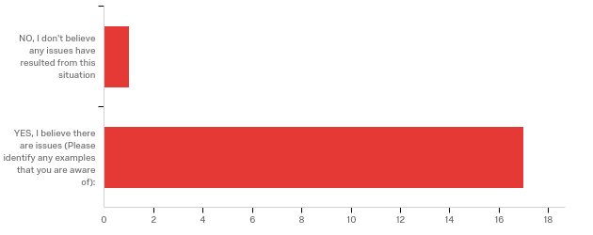

# | Answer | % | Count
1 | NO, I don't believe any issues have resulted from this situation | 5.56% | 1
2 | YES, I believe there are issues (Please identify any examples that you are aware of): | 94.44% | 17
 | Total | 100% | 18

YES, I believe there are issues (Please identify any examples that you are...
YES, I believe there are issues (Please identify any examples that you are...
There are PMs in multiple functional groups. This means that some individuals are a PM on some projects and a functional area representative on some projects. This causes some things to get done twice, other tasks to fall through the cracks and sometimes functional groups claim they don't have to do a task because the PM will take care of it.
The lack of role definition for the PM has led to some confusion in our workgroups and especially externally when consultants are utilized. MnDOT organizational structure is still “functional”, at least in the Districts. With additional funding from SRC, functional areas have staffed up while PM support staff has not changed. The chart in this article hits our role almost 100% in this current functional structure: https://edward-designer.com/web/functional-vs-projectized-vs-matrix-organizations-for-pmp-exam/ PM’s are part time pro coordinators and are sometimes criticized for their lack of staff and product they provide in their other responsibilities. The lack of PM role definition has made the role a dumping ground for unwanted tasks and coordination ranging from utility identification/coordination, survey coordination, TMP’s, consultant acquisition and management, cost estimating, and many more. Some tasks remain in the functional areas while some have become PM responsibilities. Functional areas get the benefit of staff and technicians while the PM's have little to no support staff available to them. Additionally, the implementation of working schedules and role loading has been passed on to the PM’s to facilitate because of their understanding of both the schedules and the local process.
I think there is generally confusion about the direction of the department. What are the differences between the project management group and area management? Is the intent for all project management to be done thru the PM group in the future excluding small projects that only include one functional area. Explaining this to employees would be beneficial.
Sometimes we have difficulties because people misunderstand the PM's role. These are not often and can mostly be dealt with at the district level.
Responsibilities of Project Manager and Plans Engineers are unclear. There is inconsistency on how different PMs & Plans Engineers develop their projects. Since most of the Plans Engineers have previously been PM/Plans Engineer on their projects there is a reluctancy in giving up control of some of their portions of the project. Also, some of the tasks are being done by both PM & Plans Engineer, which can creates inefficiencies.
I don't feel the PM role has been defined at all. The PM position has become a dumping ground for tasks the district and central office functional groups want done but don't want to do themselves. Many of these tasks require specialized knowledge that the PM's don't have. Examples: Final design pushing design contract management onto the PM's, and the PM's get stuck as go-betweens. Complete streets inventories that require specific knowledge of ped, bike, transit, freight and trail needs - the C.O. specialty groups should be providing that information - not the PM's guessing what they want addressed. PM's should MANAGE the project, and should not be expected to be the pack mules of project delivery.
In our District Project Managers are tasked for scope schedule and budget (as that is the main emphasis for PMs in MnDOT.) But our PMs are also tasked with project delivery tasks, including public engagement, utility contact person, compiling Transportation Management Plans, Compiling plan turn in information, participate in plan review. Our PMs have become the catch all for project delivery tasks.
some lack of accountability from functional groups in the roles they play in delaying projects.
- The PM is supposed to use the schedule to manage the project, but has no authority or recourse when functional groups miss the deliverable finish dates in the schedule. -The PM is supposed to manage the scope of the project but is often overridden by management or local government/political forces resulting in changes to the project scope and schedule after the project has entered the STIP and some work has already been completed -It is unclear what the PM's role is in the public involvement process, what this process should be, and who is responsible for leading this process
There are many people that do not recognize the authority of the Project Manager. I understand that there are in fact people that out rank the PM. However, what is occurring is that decisions are made without even consulting the PM. The PM then feels like they have no control over their project.
-Telling a PM he's accountable for the project schedule then telling him he can't change the letting to remove negative float because of "quarter" targets on lettings. Not every project is the number 1 priority and there are times it makes sense to adjust the letting instead of putting additional resources on a project that you don't have.
Several instances where either a PM assumes (or is uncertain if) a functional area has authority/responsibility (or vise-versa) resulting in confusion, frustrations, and sometimes delays.
How decisions are made and communicated has caused issues with projects. When major changes are made the PM needs to include the appropriate functional areas in the decision or inform them of the decision made. Issues are in making sure the appropriate people are involved in decisions and the appropriate communication of decisions are made and issue around them are considered appropriately. On the flip side the appropriate functional areas need to be responsive when asked as no decision or lack of response usually means the PM decides something to keep a project moving. When PM's are brought onto a project or starting it causes trouble. Roles early on need to be defined from 10 years out and etc. How projects are actively managed. Not scope and lets sit but how to keep engaged in managing scope, schedule and budge.
-The way the MnDOT organizational structure is defined, it does not allow the project manager to have adequate authority to properly manage the project and make appropriate decisions. -The MnDOT project manager does not have authority over the functional areas to allow proper staffing and decision making that is in the best interest of the project.
PM's do not have the ability to direct the work of other functional groups. It is still up to the functional groups to manage and deliver their work loads. As a PM, we do not know if they have the ability to deliver their work or not until the negative float begins. At that point, it may be too late for a project. I'm still not sold on P6 and how good a scheduling software it really is.
Project decisions are made without consultation with such as advancing projects are made without consultation with the PM. This places projects into a recovery schedule or scopes are changed to meet the new letting.

Q3 - 3. PM Decision Authority, Adequately Defined or Not? Do you believe that the decision authority for project managers within MnDOT is adequately defined to support MnDOT project success and MnDOT organization effectiveness?
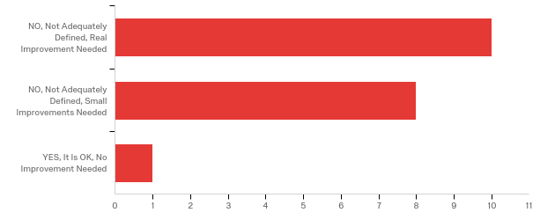

# | Answer | % | Count
1 | NO, Not Adequately Defined, Real Improvement Needed | 52.63% | 10
2 | NO, Not Adequately Defined, Small Improvements Needed | 42.11% | 8
3 | YES, It Is OK, No Improvement Needed | 5.26% | 1
 | Total | 100% | 19

Q4 - 4. Project or Organization Issues Resulting from the Current Situation with the Definition of the PM's Decision Authority Do you believe that the current way the PM decision authority is defined has caused issues for MnDOT projects and/or the MnDOT organization as a whole?
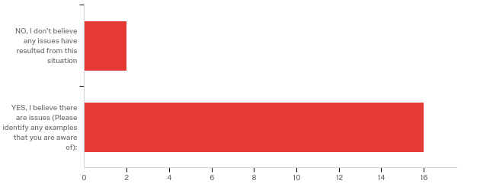

# | Answer | % | Count
1 | NO, I don't believe any issues have resulted from this situation | 11.11% | 2
2 | YES, I believe there are issues (Please identify any examples that you are aware of): | 88.89% | 16
 | Total | 100% | 18

YES, I believe there are issues (Please identify any examples that you are...
YES, I believe there are issues (Please identify any examples that you are...
PM is owner of the schedule. When something changes with the program year or letting date the SSC will not make any updates until PPMS is updated even though the PM has made the decision, and gotten approval, to change it.
There has been a lot of improvement, but some functional areas have resisted making sure PM's are aware of changes to scope, schedule, budget, and project issues. Our structure does not lend itself to PM authority, all staff reports to functional area supervisors and functional area group leads at the principal level. Staff loyalty continues to follow the functional areas and group leads. Being well liked and respected are really the only sure ways to retain any project authority.
Decision making as it relates to District Functional Groups occasionally arise, but those are easy to deal with at the project team level and, if necessary, can be escalated to district management. Less frequently, but with greater impacts on schedule, differences of opinion between district staff and CO Functional Groups arise. Mostly these are with Pre-Letting, Bridge, and ADA. Two things will help with this: 1. a greater expectation of CO FG staff being part of the project team (PM invites them to discussions, they participate). 2. a clear decision making authority and dispute resolution process.
The org structure is set up that PMs are supposed to have authority for control of the scope, schedule, and budget for their projects. However, in reality in practice many of the items are out of their control or they aren't actually given control of. Sometimes items get added to the scope of the project late in the game that can create difficulties in project deliverability, however PMs are not given control of these decisions.
PM's are held accountable for scope, schedule and budget, but have no authority to re-prioritize functional group work when they don't deliver or change the scope/budget of the projects, or don't adequately scope their needs early in the process.
In our District individual functional units are responsible to make project decisions in their expertise area. That is fine and it should be that way but there is a lack of a sense of urgency when a PM tries to bring the group to a decision.
minor project delays..
As mentioned above, decisions made about project scope that are influenced by outside stakeholders and thrust upon the PM. The PM makes decisions on a project basis, but oftentimes there are large factors at stake and there needs to be someone who is reviewing these decisions and how they relate to the entire program and their impacts to other projects in time and space
Fundamentally, the Functional Groups refuse, and I mean out right refuse, to explain why they made decisions regarding their scope on the project. They just tell the PM that they made a decision and its final. We need to get to a point where the Functional Groups present a recommended scope to the PM for approval. We need to allow the PM to ask for multiple options to be explored in good faith, and then a process to select the preferred alternative.
I feel that a lot of decisions are made up on a project by Area Engineers or functional groups without consultation with the PM. Therefore a lot of times the PM is left there to pick up the pieces and make it work.
See above.
I think the way decisions are made, if the PM followed the process properly, would be ok. Also if the functional areas that are supposed to support or help make the decisions are engaged and responsive things would be a bit better. It takes a team and when one does not support the effort things fall off the table so to speak. Allow PM's authority to start the project early and decide what is needed at a high level with a project charter and plan for time and resources needed to make a project successful moving forward.
-The way the MnDOT organizational structure is defined, it does not allow the project manager to have adequate authority to properly manage the project scope, schedule and budget and make appropriate decisions. -The MnDOT project manager does not have authority over the functional areas to allow proper staffing and decision making that is in the best interest of the project.
See number 2. Leadership, whether District or CO, needs to be more involved in holding functional groups accountable to deliver. It is not the PM's responsibility.
Letting and funding need to be balanced over the program. This extends beyond individual PM's. It should perhaps be recognized that PM's do not have decision authority over their projects. There are issues but the projects get done. Examples: missed letting when project limits extended to include additional work and R/W couldn't be obtained in time Moving letting forward forcing a recovery schedule (can't baseline a project with negative float) Changing project from reconstruct to retrofit no longer qualifying for bonding funds

Q5 - Value of a More Defined PM Role and Accountabilities 5. Value to Working Relationships Do you believe that the working relationships between project managers and MnDOT Functional Groups could be improved with a more defined PM role and accountabilities?
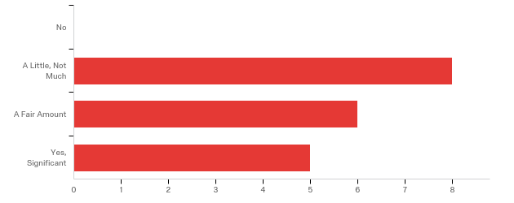

# | Answer | % | Count
1 | No | 0.00% | 0
2 | A Little, Not Much | 42.11% | 8
3 | A Fair Amount | 31.58% | 6
4 | Yes, Significant | 26.32% | 5
 | Total | 100% | 19

Q6 - 6. Value to Project Success Do you believe that the success of MnDOT projects could be improved with a more defined PM role and accountabilities?
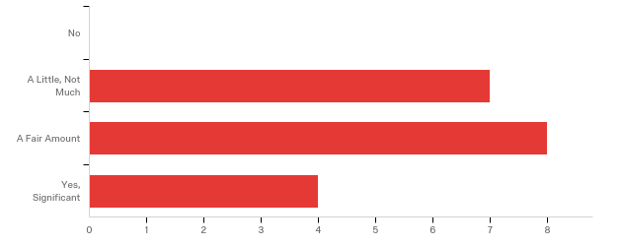

# | Answer | % | Count
1 | No | 0.00% | 0
2 | A Little, Not Much | 36.84% | 7
3 | A Fair Amount | 42.11% | 8
4 | Yes, Significant | 21.05% | 4
 | Total | 100% | 19

Q7 - 7. Examples of a More Defined PM Role If the role and accountabilities of the MnDOT PM position would be better defined, what areas or functions of the PM position would be most important to include, or to improve, such that MnDOT project success and organization effectiveness are best supported.

7. Examples of a More Defined PM Role If the role and accountabilities of t...
Not only does the role of the PM need additional clarification, the role of each functional group needs definition also. The PM does not work in a vacuum on their own, but needs the whole team in order to complete a project. Defining the responsibilities of all the groups will make the whole team work better together.
-Whether or not predesign is a project management activity. Predesign is lumped together with design in the resource management plan. Design has received staff and predesign has not. Design continues to request that predesign do layouts on all jobs including ROW construction limits, regardless of staffing level. -Roles and responsibilities in design for the PM. -Whether or not project managers are supervisors.
their role relative to different groups especially Design and Construction. It will help allay fears and get greater consistency.
Clearly define the specific tasks that the PM, Plans Engineers, and functional units are responsible for. Many of the "scope, schedule, and budget" items are unclear when put into practice.
MnDOT PM's have little authority to direct functional groups to do anything. We have to rely on a chain of command within each functional group to get things done. Additionally, the roles of Area Engineers and PM's seem to overlap in Metro.
PM's should be able to set or change priorities based on internal and external factors, and have the support of management.
1. More time in scoping, public engagement, watching budget. 2. Better group effort in keeping project activities on track led on individual projects by the PMs. But then District Management needs to lead in seeing that units are doing their activities on time or else they need to take lead in resource management. 3. Tracking budget 4. Less time in compiling plan and special provision details
define the authority the PM has over the project
How the PM deals with groups that don't meet their deliverable dates.
The PM is fundamentally responsible for the approval of scope and cost. Functional groups need to present their scope and cost to the PM for approval. they can't just assume its approved. The functional groups must be willing to produce multiple options and costs for evaluation to the PM. Then yes, a committee may be needed to choose the final outcome. Right now many functional groups say they only have time to do one option and that's it, no more.
We should lay down clear lines of decision making and relationships between the PM, Area Engineering and Functional Groups.
Clearly defined issue escalation process. With Performanced-Based Practical Design, there will be additional conflicts within projects teams. Not everyone is on board with PBPD, and these people aren't going anywhere.
The response to this questions varies from project to project. It will depend on the project scope. It will also depend on the experience and expertise that the PM possesses.
I think the expectations of each of the functional areas would help so they know what clearly they have to do and how that contributes to supporting the project and pm. I would include managers in this role as they trump decisions sometime with little input. With that defined a PM knows what to expect (where functional area stop and they start so to speak) So many times functional areas wait to be asked rather than being engaged in the process. As part of their expectations in working with PM's are being engaged and not hiding out. When a PM starts working on Job. Not at scoping but at Charter stage and how to set a project up for success from there.
-More authority of project scope, schedule and budget including decisions on internal and external staffing. -The current MnDOT organizational structure does not allow the project manager proper authority to make appropriate decisions that are in the best interest of the project.
In general, I think the organization is stretched thin. PM's are required to scope, schedule, budget, public engagement, consultant management, utility coordination, agency coordination, geometric layouts etc. on numerous projects that are in different stages of development. The message seems to be to out-source if you can't deliver but consultant management takes quite a bit of time that leaves less time for other activities. Managing P6 schedules takes time. Managing scope and risk registers takes time. WIG 2.0 is asking that more public engagement occur. What are the priorities?
it would be helpful to know who is responsible for what so there are no gaps or doubling up of work

Q8 - Value of a More Defined PM Decision Authority 8. Value of Working Relationships Do you believe that the working relationships between project managers and MnDOT Functional Groups could be improved with a more defined PM decision authority?
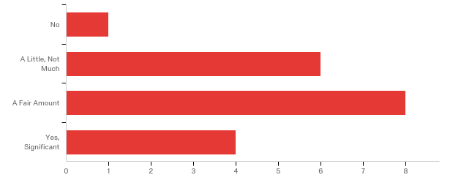

# | Answer | % | Count
1 | No | 5.26% | 1
2 | A Little, Not Much | 31.58% | 6
3 | A Fair Amount | 42.11% | 8
4 | Yes, Significant | 21.05% | 4
 | Total | 100% | 19

Q9 - 9. Value to Project Success Do you believe that the success of MnDOT projects could be improved with a more defined PM decision authority?
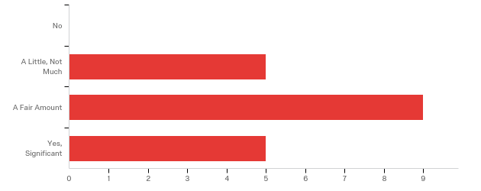

# | Answer | % | Count
1 | No | 0.00% | 0
2 | A Little, Not Much | 26.32% | 5
3 | A Fair Amount | 47.37% | 9
4 | Yes, Significant | 26.32% | 5
 | Total | 100% | 19

Q10 - 10. Examples of a More Defined PM Decision Authority If the decision authority of the MnDOT PM position would be better defined, what types of decisions would be most important to include, or to improve, such that MnDOT project success and organization effectiveness are best supported?

10. Examples of a More Defined PM Decision Authority If the decision author...
As it stands the PM is responsible for the scope, schedule and budget of a project. The functional groups are essentially in charge of the scope and the budget based on what they are willing to contribute funds to. The SSC and the functional groups control the schedule. The PM is the advisor that tries to get all the parties to cooperate.
Some of the biggest challenges to project delivery and implementing working schedules can be at the functional group lead level. It varies by area and office, some are very good. P6 has become a bartering tool for more staff or other agendas. The good Principal leads will coordinate on a level playing field with the PM’s and understand when decisions have to be made over scope, schedule and budget. Other functional leads tell PM’s “they will get it when they get it” and they get away with it because they outrank PM’s and sometimes don’t report to a common manager. From what I have read this is a very common struggle with project managers in functional organizations across many industries. In MnDOT project accountability only appears to currently apply to the PM, there appear to be no consequences for lack of delivery in the functional areas.
need to clarify what decisions are up to the FG lead, which need team involvement, and which the PM should then make. Most important is the dispute resolution though, otherwise people get stuck.
Clearly define specific decision authority over the scope, schedule, and budget. Some of this is somewhat vague and unclear to PMs, Plans Engineers, and functional units.
PM's have little control over the schedule. Some durations are excessive, but functional groups hold onto every day they can so they sequester float and avoid being blamed for missing a deadline. This makes things challenging in an environment in which projects can change on the fly and we want to hold letting dates.
1. If there is a change in scope, schedule or budget it should come to the PM first.
scope adds & review comments closeout
Decisions that impact the scope and delivery schedule of the project.
There are many functional groups that change their scope during final design. Its actually a form of black mail, because often the scope really does need to get done. However, these late changes cause quality and delay issues to a project. These functional groups will often sneak stuff in during final design and the PM has to catch it. There is very much an attitude that the PM does not make the decisions. Instead the attitude is the functional group makes the decisions.
Having prescribed documents within each functional group of the role of the PM vs. the role of the functional group team lead. Often times the PM is facilitating a decision as long its within the scope and budget. Defining when the PM may take that responsibility away from a functional group could be extremely beneficial (Or saying they never should...which I don't agree with - There are times we need to keep the project moving and will make a functional groups decision because they won't in a timely manner even after given the opportunity).
Too broad to offer one answer.
After a decision has been made and documented PM's can stop people that want to circle back and keep relooking at things 1 or 2 years later. If functional areas or managers come late in the process with changes that should have been done earlier in the process, that they can say no to them. Give the PM authority to say when a project scoping process has to be started. Some bigger jobs we are starting too late and are pressed for time. Give PM's more authority as projects enter the CHIP to have time to develop a project charter and set the project timeline, resources and other needs. This leads well in to the scoping process. Identify gaps in staffing needs early and mitigate them.
-More authority of project scope, schedule and budget including decisions on internal and external staffing. -The current MnDOT organizational structure does not allow the project manager proper authority to make appropriate decisions that are in the best interest of the project.
Again, if functional groups don't have the staff to deliver on time and are not adequately monitoring/planning their work load, I wouldn't know that as a PM until a project is in trouble.
Advancing projects Changes to project scopes

Q11 - PM Roles vs. Functional Group Roles 11. What Current Work Normally Accomplished by the PM Could Be Better Accomplished by Functional Groups? Please select on of the following that would best serve MnDOT and its customers.
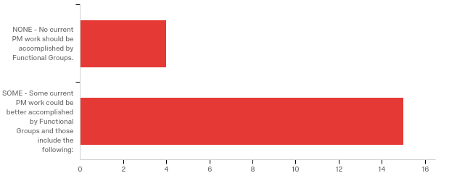

# | Answer | % | Count
1 | NONE - No current PM work should be accomplished by Functional Groups. | 21.05% | 4
2 | SOME - Some current PM work could be better accomplished by Functional Groups and those include the following: | 78.95% | 15
 | Total | 100% | 19

SOME - Some current PM work could be better accomplished by Functional Grou...
SOME - Some current PM work could be better accomplished by Functional Grou...
Filling out requests for information should be done by the group that needs it.
Scoping, schedules and role loading are often unimportant to functional areas, the project managers are left to define much of the project scope, create and maintain schedules and facilitate role loading and other initiatives. Additionally, in-house staff commitment is often not identified far enough in advance. When a functional group realizes they need help it is often too late to be successful with a consultant, this becomes the PM’s issue to try to hurry up and get a consultant or to live with the negative float. There is little consequence for the functional groups lack of delivery. Also, functional groups need to “own” their own work packages and update them to be correct to their process!
Small projects that only involve one or two functional groups.
Complete Scoping Efforts adequately. Update Project Schedules regularly. Current role of PM requires regular reminders and hand holding of Functional Groups to update schedules. Not a priority in the functional groups.
There are design oversight roles when we have consultants that could be done better by the Design Lead, but we usually have the PM do it. Another is the involvement with the environmental process on cat ex's. I think this is a factor of our district staff though.
In District 3 the PM's are being forced to write and administer consultant contracts for design work. We aren't designers and shouldn't be expected to run contracts for other functional groups. We should be responsible for contracting project development efforts like studies, environmental work and geometric design.
1. Utility coordination during plan development 2. Transportation Management Plans 3. Plan Turn In & Review This are tasks assigned to PMs in our District and may not be true in all Districts.
Functional groups should be more accountable for delivering their work in accordance with the schedule and not rely so heavily on the PM to constantly remind them of their deliverables. It is also apparent that some functional groups do a very poor job of managing their workloads and chronically miss their schedule deadlines with no consequences.
This is hard to answer. A lot could be done here. Its a collaboration. The PM wants to see options. Functional groups refuse to create options, especially options they don't like. They will refuse to make those options they don't like and then the PM has to do it.
Scoping recommendations - Getting hydraulics to look at every pipe and making prelim recs based on condition. This doesn't happen enough. Prelim layouts - not enough guidance given to consultants from prelim design staff. As such, prelim design staff is concerned with products received without conveying early expectations - This results in PMs doing a lot of in-between coordination that wouldn't be necessary with well defined guidelines. Traffic Forecasts - This could easily be accomplished by the materials team lead and should be. Routing of project plan-sets for review - have design lead route.
Public engagement, utility engineering, agreements, wetlands.
Planning - better engagement with local comp plans, local wants and needs and ways to engage the public ahead of projects that are entering the CHIP. Functional areas - early coordination is more on the PM and less on functional areas do to staffing and resource constraints. When projects are to be turned in that functional areas do their needed tasks rather than the PM chasing people down for different tasks. Plan reviews - same chasing around for people to do their reviews. Functional areas being engaged in program and looking for ways to support the PM rather than waiting to be engaged. Public engagement and exhibits seem to fall on the PM to get ready and organized and better support from CO on this would help or more support within the district.
Consultant Management Utility Coordination Environmental coordination and commitments
functional areas need to review plans for their area of expertise possibly some of the utility coordination activities and contract writing and processing

Q12 - 12. What Current Work Normally Accomplished by the Functional Groups Could Be Better Accomplished by the PM? Please select one of the following that would best serve MnDOT and its customers.
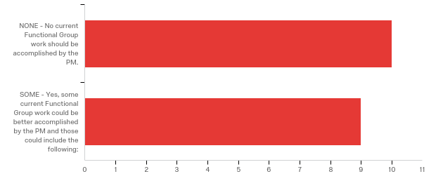

# | Answer | % | Count
1 | NONE - No current Functional Group work should be accomplished by the PM. | 52.63% | 10
2 | SOME - Yes, some current Functional Group work could be better accomplished by the PM and those could include the following: | 47.37% | 9
 | Total | 100% | 19

SOME - Yes, some current Functional Group work could be better accomplished...
SOME - Yes, some current Functional Group work could be better accomplished...
Coordination between the functional groups. Sometimes they make decisions between the groups without including the PM that have big implications for the project.
Our PM's have other responsibilities other than managing scope, schedule, budget including Predesign/Project Development/Scoping, Public Engagement/Municipal Coordination, Environmental Documentation, Cost Estimating, geometric and design standard analysis, assist in planning level and program development and most recently our group has been assigned with all Consultant Administration and Acquisition activities. There has been and continues to be issues role loading these additional responsibilities. There is a lot of additional program support required both internally and externally for explaining the program and following the HPDP process.
This will vary some by the strengths and organization of each district. We are having our PMs take a greater lead in traffic control planning. This is necessary. I'd like the PM to take over more contracting out work that FG's can't get done.
Not sure
This is hard to answer. A lot could be done here. Its a collaboration. The PM wants to see options. Functional groups refuse to create options, especially options they don't like. They will refuse to make those options they don't like and then the PM has to do it.
I believe that PM's should have the right to monitor and update functional group P6 task completion levels, and have more say in their schedules.
It's a mixed bag for PMs and design staff doing the project turn in to St. Paul. In general, it would typically make more sense coming from the PM.
saying how much input is enough in certain cases for plan reviews, scoping input and other process input. Sometimes you get nothing or very little from a functional group and have to go with it.
-Possibly managing all consultant contracts. -Functional groups should remain technical leads. -The bridge office should be treated like any other functional group. Why are they allowed to work in a black box and not coordinate with the districts? Bridge plans should be sent to districts for review and coordination with roadway plans and vice versa.

Q13 - PM Decision Authority vs. Functional Group Decision Authority 13. What Current Decisions Normally Accomplished by the PM Could Be Better Accomplished by MnDOT Functional Groups? Please select one of the following that would best serve MnDOT and its customers.
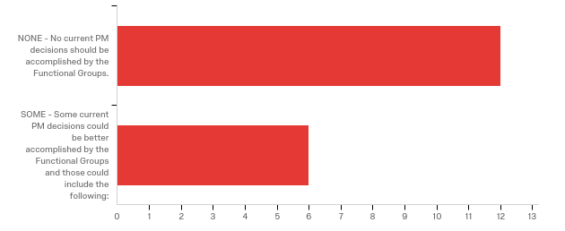

# | Answer | % | Count
1 | NONE - No current PM decisions should be accomplished by the Functional Groups. | 66.67% | 12
2 | SOME - Some current PM decisions could be better accomplished by the Functional Groups and those could include the following: | 33.33% | 6
 | Total | 100% | 18

SOME - Some current PM decisions could be better accomplished by the Functi...
SOME - Some current PM decisions could be better accomplished by the Functi...
P6 updating, work package logic and role loading is often heavily facilitated by PM’s in the district. Functional group leads need to do a better job predicting their staffing needs with role loading, the math should match the plan for consultant use.
Depends on the PM and project team. Sometimes PMs make technical decisions because FGs defer it to them when they should still be made by the FGs. I don't have any good examples off hand though.
At this point it doesn't seem like we get to make any decisions - we are constantly over-ridden by the functional groups.
Its a collaboration. The PM relies on the technical experts to provide expert advice and come up with options. The final decision is made by the PM, but the functional group expert has to collaborate with the PM to figure out what options to explore and how to best vet them.
Project plan preferences - design leads should have this information in a guidance document (the finer points not covered by the design scene)
design related decisions sometimes are made by the PM when that functional area should have input. Things around design flexibility are hard for that functional area to let go as strict adherence to standards or perceived standards is difficult to move them off. If an appropriate level in input is not being given at scoping or other situations from a functional area tell them to hire a consultant or find other ways to deliver.

Q14 - 14. What Current Decisions Normally Accomplished by MnDOT Functional Groups Could Be Better Accomplished by the PM? Please select one of the following that would best serve MnDOT and its customers.
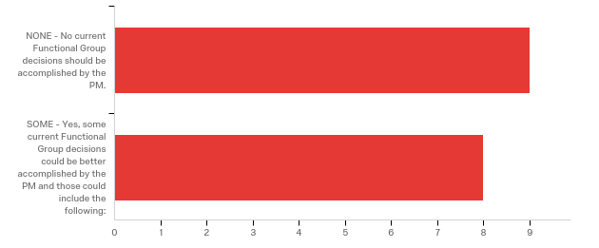

# | Answer | % | Count
1 | NONE - No current Functional Group decisions should be accomplished by the PM. | 52.94% | 9
2 | SOME - Yes, some current Functional Group decisions could be better accomplished by the PM and those could include the following: | 47.06% | 8
 | Total | 100% | 17

SOME - Yes, some current Functional Group decisions could be better accompl...
SOME - Yes, some current Functional Group decisions could be better accompl...
The project manager should be at least aware of all design decisions that have scope or schedule impacts. There may be other considerations or constraints to consider. I really don't want to volunteer for anything new, I feel busy enough! We should probably play a stronger role in developing and coordinating municipal agreements.
Any time there are disagreements between functional groups on technical decisions or when the decision will affect scope, schedule, budget, other FG workload, public commitments then the PM should decide.
1. PMs need to be the initial contact in scope, schedule and budget changes
Decisions regarding the scope of projects should rely heavily on the project manager's input with the functional group's participation
Its a collaboration. The PM relies on the technical experts to provide expert advice and come up with options. The final decision is made by the PM, but the functional group expert has to collaborate with the PM to figure out what options to explore and how to best vet them.
ADA, aesthetics, drainage design, geometric layout approvals.
pulling all the project inputs from functional areas together and weighing out each area and making and documenting the best decision for the project vs the individual input.
-Possibly managing all consultant contracts. -Functional groups should remain technical leads. -The bridge office should be treated like any other functional group. Why are they allowed to work in a black box and not coordinate with the districts? Bridge plans and specs should be sent to districts for review and coordination with roadway plans and vice versa.

Q15 - Your Comments 15. Please Enter Your Thoughts Here Your comments are important and please be aware that some of the most important survey information is often contained in written comments.

Your Comments 15. Please Enter Your Thoughts Here Your comments are imp...
The PM is unable to direct the work of any of the team members. You rely on the functional groups to work with you and stay on task. Just because my project is my number one priority it doesn't mean that it is the priority of the functional group. Sometimes this causes problems in getting activities completed on time. There are many forms that the PM has to fill out. There is a ton of overlap in the information that needs to be entered. It would be helpful if all the groups could coordinate to reduce the redundancy in the paperwork and allow the PM more time to deliver projects.
In my opinion, the problems associated with the PM role are not definition but integration. The districts have received mixed messages about where the organization structure is headed. We were told 2 years ago that MnDOT would be moving towards a bookend organization where there would be less functional staff, more consultant use and a strong program delivery PM role and strong construction PM role. Since the SRC operating budget was approved, there appears to be less effort in this direction. It would be great to see District and upper management play a more active role in implementation of a stronger PM role if it is desired. A balanced Matrix organization seems like it would be the best fit for the district where there is still a lot of experienced staff in the functional areas, however there appears to be confusion at the most basic levels of where MnDOT is going with project management. With attrition at its peak, it seems critical to have a clear goal in mind for future staffing across the organization. It would be great if the plan used language accepted by PMBOK as to where we are headed as an organization as is referenced in the following articles: https://pmstudycircle.com/2012/08/what-is-a-projectized-organization-structure/ https://pmstudycircle.com/2012/08/what-is-a-functional-organization-structure/ https://pmstudycircle.com/2012/08/what-is-a-matrix-organization-structure/ Maybe an independent audit to classify our organization would be needed first to see where we are on the spectrum between a functional organization and a projectized one.
I'm looking forward to this getting all resolved and documented. I don't think we should always ask all the districts or CO functions how they want it to be, but there should be some leadership saying, here's how it will be (as long as that leadership agrees with my views anyway).
Improvements are needed on "specific" deliverables that need to be accomplished by PMs. Since the new org structure is fairly new to PMs & functional units more clarity is needed. If PMs are supposed to be responsible for projects from inception to completion (through construction) some more clarity is needed. PMs & functional units need to relinquish authorities that they were previously responsible for. There is inconsistency in how different staff members complete their work, often due to hesitancy in giving up ownership. This can create conflicts, which can affect the success of the project.
Functional groups do not work for the PMs, so in reality the PM has little authority to direct work. The PM can only influence functional groups.
PM's are frustrated by MnDOT's attempt to move toward a PM organization without first defining what that really is. We appreciate this effort to define the roles and responsibilities, and recognize that we may not like some of the outcomes.
MnDOT is very functional group oriented. That may never be able to change totally to be like the consultant industry seems to be. The PMs have a lot to do but they have nobody working for them to give tasks too. They have to ask for help from another unit but that unit is busy on their own assignments and functional tasks. But it would be nearly impossible to create teams with enough members from all functional expertise's that report to the PM. A compromise that should be considered is to at least give each PM a design squad so some responsibilities could be taken on in a true team effort. This might help with some of those project delivery tasks I mentioned earlier like utility coordination and plan turn in.
Hamburger.
-MPCs role on projects is confusing and not well defined. In general, there are too many project sponsors with differing viewpoints that conflict. This then proves challenging meeting agency expectations. There's also no well defined work breakdown structure on where and when they are included during project discussions. -CO specialty offices - As of late, some of these groups provide recs early on, that are considered and included or rejected and relayed back. They accept this. Then later on, like to revisit items already resolved. This also periodically happens with district functional groups, but seems to be less than the CO specialty offices. -Projects coming in late prove challenging. There are separate funds that sometimes come for safety or ADA. Incorporate them into district budgets and provide performance targets instead of an additional selection process late in the game. -I believe that quite a few functional groups have not bought into SHELF projects. They feel overworked and don't spend the effort necessary on something they view as a non-priority due to it being unfunded. -Better defined priorities is important moving forward. In a limited resources environment, what are the things that absolutely still need to get done and what are items that are less critical. -Plan quality has deteriorated over the last few years causing additional resource needs in construction whether due to change orders or resolving intent conflicting plan info. We should start focusing on a risk-based plan review where its clear who is reviewing what and who's accountable for the content. If 7 different people are looking at a detail sheet, any one person will feel less concerned with a glossed review on this - regardless, we've heard a lot this past year from construction staff that these plans are creating problems in the field.
The definition of roles and responsibilities for PMs needs to be fine tuned on many fronts; Project by Project, District by District, and PM to PM. Every situation is different, and solid Project Charter and Project Management Plan can lay this out at project inception.
continue to a push for advanced design and more detailed scoping to allow more flexibility in our program. We rarely get in trouble for starting too early but do if we are too late. Push for functional areas to staff appropriately for time and input at planning and scoping level. So often not enough detail is done at scoping and when people finally look at things it is too late to easily incorporate.
-The current MnDOT organizational structure does not allow the project manager proper authority to make appropriate decisions that are in the best interest of the project. These include authority on project scope, schedule and budget including decisions on internal and external staffing. -The bridge office should be treated like any other functional group. Why are they allowed to work in a black box and not coordinate with the districts? Bridge plans and specs should be sent to districts for review and coordination with roadway plans and vice versa. -The project budget should not be set until the project has been scoped.
Overall relationships between PM and Functional Groups is good. Problems are at a higher level and are often dictated by influxes of/balancing funding, outside pressures and trying to figure out creative ways to get things done. These things tend to compromise the process to one degree or another and seems to be the norm rather than the exception.

Q16 - 16. Would You Like To Share Your Thoughts with an External Consultant? This information, like this survey, will be kept anonymous.
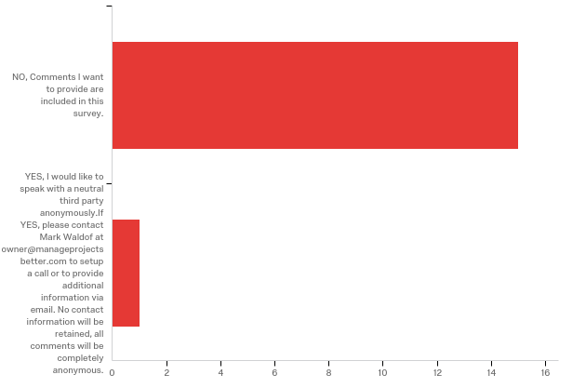

# | Answer | % | Count
1 | NO, Comments I want to provide are included in this survey. | 93.75% | 15
2 | YES, I would like to speak with a neutral third party anonymously. If YES, please contact Mark Waldof at owner@manageprojectsbetter.com to setup a call or to provide additional information via email. No contact information will be retained, all comments will be completely anonymous. | 6.25% | 1
 | Total | 100% | 16

Q17 - Your Current Experience at MnDOT 17. Your Experience (Optional, but Requested)
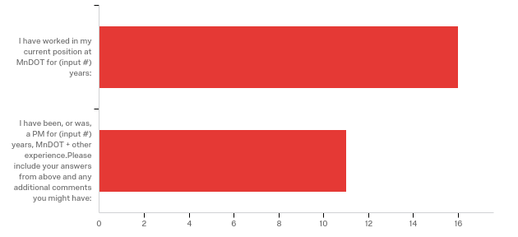

# | Answer | % | Count
1 | I have worked in my current position at MnDOT for (input #) years: | 100.00% | 16
2 | I have been, or was, a PM for (input #) years, MnDOT + other experience. Please include your answers from above and any additional comments you might have: | 68.75% | 11
 | Total | 100% | 16

I have worked in my current position at MnDOT for (input #) years:
I have worked in my current position at MnDOT for (input #) years:
1.5
3
less than 1 year
3
8
.5
10
4 years as a formal PM but 25 years with MnDOT in 4 functional areas.
3
4
16
18
6
2
5
8.5 years

I have been, or was, a PM for (input #) years, MnDOT + other experience....
I have been, or was, a PM for (input #) years, MnDOT + other experience....
I have been in my current position for 1.5 years. Before that I had experience as a functional area PM and as a PM at a consulting firm.
Going on 7 years with MnDOT overall, 1 year consulting, and going on 3 years of PM at MnDOT
more than 6 years of PM experience at MN/DOT
16 years
2
10 years
9
12 years at MNDOT, and 6 years in consulting.
Long-time MnDOT employee, short-time PM.
I have worked with MnDOT for 21 years mostly in design and project management.
21 years industry experience.

