Default Report
MnDOT Project MGMT Role Definition Survey: Manager Group
May 5th 2017, 9:47 am CDT
Q1 - Current Situation 1. PM Role and Accountability, Adequately Defined or Not? Do you believe that the role and accountabilities of the project manager within MnDOT (i.e. the functions and tasks that the PM performs and is responsible for) are adequately defined to support MnDOT project success and MnDOT organization effectiveness?
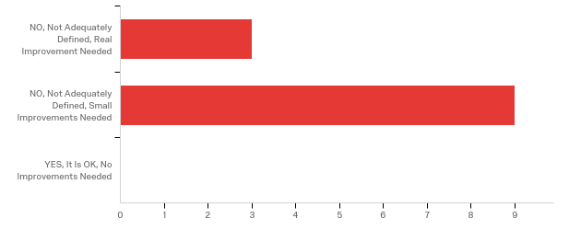

# | Answer | % | Count
1 | NO, Not Adequately Defined, Real Improvement Needed | 25.00% | 3
2 | NO, Not Adequately Defined, Small Improvements Needed | 75.00% | 9
3 | YES, It Is OK, No Improvements Needed | 0.00% | 0
 | Total | 100% | 12

Q2 - 2. Issues Resulting from the Current Situation with the Definition of the PM Role and Accountabilities Do you believe that the current way the PM role and accountabilities are defined have caused issues for MnDOT projects and/or the MnDOT organization as a whole?
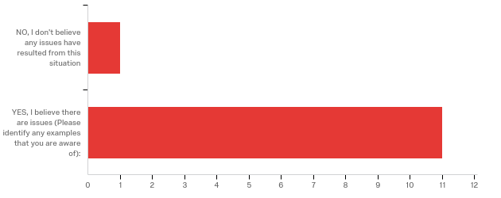

# | Answer | % | Count
1 | NO, I don't believe any issues have resulted from this situation | 8.33% | 1
2 | YES, I believe there are issues (Please identify any examples that you are aware of): | 91.67% | 11
 | Total | 100% | 12

YES, I believe there are issues (Please identify any examples that you are...
YES, I believe there are issues (Please identify any examples that you are...
What PM's have accountability for is an issues. Are they the ultimate decision maker on the project? When are they over-ruled? Can they be over-ruled?
I think MnDOT is in a transition period moving towards a project management organization. As this process has been more gradual, it has caused some conflict with the way business used to be completed.
- PM and Planning/Planner coordination and integration ...a lot of confusion still seems to exist regarding the making and tracking of expectations and commitments and the way the Planning to PM hand-off occurs or should occur. - There is confusion regarding the expectations or accountability of PMs in regards to stakeholder engagement and pre-scoping and early scoping levels of effort that may be critical (this is a resourcing issue as well). - It is my perception that the accountability and responsibility expected of PMs is not commensurate with the authority, discretion and resources they are provided. - While PM communications with functional groups, etc. is getting better, it is still significantly lacking across the board (this may be a resourcing issue as well)
TO the extent that there are growing pains, given many PMs are learning on the fly. May not have understanding of what they can control or not control.
Hand off with construction could improve, should have PM involvement through the completion of the project.
Plan reviews, whose responsibility to coordinate Plan turn in's, who sends it to CO Non PE project managers making decisions, but don't sign the plans Consultant management, who hires
Creation of so many processes/requirements for P6 schedules, role loading, complete streets reports, etc... that it takes away time to actually work on projects (self-fulfilling prophecy -- creating these requirements means that more work is needed which means more PM's are needed). I have heard from other districts that PM's manage almost all consultants -- is that efficient to have the PM manage (for example), a detail design consultant -- wouldn't it make more sense to just have detail design manage that consultant instead of having the PM in the middle? Functional groups should have the ownership of their work and determine the best way to deliver their deliverables (and be accountable if they don't); does a strong PM structure lead to weak functional groups?
Related to providing information to functional groups and coordinating with the groups.
Scoping is less efficient. PM has limited control over schedule when utilizing MnDOT staff/resources. Clash between asset managers and Project Managers on what is "needed". Engineers withhold PE signature on plan to get what they want.
Project Managers trying to manage/project develop engineered projects without any engineering background, knowledge, skill and/or abilities. We don't have much depth in skilled engineers (and non-engineers) who are managing a deliverable without any training (HPDP) or certification (PE).
"Unclear and absent decision making, failure to ensure all of the project parts are moving along timely through completion, little attention to quality and coordination, much piecemeal work that creates rework, PM's often lack understanding in technical arenas and are not trained or aware of legal requirements.

Q3 - 3. PM Decision Authority, Adequately Defined or Not? Do you believe that the decision authority for project managers within MnDOT is adequately defined to support MnDOT project success and MnDOT organization effectiveness?
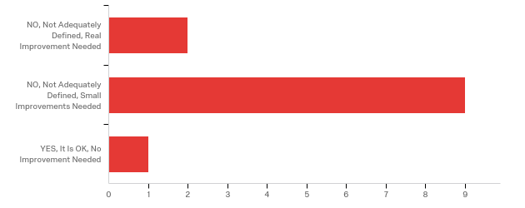

# | Answer | % | Count
1 | NO, Not Adequately Defined, Real Improvement Needed | 16.67% | 2
2 | NO, Not Adequately Defined, Small Improvements Needed | 75.00% | 9
3 | YES, It Is OK, No Improvement Needed | 8.33% | 1
 | Total | 100% | 12

Q4 - 4. Project or Organization Issues Resulting from the Current Situation with the Definition of the PM's Decision Authority Do you believe that the current way the PM decision authority is defined has caused issues for MnDOT projects and/or the MnDOT organization as a whole?
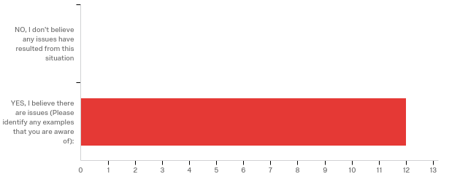

# | Answer | % | Count
1 | NO, I don't believe any issues have resulted from this situation | 0.00% | 0
2 | YES, I believe there are issues (Please identify any examples that you are aware of): | 100.00% | 12
 | Total | 100% | 12

YES, I believe there are issues (Please identify any examples that you are...
YES, I believe there are issues (Please identify any examples that you are...
A decision has to be made as to who has the authority while projects are being developed. Functional groups are making decisions that affect scope, schedule, and cost outside of the project manager.
See general examples / explanation cited under Question # 2 above.
MnDOT is a Matrix organization with much funding, scope, and program control resting with functional areas. PMs are charged with project delivery but often need to react to these drivers over the life of the project.
I think PM's need to have decision authority to a certain point. They are not necessarily responsible for making the decisions, but it is their job to ensure the decisions get made in a timely manner.
Conflicts between functional groups and PM's -- who has the experience to make those decisions
Central Office still wants control on certain things and causes confusion, delay and inefficient delivery. PM is nearly powerless to MnDOT specialty offices (both on schedule and deliverables)
I think there are challenges with who has the ultimate decision-making authority, especially when the guidance is coming from technical experts.
Same as 2.
Project development processes are not followed, development of project deliverables are not complete, timely or of high quality in many cases. There is much finger pointing and run around when trying to resolve issues.

Q5 - Value of a More Defined PM Role and Accountabilities 5. Value to Working Relationships Do you believe that the working relationships between project managers and MnDOT Functional Groups could be improved with a more defined PM role and accountabilities?
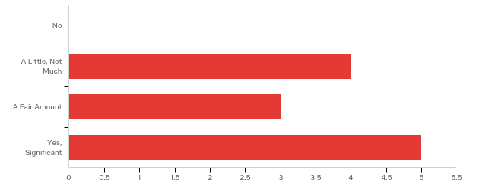

# | Answer | % | Count
1 | No | 0.00% | 0
2 | A Little, Not Much | 33.33% | 4
3 | A Fair Amount | 25.00% | 3
4 | Yes, Significant | 41.67% | 5
 | Total | 100% | 12

Q6 - 6. Value to Project Success Do you believe that the success of MnDOT projects could be improved with a more defined PM role and accountabilities?
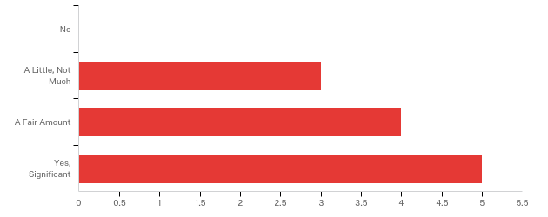

# | Answer | % | Count
1 | No | 0.00% | 0
2 | A Little, Not Much | 25.00% | 3
3 | A Fair Amount | 33.33% | 4
4 | Yes, Significant | 41.67% | 5
 | Total | 100% | 12

Q7 - 7. Examples of a More Defined PM Role If the role and accountabilities of the MnDOT PM position would be better defined, what areas or functions of the PM position would be most important to include, or to improve, such that MnDOT project success and organization effectiveness are best supported.

7. Examples of a More Defined PM Role If the role and accountabilities of t...
Identifying what authority they have and what decisions they can make. When decisions need to be escalated. What is the decision authority over functional groups (district and CO).
I think that a strong Project Management structure would provide a centralized focus for the delivery of our projects. As it stands now, the Project Managers are being held accountable for issues they have little to no control over.
See examples cited under Question # 2 above and better defined expectations, roles and accountabilities for PMs only goes so far if the authority, discretion and resourcing available to the PM is insufficient.
PMs should feel empowered to control scope and cost. Some take this role on to a higher level than others. Successful project TEAMS should be recognized, rewarded for projects on time and on budget.
P6 schedule management, getting functional leads to update their P6 schedules. Project float, who owns it and if one area is burning up the float, how can the PM make that functional area speed up their activities. Plan reviews Plan turn in Cradle to grave involvement (thru construction) Escalation process on decisions
-Roles within public involvement -- too many cooks in the kitchen? -Scalability based on project type and complexity -- many of our projects are straight-forward enough that a strong PM is not needed (sometimes feel they are a "paper pusher" - what value does that add?) -PM role in decision making - are they a facilitator? decision maker? how can they support functional groups in getting that work done?
coordination
MnDOT functional groups need to change their focus to being a project team member with the same goals as the project manager instead of doing what is perceived to be best for the functional group. If the PM does not have authority over the project team, then the PM cannot effectively manage. An decision/dispute resolution process needs to be implemented so a PM can effectively get timely decisions/resolution to issues.
A better understanding of how a project is developed and all the components that need to be considered for each project.
Understanding of the project delivery requirements, how they are completed and how to effectively schedule work tasks to limit rework and decisions delays, understanding what "done" means and what is correct?

Q8 - Value of a More Defined PM Decision Authority 8. Value of Working Relationships Do you believe that the working relationships between project managers and MnDOT Functional Groups could be improved with a more defined PM decision authority?
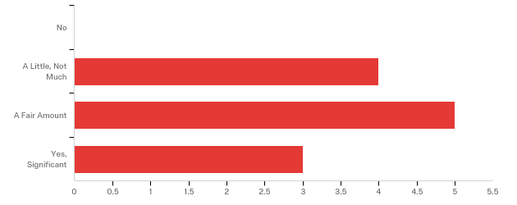

# | Answer | % | Count
1 | No | 0.00% | 0
2 | A Little, Not Much | 33.33% | 4
3 | A Fair Amount | 41.67% | 5
4 | Yes, Significant | 25.00% | 3
 | Total | 100% | 12

Q9 - 9. Value to Project Success Do you believe that the success of MnDOT projects could be improved with a more defined PM decision authority?
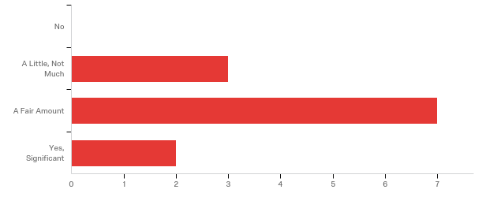

# | Answer | % | Count
1 | No | 0.00% | 0
2 | A Little, Not Much | 25.00% | 3
3 | A Fair Amount | 58.33% | 7
4 | Yes, Significant | 16.67% | 2
 | Total | 100% | 12

Q10 - 10. Examples of a More Defined PM Decision Authority If the decision authority of the MnDOT PM position would be better defined, what types of decisions would be most important to include, or to improve, such that MnDOT project success and organization effectiveness are best supported?

10. Examples of a More Defined PM Decision Authority If the decision author...
Decisions that affect project delivery.
The Project Manager should manage change on the projects they are responsible for.
I think the type of decision may be less important than the resourcing made available to the PMs and the necessity of improved and earlier engagement and communications and pre-scoping level of effort by the PMs. That said, the PM should make informed day-to-day decisions; facilitate achieving consensus or consent for cross-functional decisions; and should facilitate the elevation of particularly sensitive and major or complex decisions to higher levels.
Late changes (often good investments but overlooked or come late) driven by functional areas transcend an authority issue. Also local desires tend to emerge late, or funding issues emerge late. Somehow these issues need to be addressed to allow the PM and a project team succeed in making original schedule and budget targets.
Pavement changes Access changes Community changes (sidewalk, ADA) Safety changes Changes that affect the budget in access of $100k
see answers in question 7
Decisions regarding Performance Base Practical Design (with consultation from subject matter experts). Able to move forward when items that are "preference" instead of "must comply" are delaying the project. Plan review should be done in the District and CO review should be strictly for processing to get into bidding program. Place accountability on PM and project team.
Understanding decision-making authority would be helpful, as would a little more flexibility in moving lettings from quarter to quarter as long as construction and funding weren't impacted.
It's important to keep in mind that many of our project managers are young, not experienced in managing a project from beginning to end and in many cases don't want to be a project manager and actively spend more time trying to deflect their accountability and decisions to someone else. A better understanding of how a project is developed and all the components that need to be considered for each project.
Listen to your technical experts, understand legal boundaries, be more aware of competing priorities for groups that support the entire state before deciding your thing is the most important

Q11 - PM Roles vs. Functional Group Roles 11. What Current Work Normally Accomplished by the PM Could Be Better Accomplished by Functional Groups? Please select on of the following that would best serve MnDOT and its customers.
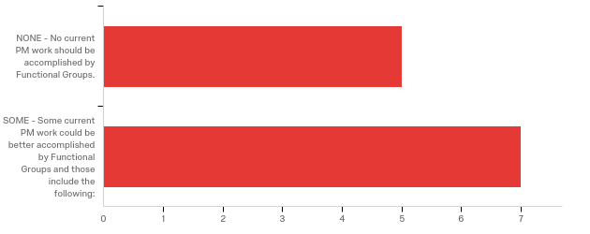

# | Answer | % | Count
1 | NONE - No current PM work should be accomplished by Functional Groups. | 41.67% | 5
2 | SOME - Some current PM work could be better accomplished by Functional Groups and those include the following: | 58.33% | 7
 | Total | 100% | 12

SOME - Some current PM work could be better accomplished by Functional Grou...
SOME - Some current PM work could be better accomplished by Functional Grou...
I can't think of specific examples right now.
I say some, but I think that clearly defining the activities and roles the Project Manager is responsible for and the activities the functional groups are responsible for would be very helpful.
If we accept that a PM today should be a cross-functional generalist that serves as the focal point for a project and must pull in and coordinate all project development and functional activities that are necessary, most PM work would be best accomplished the PM.
PMs have not taken engineering work from functional areas to much extent. IN some cases PMs could press for lower cost solutions if the project budget is being pressed. In many cases functional areas can make additional project funds available if they see a need for betterments since scoping.
- managing consultants in certain areas (design plans as a major example) - some public outreach on small projects where outreach may be limited to informing the public (construction taking the lead) - leading scope changes (writing the amendments -- should it be with materials if a fix change? those are most of the scope changes we see
Direct coordination between the right of way group and project mangers needs to occur.
The answer to this question depends on the Agency's willingness to staff resource functional groups. We have many PM's compared to the current resource levels assigned to many of the production groups. The work better performed by Functional groups is that work that there is a long history of functions performing (design, hydraulics, Envionmental, Bridge, Materials, etc...)however, the PM's also need to listen when they are told of constraints and requirements.

Q12 - 12. What Current Work Normally Accomplished by the Functional Groups Could Be Better Accomplished by the PM? Please select one of the following that would best serve MnDOT and its customers.
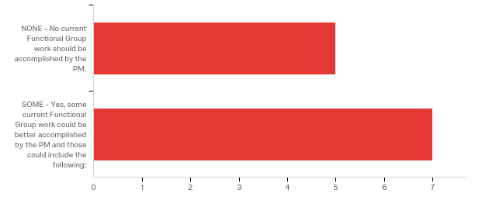

# | Answer | % | Count
1 | NONE - No current Functional Group work should be accomplished by the PM. | 41.67% | 5
2 | SOME - Yes, some current Functional Group work could be better accomplished by the PM and those could include the following: | 58.33% | 7
 | Total | 100% | 12

SOME - Yes, some current Functional Group work could be better accomplished...
SOME - Yes, some current Functional Group work could be better accomplished...
I say some, but I think that clearly defining the activities and roles the Project Manager is responsible for and the activities the functional groups are responsible for would be very helpful.
When technical decisions or work need to be accomplished and there are minimal cross-functional issues or effects, it seems appropriate that the Functional Group work that requires technical decisions with minimal cross-functional issues or effects should be work better accomplished by the Functional Group ...work that is more complex and involves cross-functional issues and effects should be facilitated and accomplished by the PM.
PMs to be more active in scoping, field walks, resolving issues inter-relating functional groups such as drainage & traffic control. Managing the hand-offs between functional groups, particularly with regard to schedules.
I am sure there are certain activities that could be swapped but I will need to touch base with the project managers before answering this.
nothing comes to mind at the moment
Some consultant contract management.
The PM's need to better understand timelines for completing work and the relationships between work functions and how to manage in a broader schedule to have successful projects. PM's also need to understand planning horizons, funding, and the relationship between their project (s) and the larger program.

Q13 - PM Decision Authority vs. Functional Group Decision Authority 13. What Current Decisions Normally Accomplished by the PM Could Be Better Accomplished by MnDOT Functional Groups? Please select one of the following that would best serve MnDOT and its customers.
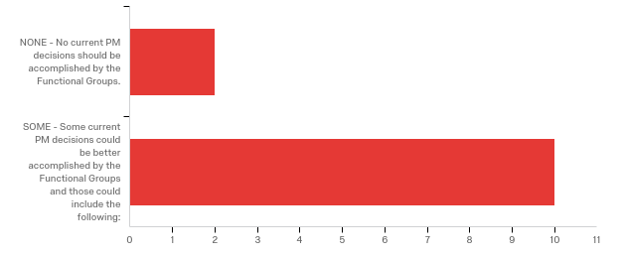

# | Answer | % | Count
1 | NONE - No current PM decisions should be accomplished by the Functional Groups. | 16.67% | 2
2 | SOME - Some current PM decisions could be better accomplished by the Functional Groups and those could include the following: | 83.33% | 10
 | Total | 100% | 12

SOME - Some current PM decisions could be better accomplished by the Functi...
SOME - Some current PM decisions could be better accomplished by the Functi...
There should be a collaboration on some issues such as: clear zone distance; anything that affects bridges, environmental permits; etc.
The functional groups should be defining the needs that define the scope of the project. However, this needs to be done during scoping and not during project development.
Technical decisions with minimal cross-functional issues and effects would be best accomplished by Functional Groups but you may want the PM to serve as a project focal point and facilitator.
Generally, they are in the right domain now
Design standards, always a tough discussion on practical design questions. Many times the practical design is not in line with our design standards. This infuriates our design engineer and design squads when a decision is made to not follow our standards, but to do more of a practical design. Most times it is the ADE or DE that makes the decision, but the PM gets blamed and creates hard feelings.
Ability to simplify the P6 schedules for projects that don't need the level of detail that other more complex projects require
Direct coordination between the right of way group and project mangers needs to occur.
Technical details that require licensure. I don't believe we need all the signatures on the title sheet of a plan. Individual sheets need signature only.
Letting functional groups determine their schedule and remaining durations Technical decisions should be left to the technical experts
Technical requirements, when and how to get the project work completed, what is needed (information) for work to progress and decision making timelines.

Q14 - 14. What Current Decisions Normally Accomplished by MnDOT Functional Groups Could Be Better Accomplished by the PM? Please select one of the following that would best serve MnDOT and its customers.
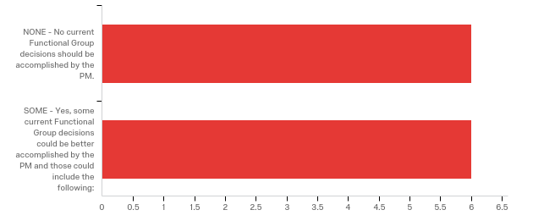

# | Answer | % | Count
1 | NONE - No current Functional Group decisions should be accomplished by the PM. | 50.00% | 6
2 | SOME - Yes, some current Functional Group decisions could be better accomplished by the PM and those could include the following: | 50.00% | 6
 | Total | 100% | 12

SOME - Yes, some current Functional Group decisions could be better accompl...
SOME - Yes, some current Functional Group decisions could be better accompl...
The PM's and the functional groups need to coordinate the scope of the project during scoping, and need to manage the deliverables during project development.
Can't say with any informed certainty but I suspect there are some Functional Group decisions that might be better accomplished or facilitated by the PM rather than Offices like Bridge, OPMTS, OES, Land Management, Materials ...
Generally, they are made in the right domain now
As stated above
Items that are on the critical path and how to manage across the broader project delivery schedule

Q15 - Your Comments 15. Please Enter Your Thoughts Here Your comments are important and please be aware that some of the most important survey information is often contained in written comments.

Your Comments 15. Please Enter Your Thoughts Here Your comments are imp...
Ultimately, PM's and functional groups need to communicate better to improve relationships. This will lead to better improvements in the project delivery process and more successful projects.
In the end, the department needs to make a decision as to the role of the PM and the authority that that position garnishes. This may step on the toes of the functional groups a little bit, but if a Project Management Organization is the vision for the department, they need to go there.
I do not have additional comments beyond what I have already cited as issues or examples under some of the previous questions.
1. We do not keep good performance metrics on scope, cost ,schedule. I think we should do more forensics on past successes and failures. 2. We fund projects via F/A investments but try to manage them as projects. If a project scope changes (often pavement, sometimes drainage, capacity, non motorized funding becomes available) and the ROI improves, is that a success or failure? 3. We have transitioned many into strictly PM role. Have we investeed enough into their development? Are expectations clear?
Project Managers are asked to do a lot with managing all projects coming into the CHIP and STIP. Many PM'S can hve up to 20 projects to manage so it gets overwhelming. When we move projects around in the program due to addional money coming in, this can throw schedules into crisis mode. Sometimes, the PM's get blamed on for asking the functional groups to speed things up, tough on relationships at times. We need to have a decision tree between CO and districts, sometimes different opinions on an issue can cause stress between the PM, district, and CO. Need to provide enough resources / tools / training to support the PM's PM's must have the soft skills, so important when dealing with the public and stakeholders. Need to target these people that fit the PD Need to have a PM series set up for non engineers.
- scalability is the key -- sometimes having PM's involved in all aspects slows down the processes and does not add much value -- functional groups know what they have to do, it gets shepherded from group to group and gets done - the role loading and complex P6 schedules are the most struggle -- it can be so cumbersome to review schedules, update them, review roles, etc... that it takes a lot of time away from work on projects. Especially when having to continually bug people (especially outside the district -- who are as busy as everybody else -- to update their sometimes multiple activities)
If we want the PM to be effective and accountable, they need to have the authority to act and the resources to get the work done. There needs to be various levels of PM that can handle mega projects or standard highway projects. Most of our PM's are at lower levels. We need to create a culture where you want to strive and aspire to become a PM. Be rewarded for it also.
We have way to many young, inexperienced individuals who have been promoted to a Principal Engineer (PE) position (and higher) without the tools necessary to be an effective project manager. And they haven't proven they can be a Project Manager. They spend more time trying to figure out ways not be a project manager because they're "to busy". We burnout the good ones and the only relief is to move to another department to get away from the chaos. You need to put PM/project development back into the hands of individuals who understand that project development is more than a checklist...it's activities that have deliverables and you need to me knowledgeable in all the deliverables so you can determine what activities are necessary. There's no short-cut to being a PM. You don't learn it in 3-day course at the U of M or a PMP certification. At this point we need an updated HPDP manual and mandatory training in it for all PM's. At this point you should probably make it "pass/fail". If you don't pass...you keep practicing. We need refresher courses and update training as the HPDP changes (some of the content is dynamic because of changes in rules and regulations). We need a process that continues to develop and grow PM's. You should probably have a number of years managing at some level before becoming a PM (not that that means success). There should be a monetary reward for good Project Managers (maybe a new classification and AEP), there should be demotion for bad ones (SE and lower). As we put more demands on PM's we have to stop asking current PE's to muti-task their current jobs like managing design squads, managing other peoples work, managing the area side, etc. It's to much to ask with the current number of projects vs. number of employees. Stop hiring PM's just because we're able to get permission to fill a position and we think they can do the job. That's not a good way to get experienced PM's and it minimizes the good ones we currently have. Maybe there should be CO oversight in the hiring of District PM's. Maybe we could take a Shared Service Center approach (or at least oversight) in the early stages. This is a big challenge for the department. We didn't get here over-night. it will take time to get us where we want to be.
A large issue with the current PM framework is the continued practice of trumping any comments, suggestions, feedback or boundaries that are identified. This has decreased trust and the ability to work in a team manner. These situations often blow up into a problem that could have bee resolved timely without all of the drama that is experienced.

Q16 - 16. Would You Like To Share Your Thoughts with an External Consultant? This information, like this survey, will be kept anonymous.
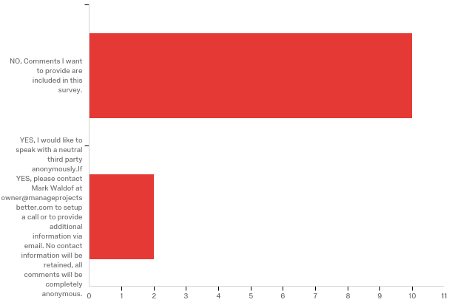

# | Answer | % | Count
1 | NO, Comments I want to provide are included in this survey. | 83.33% | 10
2 | YES, I would like to speak with a neutral third party anonymously. If YES, please contact Mark Waldof at owner@manageprojectsbetter.com to setup a call or to provide additional information via email. No contact information will be retained, all comments will be completely anonymous. | 16.67% | 2
 | Total | 100% | 12

Q17 - Your Current Experience at MnDOT 17. Your Experience (Optional, but Requested)
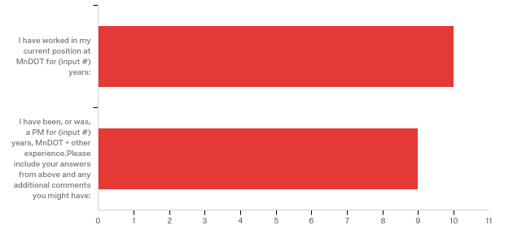

# | Answer | % | Count
1 | I have worked in my current position at MnDOT for (input #) years: | 83.33% | 10
2 | I have been, or was, a PM for (input #) years, MnDOT + other experience. Please include your answers from above and any additional comments you might have: | 75.00% | 9
 | Total | 100% | 12

I have worked in my current position at MnDOT for (input #) years:
I have worked in my current position at MnDOT for (input #) years:
6
1 year
9
13
6 years
15
5
5
This doesn't mean anything.
8

I have been, or was, a PM for (input #) years, MnDOT + other experience....
I have been, or was, a PM for (input #) years, MnDOT + other experience....
20 years
I Have been with MnDOT 29 years, in a middle-management and management capacity and had 10 years of consultant experience prior to coming to MnDOT. I managed many projects before coming to MnDOT and managed a number of projects in my early years at MnDOT but I have largely been a manager of programs and special initiatives for the past 20 years.
My role has been an engineering, or engineering specialty manager for 20+ years.
Been with MnDOT for 17 years. Managed projects for probably 4 years or so. Managed construction projects for 8 years. Oversee the district project managers
was a PM for 10 years
Was PM for 15 years, mostly in construction.
I have over 34 years working in the transportation industry in the State of Minnesota and in other parts of the nation. I've worked for Cities, Counties and the State.
7 years in three roles

