Default Report
MnDOT Project MGMT Role Definition Survey: Functional Group
May 5th 2017, 9:45 am CDT
Q1 - Current Situation 1. PM Role and Accountability, Adequately Defined or Not? Do you believe that the role and accountabilities of the project manager within MnDOT (i.e. the functions and tasks that the PM performs and is responsible for) are adequately defined to support MnDOT project success and MnDOT organization effectiveness?
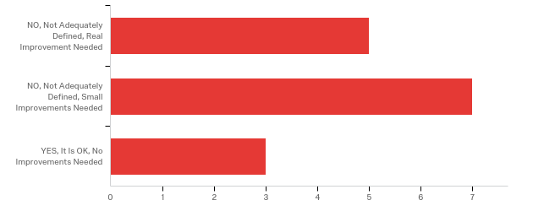

# | Answer | % | Count
1 | NO, Not Adequately Defined, Real Improvement Needed | 33.33% | 5
2 | NO, Not Adequately Defined, Small Improvements Needed | 46.67% | 7
3 | YES, It Is OK, No Improvements Needed | 20.00% | 3
 | Total | 100% | 15

Q2 - 2. Issues Resulting from the Current Situation with the Definition of the PM Role and Accountabilities Do you believe that the current way the PM role and accountabilities are defined have caused issues for MnDOT projects and/or the MnDOT organization as a whole?
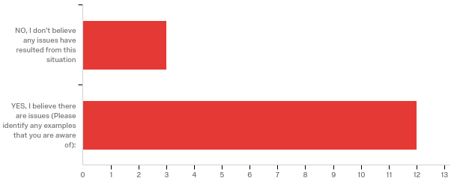

# | Answer | % | Count
1 | NO, I don't believe any issues have resulted from this situation | 20.00% | 3
2 | YES, I believe there are issues (Please identify any examples that you are aware of): | 80.00% | 12
 | Total | 100% | 15

YES, I believe there are issues (Please identify any examples that you are...
YES, I believe there are issues (Please identify any examples that you are...
There have been times when a project manager has made a decision without contacting the appropriate functional area. In some instances the functional group leader should have made the decision or at least provided input. There is some confusion about the role of the project manager when it comes to contacting other units of government about the project (detours routes on local roads for example).
Generally PMs cannot answer key questions regarding their projects (for the most part). Obtaining information or locations of information is sometimes very difficult. PMs often do not know what state portions of their projects are in when asked (i.e. bridge design, etc.). Questions asked are typically referred to others not directly associated with a project including funding, design, timelines, etc. While sometimes this is understandable, it sometimes appears the responsibility for making sure specific deliverables are completed also falls upon others without a direct connection to the project (environmental documents, etc.).
Confusion on authority, responsibility, and accountability. Nearly all relating to lack of technical skill
The roles should be included in a document so everyone is very clear with the roles and responsibilities. Currently there seems to have mixed roles and responsibilities between PMs and Design Engineers. We will have the Design Engineer give out turn in dates for the project that are different than the P6 scheduled dates the PM baselined. Also when a PM is asked for project details so the functional units can appropriately baseline the P6 schedule or scope the project, a common PM response is to ask the Design Engineer. Also I would assume it is the PM responsibility to check for conflict among the functional units plans. However my experience has been construction finds them if the functional units don't try to coordinate them. There is no good PM role in coordinating conflicts, it is left up to the functional units which is not often thought about on new roadways or full reconstruction. They seem to only check with existing conflicts.
I believe there is confusion on defined roles and accountabilities between PM's and functional groups. I don't know that there are clear, defined roles and accountabilities. In addition, I do not know that there is any type of PM training and/or procedural guideline. A new PM indicated that he/she is not receiving proper training or guidance and must seek assistance on most everything.
We have had PM move through projects, leaving the project mid stride for the next person to field on the run; making accountability aspect a bit shaky. This is not the PM's fault, but more of a fault of upper management's staff resource reassignment/accountability.
Meeting letting dates takes precedence over plan quality
Inexperienced staff running projects, hiring engineers only to manage projects (why?), PM staff unaware of what impact scope changes have on other areas, unrealistic time frames, way way way too many PM's, questionable effectiveness, the PM's are responsible only until the plans are done. Overall I would rather go back to Artemis reports and PPMS. This has almost no value for so many people, and it has taken way too many people completely out of production positions. It does no good to have people manage jobs when other departments are extremely short on help.
there is a big learning curve for project managers, and a lack of PM's that are promoted to foster the younger PM's and share their experience. It appears that there is SO much documentation out there that it is an overload for new PM's. It appears that some PM's have the approach that "just do it and beg for forgiveness".
It is not clear who should be doing public outreach and at what point it transitions from planning to project management. In addition, due to the volume of projects, it is difficult for PMs to address modal plans or other studies affecting projects in the out years of the CHIP. This has caused input from locals to come at the last minute when it becomes too late to revise the project plans.
PMs making promises to communities in regards to pavements and their types of fixes - for example, concrete vs. bituminous, mill and overlay vs. reconstruction. The pavement type fix/determination should be made in conjunction with the materials engineer.

Q3 - 3. PM Decision Authority, Adequately Defined or Not? Do you believe that the decision authority for project managers within MnDOT is adequately defined to support MnDOT project success and MnDOT organization effectiveness?
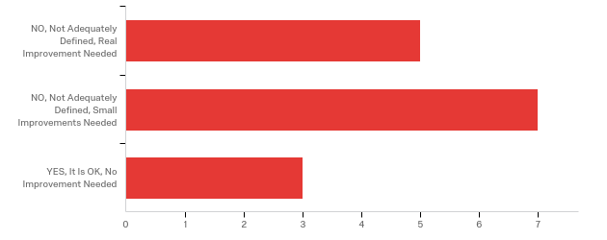

# | Answer | % | Count
1 | NO, Not Adequately Defined, Real Improvement Needed | 33.33% | 5
2 | NO, Not Adequately Defined, Small Improvements Needed | 46.67% | 7
3 | YES, It Is OK, No Improvement Needed | 20.00% | 3
 | Total | 100% | 15

Q4 - 4. Project or Organization Issues Resulting from the Current Situation with the Definition of the PM's Decision Authority Do you believe that the current way the PM decision authority is defined has caused issues for MnDOT projects and/or the MnDOT organization as a whole?

# | Answer | % | Count
1 | NO, I don't believe any issues have resulted from this situation | 20.00% | 3
2 | YES, I believe there are issues (Please identify any examples that you are aware of): | 80.00% | 12
 | Total | 100% | 15

YES, I believe there are issues (Please identify any examples that you are...
YES, I believe there are issues (Please identify any examples that you are...
See response for question #2.
Lack of decision making authority has caused delays in meeting schedules.
Yes, when PMs make project decisions not based on engineering problems occur. For example, committing to deliverables that are not within standards. Also, choosing project schedule over vetting safety and geometric issues, and attempting to control resources put our entire program and credibility as an organization at risk.
This is getting better and may only be a results of certain PM. However moving letting dates especially in scoping years and not updating the functional unit is a big issue. There is functional units preservation dollars that are tied to the main project and they can't always move them to a new year. The PM moves the project without consulting the entire project team during scoping. There has also been some situations where the PM promises things to the public without checking with the functional units on if it can or should happen first. They need to check on the impacts of their decisions before committing to them in a public or formal setting.
Again, there are uncertainties between PM and functional units. Who has final decision authority.... maybe even between PM, functional unit supervisor and even the designer. Example - a PM made a decision. Then a unit principal engineer overruled that decision.... late in the process, also. Extensive rework was required by my department, other successors and eventually in C.O.
I have been on a number of projects where Central Office has driven/influenced the project elements away from current design consensus achieved by the PM. Perhaps the authority for these decisions are not ultimately those of the PM, but then leads to some ambiguity on the decisiveness of any project decision made by the PM.
Meeting letting dates takes precedence over plan quality
The PM structure is a complete waste in my opinion.
the beg for forgiveness attitude is so prevalent.
Since the PM needs authority to make changes that would affect the budget, he/she needs to wait for management approval. Political pressure affects what that decision will be and also if plans will be changed.
Better definition of responsibilty is needed once the Resident Engineer takes over the project and the involvement of the Area Management staff.
Scope creep comes into play. The budget may not allow for all things that a community may want. The PM should check in with district personnel before promises and/or concessions are made with the communities.

Q5 - Value of a More Defined PM Role and Accountabilities 5. Value to Working Relationships Do you believe that the working relationships between project managers and MnDOT Functional Groups could be improved with a more defined PM role and accountabilities?
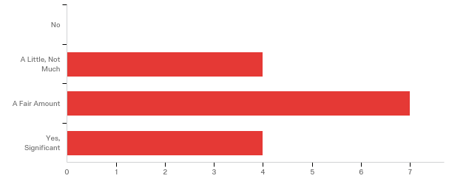

# | Answer | % | Count
1 | No | 0.00% | 0
2 | A Little, Not Much | 26.67% | 4
3 | A Fair Amount | 46.67% | 7
4 | Yes, Significant | 26.67% | 4
 | Total | 100% | 15

Q6 - 6. Value to Project Success Do you believe that the success of MnDOT projects could be improved with a more defined PM role and accountabilities?
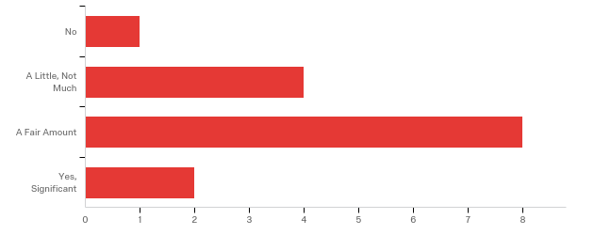

# | Answer | % | Count
1 | No | 6.67% | 1
2 | A Little, Not Much | 26.67% | 4
3 | A Fair Amount | 53.33% | 8
4 | Yes, Significant | 13.33% | 2
 | Total | 100% | 15

Q7 - 7. Examples of a More Defined PM Role If the role and accountabilities of the MnDOT PM position would be better defined, what areas or functions of the PM position would be most important to include, or to improve, such that MnDOT project success and organization effectiveness are best supported.

7. Examples of a More Defined PM Role If the role and accountabilities of t...
MnDOT should provide a clear definition of the PM's role and educate the functional areas about the role. Make it very clear where the lines of responsibility fall. The PM concept is somewhat new and fluid within the districts. It may be beneficial to have a short educational meeting with the project managers and functional groups to clarify responsibilities. PM is the key contact for all project related communication. The project manager determines when to pull in other areas when needed on the project. In my opinion the project manager is not necessarily the decision maker but rather the coordinator.
Elevating the authority and decision making of a PM would benefit the ability to deliver projects on time. Being accountable for delivering a complete quality project and not just a portion thereof would help other areas within MnDOT that have a part in the delivery do their job more efficiently and ensure projects are delivered successfully and on time.
Define Project Management Style as Weak unless directed otherwise by the district so that the program is more important than the individual project.
PM needs to be involved in all stages of plan development. This includes actively making sure there are no conflicts between functional units, existing structures and policies, etc. This should be done by reviewing the plan at all turn ins as well as scheduling meetings when needed to specifically discuss coordination if you see a conflict. PM should be coordinating all schedule changes, letting date changes even in scoping with all functional units. PM should not make any decisions until he/she consults with the affected functional units for their input. PM should effectively manage costs throughout the project and come up with an estimate at each turn in to ensure the project is on track. Any cost estimate that is off by more than 20% should be brought up to management. All last minute scope changes should be run by all functional units to know impacts on timeline, cost, etc. before they are agreed to including requests from the city or county. PM needs to ensure P6 activities are updating according to the progress.
PM's have more input on projects being added to the existing schedule due to funding availability. Time may be lacking to complete that project as originally scoped. Reduced work types may not be the best answer to fit this project in so maybe wait on this project when there's adequate time to complete it as scoped.
Authority over Geometrics and Flexible/Practical Design. There seems to be a lot of direction coming from Central Office after there is a perceived consensus on layouts.
I would like the entire PM group abolished. Go back to having the project engineers and land surveyors mange the projects. This is not working at all, has limited to no value, and is a complete loss in my opinion.
quit rewarding people who don't follow protocol.
Reporting back to other pre-defined groups.
Scope and budget issues should be discussed with functional groups, not just decided upon by the PM.

Q8 - Value of a More Defined PM Decision Authority 8. Value of Working Relationships Do you believe that the working relationships between project managers and MnDOT Functional Groups could be improved with a more defined PM decision authority?
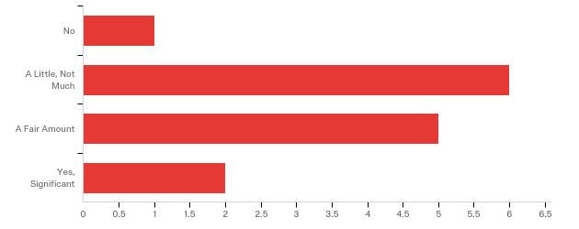

# | Answer | % | Count
1 | No | 7.14% | 1
2 | A Little, Not Much | 42.86% | 6
3 | A Fair Amount | 35.71% | 5
4 | Yes, Significant | 14.29% | 2
 | Total | 100% | 14

Q9 - 9. Value to Project Success Do you believe that the success of MnDOT projects could be improved with a more defined PM decision authority?
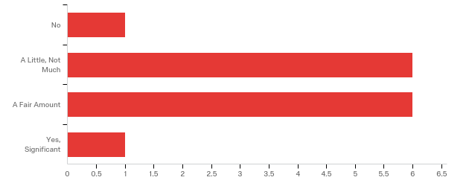

# | Answer | % | Count
1 | No | 7.14% | 1
2 | A Little, Not Much | 42.86% | 6
3 | A Fair Amount | 42.86% | 6
4 | Yes, Significant | 7.14% | 1
 | Total | 100% | 14

Q10 - 10. Examples of a More Defined PM Decision Authority If the decision authority of the MnDOT PM position would be better defined, what types of decisions would be most important to include, or to improve, such that MnDOT project success and organization effectiveness are best supported?

10. Examples of a More Defined PM Decision Authority If the decision author...
Unsure
Being able to identify how to manage resources (with a group of peers) and move a project forward based on constraints that their project faces would be an improvement. Allowing the PM to have the authority to make decisions, work with other PMs and make recommendations with regards to scope, schedule, and budget based on the project need would allow for effective delivery.
Engineers who sign the plan have legal responsibility, their decision is the final one per state law. Functional groups need to manage their resources to maximize efficiency and learning.
Change of letting dates letting project group know of the change even in scoping due to different pots of money. Change in scope - need to let project team know but also all functional units since the change in scope might now impact a new group. Before making a decision - the PM should consult the functional units it could impact. There may be impacts that would affect the decision.
Maybe similar to response in #7.
The project development process is a collaboration of the various engineering disciplines and multiple stakeholders. The process of over-riding of project decisions or any specific element design perspective by upper management or office should be clearly outlined. Having decisions over-ruled by C.O. is disheartening to the entire team.
More accountability with the functional groups. Currently their portion of the project seems to be completed at the functional groups pleasure which does affect other groups.
PM's need to know and understand the limits of their decision authority. the statutes allow MnDOT to do certain things, the statutes don't tell us what we cannot do. Which appears to be the attitude out there.
A more defined process for budget changes.
When discussion take place with the local government, public and/ or businesses that would define staging of a project.
same comments as before

Q11 - PM Roles vs. Functional Group Roles 11. What Current Work Normally Accomplished by the PM Could Be Better Accomplished by Functional Groups? Please select on of the following that would best serve MnDOT and its customers.
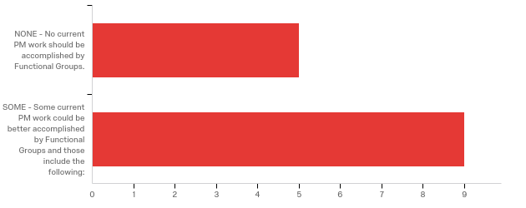

# | Answer | % | Count
1 | NONE - No current PM work should be accomplished by Functional Groups. | 35.71% | 5
2 | SOME - Some current PM work could be better accomplished by Functional Groups and those include the following: | 64.29% | 9
 | Total | 100% | 14

SOME - Some current PM work could be better accomplished by Functional Grou...
SOME - Some current PM work could be better accomplished by Functional Grou...
I do not have specific work items. Any engineering decision that falls directly in the scope of the functional area should be made by the functional group rather than the project manager.
It is unclear the role the PM currently plays as it is varied across the state. Some PMs consistently manage "too deep" into a project and others to not manage enough.
My preferred response to question 11 is NONE, however, I am not allowed this comment with the NONE selection and I believe the comment to be more valuable than the response. In D8, very few deliverables are completed by the PM. Those tasks that are PM deliverables include: Scoping Reports, Schedule initiation, Public Outreach, and at times, managing a schedule.
Function Units can assist, but the responsibility should remain with the PM.
Traffic Management Plan EAW or other environmental tasks/activities I am not familiar with all PM work
Drop the PM concept all together and have the project engineer manage the project.
As things are dispersed out to the Districts, there is not consistency from district to district in how things are done
Some work with public outreach could be better accomplished with a shared approach with planning in such areas such as modal planning, comprehensive planning and working with local units of government or other stakeholders in the out years of the CHIP.
Layouts and construction limits could be better accomplished by letting Final Design complete that work.

Q12 - 12. What Current Work Normally Accomplished by the Functional Groups Could Be Better Accomplished by the PM? Please select one of the following that would best serve MnDOT and its customers.
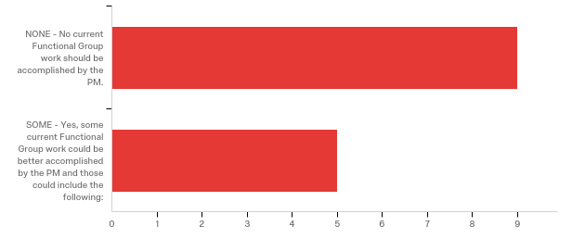

# | Answer | % | Count
1 | NONE - No current Functional Group work should be accomplished by the PM. | 64.29% | 9
2 | SOME - Yes, some current Functional Group work could be better accomplished by the PM and those could include the following: | 35.71% | 5
 | Total | 100% | 14

SOME - Yes, some current Functional Group work could be better accomplished...
SOME - Yes, some current Functional Group work could be better accomplished...
Updating project work activities.
Managing project information and direction. There are times Functional Groups dictate the direction of a project based on their desires.
My preferred response to question 12 is NONE, however, I am not allowed this comment with the NONE selection and I believe the comment to be more valuable than the response. We have discussed having PMs deliver a projects environmental and utility work, however, many efficiencies are gained by having an expert or two versus many non experts.
conflict resolution between functional units on plans. the PM should be actively looking for them. Turn in dates - currently the Design Engineer is the main go to on this topic. It should be the PM holding everyone accountable.
All the work could be managed by the functional groups. Having inexperienced people manage projects does not work. How can they manage what they don't know?

Q13 - PM Decision Authority vs. Functional Group Decision Authority 13. What Current Decisions Normally Accomplished by the PM Could Be Better Accomplished by MnDOT Functional Groups? Please select one of the following that would best serve MnDOT and its customers.
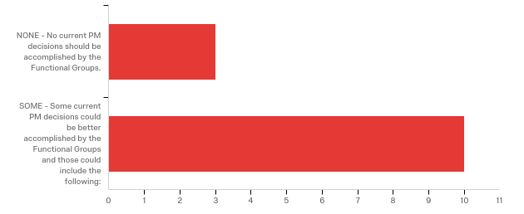

# | Answer | % | Count
1 | NONE - No current PM decisions should be accomplished by the Functional Groups. | 23.08% | 3
2 | SOME - Some current PM decisions could be better accomplished by the Functional Groups and those could include the following: | 76.92% | 10
 | Total | 100% | 13

SOME - Some current PM decisions could be better accomplished by the Functi...
SOME - Some current PM decisions could be better accomplished by the Functi...
No specific answer. Providing a clear definition of PM's decision making authority would be helpful. Some PM's make decisions that should be a functional group responsibility while others consult the functional group.
The amount of decision making across the state varies to the point where it is unclear what authority a PM has. Design decisions and the appropriate solution to a specific problem should be left to the expert or functional office.
PMs should not make functional decisions unless they are willing and prepared to sign for those decisions.
PM should still be making the decisions, but should be asking for input from the functional units before a decision is made to know the impacts of the decision.
I am not familiar with all PM decisions to properly answer this. Checked "some" in order to comment here. Possibly, realistically whether a functional group can possibly deliver on a project added to the current FY program.
Timing as to when the work is completed
All could.
I think that it should be looked at as a shared team approach, not PM vs. functional group. The PM "model" is a team approach.
Decisions directly related to work done by the other functional groups
It doesn't always happen, but the materials type fixes should not be decided by the PM and the communities. The materials functional group has to be involved in that decision.

Q14 - 14. What Current Decisions Normally Accomplished by MnDOT Functional Groups Could Be Better Accomplished by the PM? Please select one of the following that would best serve MnDOT and its customers.
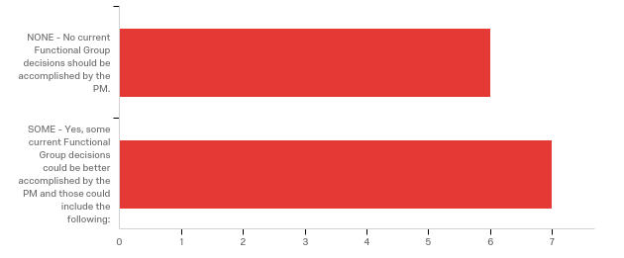

# | Answer | % | Count
1 | NONE - No current Functional Group decisions should be accomplished by the PM. | 46.15% | 6
2 | SOME - Yes, some current Functional Group decisions could be better accomplished by the PM and those could include the following: | 53.85% | 7
 | Total | 100% | 13

SOME - Yes, some current Functional Group decisions could be better accompl...
SOME - Yes, some current Functional Group decisions could be better accompl...
See previous answer.
Decisions on scope or aspects that affect the scope of a project.
Recommendations and adherence to current codes/ specifications/ practice are provided by the functional groups. PM decisions are made under those recommendations and requirements. Functional groups should not over-ride the ultimate decision made by the PM, assuming the decision meets current design criteria.
Timing as to when the work is completed
They should not manage anything a functional group does. They are not the experts.
I think that it should be looked at as a shared team approach, not PM vs. functional group. The PM "model" is a team approach.
Same comments as before

Q15 - Your Comments 15. Please Enter Your Thoughts Here Your comments are important and please be aware that some of the most important survey information is often contained in written comments.

Your Comments 15. Please Enter Your Thoughts Here Your comments are imp...
Generally speaking the PM role seems to be working fairly well in our district. It is a fairly new concept (at least in its current usage) and we are still adjusting. The biggest issue is the differences between project managers. The project manager assigned to the project should not play a big role in what ultimately gets constructed. For example, there have been several projects which would have had a different result in terms of the complete streets policy if a different project manager had been guiding the project. I have heard that there are other areas (districts) where the project manager does not work as well with the varying functional groups.
In my role, I manage multiple functional groups and I am a Project Manager. Many times, being a Project Manager is frustrating, difficult, and downright maddening. Much like democracy, project management has to function that way or we move to a totalitarian organization that begets corruption and lost of trust. Project Management is a valued function that keeps an eye on scope, schedule and budget. Also, having a single point of contact for external stakeholders is invaluable. Where we get into trouble is when people want to "solve" the frustration and difficultness by making PMs dictators of resources and decisions. State law on engineering long ago made clear who designs and signs for project elements. Those signatures are there to protect the health, safety, and human welfare; not scope, schedule and budget.
Written documentation will help in creating clear understanding. Communication is the biggest role a PM has. This is often the cause of issues. The PM should be coordinating one on one with each functional unit throughout the process to ensure they meet the deadline and fully understand the scope of the project and to better understand if there will be conflicts between functional units that otherwise would be missed. For some PM it might be helpful to have a mentor as a go to person, maybe one for each functional PM group. I have had Area Engineer PM come to me to ask about how to use the scoping database and how functional needs are entered. It would be nice to have them go to a mentor preferably one in their own unit with similar PM responsibilities.
I've seen where better communication is needed between PM's and functional groups and/or activity owners and/or upper management. Better as in more often, more firm information being conveyed or requested with due dates. Better follow up. Better consultant contract language. Accountability by all involved.
Most experienced PMs are continually engaged with the functional groups, keeping everyone abreast of decisions and progress to date. New PM should be tutored or trained to engage with and maintain working relationships with the functional groups. Decisions from upper staff or individual functional groups that push a singular desire/want should not be a reoccurring issue. The authority of design decisions should be clearly outlined and followed.
When MnDOT started the PM approach to project management, the thought was that different staff would manage different projects. Now we have designated PMs that manage projects. I think that there should be room for both. PMs have done a good job of bringing a lot of functional group information together. In some cases there should be ongoing teams on the larger projects. MnDOT has many silos and information on PM direction needs to be shared across the department to improve success. An example is that we have an ADA program, SRTS program, pedestrian plan and they all affect projects, but there is a lack of coordination between these programs.
The PM's responsibilty is to get the project completed: meeting quality requirements; on time; and within budget. They should have numerous tools at hand to do so. They should be able to use MnDOT functional groups, as well as, consultants. There has to be good communication and scheduling between PM's and the Functional group managers.
Not so much related to the PM role, but another area that needs to be discussed is the impact that ADA needs are having on projects. All too often we are removing ramps and sidewalks that have been replaced within the last 5-10 years due to changing design standards. This is killing our pavement budgets and pretty much ensures that a simple mill and overlay through an urban area can no longer happen. It requires adjusting curb and gutter profiles to meet ADA slope requirements. This then drives a larger pavement fix such as remove and replace or reconstruction.

Q16 - 16. Would You Like To Share Your Thoughts with an External Consultant? This information, like this survey, will be kept anonymous.
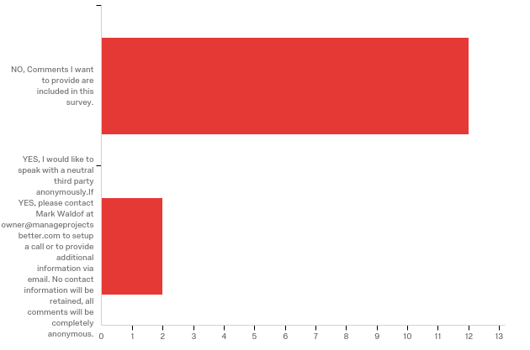

# | Answer | % | Count
1 | NO, Comments I want to provide are included in this survey. | 85.71% | 12
2 | YES, I would like to speak with a neutral third party anonymously. If YES, please contact Mark Waldof at owner@manageprojectsbetter.com to setup a call or to provide additional information via email. No contact information will be retained, all comments will be completely anonymous. | 14.29% | 2
 | Total | 100% | 14

Q17 - Your Current Experience at MnDOT 17. Your Experience (Optional, but Requested)
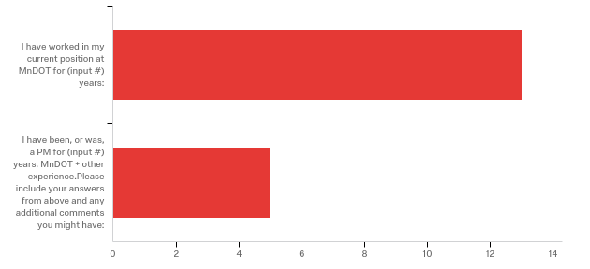

# | Answer | % | Count
1 | I have worked in my current position at MnDOT for (input #) years: | 100.00% | 13
2 | I have been, or was, a PM for (input #) years, MnDOT + other experience. Please include your answers from above and any additional comments you might have: | 38.46% | 5
 | Total | 100% | 13

I have worked in my current position at MnDOT for (input #) years:
I have worked in my current position at MnDOT for (input #) years:
18 years
5
4
10 years
27
4
20
20
6
25
4
25
5

I have been, or was, a PM for (input #) years, MnDOT + other experience....
I have been, or was, a PM for (input #) years, MnDOT + other experience....
Throughout my Civil Engineering Career I have been engineering and managing projects. I have worked in cradle to grave offices, functional offices, and project management offices. I have learned that focus and specializing lead to the most efficient and highest quality solutions. A PM along the way to make sure that we are efficiently answering the correct problem has been beneficial. I began work in January of 2005 after college graduation. I began at MNDOT in 2008. At that time I became a PM at D8 and have continued that role ever since. July of 2012 I was promoted to Functional Group Manager of: Detail Design, Hydraulics, Utilities, and ADA. Outside of MNDOT I am a co-owner of a real-estate LLC that specializes in timber and adult foster care housing. I am part of our local community celebration and run the Bean Bag Tournament. I organize three outings amongst friends that draw from 18 to 80 participants My wife and I like to backpack so we take turns planning our next adventures and we have hiked 22 national parks and a considerable chunk of the Arizona Trail.
I have been a PM for 8 years. The roles and responsibilities have changed over this time. It is good to see more emphasis being put on PM and having good projects rather than just everyone doing their own thing and throwing it together at the end to turn it in as one document. We really need the PM to understand everyone's input and plan sheets so it is on project worked on together instead of one project worked on independently and then handed in. The PM needs to understand the role of communicator in this process for a better product.
Past included 15 years of PM experience
6
I have been a MnDOT employee for 17 years in Construction, Soils, Materials, and minor Project Management.

