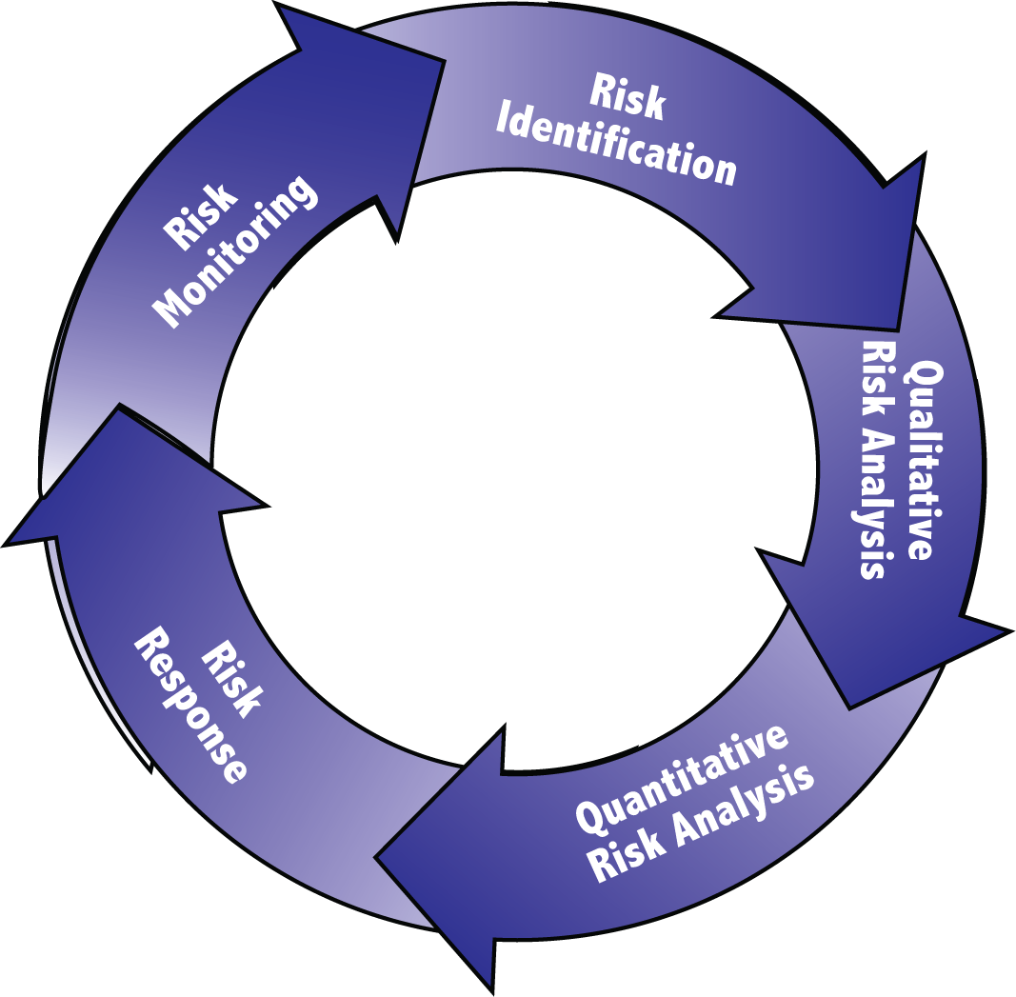

The Project Risk Management Process
The Basic Process
Risk management has three important parts: identification, analysis, and action. Before a risk can be properly managed, it must first be identified, described, understood and assessed. Careful analysis is necessary, but must be followed by action. A risk process which does not end with actions to deal with identified risks is incomplete and useless. The ultimate aim is risk management, not risk analysis.

The project risk management process (Figure 1) offers a structured way to think about risk and how to deal with it. A full project risk management endeavor includes these processes:

- Risk Management Planning – Deciding how to approach, plan, and
execute the risk management activities for a project.
- Risk Identification – Determining which risks might affect the project
and documenting their characteristics.
- Qualitative Risk Analysis – Prioritizing risks for subsequent further
analysis or action by assessing and combining their probability
probability of occurrence and impact.
- Qualitative Risk Analysis – Analyzing probabilistically the effect
of identified risks on overall project objectives.
- Risk Response – Developing options and actions to enhance
opportunities and to reduce threats to project objectives.
- Risk Monitoring – Tracking identified risks, monitoring residual risks,
identifying new risks, executing risk response plans, and evaluating
their effectiveness throughout the project lifecycle.

At its foundation, project risk management involves asking and answering a few simple questions:
- What risks might negatively (threats) or positively (opportunities) affect achieving the project objectives? (Risk Identification – The project manager or Project Risk Management Team (PRMT) uses the risk register to document risks throughout the project.
- What are the roles and responsibilities of the PRMT?
- Which of these are most important? (Qualitative risk analysis)
- How could these affect the overall outcome of the project in probabilistic terms of cost and schedule? (Quantitative risk analysis)
- What can be done about it? (Risk response)
- How effective were the responses and where is the project now? (Risk monitoring)
- Who needs to know about this? (Communication)

Four-tiered Scalability
MnDOT’s Office of Project Management worked with Central Office and District Stakeholders to draft The Project Management Processes Requirements Thresholds or PMPRT, which identifies the project management processes that should be applied on projects of different scales. Accordingly, four corresponding ranges were selected for the scalability levels of Project Risk Management. These scales are based on risk and complexity instead of dollar amounts to allow the project manager and project team flexibility. Some projects have a small budget, but because of other issues such as air quality or political sensitivity, are quite complex.

MnDOT’s risk management requirements are listed in Table 1. Refer to the PMPRT for the most current guidelines for project risk management on each scalability level.

These are minimum requirements. The project team may choose to work at a higher level than required or work at a lower level if approved by their project sponsor. The project team should also consider other factors to determine what level of risk management effort is needed. These factors may include:

• Political sensitivity

• Project type

• Project location and the community it serves

• Project Duration

• Project stakeholders

Any of these factors may warrant employing a higher scalability level.

The required activities for each Scalability Level are shown in Table 1.

TABLE 1 – LEVELS OF PROJECT RISK MANAGEMENT SCALABILITY

Risk Management Minor Moderate Major/Mega
Process
Risk Identification Yes Yes Yes
Qualitative Analysis Yes Yes Yes
Quantitative Analysis n/a n/a Yes
Risk Response Yes Yes Yes
Risk Monitoring Yes Yes Yes
Communication Yes Yes Yes

The levels differ in the Qualitative and Quantitative Analysis processes. All levels perform the other processes. Level 3 and 4 quantifies risks in probabilistic forecast terms of cost and time, whereas Levels 1 and 2 do not.

Irrespective of the project’s total cost, Level 3 or 4 might be used if any of the following activities are contemplated for the project:

• Validating the project’s contingency allowance
• Justifying and requesting additional contingency above 5%
• During construction, checking the adequacy of the remaining contingency
• During construction, requesting supplemental funds
• Allocating risks of a design‐build project
• Establishing the budget and/or completion target date to a desired level of confidence

More complex projects might request exemptions depending on the probabilistic cost. Level 4 analysis may be used in support of revisions to the project’s programming dollar amount.

