FY 17&18 Project Baseline Process
November 19, 2014

Purpose
This document provides direction on how obtain a project baseline (a.k.a. resource concurrence) on FY 2017 and 2018 pre-construction schedules in P6.
Project Baseline means all stakeholders (district and functional groups with tasks) in a project schedule have agreed to the activities, logic, activity durations, roles, and point in time when activities will be completed, and letting date of a project.
This document also provides guidance on developing recovery plans for projects with negative float.

Overview
The Project Management Battle is part of MnDOT Wildly Important Goal of Enhancing Financial Effectiveness. The goal of the current PM battle is to improve the project letting schedule from 44% to 90% by July 1, 2015 (% measured in the first ¾ of the state fiscal year). This includes a balanced letting schedule (based on the # of projects) of:
1st Quarter: 20%
2nd Quarter: 35%
3rd Quarter: 35%
4th Quarter: 10%

When developing a balanced letting schedule, the district and central office will attempt to minimize the number of large projects (> $5M) and similar work types (e.g. do not put all of the un-bonded concrete overlay projects in a single letting) in a single letting period. The districts and central office will also attempt to balance the budget using similar percentages to the number of projects.

Role & Responsibilities
Creating a balanced letting schedule requires a cooperative effort from the district, functional groups, shared service center and a balanced letting coordinator. Listed below are the primary roles:
District (Project Manager) – Ultimately responsible for delivering the project on schedule. For a project the PM will:
- Lead coordination and communication between the functional groups and district team.
- Develop preliminary schedule through the SSC.
- Provide schedule edits to the SSC.
- Champion the Scoping process.
- Provide role loading information for district activities.
- Identify activity owners for SSC Staff to assign to the activities.
District (Management) – Provides district resources to the PM, provides district leadership on incorporating all district projects into the balanced letting schedule and is directly responsible for supervising the Project Manager.
Functional Groups (Management) – Provides resources to meet the project schedules and leadership on incorporating workload into the balanced letting schedule.
Shared Service Center (SSC) – Builds and maintains project schedules. The SSC will:
- Incorporate edits requested from the Project Manager.
- Generates reports requested by the Project Manager and the District.
- Provide guidance to Project Managers and CO Functional Groups on how to baseline projects.
Balanced Letting Coordinator – Coordinates balanced letting schedule from a statewide perspective between the functional groups and districts.

Process
Step 1: Schedule Creation Process
- Project Manager completes the Scoping Document.
District Management recommends district wide program letting schedule and updates PPMS with proposed letting dates based on balanced letting schedule guidance.
- Balanced Letting Coordinator (BLC) reviews program on a statewide level and adjusts letting dates after consultation with the district ADE.
The balanced letting coordinator will consider:
- Number of projects in a letting
- Types of projects in a letting
- Location of work types throughout the state

- The Program Delivery ADE will have the letting dates updated in PPMS.
- Project Manager outlines the anticipated process (deliverables, timelines) anticipated for the project. The Project Manager requests a P6 Schedule by completing the Schedule Initiation Form and meets with the SSC to review the outline. (See PM web site at http://www.dot.state.mn.us/pm/index.html for additional information).
The SSC will work with the PM to add float limits (planned start date) to the schedule.
Float limits help define the “point in time” when work on an activity will occur. For example, if a small project has a letting date in May, the P6 schedule will show that the work can occur anytime between “now” and May due to a large amount of float. The PM and functional groups may want to show the actual design occurring in January to balance the workload. By using a float limit, it minimizes the float and moves the start of the project to a point in the future. Float limits should follow the general “rules of thumb”:
  - 0 Days – minor projects
  - 20 Days – moderate projects
  - 40 Days – major projects
- SSC prepares the schedule and provides the Project Manager with the following:
  - Gantt Chart Layout Report {1-MnDOT - Gantt Chart Layout; Global Activity Layout}
  - Relationships Report – {MnDOT Schedule Report: Relationships by WBS; Report}
  - Roles Layout Reports –
    - MnDOT - Role Review by Activity {Resource Assignment Global Layout}
    - MnDOT - Role Review by Role {Resource Assignment Global Layout}
- Project Manager reviews reports with district staff, district functional groups and provides comments back to SSC scheduler for updating in P6. Project Manager:
  - obtain roles and role hour information for all district functions, and
  - consult with central office functional groups on appropriate work packages, logic, and durations, but minimizes the amount of e-mail.
- Upon incorporation of revisions, the SSC will change the MnDOT Baseline Status code to Under Review Schedule and provide the following documents to the PM (see Attachment A for examples):
- Gantt Chart
- Relationship Report
- Roles Report
- Upon incorporation of revisions, Project Manager posts the following information on the following Sharepoint site {See Attachment B}:
- Scoping Document
- Early Notification Memo
- Gantt Chart
- Relationship Report
- Roles Report
- After all projects are loaded onto the Sharepoint site, the SSC prepares the following report for review by the district and functional groups and loads them in the functional group directory on the Sharepoint site (See Attachment E for examples):
  - Activity Layout Report: MnDOT Functional Group Summary Report
  - Activity Layout Report: 5-MnDOT – Functional Group Activity – Let Date
  - Resource Assignment Layout Report: Schedule Review – Role W Role Spreadsheet
Step 2: Baseline Process
- Functional Groups (Bridge, Foundations, Land Management, ADA, Environmental Stewardship, Railroad, Technical Support) review all work packages for the following:
  - Work package – is it correct?
  - Relationships – are they correct? Do they have the right predecessors and successors?
  - Activities – are they correct? Missing activities?
  - Activity Durations – Are the estimated working days accurate for this type of project?
  - Roles – are the classes of expertise correct?
  - Role Units – do the estimated hours that it will take to complete the work accurate?
- Functional Groups will work with Chris Thomas (Christopher.Thomas@state.mn.us) and Nancy Hanzlik (Nancy.Hanzlik@state.mn.us) to adjust roles and role hours in the schedules.
- Functional Groups will discuss the following items with the Project Manager and address the changes to the schedule at the statewide Letting Schedule Program Review meeting.
  - Were changes made to the roles and role units?
  - Can I meet the deliverable dates as shown (early start and early finish)? If no, what start date and finish date can you commit to?
  - Do I have the resources to meet this schedule?
  - If I don’t have the resources, do others in MnDOT have excess capacity or can I hire a consultant?
  - Do we need to adjust the letting date?
- Balanced Letting Coordinator schedules a statewide Letting Schedule Program Review meeting. This meeting includes Program Review ADEs, and at least one manager from each functional group. Attendees must have authority to make decisions on adjusting project schedules. This meeting will:
  - review each letting and determine if adjustments are necessary
  - Identify additional resources (consultants) to meet the schedule
  - Identify opportunities for work sharing across districts
- At the conclusion of this meeting, the SSC will make any adjustments to the schedules and the balanced letting schedule will be set.
- The SSC will baseline each project in accordance with the Schedule Creation and Baseline Process document PD-10-01. Projects with negative float require a recovery plan according to the Recovery section of this document.

Timelines for Implementation

Recovery Plan
When a project enter negative float, it is the Project Manager’s responsibility to develop a Recovery Plan.
If a project is in negative float for more than 10 working days, the SSC will change MnDOT Baseline Status Code from Baselined to Recovery.
The Recovery Plan needs to be developed in close coordination with the project team. Recovery from negative float can be achieved through multiple methods:
- Updating activity progress
- Crashing the schedule – decreasing the total project durations by adding resources (human and material) to the project schedule without altering activity sequence.
- Fast tracking activities - compressing the project schedule by overlapping activities normally performed in sequence
  - Changing the letting date – PPMS is the authoritative source for the letting date. The letting date must be changed in PPMS prior to changing the letting date in P6
Listed below are the levels of Recovery Plans required:
- A written recovery plan is not required for projects with less than 10 days of negative float that meet all four items listed below:
  - Do not require any adjustments to CO functional group resources or timelines
  - Do not require moving the letting date
  - Do not require logic changes
  - Can be mitigated through simple schedule updates or rebalancing the district resources.

- A written recovery plan is required for all other projects. The written recovery plan should:
  - Use the attached recovery plan template (Attachment D), or

  - Be documented with the appropriate approvals from the impacted users (for example, this could be an e-mail between PM and functional groups, a memo, meeting minutes, or an agreed upon red-line schedule.
The SSC will only adjust schedules that meet the above criteria. In addition, modifications in letting dates will not change in P6 until PPMS is updated.
Upon updating the schedule, the SSC will make a Baseline of the Project Schedule in accordance with Procedure PD-20-01 Schedule Maintenance, and change the MnDOT Baseline Status Code from Recovery to Baselined.

Attachment A – Reading Reports
Shown below are guides on how to read P6 reports.
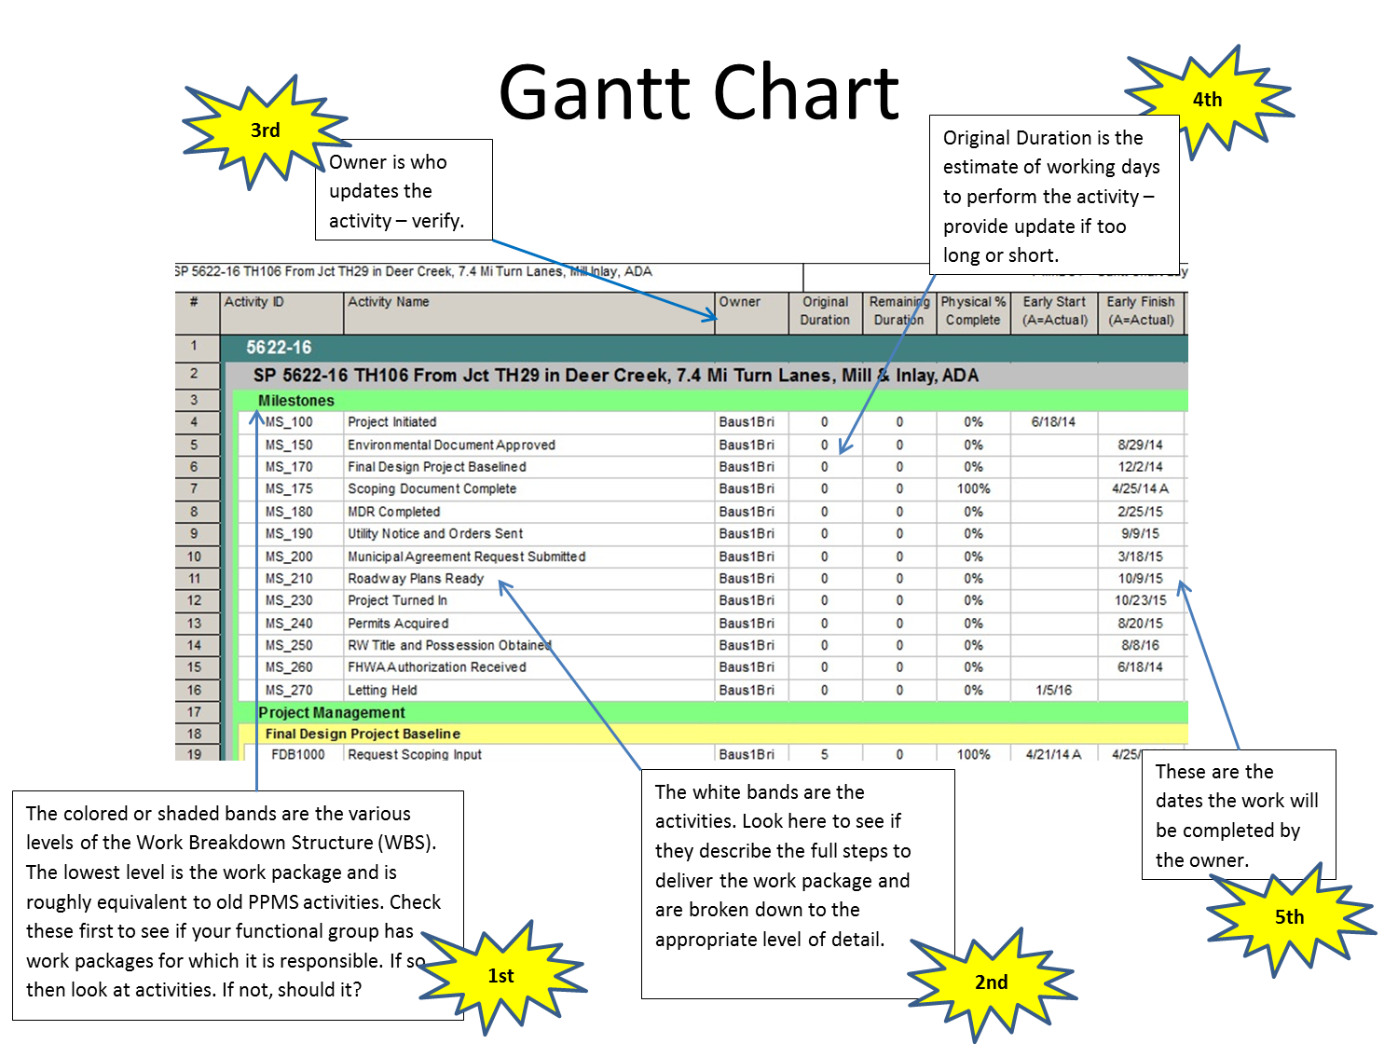
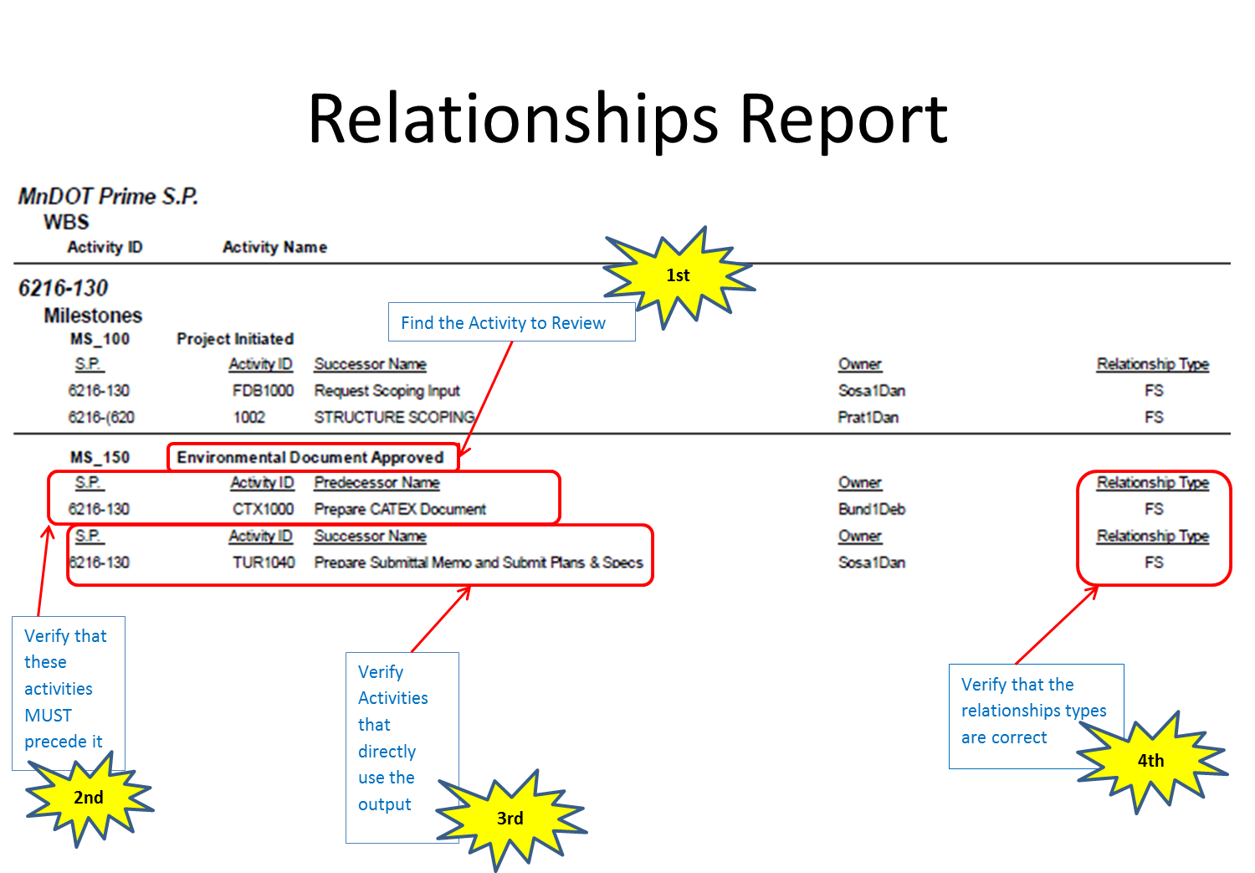
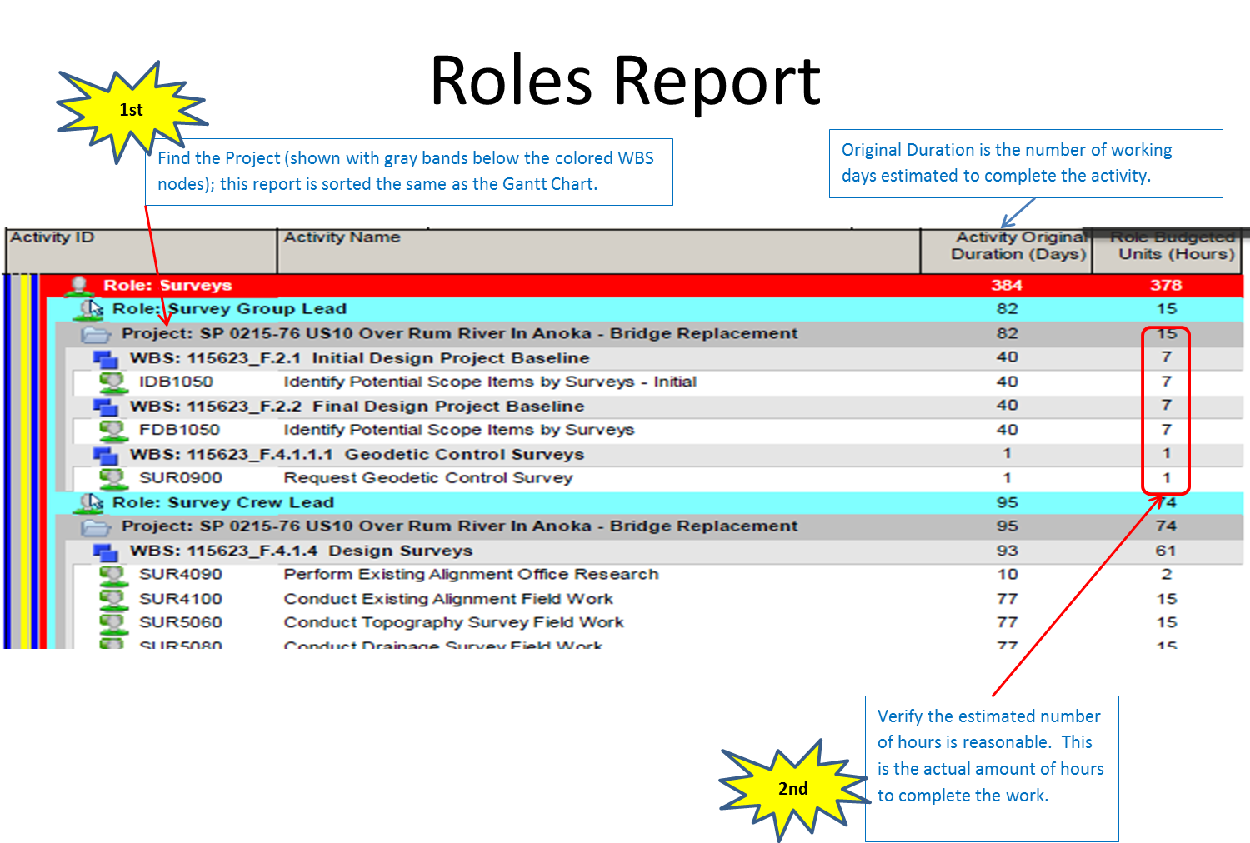

Attachment B – Typical Sharepoint Site Structure
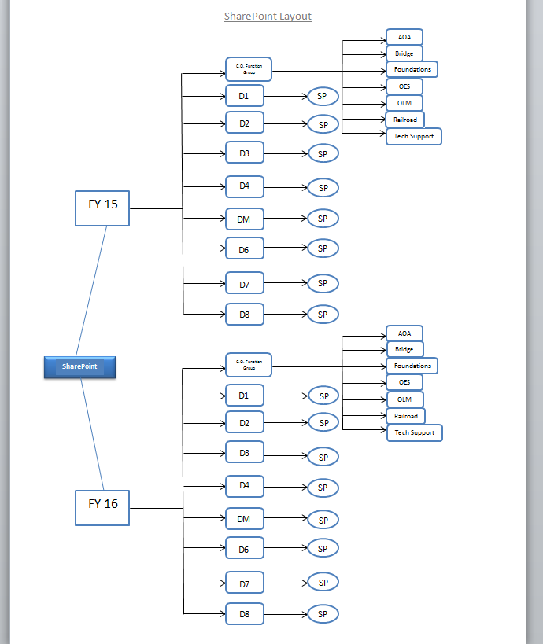
FY 18
FY 17

Attachment C – Schedule Types
Listed below are the MnDOT Baseline Status codes that will be used to track the development of a schedule from inception through “resource concurrence.” The SSC schedulers will be responsible for modifying the above codes as the schedule advances.
- Undeveloped – P6 Admin team has created the shell.
  - Planned Status (P6 Project Status)`
  - Planned or Programmed (MnDOT Project Status)
  - not in the scorecard for negative float
- Preliminary Schedule – Initial schedule set up by SSC staff based on schedule initiation form prepared by the project manager.
  - Planned Status (P6 Project Status)
  - Planned or Programmed (MnDOT Project Status)
  - Not in the scorecard for negative float
- Schedule Under Review – Preliminary Schedule has been updated by the SSC based on project manager comments and input from the functional groups. The project manager then distributes this schedule to the functional groups.
  - Planned Status (P6 Project Status) until functional groups buy-in to work packages, activities, relationships (logic), durations, role hours, and activity owners. This does not include the schedule dates (date in time when the activities will occur).
    - Planned or Programmed (MnDOT Project Status)
    - Not in the scorecard for negative float
  - Active Status (P6 Project Status) when PM obtains function group buy-in.
    - Planned or Programmed (MnDOT Project Status)
    - In the scorecard for negative float

- Baselined – PM and functional groups have agreed on the schedule dates from the Schedule Under Review schedule. SSC staff will record the baseline schedule in P6.
  - Active Status (P6 Project Status)
- Planned or Programmed (MnDOT Project Status)
- In the scorecard for negative float

- Recovery – After a schedule is baselined and a project is impacted, the status will change to Recovery until a recovery plan has been accepted by the district and functional groups. After acceptance of the recovery plan, the status will move back to baselined.
- Active Status (P6 Project Status)Planned or Programmed (MnDOT Project Status)
- In the scorecard for negative float

Attachment D – Recovery Plan Template
Attached is a draft recovery plan that can be used by a Project Manager.


NEGATIVE FLOAT RECOVERY PLAN #
PRIME S.P. (ROUTE )
ELEMENT ID #

Date | Date of Recovery Plan
Amount of Negative Float
Origin of Negative Float | What is the origin of the Negative Float?  What functional areas or external partners/organizations is the origin and/or cause of the Negative Float?  Are there multiple causes and multiple occurrences? List.
Recovery Options | The following recovery strategy will be used (use more than 1 if applicable):  Re-sequencing of work  Schedule Crashing  Allocating more internal resources  Adding Consultants  Change the Letting Date  Current Letting Date:  Proposed Letting Date:
Recovery Resolution & Justification | The following steps and actions are necessary to eliminate the negative float on this project:
Project Budget | Does the recovery plan impact project budget?  No  Yes, by  If Yes,  How much?  Why?  What is the additional source of funding?
Project Risk Register | Are there additional Risks with the Negative Float Recovery Plan?
Concurrence Checklist | The following groups need to concur with the recovery plan. Use N/A if not applicable.  Concurrence Date  District Functional Groups  Bridge  Land Management  Environmental Stewardship  Railroad  Technical Support  ADA

Attachment E – CO Functional Group Reports
- Attached are draft reports that the Central Office Functional Groups will use to view projects at the program level. These reports include:
- Functional Group Summary Report – Shows all of a functional groups work (sorted by SP). Example provided is for OLM.
- Functional Group Activity Report – Same as the Functional Group Summary Report, but also includes detailed on all of the activities. Shows all of a functional groups work (sorted by SP) and includes all of the activities.
- Role breakdown – Provides the role hours for each task

Functional Group Summary Report
