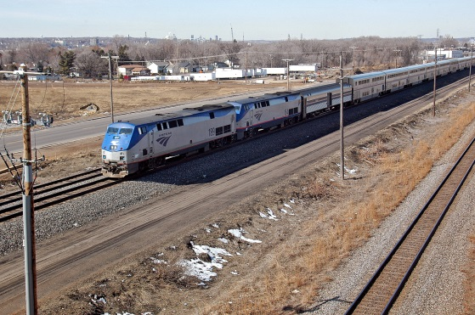
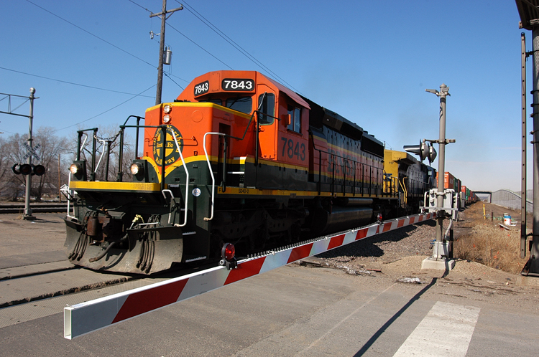
Fact Sheet

Statewide Rail Plan 2015
The Minnesota Department of Transportation is partnering with local municipalities and counties to gather public input that will inform the 2015 update of the Minnesota State Rail Plan.

What is the Rail Plan?
The Minnesota State Rail Plan is MnDOT’s modal plan for the state’s freight and passenger rail system. Its primary purpose is to establish guidance and priorities for the state transportation decisions—ensuring that efficient, competitive services are available to rail customers and that freight access to local and global markets is enhanced.

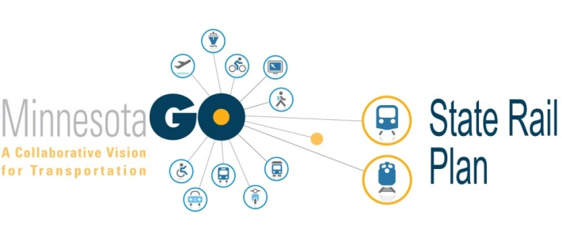
Why is a new Plan needed?
The last plan was created in 2010, this update is needed to:
- Follow a new state transportation vision and corresponding goals
- Meet new standards created in recent federal guidance
- Address changes in rail trends

What will it include?
This update will:
- Comply with federal guidance
- Address new trends
- Continue to promote safety
- Investigate funding methods
- Update priorities and project lists

Share your thoughts!
Open houses are being held throughout the state in October and November 2014, with a second round in January 2015. Three major stakeholder meetings are also scheduled, coinciding with the November 2014 Passenger Rail Forum, the December 2014 Freight and Logistics Symposium, and the January 2015 Passenger Rail Forum.
Jan 2015
2nd Round of Open Houses
DEc 2014 – Jan 2015
Plan Development
Oct – Nov 2014
1st Round of Open Houses
Feb 2015
Plan Adopted

Plan Update Schedule

For More Information
- Visit: http://www.dot.state.mn.us/aboutrail/
- Or contact: Dave Christianson, Project Manager, MnDOT, 651-366-3710, dave.christianson@state.mn.us

