

August 2014

**INTRODUCTION**

|  |  |
| --- | --- |
| **MONITORING OF PERVIOUS CONCRETE STREETS IN CITY OF SHOREVIEW. (5-YEAR REPORT)** |  |

Storm-water runoff from the Woodbridge neighborhood of the City of Shoreview had previously been managed through culverts and other hydraulic structures. In adherence to the Clean Water Act, many watersheds instituted limits to the percentage of storm water that may be allowed into certain lakes and rivers. To minimize this run-off and the associated impacts and in accordance with the City’s sustainable design policy, the City of Shoreview built the Woodbridge neighborhood local roads using pervious concrete pavements in 2008. Pervious concrete pavements exhibit high hydraulic conductivity and high sound absorption coefficient in local or low volume roads. They also provide cost savings through the minimization of hydraulic structures.

The pervious concrete was designed for an anticipated 23% porosity and zero-slump. City of Shoreview constructed these streets in 2008. The design (Figure 1) included a 7 inch pervious concrete pavement built over 18 inches of pervious base. In the proximity of Owasso Lake, the subgrade materials are very drainable sands that allow direct infiltration of runoff (Figures 2 and 3 show the neighborhood).

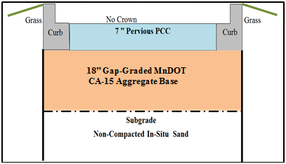

**Figure 1: General Structural & Storage Design**

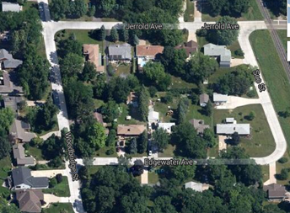

**Figure 2: Jerrold, Edgewater, Soo, Owasso & Woodbridge Streets Pervious Pavements**

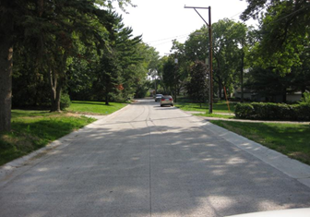

**Figure 3: Jerrold Street**

**MONITORING**

MnDOT researchers have monitored and evaluated the performance of City of Shoreview’s pervious concrete pavements since 2009. Qualitatively, joints and pavement surfaces were observed for raveling and spalling respectively. After 5 years, approximately 20 % of the total length of transverse joints was spalled. Approximately 15% of the surface was visibly raveled but the most raveled portion was the section where a deicing salt trial had been performed.

Quantitatively, sound absorption, hydraulic conductivity, and ride quality (IRI) measurements were performed twice a year on average. After analyzing the data collected, hydraulic conductivity and sound absorption were found to be decreasing over time mainly due to clogging and traffic load impact. Ride quality was also observed to decrease (IRI increased) over time. Figures 4 and 5 show the Gate-valve Perveameter testing device and some results obtained from the hydraulic conductivity testing respectively.



**Figure 4: Gate-Valve “Perveammeter” Built By MnDOT Researchers for Hydraulic Conductivity Measurement.**

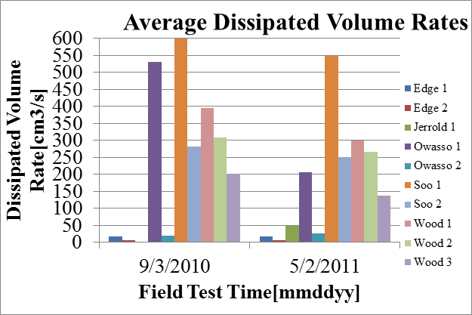

**Figure 5: Noticeable but Insignificant Yearly Change in Hydraulic Conductivity**

Ride quality requirements are not generally made for city streets but for research purposes, it is an indicator of pavement condition. As part of the monitoring, ride measurements were frequently conducted to detect changes in pavement condition using the light weight profiler (Figure 6). The results indicated initially high IRI due to roller screed paving. However, there was noticeable increase in IRI in subsequent years (Figure 6) but at 30 miles per hour the changes may not be noticeable to the rider.

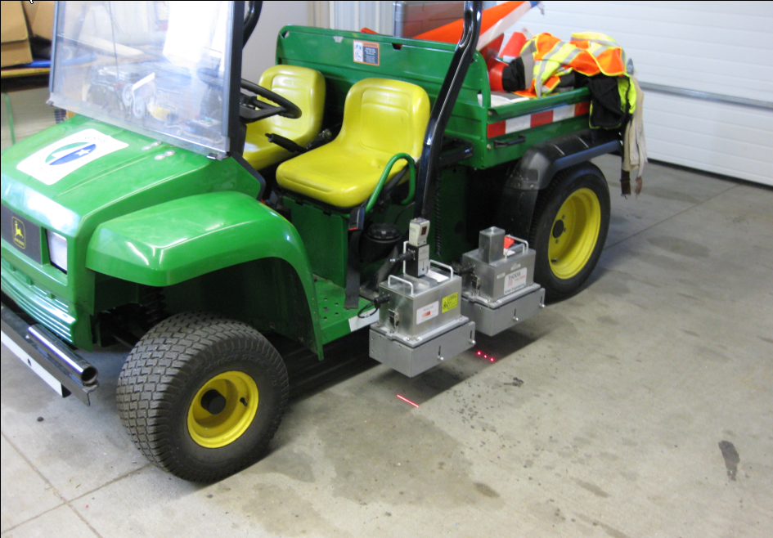

**Figure 5: Lightweight Proliler Used for Ride Measurement.**

**Figure 6: Gradual Annual Roughness Increase Was Noticeable**

One of the most informative performance indexes of pervious concrete is sound absorption coefficient. This value indicates mechanical and gravimetric (including porosity) changes of the pavement. The impedance tube (ASTM E-1050 modified for on-site testing) was used to measure sound absorption over time as shown in Figure 7. The results (Figure 8) show some decrease in the coefficient with time. This is traceable to the possibly low frequency of vacuuming of the pavement.

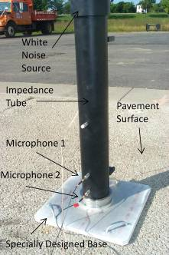

**Figure 7: Impedance Tube used for Sound Absorption Measurement**

**Figure 8: Sound Absorption at 1000 Hz**

**HYDROLOGIC EVALUATION**

After finding the actual/average monthly total precipitation records for the city of Shoreview from the proximate weather stations, the catchment area of the City’s pervious concrete streets was defined. The watershed area of the Woodbridge neighborhood was clearly delineated from the available topographical maps. As part of the monitoring and evaluation process, researchers analyzed the storm water benefits arising from the use of pervious concrete.

The yearly total volume of precipitation in the catchment area of the pervious pavements was calculated. Based on annual rainfall the topography and implied catchment area this study estimated that 35 acre-ft of water might have infiltrated the pervious pavements within the analysis period. Though the cost of alternative hydraulic structures accentuate the advantages of a pervious pavement where direct infiltration is possible, a long-term (10-year or more) performance curve will be required to furnish a tenable or comparative benefit cost analysis though a cost effectiveness may be obtained from initial cost consideration. A draft final detailed 5-year performance report will be available in late summer 2014. A detailed hydrologic evaluation was performed in the final report under review.

**RECOMMENDATION**

More elaborate studies on clogging of pervious concretes in MnROAD test cells indicate the susceptibility of clogged pervious pavements to freeze-thaw damage and raveling. Frequent vacuuming removes clogging agents and minimizes the likelihood of irreversible clogging that could occur when layers of silt and clay clog the cavities.

In 2015, a layer analysis will be performed. This will entail some use of the falling weight deflectometer to determine moduli of each layer for additional structural condition information.

**For More Information:**

**Bernard Igbafen Izevbekhai, P.E., PhD** [**Bernard.Izevbekhai@state.mn.us**](mailto:Bernard.Izevbekhai@state.mn.us).