Technical Report Documentation Page
1. Report No. | 2. | 3. Recipients Accession No.
MN/RC 2019-XX
4. Title and Subtitle |  | 5. Report Date
Effective Long Lasting Partial Depth Joint Repairs for Challenging Conditions – Literature Review |  | October 2019
 |  | 6.
7. Author(s) |  | 8. Performing Organization Report No.
Kenneth A. Tutu, Heidi Olson
9. Performing Organization Name and Address |  | 10. Project/Task/Work Unit No.
Braun Intertec Corporation
11001 Hampshire Avenue S
Minneapolis, MN 55438
 |  | 11. Contract (C) or Grant (G) No.
12. Sponsoring Organization Name and Address |  | 13. Type of Report and Period Covered
Minnesota Department of Transportation
Office of Research & Innovation
395 John Ireland Boulevard, MS 330
St. Paul, Minnesota 55155-1899
 |  | 14. Sponsoring Agency Code
15. Supplementary Notes
http://mndot.gov/research/reports/2019/2019XX.pdf
16. Abstract
The Minnesota Department of Transportation, in conjunction with other National Road Research Alliance members, is conducting a field evaluation study of 16 proprietary repair materials at the MnROAD Research Facility to aid in developing guidance for the selection and construction of partial depth repair (PDR) materials. Over 30 publications were reviewed to synthesize effective PDR construction practices, focusing on applications and limitations of PDR; material and construction considerations; and field performance. PDRs have been effectively used to treat distresses within the top one-third to one-half of the slab thickness, except for distresses caused by dowel bar misalignment; working cracks caused by shrinkage, fatigue, or foundation movement; durability cracking; and material-related problems such as alkali-silica reactivity and alkali-carbonate reactivity. Cementitious, polymeric and bituminous are common categorizations of PDR materials; however, novel materials continue to surface, and it is important a framework exits for evaluating new materials. Curing, strength, shrinkage, thermal, bonding and freeze-thaw durability characteristics need careful consideration in the selection of repair materials. Minimum compressive strength requirement for opening PDRs to traffic varies; however, there seems to be a trend toward specifying lower opening strengths, as well as monitoring in-situ strength using maturity meters, particularly if very early opening is required. Best practices for preparing patch areas; mixing, placing and consolidating repair materials; finishing and curing; as well as restoring joints are discussed.

17. Document Analysis/Descriptors |  | 18. Availability Statement
National Road Research Alliance, NRRA, MnROAD, concrete repair, joint repair, partial depth, patch |  | No restrictions. Document available from: National Technical Information Services, Alexandria, Virginia 22312
19. Security Class (this report) | 20. Security Class (this page) | 21. No. of Pages | 22. Price

Effective Long Lasting Partial Depth Joint Repairs For Challenging Conditions

LITERATURE REVIEW

Prepared by:
Kenneth A. Tutu
Heidi Olson

Braun Intertec Corporation

October 2019

Published by:
Minnesota Department of Transportation
Office of Research & Innovation
395 John Ireland Boulevard, MS 330
St. Paul, Minnesota 55155-1899

This report represents the results of research conducted by the authors and does not necessarily represent the views or policies of the Minnesota Department of Transportation or [author’s organization]. This report does not contain a standard or specified technique.
The authors, the Minnesota Department of Transportation, and [author’s organization] do not endorse products or manufacturers. Trade or manufacturers’ names appear herein solely because they are considered essential to this report.

TABLE OF CONTENTS
CHAPTER 1: INTRODUCTION 1
1.1 Partial Depth Repair 1
1.2 Applications and Limitations 1
CHAPTER 2: MATERIAL CONSIDERATIONS 3
2.1 Material Properties 3
2.2 Material Types 5
2.2.1 Cementitious Materials 5
2.2.2 Polymer-Based Concretes 6
2.2.3 Miscellaneous Patching Materials 7
2.2.4 Accessory Materials 8
2.3 Material Evaluation Methodology 10
CHAPTER 3: CONSTRUCTION CONSIDERATIONS 12
3.1 Repair Area Demarcation 12
3.2 Deteriorated Concrete Removal 12
3.3 Joint Bond Breaker Installation 13
3.4 Bonding Agent Application 13
3.5 Mixing, Placement and Consolidation 14
3.6 Finishing, Curing and Sealing 14
CHAPTER 4: PATCH PERFORMANCE 16
CHAPTER 5: SUMMARY AND CONCLUSIONS 18
REFERENCES 19

LIST OF FIGURES
Figure 1 Scored Joint Bond Breaker (Wilson et al., 1999a) 10
Figure 2 Joint Bond Breaker (Wilson et al., 1999a, as reproduced by Smith et al., 2014) 10
Figure 3 Methodology for New Product Evaluation (adapted from Tyson, 1977) 11
Figure 4 Joint Restoration Using Scored Bond Breaker (Wilson et al., 1999a) 15

LIST OF TABLES
Table 1 PDR Opening Strengths (Frentress and Harrington, 2012; Elfino et al., 2013; Collier et al., 2018) 4
Table 2 Laboratory Test Methods for Evaluating Cementitious Repair Materials 5
Table 3 Cementitious Materials (Patel et al., 1993; Frentress and Harrington, 2012; Smith et al., 2014) 5
Table 4 Polymer-Based Materials (Patel et al., 1993; Frentress and Harrington, 2012; Smith et al., 2014) 6
Table 5 Construction-Related Problems and Suggested Solutions (Smith et al., 2014) 17

Introduction

partial depth repair
Partial depth repair (PDR) is the removal and replacement of deteriorated or spalled concrete in the upper portion of concrete pavements. Spalling is defined as cracking, breaking, or chipping away of concrete at joints and cracks, which is often caused by incompressible materials that accumulate in these openings. The incompressible materials hinder slab movement induced by thermal variations, thus resulting in high compressive stresses at joints and cracks. Spalling may occur at other locations on a pavement slab due to reasons such as snowplowing, poor construction practices and popouts (ACPA, 2004). Interestingly, the spalling experienced in Texas has been generally associated with the use of certain type of siliceous river gravel, which tends to exhibit higher elastic modulus, higher coefficient of thermal expansion (CTE) and weaker bonding (Folliard et al., 2006; Markey et al., 2006).
Spalling allows the ingress of water and more incompressible materials. It propagates under the influence of environmental and traffic factors, and if proper repair is delayed, particularly for pavements located in a wetter and colder climate, the distress could progress rapidly to minimize structural integrity, safety and ride quality. PDR replaces deteriorated concrete, restores ride quality, prevents further deterioration and provides a reservoir for resealing of joints and cracks (ACPA, 1989).
Due to the detrimental effects of spalling, some highway agencies spend substantial budget on spall repairs, estimated to be in excess of one billion dollars annually in the United States (Kuo et al., 1999). Increasing budget constraints and stricter requirements to minimize traffic delays and safety hazards have necessitated the need for better materials and installation techniques for rapid construction of long lasting repairs. It is believed that about 8 to 10 percent of spall repairs fail within a year, and about half of all pavement repairs fail within five years (MDOT, 1996). However, with optimal timing of repairs, proper selection of materials and good construction practices, it is possible to produce PDRs that could last 10 to 15 years or longer (Frentress and Harrington, 2012).
The primary objective of this literature review was to synthesize effective practices for producing long lasting PDRs. The review focused on applications and limitations of PDR; material and construction considerations; and field performance of PDRs. To achieve the above stated objective, over 30 publications compiled from transportation research databases, industry associations, university research centers and state departments of transportation (DOT) libraries, were reviewed.

applications and limitations
Historically, recommendations have limited the use of PDRs to the upper third of the pavement (e.g., Patel et al., 1993; Wilson et al., 1999a; ACPA, 2004). However, it is becoming common to use PDR to treat distresses that extend as deep as one-half of the slab thickness. For instance, Minnesota, Wisconsin, Michigan, Kansas, Missouri, Colorado and South Dakota have successfully utilized PDR to correct distresses that extended to one-half of the slab (Frentress and Harrington, 2012). Because most repair materials cannot accommodate high stresses induced by movements across working joints, cracks, load transfer devices and reinforcing steel, PDR is suitable for treating distresses located within the top one-third to one-half of the slab thickness (Smith et al., 2014). The following distresses have been successfully remedied with PDRs (Frentress and Harrington, 2012; Smith et al., 2014):
- Spalling caused by accumulation of incompressible materials in joints
- Spalling caused by poor construction practices, such as poor consolidation, inadequate curing, over-finishing, weak concrete, clay balls and inadequate reinforcing steel cover
- Spalling caused by freeze-thaw as a result of inadequate air void system
- Localized areas of deterioration or scaling limited to the upper one-third to one-half of the slab thickness and of sufficient size and depth to warrant repair
- Non-working longitudinal and transverse cracks
Despite the utility of PDR, it is ineffective in treating spalling caused by dowel bar misalignment; working cracks resulting from shrinkage, fatigue, or foundation movement; durability cracking (D-cracking); and material-related issues such as alkali-silica reactivity, alkali-carbonate reactivity and ettringite formation (Frentress and Harrington, 2012; Smith et al., 2014).
Pavement coring is recommended for ascertaining the depths of deterioration to enable a suitable repair option to be selected. Locations where deteriorations reach the depth of dowel bars are candidates for a full depth repair (Wilson et al., 1999a; Smith et al., 2014). To minimize the risk of premature failures, PDRs may be undertaken before overlay construction (Wilson et al., 1999a).

MATERIAL CONSIDERATIONS
Proper material considerations are essential for producing long lasting PDRs. Poor material selection and design has been found to cause patch failures within two to three years (ACPA, 2006). Wilson et al. (1999a) identified the following common material-related causes of premature PDR failures:
- Incompatibilities between the climatic conditions during repair installation and the materials
- Thermal incompatibility between the repair material and the existing concrete
- Extreme climatic conditions during the service life of the repairs
- Inadequate cure time prior to opening repairs to traffic
- Incompatibility between the joint bond breaker and the joint sealant material
The selection of a repair material for a particular project could be challenging, since many factors need consideration, including allowable lane closure time; environmental conditions; material properties, particularly shrinkage characteristics, CTE, curing time, compatibility between repair material and existing concrete; project size and funding; and performance requirements (Frentress and Harrington, 2012; Smith et al., 2014). Regardless, cost-effective materials that provide maximum benefits should be selected. The following subsections discuss some essential properties of repair materials, benefits and drawbacks of various material types and a framework for evaluating and approving new materials.

mATERIAL PROPERTIES
To shorten lane closure times, traffic loading is permitted when patches have gained minimum strength to sustain loads. Most highway agencies use flexural strength to determine traffic-opening times for full depth repairs (FDRs), since most of FDR structural failures are caused by high tensile stresses at the bottom of slabs (Frentress and Harrington, 2012). However, Frentress and Harrington (2012) recommended using compressive strength at opening as a criterion for selecting PDR mixtures, since PDRs mostly experience compressive stress; tensile stress is accommodated by the existing concrete.
There is no consensus on minimum strength requirements for opening PDRs to traffic. This is not surprising because several material, traffic and environmental factors influence such a criterion. Frentress and Harrington (2012) noted that, since PDRs are confined and supported by the underlying concrete, the minimum compressive strength requirement at opening should be lower (typically 1,600 to 1,800 psi) than that for conventional FDRs (typically 3,000 psi or higher). They also noted that higher opening compressive strengths (e.g., 3,000 psi) may increase the risk of short-term failures than lower opening strengths (e.g., 1,600 to 1,800 psi); the higher the opening strength, the higher the complexity of the repair material composition.
Table 1 shows the opening strength requirements of some agencies. By using the HIPERPAV software to analyze typical concrete mixtures constructed in Virginia, Elfino et al. (2013) recommended a minimum opening compressive strength of 1,600 psi, provided a maturity meter was used to monitor in-situ strength. They suggested the recommended opening strength could reduce cement quantities in repair mixtures compared with the current requirement of 2,000 psi. Similarly, Collier et al. (2018), after reviewing several opening strength requirements, suggested Louisiana Department of Transportation and Development reduce their current minimum compressive strength specification of 3,000 psi to 2,000 psi in order to increase durability, while minimizing construction costs and lane closure times. They also recommended adoption of the maturity method for monitoring in-situ strength.
Table 1 PDR Opening Strengths (Frentress and Harrington, 2012; Elfino et al., 2013; Collier et al., 2018)
State | Flexural Strength  (psi) | Compressive Strength  (psi)
New York | -- | 1,527
Kansas | 300 | 1,800
Missouri | -- | 1,600
Michigan | 300 | 1,800
Minnesota | 500 | 3,000
Colorado | -- | 2,500
Nebraska | -- | 3,625
Virginia | -- | 2,000
Louisiana | -- | 3,000
There seems to be a trend toward specifying lower opening compressive strengths for PDRs and using a maturity meter to monitor in-situ strength gain, particularly if very early opening is required (e.g., 4-hour curing time). For instance, the Virginia DOT allows the use of maturity meters to monitor in-situ strength, in order to facilitate rapid decision-making on traffic-opening times (Elfino et al, 2013).
Drying shrinkage and CTE of repair materials also impact the performance of PDRs; the greater the difference in these properties between the repair material and the existing concrete, the greater the risk of debonding (Smith et al., 2014). Emmons et al. (1993) indicated that most repair materials have greater shrinkage potential than conventional concrete, hence a repair material that is restrained in a patch could induce tensile stress as high as 1,000 psi.
Apart from possessing desirable strength and shrinkage characteristics, PDR materials should also be able to withstand deterioration from freezing and thawing. Therefore, freeze-thaw durability is an important material characteristic that needs consideration. Rapid strength-gain materials, although allow for early opening to traffic, are often prone to durability-related distresses owing to their reduced curing times and slower long-term strength gain (Van Dam et al., 2005; Frentress and Harrington, 2012). Using high-quality materials and construction techniques, reducing the water-to-cement ratio and increasing aggregate volume but maintaining workability are some suggested measures for achieving early-strength without adversely affecting durability (Van Dam et al., 2005).
Flowability, rate of strength gain, water and chloride ion impermeability and ability to develop strong bond with the existing concrete have also been identified as essential material characteristics that influence the long-term performance of repair concrete materials (Deshpande, 2006). Several laboratory test methods are available for evaluating the mechanical, durability and dimensional stability properties of cementitious repair materials; Table 2 shows examples of such tests.
Table 2 Laboratory Test Methods for Evaluating Cementitious Repair Materials
Property | Test Method
Compressive strength | ASTM C 39
Drying shrinkage | ASTM C 157
Restrained shrinkage | ASTM C 1581
Slant-shear bond strength | ASTM C 882 (modified by ASTM C 928)
Tensile bond strength | ASTM C 1583
Modulus of elasticity | ASTM C 469
Coefficient of thermal expansion | ASTM C 531
Freeze-thaw resistance | ASTM C 666

mATERIAL TYPES
PDR materials may be categorized as cementitious, polymer-based and bituminous materials. Bituminous materials are mostly used for temporary, emergency-type repairs, although some proprietary products may provide longer service lives. Research (e.g., Wilson et al., 1999a) shows that bituminous patches may perform well for three to four years, but rapidly deteriorate afterward. The rest of the review focuses on cementitious and polymer-based repair materials.

Cementitious Materials
Regular Portland cement concrete (PCC) mixtures are commonly used for PDRs. Mixtures containing Type III Portland cement or Type I Portland cement plus a set-accelerator are installed when the repair must open to traffic quickly. Table 3 summarizes some benefits and drawbacks of cementitious repair materials.

Table 3 Cementitious Materials (Patel et al., 1993; Frentress and Harrington, 2012; Smith et al., 2014)
Category | Benefits | Drawbacks
Portland cement concrete | - Type I cement mixtures install easily  - Type I cement rich mixtures gain strength rapidly in warm weather  - Type III cement mixtures set faster, allowing quicker opening to traffic | - Type I cement rich mixtures gain strength slowly in cold weather; they may need insulation layers  - Difficult to place Type III cement mixtures properly
Gypsum-based concretes | - Gain strength rapidly; can open to traffic in one hour  - Applicable in non-freezing conditions  - Not affected by deicing agents | - May not perform well under moisture or in a freezing weather  - Free sulfates in typical gypsum mixtures facilitate steel corrosion  - Dry conditions are needed to install

Table 3 cont’d
Category | Benefits | Drawbacks
Magnesium phosphate concretes | - Set very quickly to yield high early-strength, impermeable material  - Bond well to clean and dry surfaces | - Small amounts of excess water can cause considerable strength loss  - Not compatible with certain types of limestone aggregate
High alumina concretes | - Gain strength rapidly, with good bonding capability on dry surfaces  - Exhibit high freeze-thaw damage resistance and very low shrinkage  - Applicable in low-temperature conditions | - Strength loss may occur over time due to a chemical conversion process during curing or later  - Conversion test can evaluate mix designs to ascertain if converted strength exceeds specified strength

Polymer-Based Concretes
Polymer resin, aggregate and a set initiator are the major constituents of polymer-based concretes. They have faster setting times than most cementitious materials and may be sensitive under certain field conditions (Frentress and Harrington, 2012). Aggregate is added to enhance thermal compatibility with the existing concrete, provide a wearing surface and improve economy (Patel et al., 1993). Table 4 presents some benefits and drawbacks of polymer-based concretes.
Table 4 Polymer-Based Materials (Patel et al., 1993; Frentress and Harrington, 2012; Smith et al., 2014)
Category | Benefits | Drawbacks
Epoxy concretes | - They are impermeable and have excellent bonding properties | - They must be thermally compatible with existing concrete to prevent patch failure (epoxies have higher CTE)  - Deep repairs should be placed in multiple lifts to control heat generation  - Not suitable to patch spalls caused by steel corrosion; adjacent sound concrete may deteriorate quickly
Methyl methacrylate (MMA) concretes | - Provide high compressive strength and good bonding  - Can be installed over a wide temperature range (40 to 130 ºF) | - Many are volatile and may pose a health hazard from prolonged exposure
Polyester-styrene concretes | - Have similar properties as MMAs  - Generally cost less | - Slower rate of strength gain than MMAs
Polyurethane concretes | - They have very quick setting times (90 seconds)  - They are very flexible | - High CTE and large initial shrinkage  - Many are moisture-intolerant, but some manufacturers exempt their products

Miscellaneous Patching Materials
There is a continual search for innovative repair materials that provide cost-effective repair solutions. For instance, Parker and Shoemaker (1991) evaluated the potential benefits of incorporating steel fibers and anchors in rapid-setting cementitious repair materials. The anchors were U-shaped No. 4 reinforcing bars inserted in holes drilled in the slabs and filled with a rapid-setting polyester grout. The anticipated benefits of the anchors were bonding enhancement between the new and old concrete and load support after bond failure. While the inclusion of the anchors did not improve patch performance, patches constructed with steel fiber-reinforced PCC exhibited better performance. The superior performance was attributed to the larger tensile strength and ductility of the fiber-reinforced concrete, which enabled the patches to better resist cracking. Also, it was thought that the steel fiber improved resistance to shrinkage and microcracking during curing.
Some product manufacturers recommend adding pea gravel to their products, a process known as extension. Deshpande and Olek (2008) conducted laboratory evaluation of four commercial rapid-setting repair materials extended with pea gravel of nominal aggregate size of 9.5 mm. Both fresh properties (slump and setting time) and hardened properties (compressive strength, slant shear strength, cracking susceptibility, drying shrinkage and freeze-thaw durability) were considerably affected by the extension; the extended products did not necessarily exhibit the properties of rapid-setting repair materials required by ASTM C 928. Also, an additional amount of water was necessary for all the extended products to exhibit the desired workability.
Some newly-proposed rapid-setting repair materials incorporate waste materials, such as fly ash and silica fume (e.g., Ghazy et al., 2016; Mohammadi et al., 2014). Song et al. (2017) formulated a rapid-setting repair material comprising fly ash, blast furnace slag and rice husk ash. Wang and Lomboy (2016) developed, for rapid repair applications, a mortar mix formula which incorporated Type I Portland cement, river sand, Class F fly ash, silica fume, limestone fines and a high-range water reducer. The mortar exhibited better self-consolidation, freeze-thaw durability and chloride ion impermeability than the commercial concrete repair product used as a control. Also, the compressive strength and modulus of rupture at one day were comparable to those of a conventional pavement concrete mixture at 28 days. However, the mortar exhibited higher autogenous shrinkage and slightly lower free drying shrinkage; the addition of micro-steel fibers slightly reduced the shrinkage. Further investigation into the fatigue and shrinkage cracking behavior of the mortar mix was recommended. Field trials will also help to evaluate the material’s performance under service conditions.
The search for newer and better repair materials and construction techniques is set to continue, and it is important an effective framework exists for an objective evaluation of potential products and their installation techniques. Section 3.2.5 presents a simple framework for evaluating new repair materials.

Accessory Materials
Bonding agents, curing materials and joint bond breakers are accessory materials that may be needed in the PDR construction process. These materials are briefly discussed below.
Bonding Agents
The bond strength between the repair and the existing concrete has a major impact on patch performance and, for early-opening-to-traffic patches, early development of bond strength is critical. Surface preparation, surface moisture condition, bonding agents, compressive strength of the repair material, curing and the presence of cracking all affect bond strength (Santos et al., 2012).
A bonding agent may not be required for some proprietary patch materials. However, the use of sand-cement grout as a bonding agent for cementitious repair materials is widely practiced. Two parts of Type I cement to one part of water and one part of sand is a popular grout recipe; however, Kansas DOT specifies a more fluid grout, comprising one part of Type I cement to three parts of water, meant to promote bonding, moisten and cool the repair area (Frentress and Harrington, 2012).
Riding and DonJuan (2014) concluded, from laboratory and field studies, that a water-to-cement ratio of one provided the best balance between workability, bond strength and wait time between grouting and material placement. A dried-out grout hinders bonding; hence, removal by sandblasting and re-application is required (Smith et al., 2014). Epoxy bonding agents have been used for both cementitious and proprietary repair materials to reduce lane closure times (Frentress and Harrington, 2012).
Curing Materials
PDRs are prone to rapid moisture loss because of their high surface-area-to-volume ratio (ACPA, 1989). Proper curing will help to maintain adequate moisture and temperature condition to facilitate strength gain, while minimizing shrinkage cracking. Frentress and Harrington (2012) identified the following characteristics of some common categories of curing compounds:
- Water-based curing compounds are readily available, but their water-retention properties reduce their caliber
- Linseed oil curing compounds provide good curing and help prevent shrinkage cracking
- Waxed-based curing compounds are very good and help to prevent shrinkage cracking
- Poly alpha methylstyrene has high solid content and requires constant mixing. If mixed properly, it provides good curing and significantly reduces shrinkage cracking.
ASTM C 309 and AASHTO M 148 provide specifications for most curing compounds. White-pigmented curing compounds create a sealing membrane that controls moisture loss; allow heat of hydration to escape, and provide curing for several days until worn out by traffic; the white color reflects solar radiation to check excessive heat development (Tyson, 1977; Van Dam et al., 2005). In hot weather, applying a white-pigmented curing compound (e.g., poly-alpha-methylstyrene) as soon as the bleed water evaporates is an effective curing method (Frentress and Harrington, 2012; Smith et al., 2014).
Moist burlap and polyethylene sheeting may also be used for curing, although they may not be the most effective method to use in hot weather because shrinkage cracking can occur from rapid moisture loss when the sheeting and burlap are removed to allow for traffic operations (Tyson 1977). Insulation blankets are effective for curing in cold weather as they retain the heat of hydration, thereby ensuring early strength development (Whiting et al., 1993; Smith et al., 2014). It is preferable to use insulating blankets in conjunction with curing compounds, since blankets alone do not significantly reduce the risk of plastic shrinkage (Whiting et al., 2005). It is advised not to place blankets just after applying a curing compound (Whiting et al., 2005).
Manufacturers of proprietary repair materials may recommend curing procedures for their products. Some highway agencies specify curing compound application rates that are 1.5 to 2 times typical rates as a precaution to prevent shrinkage cracking (Frentress and Harrington, 2012; Smith et al., 2014).

Joint Bond Breakers
Patches installed at joints or cracks, if they bond to the adjacent slab, often experience excessive compressive stresses due to slab movement. A compressible joint bond breaker prevents such undesirable bonding and relieve compressive stresses; the joint breaker also prevents the patch material from entering the joint or crack to hinder slab movement (Frentress and Harrington, 2012).
For best performance, a joint bond breaker must be nonabsorbent, closed cell, chemically inert, compressible with good recovery, compatible with joint sealant and heat resistant, if it is used with hot-poured sealants (Patel et al., 1993). Polyurethane, polystyrene, or polyethylene strips, and fiberboards have been frequently used as bond breakers to reduce the risk of joint patch failures (Patel et al., 1993). Because of the relatively high rigidity of fiberboard, it provides the most benefit at the lane-shoulder joint, where greater support is needed (Patel et al., 1993). Waxed cardboards fit well into irregular cracks, while maintaining their rigidity for placement of the repair material (Frentress and Harrington, 2012). It is noted that certain proprietary repair products have sufficient compressibility to tolerate joint movements without the need for a joint bond breaker (Smith et al., 2014).
As a good construction practice, a joint bond breaker should be scored (Figure 1) at an appropriate depth prior to installation and, upon curing of the patch material, the top strip of the bond breaker is removed to create a joint sealant reservoir (Wilson et al., 1999a). As Figure 2 shows, it is recommended bond breakers extend 1.0 inch (25mm) below and 3 inches (75 mm) beyond the repair boundaries to prevent the patch material from flowing into the joint during placement (Wilson et al., 1999a).

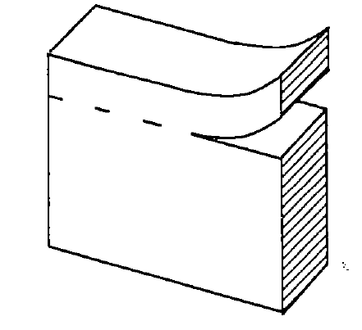
Figure 1 Scored Joint Bond Breaker (Wilson et al., 1999a)

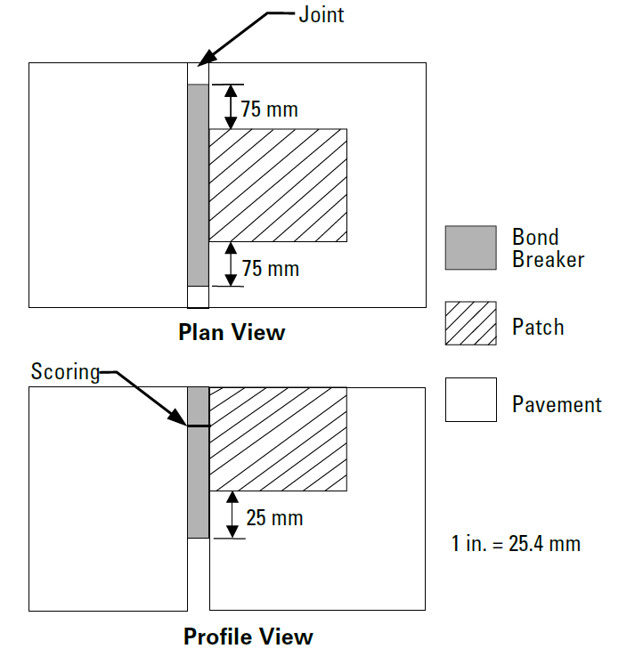

Figure 2 Joint Bond Breaker (Wilson et al., 1999a, as reproduced by Smith et al., 2014)

MATERIAL EVALUATION methodology
The proliferation of repair materials calls for an effective approach for their objective evaluation and adoption. Figure 3 shows a simple framework for evaluating new repair products (Tyson, 1977). Minimum material property values are established, based on laboratory testing or empirical experience. Products without sufficient verifiable test data to prove performance claims are screened out. If verifiable test data or an agency’s test results indicate that product has good potential, it is accepted for field trials. It is important to differentiate between material- and construction-related failures. Products that distinguish themselves in field trials may be adopted for general use, but satisfactory long-term performance must justify their continual use.
Several products may exhibit satisfactory performance in the field trials and a decision must be made regarding which product should be selected for a particular project. As previously discussed, several factors influence the selection of a repair material. In addition to the factors already discussed, it may also be useful to utilize a production chart that shows relationships between the approximate number of patches that could be installed, using a certain product, and the available lane closure time (Tyson, 1977). Such a chart will be useful, during project planning, to estimate overall lane closure time, provided the number of patches is known.

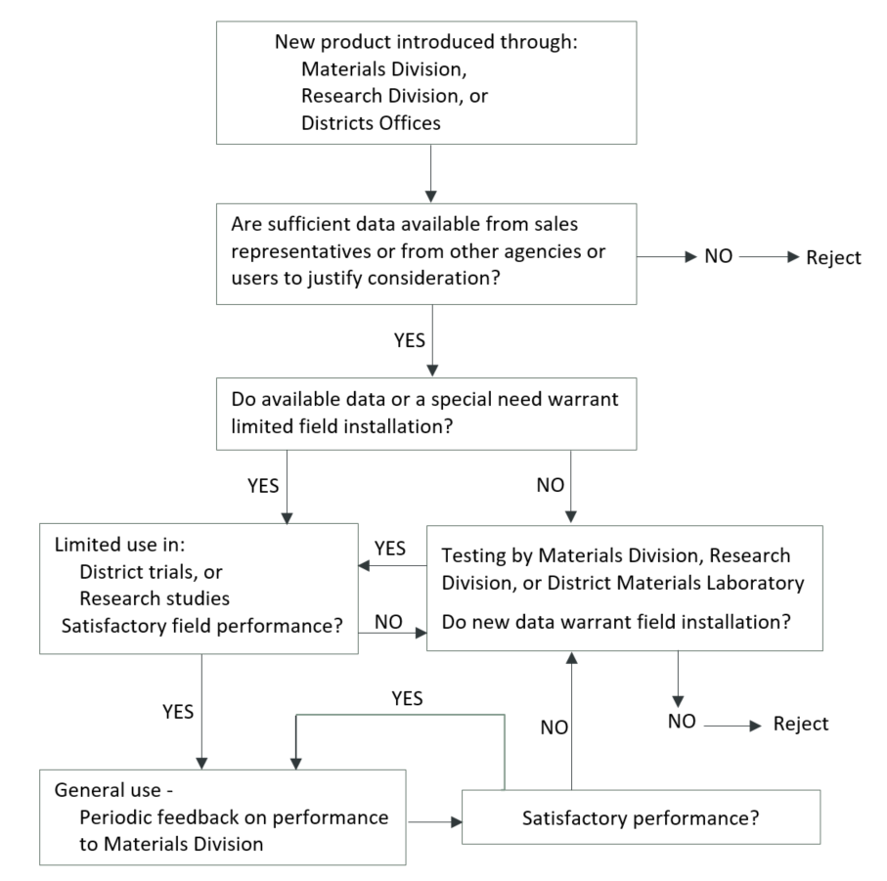
Figure 3 Methodology for New Product Evaluation (adapted from Tyson, 1977)

CONSTRUCTION CONSIDERATIONS
Tyson (1977) suggested that joint spall repairs be considered not later than the time when visual survey indicates 20 percent of the joints need PDRs. Best practices for constructing PDRs have been documented in various manuals (e.g., Patel et al., 1993; Wilson et al., 1999a; Frentress and Harrington, 2012; ACPA, 2004; ACPA, 2006). The performance of proprietary repair materials depends heavily on construction procedures, hence the manufacturer's instructions must be consulted to ensure proper installation. The construction of PDRs consists primarily of the following activities.

Repair Area Demarcation
It is widely-recognized that a zone of unsound concrete, with no visual indication of distress, exists around the limits of visibly deteriorated areas. Numerous studies (e.g., Whiting et al., 1993; Chen et al., 2009) have highlighted the importance of including this zone in the repair boundaries. Tapping the pavement slabs with a steel rod or ball peen hammer, as well as dragging a metal chain, and listening to the nature of the resulting sound (a clear ringing sound indicates sound concrete; a dull sound indicates weak concrete) is a popular technique for determining the existence and extent of unsound concrete near spalls and joints that should be removed. Commercial sounding devices may also be used.
Repair limits should extend two to six inches beyond the identifiable unsound areas suggested by the sounding test to ensure all delaminated concrete is removed (Patel et al., 1993; Whiting et al., 1993; Frentress and Harrington, 2012). Square or rectangular repair boundaries with vertical faces improve the aesthetics of patched areas and minimize cracking associated with thin edges (ACPA, 1989; Chen et al., 2009). While it is generally recommended that patches should be at least two inches deep for stability reasons, recommended minimum length and width vary from 10 to 15 inches and from 4 to 10 inches, respectively (Patel et al., 1993; Frentress and Harrington, 2012). Deteriorated areas less than a foot apart are best repaired as one patch area and, where several small spalls are present at a joint, it is proper to patch the entire joint length (Patel et al., 1993). Some proprietary material manufacturers recommend suitable patch dimensions.

Deteriorated Concrete Removal
Methods for removing deteriorated concrete include saw-and-chip (saw-and-patch), cold-milling, chipping (chip-and-patch), clean-and-patch, sandblasting, airblasting and waterblasting. Each method has its benefits and drawbacks, which will not be fully discussed here. The Strategic Highway Research Program (SHRP)/Federal Highway Administration (FHWA) study (Wilson et al., 1999b), which explored cost-effective materials and procedures for constructing PDRs, found the chip-and-patch method to be more cost-effective. Also, a Texas study (Chen et al., 2009) noted that either the chip-and-patch or saw-and-patch could provide satisfactory results, if the repair boundaries were properly identified.

Cold-milling yields tapered edges, which may be considered as a drawback. Although tapered edges are prone to cracking, those produced by cold-milling have performed satisfactorily (ACPA, 1989). The clean-and-patch is mostly used for emergency repairs under adverse conditions, while sandblasting and airblasting are effective for cleaning repair areas after concrete removal, in order to get rid of loose particles and contaminants (Wilson et al., 1999a). Equipment availability, contractor expertize, allowable lane closure time, environmental conditions and project specifications dictate the selection of concrete removal methods. Regardless of the selected method, it must ensure:
- Complete and uniform removal of deteriorated concrete to correct dimensions
- Rough surfaces that promote interlock between the repair material and the existing concrete
- Saturated surface dry and freshly exposed concrete, with no significant damage

Joint Bond Breaker Installation
As previously mentioned, joint bond breakers relieve compressive stresses and prevent the repair material from flowing into joints or cracks to impede slab movement. A key recommendation of the SHRP/FHWA partial depth spall repair study (Wilson et al., 1999b) was related to joint restoration. A bond breaker must span the entire vertical face of joints that is exposed during concrete removal. In a Virginia study in which over 10,000 partial depth patches were installed along mostly transverse joints on 400 miles of jointed concrete interstate pavement lanes, Tyson (1977) reported that a large number of the patch failures resulted from lack of joint bond breaker or failure to install a bond breaker to cover the full depth of the patches; the lower portions of the patches were in contact with the adjacent slabs, exposing them to destructive effects of slab movements. Figure 2 illustrated a recommended installation procedure for joint bond breakers.

Bonding Agent Application
The clean, freshly exposed concrete must be thoroughly coated with a suitable bonding agent, ensuring that excess material does not collect in pockets. Typically, a soft-brittle brush is used to apply epoxy-based bonding agents, while stiff-brittle brush works best for cement-based grouts; spraying is recommended for large repair areas (Frentress and Harrington, 2012; Wilson et al., 1999a).
It is crucial to apply a bonding agent just prior to placing the repair material; if the agent sets before the repair material is installed, it should be removed by sandblasting and reapplied (Smith et al., 2014). In a study to evaluate the effect of bonding agent application on PDR performance, Riding and DonJuan (2014) found cementitious grouts exhibited higher shear and tensile strengths if the repair material was placed before the grout had cured for more than 15 minutes; the bond strength started to decrease once curing had passed 15 minutes. Another significant finding was that adequate bond strength was obtained if the repair material was placed on a substrate concrete in saturated surface dry condition.

Mixing, Placement and Consolidation
Using an appropriate mixing equipment and ensuring correct mixing proportions and duration are prerequisites for producing a good quality repair mixture. Warm water may be used for mixing if ambient air temperature is below 55 ºF, and ice water at higher ambient temperatures (Wilson et al., 1999a). Excessive mixing of rapid-setting materials will reduce the available for installation, while adding water later could adversely affect strength (Wilson et al., 1999a). Small drum mixers, paddle-type mixers, mortar mixers and Jiffy mixers are typically used; however, the size of a project may not warrant the use of high-volume mixing equipment (e.g., ready-mix trucks).
It is not recommended to place cementitious and most proprietary repair materials at ambient air temperatures below 40 ºF (Wilson et al., 1999a). For instance, the Virginia DOT prohibits placing cementitious materials when air temperature is below 40 ºF; the temperature of the material at the time of placement must range from 70 to 95 ºF, unless otherwise approved (Elfino et al., 2013). Although some polymer-based concretes may be installed in cold weather, better performance results when they are installed under favorable conditions (Wilson et al., 1999a). Also, some polymer-based concretes, such as epoxies and methyl methacrylates, should be installed in maximum lift thickness of 2 inches due to their considerable heat of hydration; the time lag between lifts is often recommended by manufacturers (Wilson et al., 1999a). To avoid segregation, aggregate-containing patch materials should be placed with a shovel, slightly overfilling the patch area to compensate for volume reduction from consolidation (Wilson et al., 1999a).
Consolidation of repair mixtures using internal vibrators, vibrating screeds or manual tools will release trapped air to produce a dense material with improved durability and bonding characteristics. Poor consolidation often creates voids at the interface of the repair material and the underlying concrete, which could cause failures in less than a year (Tyson, 1977). Tools used for consolidation must be of an appropriate size and capacity for working in the repair area. Some best consolidation practices are summarized below (Wilson et al., 1999a; Smith et al., 2014):
- Holding vibrators at 15 to 30 degrees to the vertical and moving them through the entire fresh repair material according to a well-defined pattern
- Avoiding moving the repair material with vibrators to prevent segregation
- Determining adequacy of consolidation by observing when the material no longer settles, the release of air bubbles ceases, and a smooth layer of mortar appears on the surface

Finishing, Curing and Sealing
Finishing operations must be properly timed to prevent the trapping of concrete bleed water. Patches should be worked from the center toward the boundaries to pinch the patch material against the existing concrete in order to promote bonding (Wilson et al., 1999a; Frentress and Harrington, 2012). Overworking the concrete surface is strongly discouraged, so that the surface does not become brittle; susceptible to abrasion, freeze-thaw damage and chemical attack (Van Dam et al., 2005). Saw overcuts at the patch corners are typically filled with grout or joint sealant to prevent the ingress of moisture (Wilson et al., 1999a). Coating the boundaries of cementitious patches with a sand-cement grout will minimize moisture intrusion, which could cause delamination if it becomes frozen (ACPA, 1989; Whiting et al., 1993; Smith et al., 2014). Some apply a textured finish to the patches (e.g., using a broom) in order to match the texture of the existing concrete; however, this practice has little effect on the overall skid resistance of the pavement (Wilson et al., 1999a).
As noted previously, properly curing the patch material prevents rapid moisture loss, thereby minimizing the risk of shrinkage cracking and scaling, while maximizing strength gain. Late or inadequate curing must be avoided, as it can reduce the ultimate strength of PDRs by up to 40 percent (Frentress and Harrington, 2012).
The PDR construction process typically ends with joint restoration, which may be accomplished in two ways. If a scored bond breaker was installed prior to placing the repair material, the tear-off strip is removed to create a reservoir for a joint sealant (Figure 4). Another approach is to timely saw the full depth of the PDR plus ¼ inch, sandblast and airblast the saw cut, followed by inserting a closed-cell backer rod and applying a joint sealant (Wilson et al., 1999a; Frentress and Harrington, 2012). The SHRP manual entitled Materials and Procedures for Repair of Joint Seals in Concrete Pavements (Evans and Romine, 1993) provides more information on joint sealing.

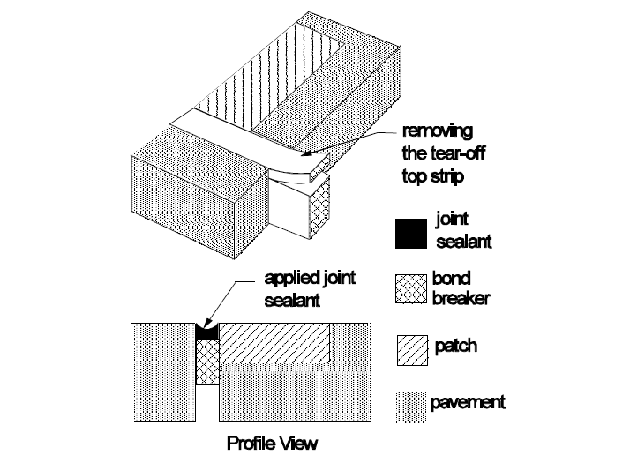
Figure 4 Joint Restoration Using Scored Bond Breaker (Wilson et al., 1999a)

patch performance
Wilson et al. (1999a) reviewed several documents which indicated 80 to 100 percent of well-constructed PDRs performed well after 3 to 10 years of service. Existing pavement condition, construction quality, material characteristics, traffic loading and environmental factors all influence the performance of PDRs. For instance, Parker and Shoemaker (1991) observed that PDRs constructed during warm weather (over 70 ºF) performed better than those constructed during cold weather. The list below shows common construction-related causes of PDR failures (Wilson et al. 1999a; Frentress and Harrington, 2012; Smith et al., 2014):
- Inappropriate use of repair techniques and materials
- Failure to remove all deteriorated material or square the patch area
- Inadequate cleaning of the patch area
- Insufficient consolidation; inadequate or improper curing
- Poor bonding between the patch material and existing concrete
- Failure to properly restore joints
- Variability in patch material quality
- Incompatibility in thermal expansion between patch material and existing concrete
In a MnROAD study (Burnham et al., 2016) conducted between 2011 and 2014 to evaluate the field performance of 22 repair materials (16 cementitious, 3 polymer-based, 3 bituminous), a total of 93 partial depth joint patches were constructed on an 18-year old pavement that had developed material-related joint distresses. Some interesting findings from the study are summarized below:
- About 59 percent of the patches were in good condition (some random cracks, limited material loss) after three years in service
- Location seemed to have had little effect on performance: 61 percent of the PDRs installed near the centerline were in good condition versus 67 percent of those in loaded areas
- Although many of the slower setting repair products exhibited a higher survivability, they were considered unsuitable for early-opening-to-traffic applications.
Similarly, the SHRP/FHWA partial-depth spall repair study (Mojab et al., 1993; Wilson et al., 1999b), which began in 1991, evaluated 11 rapid-setting cementitious, polymer-based, bituminous repair materials and five repair methods (saw-and-patch, chip-and-patch, mill-and-patch, waterblast-and-patch, and clean-and-patch). A total of 1,607 partial-depth patches were constructed on moderate- to high-volume four-lane highways located in four climatic regions: wet-freeze, wet-nonfreeze, dry-freeze and dry-nonfreeze. Field performance was monitored for 51 to 87 months, depending on the site. Major distresses observed on the cementitious and polymer-based patches included spalling, cracking, faulting and debonding (Wilson et al., 1999b). It was recommended the required service life of PDRs should influence the selection of repair materials and construction methods. Smith et al. (2014) cited several sources to develop the guidelines in Table 5 for addressing common PDR construction-related problems.
Table 5 Construction-Related Problems and Suggested Solutions (Smith et al., 2014)
Problem | Typical Causes | Typical Solutions
Deterioration found to extend beyond the original repair boundaries | - This is an unforeseen problem because the true amount of deterioration is not known until the concrete is removed | - Extend the limits of the repair area to encompass all of the deterioration  - If the deterioration extends significantly deeper than one-third to one-half of the slab thickness, FDR should be placed
Repair failures associated with inadequate compression relief provision | - Compression relief is not provided  - Compression relief material is not deep or wide enough to accommodate joint movement below repair  - Compression relief does not extend to end of repair area | - Replace the repair, making sure to provide adequate compression relief
Dowel bar exposed during concrete removal | - Concrete deterioration extends deeper  - Improper concrete removal techniques | - FDR should be used instead of the planned PDR
Reinforcing steel exposed during concrete removal | - If the steel is located in the upper third of the slab, exposing it is likely unavoidable  - If steel is exposed below the upper third of the slab, either the concrete deterioration extends deeper or improper concrete removal techniques were used | - If the steel is in the upper third of the slab, the steel should be removed to the edges and the placement of the repair material should continue as planned  - If the exposed steel is below the upper third of the slab, FDR should be used instead of the planned PDR
Repair material flows into joint or crack | - The joint insert is not extending far enough into the adjacent joint/ crack and below repair  - There is an incorrectly selected insert size for the joint/crack width | - Either remove and replace the repair, or mark the joint for sawing as soon as it can support a saw without raveling the mix  - If repair material is allowed to infiltrate a crack, it should be removed and replaced
Shrinkage cracking and surface scaling due to improper finishing and/or curing | - These issues are common when the repair material is not cured properly or adequately or if extra water is added to the surface during finishing | - Minor scaling and shrinkage cracking are typically not major issues; the repair must be monitored for additional deterioration  - If excessive scaling and cracking is observed, the repair must be replaced
Repair cracking or debonding of repair material | - Joint insert is not used or used improperly  - Inappropriate joint insert dimensions  - Repair area was not cleaned immediately prior to grouting or concrete placement  - Grout dried out before placing concrete  - Curing compound is not adequate  - Repair material is shrinkage susceptible  - Repair material was placed under adverse environmental conditions | - If the repair fails prematurely due to one of these causes, replace the repair  - It is important to determine the cause of the premature failure to avoid repetition

SUMMARY AND CONCLUSIONS
The literature review synthesized several effective practices for producing long lasting PDRs. The review focused on the applicability and limitations PDR; material and construction considerations; and field performance of PDRs. Based on this review, the following summary and conclusions are presented:
- PDRs have been successfully used to treat spalling distresses within the top one-third to one-half of the slab thickness, except for those caused by dowel bar misalignment; working cracks caused by shrinkage, fatigue, or foundation movement; durability cracking; and material-related problems such as alkali-silica reactivity and alkali-carbonate reactivity.

- PDR materials may be categorized as cementitious, polymeric, or bituminous. In recent times, new repair materials have been proposed, some incorporate waste products, such as fly ash, blast furnace, slag silica fume and rice husk ash. An effective framework must exist for objectively evaluating new materials, as they become available.

- Curing, strength, shrinkage, thermal compatibility, bonding and freeze-thaw durability are some important characteristics that should be considered in the selection of repair materials.

- Minimum compressive strength requirement for opening PDRs to traffic varies. For example, the requirements of the nine DOTs cited in this review ranged from 1,527 to 3,625 psi. However, there seems to be a shift toward specifying lower opening strengths, as well as using the maturity concept to monitor in-situ strength, especially if very early opening is required.

- Bonding agents, curing compounds and joint bond breakers are accessory materials often needed for PDRs; their careful selection and application will enhance PDR performance.

- Many construction-related factors have been associated with premature PDR failures. However, research shows that well-constructed PDRs could perform well after 3 to 10 years of service. Several best practices for preparing repair areas; mixing, placing and consolidating repair materials; finishing and curing; as well as restoring joints were discussed in the literature review.

REFERENCES
American Concrete Pavement Association (ACPA). (1989). Guidelines for Partial-Depth Repair. Technical Bulletin 003.0 CPR Arlington Heights, Illinois.

American Concrete Pavement Association (ACPA). (2004). Concrete Crack and Partial-Depth Spall Repair Manual. Manual Number JP0023P. Skokie, Illinois.

American Concrete Pavement Association (ACPA). (2006). Concrete Pavement Field Reference: Preservation and Repair. Report EB239P. Skokie, Illinois.

Burnham, T., Johnson, E., & Worel, B. (2016). Performance of Various Partial-Depth Repair Materials at the MnROAD Facility. Minnesota Department of Transportation, St. Paul.

Chen, D. H., Won, M., Zhang, Q., & Scullion, T. (2006). Field Evaluations of the Patch Materials for Partial-Depth Repairs. Journal of Materials in Civil Engineering, 21(9), 518-522. doi: 10.1061/(ASCE)0899-1561(2009)21:9(518)

Collier, Z., Raghavendra, A., & Rupnow, T. (2018). Reliable Early Opening Strength for Concrete Pavements and Patch Work. Final Report Number FHWA/LA.17/589, Louisiana Department of Transportation and Development, Baton Rouge, Louisiana.

Deshpande, Y. S. (2006). Evaluation of Commercial Rapid-Setting Materials and Rapid-Setting Self-Consolidating Concrete for Dowel Bar Retrofit Applications. Doctoral Dissertation, Purdue University.

Deshpande, Y. & Olek, J. (2008). Performance of Rapid-Setting Repair Materials for Concrete Pavements. Paper Number 08-3094, Transportation Research Board 87th Annual Meeting Compendium of Papers DVD.

Elfino, M., Habib, A., Lundy, L., & Haider, S. (2013). Concrete Pavement Patching Challenges in Virginia. Transportation Research Record, 2347(1), 52–60. doi.org/10.3141/2347-06

Emmons, P. H., Vaysburd, A. M., & McDonald, J. E. (1993). A Rational Approach to Durable Concrete Repairs. Concrete International, 15(9), 40-45.

Evans, L.D. & Romine, A.R. (1993). Concrete Pavement Repair Manuals of Practice: Materials and Procedures for Repair of Joint Seals in Concrete Pavements. SHRP-H-349. Strategic Highway Research Program (SHRP), National Research Council, Washington, D.C.

Folliard, K., Sutfin, D., Turner, R., & Whitney, D. P. (2006). Fiber in Continuously Reinforced Concrete Pavements. Texas Department of Transportation Report Number FHWA/TX-07/0-4392-2, Austin, Texas

Frentress, D. P. & Harrington, D. S. (2012). Guide for Partial-Depth Repair of Concrete Pavements. Institute for Transportation, Iowa State University, Ames, Iowa.

Ghazy, A. Bassuoni, M.T. & Shalaby, A. (2016). Nano-modified Fly Ash Concrete: A Repair Option for Concrete Pavements. American Concrete Institute Materials Journal, 113 (2), 231-242

Kuo, S., Carlo, L., & Kuenzli, C. (1999). Evaluation of Patching Materials and Placement Techniques for Rigid Pavements and Bridge Decks. Final Report Number WPI 0510861. Florida Department of Transportation, Tallahassee, Florida.

Markey, S.M., Lee, S.I, Mukhopadhyay, A. K., Zollinger, D. G., Whitney, D. P., & Fowler, D. W. (2006). Investigation of Spall Repair Materials for Concrete Pavement. Texas Department of Transportation Report Number 0-5110-1, Austin, Texas

Mojab, C.A.G., Patel, A.J., & Romine, A. R. (1993). Innovative Materials Development and Testing. Volume 5: Partial Depth Spall Repair in Jointed Concrete Pavements. Report Number SHRP-H-356. Strategic Highway Research Program, National Research Council, Washington, D.C.

Michigan Department of Transportation (MDOT). (1996). Evaluating Pavement Patching Materials: Polymers and Elastomeric Concretes. Materials and Technology Research Record Issue Number 81. Lansing, Michigan.

Mohammadi, M., Moghtadaei, R. M., & Samani, N. A. (2014). Influence of Silica Fume and Metakaolin with Two Different Types of Interfacial Adhesives on the Bond Strength of Repaired Concrete. Construction and Building Materials, Volume 51, 141-150. doi.org/10.1016/j.conbuildmat.2013.10.048

Parker Jr., F. & Shoemaker, W. L. (1991). PCC Pavement Patching Materials and Procedures. Journal of Civil Engineering Materials, 3(1), 29-47. doi.org/10.1061/(ASCE)0899-1561(1991)3:1(29)

Patel, A.J., Mojab, C.A.G., & Romine, A.R. (1993). Concrete Pavement Repair Manuals of Practice: Materials and Procedures for Rapid Repair of Partial-Depth Spalls in Concrete Pavements. SHRP-H-349. Strategic Highway Research Program (SHRP), National Research Council, Washington, D.C.

Riding, K.A. & DonJuan, J. (2014). Evaluation of Bonding Agent Application on Concrete Patch Performance. Report Number 25-1121-0003-166, Mid-America Transportation Center, University of Nebraska-Lincoln, Nebraska.

Santos, D.S., Santos, P.M.D., & Dias-da-Costa, D. (2012). Effect of Surface Preparation and Bonding Agent on the Concrete-to-Concrete Interface Strength. Construction and Building Materials, Vol. 37, 102-110. doi.org/10.1016/j.conbuildmat.2012.07.028

Smith, K., Harrington, D., Pierce, L., Ram, P., & Smith, K. (2014). Concrete Pavement Preservation Guide, Second Edition. National Concrete Pavement Technology Center, Iowa State University, Ames, Iowa.

Song, L., Li, Z., Duan, P., Huang, M., Hao, X., & Yu, Y. (2017). Novel Low Cost and Durable Rapid-repair Material Derived from Industrial and Agricultural By-Products. Ceramics International, 43(16), 14511-14516. doi.org/10.1016/j.ceramint.2017.07.106

Tyson S. S. (1977). Partial-depth Repair of Jointed PCC Pavements: Cast-in-Place and Precast Procedures. Report VHTRC 77-R37, Virginia Highway and Transportation Research Council, Charlottesville, Virginia.

Wang, K. & Lomboy, G. (2016). Developing Green, Highly Flowable, Rapid Set, High Performance Concrete for Pavement Patch Repair. InTrans Project Reports. 214. Retrieved from http://lib.dr.iastate.edu/intrans_reports/214

Whiting, D., Todres, A., Nagi, M., Yu, T., Peshkin, D., & Darter, M. (1993). Synthesis of Current and Projected Concrete Highway Technology. Strategic Highway Research Report Number SHRP-C-345, National Research Council, Washington, D.C.

Wilson, T.P., Smith, K.L., & Romine, A.R. (1999a). Materials and Procedures for Rapid Repair of Partial-Depth Spalls in Concrete Pavements − Manual of Practice. FHWA-RD-99-152. Federal Highway Administration, McLean, Virginia.

Wilson, T.P., Smith, K.L., & Romine, A.R. (1999b). LTPP Pavement Maintenance Materials: PCC Partial-Depth Spall Repair Experiment. Final Report FHWA-RD-99-153. Federal Highway Administration, McLean, Virginia.

Van Dam, T.J., Peterson, K.R., Sutter, L.L., Panguluri, A., Sytsma, J., Buch, N., Kowli, R., & Desaraju, P. (2005). NCHRP Report 540: Guidelines for Early-Opening-to-Traffic Portland Cement Concrete for Pavement Rehabilitation. Transportation Research Board of the National Academies, Washington, DC.

