Long Term Research Development
Maintaining Poor Pavements

As presented at yesterday’s pavement workshop below are questions related to Task 2; Gathering data for this long term research study.
If we can get a response from each State by June 29, 2018 it will help to keep this study moving along on schedule.
If you can not identify a response for all questions please respond with what you can optain.
A draft literature review, Task 1, has been posted to the project website.
Please contact me with any comments or questions.

- Name of State agency: Missouri DOT

- Does your State perform network roughness measurements ? Yes

- What measurement does your State use to collect roughness measurements (inches per mile) ? Yes inches per mile

- How does your State perform and collect pavement distress data (patching, longitudinal or transverse cracking, rutting, etc. …) ? Rutting measured to the nearest 0.1 inch, percent cracking in wheel path, faulting in inches and smoothness is measured by the International Roughness Index (inches/mile) measured by the equipment at highway speed. The pavement distresses are visually rated on a scale of 1 – 10 similar to PASER Rating.

- What are the pavement distress measures your State uses for reporting ?
IRI, Rutting, Condition Index (0-10), percent cracking and faulting in inches.

- How does your pavement management system define a “Poor Pavement” ?
We do not define Poor Pavement.

We only list the Criteria for”Good” Pavements as follows:

Major Road – Good Condition:
IRI < 100, or Speed limit < 55 AND condition_index ≥6
Minor Road – Good Condition:
IRI < 140, or IRI between 140 and 170 AND condition_index ≥6
Low Volume – Good Condition:
IRI < 170, or IRI between 170 and 220 and condition_index ≥6

If you do not have a pavement management system what defines a pavement in poor condition for your State ? n/a
- Please provide a listing of pavement segments in poor condition that received a “Thin” surface treatment. Route CC Caldwell County

- What is the approximate traffic volume in AADT ? 250 ADT

- What thin surface treatment(s) was applied.
At the bottom of this email are a listing of treatments, if the treatment applied does not fit please describe. (Scratch Course followed by a Chip Seal)

- What were the reported pavement performance measures prior to application of a thin surface treatment ? Rutting, Alligator Cracking and Raveling

- IRI (or other used by your State)
a. Before application of thin surface treatment. 244 IRI
b. Are there any before and after photographs? Yes
c. After application of thin surface treatment Yes
d. After year one and successive years where data is available Yes

- SR (or other used by your State)
a. Before application of thin surface treatment.
b. Are there any before and after photographs?
c. After application of thin surface treatment
d. After year one and successive years where data is available

- Cost of surface treatment
a. Total Project Cost
i. Material
ii. Installation
  - Area covered 90 miles in MoDOT’s NW District
  - Cost per lane mile ($50K per mile)

- When was next rehabilitation performed ? Scratch and Chip Treatment performed in 2014. Next treatment not yet conducted.

- What is the basic pavement structure of the roadway segment ? Unknown

Not required but if you have the following information:
- Please describe the most significant distress(s) being addressed.
Rutting/Shoving and Potholes
- Please describe the methodology or decision making process followed to select the rehabilitation application.
Due to the limited budget; a HMA overlay to correct all the profile issues, address the severe distresses; and achieve a quality dense HMA layer is not cost effective. Therefore, a scratch course is applied to where the road receives a 3/8-inch minimum HMA layer on the high spots and fills in the low areas and potholes on the roadway. This leaves a very low quality high void HMA layer. The scratch course is then chip sealed for the final wearing surface to keep the water out and prevent the poor quality HMA layer from raveling and pothole development.

- Applied treatments may be combined but should be limited to those that are considered “Thin” = less than a 2" depth.
A description of general treatments being considered in the study are on the attached definitions sheet and include:
- Thin Overlay (with or without milling)
- Thinlay (with or without milling):
- Hot in-place recycling (HIR)
- Open Graded Friction Courses (OGFC), also known as Plant Mix Seal Courses
- Texas Under Seal
- Ultra Thin Bonded Wearing Course / Paver Placed Surface Seal / Nova Chip:
- Microsurfacing
- Slurry Seal
- Chip Seal
- Fibermat Chip Seal
- Scrub Seal
- Cape Seal
- Fog Seal:
- Rejuvenating Fog Seal:
- Bio Fog Seal:
- Otta Seal
- Scratch Course
- Mastic Surface or crack Treatment

Scratch and Chip Seal Process
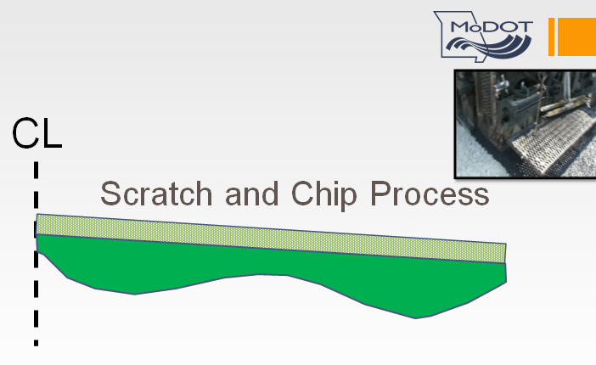

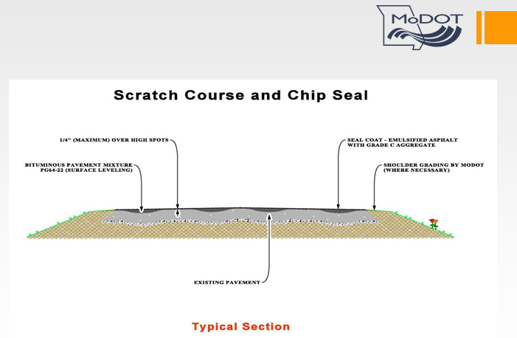

Before Picture (2013)
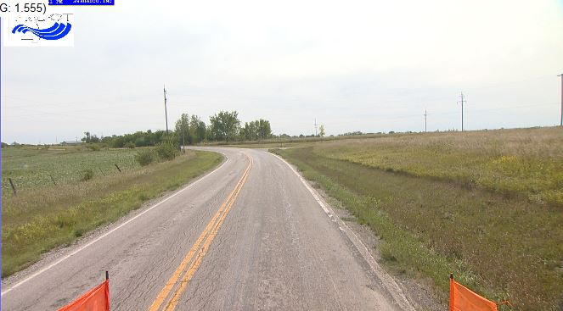
After Pictures
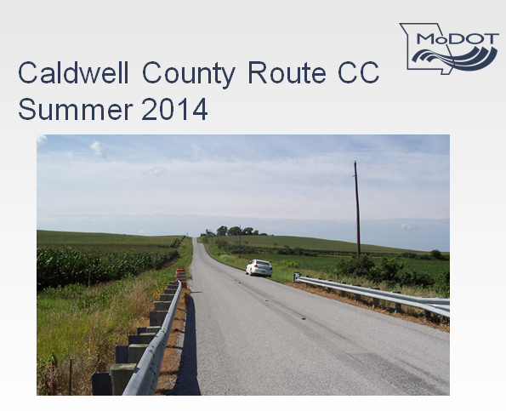

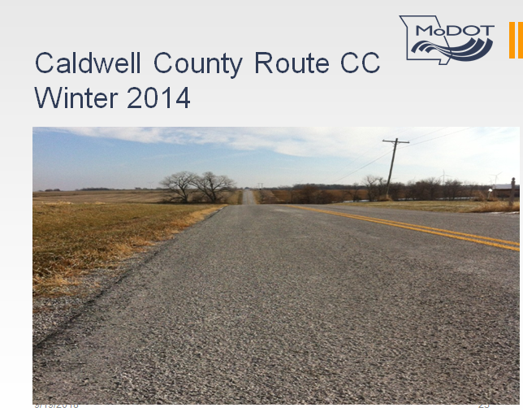
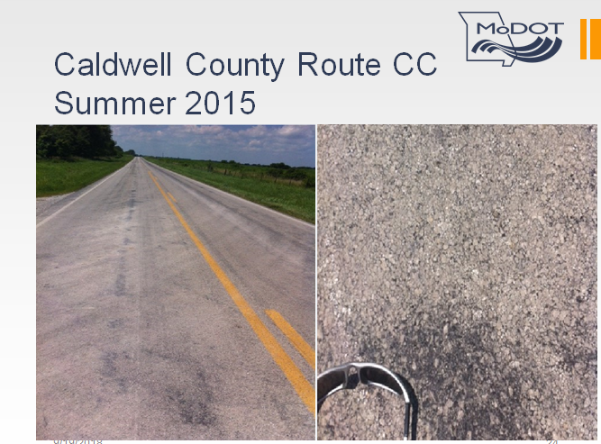

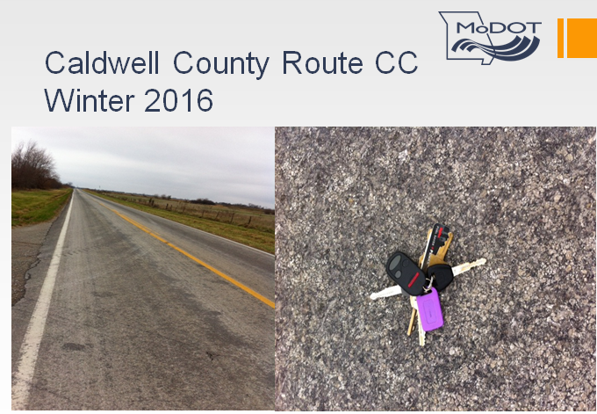

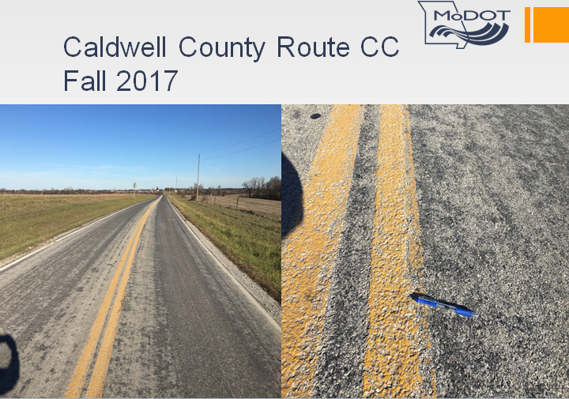

ARAN Data 2013 Before Scratch and Chip Seal Treatment
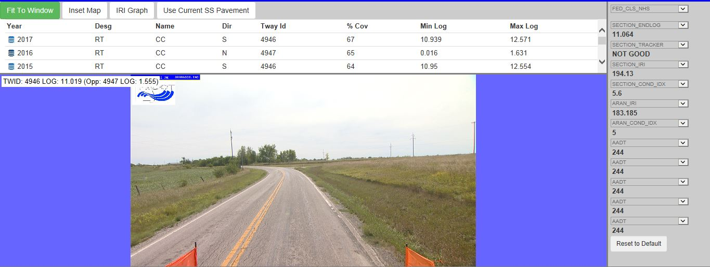

ARAN Data 2017 After Scratch and Chipp Seal Treatment

