TACK COATS
NRRA State of Practice
February 2017 Draft

Developed by NRRA Flexible Team

Contents
1.1 What is a tack coat? 3
1.2 Why NRRA Members Wanted This 3
1.2.1 NRRA Members Involved 3
1.2.2 Why This Effort is Being Done 3
2.1 NRRA State Member – Tack Summary Details 4
2.1.1 NRRA State Specifications 4
2.2 Comparison between Agencies 4
2.2.1 Bituminous Material 4
2.2.2 Equipment 7
2.2.3 Construction Requirements 7
2.2.3.1 Construction Restrictions 7
2.2.3.2 Preparation of Surface 8
2.2.3.3 Application of Bituminous Tack Coat Material Comparison 9
2.2.3.4 Field Requirements 10
2.2.3.5 Bituminous Temperature 11
2.2.4 Basis of Payment 12
3 NRRA Summary of the State of Practice 13
4 NRRA Proposed Practice/ Specification 14
4.1 Suggestion 14
4.2 Pros 14
4.3 Cons 14
5 NRRA Implementation Plan 15
References 16

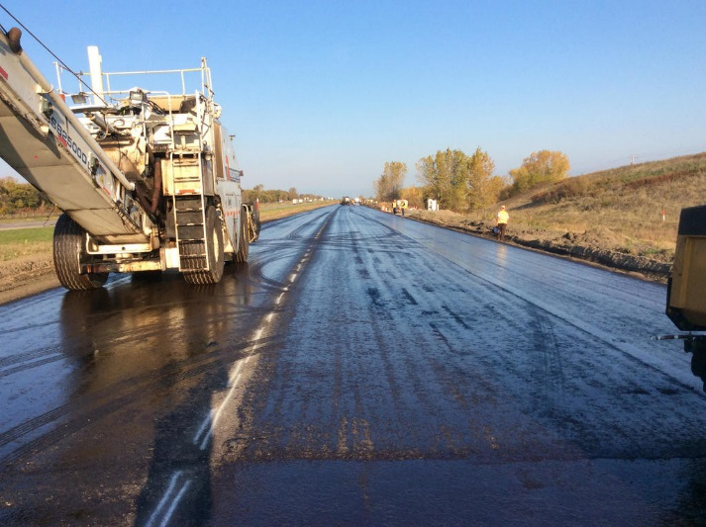
1 Background

1.1 What is a tack coat?
Tack coat – which is normally asphalt cement or asphalt emulsion – is applied to provide good bonding between the existing pavement surface and the new asphalt overlay or between the layers of each lift of HMA (Figure 1.1-1). The tack coat material is applied using a pressure distributor after making sure that the roadway surface is clean. Application rate of tack coat should also be adjusted according to the condition of pavement surface to ensure that the residual asphalt rate meet the requirements. AASHTO and other collaborating organizations (1) stated that with proper tack coat application, the residual asphalt cement content will be of approximately 0.04 to 0.06 gal/yd² for non-milled surfaces and up to 0.08 gal/yd² for milled surfaces. Before the emulsion breaks, paving of subsequent lift is not allowed and traffic should be kept off the pavement surface.
Figure 1 - Tack coat application at MnROAD 2016 construction – example of an acceptable tack coat.
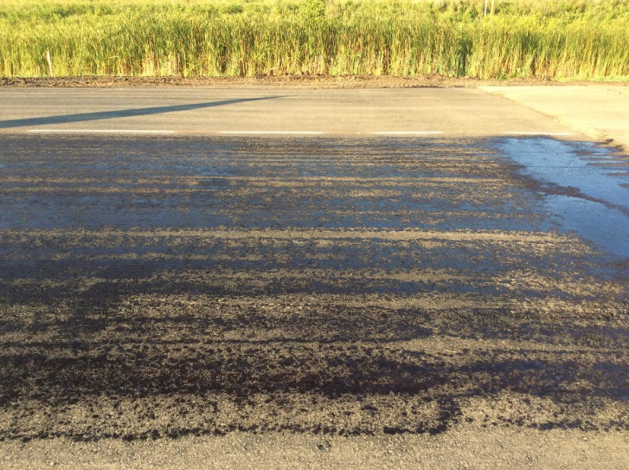
It is important to ensure that there is adequate bonding between pavement layers so that the completed pavement structure will behave as a single unit. Inadequate bonding (Figure 1.1-2) results in delamination and thus contributes to premature failures and a reduction in pavement life.

1.2 Why NRRA Members Wanted This

1.2.1 NRRA Members Involved
Six state agencies that are currently involved in the tack coat technology transfer, are California DOT, Illinois DOT, Michigan DOT, Minnesota DOT, Missouri DOT, and Wisconsin DOT.

1.2.2 Why This Effort is Being Done
The purpose of this technology transfer project is to compile a synthesis of best practices being used by NRRA members in the area of tack coats and to identify any gaps in the research that can be filled during the next round of construction activities at MnROAD.
Figure 2 - Tack coat application at MnROAD 2016 construction – note this was not acceptable and was re-applied before paving.

2.1 NRRA State Member – Tack Summary Details

2.1.1 NRRA State Specifications
This work consists of applying bituminous material on a bituminous or concrete pavement prior to an overlay, in accordance with these specifications. Prime coat is not covered in this document.
Most of the/All participating states require that tack coat shall be applied uniformly to the existing asphalt or concrete surface including milled surfaces, and to the subsurface of each course or lift, except for the final course or lift.
Table 2.1.1-1
Tack Coat Application Specification
Agency | California DOT | Illinois DOT | Michigan DOT | Minnesota DOT | Missouri DOT | Wisconsin DOT
Spec | 39-2.01C(3)(f) | 406 | 501.03 | 2357 | 407 | 455.2.5

Links to each specification
- California - 2015 Standard Specifications
- Illinois - 2016 Standard Specifications for Road and Bridge Construction
- Michigan - 2012 Standard Specifications for Construction
- Minnesota - 2016 Standard Specifications for Construction
- Missouri - 2016 Standard Specifications for Highway Construction
- Wisconsin - 2017 Standard Specifications for Highway and Structure Construction
NOTE: Michigan DOT has a permissive specification for low tracking bond coat, which will not be included in this document.

2.2 Comparison between Agencies

2.2.1 Bituminous Material
Bituminous materials for tack coat and the respective specifications from each participating state are listed in the following table. Limit the use of cutback asphalt to air temperature less than 32°F for MC-250 (Minnesota DOT) and 60°F for RC-70 (Illinois DOT).

Table 2.2.1-1
Bituminous Materials for Tack Coat
Agency | California DOT | Illinois DOT | Michigan DOT | Minnesota DOT | Missouri DOT | Wisconsin DOT
Bituminous Materials | Asphaltic emulsion or asphalt binder | Emulsified asphalt or cutback asphalt | Emulsified asphalt | Emulsified asphalt or medium cure cutback asphalt | Emulsified asphalt or performance graded asphalt binder | Emulsified asphalt or modified emulsified asphalt
Spec | 39-2.01B(10) &  39-2.01C(3)(f) | 406.02 | 501.02 | 2357.2 | 407.2 & 1015 | 455.2.5

CSS-1h is a common asphalt emulsion used by all the states as bituminous material for tack coat. Limit bituminous material for tack coat to one of the following types listed in the following table.
Table 2.2.1-2
List of Bituminous Materials
Agency | California DOT | Illinois DOT | Michigan DOT | Minnesota DOT | Missouri DOT | Wisconsin DOT
PG Asphalt Binder | X |  |  |  | X
Cutback Asphalt
MC-250 |  |  |  | X
RC-70 |  | X
Asphalt Emulsions
CSS-1h | X | X | X | X | X | X
CSS-1 | X | X |  | X | X | X
SS-1h | X | X | X |  | X | X
SS-1 | X | X |  |  | X | X
RS-1 | X | X |  |  | X
RS-2 | X | X |  |  | X
CRS-1 | X | X |  |  | X
CRS-2 | X | X |  |  | X
SS-1hP |  | X |  |  | X
CSS-1hP |  | X |  |  | X
SS-1vh |  | X
MS-2 |  |  |  |  |  | X
QS-1 | X
QS-1h | X
CQS-1 | X
CQS-1h | X
PMRS-2 | X
PMRS-2h | X
PMCRS-2 | X
PMCRS-2h | X
HFE-90 |  | X

Dilution of asphalt emulsion in the field is not allowed by Minnesota DOT and Missouri DOT. The storage tank for diluted emulsion must have a recirculation system or agitator that will prevent settlement or separation of the material. Dilution requirement for each state is listed in the following table.
Table 2.2.1-3
Dilution Requirement
Agency | California DOT | Illinois DOT | Michigan DOT | Minnesota DOT | Missouri DOT | Wisconsin DOT
Dilution | The weight ratio of added water to asphaltic emulsion must not exceed 1 to 1 |  |  | 7 parts emulsion to 3 parts water | No more than 20% of added water | Mix thoroughly with an equal quantity of potable water
Spec | 39-2.01C(3)(f) | 406.02 |  | 2357.2 | 407.4.2.4 | 455.2.4.3

Corresponding minimum residual asphalt content is summarized in the following table.
Table 2.2.1-4
Minimum Residual Asphalt Content (%)
Agency | California DOT | Illinois DOT | Michigan DOT | Minnesota DOT | Missouri DOT | Wisconsin DOT
Undiluted | Refer to spec | Refer to spec | 60 | 57 | 57 | -
Diluted | - | - |  | 40 | 45.6 | 50
MC-250 | - | - | - | 67 | - | -
Spec | 94-1.02 | 1032.06 & 1032.07 | 904.03.C | 2357.2 | 1015.20.5.1.1 | 455.3.2.1(2)

NOTE:
- Missouri DOT - Minimum residual asphalt content for undiluted emulsion is based on polymer modified slow-setting emulsion. Using the dilution requirement of 20%, the minimum residual asphalt content for diluted emulsion is calculated.
- Michigan DOT – Minimum residual asphalt content for undiluted emulsion is based on SS-1h and CSS-1h.
- Minnesota DOT – Minimum residual asphalt content for MC-250 is obtained from AASHTO M82.

2.2.2 Equipment
The contractor shall provide a distributor capable of uniformly applying material and equipped with the following (5):
- An accurate volume measuring device with tachometer
- Pressure gauges
- Thermometer for measuring temperatures of tank contents
- Power-operated pump
- Full circulation spray bars with lateral and vertical adjustments

2.2.3 Construction Requirements

2.2.3.1 Construction Restrictions
Apply tack coat in such a manner as to cause the least inconvenience to traffic and to permit one-way traffic without pickup or tracking of the bituminous material (5). Do not apply the tack coat when the road surface or weather conditions are unsuitable as determined by the Engineer. Limit the daily application of tack coat to approximately the area on which construction of the subsequent bituminous course can reasonably be expected to be completed that day.
The specifications on construction requirements for each participating state are listed in the following table. Illinois DOT and Wisconsin DOT have additional restrictions as follows:
Illinois DOT - When placing tack coat through an intersection where it is not possible to keep the lane closed, the tack coat may be covered immediately following its application with fine aggregate mechanically spread at a uniform rate of 2 to 4 lb/yd².
Wisconsin DOT – Apply tack coat only when the air temperature is 32°F or more unless the engineer approves otherwise in writing.
Table 2.2.3.1-1
Construction Restrictions Specifications
Agency | California DOT | Illinois DOT | Michigan DOT | Minnesota DOT | Missouri DOT | Wisconsin DOT
Spec | 39-2.01C(3)(f) | 406.05(b) |  | 2357.3 | 407.4.3 | 455.3.2.1

2.2.3.2 Preparation of Surface
Apply the bituminous tack coat material to a dry and clean roadway surface (5). All necessary repairs or reconditioning must have been completed as provided for in the Contract and approved by the Engineer. Remove all foreign matter on the road surface before applying tack coat and dispose of as approved by the Engineer.
The specifications on surface preparation for each participating state are listed in the following table. Missouri DOT allows pre-wetting of existing surfaces just prior to tack coat application, in accordance with 407.4.1.2.
Table 2.2.3.2-1
Surface Preparation Specifications
Agency | California DOT | Illinois DOT | Michigan DOT | Minnesota DOT | Missouri DOT | Wisconsin DOT
Spec |  | 406.05(b) | 501.03.D | 2357.3.C | 407.4.1 | 455.3.2.3

2.2.3.3 Application of Bituminous Tack Coat Material Comparison
Unless otherwise indicated in the plans or provisions, the tack coat shall be applied uniformly and at a rate that will provide a residual asphalt rate on the prepared surface as specified in the following table, as based on pavement type or condition and type of bituminous material.
Table 2.2.3.3-1
Residual Asphalt Rate (gal/yd²)
Agency | California DOT |  |  | Illinois DOT | Michigan DOT | Missouri DOT |  | Minnesota DOT |  |  | Wisconsin DOT
Spec | 39-2.01C(3)(f) |  |  | 406.05 |  | 407.4.2 |  | 2357.3.D |  |  | 455.3.2.1  (2)
Surface Type | CSS1/CSS1h, SS1/SS1h and QS1h/CQS1h | CRS1/CRS2, RS1/RS2 and QS1/CQS1 | Asphalt binder and Polymer Modified Asphaltic Emulsion |  |  | Undiluted | 20% Diluted | Undiluted | Diluted (7:3) | MC-250 | 50% Diluted
New Asphalt Surfaces | 0.02 | 0.03 | 0.02 | 0.027 | 0.05 - 0.15  Application Rate | 0.0285 | 0.0275 | 0.0285  -  0.0400 | 0.0320  -  0.0400 | 0.0335  -  0.0470 | 0.025  -  0.035
Existing Asphalt or Concrete Surfaces | 0.03 | 0.04 | 0.03 | 0.054 |  | 0.0460 | 0.0460 | 0.0460  -  0.0570 | 0.0520  -  0.0600 | 0.0605  -  0.0740
Milled Asphalt or Concrete Surfaces | 0.05 | 0.06 | 0.04 |  |  | 0.0570 | 0.0595 | 0.0400  -  0.0630 | 0.0400  -  0.0520 | 0.0605  -  0.0740

NOTE: Residual asphalt rate for Missouri DOT and Minnesota DOT are computed based on the target application rate provided.

2.2.3.4 Field Requirements
All participating states require that the tack coat must be fully cured prior to placement of HMA. Specific requirements for each state are as follows:

California DOT (39-2.01C(3)(f))
If authorized, tack coat can be omitted between layers of new HMA during the same work shift if:
- No dust, dirt, or extraneous material is present
- Surface is at least 140°F
Immediately in advance of placing HMA, apply additional tack coat to damaged areas or where loose extraneous material is removed.

Illinois DOT (406.05(b))
The residual asphalt rate will be verified a minimum of once per type of surface to be tacked as specified herein for which at least 2000 tons of HMA will be placed. The test will be according to the "Determination of Residual Asphalt in Prime and Tack Coat Materials" test procedure. If pickup occurs, paving shall be cease in order to provide additional cure time, and all areas where the pickup occurred shall be repaired. If after five days, loss of tack coat is evident prior to covering with HMA, additional tack coat shall be placed as determined by the Engineer at no additional cost to the Department.

Michigan DOT (501.03.D)
Apply the bond coat ahead of the paving operation to allow the bond coat to cure before placing HMA.

Minnesota DOT (2357.3.D)
All tack must break, turn from brown to black, before paving the subsequent lift or course. Do not allow vehicles to drive on tack that has not broken. The Engineer will compare the freshly sprayed emulsion to a brown sheet of construction paper or a black sheet of construction paper for broken tack to determine conformance with tack application uniformity. Using a distance of 1,000 feet, perform a yield check at the beginning of each project to verify the application rate is correct. The Engineer may also require the Contractor to verify application is within 10% of the intended application rate by ASTM D 2995 test method A.

Missouri DOT (407.4.2 & 407.4.3)
Upon approval by the Engineer, the target application rate may be varied by +/- 0.02 gal/yd² in the field, based upon the existing pavement condition. Re-application of tack due to excess tracking or non-uniform coverage shall be at the contractor’s expense.

Wisconsin DOT (455.3.2.4)
Correct for under application by applying additional material. If the Contractor cannot maintain the application rate within tolerances, discontinue operations and make the necessary corrections to personnel or equipment required to remedy the problem.

2.2.3.5 Bituminous Temperature
The spraying application temperature ranges for the bituminous material applied by a pressure distributor shall be according to the following table.
Table 2.2.3.5-1
Spraying Application Temperature for Bituminous Materials (°F)
Agency | California DOT |  | Illinois DOT |  | Michigan DOT |  | Minnesota DOT |  | Missouri DOT |  | Wisconsin DOT
Spec | 39-2.01C(3)(f) |  | 1032.04 |  | 904.02 |  | 2357.3.E |  | 1015.5 |  | 455.3.1
Bit Material | Min | Max | Min | Max | Min | Max | Min | Max | Min | Max | Within the limits the supplier specifies
Asphalt Binder
PG 46-28 | - | - | - | - | - | - | - | - | 260 | 325
All Other Grades | 285 | 350 | - | - | - | - | - | - | 285 | 350
Cutback Asphalt
MC-250 | - | - | - | - | - | - | 165 | 220 | - | -
RC-70 | - | - | 120 | 225 | - | - | - | - | - | -
Asphalt Emulsions
CSS-1h | - | - | 75 | 130 | 85 | 135 | 70 | 160 | 120 | 160
CSS-1 | - | - | 75 | 130 | - | - | 70 | 160 | 120 | 160
SS-1h | - | - | 75 | 130 | 85 | 135 | - | - | 120 | 160
SS-1 | - | - | 75 | 130 | - | - | - | - | 120 | 160
RS-1 | - | - | 75 | 130 | - | - | - | - | 120 | 140
RS-2 | - | - | 110 | 160 | - | - | - | - | 125 | 185
CRS-1 | - | - | 75 | 130 | - | - | - | - | 125 | 185
CRS-2 | - | - | 110 | 160 | - | - | - | - | 125 | 185
SS-1hP | - | - | 75 | 130 | - | - | - | - | - | -
CSS-1hP | - | - | 75 | 130 | - | - | - | - | - | -
SS-1vh | - | - | 160 | 180 | - | - | - | - | - | -
HFE-90 | - | - | 150 | 180 | - | - | - | - | - | -

2.2.4 Basis of Payment

California DOT (39-2.01D)
Except for tack coat used in minor HMA, pavement for tack coat is not included in the payment for hot mix asphalt. The Department does not adjust the unit price for an increase or decrease in the tack coat quantity.

Illinois DOT (406.14)
Tack coat will be paid for at the contract unit price per pound of residual asphalt for bituminous materials or polymerized bituminous materials for tack coat.

Michigan DOT (109.01.B.2.b)
The Engineer will measure asphaltic materials for payment in gallons of material at 60°F. If the Contractor furnishes asphaltic material in tank cars, the number of gallons will be determined by the Department’s laboratory and this information will be supplied on the laboratory reports. If the Contractor furnishes asphaltic material from bulk plants or partly used tank cars, the number of gallons will be calculated by weighing each load and converting to volume in gallons at 60°F.

Minnesota DOT (2357.5)
Payment for the accepted quantity of asphalt emulsion and cutback shall be at the Contract price per unit of measure. If the contract does not contain Bituminous Material for Tack Coat, the Department will include the cost of providing and applying tack coat material with other relevant pay items.

Missouri DOT (407.6)
The accepted quantity of tack coat will be paid for at the contract unit price. No direct payment shall be made for water added to the asphalt emulsion.

Wisconsin DOT (455.5.3)
Payment for tack coat is full compensation for providing tack coat; and for maintaining the completed work. The Department will adjust pay for tack coat based on whichever one of the following yields the lowest contractor compensation:
- The Department will pay, under the Nonconforming Tack Coat administrative item, for nonconforming material the Engineer allows to remain in place at 75 percent of the contract unit price.
- The Department will pay, under the Excessively Diluted Tack Coat administrative item for excessively diluted tack coat, material diluted with a greater quantity of water than specified under 455.2.4.3, as follows:
Quantity of Water^{[1]} (percent of diluted asphaltic material) | Percent of the Contract Price
<= 60 | 100
> 60 but <= 80 | 50
> 80 | 0
^{[1]} Does not include water used to produce emulsified asphalt.

3 NRRA Summary of the State of Practice

4 NRRA Proposed Practice/ Specification

4.1 Suggestion

4.2 Pros

4.3 Cons

5 NRRA Implementation Plan

References
1. AASHTO, FAA, FHWA, NAPA, USACE, APWA, and NACE (2000) Hot-Mix Asphalt
Paving Handbook. Transportation Research Board, Washington, D.C.
2. Caltrans (2015) Standard Specifications. California Department of Transportation, Sacramento, CA.
3. IDOT (2016) Standard Specifications for Road and Bridge Construction. Illinois Department of Transportation, Springfield, IL.
4. MDOT (2012) Standard Specifications for Construction. Michigan Department of Transportation, Lansing, MI.
5. MnDOT (2016) Standard Specifications for Construction. Minnesota Department of Transportation, St. Paul, MN.

6. MoDOT (2016) Standard Specifications for Highway Construction. Missouri Department of Transportation, Jefferson City, MO.

7. WisDOT (2017) Standard Specifications for Highway and Structure Construction. Wisconsin Department of Transportation, Madison, WI.

