
Minnesota Department of Transportation

Innovative Finance in Action
Alameda Corridor – Freight Rail Facility
October 2009

Background

Through the use of innovative delivery and financing mechanisms, the Alameda Corridor Project has served as a model for other freight rail and relocation projects in the United States, such as the Reno ReTrac and the Chicago Region Environmental and Transportation Efficiency (CREATE) projects. The Alameda Corridor also represented the first time that financing for a publicly financed intermodal rail and cargo facility has been secured primarily from the revenues generated from containers coming through multiple gateway ports.

In the planning stages since the early 1980s, the Alameda Corridor helped to develop and encourage the broader usage of innovative financing mechanisms. In particular, the federal loan that was provided for the Alameda Corridor project served as the precursor to the Transportation Infrastructure Finance and Innovation Act (TIFIA) loan and credit program that was enacted in 1998.

The project is also unique in the participation and the consensus achieved among several local public and quasi-public agencies, private railroad companies, state government, and the federal government. In particular, there are very few projects developed that have been able to attract the broad support and the financial participation of the railroad companies. The participation of these entities, which often have conflicting interests, highlights the importance of the Alameda Corridor project in improving the efficiency of cargo movements, improving safety, and supporting long-term economic growth. Table 1 below summarizes the main project elements.

Table 1: Project Description
Lead Public Agency: | Alameda Corridor Transportation Agency (ACTA)
Pre-Existing Conditions | Prior to the development of the Alameda Corridor, rail movements from the Port of Los Angeles and the Port of Long Beach went through nearly 220 road/rail crossings. Moreover, trains took 2 to 6 hours to travel from the ports to the downtown railyards.
Description | The project involved the development of a 20-mile rail connection between the Port of Los Angeles and the Port of Long Beach to the railyards in downtown Los Angeles. This includes a 10-mile below ground rail trench.
Goals | The project objectives were to: (i) increase the efficiency in the movement of cargo from the ports; (ii) improve train speeds; (iii) reduce congestion along the adjacent streets; (iv) improve safety through the reduction of road/rail crossings; (v) reduce vehicle emissions and noise pollution; (vi) improve access for emergency vehicles; and (vii) increase regional competitiveness.
Estimated Cost | $2.4 billion
Contract Type | Design-Build: 10-mile mid-corridor segment  Design-Bid-Build: North and South segments
Contract Duration | 5-years
Revenue Sharing | N/A
Non-Compete Provisions | N/A
Construction Began | 1997
Operation Begins | 2002
Facility Ownership | Alameda Corridor Transportation Agency (ACTA)
Fare Setting Authority | ACTA developed the initial fee schedule for the user fees and container charges in consultation with the railroad companies. Annual increases are indexed to the Consumer Price Index (CPI) and can range from 1.5 percent to 3 percent per annum.
Public Sector Benefits | The project has had the following benefits: (i) increased freight movements through the L.A. area ports; (ii) increased efficiency and train speeds—trains now take about 45 minutes to travel from the ports to downtown (iii) increased regional competitiveness; (iv) reduced air and noise pollution; and (v) improved safety.
Value for Money Analysis | The project predates the wider use of value for money analyses. An economic impact analysis was conducted in 1995 evaluated the overall impact of the L.A. port facilities on the State and U.S. economies.
Impact on Debt Limits | Funding for the project was based on the development of a standalone revenue stream. The revenue bonds that were issued by ACTA were non-recourse debt obligations secured solely by the project revenues, revenue advances from the Port of Los Angeles and the Port of Long Beach, and interest income. Bondholders do not have a mortgage interest in the project, but are limited to a lien on the revenues generated from the Alameda Corridor.

The Port of Los Angeles and the Port of Long Beach in combination represent the largest port in the United States and third largest port facility in the world after Hong Kong and Singapore. In addition, the ports represent the primary gateway for imports from Asia into the U.S. For decades, the trip between the Port of Los Angeles and the Port of Long Beach to the downtown railyards involved the movement of cargo along three separate rail lines, which were owned and operated by the Union Pacific Railroad (UPRR), the Southern Pacific railroad, and the Santa Fe Railway. Figure 1 depicts the pre-existing conditions and the consolidated rail line.

As a result, the movement of goods was extremely slow, increased congestion for road traffic at the approximately 220 east-west cross streets, and increased the potential for accidents. Traffic demand forecasts conducted at the time predicted a further worsening of conditions due to increased demand for goods moved through the ports. Actual port traffic has exceeded these forecasts. From 1995 to 2008, the combined amount of containers transported from the two ports increased from 5.3 million twenty-foot equivalent units (TEUs) to 14.3 million TEUs, representing an average increase of nearly 8 percent per annum.

Figure 1: Project Map
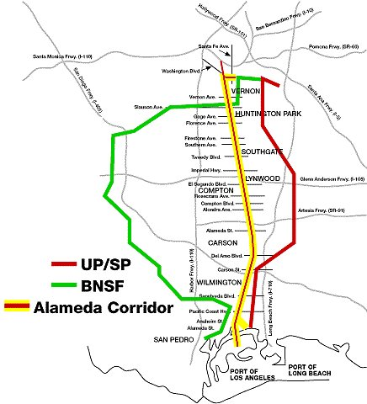
Source: Union Pacific Railroad Co.

The development of the Alameda Corridor project allowed for an unimpeded rail connection that improved the movement of goods and improved traffic conditions along parallel and adjoining streets. In particular, the project involved the development of three major components: (i) a 3-mile north segment, (ii) a 10-mile mid-corridor segment, which involved the development of a 50 foot wide, 33 foot deep grade separated rail line and 30 bridges; and (iii) a 7-mile south segment. One of the major subprojects along the north segment includes the Redondo Junction, which was intended to grade separate freight and passenger train movements from Metrolink and Amtrak rail lines. Table 2 summarizes the main project works by segment.

Table 2: Alameda Corridor Subproject by Segment
South End Subprojects | Mid-Corridor Subprojects | North End Subprojects
- UP Filler Bridge  - Storage Track  - Compton Creek Bridge  - Dominguez Channel Bridge  - Henry Ford Grade Separation  - Long Beach Bridge | - 10-mile Railroad Trench  - 30 Bridges | - LA River Bridge  - LA County Box Culvert  - Redondo Junction  - Washington Boulevard Grade Separation  - Santa Fe Grade Separation  - Downey Road Bridge  - UP RR Connector  - BNSF Connector
Source: U.S. Department of Transportation, Office of Inspector General Audit Report, Review of the Alameda Corridor Project, Federal Highway Administration and Federal Railroad Administration, October 22, 1999.

Enabling Legislation

The development of the project was supported directly and indirectly by a number of local, state, and federal legislative acts and regulation. Federal support was essential to jump-start the project as it provided the seed capital for the initial feasibility studies. The primary legislative acts for the Alameda Corridor Project include the following:

- Seed capital for project analyses was funded by a $58 million grant from the federal government that was authorized by the Surface Transportation Assistance Act of 1982;

- The Alameda Corridor Transportation Authority (ACTA) was created as a joint powers agency by the City of Los Angeles and the City of Long Beach in 1989;

- Through the Surface Transportation and Uniform Relocation Act of 1987 and the Intermodal Surface Transportation Efficiency Act of 1991 (ISTEA), additional federal funding was authorized for grade separations south of SR 91. In addition, ISTEA established a revolving loan fund for High Priority Corridors on the National Highway System;

- Under the National Highway System Designation Act of 1995, the Alameda Corridor was designated as a “High Priority Corridor” which made it eligible for the loan financing developed under ISTEA;

- In 1996, the Omnibus Budget legislation included a provision for a $58.7 million grant to secure a $400 million loan for the Alameda Corridor; and

- In 1999, the State of California enacted SB–653, the Alameda Corridor Industrial Reclamation Act of 1999, which provided assistance to the impacted cities and unincorporated communities and helped to expand commercial and industrial activities in these areas.

Project Planning and Delivery Method

The project concept for the Alameda Corridor had been under consideration since the early 1980s. To begin analyzing the feasibility of potential options, the Southern California Association of Governments (SCAG) established a Ports Advisory Committee (PAC), which included representatives from the ports, railroads, trucking firms, Caltrans, Los Angeles County Transportation Commission (the precursor to the Los Angeles County Metropolitan Transportation Authority, LACMTA) and other public agencies. In 1985, SCAG created the Alameda Corridor Task Force, whose membership was similar to that of the PAC, but also included the California Public Utilities Commission (CPUC) and each of the cities along the corridor. The Task Force prepared a plan that included the consolidation of rail operations along the Southern Pacific rail line that parallels Alameda Street, several road improvements, and grade separations.

This plan faced opposition from the railroad companies servicing the corridor since it required them to sell their existing right-of-way and the joint use of a single rail corridor. This opposition was eventually overcome through extensive discussions and analyses that demonstrated that the Alameda Corridor would reduce train delays, increase train speeds, increase the efficiency of goods moved, and increase capacity to allow for future growth.

Building on the institutional and consultative arrangements developed by the PAC, the cities of Los Angeles and Long Beach formed a joint powers authority, the Alameda Corridor Transportation Authority (ACTA) in 1989. ACTA’s Board of Directors is comprised of seven-members with one delegate each from the City of Los Angeles, the City of Long Beach, their respective city councils, the port authorities, and the LACMTA.

The 10-mile, $712 million mid-corridor segment was delivered through a design-build contract, while the north and south segments of the project were procured using traditional design-bid-build contracting. ACTA obtained design/build authority through a City of Los Angeles ordinance. The design-build contract was awarded to Tutor-Saliba, which had the lowest bid among the three proposers. Under the terms of the contract, the developer assumed price and schedule risks. ACTA estimates that the design-build contract accelerated project development by 18 months compared to traditional delivery mechanisms.

Project Financing

The Alameda Corridor Project was financed through a combination of revenue bonds, a federal loan, grants from the cities along the corridor, the port authorities, LACMTA, a state grant, the railroad companies, interest income and other sources. The critical element of the financing package was the early commitment by the railroads to pay use and container fees, which were used to secure $1.2 billion in revenues bonds and a $400 million federal loan. The federal loan was also secured through an additional $58 million grant from the federal government. The blended cost of capital for the loans and bonds was 6.5 percent. The bond financing was non-recourse to the ports, which provided limited backup pledges. Bondholders do not have a mortgage interest in the project, but are limited to a lien on the revenues generated from the corridor.

An additional $394 million in grants was provided by the ports of Los Angeles and Long Beach, which was used to purchase right-of-way (ROW) from the Southern Pacific, Union Pacific, and Santa Fe railroads in 1994. Moreover, $347 million in grants was provided from the Metropolitan Transportation Authority (LACMTA) and $95 million from interest income on the bonds and loans. LACMTA’s contribution consisted of $71 million in federal grants and approximately $276 million in state grants. In addition, the state of California also provided $18 million in direct funding for the project. Finally, the railroads also contributed roughly $7 million to the project.

Approximately $1.274 billion of these funds were used for construction activities, which accounted for 52 percent of total project costs. ROW acquisition and utility relocation totaled $548 million or 23 percent of total project costs. This amount includes the ROW that was acquired from the railroads by the ports. Project costs also include $79 million preliminary engineering and technical studies that were carried out by the ports. Program management and administrative costs were $142 million and $100 million, respectively. Table 3 summarizes the estimated source and uses for the Alameda Corridor project.

Table 3: Estimated Source and Uses of Funds for the Alameda Corridor Project
Sources | Amount ($ Millions) | % Total
Revenue Bonds | 1,160 | 48%
Port of Long Beach/Port of Los Angeles | 394 | 17%
TIFIA Loan | 400 | 16%
LACMTA Grant | 347 | 14%
State Grants | 18 | 1%
Railroad Grants | 7 | <1%
U.S. Department of Commerce Grant | 2 | <1%
Interest Income & Other | 95 | 4%
Total Sources | $2,431 | 100%
Uses | Amount ($Millions) | % Total
Program Management | 142 | 6%
Design | 27 | 1%
Construction | 1,274 | 52%
Right-of-Way | 548 | 23%
Professional Services | 24 | 1%
Administrative, Bond Issuance Costs & Settlements with Cities | 100 | 4%
Debt Service Payment | 237 | 10%
Preliminary Engineering | 79 | 3%
Total | $2,431 | 100%
Source: U.S. Department of Transportation, Office of Inspector General Audit Report, Review of the Alameda Corridor Project, Federal Highway Administration and Federal Railroad Administration, October 22, 1999.

In an audit of ACTA’s cash flow model conducted in 1999, the U.S. Department of Transportation (USDOT) found that until FY 2018, container and use fees alone would not fully cover debt service costs. To make up for potential shortfalls, the ports offered to provide annual shortfall payments through FY 2018 that would be used to meet project debt service payments. From FY 2018 through FY 2037, projected use fees would be sufficient to pay for debt service costs without needing annual contributions from the ports.

In a review of its financial statements, ACTA has run a positive balance in its operational activities, which is comprised of revenues minus operational, maintenance, and administrative expenses. However, ACTA has incurred a consistent, but steadily declining negative balance or loss in its total activities—basically, interest payments on outstanding debt and other expenses have exceeded corridor revenues. Figure 2 summarizes USDOT’s review of ACTA's cash flow model and shows the projected growth in project revenues in relation to debt obligations.

Figure 2: Summary of Estimated Annual Project Revenues, Grants from the Ports and Debt Service Payments, 2002-2037
Source: U.S. Department of Transportation, Office of Inspector General Audit Report, Review of the Alameda Corridor Project, Federal Highway Administration and Federal Railroad Administration, October 22, 1999.

ACTA’s Requirements

ACTA is responsible for the administration, construction oversight, financing, and daily operations of the Alameda Corridor. In the development of the corridor, ACTA was empowered to explore and use innovative financing approaches, develop existing property, and coordinate with other public agencies. Facility operations are overseen by a four-member Alameda Corridor Operating Committee, which includes one representative each from the Port of Long Beach, Port of Los Angeles, the BNSF, and the UPRR. The project was completed in April 2002, nine months ahead of schedule and on budget. Since facility opening through June 2008, ACTA has collected approximately $450 million in revenues, which have been used for operations, collection, monitoring, enforcement, and administrative activities as well as debt obligations.

ACTA’s mandate has subsequently been expanded to include improving SR 47, assisting the ports in optimizing on-deck rail facilities, evaluating the viability of shuttle train operations, and supporting the development of an intermodal container transfer facility. With regard to SR 47, ACTA is working with Caltrans to finalize the Environmental Impact Statement (EIS) and project funding arrangements as well as to develop a new bridge and flyover.

Project Challenges

In order for the Alameda Corridor to be developed, the project had overcome a number of challenges, including: (i) developing a stable source of revenues that could be used to pay off long-term debt obligations and to finance operational and maintenance costs; (ii) overcoming the opposition of the railroad companies; (iii) building and maintaining consensus among the public agencies who are stakeholders to the project; and (iv) developing a project design that could increase the efficiency of freight movements while attempting to minimize total costs.

Stable Revenue Source. Essential to the financing of the project was the development of a stable source of revenues to secure the revenue bonds and the federal loan. Without this revenue stream, the project could not be developed. In consultation with the railroad companies, ACTA established a schedule of use fees for containers transported along the corridor and charges imposed at the port for containers not transported along the rail line. This fee structure also includes adjustments depending on whether the containers are full or empty. The fee schedule was based on meeting interest and principle payments over 30 to 35 years. Annual fee increases are indexed to inflation, which range from a minimum of 1.5 percent to a maximum of 3 percent. Table 4 summarizes the fee schedule for the Alameda Corridor.

Table 4: Structure of Use Fees and Container Charges for the Alameda Corridor (2000$)
Use Fees for the Rail Corridor |  | Container Charges for Waterborne Containers not using the Rail Corridor
Waterborne containers entering or leaving ports | $15/TEU (loaded)  $4/TEU (empty) | Waterborne containers | $15/TEU (loaded)  $4/TEU (empty)
Non-waterborne containers | $4/TEU (loaded & empty) | N/A | N/A
Other Railcars | $8 railcar (loaded)  No Charge (empty | N/A | N/A
Source: The Alameda Corridor Project: Its Successes and Challenges, Hearing before the Subcommittee on Government Efficiency, Financial Management and Intergovernmental Relations of the Committee on Government Reform, U.S. House of Representatives, April 16, 2001.

Railroad opposition. Initially, the railroad companies serving the Los Angeles area were opposed to the project concept because none of the three railroads wished to use a shared railroad line or indirectly finance the project through rail corridor use and container fees. Through a series of discussions and negotiations lasting several years, the UPRR, the Southern Pacific, and the Santa Fe (later BNSF) railroads opted to support the project since it would serve their long-term interests without changing the competitive environment for freight movements in the region. In the end, the railroad companies agreed to support the project for the following reasons: (i) the railroads were offered cash payments for project-related ROW; (ii) container and use charges were implemented uniformly, so that no single railroad company could achieve a competitive pricing advantage; (iii) the cost of the fees could be transferred to the railroads’ customers, e.g. producers and consumers; (iv) an alternatives analyses showed that without the corridor, railroads would have to transport goods over short-distances by truck (drayage), which was more expensive relative to the use container and fees; (v) existing infrastructure on the railroad lines could not accommodate future demand and would be difficult and expensive to expand due to ROW constraints; and (vi) the project would help to reduce bottlenecks that would support faster and more efficient cargo movements, providing cost savings and increased revenues to the railroad companies.

Moreover, improved connections to the Los Angeles area ports is crucial to the overall business structure of the railroad companies. In 2001, approximately 50 percent of goods coming from the Port of Long Beach and Port of Los Angeles was transported to other parts of the U.S. Figure 3 summarizes this by showing the UPRR’s and BNSF’s connections from Los Angeles to the freight handling and distribution centers in Salt Lake City, Dallas, Houston, and Chicago.

Figure 3: UPRR and BNSF Rail Lines in the Western and Central U.S.
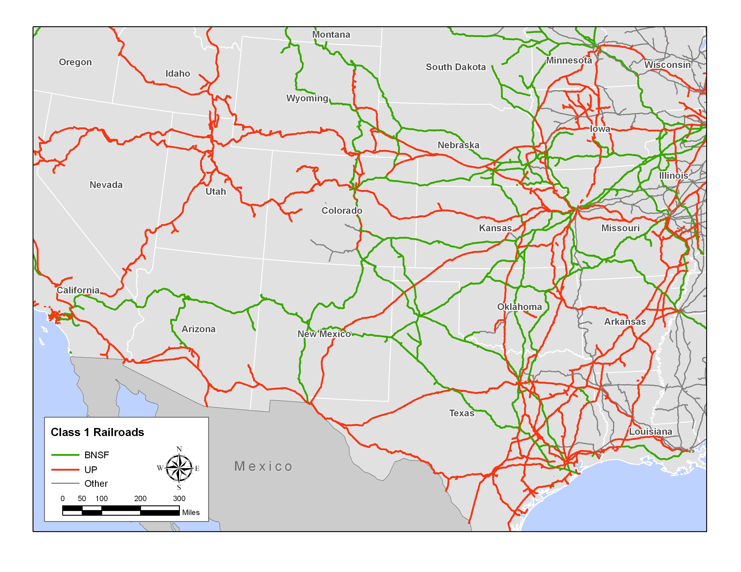
Source: Bureau of Transportation Statistics (BTS) and Jacobs Consultancy

Agency Coordination. Extensive coordination between the public agencies involved in the project was critical in resolving four major issues—project location, management, funding, and design. In particular, coordination and consensus and was required from the seven cities—Long Beach, Los Angeles, Carson, Compton, South Gate, Huntington Park and Vernon—in which the project is located. Moreover, project development also involved the Port of Los Angeles, the Port of Long Beach, LACMTA, SCAG, Metrolink, and the Southern California Regional Rail Authority. ACTA also worked closely with the state legislature, Caltrans and the California Transportation Commission in order to include the Alameda Corridor in the state’s long-range plans and to expedite funding. Agency coordination and consensus was also critical in the development of ACTA’s governance structure. ACTA’s board was originally envisioned as having 16 members, which included representation of all the cities along the corridor, including those entities not contributing funds toward project development. Through court decisions and negotiations, ACTA’s governing resolution outlined the creation of a 7-member board. ACTA also agreed to provide $12 million in funds to the cities along the corridor, which were not directly represented on its board, to mitigate against construction activities stemming from the project.

Project Design. In terms of project design, there appeared to be no major public opposition to the project concept. Notwithstanding, there were disagreements between the public and quasi-public agencies developing the project. Specifically, the City of Los Angeles and the City of Long Beach preferred a trench alignment in order to reduce the number of rail/road crossings, reduce congestion along the connecting east-west streets, and improve safety. To decrease project costs, the port authorities preferred the development of an at-grade railway. In the end, the final configuration featured a negotiated compromise between the parties involved—the development of standard grade separations at the north and south segments as well as a trench design for the central segment. Figure 4 depicts the 10-mile railroad trench that runs along the central segment.

Figure 4: Alameda Corridor Mid-Corridor Trench
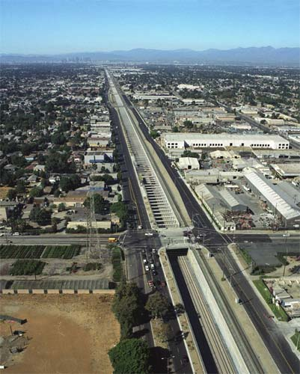
Source: SPG Media Group Ltd

Public Benefits and Value for Money

A value for money analysis was not conducted for this project. However, an economic analysis was undertaken in 1995 that examined the overall impact to the state and national economies. At the time of this study, the Port of Los Angeles, the Port of Los Angeles, rail/highway connections in the Los Angeles metropolitan area generated $74 billion in total trade for the entire U.S., $6 billion in state and local taxes, and 1.1 million full-time employment positions. This study was updated in 2007, which found that port, rail, and highway infrastructure from the L.A. ports generated $256 billion in trade, $28 billion in state and local taxes and 3.3 million full-time jobs in 2005. In this manner, the Alameda Corridor has helped to increase capacity in order to accommodate the growth in total trade. In addition, the project has helped to streamline freight movements from the ports to the distribution centers in the Los Angeles region and to the rest of the U.S. Table 5 summarizes the growth and economic impact stemming from trade activities in the Los Angeles area ports.

Table 5: Growth in the National Impact of Trade for Using Southern California’s Trade Infrastructure Network, 1995-2005
 | 1995 | 2000 | 2005 | % Change  1995 - 2005
Total Trade | $74 billion | $196 billion | $256 billion | 246%
State and Local Taxes | $6 billion | $16 billion | $28 billion | 368%
Full-Time Employment | 1.1 million | 2.0 million | 3.3 million | 200%
TEUs | 5,343,612 | 9,500,787 | 13,700,221 | 167%
Source: BST Associates, Trade Impact Study Final Report PREPARED FOR Port of Los Angeles, Port of Long Beach and the Alameda Corridor Transportation Authority, March 2007 and the Port of Los Angeles, and the Port of Long Beach.

The benefits that have accrued to the public and private sectors since the Alameda Corridor opened include the following:

- The Alameda Corridor greatly improved reliability and decreased travel time for freight rail movements. Travel time was reduced from 2 to 6 hours to about 45 minutes;

- Trains now travel at twice the average speed while accommodating 100 trains/day;

- Supported regional competitiveness in the global marketplace by facilitating the movement of goods through the Los Angeles region;

- Improved air quality through the reduction of vehicle emissions from idling cars and trucks. The Alameda Corridor represents one of the largest air abatement projects in California;

- Reduced noise pollution from trains;

- Supported economic development in the affected cities. Specifically, ACTA has provided job training and placement services to roughly 1,000 residents in the corridor; and

- Improved safety by eliminating rail crossings.

However, one predicted outcome—that the Alameda Corridor would substantially divert trucks from local highways and streets—has not yet materialized. Initial forecasts of truck diversion were based on the assessment that a significant number of trucks in the area were moving freight from the ports to the railyards, regional distribution centers and/or other parts of the United States. In actuality, most of the truck traffic in the area is comprised of short-haul movements of goods to local producers and consumers. Although there have been some reductions in vehicle emissions from the project, this has been less than expected.

Project Successes

Since it opened, the Alameda Corridor has met or exceeded revenue projections. To date, the Alameda Corridor remains one of the few examples where use and container fees have been utilized to secure debt for a publicly financed freight rail project. Since the project was completed, revenues have increased $57.9 million in 2003 (the first full year of operations) to $98.0 million in 2008, representing an average annual increase of 11 percent. In large part, this is due to the growth in port traffic, which has exceeded initial forecasts.

Another important element of the project is that it incorporated a systemic solution for moving containers from the ports, rather than a piecemeal approach. Initial feasibility studies focused on small scale improvements along the adjacent road facilities and improved grade separations. By taking a more comprehensive approach, the project was able to address the issue of slow train speeds by merging the operations of three separate rail lines and constructing a below-ground trench. In this manner, the project has had a significant impact in the flow of goods out of the ports, improved efficiency, and created sufficient capacity to accommodate future growth.

In addition, the Alameda Corridor illustrated the successful coordination between a number of public agencies and private entities. This involved the coordination and the financing from several local, regional, state, and federal agencies as well as the support of the railroad companies. The latter is significant since railroad companies are reluctant to enter into public-private partnerships that could negatively impact their cost structure, require capital contributions, and alter the competitive balance within the industry.

Finally, the project is among the few, very large public infrastructure projects built in recent years that opened ahead of schedule and within budget. At Close of Finance, it was estimated that the project would open in December 2002. In actuality, the project opened nine months ahead of schedule in April 2002. In a post-construction review of the Alameda Corridor, it was found that ACTA and the related stakeholders were able to successfully manage expenses, risk, schedule, and future demand.

Contact: Brad Larsen 651-366-4821/ brad.larsen@state.mn.us
Mn/DOT’s Innovative Finance Website: www.dot.state.mn.us/funding/innovative

The Union Pacific Railroad and the Southern Pacific railroad were merged in 1996. The Santa Fe Railway was merged with the Burlington Northern Railroad to form the Burlington Northern Santa Fe (BNSF) Railway in the same year.

