NOTES TO AUTHORS: All red text and comments are instructional or example text and should be removed.
Site ID: 53 | Site Rank: High | Figure Location: 3 – sheet 4
Site ID: 53 | Site Rank: High | Current Aerial Photo with parcel lines here  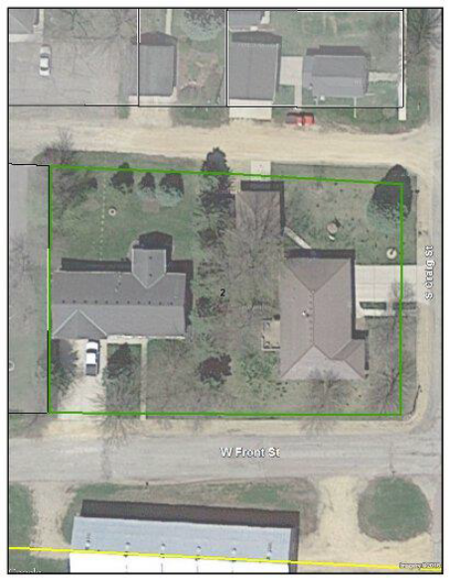
Current Site Name/Use | Bob’s Fuel
Historical Site Name(s) | Billy’s Auto Repair
Ranking Rationale | Historic vehicle repair activities (1956 – 1990). Closed LUST site with free product plume extending into MnDOT ROW.
Site Summary | The site was developed as commercial as of 1940. The 1956 city directories list the parcel as Billy’s Auto Repair. Aerial photographs from 1960 thru 1990 indicate similar structures. Aerial photograph from 1994 depicts canopy style typically associated with fueling stations. Cities directories from 1993 as Bob’s Fuel. Site reconnaissance confirmed Bob’s Fuel as current business. Closed LUST site #1453, database indicates free product and offsite contamination present.
Parcel ID | Street Address | Property Owner | Property Type
009-10056-54688 | 526 Main Street, Karlstad, MN | Bob Johnson | Commercial

SITE IMAGES
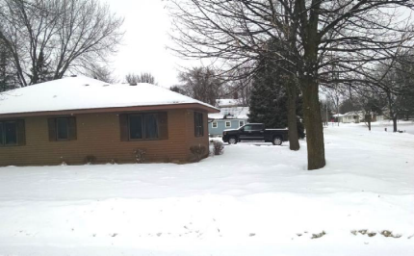  Site recon photo (ground-level/street view) with caption. | Relevant Historical Aerials (with parcel outline) with caption. | 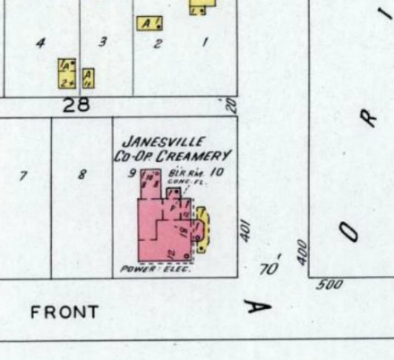  Relevant Fire Insurance Map (with parcel outline) with caption.

SITE RECONNAISSANCE
 | Site Reconnaissance |  | Other lines of Evidence
Evidence of the following: | YES | NO | YES | NO
Current Structures | ☒ | ☐ | ☐ | ☐
Demolished/Removed Structures | ☐ | ☐ | ☐ | ☐
Tanks | ☐ | ☐ | ☐ | ☐
Unidentified containers (drums, cylinders, etc.) | ☐ | ☐ | ☐ | ☐
Wells | ☐ | ☐ | ☐ | ☐
Septic System or cistern | ☐ | ☐ | ☐ | ☐
Use/Storage/Disposal of Petroleum Products or Hazardous Materials | ☐ | ☐ | ☐ | ☐
Dumping, Landfilling, or Non-native Fill | ☐ | ☐ | ☐ | ☐
Spill or Release | ☐ | ☐ | ☐ | ☐
Unpaved roads/paths with no outlet | ☐ | ☐ | ☐ | ☐
Outdoor Storage | ☐ | ☐ | ☐ | ☐
Surface Water Features | ☐ | ☐ | ☐ | ☐
Stained Soil or stressed vegetation | ☐ | ☐ | ☐ | ☐
PCB containing equipment | ☐ | ☐ | ☐ | ☐
Odors | ☐ | ☐ | ☐ | ☐
Poor Housekeeping | ☐ | ☐ | ☐ | ☐
Past Structure Use or Property Ownership | ☐ | ☐ | ☐ | ☐
Other: | ☐ | ☐ | ☐ | ☐
Description of observations and other lines of evidence
(ie. Tank size/location/contents, Number & location of drums, etc.)

HISTORICAL Summary
Date Range | Property Use | Source
1922-1935 | Two residential parcels | Sanborn Maps
1935-1955 | Filling Station and one residential parcel | Sanborn Maps, Aerial Photos
1955-1968 | Ranweiler’s Skelly Service and one vacant parcel | Aerial Photos, City Directory
1968-1988 | Ranweiler’s Skelly Service | Aerial Photos, City Directory
1988-2002 | Davis Floral | City Directory, Interview
2002-2008 | Sid’s Signs on Broadway | City Directory, Aerial Photos, Site Reconnaissance, Interview
WELL SEARCH
A search of the Minnesota Department of Health (MDH) Minnesota Well Index (MWI) identified the following well registered to, or plotted at, the site (also include wells observed onsite not listed in MWI):

Unique No. /Well Name / Total Depth (ft) / Depth to Water / Aquifer / Use / Date / Status

Logs are attached in Appendix X.

Database Search Listings

Site ID | Name | Activity

Registered Tanks:

Include size, status, name, contents, AST/UST, registered date, install date, removed/closed date.
Description if only a few tanks. If multiple tanks create a table.
MPCA Tank ID | Tank # | AST/UST | Size | Contents | Status | Install Date | Registered Date | Removed/  Closed Date

Regulatory File Review
Listing Site Summary
EXAMPLES:
LEAK 4426

A limited site investigation was conducted in July 1998 at Bob’s Fuel. Three soil
probes were advanced around the current UST basin and pump islands.

One groundwater sample was collected from GP-1, advanced south of the UST basin. GP-3 contained 804.7 micrograms/ liter (μg/L) benzene, 130,400 μg/L total xylenes, and 179,000 milligrams per liter (mg/L) GRO.

In October 2000, 6 additional soil probes were advanced at the site to investigate the
magnitude and extent of groundwater contamination. Groundwater was encountered at depths
ranging from 11 to 13 feet below grade. Groundwater samples collected from GP-4 and GP-8 were
not analyzed because of the presence of a petroleum sheen. P-9, located near the northwest
pump island area, contained 354 parts per billion (ppb) benzene and 26.5 parts per million (ppm)
THG. P-15, located near the southwest corner of the site, contained 72 ppb benzene and 1.01
ppm THG. Groundwater samples collected from the remaining six probes contained low to
nondetect petroleum hydrocarbon concentrations.

Remedial investigation activities conducted in 1993 included the advancement of seven soil
borings, five of which were completed as monitoring wells. Field screening results indicated
elevated (>10 ppm) concentrations in only three soil borings, SB-6, SB-7, and SB-9; however,
petroleum constituents were detected in only SB-7 and SB-9. SB-7 (3-5 ft) contained 13
milligrams per kilogram (mg/kg) benzene and 2,900 mg/kg THG, and SB-9 (13-15 ft) contained
0.61 mg/kg benzene and 62 mg/kg THG. MW-4 (SB-9), was the only well to contain detectable
petroleum constituents, with an initial benzene concentration of 180 μg/L and THG of 20,000
μg/L. Groundwater flow was documented to the east-southeast. Quarterly groundwater
monitoring was conducted through April 1996, and concentrations in MW-4 decreased to 62
μg/L benzene and 2,200 μg/L THG. The MPCA issued a petroleum tank release site closure letter
on June 28, 1996.

