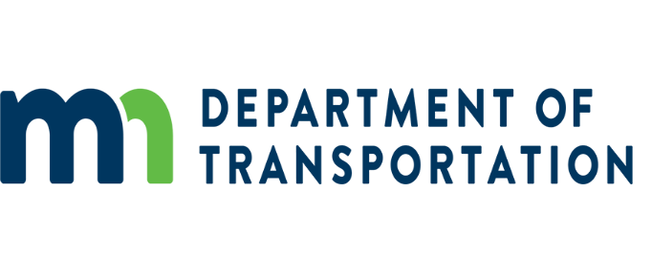

Audit Office
395 John Ireland Blvd.
St. Paul, MN 55155

Send this completed Memo, as an attachment, electronically, to Auditpreawards.dot@state.mn.us along with the Pre-Award package(s) and other require documentation.
If you have any questions regarding pre-awards and/or this form, please call or email Danielle Plocher at 651-366-4153.

Internal Memo
TO: Danielle Plocher
FROM: Sender's Name and MnDOT Office
DATE:
SUBJECT: Pre-Award Audit for Name of Consultant

Description of Project:

Type of Pre Award Audit Requested (Pre-Qual, Master, Cost Proposal-RFP, Other):
___________________________________

MnDOT Contract Number:

Total Amount of Proposed Contract (Amount to include all costs: Prime and Subs): $

Total Funding:
State: $
Federal: $
Total should match the ‘Total Amount of Proposed Contract’.

Name of the Prime Consultant:
Proposed Total Costs: $
Proposed Contract Type (Cost Plus Fixed Fee, Fixed Hourly Rate, Lump Sum, etc. See below):

Name of the Sub-Consultant:
Proposed Total Costs: $
Proposed Contract Type (Cost Plus Fixed Fee, Fixed Hourly Rate, Lump Sum, etc. See below):

Name of the Sub-Consultant:
Proposed Total Costs: $
Proposed Contract Type (Cost Plus Fixed Fee, Fixed Hourly Rate, Lump Sum, etc. See below):

Name of Sub-Consultant:
Proposed Total Costs: $
Proposed Contract Type (Cost Plus Fixed Fee, Fixed Hourly Rate, Lump Sum, etc. See below):

Attachments to this Request:
- All Pre-Awards (not including Master or pre-quals)
  - Pre-Award Questionnaire
  - Most Recent Financial Statements
  - Timesheet Sample
  - Expense Report Sample
  - Fee Schedule and/or Billing Rate Schedule, if applicable
  - Cost Proposal, If Applicable
  - Most Recent Overhead Rate Development Workpapers
  - Certification of Final Indirect Costs (Overhead) Rate
  - Cognizant and/or Acceptance letters from other State DOT’s, if applicable.
If you have any questions regarding pre-awards and/or this form, please call or email Danielle Plocher at 651-366-4153 or Danielle.plocher@state.mn.us.

