

Consultant Guide
MnDOT P/T Contract Performance Evaluation Process
Updated 1/4/17

Contents:

- Background/Executive Summary Page 2

- Step-by-Step Process Instructions for Consultants Pages 3-4

- Tutorial of Automated System for Consultants Pages 5-10

Questions or Help:

Melissa Brand
Consultant Services
651-366-4644
melissa.brand@state.mn.us

Background/Executive Summary

The Minnesota Department of Transportation (MnDOT) and the American Council of Engineering Companies of Minnesota (ACEC/MN) identified the need to revise the Professional/Technical (P/T) Contract Evaluation process due to a number of factors (e.g.: lack of valuable information, subjectivity, lack of consistency, timing of evaluations, etc.). A collaborative working team was formed with the main goal to develop tools and processes for performance evaluations that benefit MnDOT and the Consultant Community.

Goals
As stated above, the main goal was to develop tools and processes for performance evaluations that benefit MnDOT and the consultant community. In addition, the following goals were identified to improve on the existing evaluation process:
- Develop tools and processes for performance evaluations that benefit MnDOT and the Consultant Community.
- Transparency and Consistency should be included in the evaluation process.
- Define expectations of both sides up front. Establish and define criteria by which the consultant and MnDOT will be measured /evaluated.
- Include the Department of Administration’s evaluation requirements and incorporate into the process.

Working Team Outcomes
- New process for performance evaluations (including interim and final).
- New performance evaluation Master Template that includes global criteria for each contract evaluation no matter what the work type (master evaluation form).
- Contract/work specific criteria for different work types (work-type templates). All templates include the Department of Administration’s questions/requirements.
- Scoring system to minimize subjectivity and promote consistency.
- Content and process to enable Consultant Agreement Reporting & Tracking (CART) database consultant to load and create process automated evaluations.
- Process for improvement and dispute resolution.
- Process for how the evaluations affect the prequalification process.

For more information regarding the new evaluation development, working team approach and recommendations, evaluation templates and overall process, please see the working team’s Final Report:
http://www.dot.state.mn.us/consult/pdfs/collaboration-final-report-performance-evaluation-improvement.pdf

Step-by-Step Process Instructions for Consultants
P/T Contract Performance Evaluation

For the new P/T Contract Evaluation process, the Consultant has the opportunity to evaluate MnDOT and review and accept MnDOT’s evaluation. The following are step-by-step instructions for this process (red indicates specific consultant actions; green indicates specific MnDOT actions):
- Evaluation Software (ES) initiates the Consultant Evaluation and MnDOT Evaluation following MnDOT Project Manager (PM) and Contract Administrator approval of final invoice.

- A link via email to electronic evaluation is sent to MnDOT and Consultant PM. (Note the closeout process, final audit and final invoice payment cannot be completed until the evaluation process is completed.)

- MnDOT PM completes the evaluation of consultant and submits to ES.

- ES sends the consultant evaluation to MnDOT Contract Administrator (CA) to review for consistency and compliance with policies. CA coordinates with MnDOT PM if changes are necessary. If necessary, CA resubmits revised consultant evaluation to ES.

- ES sends the consultant evaluation to the Consultant PM for review. Consultant PM has 3 business days to “accept” or “contest” the consultant evaluation. If after 3 business days, there is no action, the evaluation will default to “accept.”

- Accepted consultant evaluation is posted to MnDOT database, unless Consultant rating is 10 or below, or the evaluation is contested.

- Contested consultant evaluations: Consultant may challenge ratings by requesting a meeting. If the MnDOT PM and Consultant PM cannot resolve the scoring differences, then the issue is escalated to MnDOT PM and Consultant PM’s respective supervisors. When resolved, final evaluation is submitted to ES and posted to MnDOT database.

- Accepted consultant evaluation ratings of 10 or below: ES sends evaluations with ratings of 10 or below to Assistant Consultant Services Director for review and comment. Final evaluation is submitted to ES and posted to MnDOT database.

- For final consultant evaluation ratings of 10 or below, Consultant PM must submit a performance improvement plan to the MnDOT PM. This plan and its content are at the discretion, direction and approval of the MnDOT PM. Improvement plan is saved in MnDOT official contract file.

- Consultant PM completes evaluation of MnDOT (Concurrent with MnDOT review of Consultant) and submits to ES. If the Consultant PM does not complete the evaluation within 3 business days, the system will automatically denote that the Consultant has opted to not complete.

- ES sends the MnDOT evaluation to the MnDOT PM for review. MnDOT PM has 3 business days to “accept” or “contest” the evaluation. If after 3 business days, there is no action, the evaluation will default to “accept.”

- Accepted MnDOT evaluation is posted to MnDOT database, unless MnDOT rating is 2.5 or below, or the evaluation is contested.

- Contested MnDOT evaluations: MnDOT may challenge ratings by requesting a meeting. If the MnDOT PM and Consultant PM cannot resolve the scoring differences, then the issue is escalated to MnDOT PM and Consultant PM’s respective supervisors. When resolved, final evaluation is submitted to ES and posted to MnDOT database.

- Accepted MnDOT evaluation ratings of 2.5 or below: ES sends evaluations with ratings of 2.5 or below to Assistant Consultant Services Director for review and comment. Final evaluation is sent to ES and posted to MnDOT database.

- For final MnDOT evaluation ratings of 2.5 or below, MnDOT PM must submit a performance improvement plan to the MnDOT PM Supervisor. This plan and its content are at the discretion, direction and approval of the MnDOT PM Supervisor. Improvement plan is saved in MnDOT official contract file.

- ES sends the final evaluations to MnDOT PM, Consultant PM & Consultant Firm Designee.

- Consultant Services enters ADMIN info into system.

Tutorial of Automated System – for Consultant
Consultant Evaluation of MnDOT
Sample of email that Consultant will receive (Step X. above):
TO: Consultant PM
FROM: DOT_Contract-eval
SUBJECT: Please fill out final evaluation for Contract: XXXXXXXX
________________________________________________________________________________________
MESSAGE:
Please log into the system at: http://xxxxxxxxxxxxx
Your access code is: xxxxxxxxx
Your contract number is: xxxxxxxx
Detailed instructions available on the MnDOT Consultant Services website at: www.dot.state.mn.us/consult

Consultant will:
- Note MnDOT Contract Number – you will need this for sign-in
- Copy access code
- Click on system link to complete evaluation

System Link will bring you to this screen:
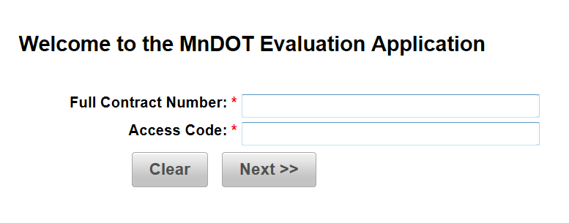

- Enter Contract Number
- Paste Access Code copied from email

This is the next screen you will see:

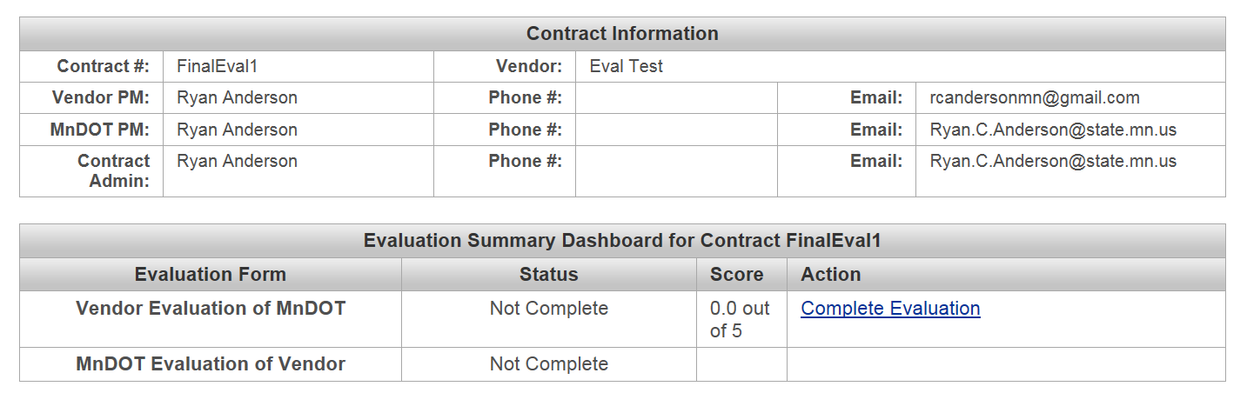

- Click on Action: Complete Evaluation

Complete the Evaluation:

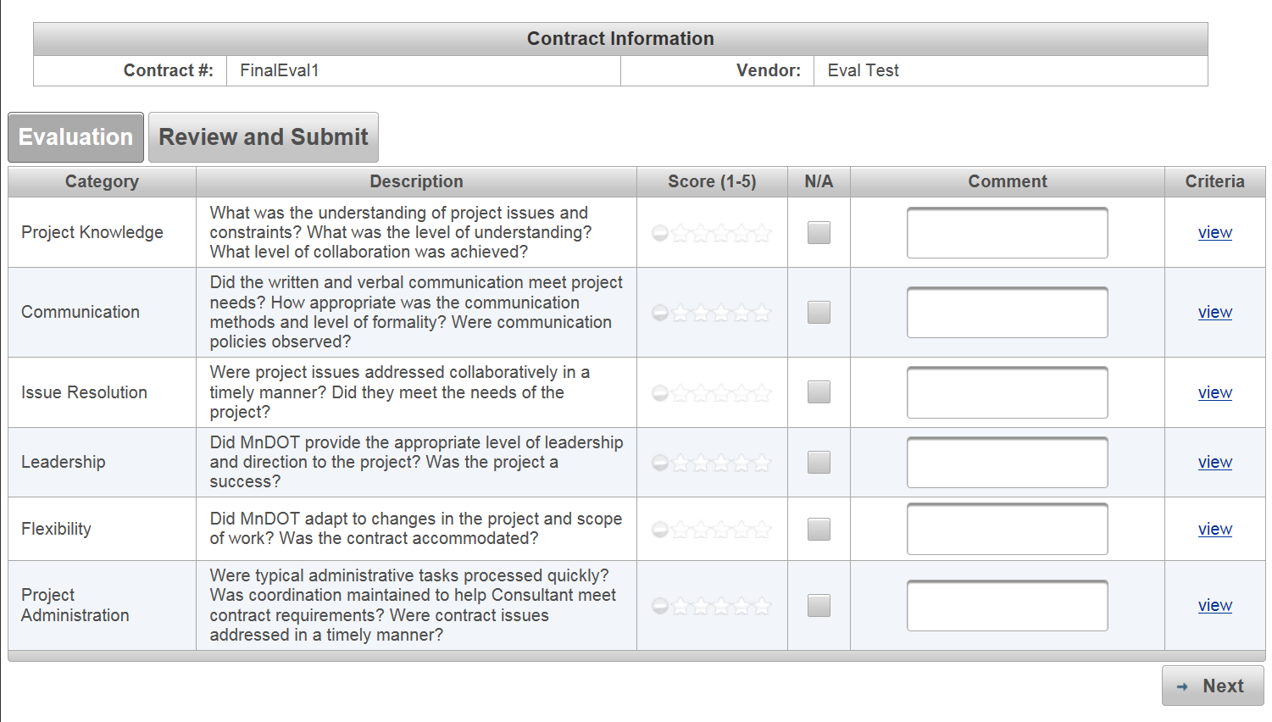

- Click on a Score 1-5 for each category. You may enter N/A.
- You are encouraged to provide a comment for each category.
- Comments are required for scores of 2 or less.
- Each Category’s Criteria scoring detail can be viewed by clicking view.
(See following screen shot for example)

Clicked on Project Knowledge Criteria view:
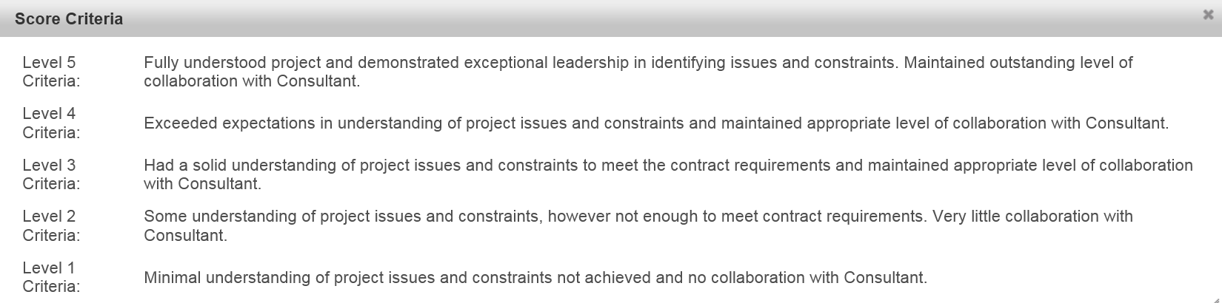

Example of completed screen:
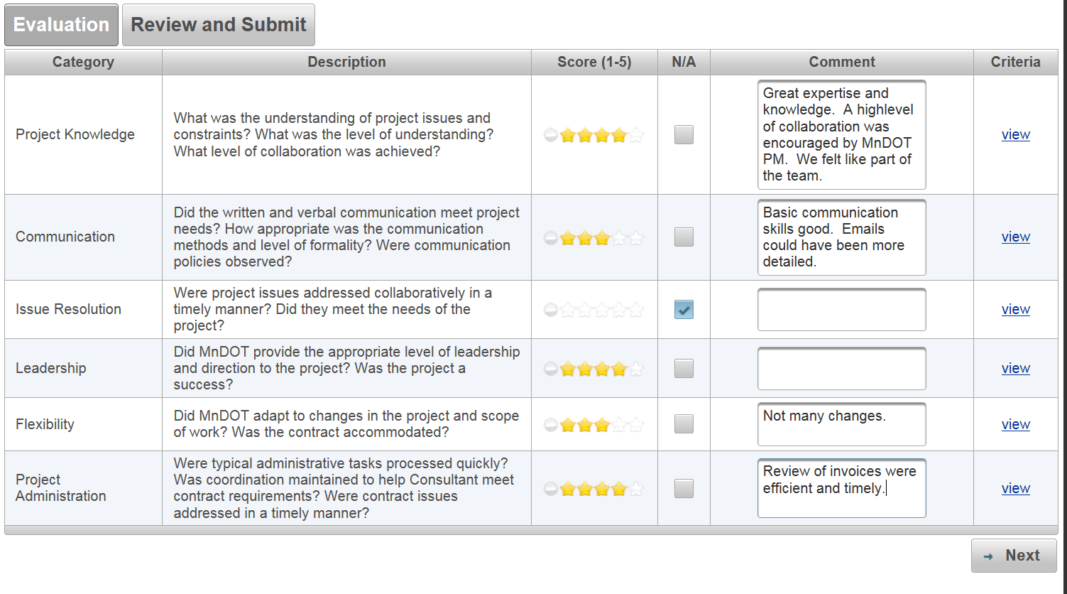
- When complete, click Next
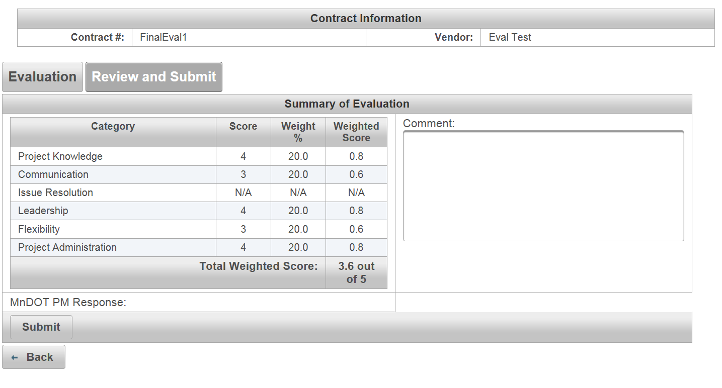
- You may enter general comments
- Then click Submit

You have completed the Evaluation of MnDOT and the system has saved it. You may close the link/window.

_______________

Complete Review and Provide Acceptance of MnDOT’s Evaluation of Consultant PM
Sample of email that consultant will receive (Step V. above):
TO: Consultant PM
FROM: DOT_Contract-eval
SUBJECT: Please review evaluation for MnDOT Contract: XXXXXXXX
________________________________________________________________________________________
MESSAGE:
Please log into the system at: http://xxxxxxxxxxxxx
Your access code is: xxxxxxxxx
Your contract number is: xxxxxxxx
Detailed instructions available on the MnDOT Consultant Services website at: www.dot.state.mn.us/consult

Consultant will:
- Note MnDOT Contract Number – you will need this for sign-in
- Copy access code
- Click on system link to complete review and acceptance (can also respond)

System Link will bring you to this screen:

- Enter Contract Number
- Paste Access Code copied from email

This is the next screen you will see:
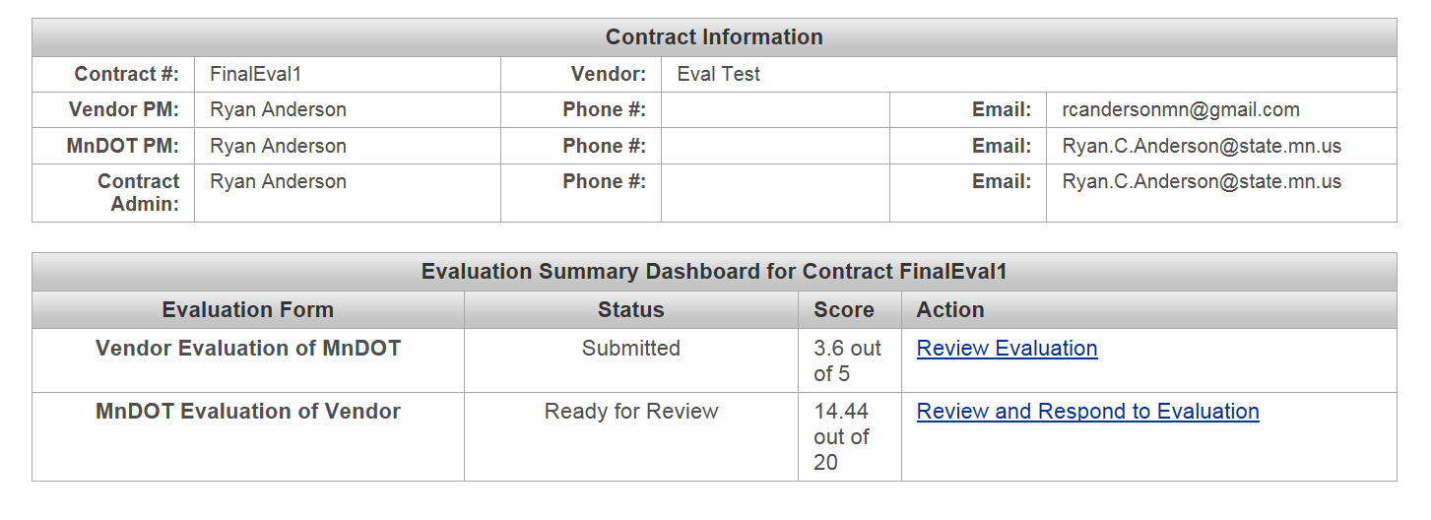
- Click on Review and Respond to Evaluation
- Review each category’s scores and comments for which you have been evaluated.
- Click “Next” on each page to move through the entire evaluation.

Once you have reviewed each Category, you will see this screen:
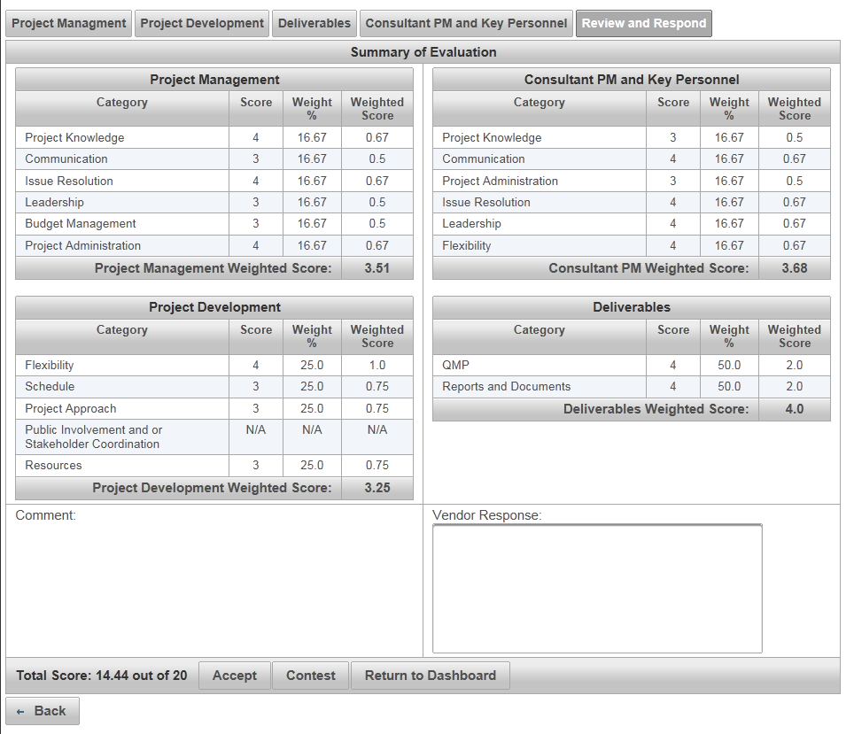

- You may provide comments/response in the Vendor Response box.
- Then either “Accept” or “Contest”

You have completed the Review/Acceptance of your evaluation and the system has saved it. You may close the link/window.

