Minnesota Department of Transportation
Statement of Compliance Form Guide

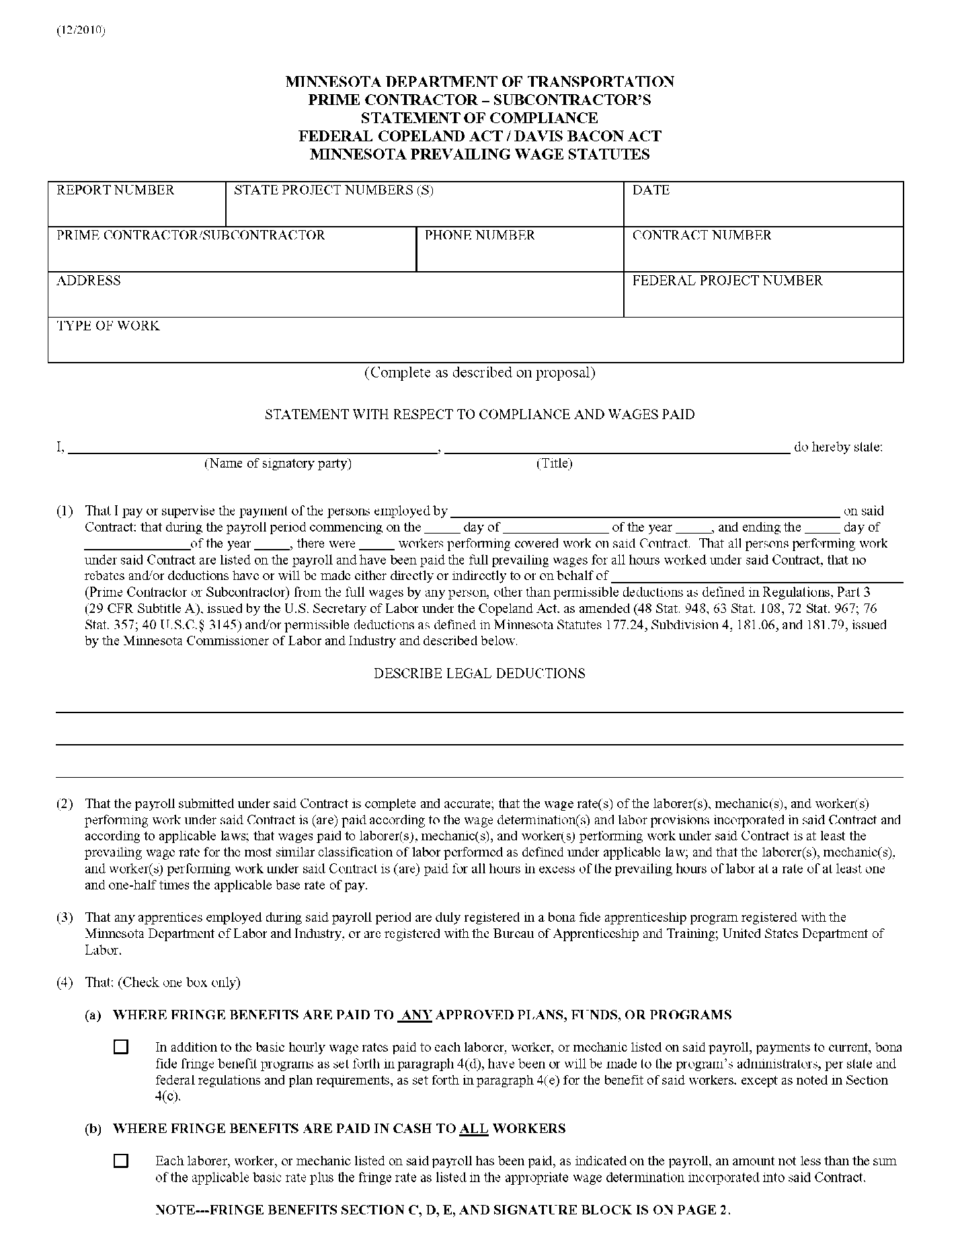
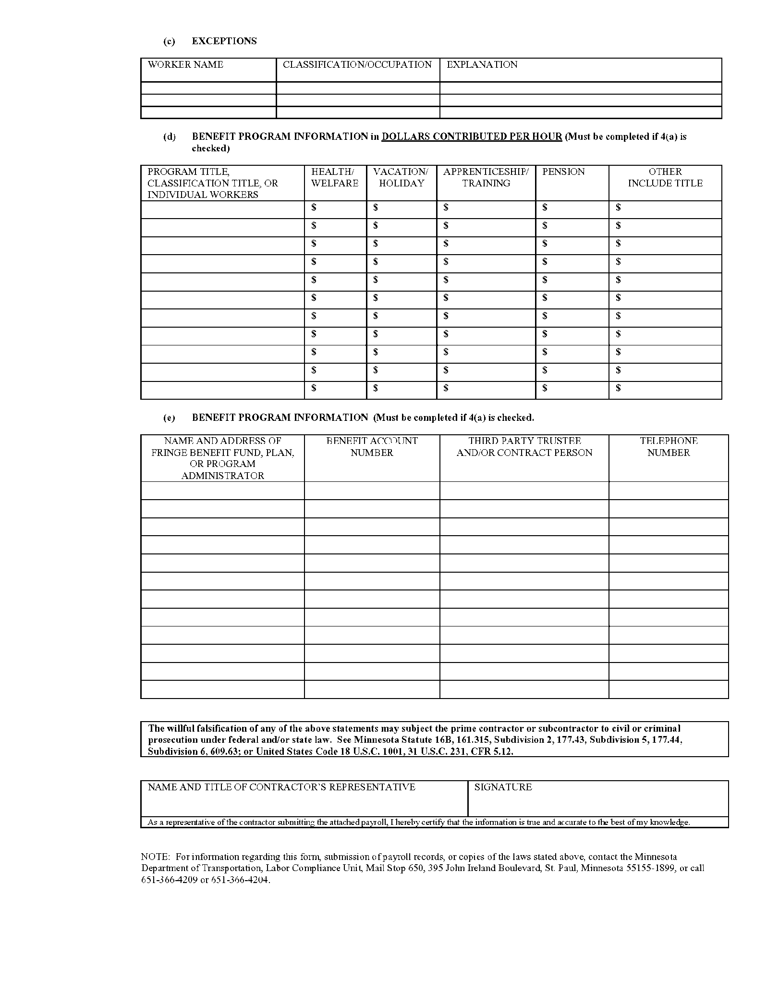
Each contractor that performed work under a contract that is funded in whole or in part with federal and/or state funds must complete the Mn/DOT Statement of Compliance Form. The form should be attached to the payroll and submitted to the Project Engineer. Incomplete forms will be returned to the contractor.
Check One Only
Must indicate the number of workers performing work on the project.

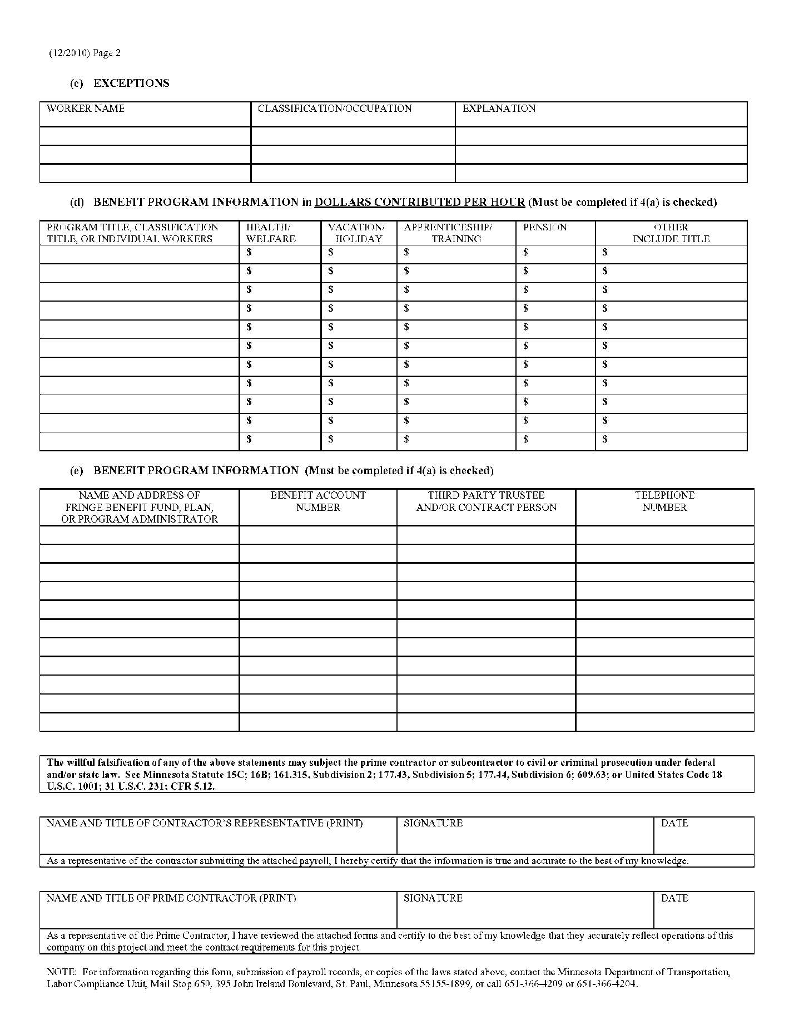
If each worker receives the same fringe benefit rate, place the title of the plan here.
OR
If each worker has a different fringe benefit rate, place their names here with the respective amounts.
OR
A separate sheet that contains the breakdown of each worker’s benefits can be attached to this form. Make note of the attachment by writing “See Attached Sheet” here.
If 4(a) is checked, enter the name(s) of the person(s) who do not receive fringe benefit(s) reported in 4(d) (e.g. non-union, seasonal worker, worker has not worked for the company long enough, etc.).

NOTE: If 4(b) is checked or if workers are listed in 4(c), the workers must receive the total contract rate, which is considered taxable income, as cash on their paycheck.
Specify the dollar amount contributed per hour as a fringe benefit. Failure to do so will result in the rejection of the form.
Fill out the complete name and address of the fringe benefit plan.
Specify the benefit account number, contact person and telephone number.
Print clearly the name and title of the representative signing the payroll.
This form must be signed or it will not be accepted.

