

wT CRLMS Sub Contractor Entering a Payroll Manually



Prepared by the Minnesota Department of Transportation (MnDOT)

September 15, 2014

Payroll Data
Payroll data can be entered into CRLMS in three ways:
- Directly entered into CRLMS.
- Entered into an AASHTO Trns•port® Payroll Excel Spreadsheet which is then converted into XML format using AASHTO Trns•port® Payroll Spreadsheet Conversion Utility (both of these are found at https://xml.cloverleaf.net/spreadsheet/). The payroll XML file is then imported into CRLMS.
- Converting data currently in a contractor’s/subcontractor’s payroll software system into the specific XML file format accepted by CRLMS. The payroll XML file is then imported into CRLMS. This conversion process would be executed by the firm who designed the contractor’s payroll software system.

This guide will show the first method: Directly entered into CRLMS.

- Login with your Username and Password.

(The examples shown are for a subcontractor logging in to CRL.)

If your log on is successful you will then see the Subcontractor Payroll Home Page
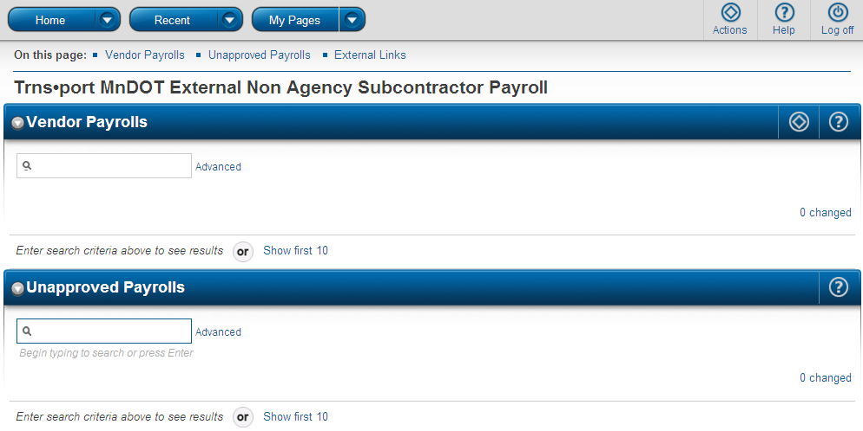
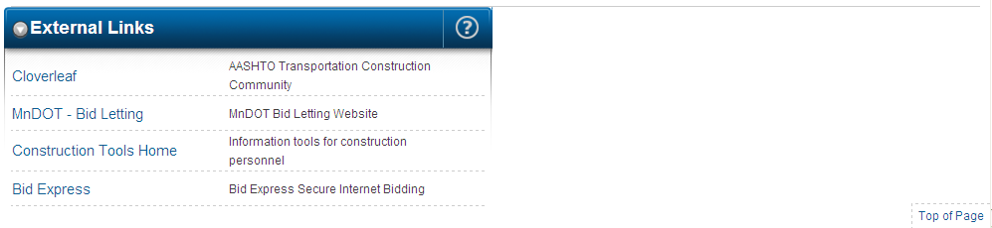

- In the quick find search box type in the contract number that you are a subcontractor on.

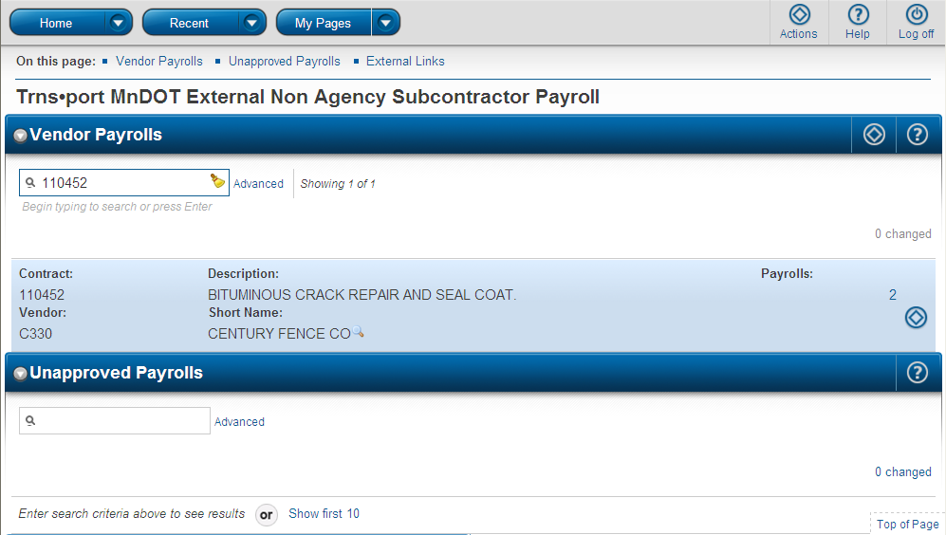
- Click on the Actions button.

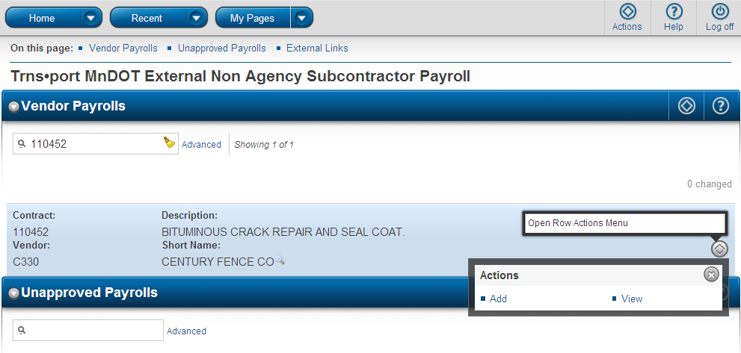
- Click on the Add link to add a new payroll.

The sections, outlined with a maroon border, show a possible glitch you may experience when trying to start a new payroll.
A contractor who is directly entering payrolls tries to start the next payroll from this screen by clicking on the Add New Payroll link
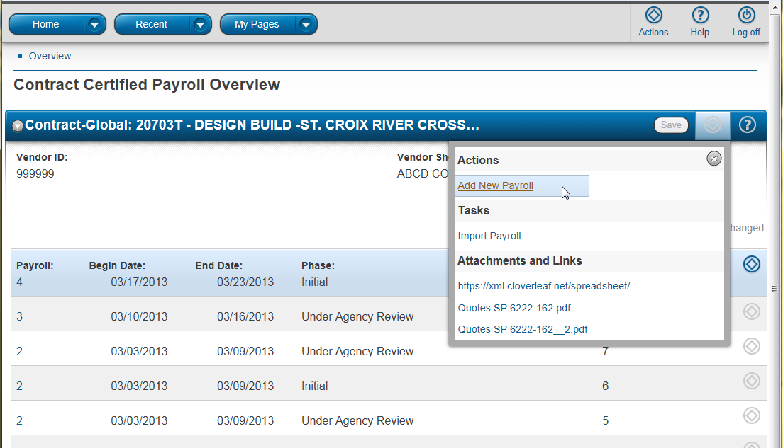

might next see this error displayed:
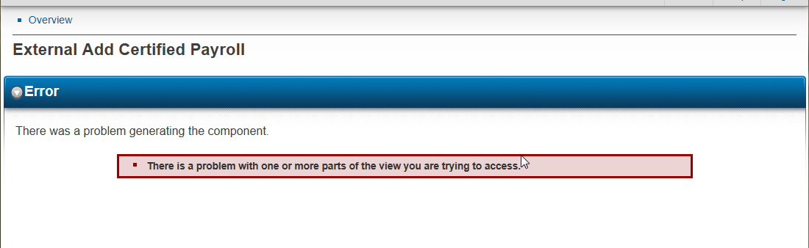

The place a contractor can successfully start the next directly entered payroll is by going back a couple steps and click on Add from this screen
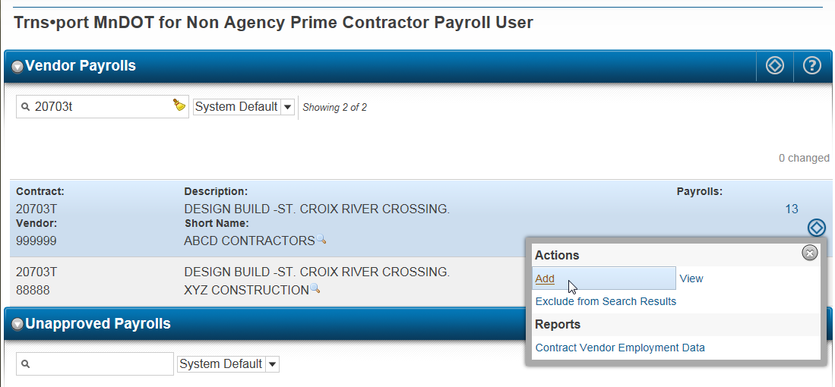

Then the correct screen to start a new payroll is reached:
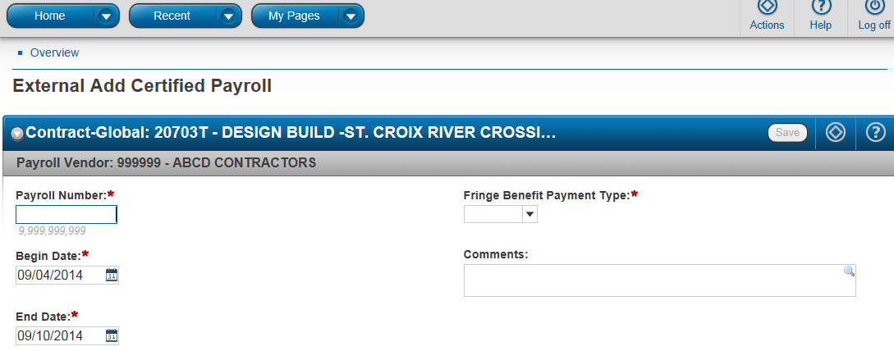

Note: Any field that has a is a required entry field.
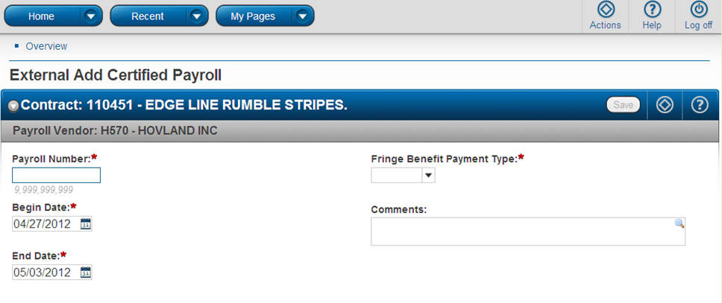
- When done making entries in these fields click the Save button.
If you do not click on the Save button and navigate to some other area of the CRLMS application the data will be lost!
- Enter the Payroll Number.
- Select the Fringe Benefit Payment type from the list.

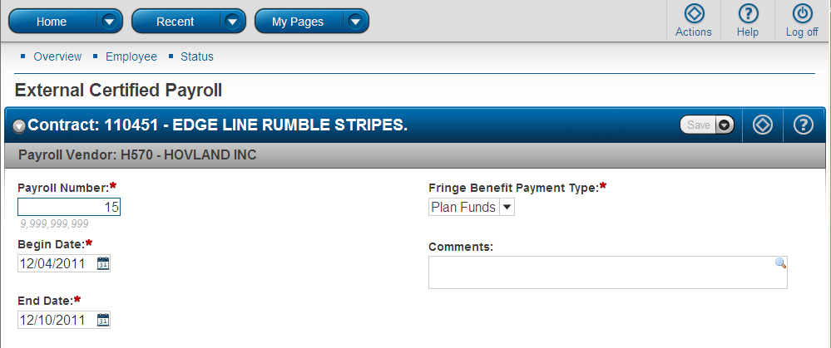
- Select the payroll beginning date from the calendar or type it.
Select the Payroll ending date from the calendar or type it.
(Enter normal payroll start day date and end day date not just the dates work was performed on the payroll)

Next you will have to enter the Benefit Program information for each Benefit Program Type.
- Click New. (screen capture shows entries for the first fringe benefit program)

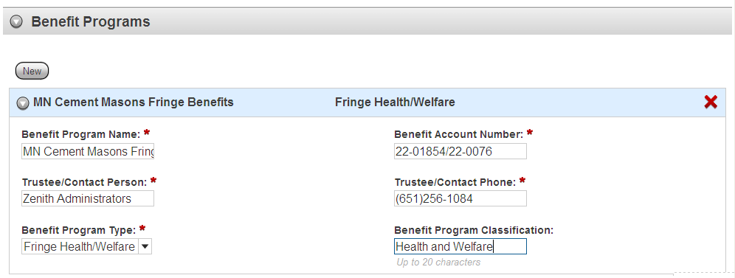
- For each benefit program type, click New and then make the required entries.

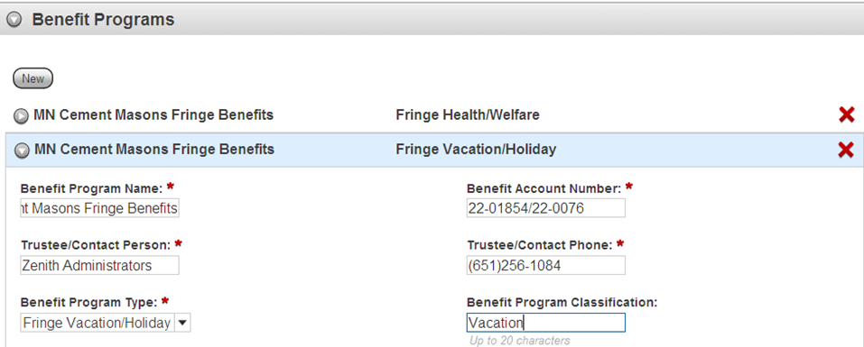

- Click the Save button once you have completed your entries in the Benefit Program fields.

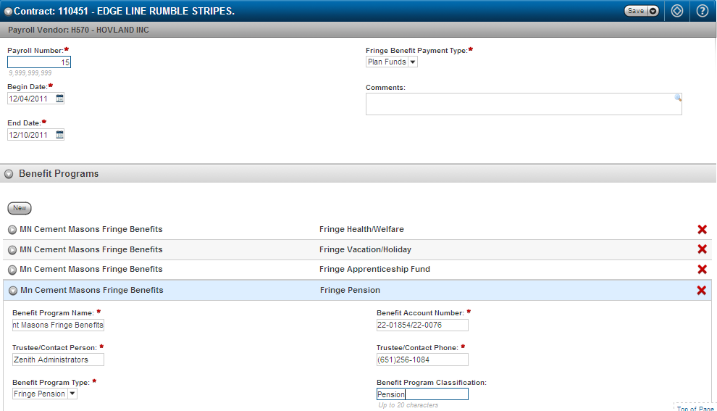
- After clicking the Save button you should see the message, “Certified Payroll – Successfully Saved” in the green box.

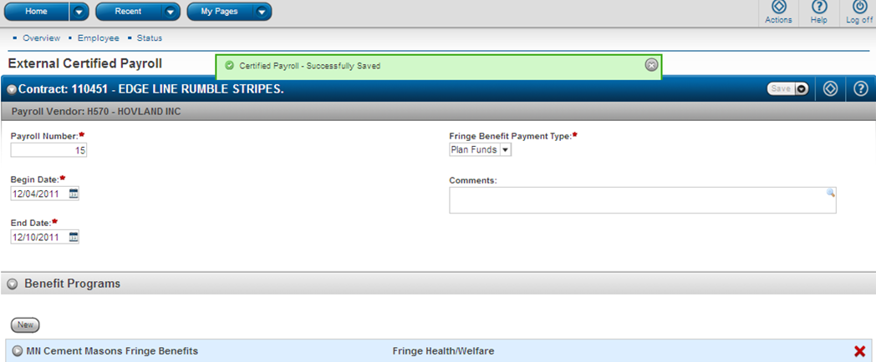

Adding Employees to the Payroll
- Click on Employee to begin entering Employee data.

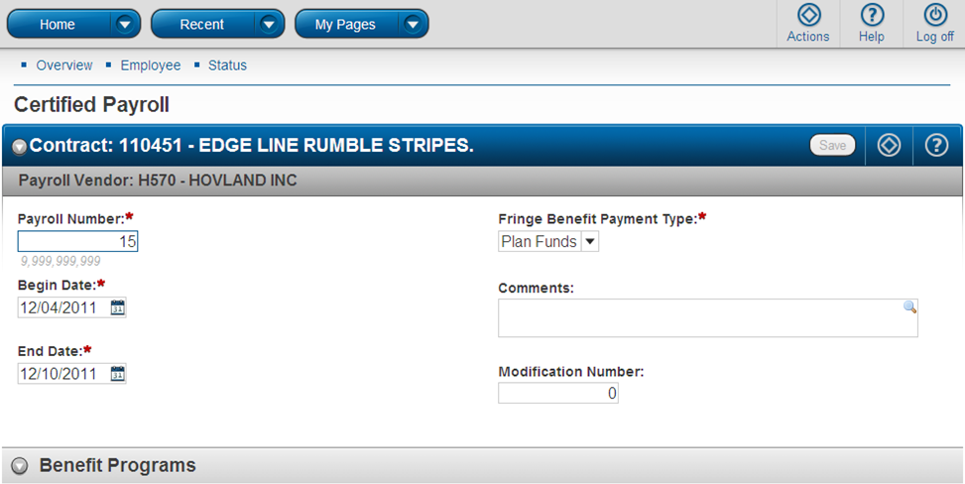

There are two ways to add an employee to the payroll:
- If the employee has not been recorded in the system, select Add Employee from the Actions menu on the component header. The system displays a modal window for adding basic information for the new employee.

- If the employee is already recorded in the system as a reference employee from a previous payroll, select Add Ref Employees from the Actions menu on the component header. The system displays a modal window for selecting an employee from the Reference Employee list.
- To add an Employee to this payroll click on this Action button.

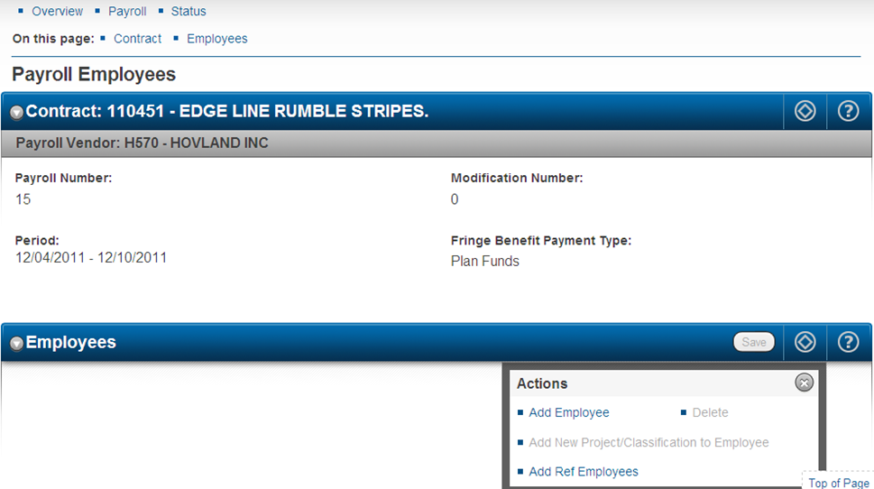
- Select Add Employee quick link if this employee has never been entered on a payroll which was entered or imported to CRLMS.
- Select Add Ref Employees quick link if this employee has previously been entered on a payroll and is in the CRLMS data base.

From the previous step, if using the Add Employee quick link, you will be presented with a Payroll Employee modal window to enter employee information.
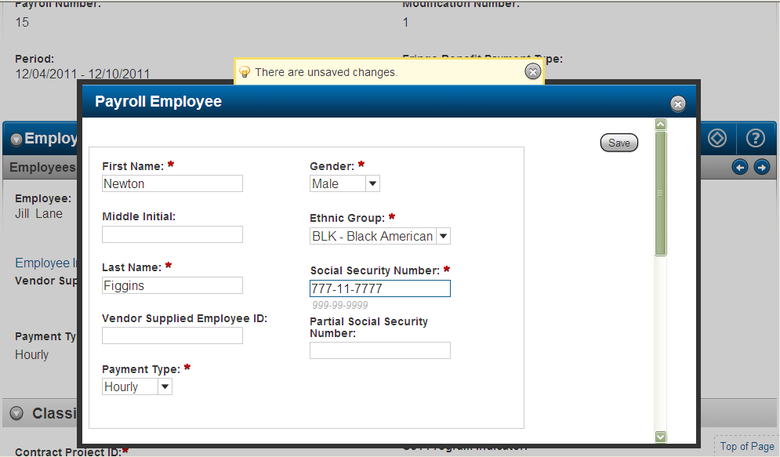
Use the scroll bar to see the lower portion of the Payroll Employee modal window (below).
Note: Minnesota requires a full Social Security Number.

Lower portion of the Payroll Employee entry screen
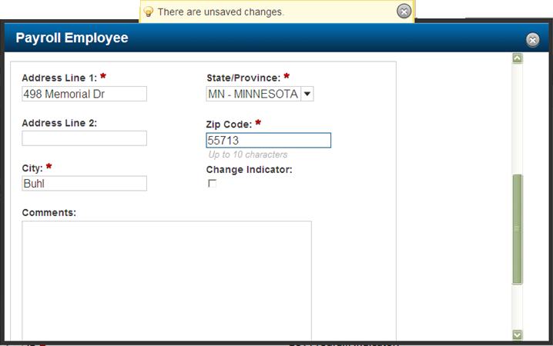
- When entries have been made in all the required payroll employee fields scroll up and click Save.

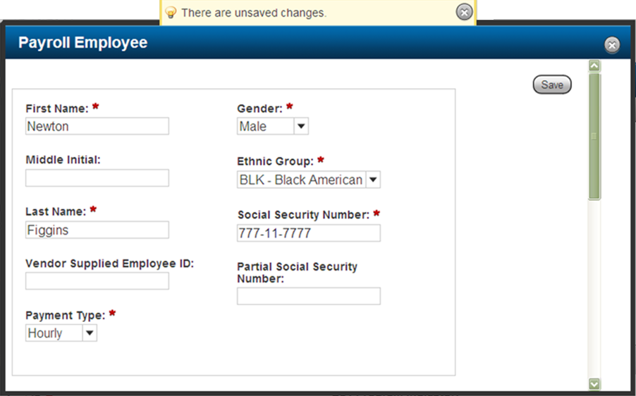
If you want to open a window to view the data just entered click the Employee Information quick link.

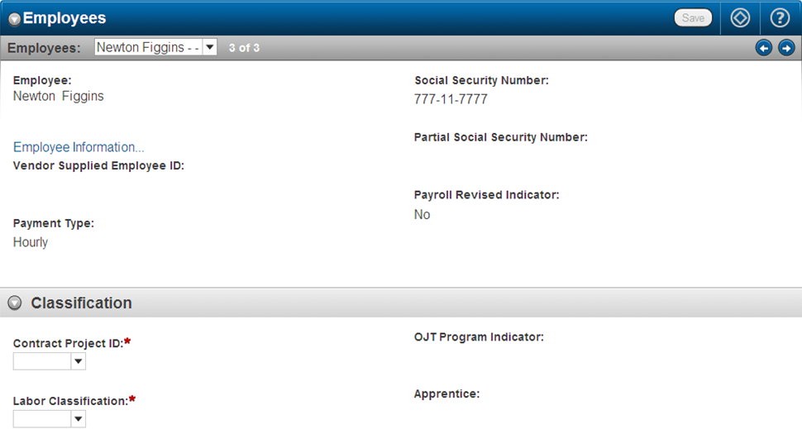

Now the employee is on this payroll. The employee will not appear in the CRLMS Reference Employee data base until the payroll is reviewed and accepted by the prime contractor and transitioned to Agency Review Status. The next steps show how to directly enter payroll data for this employee.
- Click the down arrow in the drop-down list box to select the project number the employee worked on.
Note: A contract can have multiple project numbers. This example only shows one project listed. If an employee worked on more than one project payroll data will have to be entered separately for each project.

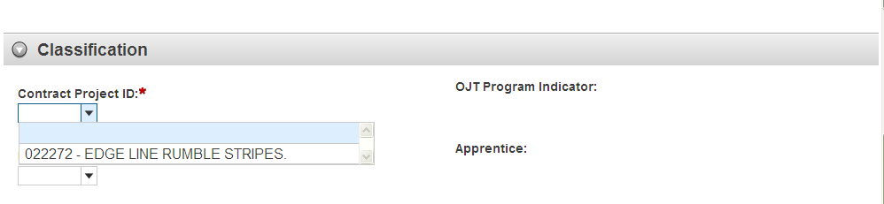
- Click the down arrow in the drop-down list box to select the Labor Classification the employee worked.
Hint: If you place your mouse over the words Labor Classification and hover there, additional information will display in the green box.

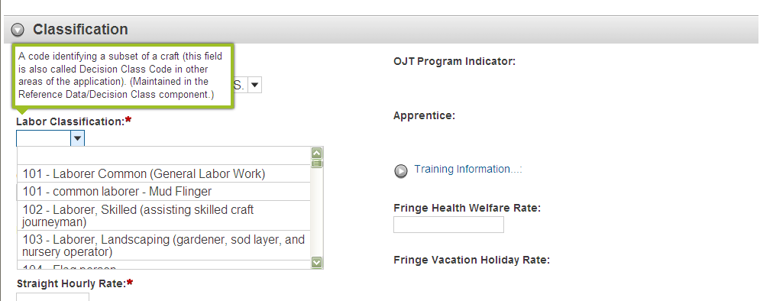
- Click the down arrow to select the Craft Code the employee worked.

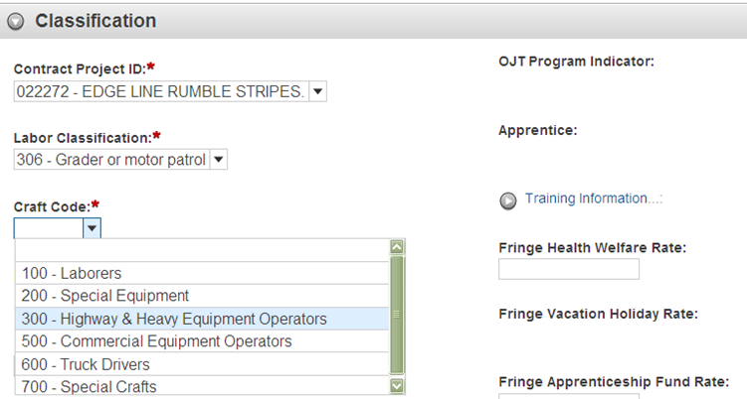
- Enter Straight Time and Overtime hourly rates.

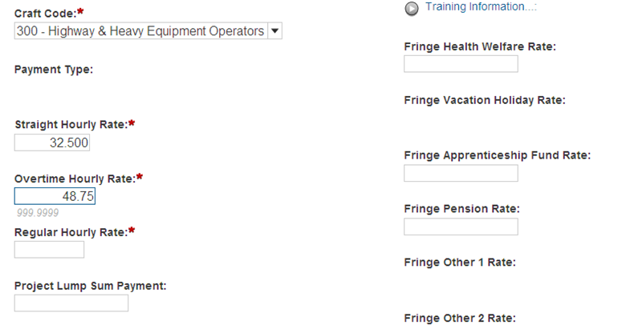

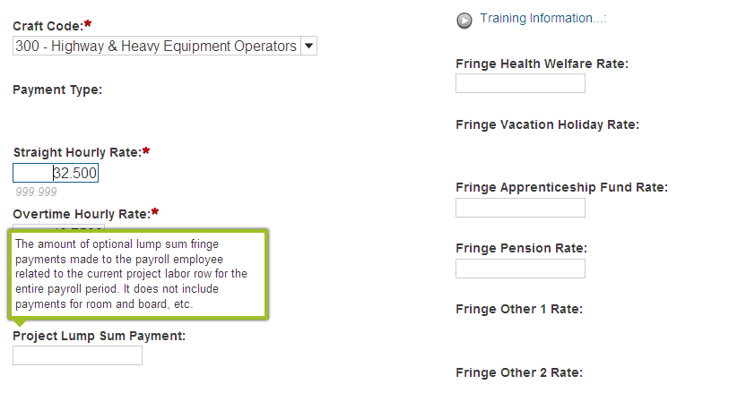
Note: Fringe data entry fields are available only for the fringe benefit programs added to this payroll.

Below is an example of this section with entries completed:
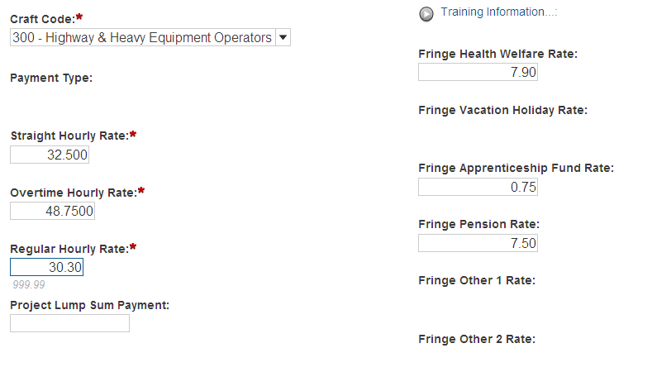

- Enter hours worked in this labor classification. (Hours worked in a different labor classification will be entered separately.)

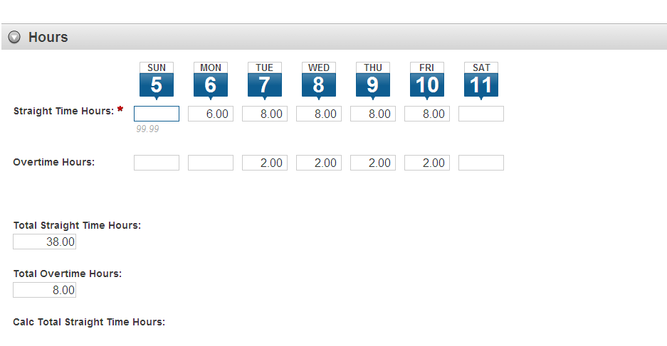
- Enter totals for this classification on payroll period.

- Next, make entries in the following fields.
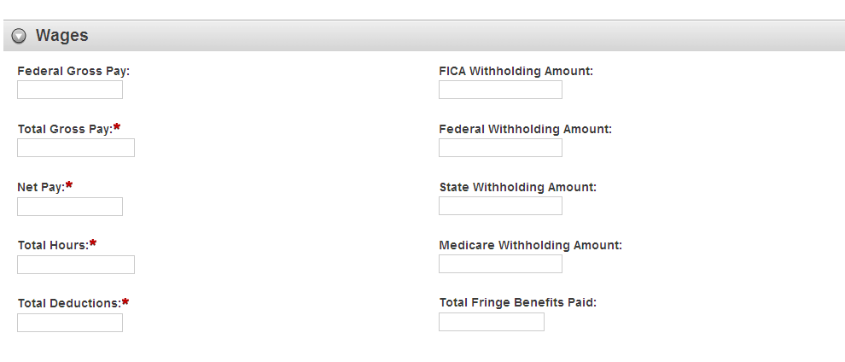

Field descriptions
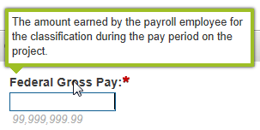 | 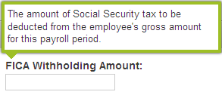
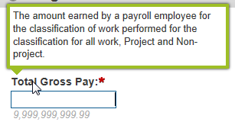 | 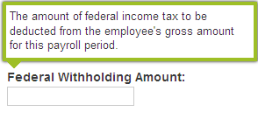
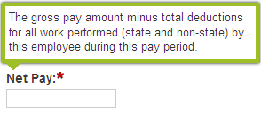 | 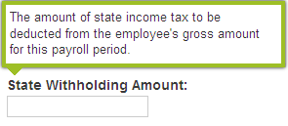
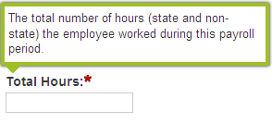 | 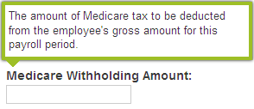
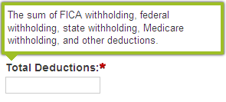 | 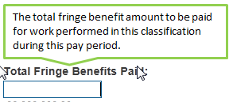

Below is an example of this section with entries completed:
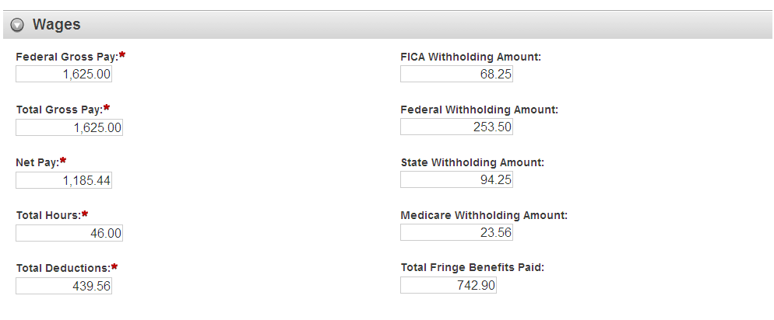
Remember! Scroll up and click the Save button. The entries will not be saved if you leave this page without saving!

Note: Other Deductions and Fringe Benefit Exceptions are optional on each payroll.

Other Deductions
Records for standard payroll deductions such as federal income tax and FICA are maintained as part of the Payroll Employee record. Other deductions refer to additional, irregular deductions an employee may choose to make (for example, money withheld for the employee's 401-K plan or to pay union dues).
To maintain other deductions for the employee, expand the record to display all the available information. You can view or change information in these fields:
- Description
If you have any “Other Deductions” to enter, click on the New button to get the description and entry fields.
- Amount

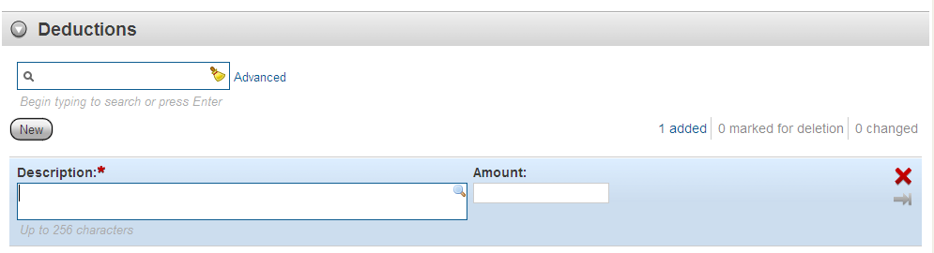

Fringe Benefit Exceptions
Fringe benefit exceptions are used to record a contractor's explanation of why the amount being paid on a fringe benefit for a payroll employee deviates from the standard amount. The exception may represent an increase or a decrease of the standard amount.
- To maintain fringe benefit exceptions for the employee, expand the record to display a list of all the fringe benefit exceptions that currently exist for the payroll employee. Each row in the list represents one fringe benefit exception.
You can view or change information in the Explanation field.
- To add a new fringe benefit exception to the list, click the New button. The system adds a new row at the bottom of the rolling list of exception records. All fields in the new row are blank. To create a complete exception record, you must enter information in the Explanation field.
- Note: You can only add a new fringe benefit exception if the Fringe Benefit Payment Type for the payroll is set to Plan Funds with Exceptions. This value can be changed on the Payroll Summary component.
- To delete a fringe benefit exception, click Delete button on the exception's row.
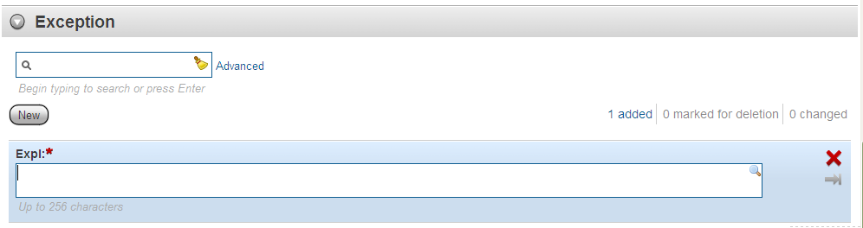
To add a new fringe benefit exception to the list, click the New button.

- When you have finished maintaining payroll employee information, scroll up and click the Save button to apply your changes to the system (including deleted information). Trns•port displays a message just above the component header to confirm that your changes were saved in the database.
Payroll employee data is now entered for this labor classification.
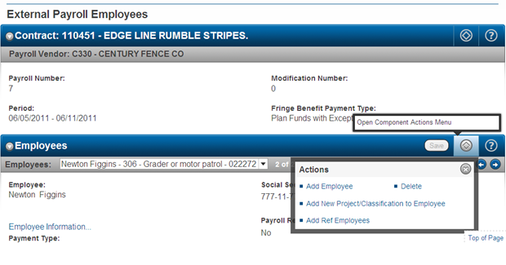
If this employee also worked in a different labor classification this pay period, click Add New Project/Classification to Employee to make the entries.

Complete the above payroll entry steps for every employee on this payroll.

Employees who work in multiple classifications on a project will have to be entered separately for each classification. This section, outlined with a maroon border, shows a possible glitch you may experience when trying to add an additional work classification to an employee on the same payroll.
A contractor adds a brand new employee to the system on a directly entered payroll.
Then, on the same payroll, the contractor tries to add another classification to the employee.
The error is: nothing happens when the Add New Project/Classification to Employee link is clicked on
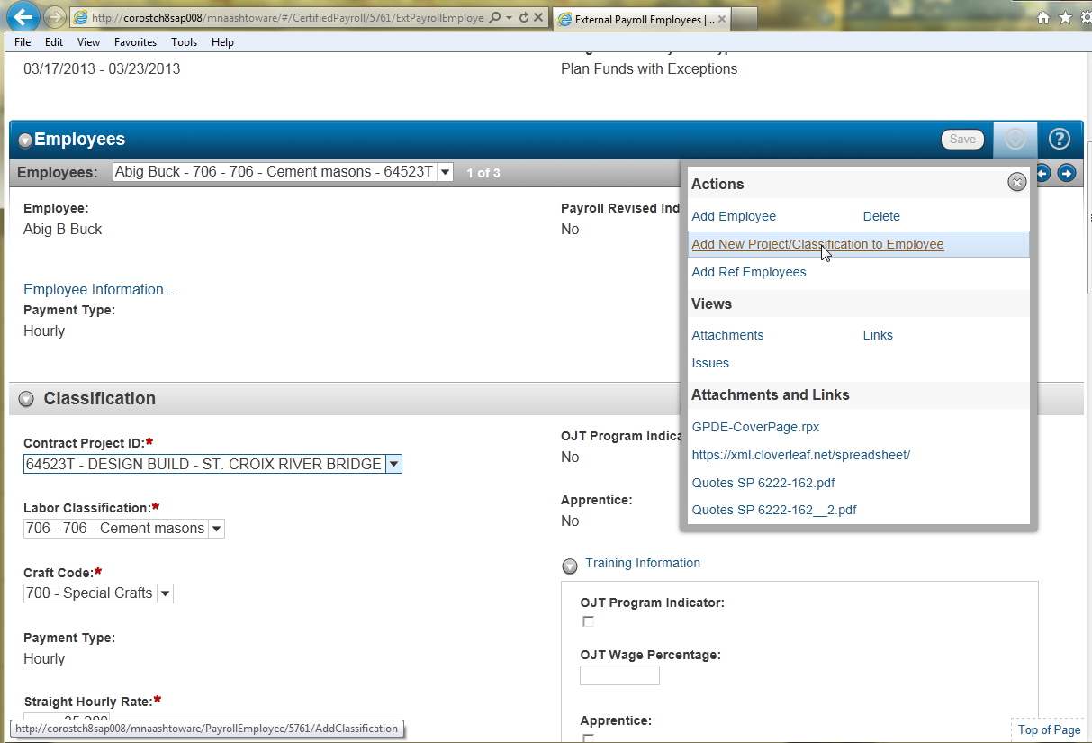

At this time the solution is to entirely reenter the employee starting from the Add Employee link and choose the next pay classification the employee worked in.
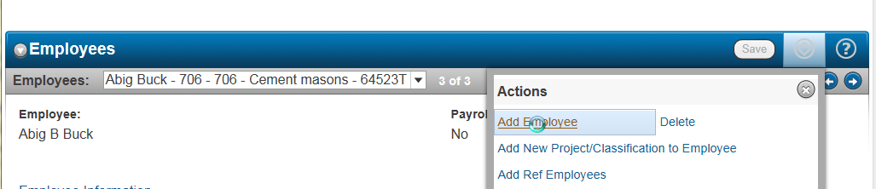

Salaried Employee Entry Process:
If you have a Salaried employee that works on the project performing Labor or Mechanic duties subject to the contract labor provisions you will need to report them on the payroll. Salaried employees are not exempt from prevailing wages or overtime. To determine the average hourly rate paid to the worker, divide their salary paid by the total hours worked each pay period. If the employee is paid less than the required classification rate for the project, the contractor must compensate the worker for the hours worked on the project the additional amount per hour on their pay check.

These are the differences when entering a salaried employee.
When entering the employee data in the Payroll Employee modal window for Payment Type select Salaried.

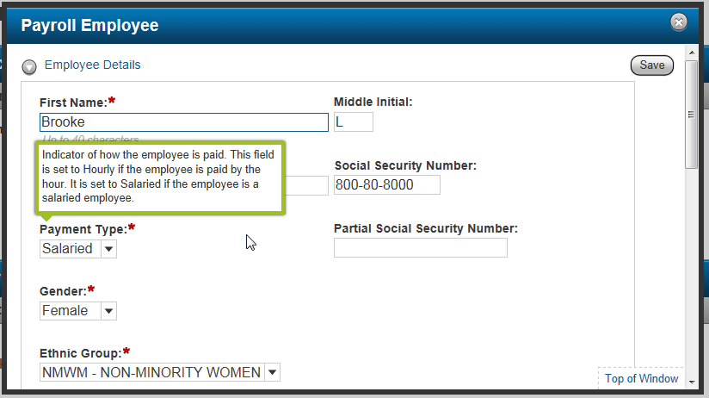

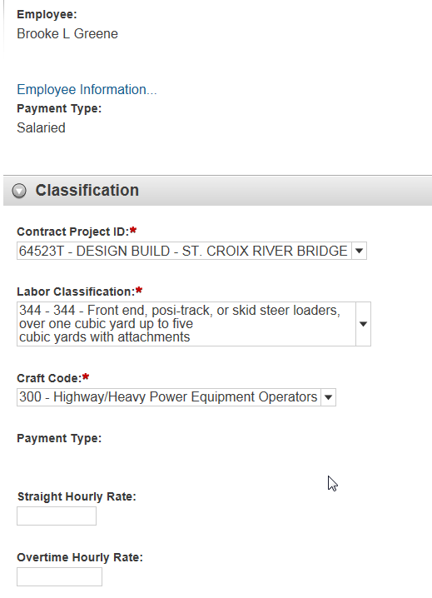
Do not enter a Straight Hourly Rate or an Overtime Hourly Rate for a salaried employee.
Leave blank.

Enter all daily hours worked in this classification on this project. Overtime hours are not entered on a separate line.

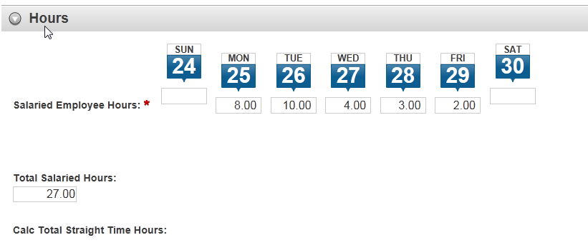
Notice that there is no Federal Gross Pay field for a salaried employee.

