

Combining Payroll XML files



Prepared by the Minnesota Department of Transportation (Mn/DOT)

November 12, 2013



AASHTO Trns•port, the AASHTO Trns•port logo, the AASHTOWare logo, BAMS/DSS, the Trns•port CRLMS logo, Trns•port Estimator, the Trns•port Estimator logo, Trns•port Expedite, the Trns•port Expedite logo, Trns•port FieldBook, the Trns•port FieldBook logo, Trns•port FieldBuilder, the Trns•port FieldBuilder logo, Trns•port FieldManager, the Trns•port FieldManager logo, LAS, the Trns•port LAS logo, PES, the Trns•port PES logo, Trns•port Preconstruction, SiteManager, Trns•port SiteManager, the Trns•port, SiteManager logo, Trns•port SiteXchange, and the Trns•port SiteXchange logo are registered trademarks of AASHTO.

Trns•port BAMS/DSS, Trns•port BAMS/DSS Standard, Trns•port CAS, Trns•port CES, Trns•port Construction, Trns•port Construction/Materials, Trns•port Estimation, Trns•port LAS, Trns•port Materials, Trns•port PES, Trns•port Preconstruction logo, Trns•port TRACER, the Trns•port TRACER logo, webTrns•port, and AASHTOWare Project are trademarks of AASHTO.

AASHTO Trns•port, Trns•port BAMS/DSS, Trns•port CAS, Trns•port CES, Trns•port CRLMS, Trns•port Expedite, Trns•port LAS, Trns•port PES, Trns•port Preconstruction, Trns•port SiteXchange, Trns•port SitePad, and Trns•port SiteManager represent one or more proprietary products of AASHTO.

AASHTOWare is a registered service mark and trademark of AASHTO. Other product and company names mentioned herein may be trademarks and/or service marks of their respective owners.

FieldManager, FieldBook, and FieldBuilder represent one or more proprietary products jointly owned by InfoTech, Inc., and the State of Michigan.

FieldNet represents a proprietary product of Info Tech, Inc.

© Copyright 2013 by the American Association of State Highway and Transportation Officials, Inc. All rights reserved. This document or parts thereof may not be reproduced in any form without written permission of the publisher. Printed in the United States of America.

This guide shows the steps to combine data from more than one XML file prior to importing the combined XML file to Civil Rights & Labor (CRL). The CRL application has no limits on the size of XML files that can be imported.

The following procedures can be used to import payrolls with more than 50 classifications or more than 18 lines of fringe benefit information, which are the limitations found on the Excel spreadsheet.

Combining employee payroll data from two XML files into one XML file is covered on pages 3 - 12. Combining fringe benefit information from two XML files into one XML file is covered on pages 13 - 19.

Note: a contractor can always import the first 50 classifications and 18 lines of fringe benefit information in the usual manner. Then log into the CRL application, before signing the payroll, and add additional fringe benefit information and/or payroll employees directly to the imported payroll information.

Combining employee payroll data

- Enter employee payroll data for the first 50 classifications on MnDOT’s version of the Excel spreadsheet, found at http://www.dot.state.mn.us/const/labor/civil-rights-labor.html, and save the Excel file as Payroll No X Part 1.

- Enter the remaining employee classifications on a separate copy of the MnDOT Excel spreadsheet with the same payroll number and week ending date as Part 1 and save the file as Payroll No X Part 2.

- At this point you have two Excel files:
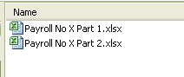

- Convert each Excel file to XML files using AASHTO Trns•port® Payroll Spreadsheet Conversion Utility. Save each file to a local drive.

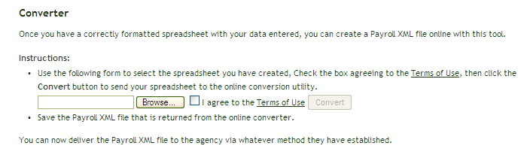

- At this point you have two Excel files converted to XML files:
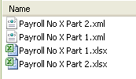

If you double click on either XML file it will open in an internet window but you would only be able to copy from the file and not be able to paste to add data to the other XML file. To combine XML files, the files must be opened with an application (XML editor) which permits both copying and pasting. Microsoft Notepad is shown in this guide because it is standard on most IBM compatible PC’s.

MnDOT recommends downloading “Notepad++” to your computer from the following link: http://notepad-plus-plus.org/. This application contains extra features which will aid in processing XML files.

- Open XML Payroll No X Part 1 by clicking once on the filename, then right click, slide down to Open With and over to Notepad. Just leave the file open in the notepad application window for now. We will need it in minute.

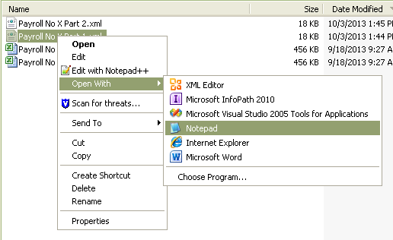

Note: If you downloaded Notepad++ that application may show up in the first sub window depending on which Windows operating system you are running.

- Open XML Payroll No X Part 2 by clicking once on the filename, then right click, slide down to Open With and over to Notepad

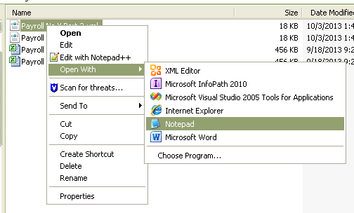

At this point, both XML Payroll files are now open

- The top of the Payroll No X Part 2 XML file looks similar to this:
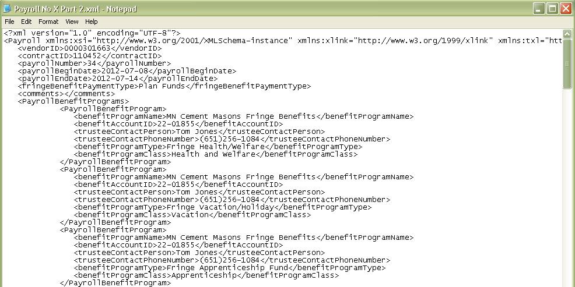

Note: XML, which stands for eXtensible Markup Language, is just information wrapped in tags. The information is structured into root elements, child elements and subchild elements. Root elements are located furthest to the left in the document. Child elements are under and indented right of root elements.
<root>
<child>
<subchild>….</subchild>
</child>
</root>

In the example below <PayrollEmployee> is a subchild element to <PayrollEmployees>.
- Scroll down until you come to the row <PayrollEmployee>, the subchild element under <PayrollEmployees> (with an “s” at the end of Employee). This is the starting point for copying data to be pasted into the other XML file.

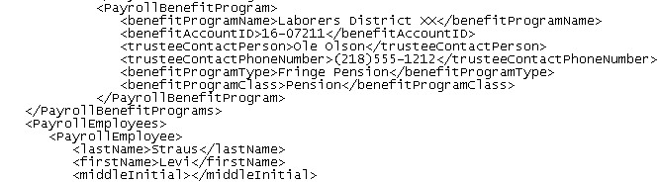

- On the <PayrollEmployee> row place your cursor as far to the left as possible to capture all the blank spaces. Then start highlighting and scrolling down. The highlighted copy box should appear vertically straight (flat) on the left side when completed correctly.

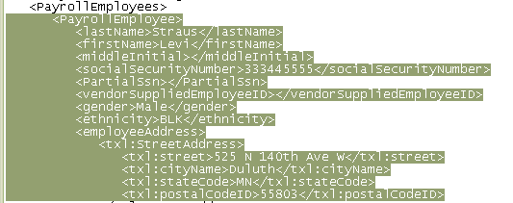

Continue scrolling to capture all employee data down to the entire line ending with </PayrollEmployee> Do not capture the line with </PayrollEmployees> (with an “s” at the end of Employee)

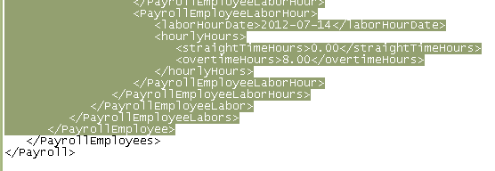

- Right click the mouse and click Copy
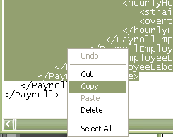

- Next go back to the previously opened Payroll No X Part 1

- Scroll down to the bottom, place your cursor at the end of this row and hit enter to create a blank row above </PayrollEmployees> (with an “s” at the end of Employee). Do not move the cursor.

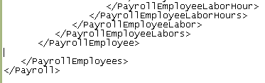

- Right click the mouse and click on Paste

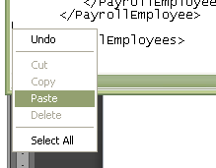

- Check to see if you have any blank rows in the now combined XML file. If so delete them.

- Next save Payroll No X Part 1 as Payroll No X Combined XML
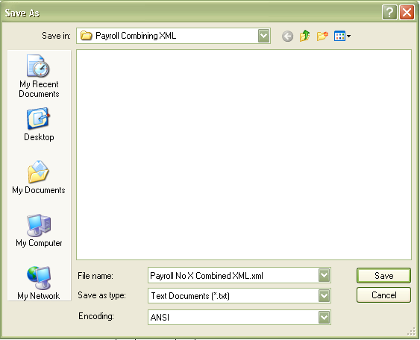

- After you have experience doing this you might feel confident enough to skip the next three steps.

- Navigate to Cloverleaf XML https://xml.cloverleaf.net/ and click on XML Resource Kit

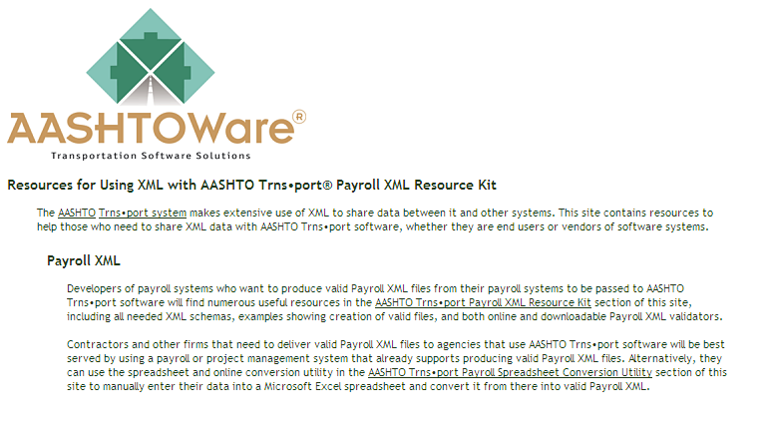

- Click on a Validator and follow the steps
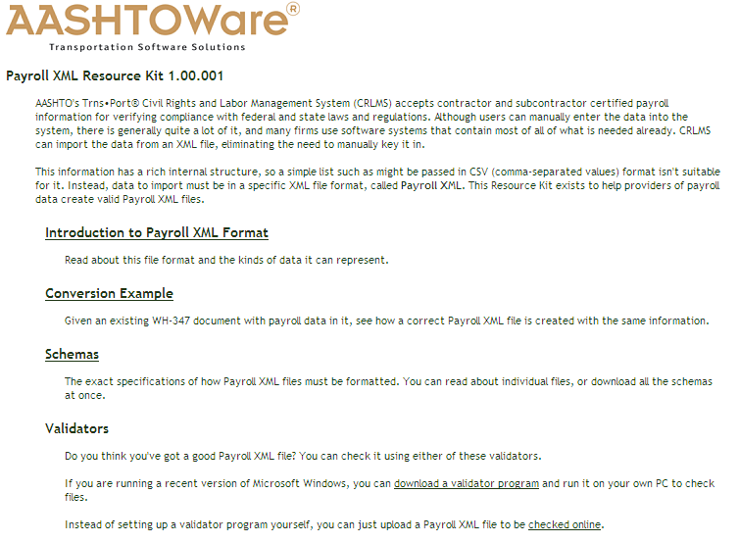

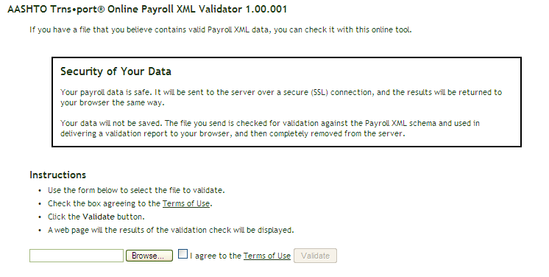

- Navigate to and select your combined XML file, agree to Terms of Use and click Validate

If your XML file is valid you will see this:
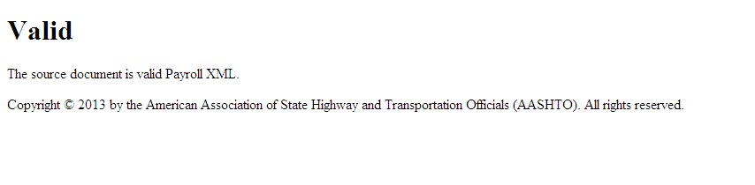

This only means the XML file matches the valid schema which defines Payroll XML acceptable to the CRL application.

- Import your combined XML file to CRL following your normal import process.

Combining fringe benefit data
The combining of fringe benefit information from two XML files into one XML file is similar to the process steps for combining payroll information; the data is just located in a different section on the XML file.

- Enter fringe benefit data in the first 18 rows on MnDOT’s version of the Excel spreadsheet, found at http://www.dot.state.mn.us/const/labor/civil-rights-labor.html, and save the Excel file as Payroll No X Part 1.

- Enter the remaining fringe benefit data on a separate copy of the MnDOT Excel spreadsheet and save the file as Payroll No X Part 2.

- At this point you have two Excel files:

- Convert each Excel file to XML files using AASHTO Trns•port® Payroll Spreadsheet Conversion Utility. Save each file to a local drive.

- At this point you have two Excel files converted to XML files:

- Open XML Payroll No X Part 1 by clicking once on the filename, then right click, slide down to Open With and over to Notepad. Just leave the file open in the notepad application window for now. We will need it in minute.

- Open XML Payroll No X Part 2 by clicking once on the filename, then right click, slide down to Open With and over to Notepad

At this point, both XML Payroll files are now open

- The top of the Payroll No X Part 2 XML file looks similar to this:

The benefit program data starts here.

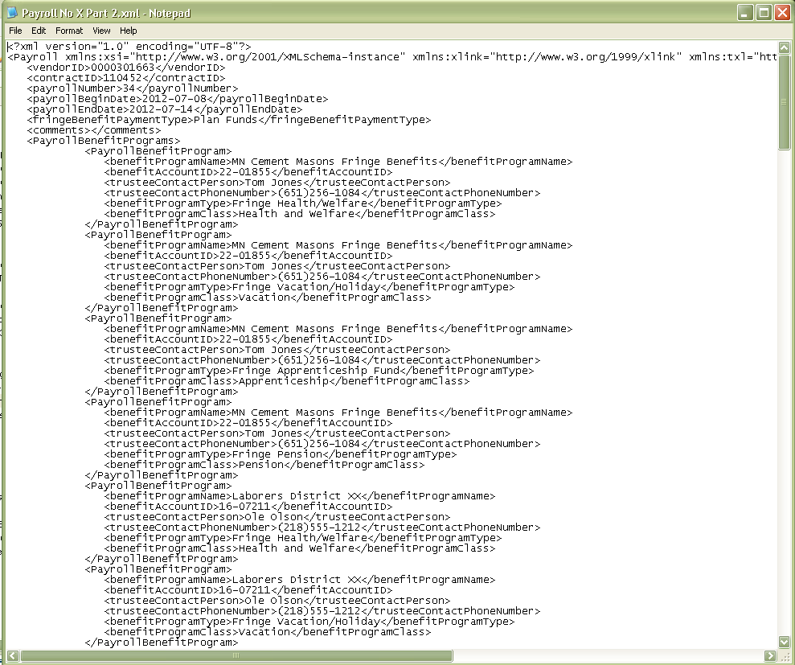

Note: The information in XML files is structured into root elements, child elements and subchild elements. Root elements are located furthest to the left in the document. Child elements are under and indented right of root elements.
<root>
<child>
<subchild>….</subchild>
</child>
</root>

- The subchild element under <PayrollBenefitPrograms> (with an “s” at the end of Program) is <PayrollBenefitProgram> (no “s” on the end of Program). The far left of this row is the starting point for copying data to be pasted into the other XML file.

On the < PayrollBenefitProgram > row place your cursor as far to the left as possible to capture all the blank spaces. Then start highlighting and scrolling down. The highlighted copy box should appear vertically straight (flat) on the left side when completed correctly.

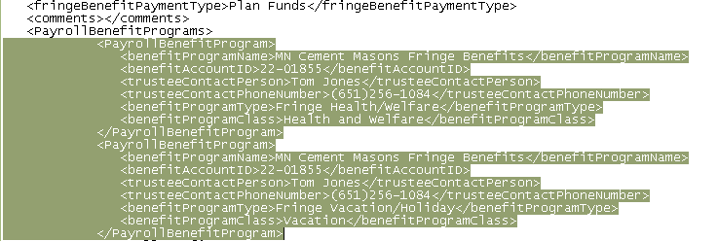

Continue scrolling to capture down to the entire line ending with </PayrollBenefitProgram>.
Do not capture the line with </PayrollBenefitPrograms> (with an “s” at the end of Program).

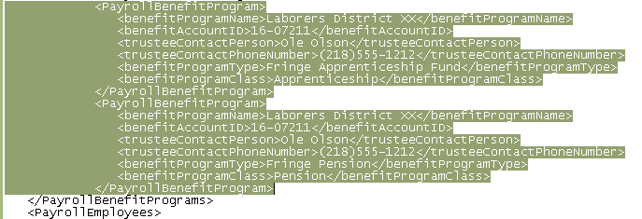

Right click your mouse and Copy

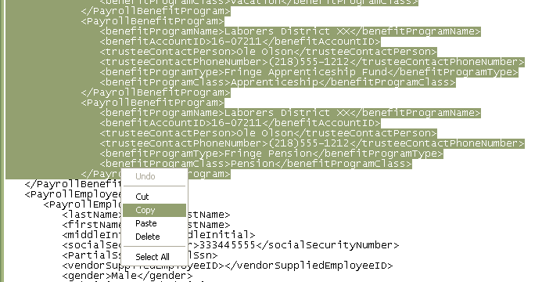

- Next go back to the previously opened Payroll No X Part 1

- Scroll down a little and place your cursor at the end of this row and hit enter to create a blank row above </PayrollBenefitPrograms> (with an “s” at the end of Program). Do not move the cursor.

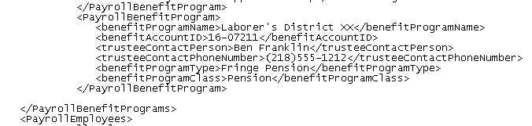

- Right click your mouse and then click Paste

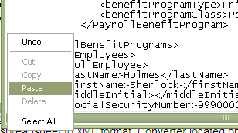

- Check to see if you have any blank rows in the now combined XML file. If so delete them.

- When finished, you can run the payroll through the steps on pages 10 -12 to validate the fringe benefit data similar to running the payroll information through the validator.

- Save Payroll No X Part 1 as Payroll No X Combined XML

- Validate your now combined XML file as described on pages 10, 11 and 12 of this guide.

- Import your combined XML file to CRL using your normal payroll import process.

