MnDOT 2017 Asset Management Gap Assessment

Final
Sept. 13, 2017

Page intentionally blank

Contents
Introduction 1
Summary of Recommendations 2
Description of this Project 3
Background of Transportation Asset Management 3
The MnDOT Highway Network 5
Pavement Conditions and Trends 6
Bridge Conditions and Trends 9
Drainage, Signs, and Other Assets 13
Tradeoffs Among the ‘Other’ Assets 15
Asset Management Reporting 16
Recommendations 16
1. Adopt formal asset management polices 17
2. Evaluate if additional performance measures may encourage a life-cycle approach for flexible pavements 17
3 Agree upon statewide maintenance priorities and targets 20
4. Document maintenance processes needed to achieve the priorities and targets 21
5. Identify core TAMS data that supports decision making and treat them as valuable assets 22
6. Consider asset valuation as another decision-making tool 23

Introduction
This document summarizes the asset management practices of the Minnesota Department of Transportation (MnDOT) and recommends next steps to further strengthen those practices.
Federal statute defines asset management as:
“The term ‘asset management’ means a strategic and systematic process of operating, maintaining, and improving physical assets, with a focus on both engineering and economic analysis based upon quality information, to identify a structured sequence of maintenance, repair, rehabilitation, and replacement actions that will achieve and sustain a desired state of good repair over the lifecycle of the assets at minimum practicable cost.”
MnDOT began this analysis with one of the nation’s most advanced asset management programs already in place. It has produced a transportation asset management plan (TAMP), regularly updates a 20-year State Highway Investment Plan (MnSHIP), and is an early leader in risk management.
The identification of gaps and the recommendations on how to fill them must be viewed in the context of the already mature MnDOT asset management practices. Its practices include the usual asset management elements such as relying on a pavement management system, reporting on asset conditions, and using performance measures to re-allocate resources among assets and districts as conditions change over time. In addition, its asset conditions are generally good and the department has clearly articulated the needed investment to keep them in good condition for 20 years.
In addition, it has several advances not common in most states. These include:
- A management system for forecasting bridge conditions, not merely inventorying them;
- A drainage asset inventory;
- A pavement marking inventory;
- A sign inventory;
- Annual financial forecast updates based upon risk-based assessments of inflation, revenue trends, and other uncertainties;
- Long-standing performance measures with asset-condition targets, and processes for continual monitoring and reporting.
The lack of these processes are the typical gaps seen in most transportation agencies. MnDOT’s use of these processes for many years illustrates the maturity and comprehensiveness of its asset management efforts. Some practices such as the 20-year financial forecast are in their third generation. The pavement marking and drainage management systems are so mature they are about to be updated with more modern systems. In many states, these processes and systems have not yet begun.
Recognizing this backdrop of asset management maturity is necessary to understand the context of the recommendations. These recommendations largely address degree rather than actual gaps. A gap infers an absence but each area of recommendation already has asset management programs or efforts. Instead of filling an absolute gap, the recommendations are intended to further narrow the gap between good asset management practices and state-of-the-art practices.

Summary of Recommendations
This report makes six recommendations which are summarized here and elaborated at the end of the report.
- Adopt formal asset management policies, definitions, and objectives. Although all staff interviewed expressed support for asset management, it was not clear that all shared the same understanding of what it is. More clear definitions of what asset management is and how MnDOT practices it could clarify understanding in the decentralized agency.
- Adopt pavement performance measures that explicitly encourage preservation. MnDOT long has been a leader in performance management and pavement management with commendable results. It could further enhance its asset management practices by adding performance measures that specifically encourage preservation and a long term life-cycle approach to project selection and maintenance.
Recommendations 3, 4, and 5 are linked to support development of the Transportation Asset Management System (TAMS.)
- Adopt statewide core maintenance priorities and targets. MnDOT should identify its core maintenance priorities, set targets for them, and use the targets to influence budgeting and resource allocation. Currently, MnDOT bases maintenance budgets on historical splits. Other than snow and ice control, it is not clear what its maintenance priorities are, and how for example preventive maintenance activities are considered. Many maintenance performance measures have not been tracked in recent years. Also, each district appears to identify its own priorities. Although district flexibility is essential, the apparent lack of maintenance priorities and targets appears to blunt the ability to clearly estimate and budget for maintenance investment needs. In addition, uncertainty about maintenance priorities could complicate the development of TAMS which is intended to support maintenance decision making and budgeting.
- Identify and document the business processes for the core maintenance priorities so they can be supported by TAMS. With the core maintenance priorities and targets identified, MnDOT should document the maintenance business processes needed for those priorities. Then, TAMS can be configured to provide the information and functionality to support maintenance decision makers as they strive to achieve the targets. The development of TAMS provides MnDOT the perfect opportunity to clarify its highest priority maintenance functions. District and central office maintenance personnel could identify statewide core maintenance processes, such as those needed for pavement marking, culverts, signs, or snow and ice operations. In addition, special needs such as for the deep storm tunnels and enclosed drainage in the Metro district can be identified. Then, TAMS can be configured to meet the data needs for these core, high-priority maintenance processes. Without this step, TAMS may be capturing the existing management system data but without tailoring it to meet MnDOT’s updated maintenance priorities. If TAMS does not meet the high-priority needs of maintenance users, there will be less incentive for the users to populate its data and use its analytic capabilities. MnDOT does not need to document every maintenance process – only those that support the highest priority functions.
- Identify core TAMS data that support decision making and treat them as valuable assets. Closely related to recommendations 4 and 5 is the recommendation to treat the data that will feed the core maintenance priorities in TAMS as valuable assets. Like any valuable assets, they would be treated to standards for how they are acquired, maintained, used, and measured. Data is expensive to collect and maintain. However, making decisions without data can be even more costly. As MnDOT clarifies its key maintenance priorities, it could benefit from codifying how the data for its key priorities are collected, stored, accessed and updated consistently, and how they are an invaluable part of its infrastructure assets. Collecting too much data, or the wrong data, saddles MnDOT with ongoing expense. Not collecting the data needed for making decisions at various levels in MnDOT, and not storing the data in a standard format, diminishes the utility of TAMS and impedes the ability to make well-informed investment tradeoffs.
- Consider asset valuation as an additional decision-making tool. Asset valuation is the assignment of monetary value to the physical infrastructure based on the infrastructure’s size, condition, age, and cost to construct. It allows agencies to assign a monetary value to the deterioration of assets and express that value as depreciation or lost equity to the public’s assets. Reporting asset valuation and the value that could be lost through inadequate investment could give MnDOT another tool with which to communicate investment needs and consequences.

Description of this Project
The MnDOT, the Federal Highway Administration (FHWA), and a consultant team conducted eight activities to generate this report. Those were:
- Conduct a project kick off meeting
- Review relevant MnDOT materials and reports
- Interview MnDOT officials, both in headquarters and the districts
- Survey staff
- Hold a half-day workshop to review survey results
- Draft an implementation plan
- Conduct second workshop to review implementation plan
- Incorporate comments and complete implementation plan.

Background of Transportation Asset Management
The strategic and systematic process of asset management involves a complex process based upon a simple fact -- Assets cost less to maintain over their lifecycle if they receive proper treatment at the proper times. If they are left to deteriorate, they cost much more to restore.
This simple fact becomes complex for several reasons. First, an agency has hundreds of thousands of assets all of different age and condition and with each requiring different treatments. Second, over their lifecycle it is most economical to treat assets when their deterioration is minor and not waiting until they require expensive rehabilitation or replacement. However, anticipating the proper treatment at the proper time for thousands of assets requires sophisticated asset inventories that track each asset’s condition and needs. Third, because it can take several years to develop a highway project, anticipating when an asset needs treatment and having projects ready to bid requires extensive advanced planning. In short, asset management requires complex asset inventories, sound engineering to anticipate treatment needs and reliable processes to deliver capital projects and in-house maintenance treatments at the right time for thousands of assets each year.
Further complicating asset management is a lack of money. An agency may know what treatment the asset needs, but may lack the money or staff to provide it. This compels the agency to prioritize and make tradeoffs. It may understand the optimum asset management strategy for its assets but must settle for lesser treatments to balance limited budgets. This puts the agency in a continuous “catch up” mode where it is treating some assets at the proper time but letting other assets deteriorate. The deteriorated assets multiply, create a backlog, and require more expensive repairs that may be postponed for years.
A final complexity is organizational coordination and political support. Many headquarters units and the agency’s districts all need to coordinate efforts to collect data on all the assets and then schedule the proper treatment at the proper time. For this to happen, legislatures and commissions must understand why these processes are needed and must provide the money for staff, data, management systems, and preservation and maintenance required for managing assets economically over their lifecycles.
In short, asset management is a systematic approach to sustaining the physical condition of transportation infrastructure at the highest condition with available resources. Documents such as safety, freight or congestion plans address how well the highway network moves people and goods. An asset management plan addresses the physical condition of infrastructure, which is the most fundamental consideration of a transportation network. If it deteriorates far enough, it will be neither safe nor efficient. Hence, asset management addresses the fundamental issue of how an agency measures, manages, invests in, treats and maintains the physical condition of its assets.
The Federal Highway Administration (FHWA) in 2016 published final rules for what must be included in each state’s 10-year transportation asset management plan. They include:
  - Asset management objectives. The objectives must align with the agency’s mission, and must be consistent with the purpose of asset management which is to achieve and sustain the desired state of good repair over the lifecycle of the asset at a minimum practicable cost.
  - Asset management measures and targets to assess the condition of the assets and performance of the highway, and are consistent with the State’s asset management objectives.
  - A summary description of the condition of NHS pavements and bridges, regardless of ownership.
  - Performance gap identification. A performance gap is the gap between the current asset condition and State DOT targets for asset condition, and the gaps in system performance effectiveness that are best addressed by improving the physical assets.
  - Lifecycle planning, which means a process to estimate the cost of managing an asset class, or asset sub-group over its whole life with consideration for minimizing cost while preserving or improving the condition.
  - Risk management analysis, including the results of NHS pavements and bridges, and of assets subject to repeated damage during emergencies.
  - A financial plan which is a long-term plan spanning 10 years or longer, presenting a State DOT’s estimates of projected available financial resources and predicted expenditures in major asset categories that can be used to achieve State DOT targets and….highlighting how resources are expected to be allocated based on asset strategies, needs, shortfalls, and agency policies.
  - Investment strategies which are a set of strategies that result from evaluating various levels of funding to achieve State DOT targets for asset condition and system performance effectiveness at a minimum practicable cost while managing risks.

The MnDOT Highway Network
A combination of a relatively large landmass and dispersed population creates the need for MnDOT to manage a large highway network with diverse conditions. It manages the congested and growing Minneapolis/St. Paul region as well as a large rural network that can be lightly travelled but critical for rural economies.
The Minnesota DOT serves the 12th largest state by area with just under 87,000 square miles, with the nation’s 20th largest population totaling about 5.5 million people. FHWA reports it has the nation’s 22nd largest highway network with FHWA reporting 11,871 miles of road under the agency’s jurisdiction. The population is highly concentrated with 22 percent of it in Hennepin County encompassing the Twin Cities. Out of 87 counties, the top five include 50.4 percent of the state’s total population. Minnesota is an economically robust state whose population has grown 17.1 percent since 1996. However, the growth is uneven with 31 of the 87 counties experiencing population declines over that period. Minnesota’s 2016 unemployment rate of 3.8 percent is the nation’s tenth best. However, unemployment is uneven across the state with the far northern Koochiching County with a 7 percent unemployment rate, and Cottonwood County with a 9 percent rate.

Pavement Conditions and Trends
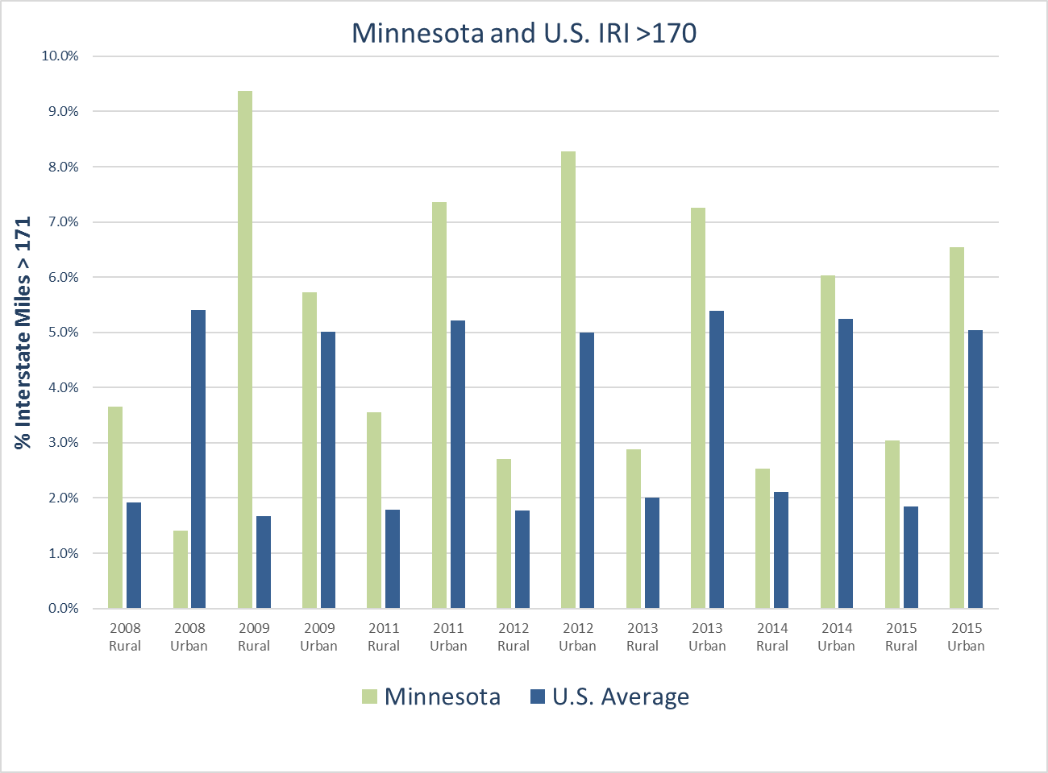
Although MnDOT’s roadway conditions generally are good, its urban Interstate Highway System pavements are worse than national averages at least in terms of one surface distress, the International Roughness Index (IRI.) As seen in Figure 1, the percentage of miles with an IRI above 171 is higher in Minnesota than nationally, and has been since at least 2008. Note that FHWA did not publish data for 2010.
Figure 1 MnDOT’s Interstate ‘roughness’ comparision
When urban Interstate pavement conditions are averaged from 2011 to 2015, MnDOT’s pavement roughness is the 11th highest nationally. That ranking excludes Washington, D.C. which is not included because of its small sample size. Minnesota built much of its urban freeway system with concrete which often produces higher IRI values. In addition, many miles of the urban Interstate pavements are more than two decades old and display noticeable distresses.
MnDOT produces a detailed annual pavement-condition report that evaluates pavements on several structural metrics in addition to the surface characteristic of IRI. Each year, since the late 1960s, MnDOT’s Pavement Management Unit has collected pavement data on the state system, known as the trunk system. In recent years, it has collected roughness condition data in both directions on all trunk system routes. Cracking data are analyzed for the first 500 feet of each mile and section with one direction measured for undivided roads, and the outside lane in both directions measured for divided routes.
MnDOT calculates four pavement-condition metrics. Those are a Ride Quality Index (RQI), a Surface Rating (SR), a Pavement Quality Index (PQI) and Remaining Service Life (RSL.) Each provides different insight into pavement health allowing the agency to better understand pavement performance, and to improve forecasting. The Ride Quality Index is a 0-5 smoothness calculation MnDOT uses instead of only IRI to measure the smoothness, or lack of it, the driver experiences. The surface rating is calculated from surface distresses such as cracks, potholes, patches and ruts. The distresses are multiplied by a weighting factor that captures severity and serious distresses such as alligator cracking or broken panels.
Figure 2 MnDOT’s ride quality trends.
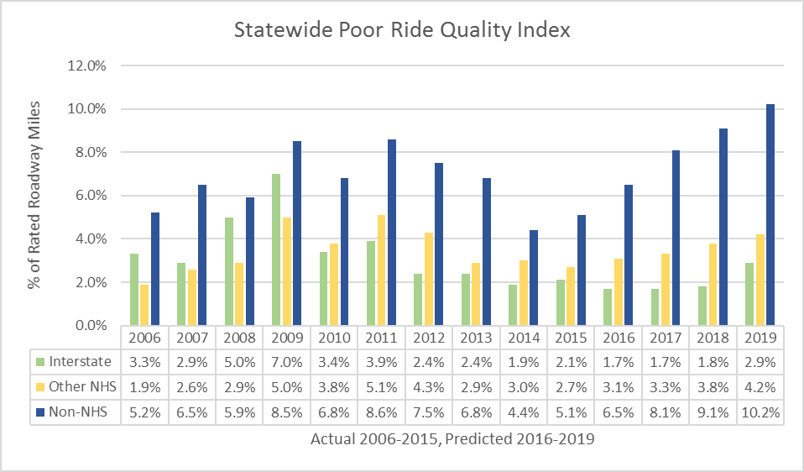
Figure 3 MnDOT remaining service life trends.
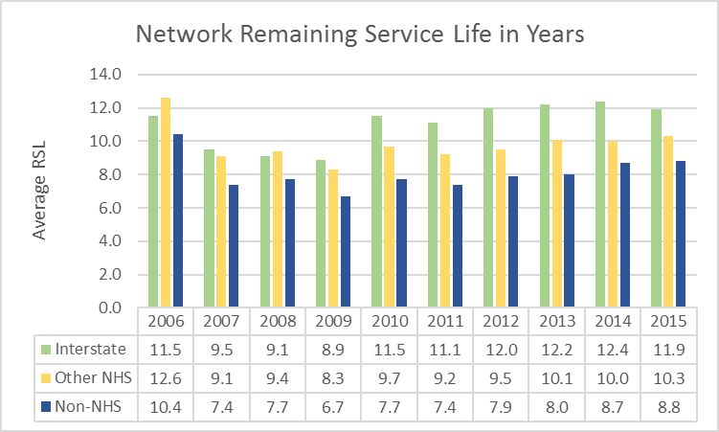
The Pavement Quality Index is a composite of the ride and structural defects and is the square root of a section’s Ride Quality times its Surface Rating.
The fourth measure directly relates to the sustainability of MnDOT’s pavements. It is the Remaining Service Life (RSL). MnDOT calculates it by estimating the length of time before the Ride Quality Index falls to a 2.5 out a 0-5 rating. The RSL is calculated statewide and for each district by the Interstate Highway System, other National Highway System (NHS), and for the non-NHS.
MnDOT also has used performance targets for many years to report conditions, and measure the condition of the pavement network. MnDOT’s Interstate Highway target is 70 percent or more in “good” condition and no more than 2 percent poor. Its target for non-Interstate NHS is 65 percent “good” and no more than 4 percent poor. It’s targets for the non-NHS routes are 60% “good” and not more than 10% poor. Table 1 lists the performance categories.
Table 1 MnDOT pavement performance categories
Descriptive Category | RQI Range | Performance Measure Category
Very Good | 5.0-4.1 | Good
Good | 4.0-3.1
Fair | 3.0-2.1
Poor | 2.0-1.1 | Poor
Very Poor | 1.0-0.0

MnDOT staff, the state’s governor, and the media have discussed extensively the need for additional investment. MnDOT’s data supports informed discussion of the investments needed to support sustainable conditions. MnDOT’s annual pavement report forecasts that pavement conditions on all three systems will deteriorate based upon the projects scheduled in the current four-year State Transportation Improvement Program (STIP.) Although the percentage of good Interstate pavement declines only slightly by 2019, the amount of poor pavement grows as more fair pavement deteriorates. Programmed projects restrain the growth in poor pavements on the Interstate System but the remaining NHS and non-NHS see measurable increases in the percentage of the systems with poor pavements. Between 2015 and 2019 the percentage of poor pavements on the non-NHS doubles from 5.1 percent to 10.2 percent.
The picture presented by the remaining service life is mixed. The overall remaining service life for Interstate Highways is better than between 2007 and 2009 but has slightly deteriorated between 2012 and 2015. The RSL for both the non-Interstate NHS and non-NHS have declined compared to 2006 but show gradual improvement from a low in 2007.
The RSL varies considerably by district. While the 2015 statewide average was 11.9 years, for district 7 it was only 5.6 years. For the metro district, it was 10.1 years. In Minnesota, districts are called Area Transportation Partnerships, or ATPs.

Bridge Conditions and Trends
Minnesota bridges are above national averages as seen in Figures 4 and 5. MnDOT’s NHS structurally deficiency percentage was substantially below the national average since 2000 but the difference between the state and U.S. average narrowed in recent years. Overall for all bridges across the state, a similar trend is evident. Although state conditions are better than national averages, that trend is narrowing and overall state bridge deficiencies are higher now than in some previous years. The jump in deficiencies seen in 2012 is attributed to two large structures slipping from fair to poor.
Figure 4 MnDOT NHS Bridge Conditions.
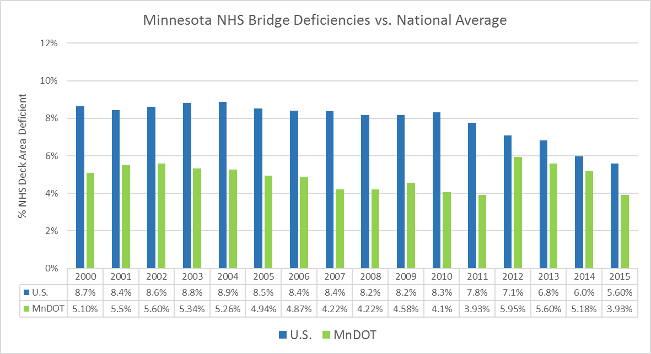
While the National Bridge Inventory captures only structural deficiency and functional obsolescence, MnDOT has since 1997 used a more detailed set of performance measures and targets. It also produces an annual Minnesota Bridges report that summarizes conditions statewide, by district, by length, by ownership, and by type of deficiency. It also reports on performance of the measures and targets. Its three bridge performance measures are Structural Condition Rating, Geometric Rating, and Load Carrying Capacity Rating. The targets are:
- For structural condition to have 55% of the bridges in good condition and no more than 2% poor;
- For geometric rating to have 50% in good condition and no more than 5% poor, or structurally obsolete, and;
- For load capacity to have 50% HS25 capacity or greater and no load-posted structures.
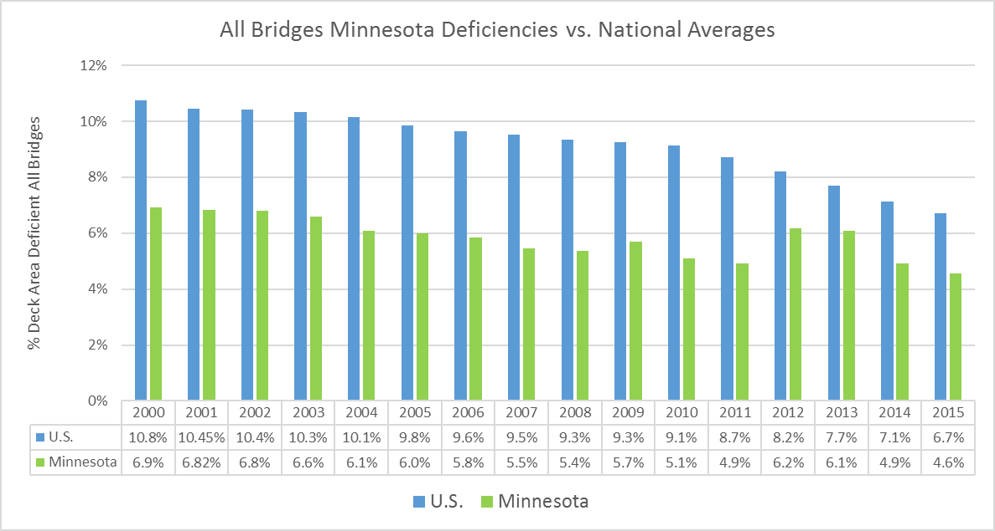
Figure 5 Conditions for all Minnesota bridges
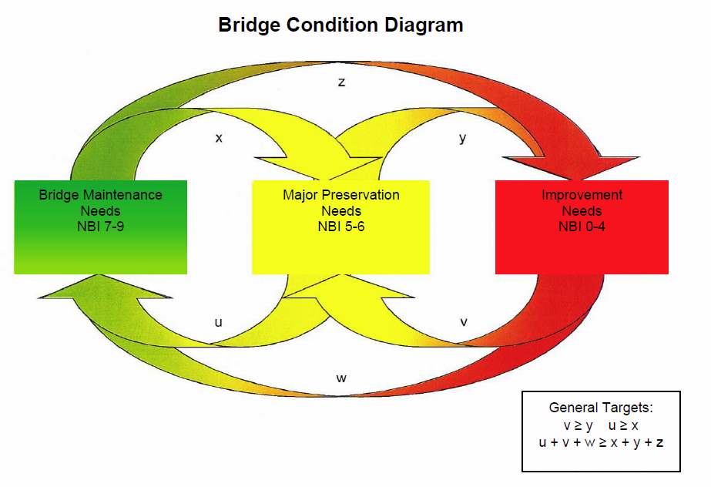
MnDOT pursues a balanced bridge strategy that stresses application of preservation, maintenance, rehabilitation, and replacement at the appropriate times. The intent is to address deficiencies to prevent structures from falling into a lower, and more expensive, condition state as illustrated in Figure 6. As bridges begin to deteriorate and move from a condition 7 to a 5 or 6, preservation and rehabilitation treatments are applied to return them a condition level of 7 to 9, avoiding as long as practical more expensive replacement.
Figure 6 MnDOT’s bridge treatment logic
The Fiscal Year 2016 through 2020 Bridge Preservation and Improvement Guideline spells out how central office and district staff are to select structures for the appropriate treatment. Depending upon a structure’s condition and its point in its lifecycle, the guideline recommends appropriate treatment in the following categories.
Minor Preservation: These treatments are conducted by district staff and can include crack sealing, debris removal, deck patching, joint sealing, joint repairs, and deck flushing.
Major Preservation: These are usually contracted and can include joint repair, elimination of deck joints, deck overlays, approach panel repair or replacement, painting, bearing replacement or maintenance, cathodic protection or chloride extraction.
Bridge Rehabilitation: This also is contracted and can include deck replacement, superstructure replacement, widening on existing substructure, major structural repairs without increasing capacity.
Bridge Replacement: Replacements are considered when rehabilitation would cost 70% or more of the cost of replacement, or when one or more main structural elements are in poor condition.
The guideline says the process for determining bridge investment needs is the Bridge Replacement and Improvement Management System, or BRIM. The system identifies specific bridges and work times in addition to estimating costs and the predicted risk of service interruption.
BRIM analyzes bridge inspection data and inventory data to predict the replacement or improvement needs for each bridge based on expected deterioration. BRIM then uses risk assessment methods to determine the bridge’s probability of service interruption and user consequences to establish a Bridge Planning Index (BPI.) Based on the BPI and input from the district staff, a candidate list of bridges and work types is produced. Then, district and central office engineers conduct field inspections and review inspection histories to refine bridge candidates and identify the appropriate treatment.
The result of MnDOT’s bridge program and process has been to produce a stable inventory of conditions over time as seen in Figure 7.
Figure 7 Bridge condition trends as reported by MnDOT’s performance measures
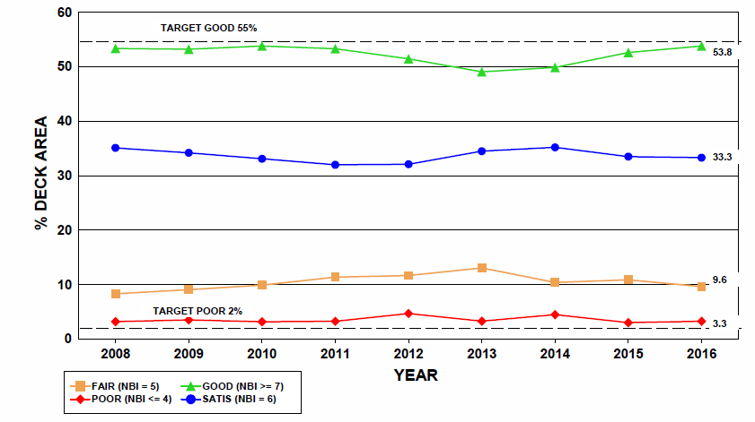

Drainage, Signs, and Other Assets
MnDOT has a commendable set of other asset inventories or systems which are not common in most states. However, the assets may currently be in different, unconnected databases and the quality of the data may depend upon the priorities of districts who collect them.

Drainage Assets
The HydInfra inventory system evolved from a 1986 culvert inspection manual and by 1996 was designed as an inventory and rating system for culverts, pipes, aprons, ponds, ditches, outfalls and other hydraulic assets. At the time MnDOT developed its initial TAMP draft, a performance measure for highway culverts was developed and HydInfra has supported reporting on this culvert-condition performance measure. stricts inspect the assets and rate them on a 1-4 scale. Some district personnel use the system to prioritize culvert replacements and to plan for replacement of deteriorated culverts when roadway projects are programmed, and to plan for and prioritize maintenance work; however this practice is not consistent statewide.
MnDOT officials report that the inventory is good for items such as culverts under major or trunk routes. The extent of other data districts have collected or update depends on district needs and interests. The Metro district that includes Minneapolis and St. Paul uses HydInfra extensively for many assets such as enclosed storm sewer systems and stormwater tunnels. Its personnel report that because of their extensive environmental permitting for storm water, the system is very important to them. Other more rural districts also rely on it and would like to understand if the cost and effort to expand the inventory further to include driveway pipes would be worthwhile. Although it will not provide a complete storm sewer inventory in greater Minnesota, MnDOT is taking advantage of a statewide LiDAR survey currently being performed to locate catch basins and manholes visible within the roadway. This data will ease (and hopefully encourage) populating of storm sewer data in rural districts, though the department has not adopted this as an official position.
District personnel are responsible for conducting condition inspections of highway culverts on a cycle which is dependent on the condition of the subject culverts, which varies from annually for very poor pipes to a 6 year cycle for very good pipes. Although compliance with the inspection cycle is a measure tracked by the department, inspection activities compete with other maintenance products and services for staff resources and may suffer from other work needs determined on a local basis to be higher priority. i
MnDOT officials say HydInfra’s biggest benefit is in risk mitigation. If culverts are flagged as being in poor condition it prompts action that could avoid a dangerous or expensive culvert collapse. Before last year, the culverts were only examined for high-risk when a project was considered in its section. Starting last year, “flags” were added to HydInfra to draw attention to high-priority structures.
HydInfra is not used systematically at a statewide level to estimate capital or maintenance needs to achieve a certain hydraulic condition level, although a decision tree with repair recommendations is available. However, until 2014 it had been used to measure performance statewide and by district of whether inspections occurred and to report on the percentage of culverts in poor or very poor condition. MnDOT can conduct ad hoc reporting of how much is spent on hydraulic maintenance by pulling labor reports from its labor-reporting system and matching them with HydInfra data. The HydInfra data also can be mapped if it is exported to the department’s Georilla mapping application. A department developer produced an additional application to simplify mapping but the maintenance of that application depends upon the workload of the developer.
The plan is for the new TAMS system to replace HydInfra.
MnDOT included an analysis of its highway culvert inventory in its initial Draft TAMP.

Sign Assets
MnDOT also has a SignTrack inventory system for its roadway signs which each district maintains (District 7 uses a different software program which was once in use at MnDOT called Cartegraph).
MnDOT conducted a study of its signs in 2013 and uses its results to base an average 15-year replacement cycle. Staff estimated that the inventory has 400,000 sign records, and about 60,000 signs are more than 15 years old. Staff report they don’t think MnDOT has many problems with poor reflectivity but that it does have too many faded or cracked signs.
It is up to each district to maintain its sign infrastructure and districts maintain the signs with their district allocations. The department reported up until 2014 two sign performance measures. One was of the percentage of signs older than 12 years, with plans to shift the timeframe to 15 years. The second was public satisfaction with signs. A third measure on the transfer of sign inventory to a Traffic Asset Management System was tracked in 2013 and 2014.
Under the LiDAR project mentioned above, MnDOT is currently updating inventory and location data for its signing infrastructure.
As part of the implementation of its TAMS project, MnDOT will transition to the new software and retire both of the existing management systems.

Pavement Markings
MnDOT has a rather old and in-house developed Excel-based pavement marking data base. Although the system is many years old and lacks a lot of functionality, the fact that it exists and has been used for many years is a testament to the department’s efforts. Most state DOTs lack any sort of pavement marking inventory. For pavement markings, MnDOT allocates about $7 million annually and conducts the work in-house after determining that its crews were more economical than contractors. Districts pay for the re-striping with their funds but schedule the work with the centralized crews. The centralized crews travel the state to conduct the striping. The department reported statewide and district pavement marking performance measurements up to 2013. Those two measures were public satisfaction with pavement markings and districts’ compliance with a department pavement-marking technical memo.
Similarly to the sign inventory mentioned above, MnDOT is updating and completing its pavement marking inventory as part of the statewide LiDAR survey.
Again, MnDOT plans for TAMS to replace the in-house pavement marking inventory.

Guardrail
The Metro district has a guardrail inventory and process for tracking guardrail hits and repairs. Other districts do not have a guardrail inventory, however, the statewide LiDAR survey was commissioned in large part to develop such an inventory which will be incorporated into the TAMS statewide database.
MnDOT’s performance measurement office has proposed measures for inspection of cable median barrier and attenuators but there is not data to populate the measures as yet.

ITS and Related Equipment
The MnDOT maintenance office has a statewide inventory and condition database for Road and Weather Information System (RWIS) sensors which was recently transitioned from a stand-alone system into TAMS. It uses it to track condition and to make needed repairs, and track associated costs.
The Metro district has replaced several databases with one (TAMS) that tracks Intelligent Transportation System (ITS) assets such as dynamic message signs, ramp meters, cameras, loop detectors, toll pass readers, cabinets and other similar assets. The inventory does not have condition data but they estimate the condition based on the assets’ age. They use the system for generating work orders and for recording inspection and maintenance histories. MnDOT plans to include ITS assets in its next asset management plan, and to begin to develop a longer-term plan for recycling out obsolete assets and refreshing the system with updated components.
MnDOT is currently preparing a second iteration/edition of its initial TAMP and has nearly completed analyses’ of these devices for inclusion.

Other Structures
Although MnDOT has a well-established process to sustain its bridge inventories, it has less-than-complete processes for other structures such as retaining walls, noise walls, overhead signs and barrier rail. Staff report they are attempting but struggling to develop inventories and “owners” for the other structures. Again, they hope that adoption of TAMS will simplify the management of those assets. They have also included these assets in the second iteration of the TAMP.

Tradeoffs Among the ‘Other’ Assets
Although most asset management tradeoff decisions are between pavement assets and bridge assets, several MnDOT staff emphasized the need for good inventories and condition data for these “other” assets in order to make well-informed tradeoff decisions. This point was emphasized particularly by staff from the Metro district. They repeatedly stressed the constraints they face in meeting all the needs for noise walls, retaining walls, regulated drainage assets, ITS components, and other non-pavement and non-bridge assets. This point was raised in a different fashion by the financial planning staff, and the district engineers. They noted that investment in many maintenance items was set by long-standing formulas and not necessarily by analysis of how much investment is needed to calibrate a condition level. Many expressed the hope that TAMS will provide better data on the condition and investment needs of more assets beyond pavements and bridges.

Asset Management Reporting
Another important element of MnDOT’s asset management processes is its extensive reporting. It has produced three generations of its MnSHIP 20-year highway investment plan. This report provides a 20-year revenue and inflation forecast as well as estimates of the needs by major programs, such as for bridges, pavements, safety, and mobility. It explains how resources are allocated by program and how asset conditions are expected to decline as a result of a lack of revenue. MnSHIP illustrates the tradeoffs MnDOT is proposing, such as sustaining higher investment levels in NHS assets and reluctantly accepting significantly lower conditions in non-NHS assets by 2037 if investment levels remain as projected. Staff note that MnSHIP calls for an additional $12 billion in investments and that is approximately the amount the governor called for in an investment proposal.
For the first time since the beginning of its asset management program, MnDOT was able to run its pavement and bridge (agency personnel) cost models against the conditions forecast at various investment levels in the most recent MnSHIP.
In 2013 MnDOT produced a first-generation transportation asset management plan addressing the elements included in draft Federal asset management regulations, in addition to several asset classes not required. As mentioned above, additional asset classes are being studied and prepared for potential inclusion in MnDOT’s final TAMP. The department also produces an annual Performance Report that summarized performance of the department and the condition of key assets such as pavements and bridges. In 2012, it produced a Highway Systems Operations Plan that examined the long-term investment need for assets such as drainage structures, guardrail, signing, pavement markings, and lighting. However, that report has not been updated. MnDOT also produced in 2015 a statewide ITS plan.

Recommendations
This report makes six inter-related recommendations. As was emphasized in the introduction, these recommendations are intended to take MnDOT from “good to great.” The gap analysis was predicated on the assumption that MnDOT already has mature asset management practices that are more advanced than those in most states. These recommendations look ahead to “state of the art” asset management practices that extend beyond bridges and pavements and encompass additional assets. Central to the recommendations is the need for clear policies and data to allow MnDOT to more fully make tradeoffs between not only pavements and bridges but among more asset classes such as drainage, lighting, guardrail and cable, ITS assets, and other critical assets.
Although each recommendation is important, collectively they would create greater synergies for the asset management efforts.

1. Adopt formal asset management polices
Although a strong commitment to asset management exists and is described in planning documents, it is not documented explicitly in policies and objectives. The commitment is largely inferential and assumed by the asset management “structure” that exists in the management systems, asset-condition reports, and performance measures.
The lack of formal policy combined with a decentralized structure may lead to different interpretations of what is “asset management” and how it is pursued at MnDOT. A clear asset management policy could indicate to districts and all agency personnel that the department wants the best long-term investments, not just the best short-term conditions.
It appeared through the interviews, that some staff thought that achieving targets for pavement surface conditions illustrated the agency’s commitment to asset management. However, meeting surface condition targets through periodic overlays may not be the lowest-lifecycle treatment for all pavements. Not apparent when district staff discussed project-selection was the need to continuously identify the proper treatment at the proper time for each section to extend pavement life and lower its lifecycle cost.
MnDOT’s commitment to asset management, and to lowering lifecycle costs, is evident in its asset management plan. However, it was less clear that those same principles drove all programming or maintenance decisions. The policy could define what MnDOT means by asset management and emphasize that programming seeks to achieve the lowest lifecycle costs balanced with the need to achieve short-term targets. As a result, staff could be supported to more heavily invest in maintenance and preservation which may produce better long-term conditions, even if they come at the expense of lower short-term conditions.
The recommendation to adopt formal asset policies is intended to complement the second recommendation.

2. Evaluate if additional performance measures may encourage a life-cycle approach for flexible pavements
MnDOT could evaluate if new or additional performance measures would better support a long-term asset management approach to managing flexible pavements. The target for Interstate Highway System pavement is that no more than 2% of the system have poor ride quality and at least 70 percent be in good condition. For the non-Interstate National Highway System, the target is 65% good ride quality and not more than 4% poor. For non-NHS pavements, the target is 60% or more good and 10 percent or less poor.
Some district programming staff say the targets encourage them to pursue a worst first approach. Although they understand good pavement preservation strategies that would pursue a “keeping good roads good” approach, they say the performance targets do not reward preservation investments. MnDOT believes it should evaluate whether the pavement management models give enough credit to PM investments.
MnDOT currently centralizes pavement-investment decisions based upon its assumption that MAP-21 Federal performance targets would examine the states’ NHS pavement conditions. This was a logical decision to make several years ago. At the time, MAP-21 set in statute a target of no more than 10 percent of the NHS bridges to be structurally deficient. If a state exceeded that amount, it would face restrictions on how it could invest Federal-aid until it had achieved the condition target.
At the time, MAP-21 instructed FHWA to develop a pavement target. FHWA adopted a final target in 2016 and it was substantially different than the target for bridges. The pavement target is that no more than 5% of Interstate Highway System pavements be in poor condition. FHWA did not adopt a NHS target but leaves it up to the State to set its NHS pavement targets. Very closely related to this provision of leaving NHS condition targets up to the States are provisions in the final asset management rule. Those provisions call for the States’ asset management plan to identify strategies and investments to achieve a “state of good repair” for the NHS. Defining a “state of good repair” is left up to the State. The result of the condition-target rule and the asset management rule is that States have much more flexibility for setting NHS pavement targets and in defining what they think is a “state of good repair” for the NHS pavements. Although States have to set short-term condition targets for the required two-year and four-year performance reports required under the performance management rule, those targets are left up to the State.
MnDOT could adopt new targets or additional targets that seek to achieve the highest overall network level condition over 20 years, instead of just trying to achieve a short-term condition target. Or it could adopt a target of achieving the highest NHS remaining service life. Or it could add targets to measure the extent to which it capitalizes on opportunities for using low-cost preservation treatments. Additional measures could be to reduce the number of miles with serious cracking such as alligator, block, or wheel-path cracking, or to reduce the rate of pavement decline. In short, it has the flexibility to adopt new or additional measures that encourage a life-cycle approach to pavement investment.
MnDOT also may benefit from a review of its targets because they appear to be largely reliant on surface conditions, not the long-term structural condition of the pavements. MnDOT produces performance measures that assess ride quality, cracking, and remaining service life. Collectively, these appear to be balanced measures that address users’ concern over smoothness with engineering and economic concerns over structurally sound pavements. However, surface conditions dominate the measures.
The official performance measure that the department reports is its Ride Quality Index (RQI) which is based on the International Roughness Index (IRI). The IRI values are converted into a 0-5 scale. It is the measure by which districts are judged and it is the primary measure reported in the asset management plan and the MnSHIP. MnDOT has prioritized this measure in accordance with their belief that customers’ highly value ride. MnDOT is also concerned with seasonal variations in ride not being reflected in the measure due to surveys being taken in the summer, while perhaps half of the annual usage of the pavement occurs during frozen conditions.
The department also reports a Surface Rating (SR) which is based upon rutting, cracking, and potholes observed on the surface. This measure does capture some important pavement structural indicators. It captures for flexible pavement alligator or block cracking, and wheel path cracking. For rigid pavements, it captures broken concrete slabs or bad joints. However, this measure does not drive programming.
The Surface Rating data is combined with the ride quality data to produce a Pavement Quality Index (PQI). It is equal to the square root of the sum of Ride Quality Index multiplied by the Surface Cracking. Although the PQI includes some structural pavement elements, those are diluted by combination with the Ride Quality data. Furthermore, any pavement recently resurfaced may have deep structural problems but they will not be apparent based up a surface-only survey.
Finally, the department also produces a Remaining Service Life (RSL) measure which would appear to support asset management. The greater the number of remaining years of service, apparently the greater the pavement structure. However, the MnDOT RSL is based on the number of years until the surface degrades to a Ride Quality Index condition of 2.5 out of 5. Therefore, what is measured is the years of good surface life, and not necessarily the years of good overall pavement performance.
This recommendation to re-study the flexible pavement performance measures is made with full acknowledgement that MnDOT has a strong, veteran team of pavement analysts and they are using a sophisticated pavement model. The suggestion is that MnDOT may benefit from investigating whether additional measures, combined with the asset management policy, could further incentivize investments in preservation. The leading impediment to more preservation investment is a lack of money and a higher-than-desired number of poor-condition pavements. However, the amount of poor pavement is disproportionately in three of the department’s eight districts. Five of the eight districts have above-average conditions that would seem to benefit from a preservation-first approach. It may be possible that over the course of a decade, MnDOT could create higher overall network conditions by emphasizing preservation in the five above-average districts and pavement rehabilitation in the three below-average districts as seen in Figure 8.
Figure 8 Poor ride quality miles by district
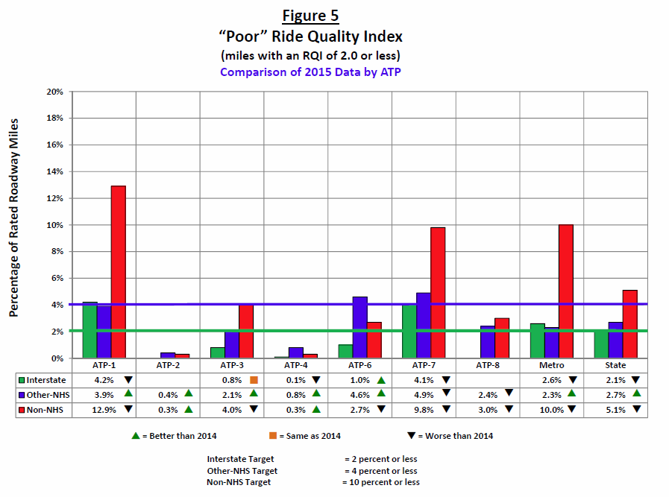

3 Agree upon statewide maintenance priorities and targets
The third recommendation is to adopt statewide core maintenance priorities and targets. MnDOT should identify its core maintenance priorities, set targets for them, and use the targets to influence budgeting and resource allocation. Currently, MnDOT bases maintenance budgets on historical splits. Other than snow and ice control, it is not clear what its maintenance priorities are. Many maintenance performance measures have not been tracked in recent years. Also, each district appears to identify its own priorities. Although district flexibility is essential, the apparent lack of maintenance priorities and targets blunts the ability to clearly estimate and budget for maintenance investment needs. In addition, uncertainty about maintenance priorities could complicate the development of TAMS which is intended to support maintenance decision making and budgeting.
Providing districts leeway in setting priorities is justifiable as districts may experience emergencies or unique local needs. However, the lack of statewide consensus or formal targets for the condition of these roadside assets and maintenance activities reduces MnDOT’s ability to plan for them. The setting of district maintenance budgets is done by general formula and not set by maintenance needs as determined by condition data. Similarly, maintenance staffing levels are not set by the labor needed to achieve agreed-upon maintenance targets. Instead, district maintenance and labor budgets are set by formula based upon general factors such as population and lane miles.
It would appear that MnDOT would have more clarity and sense of priority for maintenance investments if it more clearly understood its conditions, its targets, and the costs necessary to sustain the targeted maintenance conditions.
Any set of statewide maintenance priorities should allow for district flexibility. When the Ohio DOT adopted a set of statewide maintenance priorities, it determined that achieving those priorities would consume about 35 percent of available maintenance labor hours. The remaining hours were left for District priorities. Within the 35 percent of required hours were hours for tasks districts were performing already such as drainage maintenance, shoulder drop off repair, mowing, sign maintenance and so forth. The statewide priorities set minimum condition targets for basic roadway elements but also allowed discretion for district priorities. Another factor that can accommodate district priorities, is to allow districts latitude to set the targets for these items within a range of tolerable targets. For example, on a five-point scale districts could chose to set targets for some items at either 4 “good” or 5 “excellent.” Either would be acceptable but would allow districts further latitude while also ensuring that acceptable maintenance conditions are met statewide.
The 2012 Highway Systems Operations Plan provides an example of what could be updated. Also, the department has drafted a set of 59 maintenance-related performance measures, although data does not exist to populate most of them. This could serve as the starting point for a maintenance-led analysis of which of these measures are critical, which are important, and which are only desirable. Also, such a list of measures and priorities could vary by district. What is critical in the Metro district may not be in upstate rural Minnesota.
Reaching consensus on the key measures and their targeted level of performance would allow MnDOT to calibrate more closely its investment needs, clarify priorities for districts, and lead to better understanding of which maintenance data are most important to collect and maintain.
Without a clear set of priorities and targets, it is less clear which data and what functionality are most important for TAMS to provide. TAMS could focus more closely on the high-priority functions and data that support target attainment.

4. Document maintenance processes needed to achieve the priorities and targets
Building from recommendation 3, recommendation 4 is to document the key business processes for the core maintenance priorities so they can be supported by TAMS. Then, TAMS can be configured to provide the information and functionality to support maintenance decision makers as they strive to achieve the targets. The development of TAMS provides MnDOT the perfect opportunity to clarify its highest priority maintenance functions. District and central office maintenance personnel could identify statewide core maintenance processes, such as those needed for pavement marking, culverts, signs, or snow and ice operations. In addition, special needs such as for the deep storm tunnels and enclosed drainage in the Metro district can be identified. Then, TAMS can be configured to meet the data needs for these core, high-priority maintenance processes. Without this step, TAMS may be capturing the existing management system data but without tailoring it to meet MnDOT’s updated maintenance priorities. If TAMS does not meet the high-priority needs of maintenance users, there will be less incentive for the users to populate its data and use its analytic capabilities.
MnDOT does not need to document in great detail every maintenance process – only those that support the highest priority functions. For example, MnDOT could apply the 80/20 approach. Which 20 percent of maintenance activities consume 80 percent of the maintenance crews’ time? Out of hundreds of maintenance activities, which 25 would MnDOT include in a maintenance dashboard? Once, these decisions are made, then document what are the processes for assigning labor, equipment, materials, or contractors to perform these tasks. TAMS could be configured to provide information, inventories, conditions, locations, work orders, and documentation to support decision making around those priorities. For lower priority or less-frequent tasks, TAMS could provide less data and functionality, such as only cost, hours, material, and location of activities.
TAMS provides MnDOT the opportunity to replace several old systems with ones that include simplified data entry, data retrieval, mapping, and analytical capabilities. Documenting and agreeing upon business practices is the first recommended step in application development. Otherwise, the new system could be developed without meeting users’ current needs. Data that users want may be missing, or data that is collected may not be useful for decision making.
The adoption of TAMS provides increased opportunity, and increased need, to address Issue 3, the setting of statewide maintenance priorities. The setting of maintenance priorities and targets could be used to prioritize the criticality of the TAMS data collection. Data for critical activities may be collected with greater frequency and with higher quality assurance than data for desirable activities. Also, the prioritization effort could determine what data is needed, and not needed, for users at the county, district, and statewide level. Without the linking of the business practices with the TAMS functionality, MnDOT will be less assured that the significant TAMS efforts will enhance its maintenance operations.

5. Identify core TAMS data that supports decision making and treat them as valuable assets
Building from recommendations 3 and 4, recommendation 5 is to identify core TAMS data that support decision making and treat them as valuable assets. Like any valuable assets, they would be treated to standards for how they are acquired, maintained, used, and measured. Data is expensive to collect and maintain. However, making decisions without data can be even more costly. As MnDOT clarifies its key maintenance priorities, it could benefit from codifying how the data for its key priorities are collected, stored, accessed and updated consistently, and how they are an invaluable part of its infrastructure assets. Collecting too much data, or the wrong data, saddles MnDOT with ongoing expense. Not collecting the data needed for making decisions at various levels in MnDOT, and not storing the data in a standard format, diminishes the utility of TAMS and impedes the ability to make well-informed investment tradeoffs.
MnDOT could consider guidelines for each data set that will feed TAMS. The guidelines could include who collects the data, at what frequency, how it is geo-located, and what templates or tools are used to collect it. Such guidelines can increase the accuracy of the data, and ensure that is can be used by other programs. A key recommendation is to collect data once and use it multiple times. Multiple uses requires data to be in a common format suitable across many platforms.
MnDOT has high expectations for TAMS and how it will tie together information from hundreds of users ranging from those who submit maintenance workers’ timesheets to those who inspect noise barriers. For TAMS data to be useful for so much analysis, it will need to be collected so that it meets users’ informational needs and also can interact across multiple databases and platforms.

6. Consider asset valuation as another decision-making tool
Asset valuation is used in nations such as Britain, Australia, and New Zealand to support asset management and long-term decision making. Asset valuation is defined as the assignment of monetary value to infrastructure based on the infrastructure’s condition, size, age, and cost to construct or replace. Several benefits drive its use abroad.
First, is simply good accounting. The accounting frameworks in several countries require the reporting of the value of physical assets, as well as financial assets such as cash or bonds. This reporting of physical assets is required in private-sector accounting. The logic is to apply the same principles to the public sector because infrastructure is among the most valuable assets owned by the public. To provide the public a full accounting of its assets, the value of its physical assets must be reported accurately.
Secondly, once assets are valued, the annual depreciation can be captured. This lets the public know how much of its collective “equity” is lost each year through deterioration or age of the assets. Government’s efforts to reduce deterioration, and thus loss of value, can be encouraged. Also, the “savings” from not performing preservation or maintenance is compared to increased loss of value caused by accelerated deterioration. An example could be seen in the painting of bridge steel beams. Not painting them saves a capital outlay but could be offset by the greater depreciation. The value of bridge painting becomes more apparent when its initial cost is offset by a reduction in the annual depreciation expense.
Third, asset valuation gives governments a financial benchmark to determine if they are investing adequately. Governments can compare their annual investments in preservation and maintenance to their annual depreciation. This allows them to plan for the next decade how much they should invest annually to offset depreciation and to retain the value of the public’s investment.
Fourth, is to encourage sustainability. Asset valuation is used in the other nations to highlight the concept of “intergenerational equity” or “financial sustainability.” Comparing infrastructure investments to the amount of depreciation allows agencies to determine if they are passing on liabilities or assets to future generations. The current generation inherited assets in a certain condition and of a certain value. Asset valuation allows an understanding of whether the current generation is passing on to the next generation assets of equal value. If the future value of assets is less than the current value, this generation is passing on less societal “equity” to its children. A fundamental long-term budgeting concept in Australia, New Zealand, and Britain is for each generation to invest properly in its infrastructure to sustain their value for future users.
MnDOT like every other state transportation agency reports asset values in the state’s annual Comprehensive Annual Financial Report (CAFR). However, the CAFR is read by very few. Also, in the U.S. asset valuation is diminished in importance because of the rule under which it is governed. The Government Accounting Standards Board statement 34, or GASB 34, requires as a default method historical depreciation. This means than assets are depreciated each year through “straight line” depreciation based on their age and not their condition. A bridge could be 50 years old and in good condition because of good maintenance but it could be valued at zero simply because it originally was given a useful life of 50 years.
States can use a “modified” reporting approach, as does MnDOT. This allows more latitude to rely on asset management systems to report values. However, the effect is that almost no one reads the CAFR and the asset values are not useful for investment decision making because the cost of the depreciation is so under-valued as to be meaningless.
Despite GASB 34, there is nothing stopping states from reporting realistic asset values in their budget, asset management reports, or even demonstrating them in their CAFR alongside the GASB 34 values. By doing so, the states can present a more realistic picture of the financial cost to society of not maintaining adequately its infrastructure.
The concept of asset valuation can be particularly appealing to legislators or others with a private-sector background. They are familiar with asset valuation from the balance sheets in their businesses. By using the same terminology seen in the private sector, the state DOT conveys that the agency understands that it is managing the state’s most valuable physical asset. Also, it can demonstrate that the agency is prudently managing that asset to preserve it for future users.

USC Title 23 Section 101
FHWA Public Road Length – 2015 Miles by Ownership, Table HM-10
US Bureau of Labor Statistics at https://www.bls.gov/web/laus/laumstrk.htm
Minnesota Employment and Economic Development Office, County Unemployment Data, Oct. 2016
MnDOT 2015 Pavement Condition Annual Report, December 2015

